IEEE P802.11
Wireless LANs
Proposed Resolution to CID 68, 69, 70, 72, 77, 78, 80, 112, and 217 on TGaj D1.0 in LB217
Date: 2016-03-16
Author(s):
Name | Company | Address | Phone | Email
Shiwen HE | SEU |  |  | shiwenhe@seu.edu.cn

Abstract

This document proposes resolutions CID 68, 69, 70, 72, 77, 78, 80, 112, and 217 on TGaj D1.0 in LB217.

Editorial Comments
CID | Clause | Page | Line | Type | Comment | Proposed Change | Remark
68 |  | 30 | 10 | T | The information says "QMG Operation" and the Names "DMG Operation" - which is it? | Choose one.
69 |  | 30 | 23 | T | The Information says "QMG Extended Capabilities" and the note says "Extended Capabilities" - which is it? | Choose one.
217 | 8.3.4.2 | 30 | 20 | T | "The Extended Capabilities element is present if any of the fields in this element are nonzero."  where is the Extended Capabilities element in the DMG Beacon frame be defined?
Proposed resolution: Revised.
We have revised this error according to the suggestion.
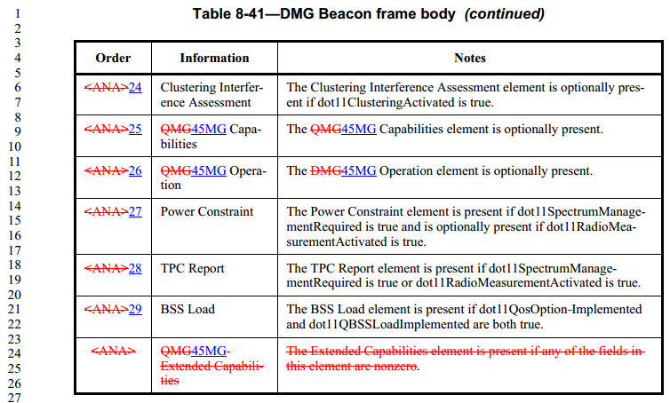
We have deleted the 45MG Extended Capabilities field in 45MG Capabilities element format and adjusted the structure of 45MG Extended Capabilities field.
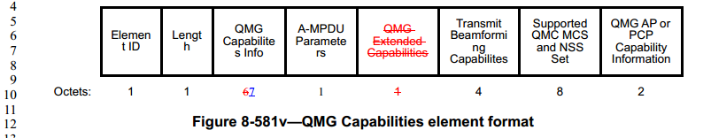

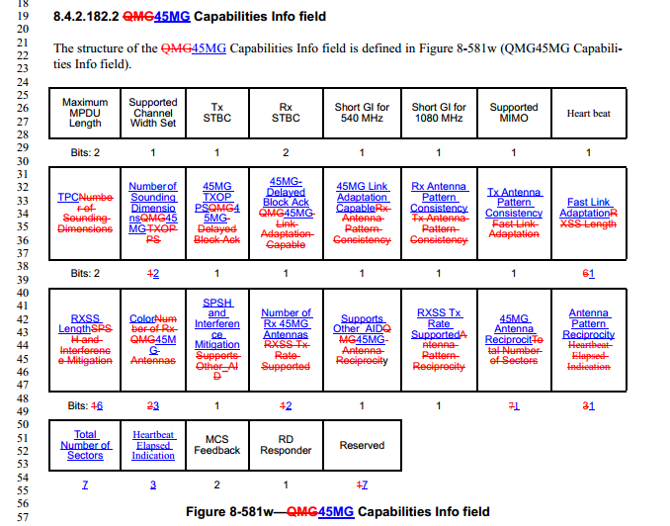

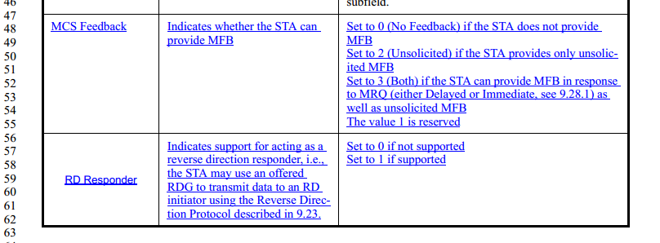
8.4.2.182.5 QMG Extended Capabilities field
The structure of the QMG Extended Capabilities field of the QMG Capabilities element is defined in QMG Extended Capabilities field.
 | PCO | PCO  Transition Time | MCS  Feedback | +QMGC Support | RD  Responder | Reserved
Bits: | 1 | 2 | 2 | 1 | 1 | 1
- QMG Extended Capabilities field
The subfields of the QMG Extended Capabilities field are defined in Subfields of the QMG Extended Capabilities fieldinput.doc
- Subfields of the QMG Extended Capabilities fieldinput.doc
Subfield | Definition | Encoding
PCO | Indicates support for PCO.  When transmitted by an AP: indicates whether the AP can operate its BSS as a PCO BSS.  When transmitted by a non-AP STA: indicates whether the STA can operate as a PCO active STA when the Transition Time subfield in its QMG Extended Capabilities field meets the intended transition time of the PCO capable AP. | Set to 0 if not supported  Set to 1 if supported
PCO Transition Time | When transmitted by a non-AP STA: indicates that the STA can switch between 540 MHz channel width and 1080 MHz channel width within the specified time.  When transmitted by an AP: indicates the PCO Transition Time to be used during PCO operation. The value contained in this field is dynamic when transmitted by an AP, i.e., the value of this field may change at any time during the lifetime of the association of a STA with the AP. See 10.17a.3 (Operation at a PCO active non-AP STA). | If the PCO subfield is equal to 0, this field is reserved.  Otherwise:  Set to 1 for 400 μs  Set to 2 for 1.5 ms  Set to 3 for 5 ms  Set to 0 for no transition. In this case, the PCO active STA does not change its operating channel width and is able to receive 1080 MHz PPDUs during the 540 MHz phase (see 10.17a (Phased coexistence operation (PCO) for QMG STAs)).
MCS Feedback | Indicates whether the STA can provide MFB | Set to 0 (No Feedback) if the STA does not provide MFB  Set to 2 (Unsolicited) if the STA provides only unsolicited MFB  Set to 3 (Both) if the STA can provide MFB in response to MRQ (either Delayed or Immediate, see 9.28.1) as well as unsolicited MFB  The value 1 is reserved
+QMGC Support | Indicates support of the QMG Control field. See 9.9 | Set to 0 if not supported  Set to 1 if supported
RD Responder | Indicates support for acting as a reverse direction responder, i.e., the STA may use an offered RDG to transmit data to an RD initiator using the Reverse Direction Protocol described in 9.23. | Set to 0 if not supported  Set to 1 if supported

CID | Clause | Page | Line | Type | Comment | Proposed Change | Remark
70 | 8.4.1.45 | 32 | 46 | T | I don't believe the Band ID field is administered by the ANA | choose the next value
Proposed resolution: Revised
Insert the following row into Table 8-62 before the last row:
- Band ID field
Band ID value | Meaning
<NAN>6 | 45GHz

CID | Clause | Page | Line | Type | Comment | Proposed Change | Remark
72 |  | 37 | 47 | T | "The explanation on how" - grammar | change "on" to "of"
Proposed resolution: Revised
The explanation onof how these angles are generated from the beamforming feedback matrix…….

CID | Clause | Page | Line | Type | Comment | Proposed Change | Remark
77 | 8.4.2.182.2 | 61 | 6 | T | "COLOR" - the MAC generally does not have field names in capitals, except for abbreviations, even if the PHY fields are capitals. | Rename this field and all references to "Color".
Proposed resolution: Revised

COLORolor | Indicates the value that is used for the TXVECTOR parameter COLOR in frames transmitted by members of this BSS, as described in 9.20 (Partial AID, Uplink Indication and COLOR in 45MG PPDUsGroup ID and partial AID in VHT and 45MG PPDUs). | Set to an unsigned integer in the range 0 to 7 if sent by an AP.  Otherwise reserved.

CID | Clause | Page | Line | Type | Comment | Proposed Change | Remark
78 | 8.4.2.184 | 69 | 41 | T | "Operating Mode Notification element" - this name has already been used. | Rename to "QMG Operating Mode Notification element" throughout the draft.
Proposed resolution: Revised
We have revised the corresponding description according to the suggestion as follows.
8.4.2.184 45MG Operating Mode Notification element
The 45MG Operating Mode Notification element is used to notify STAs that the transmitting STA is changing its operating channel width, the maximum number of spatial streams it can receive, or both. The format of the 45MG Operating Mode Notification element is defined in 45MG
 | Element ID | Length | QMG45MG Operating Mode
Octets: | 1 | 1 | 1
- 45MG Operating Mode Notification elementinput.doc

CID | Clause | Page | Line | Type | Comment | Proposed Change | Remark
80 | 9.3.2.7 | 89 | 20 | T | "A QMG STA that is addressed by an RTS frame in a QMG or QMG duplicate PPDU " -- This doesn't work. A STA can respond only to what it actually receives, which might be a lot less than is addressed to it. | Reword so that the event is receiving the RTS frame, not being addressed.  Likewise line 32
Proposed resolution: Revised
A 45MG STA that is addressed by has received an RTS frame in a 45MG or 45MG duplicate PPDU that has the RXVECTOR parameter DYN_BANDWIDTH equal to Static behaves as follows:

A 45MG STA that is addressed byhas received an RTS frame in a45MG or 45MG duplicate PPDU that has the RXVECTOR parameter DYN_BANDWIDTH equal to Dynamic behaves as follows:
CID | Clause | Page | Line | Type | Comment | Proposed Change | Remark
112 | 26.13.2 | 273 | 1 | T | Reference is incomplete | Resolve reference TBD
Proposed resolution: Revised
After the reception of the final bit of the last PSDU octet, and possible padding bits, the receiver shall be returned to the RX IDLE state, as shown in TBDError: Reference source not found.

