IEEE P802.11
Wireless LANs
Proposed Resolution to CID 17, 20, 21, 43, 61, and 114 on TGaj D1.0 in LB217
Date: 2016-03-14
Author(s):
Name | Company | Address | Phone | Email
Shiwen HE | SEU |  |  | shiwenhe@seu.edu.cn

Abstract

This document proposes resolutions CID 17, 20, 21, 43, 61, and 114 on TGaj D1.0 in LB217.

Editorial Comments
CID | Clause | Page | Line | Type | Comment | Proposed Change | Remark
17 |  |  |  | T | Confict of types. While it is defined that a QMG STA is a DMG STA, there are a few places where a new QMG STA behavior is described in parallel to an existing baseline DMG STA behavior. Clearly, the baseline DMG STA behavior is not intended to apply to the QMG STA in such a case, but nothing has been changed in the baseline DMG STA behavior to exclude a QMG STA which is by definition a DMG STA from also performing that baseline DMG STA behavior. These places need to be identified and the text relating to them needs to be modified to indicate that the existing DMG STA references are for DMG STA that are not also QMG STA.  A specific example of this is found in 9.7.1 P89 L64 where a paragraph describes which multirate rules to use and within that modified paragraph, it first shows the baseline text which mentions what a DMG STA does, and then new text is inserted to mention what a QMG STA does. Since the draft now creates a second set of STA instructions and a QMG STA is both a QMG STA and a DMG STA, a QMG STA by definition must obey both sets of instructions/rules. This cannot be correct. There are probably other instances of this type of conflict in the draft which must be addressed.  And there is also CDMG STA and i am not certain how that one fits into this conundrum.. | For the particular instance cited in 9.7.1, simply change the baseline references to DMG STA to read "DMG STA there are not also QMG STA" or perhaps, more compactly, non-QMG DMG STA, to invent a term. Find other instances of behavioral conflict between QMG STA and DMG STA and resolve them in a similar manner. Some changes might need to be made for CDMG as well.
20 | 9.36 | 109 | 60 | T | This is a specific case where there is confusion about what a QMG STA should do because it is both DMG and QMG. The language is not correctly specified here. Instead of simply having sentences and paragraphs relating to DMG STA and QMG STA behavior, the DMG references, where a QMG STA reference has been inserted, need to be references to non-QMG DMG STA. | Change references of "DMG STA" to "non-QMG DMG STA" as appropriate throughout 9.36.
Proposed resolution: Revised
We propose to change “QMG” to “45MG”. In 11aj a 45MG STA is not a DMG STA. The 45MG STA is newly defined in 11aj in parallel with HT/VHT/DMG STA although it also adopts a number of mechanisms currently defined for DMG STAs. This will be noted in the draft where applicable. A CDMG STA is defined as a DMG STA with additional features, see details in resolution to CID 31. According to the suggestion, we have revised the corresponding description as follows:
“9.7 Multirate support
9.7.1 Overview
Otherwise, a non-DMG STA and non-45MG STA shall transmit the frame using a rate that is in accordance with rules defined in 9.7.5 (Rate selection for Data and Management frames) and 9.7.6 (Rate selection for Control frames). A DMG STA shall transmit the frame using a rate that is in accordance with rules defined in 9.7.7 (Multirate support for DMG STAs). A 45MG STA shall transmit the frame using a rate that is in accordance with rules defined in 9.7.7a (Multirate support for 45MG STAs). ”

CID | Clause | Page | Line | Type | Comment | Proposed Change | Remark
21 | 9.2.1 | 89 |  | T | Which channel access mechanism is used for CDMG and QMG?  For clarification, please update Figure 9-1 and 9-2 in sub-clause 9.2.1 (General).  It seems that CDMG is referring DMG Channel Access and and QMG is referring DCF?  If they are using different channel access mechanism, please provide any reasoning information in the comment resolution. (for example, submission number for understanding)  Since a path loss in 45GHz is more closer than that of 60GHz (not that of below 5GHz), I don't know why QMG is referring DCF. | Please update Figure 9-1 and 9-2 in sub-clause 9.2.1 (General).  And, please leave any reasoning information in the comment resolution. (for example, submission number for understanding)
Proposed resolution: Revised
We have added the corresponding description of 45MG MAC STA architecture. A CDMG STA is a DMG STA. So it follows the same rule as DMG STAs.
9.2 MAC architecture
9.2.1 General
Change the first paragraph as follows:
The MAC architecture is shown in Figure 9-1 (Non-DMG STA MAC architecture), Figure 9-2 (DMG STA MAC architecture) and Error: Reference source not found.
Insert the following Figure 9-2a (45MG STA MAC architecture) and the corresponding description after the third paragraph.
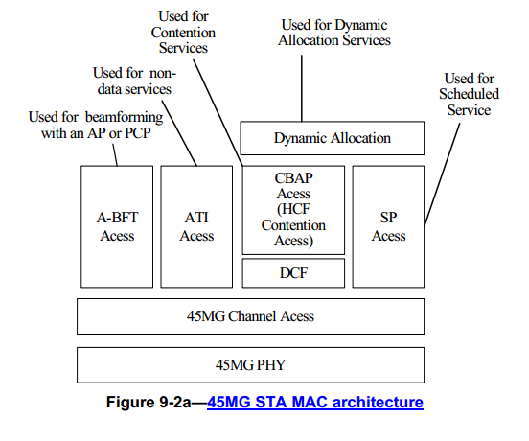
In a 45MG STA:
- The MAC provides services using the 45MG channel access mechanisms.
- Specific rules apply for access during scheduled periods, which include the association beamforming training (A-BFT) period, announcement transmission interval (ATI), contention based access period (CBAP), and service period (SP).
- The DCF is used during contention based access periods.
- Dynamic allocation (Error: Reference source not found) is built on service period and contention based access period.

CID | Clause | Page | Line | Type | Comment | Proposed Change | Remark
43 |  |  |  | T | Paragraph 3 of section 2 claims the following:  "no coexisetence issue as there is no other wireless system operating in this 45 GHz frequency band in China at the time 802.11aj [1] was completed."  Is this really a good basis for coexistence? It is basically saying that 11aj is the first to occupy this spectrum and therefore doesn't have to worry about coexistence. What etiquette does 11aj propose so when others do use this band, the uses can coexist equitably? | Provide a coexistence mechanism that will allow future use of the band on an equitable basis.
Proposed resolution: Reject
The 45MG BSS operated at the frequency band of 40-50GHz do not need to consider the coexistence issue.

CID | Clause | Page | Line | Type | Comment | Proposed Change | Remark
61 |  |  |  | T | It is not clear to me whether a QMG is a refinement of CDMG or DMG. Is it possible for a CDMG STA not to support all the CDMG or DMG behaviour, in addition to the new behaviour?  If the is not the case, then I expect that in many of the locations where | Specify (in clause 4) whether a QMG is a CDMG or a DMG STA. If it is not, review all occurrences of non-DMG and DMG in the baseline and determine where QMG needs to be added.
Proposed resolution: Reject
We propose to change “QMG” to “45MG”. The 45MG STA is newly defined in 11aj in parallel with HT/VHT/DMG STA although it also adopts a number of mechanisms currently defined for DMG STAs. A CDMG STA is a DMG STA with additional a few new features, see resolution to CID 60.
CID | Clause | Page | Line | Type | Comment | Proposed Change | Remark
114 | 9.38 | 134 |  | T | Not clear how devices do initial BF  The process is very high level and not clear. Furthermore, not  clear what exactly mandatory to be supported. | Standard should specify the flows to perform BeamForming.  It is one the essential flows in mmWave communication.  Some flows and some parts are manadatory and some are optional. It is not clear from the document.
Proposed resolution: Revised
Insert the following paragraph after the last paragraph in 9.38.1:
45MG STAs follow the same beamforming training rules used for DMG STAs with only replacing DMG with 45MG in the description and using the preamble and BRP sequence designed for 45MG STAs and do not follow the rules of CDMG beamforming for CDMG STAs as described in Error: Reference source not found.

