IEEE P802.11
Wireless LANs
Proposed Resolution to CID 11, 12, 13, 14, 16, 46, 54, 55, 56, 63, 65, 71, 283, 296, and 300 on TGaj D1.0 in LB217
Date: 2016-03-14
Author(s):
Name | Company | Address | Phone | Email
Shiwen HE | SEU |  |  | shiwenhe@seu.edu.cn

Abstract

This document proposes resolutions CID 11, 12, 13, 14, 16, 46, 54, 55, 56, 63, 65, 71, 283, 296, and 300 on TGaj D1.0 in LB217.

Editorial Comments
CID | Clause | Page | Line | Type | Comment | Proposed Change | Remark
11 | 8.2.4.1.8 | 22 | 37 | T | Proposed changes are inadequate. | The changes here are problematic. They refer to the use of the More Data subfield by a QMG STA, but the baseline More Data usage needs to be modified to exclude its applicability to the QMG STA to avoid a conflict. This is a general problem in the construction of this draft and needs to be addressed globally.
12 | 8.2.4.1.8 | 22 | 38 | T | Missing adjective - or maybe not - I have not read far enough to know whether the feature always uses the QMG adjective or not. But the cited reference subclause includes it. | Change the phrase "support the TXOP power save feature" to "support the QMG TXOP power save feature"
54 | 8.2.4.8 | 22 | 37 | T | Proposed changes are inadequate. | The changes here are problematic. They refer to the use of the More Data subfield by a QMG STA, but the baseline More Data usage needs to be modified to exclude its applicability to the QMG STA to avoid a conflict. This is a general problem in the construction of this draft and needs to be addressed globally.
63 | 8.2.4.1.8 | 22 | 38 | T | "transmitted by a QMG AP to a QMG STA"  Try and avoid unnecessarily qualifications. A QMG AP can only transmit to a QMG STA, so the "to a QMG STA" is unnecessary. | Delete "to a QMG STA".
Proposed resolution: Revised
Insert the following paragraph at the end after the seventh paragraph of 8.2.4.1.8:
The More Data subfield is set to 1 in individually addressed frames transmitted by a 45MG AP to a QMG STA when both support the 45MG TXOP power save feature (as determined from their 45MG Capabilities elements) to indicate that at least one additional buffered BU is present for the STA, see 10.2.2.20 (45MG TXOP power save).

CID | Clause | Page | Line | Type | Comment | Proposed Change | Remark
13 | 8.2.4.1.9 | 25 | 19 | T | Average of what and when? | Please clarify - the average SNR is the average SNR of what? Propose: The average SNR of the signal received from the Voyager spacecraft during the first ten minutes after leaving the solar system.
55 | 8.2.4.9 | 25 | 19 | T | Incomplete sentence -- average of what over what time period? | Please clarify - the average SNR is the average SNR of what?
Proposed resolution: Reject
The definition of the Average SNR is given in the column “Definition” for “SNR” in Table 8-20b cited as follows. Change “QMG” to “45MG” in the table.
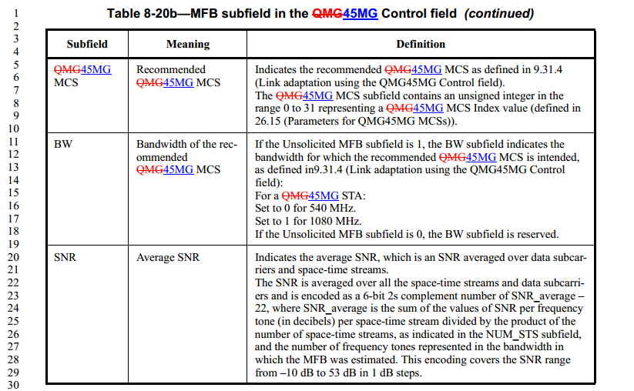

CID | Clause | Page | Line | Type | Comment | Proposed Change | Remark
14 | 8.3.1.10 | 26 | 53 | T | how do I know if a control wrapper frame is a QMG control wrapper frame or an old fashioned control wrapper frame? | Clarify.
46 | 8.3.1.10 | 26 | 64 | T | The parenthetical comment is somewhat confusing and is not needed: "(i.e., excluding the Control Wrapper frame)." | Delete this parenthetical comment: "(i.e., excluding the Control Wrapper frame)"
56 | 8.3.1.10 | 26 | 53 | T | how do I know if a control wrapper frame is a QMG control wrapper frame or an old fashioned control wrapper frame? | Clarify.
65 | 8.3.1.10 | 26 | 53 | T | I have no understanding of why a QMG STA needs to bother with a control wrapper frame. This was introduced in .11n to avoid creating issues with legacy devices that would not understand +HTC.  In a greenfield band, you don't need this extra complexity. | Remove all use of Control Wrapper frame from QMG.
296 | 8.3.1.10 | 26 | 64 | T | The draft now defines two different frames under the same clause (8.3.1.10). This is very confusing and may cause errors (as seen in this draft). For example, for the existing Control Wrapper frame is used (per baseline) to wrape any other control frame (excluding the Control Wrapper frame) which would after the TGaj amendment include wrapping the QMG Control Wrapper frame.  Besides, there is no statement in TGaj when to use the QMG Control Wrapper frame. P26L64 does only state how to use the Control Wrapper frame and this statement is contradicting the existing baseline text.  Maybe the TGaj draft meant to say how to use the QMG Control Wrapper frame (and missed the word QMG here ?).  Anyway, the existing baseline text needs to be modified as well to resolve any contradictions. | per comment
Proposed resolution: Revised
We have removed all use of Control Wrapper frame from 45MG.
8.3.1 Control frames
8.3.1.10 Control wrapper frame
Insert the following figure and paragraphs at the end of 8.3.10:
The format of the QMG Control Wrapper frame is shown in Error: Reference source not found
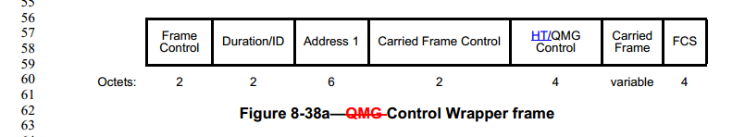
The Control Wrapper frame is used to wrap any other control frame (i.e., excluding the Control Wrapper frame) together with a QMG Control field.
The QMG Control field is defined in Error: Reference source not found.

Insert the following sentence at the end of the first paragraph of 9.9:
If the value of dot11QMGControlFieldSupported is true, a STA shall set the +QMGC Support subfield of the QMG Extended Capabilities field of the QMG Capabilities element to 1 in QMG Capabilities elements that it transmits.

Insert the following sentence at the end of the first paragraph of 9.9:
If the value of dot11QMGControlFieldSupported is true, a STA shall set the +QMGC Support subfield of the QMG Extended Capabilities field of the QMG Capabilities element to 1 in QMG Capabilities elements that it transmits.

Insert the following sentence at the end of the fifth paragraph of 9.9:
A QMG Control field shall not be present in a frame addressed to a STA unless that STA declares support for +QMGC in the QMG Capabilities Info field of its QMG Capabilities element.
Insert the following note after the sixth paragraph of 9.9:
NOTE—A QMG STA that does not support +QMGC that receives a +QMGC frame addressed to another STA still performs the CRC on the actual length of the MPDU and uses the Duration/ID field to update the NAV, as described in 9.3.2.4 (Setting and resetting the NAV).
Insert the following subclause after subclause 9.9:
9.9a QMG Control field operation
If the QMG Control field is present in an MPDU aggregated in an A-MPDU, then all MPDUs of the same frame type (i.e., having the same value for the Type subfield of the Frame Control field) aggregated in the same A-MPDU shall contain a QMG Control field. The QMG Control field of all MPDUs containing the QMG Control field aggregated in the same A-MPDU shall be set to the same value.

9.10 Control Wrapper operation
Insert the following sentence and note at the end of the first paragraph of 9.10:
A STA supporting the QMG Control field that receives a Control Wrapper frame shall process it as though it received a frame of the subtype of the wrapped frame.
NOTE—A STA supporting the QMG Control field can reset the NAV set by a wrapped RTS frame following the rules defined in 9.3.2.4 (Setting and resetting the NAV).

CID | Clause | Page | Line | Type | Comment | Proposed Change | Remark
16 | 8.4.1.46 | 32 | 56 | T | Incorrect wording. | Change "The definition of QMG parameters field is the same with that of the DMG parameters field" to "The definition of the QMG parameters field is the same as the definition of the DMG parameters field"
71 | 8.4.1.46 | 32 | 52 | T | "DMG and QMG Parameters field" - If you rename a field in the baseline, you have to edit all occurrences of that field name to the new value. Have you checked? | Check for all occurrences of "DMG Parameters field" in the baseline and add an edit for them.
283 | 8.4.1.46 | 32 | 56 | T | "Note—The definition of QMG parameters field is the same with that of the DMG parameters field."  This is an informative note; but the draft requires a normative definition of the QMG Parameters field | Add normative spec for QMG parameter field
Proposed resolution: Revised
Change the title of 8.4.1.46 as follows:
8.4.1.46 DMG and QMG Parameters field and 45MG Parameters field
Insert the following note at the end of 8.4.1.46:
Note—The definition of QMG parameters field is the same with that of the DMG parameters fieldThe definition of the 45MG parameters field is the same as the definition of the DMG parameters field.

CID | Clause | Page | Line | Type | Comment | Proposed Change | Remark
300 | 6.3.26 |  |  | T | Missing modifications for MLME-ADDTS.response | Include required modifications for MLME-ADDTS.response in draft
Proposed resolution: Revised
6.3.26.5 MLME-ADDTS.response
6.3.26.5.2 Semantics of the service primitive
Change the primitive parameter list in 6.3.26.5.2 as follows:
The primitive parameters are as follows:
MLME-ADDTS.response(
ResultCode,
DialogToken,
STAAddress,
TSDelay,
TSPEC,
Schedule,
TCLAS,
TCLASProcessing,
EBR,
HigherLayerStreamID,
DMG TSPEC,
45MG TSPEC,
Multi-band,
U-PID,
MMS,
VendorSpecificInfo
)
Insert the following rows before the ‘DMG TSPEC’ row in the untitled table in 6.3.26.4.2:
45MG  TSPEC | 45MG TSPEC  element | As defined in  8.4.2.133 (DMG TSPEC element and QMG TSPEC element) | Specifies the characteristics and QoS scheduling  requirements of the 45MG allocation request.

