IEEE P802.11
Wireless LANs
Proposed Resolution to CID 9, 10, 28, 32,34, 45, 53, 62, 64, 113, 130, 192, and 215 on TGaj D1.0 in LB217
Date: 2016-01-27
Author(s):
Name | Company | Address | Phone | Email
Shiwen HE | SEU |  |  | shiwenhe@seu.edu.cn

Abstract

This document proposes resolutions CID 9, 10, 28, 32,34, 45, 53, 62, 64, 113, 130, 192, and 215 on TGaj D1.0 in LB217.

Editorial Comments
CID | Clause | Page | Line | Type | Comment | Proposed Change | Remark
9 | 8.2.3 | 22 | 11 | T | Missing editing marks. | Change marks are not shown for the text changes to the second paragraph of 8.2.3. And there is some underlining in the new figure that is extraneous (see the QMG control field
10 | 8.2.3 | 22 | 11 | G | Proposed changes are inadequate. | The change cited proposes to add a figure, but there is no text added which references the new figure and the existing baseline figure 8-1 and the text referencing that baseline figure must be modified to note that the first figure does not apply to QMG STAs. I.e. a lot of references in the baseline text to "STA" need to be changed to "non-QMG STA" in order to keep a QMG STA from having to obey the baseline operation for non-QMG STA. I.e. the problem cited here is a global problem and the solution will affect much more than this single citation. Reading a bit farther, i see that the intent in this figure was to change the HT Control field to QMG Control field - the change marks do not show this properly. And there is a better way to do this that redefines the 4 octets under a new name and then inculdes a table that defines the subfields according to some switches. Talk to Aflred Asterjahdi to get the picture. Note also that the proposed changes to 9.9 HT Control field operation are already following that line of thinking - i.e. there is no attempt to create a new subclause that describes the use of the QMG Control field, but instead, that behavior is inserted into the subclause for HT Control field.
28 | 8.2.3 | 22 | 20 | T | Editing instructions for 8.2.3 do not look correct. The Figure 8-1a is being inserted as a new figure, but it has "QMG" underlined. In addition, the second paragraph is claimed to be changed, but there is no underlining or strikethrough showing changes there. | Fix editing instructions for 8.2.3: Remove underlining of "QMG" in Figure 8-1a, show changes to the second paragraph, and add a text reference to the new figure.
34 | 8.2.4.9 | 22 | 47 | T | It is not clear why QMG Control filed is present always. It shall not be included at least for non-11aj STAs. | Need further clarification in which case QMG Control field is present in a Control Wrapper frame.
45 | 8.2.3 | 22 | 7 | T | Figure 8-1a is inserted without any reference or explanation in the text. | Add a reference to "Figure 8-1a" in the text and provide some brief text on what is shown.
53 | 8.2.3 | 22 | 11 | T | Proposed changes are not sufficient and needs more thorough work. | More changes are needed to systematically examine current reference of STA to differentiate QMG and non-QMG STAs.
62 | 8.2.3 | 22 | 24 | T | Every figure and table that has a number must have a reference from the text.  You must avoid creating contradictions, so where ever you have a "special QMG" version of somehting, you have to edit the non-QMG version and add "for non-QMG STAs". | However, I don't think this is best way to go. I suggest adding the QMG Control field to the existing Figure 8-1, and the description of this field can say "present only in QMG MPDUs".
64 | 8.2.4.1.9 | 22 | 47 | T | "The QMG Control field is always present in a Control Wrapper frame and is present in QoS Data and  Management frames as determined by the Order bit of the Frame Control field as defined in 8.2.4.1.10 (Order field)." - this is certainly not true for non-Q | Limit to QMG frames.
113 | 8.2.3 | 22 | 9 | T | Frame format insertion is not clear. Is the current paragraph in the section to be deleted? Added to? | Modify the inserted paragraph to apply to QMG STAs only
130 | 8.2.3 | 22 | 18 | T | In REVmc4.2, the length of the Frame Body field in MAC frame format is indicated by 'variable'. | Change '0-11426' to 'variable'.
192 | 8.2.3 | 22 | 12 | T | Missing editorial instructions: The paragraph does not show any changes according to the style guidelines.  It seems that text is added to the existing paragraph, but the addition is not underlined | provide correct editorial instruction and highlighted text changes per editor's style guide
215 | 8.2.3 | 22 | 20 | T | Figure is inserted (i.e. added), hence QMG should not be underlined. Editorial instructions above should say "new Figure" to make this clear | per comment
Proposed resolution: Revised
We add a new subclause to describe clearly the 45MG Control field due to the fact that the 45MG Control field is a totally new field and different from the HT Control field. In addition, there is no coexisting problem between IEEE 802.11aj and IEEE 802.11ac/n. We have simply remedied the title of 8.2.4.9 as follows.
Change the second paragraph of 8.2.3 and insert Figure 8-1 as indicated below:
The Frame Body field is of variable size, constrained as defined in 8.2.4.7.1 (General). The maximum frame body size is determined by the maximum MSDU size (2304 octets) or the maximum A-MSDU size (3839 or 7935 octets, depending upon the STA’s capability), plus any overhead from security encapsulation.

Octets: 2 | 2 | 6 | 6 | 6 | 2 | 6 | 2 | 4 | 0-11426variable | 4
Frame Control | Duration/ID | Address1 | Address 2 | Address 3 | SequenceControl | Address 4 | QoS Control | HT/45MG Control | Frame Body | FCS
- MAC frame format for QMG STAs
Insert the following note at the end of subclause 8.2.3.
Note: The 45MG Control field presents only in 45MG MPDUs.
8.2.4.1.10 Order subfield
Insert the following paragraphs after the third paragraph of 8.2.4.1.10:
For QMG STA, the Order subfield is 1 bit in length. It is used for two purposes:
- It is set to 1 in a non-QoS Data frame transmitted by a non-QoS QMG STA to indicate that the frame contains an MSDU, or fragment thereof, that is being transferred using the StrictlyOrdered service class.
- It is set to 1 in an QoS Data or Management frame transmitted by an QoS QMG STA to indicate that the frame contains an 45MG Control field.
Otherwise, the Order subfield is set to 0.
Insert the following subclause, 8.2.4.96a, after 8.2.4.86:
8.2.4.6a 45MG Control field
The QMG Control field is always present in a Control Wrapper frame and is present in QoS Data and Management frames as determined by the Order bit of the Frame Control field as defined in 8.2.4.1.10 (Order field).
NOTE 1—The only Control frame subtype for which QMG Control field is present is the Control Wrapper frame. A Control frame that is described as +QMGC (e.g., an RTS+QMGC, CTS+QMGC, BlockAck+QMGC or BlockAckReq+QMGC frame) implies the use of the Control Wrapper frame to carry that Control frame.
The format of the 4-octet 45MG Control field is shown in Error: Reference source not found.
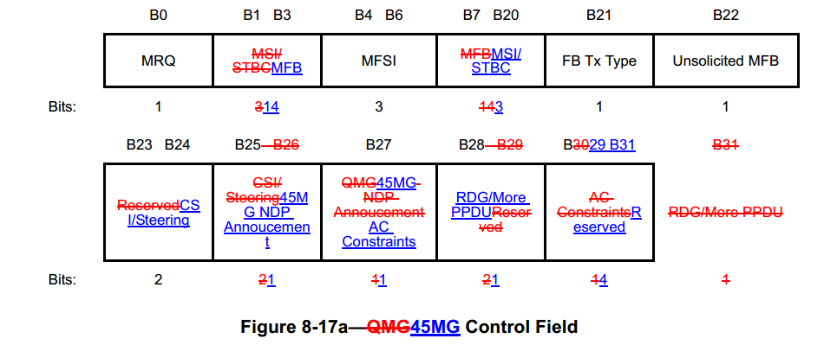

- Subfields corresponding to link adaptationinput.doc
Subfield |  | Meaning |  | Definition
MSI/STBCMFB |  | MRQ sequence identifier/STBC indicationNUM_STS, QMG MCS, BW and SNR feedback |  | MFB subfield is interpreted as defined in Error: Reference source not found. This subfield contains the recommended MFB. The combination of 45MG MCS=31 and NUM_STS=3 indicates that no feedback is present.If the Unsolicited MFB subfield is 0 and the MRQ subfield is 1, the MSI/STBC subfield contains a sequence number in the range 0 to 6 that identifies the specific MCS feedback request.  If the Unsolicited MFB subfield is 0 and the MRQ subfield is 0, the MSI/STBC subfield is reserved.  If the Unsolicited MFB subfield is 1 and the MFB does not contain the value representing “no feedback is present,” the MSI/STBC field contains the Compressed MSI and STBC Indication subfields as shown in Error: Reference source not found.  The STBC Indication subfield indicates whether the estimate in the MFB subfield is computed based on a PPDU using STBC encoding:  Set to 0 if the PPDU was not STBC encoded.  Set to 1 if the PPDU was STBC encoded.  The Compressed MSI subfield contains a sequence number that identifies the specific MCS feedback request. It is in the range 0 to 3 if STBC Indication equals 0 or in the range 0 to 2 if STBC Indication equals 1.  Otherwise, the MSI/STBC subfield is reserved.
MFBMSI/STBC |  | MRQ sequence identifier/STBC indicationNUM_STS, QMG MCS, BW and SNR feedback |  | MFB subfield is interpreted as defined in Error: Reference source not found. This subfield contains the recommended MFB. The combination of QMG MCS=31 and NUM_STS=3 indicates that no feedback is present.If the Unsolicited MFB subfield is 0 and the MRQ subfield is 1, the MSI/STBC subfield contains a sequence number in the range 0 to 6 that identifies the specific MCS feedback request.  If the Unsolicited MFB subfield is 0 and the MRQ subfield is 0, the MSI/STBC subfield is reserved.  If the Unsolicited MFB subfield is 1 and the MFB does not contain the value representing “no feedback is present,” the MSI/STBC field contains the Compressed MSI and STBC Indication subfields as shown in Error: Reference source not found.  The STBC Indication subfield indicates whether the estimate in the MFB subfield is computed based on a PPDU using STBC encoding:  Set to 0 if the PPDU was not STBC encoded.  Set to 1 if the PPDU was STBC encoded.  The Compressed MSI subfield contains a sequence number that identifies the specific MCS feedback request. It is in the range 0 to 3 if STBC Indication equals 0 or in the range 0 to 2 if STBC Indication equals 1.  Otherwise, the MSI/STBC subfield is reserved.
FB Tx Type | Transmission type  of the measured  PPDU |  | If the Unsolicited MFB subfield is 1, the MFB does not contain the value representing “no feedback is present,” and FB Tx Type subfield is 0, then the unsolicited MFB is estimated from a 45MG PPDU with RXVECTOR parameter BEAMFORMED equal to 0.  If the Unsolicited MFB subfield is 1, the MFB does not contain the value representing “no feedback is present,” and the FB Tx Type subfield is 1, then the unsolicited MFB is estimated from a 45MG PPDU with RXVECTOR parameter BEAMFORMED equal to 1.  Otherwise, this subfield is reserved.

CID | Clause | Page | Line | Type | Comment | Proposed Change | Remark
32 | 8.3.2.6a | 89 | 9 | T | "A QMG STA transmits an RTS frame carried in QMG or QMG duplicate format" should be either "A QMG STA may transmit an RTS frame carried in QMG or QMG duplicate format" or "A QMG STA shall transmit an RTS frame carried in QMG or QMG duplicate format" or "The RTS frane that a QMG STA transmits shall be carried in QMG or QMG duplicate format". | Change the referred sentence to either of the proposed suggestions.
Proposed resolution: Revised
A QMG STA transmits an RTS frame carried in QMG or QMG duplicate formatA 45MG STA shall transmit an RTS frame carried in 45MG or 45MG duplicate format.

