IEEE P802.11
Wireless LANs
802.11
SB1 - Proposed resolutions for CIDs 7188-7614-7588
Date: 2016-02-19
Author(s):
Name | Company | Address | Phone | email
Emily Qi | Intel Corporation |  |  | Emily.h.qi@intel.com
Abstract

This document contains proposed resolutions to SB1 comments: CID 7188, CID 7614, and CID 7588

CID | Page | Clause | Comment | Proposed Change | Owning Ad-hoc
7188 | 716.08 | 9.4.1.53 | "In a VHT STA see Table 9-74 (Setting of the Channel Width subfield and  Dynamic Extended NSS BW subfield at a VHT STA transmitting the Operating  Mode field)(Setting of the Channel Width subfield and Dynamic Extended NSS  BW subfield at a VHT STA transmitting the Operating Mode field)" has duplication | Remove the second paren. Check all the other subclause parens in the change which added Extended NSS BW Support as it looks as if they might have been included as-is | MAC

Discussion:

Agreed with the commenter at cited location 715.08.
There is no other instance identified.

Proposed Resolution:
Revised.
At 715.10, delete: “(Setting of the Channel Width subfield and Dynamic Extended NSS
BW subfield at a VHT STA transmitting the Operating Mode field)"

CID | Page | Clause | Comment | Proposed Change | Owning Ad-hoc
7614 | 948.25 | 9.4.2.75 | "The Current Count field is reserved when the FMS Counter field is included in the FMS Status subelement." -- but the FMS Counter field is not an optional field, so is always included. Is this saying that if an FMS Status subelement is present in an MMPDU that also includes an FMS Descriptor element, then the Current Count field of the latter is reserved? | If that's indeed what it's trying to say, make it say it, otherwise make it say what it's actually trying to say | MAC

Discussion:

The FMS Status subelement includes the FMS Counter field. The FMS Counter field definition (in 9.4.2.75, cited location) is refered in the FMS Status subelement definition in 9.4.2.77, see 951.51:

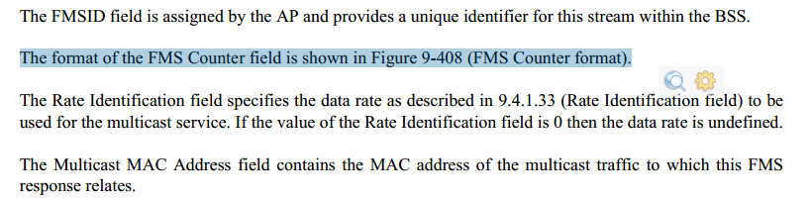

The cited text is for the clarification when the FMS Counter field is used in the FMS status subelement.

To avoid confusion, suggest removing cited text "The Current Count field is reserved when the FMS Counter field is included in the FMS Status subelement." in 9.4.2.75, and add definitions/clarification in 9.4.2.77.

Proposed Resolution:
Revised.
At 948.25, delete: “The Current Count field is reserved when the FMS Counter field is included in the FMS Status subelement."

At 951.51, make following changes:
The format of the FMS Counter field is shown in Figure 9-408 (FMS Counter format). The FMS Counter ID field of the FMS Counter field is defined in 9.4.2.75. The Current Count field of the FMS Counter field is reserved in the the FMS Status subelement.

The Rate Identification field specifies the data rate as described in 9.4.1.33 (Rate Identification field) to be used for the multicast service. If the value of the Rate Identification field is 0 then the data rate is undefined.

CID | Page | Clause | Comment | Proposed Change | Owning Ad-hoc
7588 | 1593.48 | 11.2.2.16.4 | The FMS Status subelement includes  both a delivery interval and a max delivery interval, but clearly  the delivery interval only specifies the delivery interval (duh!).  There are two cases here: one where  the AP said "Alternate proposed, due to AP changed the delivery interval" and one where it  said "Alternate proposed, due to AP changed the maximum delivery interval". So need to say that the FMS Status  subelement only specifies one or the other respectively?  Or should the statement be:  If the Element Status value in FMS Status subelement is one of [...]:  --- The AP does not deliver the requested streams at the delivery interval and maximum delivery interval as specified by the non-  AP STA in the FMS Request element. The FMS Status  subelement specifies a delivery interval and a maximum delivery interval that the AP is willing to accept for the specified  streams if the non-AP STA sends another FMS Request with that delivery interval and maximum delivery interval specified.  --- The non-AP STA may submit a new FMS Request that includes the delivery interval value and maximum delivery interval  received from the AP. If the AP accepts this new FMS Request, it shall respond as described in 10.2.2.16.2 (FMS general procedures).  ? | As it says in the comment | MAC

Discussion:
Agreed.

Proposed Resolution:
Revised.

At 1593.48, make following changes:
— If the Element Status value in FMS Status subelement is one of “Alternate proposed, due to existing
stream with different delivery interval”, “Alternate proposed, due to policy limits on AP”, “Alternate proposed, because the AP changed the delivery interval”, and “Alternate proposed, because the AP changed the maximum delivery interval”:
— The AP does not deliver the requested streams at the delivery interval and maximum delivery interval as specified by the non-AP STA in the FMS Request element. The delivery interval specified in the FMS Status subelement specifies a delivery interval The FMS Status
subelement specifies a delivery interval and a maximum delivery interval that the AP is willing to accept for the specified streams if the non-AP STA sends another FMS Request with that delivery interval and maximum delivery interval specified.
— The non-AP STA may submit a new FMS Request that includes the delivery interval value received from the AP. If the AP accepts this new FMS Request, it shall respond as described in 11.2.2.16.2 (FMS general procedures).

