IEEE P802.11
Wireless LANs
802.11
SB1 - Proposed resolutions for trivial technical comments
Date: 2016-02-19
Author(s):
Name | Company | Address | Phone | email
Emily Qi | Intel Corporation |  |  | Emily.h.qi@intel.com
Abstract

This document contains some proposed resolutions to SB1 comments - 29 comments.

The comments trivial technical comments that are “owned” by EDITOR.

==

CID | Page | Clause | Resn Status | Comment | Proposed Change | Resolution | Owning Ad-hoc
7713 |  |  |  | There are 6 instances of "set to No Acknowledgement". All but the last refer to the Ack Policy subfield, where the enum is actually "No Ack" | Change to "set to No Ack" for all but the last |  | EDITOR

Discussion:
Search through the D5.0, I found 2 instance of “set to No Acknowledgement”, and 5 instances of “set to No Acknowledgment”. Furthermore, 4 instances of “No Acknowledgement”, and 30 instances of “No Acknowledgment”.

If it refers to the Ack Policy subfield in QoS Control field of QoS Data frame, the value should be “No Ack”, see 578.60
If it refers to the BAR Ack Policy subfield in the BAR Control field of the BlockAckReq frame or BA Ack Policy subfield in the BA Control field of the BlockAck frame, the value should be “No Acknowledgment”, see 602.48, and 606.29.

Proposed Resolution:
Revised.
At 1256.61, 1401.2, 2956.47, and 3409.12: change “No Acknowledgement” to “No Acknowledgment”.
At 339.42: change “no acknowledgement” to “no acknowledgment”.
At 1255.39(2 instances), 1255.48, 1255.52: change “set to No Acknowledgment” to “set to No Ack”

==
CID | Page | Clause | Resn Status | Comment | Proposed Change | Resolution | Owning Ad-hoc
7281 | 150.51 | 6.3.3.3.2 |  | 126 and 127 are not valid "rate"s (they're BSS membership selectors) | Change "1-127" to "1-125" here and at the top of the next page | 7281 | 150.51
7282 | 159.30 | 6.3.4.2.2 |  | 126 and 127 are not valid "rate"s (they're BSS membership selectors) | Change "1-127" to "1-125" |  | EDITOR
7287 | 201.52 | 6.3.11.2.2 |  | 126 and 127 are not valid "rate"s (they're BSS membership selectors) | Change "1-127" to "1-125" |  | EDITOR

Discussion:

Note that these 3 comments are commenting on “BSSBasicRateSet”, “OperationalRateSet” paraemters in
MLME-SCAN.confirm, MLME-JOIN.request, and MLME-START.request.

Agreed with the commenter that 126 and 127 are not rates, they are BSS membership selectors.

Similar comments are CID 7278, and 7280. Assigned these 3 comments to Graham and Mark on Feb 19, 2016

Proposed Resolution:
TBD

==

CID | Page | Clause | Resn Status | Comment | Proposed Change | Resolution | Owning Ad-hoc
7283 | 173.47 | 6.3.7.3.2 |  | 126 and 127 are not valid "rate"s (they're BSS membership selectors) | Change "1-127" to "1-125" and add a row for BSSMembershipSelectorSet |  | EDITOR
7284 | 177.36 | 6.3.7.4.2 |  | 126 and 127 are not valid "rate"s (they're BSS membership selectors) | Change "1-127" to "1-125" |  | EDITOR
7285 | 187.29 | 6.3.8.3.2 |  | 126 and 127 are not valid "rate"s (they're BSS membership selectors) | Change "1-127" to "1-125" and add a row for BSSMembershipSelectorSet |  | EDITOR
7286 | 190.50 | 6.3.8.4.2 |  | 126 and 127 are not valid "rate"s (they're BSS membership selectors) | Change "1-127" to "1-125" |  | EDITOR
7288 | 246.60 | 6.3.27.3.2 |  | 126 and 127 are not valid "rate"s (they're BSS membership selectors) | Change "1-127" to "1-125" |  | EDITOR
7289 | 247.58 | 6.3.27.4.2 |  | 126 and 127 are not valid "rate"s (they're BSS membership selectors) | Change "1-127" to "1-125" |  | EDITOR
7290 | 249.03 | 6.3.27.5.2 |  | 126 and 127 are not valid "rate"s (they're BSS membership selectors) | Change "1-127" to "1-125" |  | EDITOR

Discussion:

Note that these 7 comments are commenting on “SupportedRates” that are carried in Assocation Request/Response frames, Reassociation Request/Response frames, and DLS Request/Response drames.

Agreed with the commenter that 126 and 127 are not rates, they are BSS membership selectors.

However, since the Supported Rates and BSS Membership Selectors element is included in the corresponding frames, not only “Supported Rates”, the “SupportedRates” paramters in the corresponding primitives should be changed to “SupportedRates and BSSMembershipSelector”.

More changes are needed. Mark and Graham will look at them.

Proposed Resolution: TBD
Revised.
In clause 6, change all “SupportedRates” to “SupportedRates and BSSMembershipSelector”. 14 instances.

===

CID | Page | Clause | Resn Status | Comment | Proposed Change | Resolution | Owning Ad-hoc
7054 | 203.30 | 6.3.11.2.2 |  | "may be present" does not match WG11 style for Clause 6/9 in this context. | Change "may be present" to "is optionally present" at:cited location + 634.14, 634.16, 827.50, 828.30(other instances are covered by individual comments) |  | EDITOR

Discussion:
Checked with cited locations. Agreed.

Proposed Resolution:
Accepted.

===

CID | Page | Clause | Resn Status | Comment | Proposed Change | Resolution | Owning Ad-hoc
7554 | 228.27 | 6.3.24.1.4 |  | "Specifies that Data frames neither from the MAC address nor to the MAC address areprotected." -- huh? | Change to "Specifies that Data frames to and from the MAC address are not protected." | 7554 | 228.27

Discussion:
Agreed.

Proposed Resolution:
Accepted.

CID | Page | Clause | Resn Status | Comment | Proposed Change | Resolution | Owning Ad-hoc
7258 | 487.28 | 6.9.37.3.2 | J | It says "A set of information fields" | Change to "A set of elements" | 7258 | 487.28

Discussion:
The “ChannelAvailabilityQuery” included in the Channel Availability Query frame is a set of fields, not elements.
“A set of information fields” is correct. No change needed.

Proposed Resolution:
Rejected.

Reject Reason: The “ChannelAvailabilityQuery” included in the Channel Availability Query frame is a set of fields, not elements. “A set of information fields” is correct. No change needed.

CID | Page | Clause | Resn Status | Comment | Proposed Change | Resolution | Owning Ad-hoc
7646 | 1284.13 | 10.3.2.12.2 |  | "A STA operating as a QoS STA transmitting a QoS Data frame" -- a non-QoS STA does not transmit QoS Data frames | Simplify to "A STA transmitting a QoS Data frame" | 7646 | 1284.13

Discussion:
Agreed.

Proposed Resolution:
Accepted.

CID | Page | Clause | Resn Status | Comment | Proposed Change | Resolution | Owning Ad-hoc
7308 | 1346.29 | 10.21.3 |  | What does "an element or element-specific Information field" mean? | Change to "an element" | 7308 | 1346.29

Discussion:
Cited text:
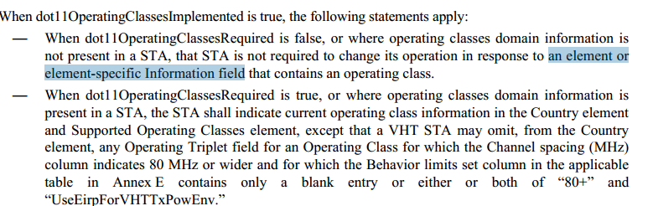

The cited text “element-specific Information field” doesn’t add information new.
Agreed with commenter’s suggestion.

Proposed Resolution:
Accepted.

CID | Page | Clause | Resn Status | Comment | Proposed Change | Resolution | Owning Ad-hoc
7309 | 1346.59 | 10.21.4 |  | What does "an element or element-specific Information field" mean? | Change to "an element" | 7309 | 1346.59

Discussion:
Cited text:

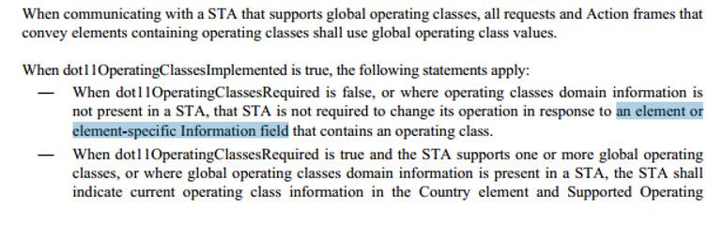

The cited text “element-specific Information field” doesn’t add new information.
Agreed with commenter’s suggestion.

Proposed Resolution:
Accepted.

CID | Page | Clause | Resn Status | Comment | Proposed Change | Resolution | Owning Ad-hoc
7096 | 1420.49 | 10.26.5.3 |  | "A VHT STA shall set the HT Capabilities element HT Capability Information field L-SIG TXOP Protection Support subfield to 0 during (re)association." -- this is not specific to "rules at the TXOP responder". | Move cited para to 10.26.5.1 (General). | 7096 | 1420.49

Discussion:
Agreed.

Proposed Resolution:
Revised.
At 1420.49, remove: "A VHT STA shall set the HT Capabilities element HT Capability Information field L-SIG TXOP Protection Support subfield to 0 during (re)association."
At 1417.64, add a para: "A VHT STA shall set the HT Capabilities element HT Capability Information field L-SIG TXOP Protection Support subfield to 0 during (re)association."

==
CID | Page | Clause | Resn Status | Comment | Proposed Change | Resolution | Owning Ad-hoc
7491 | 1473.04 | 10.36 |  | There are about 89 instances of "NAV timer", mostly in DMG-specific stuff. But such an object is not defined | Delete "timer" in all cases | 7491 | 1473.04

Discussion:
Found 70 instances of “NAV timer(s)”, and 9 instances of “TXNAV timer”.

“TXNAV timer” is defined at 1356.12. Therefore, “TXNAV timer” is out of the scope of this comment.

For 70 instances of “NAV timer(s)”, agreed with the commenter that “timer” can be removed.

Proposed Resolution:
Revised.
Throughout the draft, change “NAV timer” to “NAV”, and change “NAV timers” to “NAVs”.

===
CID | Page | Clause | Resn Status | Comment | Proposed Change | Resolution | Owning Ad-hoc
7144 | 1552.16 | 10.41.3.1 | V | This page contains 2 instances of "can" that are unclear, one on line 16, the other on line 35. | Replace instance of "can" on line 16 with "may". Either do the same for the instance on line 35 or change "can use the SP allocation" to "can use the resulting SP allocation" | 7144 | 1552.16

Discussion:
Agreed.

Proposed Resolution:
Revised.
At 1552.16, change as follows:

“The TPA procedure can includes the estimation of the sampling frequency-offset (SFO), in order for the source REDS and RDS to adjust their SFOs.”

At 1552.35, change “can” to “might”.

===
CID | Page | Clause | Resn Status | Comment | Proposed Change | Resolution | Owning Ad-hoc
7098 | 1598.12 | 11.2.2.19 |  | Reference to Table 11-2 is incorrect. | Remove reference, or point it to a better location. | 7098 | 1598.12

Discussion:
Agreed. The Table reference is in correct. There is no need to add a reference for “active mode”.
Cited text:
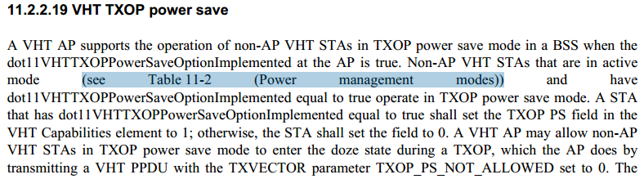

Proposed Resolution:
Revised.
At 1598.12: Delete: “(see Table 11-2 (Power management modes))”.

==

CID | Page | Clause | Resn Status | Comment | Proposed Change | Resolution | Owning Ad-hoc
7100 | 1704.46 | 11.11.10.3 |  | The heading of this subclause "Receiving a neighbor report" does not agree with the content "shall include an xyz element". | Find a more appropriate heading, such as "Responding to a Neighbor Report request". | 7100 | 1704.46

Discussion:
Agreed.

Proposed Resolution:
Revised.
At 1704.46, change "Receiving a neighbor report" to “Responding to a neighbor report request".

====

CID | Page | Clause | Resn Status | Comment | Proposed Change | Resolution | Owning Ad-hoc
7124 | 1705.40 | 11.11.10.3 |  | "(i.e., in this case the Neighbor Report Response frame contains zero or more Neighbor Report elements)" -- the following sentence appears to duplicate this. | Delete either cited text or following sentence. | 7124 | 1705.40

Discussion:
Agreed.

Proposed Resolution:
Revised.
At 1705.40, delete: “(i.e., in this case the Neighbor Report Response frame contains zero or more Neighbor Report elements)"

==
CID | Page | Clause | Resn Status | Comment | Proposed Change | Resolution | Owning Ad-hoc
7129 | 1897.52 | 11.46 |  | "ESP STAs should determine values" - normative requirements should be on single devices, not collections of them | Reword "An ESP STA should determine a value" | 7129 | 1897.52

Discussion:
Agreed.

Proposed Resolution:
Accepted.

==
CID | Page | Clause | Resn Status | Comment | Proposed Change | Resolution | Owning Ad-hoc
7108 | 2621.31 | 22.1.1 |  | There is no 22.6. There was no 22.6 even before the renumbering exercise. | Remove reference to 22.6. | 7108 | 2621.31

Discussion:
Agreed.

Proposed Resolution:
Revised.

At 2621.31, change as follows:
All TVHT transmissions in one BCU shall use the VHT PHY parameters for 40 MHz channel defined in
21.3 (VHT PHY), 21.4 (VHT PLME), and 21.5 (Parameters for VHT-MCSs), and 22.6 with a sampling clock change to fit into each of the BCU bandwidths and with the number of encoders (NES) always being 1 (for SU-MIMO and per user in MU-MIMO).

==
CID | Page | Clause | Resn Status | Comment | Proposed Change | Resolution | Owning Ad-hoc
7126 | 3186.61 | C.3 |  | The mib variable dot11ChannelUtilizationBeaconInterval is defined as such consistently in the mib, but is consistently refered to in the plural form. | Make all such the plural form - i.e., change the MIB. | 7126 | 3186.61

Discussion:
Agreed.

Proposed Resolution:
Revised.
In Annex C, change all “dot11ChannelUtilizationBeaconInterval” to “dot11ChannelUtilizationBeaconIntervals”, 5 instances.

==
CID | Page | Clause | Resn Status | Comment | Proposed Change | Resolution | Owning Ad-hoc
7130 | 3581.22 | N.1 |  | The new para at 22 would fit better in subclause N.2. | Move it to N.2 - perhaps at line 56. | 7130 | 3581.22

Discussion:
There no consense to move the para.

Proposed Resolution:
Revised.

At 3581.22: change the cited para as follows:
“Definition: iIn this annex a wireless local area network (WLAN) system is a system that includes the distribution system (DS), access point (AP), and portal entities. It is also the logical location of distribution and integration service functions of an extended service set (ESS). A WLAN system contains an optional portal and one or more APs in addition to the DS.”

==
CID | Page | Clause | Resn Status | Comment | Proposed Change | Resolution | Owning Ad-hoc
7103 | 1883.25 | 11.43 |  | "B0-B1 (BW) in TVHT-SIG-A1"- the MAC has no knowledge of the contents of particular signal fields in the PHY (rightly so). | Reword so that this refers only to TXVECTOR/RXVECTOR parameters. | 7103 | 1883.25

Discussion:
Need help from a “PHY” person.
Assigned to Adrian.

Proposed Resolution:
TBD

==
CID | Page | Clause | Resn Status | Comment | Proposed Change | Resolution | Owning Ad-hoc
7104 | 1897.37 | 11.46 |  | "the STA may assume any value for the average MSDU size" - No normative effect can be attributed to "may assume"? | Reword in terms of observable behaviour. | 7104 | 1897.37

Discussion:

Need inputs. Assigned to Adrian.

At 1897.37:

If the AverageMSDUSizeOutbound parameter for an access category is equal to 0 in the MLME-ESTIMATED-THROUGHPUT.request primitive, the STA may assume any value for the average MSDU size used in calculating the estimated throughput to be included in the corresponding access category in the EstimatedThroughputOutbound parameter of the MLMEESTIMATED-THROUGHPUT.confirm primitive, but should use a value of 1500 octets.

At 1897.46:

If the AverageMSDUSizeOutbound parameter for an access category is equal to 0 in the MLME-ESTIMATED-THROUGHPUT.request primitive, the STA may assume any value for the average MSDU size used in calculating the estimated throughput to be included in the corresponding access category in the EstimatedThroughputOutbound parameter of the MLMEESTIMATED-THROUGHPUT.confirm primitive, but should use a value of 1500 octets.

Proposed Resolution:
TBD

