IEEE P802.11
Wireless LANs
Proposed Resolution to CID 2-7 on TGaj D1.0 in LB217
Date: 2016-01-27
Author(s):
Name | Company | Address | Phone | Email
Shiwen HE | SEU |  |  | shiwenhe@seu.edu.cn

Abstract

This document proposes resolutions CID 2-7 on TGaj D1.0 in LB217.

Editorial Comments

CID | Clause | Page | Line | Type | Comment | Proposed Change | Remark
2 | 26.3.5.2 | 215 | 24 | T | Equation(26-10) | Sequence Z(n mod 256) in Equation(26-10) should be multipled by exp((jπn/2) .  That is, rSTF(nTc)=Z(n mod 256) exp(jπn/2).
3 | 26.3.5.3 | 215 | 42 | T | Equation(26-11) | All sequences Z(n mod 256) in Equation(26-11) should be multipled by exp(jπn/2).
4 | 26.3.5.4 | 216 | 4 | T | Equation(26-12) | All sequences Z(n mod 256) in Equation(26-12) should be multipled by exp(jπn/2).
5 | 26.3.5.5 | 216 | 23,  33 | T | Equation(26-13) and Equation(26-14) | All sequences Z(n mod 256) in Equation(26-13) and Equation(26-14) should be multipled by exp(jπn/2).
6 | 26.3.5.6 | 217 | 8,  18 | T | Equation(26-15) and Equation(26-16) | All sequences Z(n mod 256) in Equation(26-15) and Equation(26-16) should be multipled by exp(jπn/2).
Proposed resolution: Accept
We have revised the Equations (26-10)- to Equation (26-16) according the suggestions, cited as follows
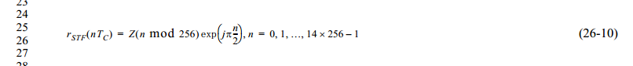
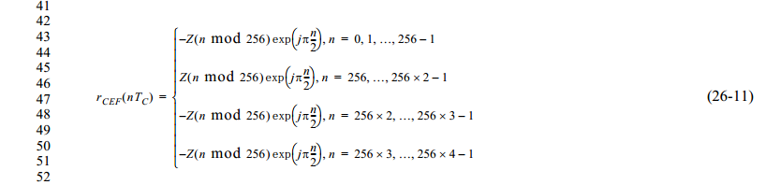
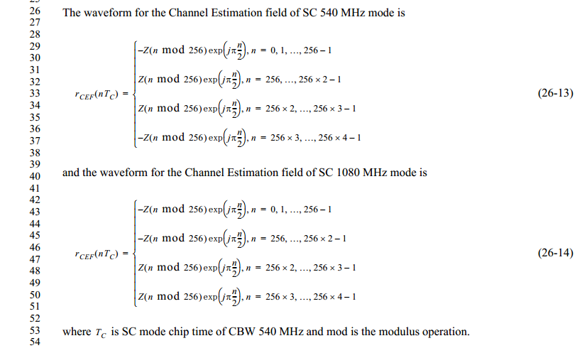
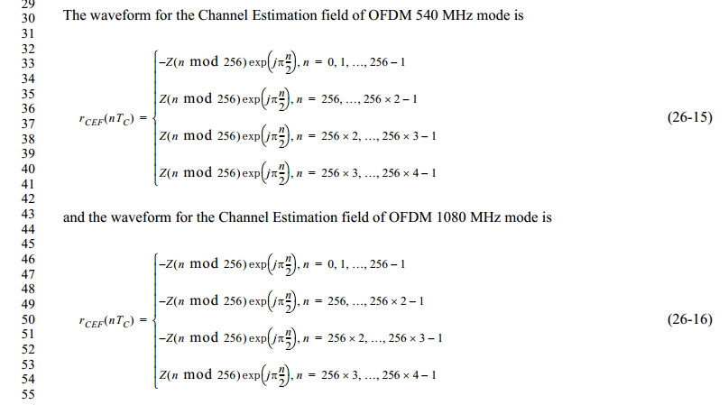

CID | Clause | Page | Line | Type | Comment | Proposed Change | Remark
7 | 26.5.6.7 | 239 | 33-37 | T | Spatial Expansion Intex 3 | In order to avoiding the unintentional beamforming, suggest to revise the transmission style of one stream by three number of antennas by a better style, such as B. Hochwald, T. L. Marzetta and C. B. Papadias, "A transmitter diversity scheme for wideband CDMA systems based on space-time spreading", IEEE Journal on Selected Areas in Commun., vol. 19, no. 1, Jan. 2001, pp. 48-60.  In additional, there are typos in the table.
Proposed resolution: Accept
We have revised the spatial expansion mechanism according the suggestion in the given reference and corrected these typos.
