IEEE P802.11
Wireless LANs
Proposed Resolutions for Clause 9.27.11
Date: 2016-01-15
Author(s):
Name | Affiliation | Address | Phone | email
Hitoshi Morioka | SRC Software | Fukuoka, JAPAN |  | hmorioka@src-soft.com
Abstract
This document describes proposed resolutions for Clause 9.27.11.
Addressed CIDs are:
10662, 10138, 10502, 10660, 10661, 10141, 10140

Baseline document is Draft P802.11ai D6.0.

9.27 MAC frame processing
Modify the clause as following:

9.27.11 Element fragmentation
The general format of elements limits the size of the information in each element to 255 octets in an element without Element ID Extension field or 254 octets in an element with Element ID Extension field. [CID10662, 10138] Information that is too large for to fit in [CID10502] a single element shall be fragmented into a series of elements consisting of the element that the information does not fit, immediately followed by one or more Fragment elements as illustrated in Figure 9-91 (Example of the element fragmentation). The information Elements that are less than 256 octets fits in a single element [CID10138, 10660] shall not be fragmented. A fragmented element and the series of one or more Fragment elements that comprise the remaining information of the fragmented element shall all appear in the same MMPDU. All the information for a fragmented element shall appear in the same MMPDU. [CID10661]

The information to be fragmented is divided into M + N portions, where:

Element without Element ID Extension: [CID10662, 10141]
- M is Floor(L/255).
- N is equal to 1 if L mod 255 > 0 and equal to 0 otherwise.
- L is the size of the information in octets.

Element with Element ID Extension:
- M is Floor(1+(L-254)/255).
- N is equal to 1 if (L-254) mod 255 > 0 and equal to 0 otherwise.
- L is the size of the information in octets. [CID10662, 10141]

The element into which the information does not fit is filled with the first portion of information and shall be termed the leading element. The leading element shall contain 255 octets of information in case of the element without Element ID Extension, or 254 octets of information in case of the element with Element ID Extension. [CID10662, 10138] This element is immediately followed by M-1 Fragment elements, each containing the next portion of 255 octets of information. If N = 1 these elements shall be immediately followed by the last portion of information.

NOTE—A Fragment element never follows an element with fewer than 255 octets of information without Element ID Extension, and an element with fewer than 254 octets of information with Element ID Extension. [CID10662, 10138] A Fragment element is never fragmented.

Insert the following figure after Figure 9-91:
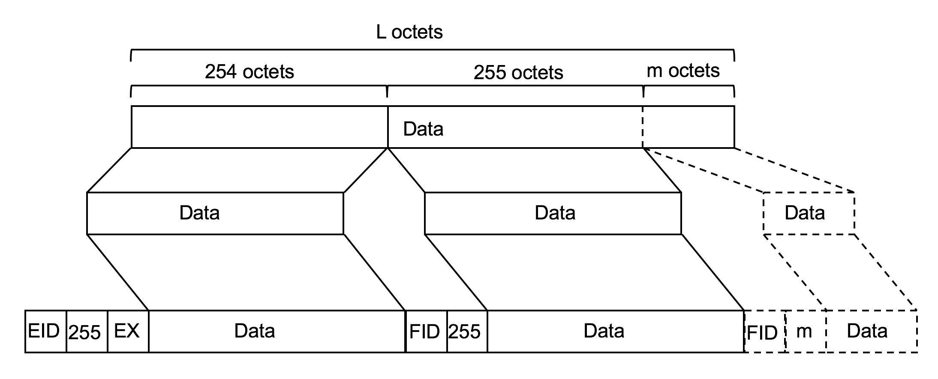
EID: The element ID of the fragmented element
EX: The element ID Extention of the fragmented element
FID: The Fragment element ID
m: (L-254) mod 255

Figure 9-xx — Example of the element fragmentation with Element ID Extension
[CID10662, 10140]

