IEEE P802.11
Wireless LANs
Annex text: PAD Protocol for ANDSF
Date: 2014-05-14
Author(s):
Name | Company | Address | Phone | email
Joe Kwak | InterDigital | PO Box 93, Hawkesbury, ON Canada K6A2R4 | +1-630-739-4159 | joekwak@sbcglobal.net
Abstract
This document provides draft text for an annex which describes the functions of the Pre-Association Discovery Protocol (PADP) used to provide ANDSF discovery service to a STA prior to association. This document is a text version of the powerpoint document 802.11/14-0158r2 which has been updated since presentation at the March meeting in Beijing.

Annex AQ3 Using PADP with existing Discovery Protocols

(informative)

This informative annex provides use cases and detailed message flow charts showing examples of how to use PADP with the commonly available discovery protocols: UPnP, bonjour, etc. These examples are provided to clarify the flexibility and intended uses for the PADP defined in this amendment.

Annex AQ3.1 Pre-Association Discovery using ANDSF

This Annex provides a detailed example of a STA in a pre-associated state which is able to use the the PADP to access network discovery information from a 3GPP Access Network Discovery Service Function. A dual-mode 3GPP cellular and WiFi STA normally retrieves WLAN availability and policy for use information for its local area from a local ANDSF. The network operators load and configure the ANDSF with WiFi network access information tailored to each country or world location based on roaming agreements, access policies and QOS in order to serve all the roaming STAs managed by that operator. The STA uses this information to select the best WLAN for access based on this capability and policy information.

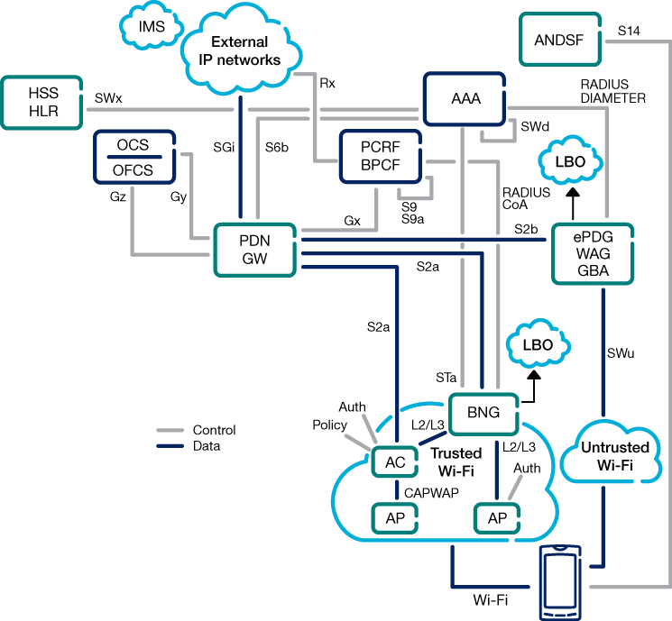
Figure A1: 3GPP Cellular Network Architecture showing the ANDSF and Provisions for WiFi/Cellular Interworking.

Figure A1 shows the ANDSF in the context of the 3GPP cellular network. The STA can access the ANDSF either through the cellular network while it is connected, or through the WLAN network after it is associated. The ANDSF IP address is discoverable using normal DNS methods. For a WLAN STA which is not associated, the PADP provides a means for the STA to use the ANDSF access protocol to retrieve (discover) network information to assist the STA in selecting the right local WLAN network.

UE

4
. Access Network I
nfo Request

5
. Access Network Info Response

1. PADP
→

Limited IP connectivity

6
. UE makes access

network selection and

handover decision

7. UE associates to

selected WLAN

ANDSF

-

3. Establish secure communication

2. Discover ANDSF IP address

AP/PADPxy

Figure A2: ANDSF Access Enabled by PAD Proxy.

Figure A2 shows the transaction steps for a STA (shown as UE or User Equipment) to retrieve Network Information from the ANDSF. The PADP assists the STA to setup the required secure communication with the ANDSF so that the ANDSF may provide the requested Access Network Information Response. Steps 1, 2 and 3 use the PADP transparent mode to encapsulate Higher Layer Protocol (HLP) messages and, by using the PAD Proxy server as an intermediary, to forward these messages in both directions to and from the ANDSF.

Figure A3 shows the detailed message flows for steps 1-3 which establishes secure communication between the ULP and the ANDSF. Step 1 of the ANDSF access provides the STA with limited IP connectivity for the Upper Layer Protocols (ULP) in the STA. The STA is preconfigured with a PADP proxy application (PADPxy-A) which is designed to work with a proxy server to facilitate ANDSF access using PADP transparent HLP message encapsulation. For each discovery protocol served by PADP, there is a unique application used to access that discovery protocol while in a pre-associate state. The ANDSF PADPxy application works for ANDSF discovery only, while other applications are written for UPnP and other well known discovery protocols. When the STA initializes in the pre-associated state, the STA scans for available BSSs in the area. Then the PADPxy application in the STA attempts to locate an ANDSF proxy server in one of the scanned networks. The PADPxy sends to an AP an ANQP Request which specifies the ANDSF Proxy server it wants to discover. The AP processes the ANQP Request and, in this example, returns the identifier for instance A of the ANDSF Proxy service (PADPxy-A) which it has located. The PADPxy application in the STA then indicates that limited IP connectivity is available. This is the same indication that WiFi STAs present to the user when associating with an open BSS which requires additional user input prior to providing full access.

3. Establish secure communication

PADPxy-A

STA

ANQP Req(PADPxy.ANDSF)

ANQP Resp(
PADPxy
-
A)

ANDSFb

PLMN
c

ULP

PADP
-
Encap(
DNS Req(ANDSF.MCC.MNC))

-
Encap(
DNS Resp(IP Add of
ANDSFb
)
)

DNS Resp(IP Add of ANDSFb)

DNS Req(ANDSF.MCC.MNC)

DNS Req(ANDSF.MCC.MNC))

DNS Resp(IP Add of ANDSFb)

A

B

A

B

-
Encap(
http:TLS
-
Clien
tHello({Ks1,Ks2…})

-
Encap(
http:TLS
-
ServerHello(Ks2))
http:TLS
-
ServerHello(Ks2)

http:TLS
-
ClientHello({Ks1,Ks2…})

http:TLS
-
ClientHello({Ks1,Ks2…})

http:TLS
-
ServerHello(Ks2)

-

AP

-

DNS

Server

Limited IP connectivity
)

1. PADP
→

Limited IP connectivity

2. Discover ANDSF IP address

PADPxy-A
PADP
PADP
PADP

NOTE A: PADPxy decapsulates message and substitutes its own IP add in header to replace dummy IP add from STA
NOTE B: PADPxy substitutes dummy IP add from STA to replace its own IP add in header, then encapsulates and sends to AP

Figure A3: ANDSF Access - Detailed Transactions for Steps 1,2 and Part of Step 3.

Step 2 of the ANDSF access allows the ULP to discover the IP address of the ANDSF. The ULP sends a IP packet for a DNSRequest to the lower layers; this DNSRequest contains a parameter specifying which ANDSF server the ULP is requesting. The ULP uses a local dummy IP address as its own sender address for this IP packet. The request parameter includes the Mobile Country Code (MCC) for the location of the STA and also the Mobile NetworkCode (MNC) for the operator of the home network for the STA. The PADPxy application in the STA encapsulates the DNSRequest message in a TransparentProtocol (TP) encapsulation message and addresses this to the PADPxy-A and forwards this to the AP. The AP recognizes the encapsulated message as a TP message addressed to PADPxy-A and forwards the message to the identified PADPxy-A server. The PADPxy-A decapsulates message and substitutes its own IP add in header to replace dummy IP add from STA. The PADPxy-A then sends the IP packet to the local DNS. The DNS server process the DNSRequest and identifies the particular ANDSF server specified by the parameters in the DNSRequest. The DNS server formats a DNSResponse message containing the IP address of the requested ANDSF server and sends it back to the PADPxy-A. The PADPxy-A receives the DNSResponse and substitutes the dummy IP add from STA to replace its own IP add in header, then encapsulates and sends the DNSResponse to the AP. The AP recognizes the TP encapsulated message and forwards it to the STA. In the STA, the PADPxy application decapsulates the TP message and sends it to the ULP as the DNSResponse resulting from the prior ULP DNSRequest. With this DNSResponse, the ULP has now discovered the IP address of the ANDSF server for his network provider and his current country location.

Step 3 of the ANDSF access sets up a secure TLS (https:) connection between the ULP and the identified ANDSF. The ULP initiates the secure connection by sending a TLS-ClientHello message to the ANDSF using an insecure http message. Here again the ULP uses its dummy local IP address for this IP message and also includes in the TLS-ClientHello message the list of shared keysets available in the ULP. The PADPxy application in the STA encapsulates the TLS-ClientHello message in a TransparentProtocol (TP) encapsulation message and addresses this to the PADPxy-A and forwards this to the AP. The AP recognizes the encapsulated message as a TP message addressed to PADPxy-A and forwards the message to the identified PADPxy-A server. The PADPxy-A decapsulates message and substitutes its own IP add in header to replace dummy IP add from STA. The PADPxy-A then sends the IP packet to the requested ANDSF server. The ANDSF server receives the TLS-ClientHello message from the ULP and considers the set of keys supplied in the message. The ANDSF selects one of the shared keys (Ks2) and responds with a TLS-ServerHello message which it sends to the PADPxy-A. The TLS-ServerHello message contains the selected common keyset to use for the TLS setup. The PADPxy-A receives the TLS-ServerHello message and substitutes the dummy IP add from STA to replace its own IP add in header, then encapsulates and sends the TLS-ServerHello message to the AP. The AP recognizes the TP encapsulated message and forwards it to the STA. In the STA, the PADPxy application decapsulates the TP message and sends the TLS-ServerHello message to the ULP.

NOTE A: PADPxy decapsulates message and substitutes its own IP add in header to replace dummy IP add from STA
NOTE B: PADPxy substitutes dummy IP add from STA to replace its own IP add in header, then encapsulates and sends to AP

Figure A4: ANDSF Access - Detailed Transactions for Step 3 and below.

Figure A4 shows the remainder of Step 3 which establishes secure communication. The ULP continues the secure connection setup by sending a TLS-ClientKeyExchange message to the ANDSF using an insecure http message. Here again the ULP uses its dummy local IP address for this IP message and also includes in the TLS- ClientKeyExchange the keyset information for the selected Ks2 shared common key. The PADPxy application in the STA encapsulates the TLS- ClientKeyExchange message in a TransparentProtocol (TP) encapsulation message and addresses this to the PADPxy-A and forwards this to the AP. The AP recognizes the encapsulated message as a TP message addressed to PADPxy-A and forwards the message to the identified PADPxy-A server. The PADPxy-A decapsulates message and substitutes its own IP add in header to replace dummy IP add from STA. The PADPxy-A then sends the IP packet to the requested ANDSF server. The ANDSF server receives the TLS- ClientKeyExchange message from the ULP and responds with a TLS-ServerChangeCipherSuite&Finished message which it sends to the PADPxy-A. The TLS-ServerHello message contains the selected common keyset to use for the TLS setup. The PADPxy-A receives the TLS- ServerChangeCipherSuite&Finished message and substitutes the dummy IP add from STA to replace its own IP add in header, then encapsulates and sends the TLS- ServerChangeCipherSuite&Finished message to the AP. The AP recognizes the TP encapsulated message and forwards it to the STA. In the STA, the PADPxy application decapsulates the TP message and sends the TLS- ServerChangeCipherSuite&Finished message to the ULP. This four-way exchange between the ULP and ANDSF produces a common cipher suite which the ULP now uses to encrypt future messages to the ANDSF server. This completes the TLS setup process and the following messages are exchanged using secure https:.

The ULP uses the established secure connection to send an AccessNetworkInfoRequest message to the ANDSF. Similar to prior message flows, the PADPxy application and PADPxy-A server encapsulate and decapsulate the message and swap the IP addresses to forward the message to the ANDSF. The ANDSF formats and responds with an AccesNetworkInfoResponse message. This response message contains all the policy and local access network information needed by the ULP to select and connect to an appropriate WLAN network. This message may be quite large and may use fragmentation to transmit the entire message in multiple packet transmissions. When the ULP receives the complete AccessNetworkInfoResponse message, it stores the info locally in a management object tree containing the 3GPP operator supplied required logic and conditions for network selection for the ULP in the country and area in which it is currently located.

Note that the use of the PADPxy entities in this example is not immune to hacking and security attacks. To prevent abuse and exploitation of the PADPxy for purposes other than network discovery, the participating entities should authenticate each other prior to any proxy message processing. The AP must be assured that the PADPxy server it is communicating with is a valid PADPxy to be used for network discovery. The PADPxy server must be assured that the ANDSF it is communicating with is a valid ANDSF and will be used only to retrieve the requested access network information. The means by which the AP, PADPxy and ANDSF authenticate eachother is out of scope for this amendment. Typical methods which may be used for entity authentication for PADP include pre-configured shared keys, and pre-configure certificates obtained from a trusted Certificate Authority. Other authentication methods may also apply to this PADP example.

References for this Annex:

- http://www.3gpp.org/DynaReport/23003.htm
3GPP Network Elements: Numbering, Addressing, and Identification –Explains ANDSF discovery mechanism using DNS .
- http://www.3gpp.org/DynaReport/33222.htm
Generic Authentication Architecture and Access to 3GPP Network Using https: --Explains authentication and TLS security for ANDSF connection based on preconfigured or bootstrapped shared key.
- http://tools.ietf.org/html/rfc2818
HTTP over TLS—General reference for setting up https:.
- http://www.3gpp.org/DynaReport/23234.htm
Specification of 3GPP-WLAN Interworking—Broad reference that provides detail on WLAN-ANDSF interface.
- http://www.3gpp.org/DynaReport/23402.htm
Specification for non-3GPP Access to 3GPP Network—Includes architecture and interworking descriptions for WLAN discovery and connection to ANDSF.
- http://www.3gpp.org/DynaReport/23865.htm
Study of WLAN Selection and Policy Application using ANDSF Information—provides set of illustrative examples showing how STAs use ANDSF Management Object (MO) data to select WLAN.
- http://www.3gpp.org/DynaReport/234312htm
Specification of ANDSF MO—Complete MO details and structure of WLAN selection policy MO tree.

