IEEE P802.11
Wireless LANs
D0.01 PHY related comment resolutions (part 1)
Date: 2014-05-21
Author(s):
Name | Company | Address | Phone | Email
Changming Zhang | Tsinghua University |  |  | zhangcm10@mails.tsinghua.edu.cn

Abstract

This document proposes revised resolutions to TGaj D0.01 CID 83.

Technical Comments

CID | Clause | Page | Line | Type | Comment | Suggestion Remedy | Remark
83 | 25.1.1 | 35 | 12 | TR | It's not necessary to split SC into HR and MR. The only difference is MR requested as mandatory and HR is optional. | Keep one single SC
Proposed resolution: Accept
As the comment, we have merged MR SC PHY and HR SC PHY into SC PHY, as shown in 25.6.

25.6 CDMG SC PHY

25.6.1 Introduction
Transmission and reception of SC PHY PPDUs is mandatory for CMCS 1-9, and optional for CMCS 10-16.

25.6.2 Frame format
The SC frame is composed of the Short Training Field (STF), the channel estimation field (CE), the Header, SC blocks and optional training fields, as shown in Figure 25-10.

F 1Figure 25-10—SC frame format

25.6.3 Transmission

25.6.3.1 Header

25.6.3.1.1 General
In the SC PHY, the preamble is followed by the header. The header consists of several fields which define the details of the PPDU to be transmitted. The encoding and modulation of the header is described in subclause .

The header fields are described in Table 25-11.

T 1Table 25-11—11 SC Header fields
Field Name | Number of bits | Start Bit | Description
Scrambler Initialization | 7 | 0 | bits X1-X7 of the initial scrambler state.
CMCS | 6 | 7 | Index into the Modulation and Coding Scheme table
Length | 18 | 13 | Number of data octets in the PSDU. Range 1-262143.
Additional PPDU | 1 | 31
  Contains a copy of the parameter ADD-PPDU from the TXVECTOR. A value of 1 indicates that this PPDU is immediately followed by another PPDU with no IFS or preamble on the subsequent PPDU. A value of 0 indicates that no additional PPDU follows this PPDU.
Packet type | 1 | 32
  Corresponds to the TXVECTOR parameter PACKET-TYPE.
  - Packet Type = 0 indicates either a packet whose data part is followed by one or more TRN-R subfields, or a packet that is requesting TRN-R subfields to be appended to a future response packet.
  - Packet Type = 1 indicates a packet whose data part is followed by one or more TRN-T subfields.
  The field is reserved when the Training Length field is 0.
Training Length | 5 | 33
  Corresponds to the TXVECTOR parameter TRN-LEN.
  If the Beam Tracking Request field is 0, the Training Length field indicates the length of the training field. The use of this field is defined in 25.10.2.2.3. A value of 0 indicates that no training field is present in this PPDU.
  If the Beam Tracking Request field is 1 and the Packet Type field is 1, the Training Length field indicates the length of the training field. If the Packet Type field is 0, the Training Length field indicates the length of the training field requested for receive training.
Aggregation | 1 | 38 | Set to 1 to indicate that the PPDU in the data portion of the packet contains an A-MPDU; otherwise, set to 0.
Beam Tracking Request | 1 | 39
  Corresponds to the TXVECTOR parameter BEAM_TRACKING_REQUEST.
  Set to 1 to indicate the need for beam tracking (9.35.7); otherwise, set to 0.
  The Beam Tracking Request field is reserved when the Training Length field is 0.
Last RSSI | 4 | 40
  Contains a copy of the parameter LAST_RSSI from the TXVECTOR. When set to 0, this field reserved and ignored by the receiver.
  The value is an unsigned integer:
  - Values of 2-14 represent power levels (-71+value×2) dBm.
  - A value of 15 represents a power greater than or equal to -42 dBm.
  - A value of 1 represents a power less than or equal to -68 dBm.
  Value of 0 indicates that the previous packet was not received a SIFS period before the current transmission.
 | 1 | 44
  Turnaround
  As defined in Table 25-1.
Reserved | 3 | 45 | Set to 0, ignored by receiver
HCS | 16 | 48 | Header check sequence. Definition of this field calculation is in Error: Reference source not found.
All the numeric fields are encoded in unsigned binary, least significant bit first.
Reserved bits are set to 0 by the transmitter and shall be ignored by the receiver.
If the Additional PPDU field is equal to 1, the Training Length field shall be set to 0.

25.6.3.1.2 Modulation and Coding Scheme
The modulation and coding scheme defines the modulation and code rate that is used in the PPDU. The modulation and coding schemes for SC are defined in Table 25-12.

T 2Table 25-12—Modulation and Coding Scheme for SC PHY
CMCS Index | Modulation | N_{CBPS} | Repetition | Code Rate | Data Rate (Mbps)
1 | π/2-BPSK | 1 | 2 | 1/2 | 192.5
2 | π/2-BPSK | 1 | 1 | 1/2 | 385
3 | π/2-BPSK | 1 | 1 | 5/8 | 481.25
4 | π/2-BPSK | 1 | 1 | 3/4 | 577.5
5 | π/2-BPSK | 1 | 1 | 13/16 | 625.625
6 | π/2-QPSK | 2 | 1 | 1/2 | 770
7 | π/2-QPSK | 2 | 1 | 5/8 | 962.5
8 | π/2-QPSK | 2 | 1 | 3/4 | 1155
9 | π/2-QPSK | 2 | 1 | 13/16 | 1251.25
10 | π/2-16QAM | 4 | 1 | 1/2 | 1540
11 | π/2-16QAM | 4 | 1 | 5/8 | 1925
12 | π/2-16QAM | 4 | 1 | 3/4 | 2310
13 | π/2-16QAM | 4 | 1 | 13/16 | 2502.5
14 | π/2-64QAM | 6 | 1 | 5/8 | 2887.5
15 | π/2-64QAM | 6 | 1 | 3/4 | 3465
16 | π/2-64QAM | 6 | 1 | 13/16 | 3453.75

25.6.3.1.3 Generation of the HCS bits
Calculation of the HCS for bits 0-47 of the header is defined in subclause Error: Reference source not found.

25.6.3.1.4 Header encoding and modulation
See 21.6.3.1.4.

25.6.3.2 The Data field

25.6.3.2.1 General
The data field consists of the payload data of the PSDU and possible padding. The data are padded with zeros, scrambled, encoded and modulated as described in the following subclauses.

25.6.3.2.2 Scrambler
See 21.6.3.2.2.

25.6.3.2.3 Encoding
- See 21.6.3.2.3

25.6.3.2.4 Modulation Mapping

25.6.3.2.4.1 General
The coded and padded bit stream is converted into a stream of complex constellation points according to the modulation specified in the CMCS table.

25.6.3.2.4.2 π/2-BPSK Modulation
In π/2-BPSK modulation, the input bit stream is mapped according to the following equation: ${\tilde{s}}_{k}=2⋅c_{k}−1$, where c_{k} is the k^{th} input coded (or scrambled pad) bit. Each output symbol is then rotated according to the following equation:.

F 2Figure 25-11—BPSK constellation bit encoding
NOTE – With appropriate choice of transmit filtering, π/2-BPSK is equivalent to a precoded pulse-shaped MSK (e.g., GMSK). The precoder is simply $b_{\text{out},k}=b_{\text{in},k}⊕b_{\text{in},k−1},k=0,1,\text{.}\text{.}\text{.}$, where b_{in,k} is the scrambled input stream, b_{in,-1} is 0, and b_{out,k} is the input to the (G)MSK modulator.

25.6.3.2.4.3 π/2-QPSK Modulation
In π/2-QPSK modulation, the input bit stream is grouped into sets of 2 bits and mapped according to the following equation: , where k is the output symbol index, k = 0, 1, …. Each outputc symbol is then rotated according to the following equation: .

F 3Figure 25-12—QPSK constellation bit encoding

25.6.3.2.4.4 π/2-16QAM Modulation
In π/2-16QAM modulation, the input bit stream is grouped into sets of 4 bits and mapped according to the following equation: , where k is the output symbol index, k = 0, 1, …. Each output symbol is then rotated according to the following equation: .
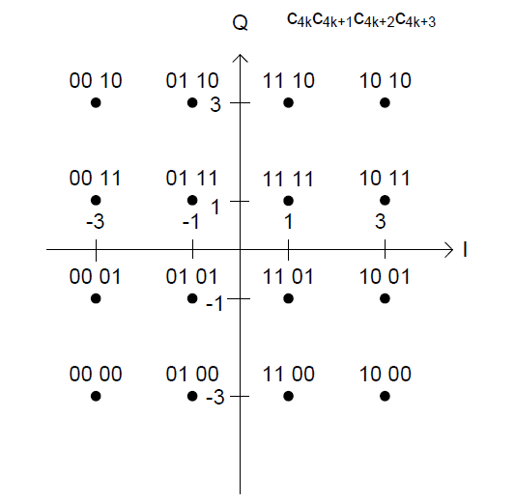

F 4Figure 25-13—16QAM constellation bit encoding

22.7.3.2.4.5 π/2-64QAM Modulation
In π/2-64QAM modulation, the input bit stream is grouped into sets of 6 bits and mapped according to the following equation: 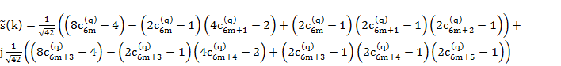, where k is the output symbol index, k = 0, 1, …. Each output symbol is then rotated according to the following equation: .
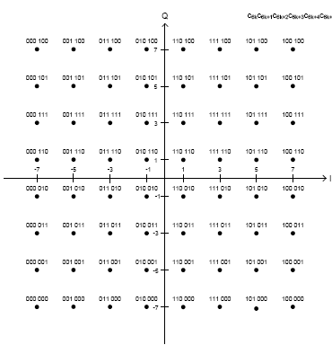

F 5Figure 25-14—64QAM constellation bit encoding

25.6.3.2.5 Symbol Blocking and Guard Insertion
Each group of N_{CBPB} bits is pre-pended by π/2-BPSK symbols generated by the 64 point Golay sequence Ga₆₄ defined in 21.11. N_{CBPB} values are shown in Table 25-13. The starting index for the first symbol for π/2 rotation is 0.

T 3Table 25-13—Values of N_{CBPB}
Symbol Mapping | N_{CBPB}
π/2-BPSK | 448
π/2-QPSK | 896
If the Additional PPDU field within the PLCP header is equal to 0, the final block transmitted is followed by the same Golay sequence guard interval. If the Additional PPDU field within the PLCP header is equal to 1, the final block transmitted of the last PPDU in an A-PPDU is followed by the same Golay sequence guard interval.
448 symbols
448 symbols
448 symbols
64
64
64
GI
DATA
GI
DATA
GI
DATA
64
GI

F 6Figure 25-15—Block transmission

25.6.4 Performance requirements

25.6.4.1 Transmit Requirements

25.6.4.1.1 Transmit EVM
The transmit EVM accuracy test shall be performed by instrumentation capable of converting the transmitted signal into a stream of complex samples, with sufficient accuracy in terms of I/Q arm amplitude and phase balance, dc offsets, phase noise, etc.
The instrumentation shall perform carrier lock, symbol timing recovery and amplitude adjustment while making the measurements. The equalizer shall be trained using information in the SC preamble (STF and/or CEF). For the SC PHY EVM, measuring Ns samples at the sample rate, the measured symbols should not contain the first and the last hundred symbols of a given packet (ramp up/down). The EVM is calculated according to the formula below:
Where Ns is the number of samples to be measured and Ns shall be 1000, is the average power of the constellation, is the complex coordinates of the measured symbol i, is the complex coordinates of the ideal constellation point for the measured symbol i, and (Io, Qo) is the complex DC term chosen to minimize EVM.
The test equipment should use a root-raised cosine filter with roll-off factor of 0.25 for the pulse shaping filter when conducting EVM measurement.
The transmit pulse shaping used is left to the implementer.
The relative constellation error (EVM) shall not exceed a CMCS dependent value according to the table below.

T 4Table 25-14—Modulation and Coding Scheme for SC PHY
CMCS Indexes | Modulation | Coding Rate | EVM Value [dB]
1 | π/2-BPSK | 1/2 with repetition | -6
2 | π/2-BPSK | 1/2 | -7
3 | π/2-BPSK | 5/8 | -9
4 | π/2-BPSK | 3/4 | -10
5 | π/2-BPSK | 13/16 | -12
6 | π/2-QPSK | 1/2 | -11
7 | π/2-QPSK | 5/8 | -12
8 | π/2-QPSK | 3/4 | -13
9 | π/2-QPSK | 13/16 | -15
10 | π/2-16QAM | 1/2 | -19
11 | π/2-16QAM | 5/8 | -20
12 | π/2-16QAM | 3/4 | -21
13 | π/2-16QAM | 13/16 | -23
14 | π/2-64QAM | 5/8 | -25
15 | π/2-64QAM | 3/4 | -26
16 | π/2-64QAM | 13/16 | -28

25.6.4.1.2 Time of Departure accuracy
The Time of Departure accuracy test evaluates TIME_OF_DEPARTURE against aTxPmdTxStartRMS and aTxPmdTxStartRMS against TIME_OF_DEPARTURE_ACCURACY_TEST_THRESH as defined in Annex T with the following test parameters:
- MULTICHANNEL_SAMPLING_RATE is 880x10⁶ sample/s
- FIRST_TRANSITION_FIELD is Short Training field
- SECOND_TRANSITION_FIELD is Channel Estimation field
- TRAINING_FIELD is Channel Estimation field
- TIME_OF_DEPARTURE_ACCURACY_TEST_THRESH is 80 ns
NOTE — The indicated windowing applies to the time of departure accuracy test equipment, and not the transmitter or receiver.

25.6.4.2 Rx Requirements

25.6.4.2.1 Introduction
This subclause describes the receiver requirements of the CDMG SC PHY.

25.6.4.2.2 CCA
The start of a valid CDMG SC PHY transmission at a receive level greater than the minimum sensitivity for CMCS 1 (-68dBm) shall cause CCA to indicate busy with a probability > 90% within 1 us. The receiver shall hold the carrier sense signal busy for any signal 20 dB above the minimum sensitivity for CMCS 1.

