IEEE P802.11
Wireless LANs
D0.01 PHY related comment resolutions (part 1)
Date: 2014-04-11
Author(s):
Name | Company | Address | Phone | Email
Changming Zhang | Tsinghua University |  |  | zhangcm10@mails.tsinghua.edu.cn
Bo Gao | Tsinghua University |  |  | gaob10@mails.tsinghua.edu.cn

Abstract

This document proposes resolutions to TGaj D0.01 CIDs: 82, 83, 85, 86, 87, 89, 94, 96, 97, 99, 101, 102, 104, 105, 107, 108, 109, 129, and 131.

Editorial Comments

CID | Clause | Page | Line | Type | Comment | Suggestion Remedy | Remark
99 | 25.7.3.2.5 | 64 | 61 | ER | The whole paragraph is confusing | Revise the statement in a clearer way.
Proposed resolution: Accept
The confusing paragraph has been changed as follows:
“If the Additional PPDU field within the PLCP header is equal to 0, the final block transmitted is 8 followed by the same Golay sequence guard interval. If the Additional PPDU field within the PLCP 9 header is equal to 1, the final block transmitted of the last PPDU in an A-PPDU is followed by the 10 same Golay sequence guard interval.”

CID | Clause | Page | Line | Type | Comment | Suggestion Remedy | Remark
101 | 25.7.4.1.1 | 65 | 29 | ER | "MR SC PHY" should be "HR SC PHY" | as the comments
Proposed resolution: Accept
It has been modified as suggested as follows:
“For the MR HR SC PHY EVM, measuring Ns samples at the sample rate, the measured symbols should not contain the first and the last hundred symbols of a given packet (ramp up/down).”

CID | Clause | Page | Line | Type | Comment | Suggestion Remedy | Remark
102 | 25.7.4.1.1 | 65 | 53 | ER | Table 25-19 is not for MR SC but for HR. | as the comments
Proposed resolution: Accept
This table is indeed for HR, and the title name has been changed as follows,

“Table 22-19—Modulation and Coding Scheme for HR MR SC”

Technical Comments

CID | Clause | Page | Line | Type | Comment | Suggestion Remedy | Remark
82 | 25.1.1 | 35 | 6 | TR | Generally, CDMG PHY also includes operation on 2.16GHz channel. It's better to add necessary reference even some definition may be the same as that in 11ad. | Formula should be centered. Other lines should use proper indentation.
Proposed resolution: Accept
Actually, in 11aj, the PHY consists DMG PHY (for 2.16 GHz, which is the same as 11ad and will be treated as the 21st chapter) and CDMG PHY (for 1.08 GHz,it is new and regarded as the 25th chapter). At the beginning of the 25th chapter, we have addressed it as follows:
“The CDMG PHY is designed for the 1.08 GHz channel, and the DMG PHY in Chapter 21 is designed for the 2.16 GHz channel. As many aspects of CDMG PHY are the same as DMG PHY, this chapter mainly lists the new features corresponding to Chapter 21.”

CID | Clause | Page | Line | Type | Comment | Suggestion Remedy | Remark
83 | 25.1.1 | 35 | 12 | TR | It's not necessary to split SC into HR and MR. The only difference is MR requested as mandatory and HR is optional. | Keep one single SC
Proposed resolution: Reject
The frame structure is different between HR and MR SC PHY, as we PA nonlinearity is only managed for the HR SC PHY, which is achieved by distorted constellation estimation and demodulation. The frame difference lies in the header part as expressed in 25.7.3.1.1:
“In the HR SC PHY, the header contains two parts, the first part is the same as the header of the MR SC PHY given in Error: Reference source not found, and the last BLK is the training BLK (TBLK) that used to estimate distorted constellation, so as to react the nonlinearity of power amplifier (PA). The header of HR SC PHY is given in the figure below.

F 1Figure 25-15—Header of HR SC PHY
The first part of header consists of several fields which define the details of the PPDU to be transmitted. The fields of the first part are the same as that in Table 25-11.The encoding and modulation is also the same as that described in subclause Error: Reference source not found.”

CID | Clause | Page | Line | Type | Comment | Suggestion Remedy | Remark
85 | 25.3.3.5 | 40 | 24 | TR | The content is not complete. | Refer to 11ad.
Proposed resolution: Accept
The statement keeps the same style with that in 11ad, which is the same as the 2.16 GHz PHY in chpater 21, as given by:
“The transmitter center frequency leakage shall not exceed –23 dB relative to the overall transmitted power or, equivalently, in OFDM (CMCS 17-28), +2.5 dB relative to the average energy of a subcarrier, measured over a subcarrier spacing bandwidth.”
In 11ad, the statement is:
“The transmitter center frequency leakage shall not exceed –23 dB relative to the overall transmitted power or, equivalently, in OFDM (MCS 13-24), +2.5 dB relative to the average power of a subcarrier, measured over a subcarrier spacing bandwidth.”

CID | Clause | Page | Line | Type | Comment | Suggestion Remedy | Remark
86 | 25.3.6.2 | 45 | 64 | TR | The statement is wrong. | Change 'a single repetition of ' to 'a single sequence'.
Proposed resolution: Accept
The statement “a single repetition of” has been changed to “a single sequence”, which is shown as follows,
“The Short Training field is composed of 18 repetitions of sequences Ga₁₂₈(n) of length 128 defined in 21.11, a single frequency sequence (SFS) of length 256 that used for IQ imbalance estimation, followed by a single repetition of sequence –Ga₁₂₈(n)..”

CID | Clause | Page | Line | Type | Comment | Suggestion Remedy | Remark
87 | 25.4.4.2.2 | 50 | 39 | TR | Since the CDMG Control PHY can work on both 1.08GHz and 2.16GHz, the sensitivity and CCA judgment process should be defined for both cases. | Complete the definition.
Proposed resolution: Accept
This chapter corresponds to only 1.08 GHz, and the related statement for 2.16 GHz is given in chapter 21.

CID | Clause | Page | Line | Type | Comment | Suggestion Remedy | Remark
89 | 25.5.3.1.1 | 51 | 28 | TR | The lower limit of the length field is 0 which is different from the value of 1 in 11ad. Is it possible to send a null data payload frame in 11aj? | Complete the definition.
Proposed resolution: Accept
The lower limit of the length field also should be changed to 1, and we have changed it as follows:
“Number of data octets in the PSDU. Range 01-262143.”

CID | Clause | Page | Line | Type | Comment | Suggestion Remedy | Remark
94 | 25.6.3.2.5 | 60 | 11 | TR | The whole paragraph is confusing. | Revise the statement in a clearer way.
Proposed resolution: Accept
The confusing paragraph has been changed as follows:
“If the Additional PPDU field within the PLCP header is equal to 0, the final block transmitted is 8 followed by the same Golay sequence guard interval. If the Additional PPDU field within the PLCP 9 header is equal to 1, the final block transmitted of the last PPDU in an A-PPDU is followed by the 10 same Golay sequence guard interval.”

CID | Clause | Page | Line | Type | Comment | Suggestion Remedy | Remark
96 | 25.7.3.1.1 | 62 | 32 | TR | The format of TBLK is never defined anywhere in the spec draft. | Please define the format of TBLK somewhere in the spec
Proposed resolution: Accept
TBLK means training BLK and has been defined in 25.7.3.1.3 as follows:
“The TBLK is composed of N_{GI}(64) guard symbols and 448 training symbols. The modulation of the training symbols is the same as the data field, i.e., π/2-16QAM or π/2-64QAM. In the 448 training symbols, each constellation point of the corresponding modulation appears with the same times. Namely, each constellation point appears 28 and 7 times for π/2-16QAM and π/2-64QAM, as shown in Table 22-16 and Table 22-17, respectively.

T 1Table 22-16—Training symbols in the TBLK for π/2-16QAM
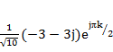，k=16n | 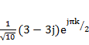，k=16n+8
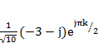，k=16n+1 | 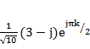，k=16n+9
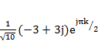，k=16n+2 | 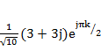，k=16n+10
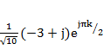，k=16n+3 | 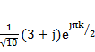，k=16n+11
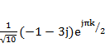，k=16n+4 | 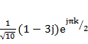，k=16n+12
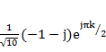，k=16n+5 | 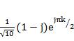，k=16n+13
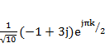，k=16n+6 | 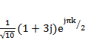，k=16n+14
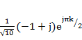，k=16n+7 | 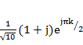，k=16n+15
Where n=0,1,…,27.

T 2Table 22-17—Training symbols in the TBLK for π/2-64QAM
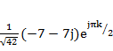，k=64n | 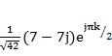，k=64n＋32
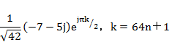 | 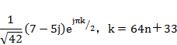
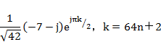 | 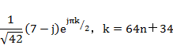
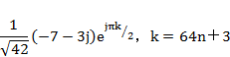 | 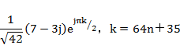
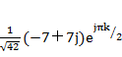，k=64n＋4 | 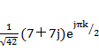，k=64n＋36
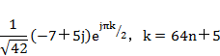 | 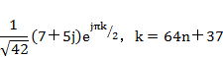
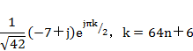 | 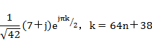
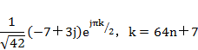 | 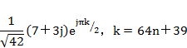
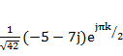，k=64n＋8 | 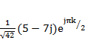，k=64n＋40
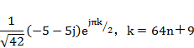 | 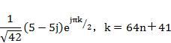
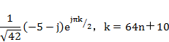 | 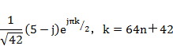
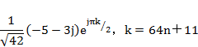 | 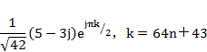
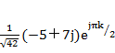，k=64n＋12 | 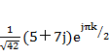，k=64n＋44
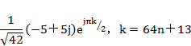 | 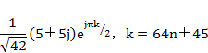
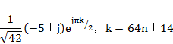 | 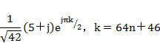
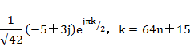 | 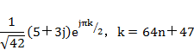
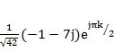，k=64n＋16 | 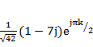，k=64n＋48
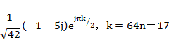 | 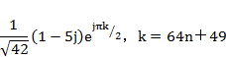
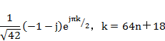 | 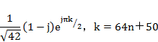
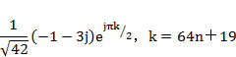 | 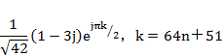
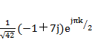，k=64n＋20 | 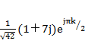，k=64n＋52
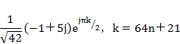 | 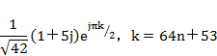
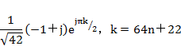 | 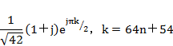
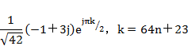 | 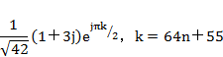
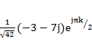，k=64n＋24 | 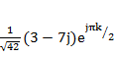，k=64n＋56
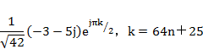 | 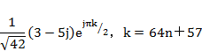
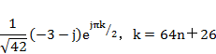 | 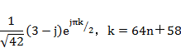
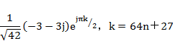 | 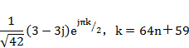
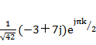，k=64n＋28 | 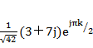，k=64n＋60
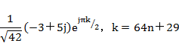 | 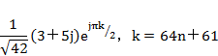
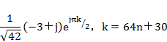 | 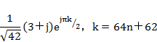
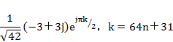 | 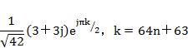
Where n=0,1,…,6.”

CID | Clause | Page | Line | Type | Comment | Suggestion Remedy | Remark
97 | 25.7.3.1.2 | 63 | 6 | TR | For MCS index 10, if repetition value is 2, the data rate value should be 1540/2. | Repetition value is modified to 1, or data rate value is modified to 770. The former seems to be reasonable.
Proposed resolution: Accept
The repetition value is modified to 1 as follows,
CMCS Index | Modulation | N_{CBPS} | Repetition | Code Rate | Data Rate (Mbps)
10 | π/2-16QAM | 4 | 21 | 1/2 | 1540

CID | Clause | Page | Line | Type | Comment | Suggestion Remedy | Remark
104 | 25.9 | 68 | 17 | TR | In Figure 21-19 the MCS is not suitable for CMCS | Draw another figure or add some special explanation
Proposed resolution: Accept
A new figure based on 11aj-PHY is drawn for MCS. Change the paragraph in P68L17 as follows:
“A typical transmit state machine is shown in Figure 21-19 Figure 22-19.
Figure 22-19—Typical Tx state machine (Training Length=0 is assumed).”
CID | Clause | Page | Line | Type | Comment | Suggestion Remedy | Remark
105 | 25.10 | 68 | 34 | TR | According to the previous description there exists SC low-power/ SC MR/ SC HR, PLCP receive procedure should be described all these conditions. | as the comments
Proposed resolution: Accept
As the comments, we revise the corresponding paragraph to follow the modes of SC low-power/ SC MR/ SC HR. Change the paragraph in P68L34 as follows:
“After the PHY-CCA.indication(BUSY) is issued, the PHY entity shall search for the CE field and begin receiving the CE field. During the reception of the CE field, the PMD indicates to the PLCP the type of PHY of the packet. The PHY demodulates the header according to the PHY type determined during the PLCP. If the CE field indicated a SC MR SC/HR SC PHY, the receiver is capable of receiving low-power SC PHY, and dot11LowPowerSCPHYActivated is true, then the PHY shall attempt to demodulate both a SC MR SC/HR SC header and an SC low-power header. The PLCP shall decode the header and indicate to the PMD the CMCS, length and other parameters needed for the demodulation of the packet. At the end of the data portion of the packet, the PHY shall indicate PHY_RXEND.ind(No_Error) to the MAC. If the header indicated the presence of training field, the PMD shall continue to receive these training fields after the data portion of the packet. After the end of these fields, the PMD shall send the measurements to the PLCP using the PMD_CHAN_MEAS.ind. After the end of the training fields, the PHY shall indicate PHY_CCA.ind(Idle).”

CID | Clause | Page | Line | Type | Comment | Suggestion Remedy | Remark
107 | 25.11.2.2.2 | 69 | 34 | TR | The sentence only refer to MPDU, A-MPDU or MMPDU which is equal to data field, while STF, CE, Header fields are not included. In general, MPDU should be transparent for PHY layer, so it should not appear in PHY packet structure description. | Please clarify
Proposed resolution: Accept
Referring to the IEEE 802.11ad corresponding sentence, we revise the paragraph. Change the paragraph in P69L34 as follows:
“Each Beam Refinement packet is composed of an MPDU, A-MPDU or MMPDU STF, a CE field, and a data field followed by a training field containing an AGC training field and a receiver training field.”

CID | Clause | Page | Line | Type | Comment | Suggestion Remedy | Remark
108 | 25.11.2.2.3 | 69 | 54 | TR | It depicts "within the SC header and control PHY header", however, in 802.11ad the corresponding sentence is "within the SC header, control PHY header, LP SC PHY header, and OFDM header", 1. why are LP SC PHY header and OFDM header missing? 2. SC header should not be equal to the sum of LP SC PHY header, SC MR header and HR MR header, because SC header has been used in 21 chapter. | The sentence should include all header types.
Proposed resolution: Accept
As the comments, we revise the paragraph. Change the paragraph in P69L54 as follows:
“The packet type and training length fields present within the SC header and control PHY header the MR SC header, HR SC header, control PHY header, LP SC PHY header, and OFDM header are used to indicate, respectively, that a packet is beam refinement packet and the length of the training fields.”

CID | Clause | Page | Line | Type | Comment | Suggestion Remedy | Remark
109 | 25.11.2.2.5 | 70 | 56 | TR | [Ga64 Ga64 Ga64 Ga64 ] and [Gb64 Gb64 Gb64 Gb64 ] are not complete | should be [Ga64 Ga64 Ga64 Ga64 Ga64 ] and [Gb64 Gb64 Gb64 Gb64 Gb64 ]
Proposed resolution: Accept
As the comments, we revise the paragraph. Change the paragraph in P70L65 as follows:
“The beam refinement AGC fields are composed of 4N repetitions of the sequence [Ga₆₄ Ga₆₄ Ga₆₄ Ga₆₄ ] [Ga₆₄ Ga₆₄ Ga₆₄ Ga₆₄ Ga₆₄] when the packet is transmitted using the OFDM or SC MR/HR SC PHY and [Gb₆₄ Gb₆₄ Gb₆₄ Gb₆₄ ] [Gb₆₄ Gb₆₄ Gb₆₄ Gb₆₄ Gb₆₄] when the packet is transmitted using the Control PHY. The sequences are transmitted using rotated π/2-BPSK modulation. Any transmit signal transients that occur due to this TX AWV configuration change shall completely settle by the end of the first Ga₆₄ or Gb₆₄ subsequence.”

CID | Clause | Page | Line | Type | Comment | Suggestion Remedy | Remark
129 | 25 | 35 | 1 | TR | CDMG PHY specification in Section 25 deals with CBW = 1.08 GHz only. CDMG PHY specification for CBW = 2.16 GHz is not given. | CDMG PHY specification in Section 25 deals with CBW = 1.08 GHz only. CDMG PHY specification for CBW = 2.16 GHz is not given.
Proposed resolution: Accept
In this edition, Chapter 21 is not added, which describes DMG PHY corresponding to 2.16 GHz. In the following editions, it will be added. Also at the beginning of Chapter 25, we have addressed it as follows:
“The CDMG PHY is designed for the 1.08 GHz channel, and the DMG PHY in Chapter 21 is designed for the 2.16 GHz channel. As many aspects of CDMG PHY are the same as DMG PHY, this chapter mainly lists the new features corresponding to Chapter 21.”

CID | Clause | Page | Line | Type | Comment | Suggestion Remedy | Remark
131 | 25.7.3.1.2 | 63 | 3 | TR | CMCS 12 and CMCS 14 achieve the same data rate 2310 Mbps. It does not make sense to maintain two different MCS levels with the same data rate in the specification. | Remove the CMCS 14.
Proposed resolution: Accept
CMCS 14 has been removed as follows,

T 3Table 22-15—Modulation and Coding Scheme for HR SC
CMCS Index | Modulation | N_{CBPS} | Repetition | Code Rate | Data Rate (Mbps)
10 | π/2-16QAM | 4 | 2 | 1/2 | 1540
11 | π/2-16QAM | 4 | 1 | 5/8 | 1925
12 | π/2-16QAM | 4 | 1 | 3/4 | 2310
13 | π/2-16QAM | 4 | 1 | 13/16 | 2502.5
14 | π/2-64QAM | 6 | 1 | 1/2 | 2310
1514 | π/2-64QAM | 6 | 1 | 5/8 | 2887.5
1615 | π/2-64QAM | 6 | 1 | 3/4 | 3465
1716 | π/2-64QAM | 6 | 1 | 13/16 | 3453.75

