IEEE P802.11
Wireless LANs
(LB200) TGah D1.0 PHY Comment Resolutions on Clause 24.2.3
Date: 2014-03-10
Author(s):
Name | Affiliation | Address | Phone | Email
Hongyuan Zhang | Marvell
Minho Cheong

This document provides PHY resolutions for CIDs on Clause 24.2.3: CID 1309

CID | Commenter | Page | Clause | Assignee | Comment | Proposed Change | Resolution
1309 | Adrian Stephens | 255.08 | 24.2.3 | Minho | "If the operating channel width is wider than 1 MHz, then the transmission shall use the primary 1 MHz channel"  Is this a rule for the PHY or the MAC. i.e. does the PHY know about the location of the primary channel or does the MAC?  Regardless, a normative rule such as this should not be tucked away into the definition of a PPDU format table. | Determine whether this is a rule for the MAC or the PHY. If the PHY, move out of the table into a new subclause "channel selection based on PPDU format". If the MAC, do likewise, but relate the "shall" statement to PHY SAP primitives or MIB variables that control the channel placement of the transmission.  Ditto for all other "transmission shall use" statements in this table. | REJECT.  The current expression used in the mentioned table indicates how PHY operates under different values of the related TxVector parameters, and it is almost the same as those text used in the corresponsding table of latest 802.11ac draft.  Please see Table 22-2 (PPDU format as a function of CH_BANDWIDTH parameter) of 802.11ac draft.  Separately, clause 10.47 explains the BSS operation in MAC.
<Discussion>
The current expression used here is the almost same as those used in the corresponsding table of latest 802.11ac draft.
Please see Table 22-2 (PPDU format as a function of CH_BANDWIDTH parameter) of 802.11ac draft, especially texts under-lined as red in the below.

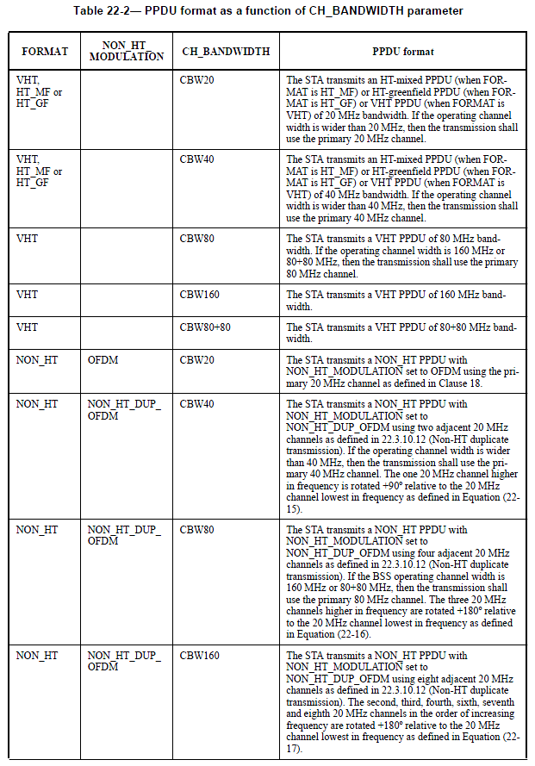

TGah editor: No change

