IEEE P802.11
Wireless LANs
802.11
CID 2164 and CID 2407
Date: 2014-03-19
Author(s):
Name | Company | Address | Phone | email
Carlos Aldana | Qualcomm Corporation |  |  | caldana@qca.qualcomm.com
Jonathan Segev | Intel Corporation |  |  | jonathan.segev@intel.com
Qi Wang | Broadcom Corporation |  |  | qi.wang@broadcom.com
Liwen Chu | Marvell Semiconductor |  |  | liwenchu@marvell.com
Naveen Kakani | CSR |  |  | naveen.kakani@csr.com
ChaoChun Wang | Mediatek |  |  | chaochun.wang@mediatek.com
Brian Hart | Cisco Systems |  |  | brianh@cisco.com
Abstract

This document contains some proposed resolutions to comments CID 2164 and CID 2407.

Pertinent comment

CID | Page | Clause | Resn Status | Comment | Proposed Change | Resolution | Owning Ad-hoc
2164 | 1543 | 10.24.6 |  | The fine timing measurement procedure is OK as far as it goes, but it lacks some optimizations necessary to make it useful. Perhaps the most significant issue is that a STA has to be permanently on the channel negotiated with STA1 in order to receive Fine Timing Measurement frames. This means it can't do power saving, and can't perform location simultaneously with STA1s on different channels. | Add support for STA2 power saving during location determination. Add support that allows a STA2 to perform ranging with STA1s on different channels |  | MAC
2407 | 1544 | 10.24.6 |  | Text says: "A STA that supports the fine timing measurement procedure may transmit a Fine Timing Measurement  Request frame to a peer STA". Yet, the figure 10-31 shows the request frame as being mandatory (not dotted line). | Align figures 10-30 and 10-31. In both figures the Request Frame is optional (right?), but in 10-30 it is dotted line, while in 10-31 is not.  Also in figure 10-30 there is a star next to the Request, what does that mean?  Make the Request Frame in both figures either dotted line or continuous line. The star should also be present in both figures or in neither.

Discussion
In this contribution we
- allow for a periodic fine timing measurement exchange to occur between STAs.
- introduce a new IE that forms the basis for negotiation between the two parties. This IE allows for STAs to go to power save mode in the middle of a fine timing measurement exchange.
- recommend that a fine timing measurement response to a fine timing measurement request occurs within 10ms.

Section 8.4.2.1
[Note to editor:]
Add a row to Table 8-61 to indicate Fine Timing Measurement Parameter Element that is extensible.
Fine Timing Measurement Parameter (see 8.4.2.157 (Fine Timing Measurement Parameter element)) | 191 | Yes

[Note to editor:]
Add a new Section
8.4.2.157 Fine Timing Measurement Parameter element
The Fine Timing Measurement Parameter element contains a number of fields that are used to advertise the desired fine timing measurement configuration from one STA to another. The Fine Timing Measurement Parameter element may be included in the Initial Fine Timing Measurement Request Frame, as described in 8.6.8.25, and the Initial Fine Timing Measurement frame, as described in 8.6.8.26. The use of the Fine Timing Measurement Parameter element is described in 10.24.6.

 |  | B0 B7 | B8 B15 |  | B16 B18 | B19 B23 | B24 B27 | B28 B31 | B32 B39 | B40 B55
 |  | Element ID | Length |  | Status Indication | Value | Number of Bursts Exponent | Burst Timeout | Min Delta FTM | Partial TSF Timer
Bits: |  | 8 | 8 |  | 3 | 5 | 4 | 4 | 8 | 16
 |  | B56 | B57 |  | B58 | B59 B63 | B64 B65 | B66 B71 | B72 B87
 |  | ASAP | FTM_1 timestamps available |  | Reserved | FTMs per Burst | Reserved | FTM Channel Spacing/Format | Burst Period
Bits |  | 1 | 1 |  | 1 | 5 | 2 | 6 | 16

The Element ID and Length fields are defined in 8.4.2.1 (General).

When the Fine Timing Measurement element is sent in the first Fine Timing Measurement frame following a Fine Timing Measurement Request frame establishing an FTM session, the Status Indication and Value fields provide the result of a Fine Timing Measurement Request frame; otherwise, these fields are reserved.

The Status Indication field is a value in Table AAA, indicating the responding STA’s response to the Fine Timing Request.
The Value field is used when the Status Indication field is set to 4; otherwise this field is reserved.
Table AAA- Status Indication
Value | Description
0 | Reserved
1 | Successful. Indicates FTM exchange about to begin. All fields accepted
2 | Overriden. Indicates FTM exchange about to begin. One or more fields overridden
3 | Request incapable (do not send same request again)
4 | Request failed. Do not send new request for “Value” seconds
5–7 | Reserved

The Number of Bursts Exponent field indicates how many bursts are requested/allocated if included in a Fine Timing Measurement Request/Fine Timing Measurement frame respectively, where the number of bursts is 2^{Number of Bursts Exponent}. The value 15 in the Fine Timing Measurement Request indicates no preference by the initiating STA and is a valid when set by the responding STA.
The Burst Timeout field indicates the duration of a burst instance, defined in 10.24.6.4. Table BBB indicates the mapping.
Table BBB- Burst Timeout
Value | Description
0 | 250us
1 | 500us
2 | 1ms
3 | 2ms
4 | 4ms
5 | 8ms
6 | 16ms
7 | 32ms
8 | 64ms
9 | 128ms
10-14 | Reserved
15 | No preference

The Min Delta FTM field indicates the minimum time between consecutive Fine Timing Measurement frames. It is measured from the start of a Fine Timing Measurement frame to the start of following Fine Timing Measurement frame, in units of 100 µs. The value 0 indicates no preference by initiating STA and is not used by the responding STA.
The Partial TSF Timer field indicates the partial value of the responding STA’s TSF timer at the time of the first burst instance. The unit is in TUs and the partial value is derived as follows: from the 64 TSF timer bits, remove the most significant 38 bits and the least significant 10 bits. The initiating STA can request a preferred value when the ASAP field is set to 0.
The ASAP field indicates the desire by the initiating STA to start the fine timing measurement procedure within 10 ms of the last Fine timing Measurement Request frame. When this bit is set to 1 by the initiating STA, the Partial TSF Timer field in the Fine Timing Measurement Request frame can be ignored by the responding STA. This field is also used by the responding STA to signal whether that request has been honored or not. When this field is set to 0 by the responding STA, the partial TSF Timer field in the Initial Fine Timing Measurement frame indicates when the Fine Timing Measurement Request trigger frame should be sent by the initiating STA. When this field is set to 1 by the responding STA, the partial TSF Timer field in the Initial Fine Timing Measurement frame can be ignored by the initiating STA.
The FTMs per Burst field indicates how many fine timing measurements are requested per burst instance. The maximum value is 31; values in the range 32-127 are reserved. The value 0 indicates no preference by the initiating STA and is not used by the responding STA.
The FTM_1 timestamps available field indicates that the timestamps for the Initial Fine Timing Measurement frame have been captured and are valid. If this is the case, it is set to 1. Otherwise, it is set to 0. This field is reserved when transmitted in the Fine Timing Measurement Request frame.
The FTM Channel Spacing/Format field indicates the desired packet bandwidth/format used by all the Fine Timing Measurement frames in a FTM session according to table CCC. The value 0 indicates no preference by the initiating STA and is not used by the responding STA.

Field Value | FORMAT | CH_BANDWIDTH (MHz)
0 | No preference | No preference
1 | NON_HT | 5
2 | NON_HT | 10
3 | NON_HT | 20
4 | HT_MF | 20
5 | VHT | 20
6 | HT_MF | 40
7 | VHT | 40
8 | VHT | 80
9 | VHT | 80+80
10 | VHT | 160
11 | DMG | 2160
12-63 | Reserved | Reserved
The Burst Period field indicates the interval between two consecutive burst instances, in units of 100 ms. The value 0 indicates no preference by the initiating STA.
NOTE---The maximum Burst Period is 1.82 hours and the TSF error listed in section 10.1.3.9 results in 655 ms of worst-case error in the burst timeout window over this Burst Period. To address this, the initiating STA can send a Fine Timing Measurement Request trigger frame a corresponding amount of time before the beginning of the burst timeout window. If no Fine Timing Measurement frame is received, the next received beacon from the responding STA gives an indication of the incurred clock drift.

- Fine Timing Measurement Request frame format
The format of the Timing Measurement Request frame is shown in Figure 8-588 Fine Timing Measurement Request frame format.
 | Category | Action | Trigger | optional  Fine Timing Measurement Parameter Element
Octets: | 1 | 1 | 1 | variable
Figure 8-588 Fine Timing Measurement Request frame format

The category field is set to the value for Public, specified in Table 8-43 (Category values).
The Public Action field is set to indicate a Fine Timing Measurement Request frame, as defined in Table 8-257 (Public Action Field values).

The Trigger field set to the value 1 indicates that the initiating STA requests a Fine Timing Measurement procedure at the responding STA as defined in 10.24.6 (Fine Timing measurement procedure). The trigger field set to the value 0 indicates that the initiating STA requests that the initiating STA stops sending Fine Timing Measurement frames. Trigger field values 2–255 are reserved.
When Fine Timing measurement exchange occurs, the Fine Timing Measurement Parameters element signals a set of desired parameters from the initiating STA to the responding STA. In this case, the Fine Timing Measurement Parameter element is present in the first Fine Timing Measurement Request frame. The first Fine Timing Measurement Request frame is called the Initial Fine Timing Measurement Request frame. The first Fine Timing Measurement frame is called the Initial Fine Timing Measurement frame. Subsequent Fine Timing Measurement Request frames are used as trigger and signal the availability of the initiating STA within the burst instance and do not contain the Fine Timing Measurement Parameter Element.
- Fine Timing Measurement frame format
The Fine Timing Measurement frame is used to support the fine timing measurement procedure described in 10.24.6 (Fine Timing measurement procedure). The format of the Fine Timing Measurement frame is shown in Error: Reference source not found.

 | B0 B7 | B8 B15 | B16 B23 | B24 B31 | B32 B79 | B80 B127 | B128 | B129 B 143
 | Category | Action | Dialog Token | Follow Up Dialog Token | TOD | TOA | TOD  Not Continuous | Max TOD Error
Bits: | 8 | 8 | 8 | 8 | 48 | 48 | 1 | 15
 | B144 | B145 B159
 | TOA Not Continuous | Max TOA Error | optional  Fine Timing Measurement Parameter Element
Bits | 1 | 15 | variable
Figure 8-589 Fine Timing Measurement frame format

The category field is set to the value for Public, specified in Table 8-43 (Category values).
The Public Action field is set to indicate a Fine Timing Measurement frame, as defined in Table 8-257 (Public Action field values).
The Dialog Token field is a nonzero value chosen by the responding STA to identify the Fine Timing Measurement frame as the first of a pair, with the second or follow up Fine Timing Measurement frame to be sent later. The Dialog Token field is set to 0 to indicate that the Fine Timing Measurement frame will not be followed by a subsequent follow up Fine Timing Measurement frame.
The Follow Up Dialog Token is the nonzero value of the Dialog Token field of the previously transmitted Fine Timing Measurement frame to indicate that it is the follow up Fine Timing Measurement frame and that the TOD, TOA, Max TOD Error and Max TOA Error fields contain the values of the timestamps captured with the first Fine Timing Measurement frame of the pair. The Follow Up Dialog Token is 0 to indicate that the Fine Timing Measurement frame is not a follow up to a previously transmitted Fine Timing Measurement frame. The value 0 in this field also indicates that TOD, TOA, Max TOD Error, and Max TOA Error fields are reserved. See 10.24.6 (Fine Timing measurement procedure).
The TOD, TOA, Max TOD Error, and Max TOA Error fields are expressed in units of 0.1 ns.
The TOD field contains a timestamp that represents the time (with respect to an underlying time base) at which the start of the preamble of the previously transmitted Fine Timing Measurement frame appeared at the transmit antenna connector.
The TOA field contains a timestamp that represents the time (with respect to an underlying time base) at which the start of the preamble of the Ack frame to the previously transmitted Fine Timing Measurement frame arrived at the receive antenna connector.
NOTE—The values specified in the TOD and TOA fields are described in 6.3.70 (Fine timing measurement request).
The TOD Not Continuous field indicates that the TOD value is with respect to a different underlying time base than the last transmitted TOD value. It is set to 1 when a discontinuity is present. It may also be set to 1 when the TOD field wraps around the maximum counter value of 2⁴⁸-1. Otherwise, it is set to 0.
The Max TOD Error field contains an upper bound for the error in the value specified in the TOD field. For instance, a value of 2 in the Max TOD Error field indicates that the value in the TOD field has a maximum error of ± 0.2 ns.
The TOA Not Continuous field indicates that the TOA value is with respect to a different underlying time base than the last transmitted TOA value. It is set to 1 when a discontinuity is present. It may also be set to 1 when the TOA field wraps around the maximum counter value of 2⁴⁸-1. Otherwise, it is set to 0.
The Max TOA Error field contains an upper bound for the error in the value specified in the TOA field. For instance, a value of 2 in the Max TOA Error field indicates that the value in the TOA field has a maximum error of ± 0.2 ns.
A value of 0 for the Max TOD Error or the Max TOA Error field indicates that the upper bound on the error in the corresponding TOD or TOA value is unknown. A value of 32767 indicates that the upper bound on the error is greater than or equal to 3.2767 µs.
- Fine timing measurement procedure
10.24.6.1 Overview
The Fine Timing Measurement Procedure allows a STA to obtain its range with another STA. A STA may perform this procedure with multiple STAs in order to obtain its location.
An FTM session is an instance of an FTM procedure between an initiating STA and a responding STA along with the associated scheduling and operational parameters of that instance (See FTM Parameter IE 8.4.2.157). An FTM session is composed of a negotiation, measurement exchange and termination. A STA may have multiple concurrent FTM sessions. Concurrent FTM sessions may occur with responding STAs that are members of different BSSs and possibly different ESSs, or possibly outside of a BSS, each session using its own scheduling, channel and operative parameters.
A responding STA may be required to provide a fine timing measurement service to a large number of initiating STAs (e.g. an AP providing measurements to STAs at a mall or a store). On the other hand, an initiating STA may have multiple ongoing FTM sessions on the same or different channels with different responding STAs, while being associated to an AP for the exchange of data or signaling.
To support the constraints of both the initiating and responding STAs, during the negotiation phase the initiating STA initially requests a preferred periodic time window allocation. The responding STA subsequently responds by accepting or overriding the allocation request based on its resource availability and capability.
Since some of the initiating STA’s activities may be non-deterministic and may have higher precedence than the FTM session (e.g. data transfer interaction with an associated AP), a conflict may prevent the initiating STA from being available at the beginning of the burst instance.
Figure xyx below describes an example of such scheduling conflicts.

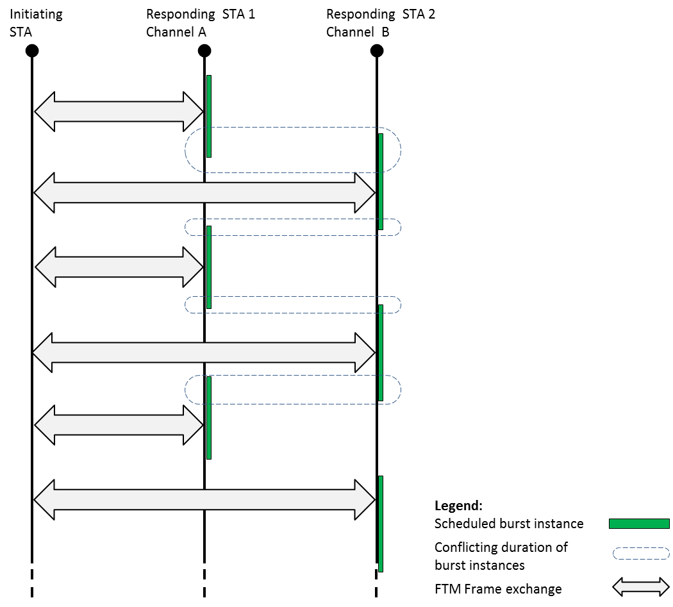
Figure xyx – Concurrent FTM sessions
The initiating STA in figure xyx establishes sessions with responding STA 1 and responding STA 2 on different channels. The sessions’ burst periodicity may be different as well as the STAs’ clock offsets and thus, over time, some temporal conflicts may occur. To overcome this, during each burst instance the initiating STA indicates its availability by transmitting a trigger frame in the form of a Fine Timing Measurement Request frame. During each burst instance, the responding STA transmits one or more fine timing measurement frames as negotiated.
10.24.6.2 FTM Capabilities
Implementation of fine timing measurement is optional for a WNM STA. A STA in which dot11MgmtOptionFineTimingMsmtActivated is true is defined as a STA that supports fine timing measurement.
When dot11MgmtOptionFineTimingMsmtActivated is true, dot11WirelessManagementImplemented shall be true.
A STA in which dot11MgmtOptionFineTimingMsmtActivated is true shall set the Fine Timing Measurement field of the Extended Capabilities element to 1.
A STA in which dot11MgmtOptionFineTimingMsmtActivated is false shall set the Fine Timing Measurement field in the Extended Capabilities element to 0. The STA does not support the fine timing measurement procedure.

10.24.6.3 Fine Timing Measurement Procedure Setup
A STA that supports the fine timing measurement procedure may shall transmit a Fine Timing Measurement Request frame to a peer STA to initiate a Fine Timing Measurement procedure request to initiate or to stop and on going Fine Timing Measurement procedure, depending of the value of the Trigger field in the request frame see figure 10-31 (Fine Timing Measurement Procedure). A STA that supports the fine timing measurement procedure may transmit Fine Timing Measurement frames addressed to a peer STA that also supports the fine timing measurement procedure.
The initiating STA sends a Fine Timing Measurement Request frame which may include a set of scheduling parameters to describe the initiating STA’s availability for measurement exchange. The responding STA may accept or modify the requested parameters. The responding STA should transmit a Fine Timing Measurement frame within 10ms to the Fine Timing Measurement Request frame. The Fine Timing Measurement frame may include the optional Fine Timing Measurement Parameter element. The value of the Status Indication field indicates whether the request was accepted, modified or rejected.
The responding STA’s selection of the Min Delta FTM value shall be greater than or equal to the corresponding value requested by the initiating STA.
10.24.6.4 Measurement exchange
Fine Timing Measurements frames are sent during each availability time windows called burst instances. The timing and composition of the burst instances are defined by the following parameters:
- Partial TSF Timer – The partial TSF timer at the beginning of the first burst instance.
- Burst Timeout – The time duration of each burst instance starting at the boundary of a burst period.
- Burst Period – The interval from the beginning of one burst instance to the beginning of the following burst instance.
- FTMs per Burst – The number of Fine Timing Measurement frames transmitted in each burst instance.
The initiating STA shall transmit a Fine Timing Measurement Request trigger frame, which serves as a trigger, as soon as it is available on channel to decode the medium. This indicates to the responding STA its availability for the remainder of the burst instance. Following this trigger frame the responding STA shall transmit an Ack frame and one or more Fine Timing Measurement frames. Within each burst instance, consecutive Fine Timing Measurement frames shall be spaced at least Min Delta FTM apart. Within each burst instance the initiating STA shall perform fine timing measurement on each Fine Timing Measurement frame addressed to it.

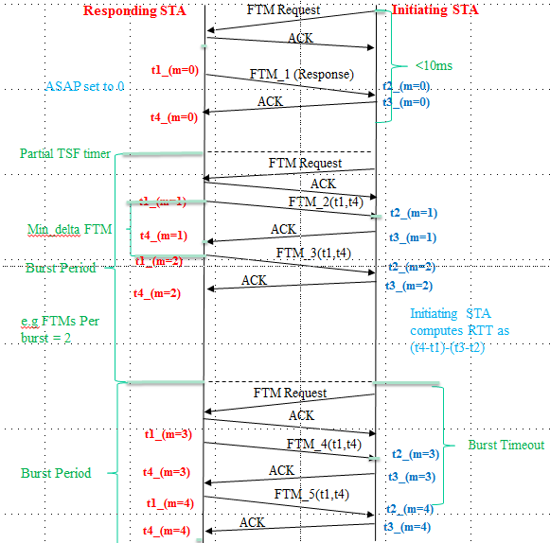
Figure XX
The initiating STA may request the responding STA to start the burst instances “as soon as possible” and have the response frame Fine Timing Measurement frame perform FTM measurement by setting the ASAP field to 1. If the responding STA performs fine timing measurement on the Fine Timing Measurement frame it shall signal this by setting the FTM_1 timestamps available field to 1. The first burst instance shall start at the value indicated by the Partial TSF timer field. The scheduling in this case can be seen in figure YY below.

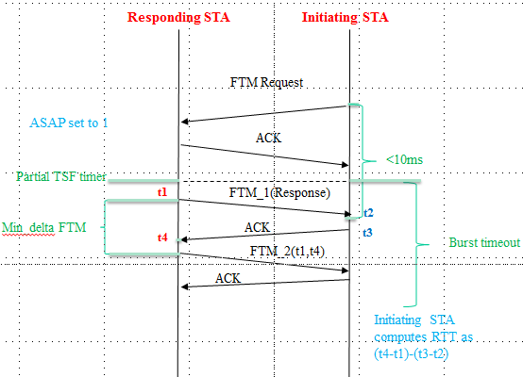
Figure YY
The initiating STA may also request a single set of fine timing measurements to be taken, in which case it will set the Number of Bursts Exponent field to 0 and set the ASAP field to 1. The single set of fine timing measurements may be composed of 2 or more measurements.
Both the responding STA and initiating STA shall transmit using a single RF chain.
The initiating STA may request the Fine Timing Measurement to have a certain format and CH_BANDWIDTH by setting the values in the FTM Channel Spacing/Format field of the Fine Timing Measurement element in the Fine Timing Measurement Request frame.

A responding STA transmits Fine Timing Measurement frames in overlapping pairs. The first Fine Timing Measurement frame of a pair contains a nonzero Dialog Token. The follow up Fine Timing Measurement frame contains a Follow Up Dialog Token set to the value of the Dialog Token in the first frame of the pair. Dialog Tokens of consecutive Fine Timing Measurement frames shall, excluding retries, be consecutive, except when the value wraps around to 1. The first Fine Timing Measurement Frame that is responded within 10 ms from the Initial Fine Timing Measurement Request frame may or may not have captured timestamps. This is indicated by the FTM_1 timestamps available field in the Fine Timing Measurement Parameter element. With the first Fine Timing Measurement frame, both STAs capture timestamps. The responding STA captures the time at which the Fine Timing Measurement frame is transmitted (t1). The initiating STA captures the time at which the Fine Timing Measurement frame arrives (t2) and the time at which the Ack response is transmitted (t3). The responding STA captures the time at which the Ack frame arrives (t4). See Figure 6-17 (Fine timing measurement primitives and timestamps capture) in 6.3.58 (Fine timing measurement). In the follow up Fine Timing Measurement frame, the responding STA transfers the timestamp values it captured (t1 and t4) to the initiating STA. In this follow up Fine Timing Measurement frame, the timestamp values (t1 and t4) shall be the measurement according to the responding STA’s clock (i.e. without correcting the clock offset).
See Figure XX for Periodic fine timing measurements when the ASAP field is set to 0 and Figure ZZ when the ASAP field is set to 1.
The Ack frame shall should have the same CH_BANDWIDTH as the preceding fine timing measurement frame.
NOTE—A Fine Timing Measurement frame can contain nonzero values in both the Dialog Token and Follow Up Dialog Token fields, meaning that the Action frame contains follow up information from a previous measurement, and new Timestamp values are captured to be sent in a future follow up Fine Timing Measurement frame.
The round trip time (RTT) is defined by :
- RTT = [(t4 – t1) – (t3 – t2)]
If the Ack frame for a transmitted Fine Timing Measurement frame is not received, the responding STA may retransmit the frame. The responding STA shall capture a new set of timestamps for the retransmitted frame and its Ack frame.
10.24.6.3 Fine Timing Measurement parameter modification
During an ongoing FTM session, the initiating STA may request to modify the session parameters by transmitting a Fine Timing Measurement Request frame with trigger value of 1, including a new Fine Timing Measurement Parameter element. Upon reception of such a Fine Timing Measurement Request frame the ongoing FTM session is terminated and the procedure follows the behavior described in section 10.24.6.2.
10.24.6.4 Fine Timing Measurement termination
There are two four ways that an FTM session is terminated to stop this frame exchange:
- The responding STA sends a Fine Timing Measurement Frame with Dialog Token set to 0.
- The initiating STA sends a Fine Timing Measurement Request Frame with Trigger set to 0.
- The initiating STA requests to modify the Fine Timing Measurement parameters (see 10.24.6.3).
- When the number of bursts agreed during the FTM session setup has been reached.

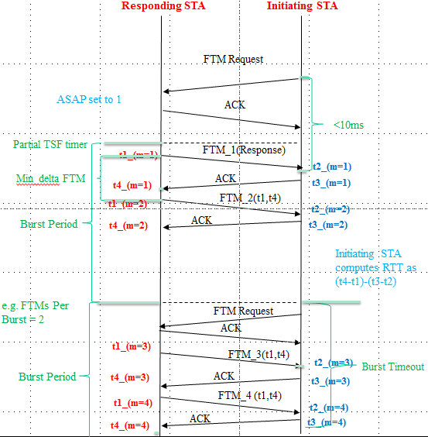
Figure ZZ

Section 10.26.1.2
Please make the following changes :

- Default QMF policyinput.doc
Description | Management Frame Subtype value from Table 8-2 (Valid type and subtype combinations) | Category value from Table 8-43 (Category values) | Action class field | QMF access category
(Re)Association Request/Response | 0000–0011 | N/A | N/A | AC_VO
Probe Request (individually addressed | 0100 | N/A | N/A | AC_VO
Probe Request (group addressed) | 0100 | N/A | N/A | AC_BE
Probe Response | 0101 | N/A | N/A | AC_BE
Timing Advertisement | 0110 | N/A | N/A | AC_BE
Beacon, ATIM, Disassociation, Authentication, Deauthentication | 1000–1100 | N/A | N/A | AC_VO
Spectrum management | 1101 | 0 | 0–3 | AC_BE
Spectrum management— channel switch  announcement | 1101 | 0 | 4 | AC_VO
QoS | 1101 | 1 | 0–3 | AC_VO
DLS | 1101 | 2 | 0–2 | AC_BE
Block Ack | 1101 | 3 | 0–2 | AC_VO
Public | 1101 | 4 | 0, 1, 3, 5–6, 8–9 | AC_BE
Public—DSE deenablement, extended channel switch announcement | 1101 | 4 | 2, 4 | AC_VO
Public—measurement pilot | 1101 | 4 | 7 | AC_VO
Public—TDLS  Discovery Response | 1101 | 4 | 14 | AC_VO
Public— Fine Timing Measurement Frame | 1101 | 4 | ANA | AC_VO
Public— Fine Timing Measurement Request | 1101 | 4 | ANA | AC_VO
Radio measurement | 1101 | 5 | 0–5 | AC_BE
Fast BSS Transition | 1101 | 6 | 0–4 | AC_VO
HT | 1101 | 7 | 0–3 | AC_VO
HT | 1101, 1110 | 7 | 4–7 | AC_VO
SA Query | 1101 | 8 | 0–1 | AC_VO
Protected Dual of Public Action | 1101 | 9 | 1–2, 5–6, 8–9 | AC_BE
Protected Dual of Public Action—extended channel switch announcement | 1101 | 9 | 4 | AC_VO
WNM | 1101 | 10 | 0–24 | AC_BE
Unprotected WNM | 1101 | 11 | 0–1 | AC_BE
Mesh Action—HWMP Mesh Path Selection | 1101 | 13 | 1 | AC_VO
Mesh Action—  Congestion Control | 1011 | 13 | 3 | AC_VO
Mesh Action | 1101 | 13 | 0, 2, 4–10 | AC_BE
Multihop Action | 1101 | 14 | 0–1 | AC_BE
Self Protected | 1101 | 15 | 0–5 | AC_VI
Reserved (used by WFA) | 1101 | 17 | All | AC_BE
Vendor-specific Protected | 1101 | 126 | N/A | AC_BE
Vendor-specific | 1101 | 127 | N/A | AC_BE

