IEEE P802.11
Wireless LANs
802.11
CID 2164
Date: 2014-01-22
Author(s):
Name | Company | Address | Phone | email
Carlos Aldana | Qualcomm Corporation |  |  | caldana@qca.qualcomm.com
Jonathan Segev | Intel Corporation |  |  | jonathan.segev@intel.com
Qi Wang | Broadcom Corporation |  |  | qi.wang@broadcom.com
Liwen Chu | Marvell Semiconductor |  |  | liwenchu@marvell.com
Naveen Kakani | CSR |  |  | naveen.kakani@csr.com
Abstract

This document contains some proposed resolutions to comments CID 2164.

Pertinent comment

CID | Page | Clause | Resn Status | Comment | Proposed Change | Resolution | Owning Ad-hoc
2164 | 1543 | 10.24.6 |  | The fine timing measurement procedure is OK as far as it goes, but it lacks some optimizations necessary to make it useful. Perhaps the most significant issue is that a STA has to be permanently on the channel negotiated with STA1 in order to receive Fine Timing Measurement frames. This means it can't do power saving, and can't perform location simultaneously with STA1s on different channels. | Add support for STA2 power saving during location determination. Add support that allows a STA2 to perform ranging with STA1s on different channels |  | MAC

Section 8.4.2.1
[Note to editor:]
Add a row to Table 8-61 to indicate Fine Timing Measurement Parameter Element.

[Note to editor:]
Add a new Section
8.4.2.157 Fine Timing Measurement Parameter element
The Fine Timing Measurement Parameter element contains a number of fields that are used to advertise the desired fine timing measurement configuration from one STA to another. The Fine Timing Measurement Parameter element may be included in the initial Fine Timing Measurement Request Frame, as described in 8.6.8.25, and the initial Fine Timing Measurement frame, as described in 8.6.8.26. The use of the Fine Timing Measurement Parameter element is described in 10.24.6.
 | Element  ID | Length | Status  Indication+Value | Number of bursts exponent (4 bits)+Burst Timeout (4 bits) | Min Delta FTM | Burst Offset | FTM_1 timestamps available (1 bit) + FTMs per burst (5 bits, 2  Reserved) | FTM Channel Spacing/format(6 bits, 2 reserved) | Burst Period
Octets: | 1 | 1 | 1 | 1 | 1 | 2 | 1 | 1 | 2
Fine Timing Measurement Parameter Element

The Element ID and Length fields are defined in 8.4.2.1 (General).

The Length field is set to the total number of octets following the length field.

When the Fine Timing Measurement element is sent in the first Fine Timing Measurement frame following a Fine Timing Measurement Request frame establishing a fine timing measurement session, the “Status Indication+Value” field provides the result of a Fine Timing Measurement Request frame.

Status Indication occupies the 3 MSBs of “Status Indication+Value” field. The Status Indication field is a value in Table AAA, indicating the STA’s response to the Fine Timing Request. It is set to value “0” Reserved when included in a Fine Timing Measurement Request frame.

Value occupies the 5 LSBs of “Status Indication+Value” field and is used when Status Indication field is set to 4.

Table AAA- Status Indication
Value | Description
0 | Reserved
1 | Successful. Indicates FTM exchange about to begin. Accepted all fields.
2 | Overriden. Indicates FTM exchange about to begin. Override of one or more fields.
3 | Request incapable (do not send same request again)
4 | Request failed. Do not send new request for “Value” seconds.
5–7 | Reserved
The Number of burst exponent field occupies the 4 LSBs of the octet following the status indication. This indicates how many bursts (2^exponent) are requested/allocated if included in a Fine Timing Measurement Request/Fine Timing Measurement frame respectively. The value of 15 in the Fine Timing Measurement Request indicates no preference by the initiating STA.
The Burst Timeout field occupies the MSBs of the octet following the status indication. This indicates the time duration of the burst instance defined in 10.24.6. Table BBB indicates the mapping.
Table BBB- Burst Timeout
Value | Description
0 | 250us
1 | 500us
2 | 1ms
3 | 2ms
4 | 4ms
5 | 8ms
6 | 16ms
7 | 32ms
8 | 64ms
9 | 128ms
10-14 | Reserved
15 | No preference

The Min delta FTM field indicates the minimum time between consecutive fine timing measurement frames. It is measured from the start of a Fine Timing Measurement frame to the start of following Fine Timing Measurement frame. The units are 100us. Value of 0 indicates no preference by initiating STA.
The Burst Offset field indicates the time duration between the reception of the initial Fine Timing Measurement Request frame and the beginning of the first burst instancethe inunits isarine . vValue of0 from the initiating STA indicates “as quickly as possible”. A value of 65535 indicates no preference by initiating STA. A value of 0 is not allowed by Responding STA. A value of 65535 is reserved by the responding STA.
The FTMs per Burst sub-field indicates how many measurements are requested per burst instance. Max value is 31. Values in the range 32-126 are reserved. Value of 127 indicates no preference by initiating STA.
The 1-bit FTM_1 timestamps available sub-field is the most significant bit of the octet and indicates that the timestamps for the first Fine Timing Measurement frame have been captured and are valid. If this is the case, it is set to 1. Otherwise, it shall be set to 0.
The FTM Channel Spacing/Format field occupies the least significant bits of the octet and indicates the desired packet bandwidth/format used by Fine Timing Measurement frames according to table CCC. The value of 0 indicates no preference by the initiating STA.

Field Value | Format | CH_BANDWIDTH (MHz)
1 | Non-HT | 5
2 | Non-HT | 10
3 | Non-HT | 20
4 | HT_MF | 20
5 | VHT | 20
6 | HT_MF | 40
7 | VHT | 40
8 | VHT | 80
9 | VHT | 80+80
10 | VHT | 160
11 | DMG | 2160
0,12-63 | Reserved | Reserved

The Burst Period indicates the time duration between two consecutive burst instances.

- Fine Timing Measurement Request frame format
The format of the Timing Measurement Request frame is shown in Figure 8-588 Fine Timing Measurement Request frame format.
 | Category | Action | Trigger | optional  FTM Parameter Element
Octets: | 1 | 1 | 1 | variable
Figure 8-588 Fine Timing Measurement Request frame format

The category field is set to the value for Public, specified in Table 8-43 (Category values).
The Public Action field is set to indicate a Fine Timing Measurement Request frame, as defined in Table 8-257 (Public Action Field values).

The Trigger field set to the value 1 indicates that the initiating STA requests a Fine Timing Measurement procedure at the responding STA as defined in 10.24.6 (Fine Timing measurement procedure). The trigger field set to the value 0 indicates that the initiating STA requests that the initiating STA stops sending Fine Timing Measurement frames. Trigger field values 2–255 are reserved.
When Fine Timing measurement exchange occurs, the Fine Timing Measurement Parameters element signals a set of desired parameters from the initiating STA to the responding STA. In this case, the Fine Timing Measurement Parameter element is present in the first Fine Timing Measurement Request frame of a sequence. Subsequent Fine Timing Measurement Request frames are used as trigger and signal the availability of the initiating STA within burst instance and cannot contain the Fine Timing MeasurementTM IndicatnElements field.
- Fine Timing Measurement frame format
The Fine Timing Measurement frame is used to support the fine timing measurement procedure described in 10.24.6 (Fine Timing measurement procedure). The format of the Fine Timing Measurement frame is shown in Fine Timing Measurement frame format.
 | Category | Action | Dialog Token | Follow Up Dialog Token | TOD
Octets: | 1 | 1 | 1 | 1 | 6
 | TOA | Max TOD Error | Max TOA Error | Optional  FTM Parameter Element
Octets: | 6 | 2 | 2 | Variable
- Fine Timing Measurement frame format

The category field is set to the value for Public, specified in Table 8-43 (Category values).
The Public Action field is set to indicate a Fine Timing Measurement frame, as defined in Table 8-257 (Public Action field values).
The Dialog Token field is a nonzero value chosen by the responding STA to identify the Fine Timing Measurement frame as the first of a pair, with the second or follow-up Timing Measurement frame to be sent later. The Dialog Token field is set to 0 to indicate that the Timing Measurement frame will not be followed by a subsequent follow-up Timing Measurement frame.
The Follow Up Dialog Token is the nonzero value of the Dialog Token field of the previously transmitted Timing Measurement frame to indicate that it is the follow up Timing Measurement frame and that the TOD, TOA, Max TOD Error and Max TOA Error fields contain the values of the timestamps captured with the first Timing Measurement frame of the pair. The Follow Up Dialog Token is 0 to indicate that the Fine Timing Measurement frame is not a follow up to a previously transmitted Timing Measurement frame. The value 0 in this field also indicates that TOD, TOA, Max TOD Error, and Max TOA Error fields are reserved. See 10.24.6 (Fine Timing measurement procedure).
The TOD, TOA, Max TOD Error, and Max TOA Error fields are expressed in units of 0.1 ns.
The TOD field contains a timestamp that represents the time at which the start of the preamble of the previously transmitted Timing Measurement frame appeared at the transmit antenna connector.
The TOA field contains a timestamp that represents the time at which the start of the preamble of the Ack frame to the previously transmitted Timing Measurement frame arrived at the receive antenna connector.
NOTE—The values specified in the TOD and TOA fields are described in 6.3.70 (Fine timing measurement request).
The Max TOD Error field contains an upper bound for the error in the value specified in the TOD field. For instance, a value of 2 in the Max TOD Error field indicates that the value in the TOD field has a maximum error of ± 0.2 ns.
The Max TOA Error field contains an upper bound for the error in the value specified in the TOA field. For instance, a value of 2 in the Max TOA Error field indicates that the value in the TOA field has a maximum error of ± 0.2 ns.
A value of 0 for the Max TOD Error or the Max TOA Error field indicates that the upper bound on the error in the corresponding TOD or TOA value is unknown. A value of 65 535 indicates that the upper bound on the error is greater than or equal to 6.5535 us.
- Fine timing measurement procedure
10.24.6.1 FTM Capabilities
Implementation of fine timing measurement is optional for a WNM STA. A STA in which dot11MgmtOptionFineTimingMsmtActivated is true is defined as a STA that supports fine timing measurement.
When dot11MgmtOptionFineTimingMsmtActivated is true, dot11WirelessManagementImplemented shall be true.
A STA in which dot11MgmtOptionFineTimingMsmtActivated is true shall set the Fine Timing Measurement field of the Extended Capabilities element to 1.
A STA in which dot11MgmtOptionFineTimingMsmtActivated is false shall set the Fine Timing Measurement field in the Extended Capabilities element to 0. The STA does not support the fine timing measurement procedure.

10.24.6.2 Fine Timing Measurement Procedure Setup
A STA that supports the fine timing measurement procedure may shall transmit a Fine Timing Measurement Request frame to a peer STA to initiate a Fine Timing Measurement procedure request to initiate or to stop and on going Fine Timing Measurment procedure, depending of the value of the Trigger field in the request frame see figure 10-31 (Fine Timing Measurement Procedure). A STA that supports the fine timing measurement procedure may transmit Fine Timing Measurement frames addressed to a peer STA that also supports the fine timing measurement procedure. The Initiating STA sends a Fine Timing Measurement Request frame which may include a set of scheduling parameters to describe the initiating STA’s availability for measurement exchange. The Responding STA may accept or modify the requested parameters and responds within 10 msec with a Fine Timing Measurement frame that may include the optional Fine Timing Measurement Parameter element. The value of the status field indicates whether the request was accepted, modified or rejected.
The Responding STA’s selection of the Min Delta FTM value shall be greater than or equal to the corresponding value requested by the Initiating STA.
The Responding STA’s selection of the Burst Offset value shall be greater than or equal to the corresponding value requested by the Initiating STA.
10.24.6.3 Measurement exchange
Fine Timing Measurements frames are sent during each availability time windows called burst instances. The timing of the burst instances are defined by the following parameters:
- Burst offset – The time duration from the reception of the initial Fine Timing Measurement Request to the beginning of the first burst instance.
- Burst timeout – The time duration of each burst instance starting at the boundary of a burst period.

- Burst period – The time duration from the beginning of one burst instance to the beginning of the following burst instance.
The Initiating STA shall transmit a Fine Timing Measurement Request trigger frame, which serves as a trigger, as soon as it is available on channel to decode the medium. This indicates to the Responding STA its availability until the remainder of the burst instance. Following this trigger frame the Responding STA shall transmit an Ack frame and one or more fine timing measurement frames. Within each burst, consecutive Fine Timing Measurement frames shall be spaced at least Min Delta FTM apart. Within each burst instance the Initiating STA shall perform fine timing measurement on each Fine Timing Measurement frame addressed to it.

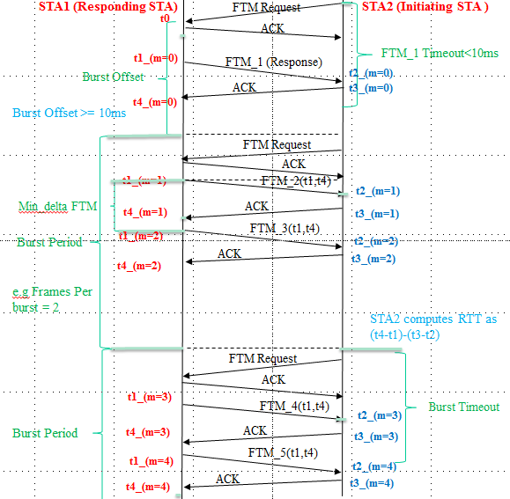
Figure XX
The Initiating STA may request the Responding STA to start the burst instances “as quickly as possible” and have the response frame Fine Timing Measurement frame perform FTM measurement by setting the burst offset parameter to “as quickly as possible”. If the Responding STA performs fine timing measurement on the Fine Timing Measurement frame it shall signal this by setting the FTM_1 timestamps available field to “1”. The first burst instance shall start Burst Offset away from the reception of the Fine Timing Measurement Request frame used for service establishment. The scheduling in this case can be seen in figure YY below.

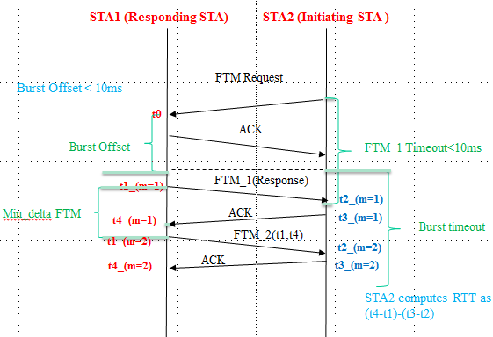
Figure YY
The initiating STA may also request a single set of range measurements to be taken, in which case it will set the Number of burst exponent field to “0” and set the Burst Offset field to “as quickly as possible”. The single set of range measurement may be composed of 2 or more measurements taken in a single burst instance.
Both the Responding STA and initiating STA shall transmit using a single RF chain.
The initiating STA may request the Fine Timing Measurement to have a certain format and CH_BANDWIDTH by setting the values in the FTM Channel Spacing /Format field of the Fine Timing Measurement element in the Fine Timing Measurement Request frame.
.
A responding STA transmits Fine Timing Measurement frames in overlapping pairs. The first Fine Timing Measurement frame of a pair contains a nonzero Dialog Token. The follow up Fine Timing Measurement frame contains a Follow Up Dialog Token set to the value of the Dialog Token in the first frame of the pair. Dialog tokens of successfully received consecutive Fine Timing Measurement frames shall be monotonically increasing. The first Fine Timing Measurement Frame that is responded within 10ms from the initial FTM Request may or may not have captured timestamps. This is indicated by the FTM_1 timestamps available field in the Fine Timing Measurement Parameter element. With the first Fine Timing Measurement frame, both STAs capture timestamps. The responding STA captures the time at which the Fine Timing Measurement frame is transmitted (t1). The initiating STA captures the time at which the Fine Timing Measurement frame arrives (t2) and the time at which the Ack response is transmitted (t3). The responding STA captures the time at which the Ack frame arrives (t4). See Figure 6-17 (Fine timing measurement primitives and timestamps capture) in 6.3.58 (Fine timing measurement). In the follow up Fine Timing Measurement frame, the responding STA transfers the timestamp values it captured (t1 and t4) to the initiating STA. In this follow up Fine Timing Measurement frame, the timestamp values (t1 and t4) shall be the measurement according to the responding STA’s clock (i.e. without correcting the clock offset).

See Figure XX for Periodic fine timing measurements when the Burst offset >= 10ms and Figure ZZ when the Burst Offset < 10ms.
The Ack frame shall should have the same CH_BANDWIDTH as the preceding fine timing measurement frame.
NOTE—A Fine Timing Measurement frame can contain nonzero values in both the Dialog Token and Follow Up Dialog Token fields, meaning that the Action frame contains follow up information from a previous measurement, and new Timestamp values are captured to be sent in a future follow up Fine Timing Measurement frame.
The round trip time (RTT) is defined by :
- RTT = [(t4 – t1) – (t3 – t2)]
The only two cases for which Dialog Tokens may be reused are when retransmission of a Fine Timing Measurement frame happens or when Dialog Token reaches 255 and the next value of 1 is reused. If the Ack frame for a transmitted Fine Timing Measurement frame is not received, the responding STA may retransmit the frame. The responding STA shall capture a new set of timestamps for the retransmitted frame and its Ack frame.
10.24.6.3 Fine Timing Measurement parameter modification
During an ongoing Fine Timing Measurement session, the Initiating STA may request to modify the session parameters by transmitting a Fine Timing Measurement Request frame with trigger value of 1, including a new Fine Timing Measurement Parameter element. Upon reception of such a Fine Timing Measurement Request frame the ongoing FTM session is terminated and the procedure follows the behavior described in section 10.24.6.2.

10.24.6.4 Fine Timing Measurement termination
There are two four ways that a Fine Timing Measurement session is terminated to stop this frame exchange:
- The Responding STA sends a Fine Timing Measurement Frame with Dialog Token set to 0.
- The Initiating STA sends a Fine Timing Measurement Request Frame with Trigger set to 0.
- The Initiating STA request to modify the Fine Timing Measurement parameters (see 10.24.6.4).
- When the number of bursts instance allocated during a fine timing measurement session setup has been reached.

- setup has

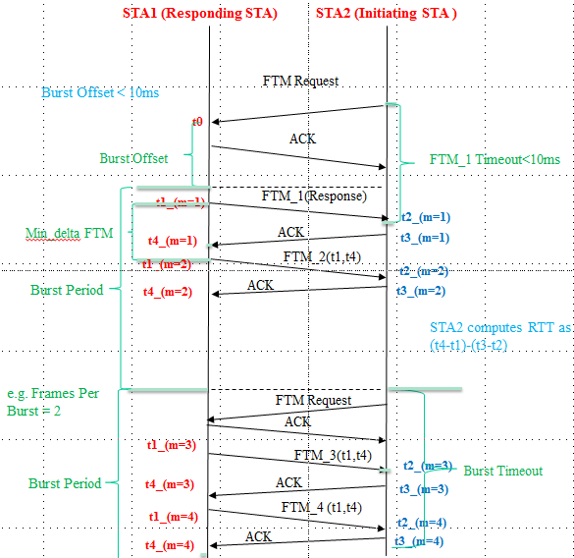
Figure ZZ

