IEEE P802.11
Wireless LANs
Example usage of FILS HLP wrapped data TLV
Date: 2013-09-10
Author(s):
Name | Affiliation | Address | Phone | email
Hitoshi Morioka | Allied Telesis R&D Center | 2-14-38 Tenjin, Chuo-ku, Fukuoka 810-0001 JAPAN | +81 92 771 7630 | hmorioka@root-hq.com
Abstract
This document is a proposed normative text about example usage of FILS HLP wrapped data TLV.

Add new clause Annex x:

Annex x

(informative)

Example usage of FILS HLP wrapped data TLV during Association

x.1 DHCPv4

x.1.1 With Rapid Commit Option

By using DHCPv4 with Rapid Commit Option (RCO), IP layer can be configured in one round-trip packet exchange between a STA and a DHCP server. So it is recommended for FILS.

In this case, DHCP messages should be carried by FILS HLP wrapped data TLV in FILS Secure Container element in Association Request and Response as shown in Figure x-1.

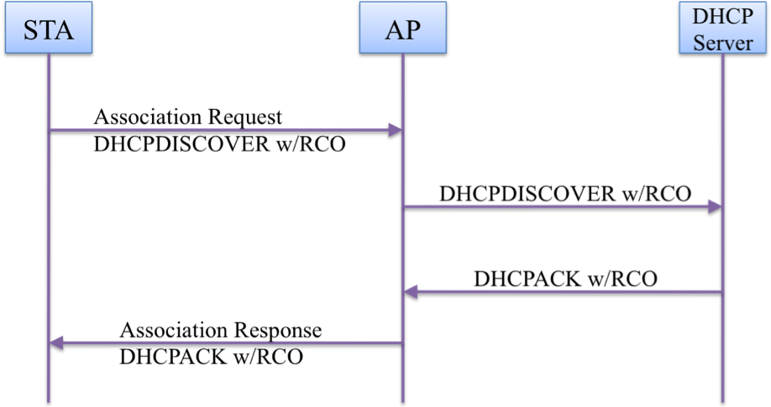
Figure x-1---- Example for DHCPv4 with Rapid Commit Option

x.1.2 Without Rapid Commit Option

In case of DHCPv4 without Rapid Commit Option, it takes two round-trip packet exchanges between a STA and a DHCP server to configure IP layer.

In this case, the first one round-trip DHCP messages should be carried by FILS HLP wrapped data TLV in FILS Secure Container element in Association Request and Response as shown in Figure x-2.

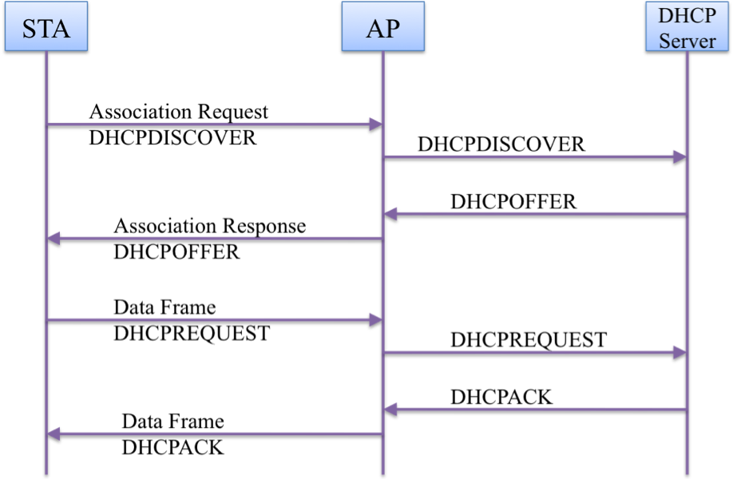
Figure x-2---- Example FILS HLP transport during association usage for DHCPv4 without Rapid Commit Option

x.2 IPv6 Stateless Address Autoconfiguration

In case of using IPv6 Stateless Address Autoconfiguration, Router Solicitation and Router Advertisement should be carried by FILS HLP transport during association as shown in Figure x-3.

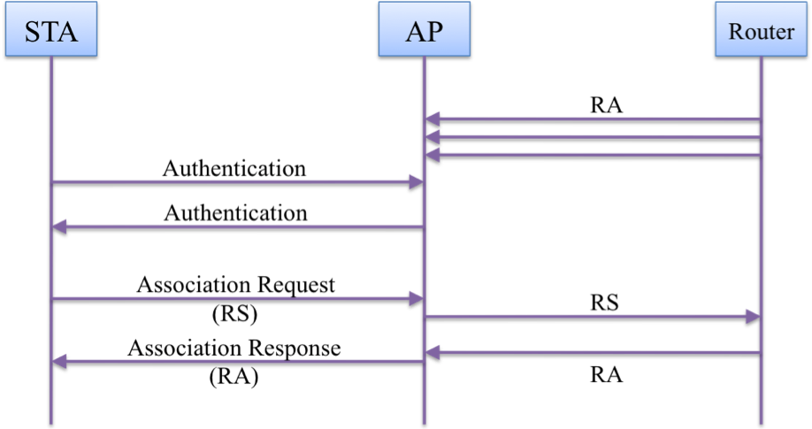
Figure x-3---- Example FILS HLP transport during association usage for IPv6 Stateless Address Autoconfiguration

x.3 ARP

To reduce ARP packet exchange, AP should transmit Gratuitous ARP packet of link-local nodes (e.g. gateway, DNS server) by FILS HLP wrapped data TLV in FILS Secure Container as shown in Figure x-4.

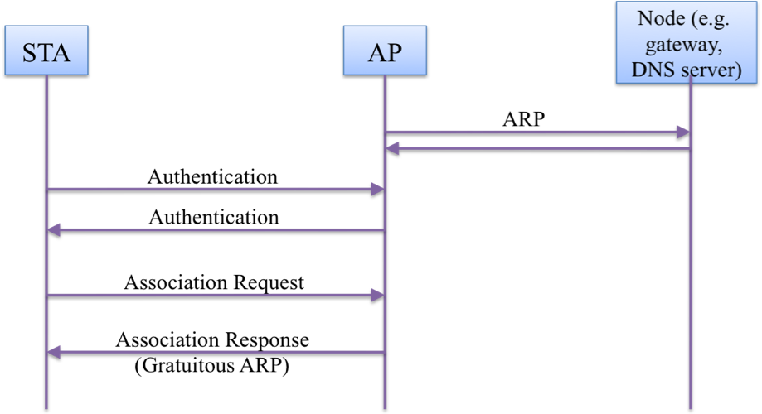
Figure x-4---- Example FILS HLP transport during association usage for ARP

x.4 NDP

To reduce NDP packet exchange, AP should transmit NA packet of link-local nodes (e.g. DNS server) by FILS HLP wrapped data in FILS Secure Container as shown in Figure x-5.

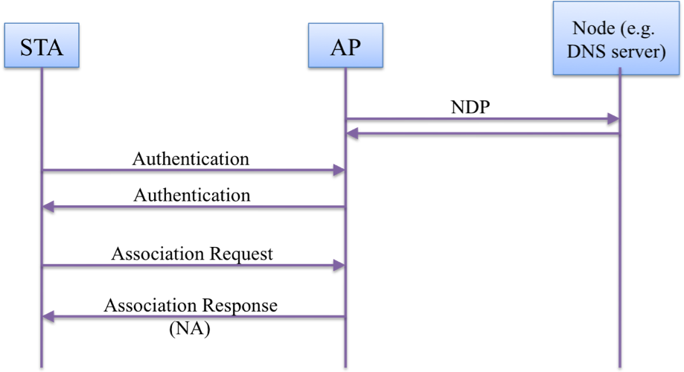
Figure x-5---- Example FILS HLP transport during association usage for NDP

