IEEE P802.11  
Wireless LANs

|  |  |  |  |  |
| --- | --- | --- | --- | --- |
| Comment Resolution for CIDs 10216 and 10242 | | | | |
| Date: 2013-05-30 | | | | |
| Author: | | | | |
| Name | Affiliation | Address | Phone | Email |
| Edward Au | Huawei Technologies | 303 Terry Fox Drive, Suite 400, K2K 3J1 Kanata Ontario |  | [edward.au@huawei.com](mailto:brianh@cisco.com) |

##### This submission presents proposed resolution to CIDs 10216 and 10242. Changes indicated by a mixture of Word track-changes and instructions.

##### CID 10216

|  |  |  |  |  |  |
| --- | --- | --- | --- | --- | --- |
| CID | Clause | Page | Line | Comment | Proposed Change |
| 10216 | 22.4.4 | 334 | 31 | "The static VHT PHY characteristics, provided through the PLME-CHARACTERISTICS service primitive, shall be as shown in Table 20-25 (MIMO PHY characteristics) unless otherwise listed in Table 22-29 (VHT PHY characteristics)."  Because Table 20-25 is providing the aTxPHYDelay and aRxPHYDelay (Values are an implementation dependent), it is not needed to define the redundant VHT PHY characteristics in Table 22-29. | Remove a first row (aTxPHYDelay) and a second row (aRxPHYDelay) from Table 22-29. |

***Discussion and Proposed Resolution:***

**Rejected.**

The following shows a snapshot of Table 22-29 in P802.11ac_D5.0 and Table 20-25 in IEEE802.11-2012. When compared with the entries in both tables, there is no common element. Note here that while aTxRFDelay and aRxRF Delay are included in Table 20-25, aTxPHYDelay and aRxPHYDelay, which are of different definitions, are included in Table 22-29.

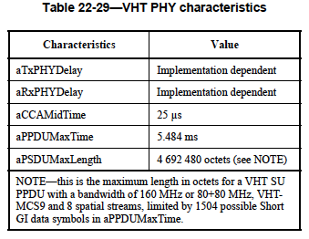

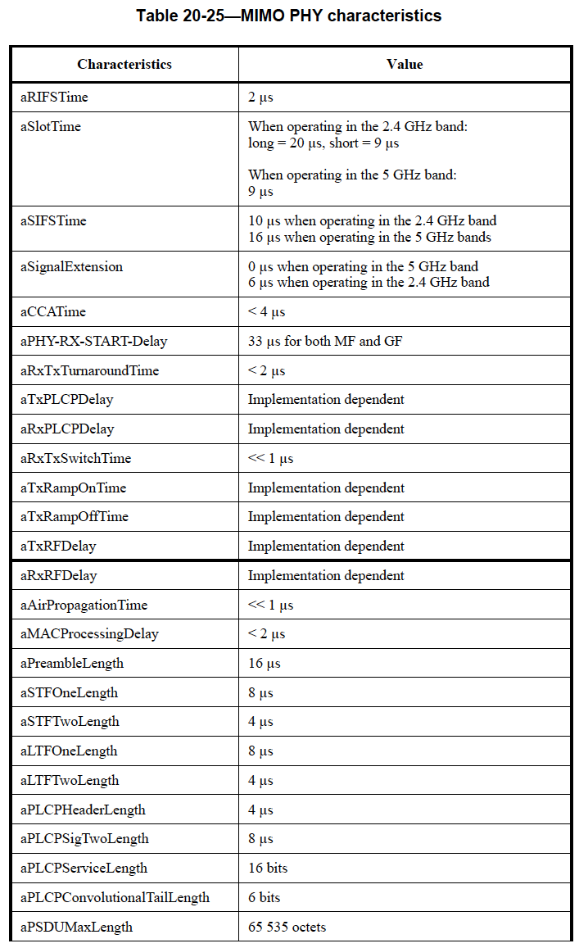

##### CID 10242

|  |  |  |  |  |  |
| --- | --- | --- | --- | --- | --- |
| CID | Clause | Page | Line | Comment | Proposed Change |
| 10242 | 3.2 | 7 | 21 | Subclauses 3.1 - 3.3 really don't need to define JammedTogetherWords, especially when this term is defined in the draft to be the name of a parameter of the MLME-START.request or the BSSDescription. Parameters of primitives should not be defined in subclauses 3.1 or 3.2 -- they are defined in clauses 6 and 7. Besides, the term "VHT set" isn't used, so why not just use that as the unique term for this concept? | Replace "BSSBasicVHTMCS_NSSSet" with "VHT set" inside the parens on this line and in every location in the main text that is not specifically referencing the defined parameter of the MLME-START.request primitive. |

***Discussion and Proposed Resolution:***

**Rejected.**

It is not correct that there are no JammedTogetherWords defined in subclauses 3.1-3.3. As referred to clause 3.2 of IEEE802.11-2012 (c.f., page 26), we do have a definition of BSSBasicMCSSet:



Further, the term “VHT set” suggested by the commenter is not sufficient to reflect that both MCS and number of spatial streams are formed together as a tuple.