IEEE P802.11  
Wireless LANs

|  |  |  |  |  |
| --- | --- | --- | --- | --- |
| LB192 D3.0 comment resolution (Misc PHY comments) | | | | |
| Date: 2013-03-18 | | | | |
| Author(s): | | | | |
| Name | Company | Address | Phone | email |
| Tevfik Yucek | Qualcomm | 1700 Technology Drive, San Jose, CA | 408-6521053 | [tyucek@qca.qualcomm.com](mailto:tyucek@qca.qualcomm.com) |
|  |  |  |  |  |

Abstract

This document contains proposed resolution of some miscellaneous PHY comments in LB192 of P802.11af D3.0. Proposed resolutions are based on 802.11af draft text D3.0.

This submission provides resolution to comments 2040, 2042, 2047, 2038, 2022, 2023 and 2079.

**Interpretation of a Motion to Adopt**

A motion to approve this submission means that the editing instructions and any changed or added material are actioned in the TGaf Draft. This introduction is not part of the adopted material.

***Editing instructions formatted like this are intended to be copied into the TGaf Draft (i.e. they are instructions to the 802.11 editor on how to merge the text with the baseline documents).***

***TGaf Editor: Editing instructions preceded by “TGaf Editor” are instructions to the TGaf editor to modify existing material in the TGaf draft. As a result of adopting the changes, the TGaf editor will execute the instructions rather than copy them to the TGaf Draft.***

***Submission Note: Notes to the reader of this submission are not part of the motion to adopt. These notes are there to clarify or provide context.***

# Short Interframe Spacing (SIFS) related comments:

| **CID** | **Page** | **Clause** | **Comment** | **Proposed Change** | **Proposed Resolution** |
| --- | --- | --- | --- | --- | --- |
| 2040 | 218 | 23.2.2 | The entire "LENGTH" parameter seems superfluous (because FORMAT is never HT_MF or HT_GF). | Delete "LENGTH" table entry in table 23-1 | ACCEPTED.  The parameter is not needed in Clause 23. |
| 2042 | 221 | 23.2.4 | We need a definition of t_DATA for NON_HT preamble (to go with our definition of t_SIGNAL) | Add text ", and t_DATA is equal to 20 multiplied by X us, " before "where" in line 65 | ACCEPTED.  We agree with the commenter and add definition of t_DATA to text. Please see editing instructions for the changes. |
| 2147 | 2 | 23.1.1 | The terms of TVHT SU PPDU and TVHT MU PPDU are not defined. | Define TVHT SU PPDU and TVHT MU PPDU as follows: television very high throughput (TVHT) single user (SU) physical layer protocol data unit (PPDU): A TVHT PPDU transmitted with the TXVECTOR parameters FORMAT equal to VHT , CH_BANDWIDTH equal to TVHT_W, TVHT_2W, TVHT_4W, TVHT_W+W or TVHT_2W_2W and GROUP_ID equal to 0 or 63. television very high throughput (TVHT) multi-user (MU) physical layer protocol data unit (PPDU): A TVHT PPDU transmitted with the TXVECTOR parameters FORMAT equal to VHT, , CH_BANDWIDTH equal to TVHT_W, TVHT_2W, TVHT_4W, TVHT_W+W or TVHT_2W_2W and GROUP_ID in the range 1 to 62. | REVISED.  Clause 23 does not define TVHT SU PPDU and TVHT MU PPDU. However, there are some parts of the spec that uses these parameters which needs to be removed. In the editorial comments, it is proposed that these references be removed. |
| 2038 | 229 | 23.3.4.6 | "In multiple BCU transmissions TVHT_MODE_2C, TVHT_MODE_2N, TVHT_MODE_4C, and TVHT_MODE_4N, the TVHT-STF subcarriers of one BCU are repeated in each BCU with an appropriate phase rotation factor being applied as described in 23.3.8.2.4 (TVHT-STF definition)." However, 23.3.8.2.4 does not mention the case of multi-BCU. Same issue with TVHT-LTF. | In 23.3.8.2.4 and 23.3.8.2.5, describe how to construct TVHT-STF and TVHT-LTF for the multi-BCU cases. | REJECTED.  Section 23.3.8.2.4 states “The TVHT-STF field for *each BCU* in any transmission mode is defined by…” so it indeed defines multi-BCU waveforms. Furthermore, applied phase rotations for each BCU are defined in Table 23-12 (the gamma sub_k, m) |
| 2022 | 75 | 8.4.2.31 | Do you really want AC_BE and AC_BK TXOP Limits to be 0? This means that one packet of any length can be sent. With aggregation this can be greater than what is allowed for AC_VI. I have presented on TXOP Limits to 11mc and proposed that AC_BE and AC_BK should be set to half the TXOP Limit for AC_VI. | Set AC_BK and AC_BK TXOP Limit to 11.28ms in Table 8-105 | REJECTED.  Discussion: Commenter has this issue discussed in 802.11-13/0014r0. The change is not in the approved mc draft 1.0.  Commenter is encouraged to bring a presentation to TGaf for further discussion. Proposed change is not needed to get regulatory approval so it is outsite the scope of TGaf PAR. |
| 2023 | 75 | 8.4.2.32 | AC_VO TXOP Limit should be 11.28ms not 11.28us | in Table 8-105 for AC_VO replace "11.28us" with "11.28ms" | ACCEPTED.  This is a typo introduced in 12-1373r0. Change is editorial. |
| 2079 | 49 | 8.4.2.31 | Some TXOP limits of clause 23 PHY are too short. May be unit is typo. | Correct clause 23 PHY's TXOP limit unit from "us" to "ms". | ACCEPTED.  This is a typo introduced in 12-1373r0. Change is editorial. |

# Editing instructions

***TGaf editor: Change the paragraph in 23.2.4 as shown below***

Modulation-dependent parameters for Non-HT duplicate mode in TVWS band is defined in Table 23-3 (Modulation-dependent parameters for Non-HT duplicate mode in TVWS band). Timing related parameters are defined in Table 23-8 (Timing-related parameters). *tSIGNAL* in Equation (18-2) is equal to 16 multiplied by X μs and *t_DATA* in Equation (18-2) is equal to 20 multiplied by X μs, where X is 7.5 for 6 MHz and 7 MHz unit channels and by 5.625 for 8 MHz channels.

***TGaf editor: remove section 23.3.11.3 Maximum Number of Total Spatial Streams in TVHT MU PPDUs.***

***TGaf editor: Change the first paragraph of 23.3.4.9.1 as shown below***

The construction of the Data field in a ~~T~~VHT SU PPDU with BCC encoding proceeds as defined in 22.3.4.9.1 (Using BCC) reading Clause 23 for references to Clause 22 except:

***TGaf editor: Change the first paragraph of 23.3.4.9.2 as shown below***

The construction of the Data field in a ~~T~~VHT SU PPDU with LDPC encoding proceeds as defined in 22.3.4.9.2 (Using LDPC) reading Clause 23 for references to Clause 22 except:

***TGaf editor: Change the first sentence of 23.3.18.1 as shown below***

For a TVHT_W+W mask PPDU of ~~T~~VHT or non-HT duplicate format, the overall transmit spectral mask is constructed in the following manner.

***TGaf editor: Change Table 23-21 as shown below***

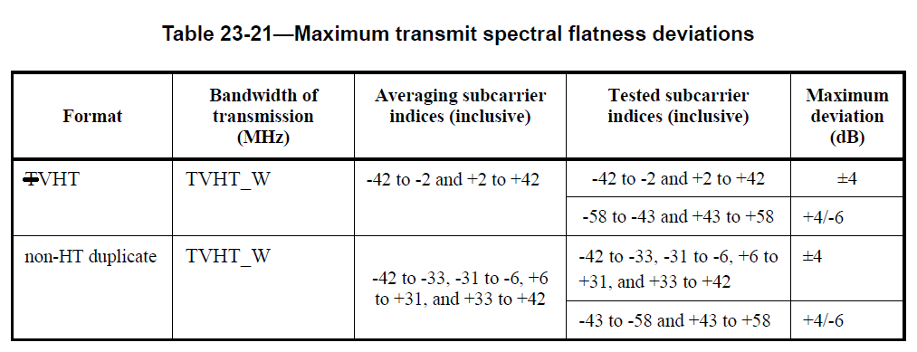

***TGaf editor: Change Table 23-22 as shown below***

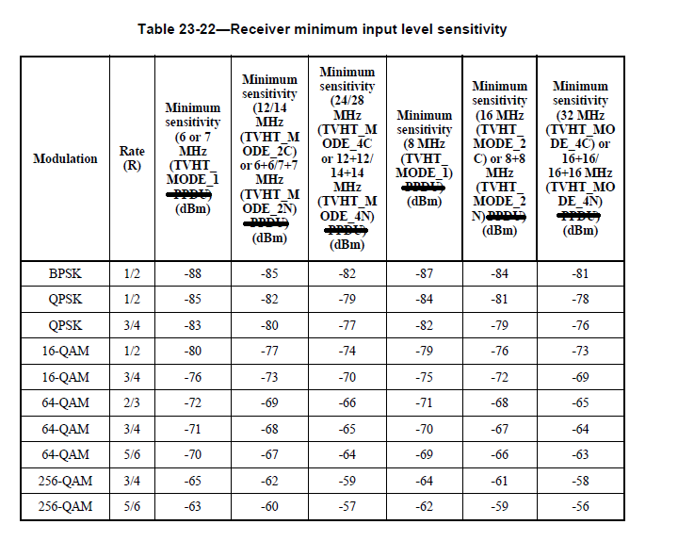

***TGaf editor: Change Table 8-105 as shown in 8.4.2.31 EDCA Parameter Set element***

|  |  |  |  |  |  |  |  |
| --- | --- | --- | --- | --- | --- | --- | --- |
| AC | CWmin | CWmax | AIFSN | TXOP limit | | | |
| For PHYs defined  in Clause 16 and  Clause 17 | For PHYs defined  in Clause 18,  Clause 19, and  Clause 20 | For PHY defined in Clause 23 | Other  PHYs |
| AC_BK | aCWmin | aCWmax | 7 | 0 | 0 | 0 | 0 |
| AC_BE | aCWmin | aCWmax | 3 | 0 | 0 | 0 | 0 |
| AC_VI | (aCWmin+1)/2 – 1 | aCWmin | 2 | 6.016 ms | 3.008 ms | 22.56ms (basic channel unit: 6 or 7 MHz),  16.92~~u~~ms (basic channel unit: 8MHZ) | 0 |
| AC_VO | (aCWmin+1)/4 – 1 | (aCWmin+1)/2 – 1 | 2 | 3.264 ms | 1.504 ms | 11.28~~u~~ms (basic channel unit: 6 or 7MHz),  8.46~~u~~ms (basic channel unit: 8MHz) | 0 |