IEEE P802.11
Wireless LANs
Considerations on AP Architectural models
Date: 2014-03-09
Author(s):
Name | Affiliation | Address | Phone | email
Mark Hamilton | Spectralink, Corp | 2560 55th St.  Boulder, CO 80301 | +1-303-441-7553 | Mark.hamilton@spectralink.com

Abstract
Some discussion topics and thoughts about 802.11 Access Points, Distribution Service and Portals, and how they could/should be modelled in the logical architecture.
Revision History
R0 – First revision. Jan13, 2013. With apologies for the low-tech pictures.
R1 – Added discussion of, and questions on, 802.11 Figure 5-1 concepts, from January face-to-face session. Added a list of 802.1 documents for reference. Clarified which text is quoted directly from referenced documents.
R2 – Significant re-write. Included discussion based on diagram from 11-13/198r0, which was submitted as AP RM for 802 O&A document. Added a new proposal for Figure 5-1 in 802.11-2012, to simplify and clarify the AP role and relationship to the generic STA concept.
R3 – Corrected Revision History and Date. Fixed a few typos.
R4 – Further simplified the proposal for Figure 5-1, in discussion following the original proposal.
R5 – Updated drawing on page 14, to just say “802.11” instead of “802.11 Scope”. Updated drawing on page 15, per ARC SC discussion May 15, and to match what is submitted to 802 O&A.
R6 – Updated final drawings (page 14 and page 15) with minor changes per ARC SC discussions: added clarification of LLC sublayer’s location in ‘stack’ drawing and clarified some labels; on page 15, a Portal connects to any non-802.11 network (not only other 802 networks), and added arrows to clarify that paths are all bi-directional.
R7 – A bit more cleanup on the figure on page 14, to show the switching function versus non-AP (null) shim a bit more clearly.
R8 – Some more corrections to the figure on page 14, creating a new on page 15 (keeping page 14 for reference).
R9 – Added proposed view of page 14 figure (which represents Figure 5-1 in REVmc D2.0) for the transparent FST case (to represent Figure 5-2 in REVmc D2.0). New figure is on page 15.
Purpose

This paper is a combination of stream-of-consciousness flow, and capture of discussions on the question:

What is the architectural model for APs, the Distribution System, and Portals, in an 802.11 infrastructure?

Background material

In prior discussions and submissions, this model of an 802.11 STA (AP or non-AP) has been incorporated into 802 O&A: (This is a slight modification to 802.11-2012 Figure 4-15.)

In an attempt to expand this model of a STA to specifically address the unique features of an AP’s STA, the model was enhanced with frame flow arrows, somewhat similar to those in 802.11-2012 Figure 5-1, but also including that these flows might be within the AP, might be across the DS, or might be to and through a Portal:

It is generally agreed that this model is too complicated to understand what the flows are trying to demonstrate.

This paper discusses the various concepts involved, and tries to distil out a more useful diagram as the architecture’s reference model.

The following references seem to be the most relevant 802.1 documents related to this subject:
- 802.1D-2004 (MAC bridging) – obsolete, for purposes of this discussion
- 802.1Q-2011 (VLAN-aware bridging) (802.1aq)
- 802.1AC-2012 (MAC Service)
- 802.1X-2010 (Port-based Security)

Some relevant definitions, for reference, from 802.11-2012:

access point (AP): An entity that contains one station (STA) and provides access to the distribution
services, via the wireless medium (WM) for associated STAs.

station (STA): A logical entity that is a singly addressable instance of a medium access control (MAC) and
physical layer (PHY) interface to the wireless medium (WM).

distribution service: The service that, by using association information, delivers medium access control
(MAC) service data units (MSDUs) within the distribution system (DS).

distribution system (DS): A system used to interconnect a set of basic service sets (BSSs) and integrated
local area networks (LANs) to create an extended service set (ESS).

distribution system medium (DSM): The medium or set of media used by a distribution system (DS) for
communications between access points (APs), mesh gates, and portals of an extended service set (ESS).

distribution system service (DSS): The set of services provided by the distribution system (DS) that enable
the medium access control (MAC) to transport MAC service data units (MSDUs) between stations (STAs)
that are not in direct communication with each other over a single instance of the wireless medium (WM).
These services include transport of MSDUs between the access points (APs) of basic service sets (BSSs)
within an extended service set (ESS), transport of MSDUs between portals and BSSs within an ESS,
transport of MSDUs between mesh gates in the same or different mesh basic service sets (MBSSs), transport
of MSDUs between mesh gates and APs, transport of MSDUs between mesh gates and portals, and transport
of MSDUs between STAs in the same BSS in cases where the MSDU has a group destination address or
where the destination is an individual address and the STA is associated with an AP.
NOTE—DSSs are provided between pairs of MACs not on the same instance of the WM.

portal: The logical point at which the integration service is provided.

integration service: The service that enables delivery of medium access control (MAC) service data units
(MSDUs) between the distribution system (DS) and a local area network (LAN) (via a portal).

infrastructure: The infrastructure includes the distribution system medium (DSM), access point (AP), and
portal entities. It is also the logical location of distribution and integration service functions of an extended
service set (ESS). An infrastructure contains one or more APs and zero or more portals in addition to the
distribution system (DS).

From 802.1Q-2011:

Bridge: A Bridge implemented in accordance with Clause 5 of this standard.

Bridge Port: A service access point (SAP) that provides the EISS to the MAC Relay Entity of a
VLAN-aware Bridge component, or that provides the ISS to the MAC Relay Entity of a MAC Bridge, and
the interface stack that supports that SAP (see 6.1.4, 8.5).

Definitions from context in 802.1Q-2011:

“6.1.6 MAC Service clients

The protocol entity that uses the service provided at an MSAP is commonly referred to as client of the MAC
Service or of the entity providing the service. Within a Bridge, the MAC Relay Entity is a client of the ISS or
EISS, and the LLC Entity is a client of the MAC Service. The LLC Entity is specified in ISO/IEC 8802.2
and provides protocol dentification, multiplexing and demultiplexing to and from a number of clients that
use a common MSAP. The clients of LLC are also often referred to as clients of the MAC.

NOTE—For the purposes of this standard, the terms “LLC” and “LLC Entity” include the service provided by the
operation of entities that support protocol discrimination using an EtherType, i.e., protocol discrimination based on the
Type interpretation of the Length/Type field as specified in IEEE Std 802a™-2003 [B6].”

“6.6 Internal Sublayer Service

The Internal Sublayer Service (ISS) augments the specification of the MAC Service (ISO/IEC 15802-1)
with elements necessary to the performance of the relay function. Within an end station, these additional
elements are considered either to be below the MAC Service boundary, and pertinent only to the operation
of the service provider, or to be local matters not forming part of the peer-to-peer nature of the MAC
Service. The ISS excludes MAC-specific features and procedures whose operation is confined to an
individual LAN.

NOTE—No new service primitives are defined. The frame_check_sequence, drop_eligible,
service_access_point_identifier, and connection_identifier are added to the list of parameters associated with the
MA_UNITDATA.request and MA_UNITDATA.indication primitives.”

“6.8 Enhanced Internal Sublayer Service

The EISS is derived from the ISS (see 6.6) by augmenting that specification with elements necessary to the
operation of the tagging and untagging functions of a VLAN-aware Bridge (3.200). Within the attached end
station, these elements can be considered either to be below the MAC Service boundary, and pertinent only
to the operation of the service provider, or to be local matters not forming part of the peer-to-peer nature of
the MAC Service.

The EISS provides the same service status and point-to-point parameters as the ISS (6.6.2, 6.6.3).”

Discussion

Are any of the components of an 802.11 infrastructure acting as an 802 Bridge, or perhaps subset of function of a Bridge?

- 802.11 makes it clear that non-AP STAs, in an infrastructure BSS, provide the MAC Service to the LLC layer by transferring frames to the AP, which then forwards them to the recipient STA.
- If the recipient STA is associated to the same AP as the originating STA, the AP forwards the frame directly, using an internal relay facility, per Figure 5-1. However, the definition of the Distribution System Service says the DS is included in this forwarding activity, presumably effectively doing a “loopback” forwarding.
- If the recipient STA is associated to another AP in the same ESS, the AP forwards the frame via the Distribution System to the AP that has the recipient associated, and that AP forwards the frame to the recipient STA.
- If the recipient STA is outside the ESS, but on another integrated 802 network, the frame is forwarded via the DS to a portal, and the portal uses the integration service to pass the frame to the non-802.11 LAN.
- All the above is transparent to the MAC user (LLC or equivalent) – this is explicit in the 802.11 text.

Many of these concepts are the same, or similar, in 802 Bridges. Also note that the 802.1 Standards that define Bridges recognize that the MAC service provided to “end users” (LLC) is slightly different than that provided to intermediate nodes that need to do frame forwarding (Bridges).

From 802.1AC, 7.6 (MAC Service clients):
“The protocol entity that uses the service provided at a MAC Service access point (MSAP) is commonly referred to as the client of the MAC Service or of the entity providing the service. Within a Bridge, the MAC Relay Entity is a client of the Internal Sublayer Service (ISS), and the Logical Link Control (LLC) Entity is a client of the MAC Service. The LLC Entity is specified in ISO/IEC 8802.2 and provides protocol identification, multiplexing, and demultiplexing to and from a number of clients that use a common MSAP.”

However, 802 Bridges also perform other functions beyond just frame forwarding, including topology management actions (learning, loop-prevention, etc.). These are not (currently) specified in 802.11 APs, DS, or Portals.

We look to 802.1Q-2011 for these differences to appear in the modelling.

This is the general model structure for Bridges from 802.1Q-2011 (note the MAC Service (MS) vs. the Internal Sublayer Service (ISS)):

NOTE—The notation “IEEE Std 802.n” in this figure indicates that the specifications for these functions can be found in the relevant standard for the media access method concerned; for example, n would be 3 (IEEE Std 802.3) in the case of Ethernet.

Figure 8-2—VLAN-aware Bridge architecture
In another Figure, note the “Forwarding Process” and its associated information/databases to support the forwarding:

Figure 8-3—Relaying MAC frames

And, another Figure showing how typical 802 Bridges ‘learn’ the network topology and their forwarding rules:

Figure 8-4—Observation of network traffic

Surely, an AP/DS/Portal combination, to provide the MAC Service operation transparently to LLC, must do the same functions, although in 802.11 the forwarding database is part of the Distribution System, and the ‘learning’ is done via Association tracking.

Further, consider the relationship of 802.1X security models to 802.11…

From 802.1X-2010, the basic model of the ports, and entities involved in providing the security service looks like this:

Figure 6-2—Port-based network access control with MACsec
To accommodate Bridges, the model is enhanced at a Bridge Port:

Figure 7-3—Network access controlled VLAN-aware Bridge Port with PAC

In these models (from 802.1X), the difference between the MAC Service provided to an end user (LLC) is not clearly shown as different from the service provided to a relay/forwarding function.

802.11-2012 models an AP thus (note the 802.1X port filtering in conjunction with the relay function):

Figure 5-1—MAC data plane architecture

802.11 does not have a model for an AP that also shows the DS, and how the relay function accomplishes frame forwarding between BSSs within an ESS.

Several items of note (or perhaps confusion) about this diagram:
- In the non-RSNA case, it seems simple that an AP has a relay (forwarding) function that can intercept received MSDUs and cause them to be sent back out to another associated non-AP STA. This covers the simple, intra-BSS forwarding case.
- In the RSNA case, this is expanded to show that 802.1X controlled port filtering applies to this process, which is fine. But, the “simple forwarding” function has now turned into a box labelled “802.1 MAC Relay Entity”. Is this really a (full) MAC Relay Entity as defined by 802.1D/802.1Q? Probably not, but it might be a subset. Also, why does this ‘cross-over’ in the figure not extend all the way across, like the non-RSNA case does? What is the ‘hole’ below this cross-over trying to indicate? What do the empty (unlabelled) boxes on the extreme left and right represent?
- Where in this diagram, if anywhere, does inter-BSS but intra-ESS frame forwarding happen?
- Where in this diagram, if anywhere, does forwarding to/from a Portal happen?
- What is intended by the “out of the top”/”into the top” boundary on the left and right of the diagram? Is that where local (‘destination’) traffic goes in/out of the stack? Almost surely, yes. But, is it also where anything else flows, and if so, what (DS/Portal traffic?)?

This model/diagram was introduced in 802.11i-2004:
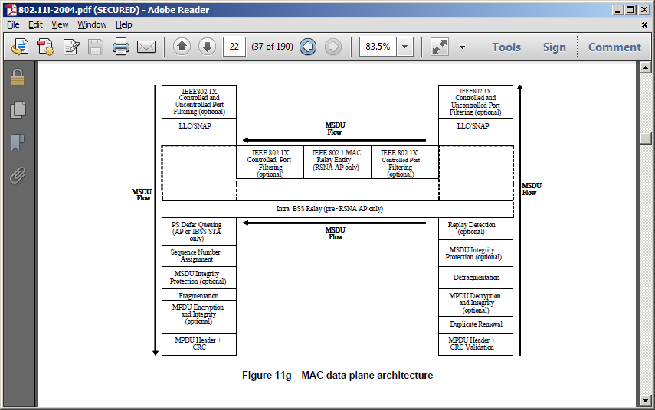

Note that the Figure from 802.11i has dotted lines around the empty boxes. Perhaps this was to indicate that these are not actually “there” in the architecture – that is that they serve no purpose – but that they are for diagraming purposes to indicate a notion of the adjacent boxes being all “connected as appropriate” or something similar.

A personal opinion: these empty boxes could be replaced by a “decision switch” in the flow, where the AP splits traffic that is destined for another associated STA from the traffic which is destined to either local upper layers or to the Distribution System.

But, then, can we simplify by simply saying that all frames are delivered (or accepted) either to (from) the local upper-layers (through the uncontrolled and controlled ports), or to the Distributeion Service (only through a controlled port)? If the frame is destined for another STA associated to the same AP, the Distribution Service does the trivial mapping and sends the frame back out the AP’s TX stack immediately. Any more complicated forwarding is handled by the DS. This is actually explicitly covered in the definition of Destination Service.

Thus, we can simplify the Figure to something like this:

A nice benefit of this visualization is that the major structure of the STA and MAC Entity are the same on both AP and non-AP STA. The only difference in the data plane is that the AP adds the Local switching function access to the DS (and the DS attachment itself). That is:

Note, that an AP also differs in the management plane, as it starts and controls the BSS and has some other unique features as detailed in the 802.11 Standard.
Now that we’ve removed the horizontal structure between the TX and RX sides of the “stack”, we can further simplify by aligning and merging the functions for each down/up (TX/RX) flow through the stack. Also, we can more easily show the extent of 802.11, and clarify the difference between AP and non-AP STA a bit:

Next, add RX and TX MSDU Rate Limiting, and Address 1 address filtering (they got lost somewhere in the above). Also add Packet Number assignment, to be complete compared to sequence number handling. And, move duplicate detection and replay detection to logical points in the stack.

In an attempt to make the “Non-AP STA vs AP” box more clear, replace that layer in the stack with a place-holder box, and describe the place-holder replacements for the non-AP, AP and mesh STA cases:

Lastly, here is a proposed view for the transparent FST case, to replace Figure 5-2:

Consider the above figure, in combination with a high-level overview of the larger WLAN system architecture, showing possible data plane paths for MSDUs:

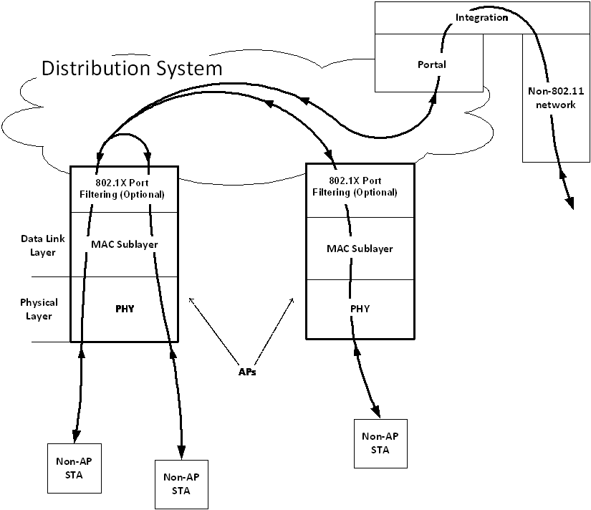

Questions for discussion:
- Is the MAC Service provided to the relay function (in the original figures) or the DS (in the new figures), the same as the MAC Service provided to LLC?
  - Proposed response: No. In fact, the MAC Service isn’t provided to the DS, it is provided to a selection function that decides between local and non-local destination. Non-local destination frames are passed to the DS via the Distribution System Service, which provides a different service from that provided by the MAC SAP. (See Annex R of IEEE 802.11-2012 for an informative discussion.)
- Does the above question change if the relay function is doing local forwarding (within the BSS) or using the DS to get to the recipient’s AP?
  - The new figure’s approach would say ‘no’, as all non-local frames are treated the same and delivered to the DS, which may immediately loop the frame back in the local forwarding case.
- How about the Portal case?
  - Here again, the DS is a homogeneous service, delivering MSDUs to and from the Portal in the same fashion as it does APs within the ESS.
- Is a Portal an 802 Bridge? Is the combination of AP, DS and Portal, a logical collection that together form an 802 Bridge?
  - None of the components mentioned (AP, DS or Portal) perform the functions described for an 802 bridge per 802.1Q. Therefore, No. Rather, since the operation of these components is transparent to LLC, it seems more natural to model the collection – functionally – as something slightly more than a single end station (because there are multiple MAC Addressable entities within the WLAN system) but less (that is, simpler) than a bridge.
  - Note that a WLAN system may use a bridged 802 network in the provisioning of its services. In particular, the DS explicitly can use any appropriate technology, including an 802 bridged network. This does not affect, nor it is reflected in the architecture, however, as it is left as an implementation option.
  - There is value in recognizing that a WLAN system is not a single end station. In particular, the work of 802.11 TGak and 802.1Qbz has the goal of supporting the optional integration of 802.11 network systems into 802 bridged networks for general use. This requires developing a model (which uses or maps to 802 terminology and concepts) to describe the WLAN system, and which accounts for quality of service, reliability and hop cost metrics unique to wireless. The nature of this modeling is still being debated.
- With the activities in TGak to add concepts of 802 Bridging to non-AP STAs (in an infrastructure BSS), do the APs also need concepts added to participate in the overall bridging architecture (including, for example, loop-detection)?
  - Per the above, this is TBD within TGak.
- Is the new visualization useful to see that a non-AP STA, when bridging is added (per TGak), adds something like the data plane elements shown as “Unique to AP”. However, such a STA does not add the management plane items of starting or controlling the BSS. This seems to be helpful to scope the nature of the changes needed. Of course, the Distribution System is replaced by a full 802 MAC Relay, per the 802.1Q Figures above, but the concepts have a logical mapping.
  - Also, TBD.
- The last proposal for a replacement Figure 5-1 shows a line that limits the 802.11 scope (to items below the line). In previous architecture discussions, such a limit of 802.11 scope was deemed limiting (particularly in the context of the Reference Model (5.7) discussion in IEEE 802.11-2007). Is this a concern for the new figure?
  - If this line is acceptable/desirable, is it in the right place? Note that the 802.1X PAC/SecY is “below” the line, but is arguably not in 802.11’s scope. Although, 802.11 somewhat defines its own Controlled/Uncontrolled port filtering, rather than strictly using 802.1X’s. This part of the figure may still be confusing and/or need work.
- Note the location of the MAC SAP (designed with “(M)” in the figure). It is well below the “top of the 802.11 stack.” But, also note that above it is only “switching/filtering” type operations, that don’t change the service provided. Is this acceptable/agreed?
- Are the function blocks shown in the “stack” a complete set (and at the appropriate level of detail)? Are they in the right order?
- How many Portals are there in a WLAN system? Zero or one, or can there be multiple? Can there be multiple only if they connect to distinct non-802.11 networks (not two points of access to the same (bridged) network)? (What does “distinct” actually mean in this context, and can we define it?) Care needs to be taken here, or we end up with routing table issues, or their equivalent.
- How can we incorporate the concept of a Mesh STA, Mesh Gate, IBSS STA, or other STA types into the figure? (Or should we try?)
Finally, once decisions are made on the above, consider any updates needed to 802.1Q’s text from 802.1Q-2011, describing mapping of 802.1Q concepts to 802.11 behaviors:

“6.7.2 Support by IEEE Std 802.11 (Wireless LAN)

The wireless LAN access method is specified in IEEE Std 802.11, 1999 Edition. Clause 7 of that standard
specifies frame formats, Clause 9 specifies the MAC sublayer function, and Clause 11 specifies the
mandatory MAC sublayer management function.

A Bridge to an IEEE 802.11 LAN shall connect to an IEEE 802.11 Portal, which in turn connects to an IEEE
802.11 Distribution System. For the purposes of bridging, the service interface presented at the Portal is
identical to the service interface presented at the IEEE 802.11 MAC SAP. An instance of an 8802-11
Distribution System can be implemented from IEEE 802 LAN components. IEEE 802.11 STAs attach to the
Distribution System via an IEEE 802.11 Access Point. A bridge shall not connect to an IEEE 802.11
Independent BSS. For a description of the IEEE 802.11 architecture, see Clause 5 of IEEE Std 802.11.

On receipt of an M_UNITDATA.request primitive, the portal constructs a MAC Service Data Unit and
passes it to the MAC Data service for transmission (in accordance with the frame formats and procedures
specified in IEEE Std 802.11 Clauses 6, 7, 9, and Annex C) using the parameters supplied as specified
below.

On receipt of a valid MAC Service Data Unit (see IEEE Std 802.11 Clauses 6, 7, 9, and Annex C), the portal
generates an M_UNITDATA.indication primitive with parameter values derived from the frame fields as
specified below.

When processing MSDU_from_LLC, the Type subfield of the Frame Control field specified in 7.1.3.1 of
IEEE Std 802.11 shall be encoded as Data in MAC frames (see Table 1 in IEEE Std 802.11).
The destination_address parameter is encoded in MAC frames as the DA described in Table 4 of 7.2.2 of
IEEE Std 802.11.

The source_address parameter is encoded in MAC frames as the SA described in Table 4 of 7.2.2 of IEEE
Std 802.11.

The mac_service_data_unit parameter is encoded in the Frame Body field (IEEE Std 802.11, 7.1.3.5) of
MAC frames. The length of the MSDU shall be _ 2304 octets. The length is not encoded in MAC frames;
rather, it is conveyed in the PHY headers.

The user_priority parameter is not encoded in MAC frames. The user_priority parameter provided in an
M_UNITDATA.indication primitive shall take the value of the Default_User_Priority parameter for the port
through which the MAC Service Data Unit was received. The default value of this parameter is 0, it may be
set by management, in which case the capability to set it to any of the values 0 through 7 shall be provided.
The Frame Check Sequence (FCS) field of MAC frames is calculated and encoded in accordance with IEEE
Std 802.11, 7.1.3.6.

No special action, above that specified in IEEE Std 802.11, is required for the support of the MAC Internal
Sublayer Service by the wireless LAN access method.”

