IEEE P802.11
Wireless LANs
Considerations on AP Architectural models
Date: 2013-01-13
Author(s):
Name | Affiliation | Address | Phone | email
Mark Hamilton | SpectraLink, Corp | 1765 W. 121st Ave  Westminster, CO 80234 | +1-720-872-7445 | Mark.hamilton@spectralink.com

Abstract
Some discussion topics and thoughts about 802.11 Access Points, Distribution Service and Portals, and how they could/should be modelled in the logical architecture.
Revision History
R0 – First revision. Jan13, 2013. With apologies for the low-tech pictures.
What is the architectural model for APs, the Distribution System, and Portals?

Are any of these acting as an 802 Bridge, or perhaps subset of function of a Bridge?

- 802.11 makes it clear that non-AP STAs, in an infrastructure BSS, provide the MAC Service to the LLC layer by transferring frames to the AP, which then forwards them to the recipient STA.
- If the recipient STA is associated to the same AP as the originating STA, the AP forwards the frame directly, using an internal relay facility.
- If the recipient STA is associated to another AP in the same ESS, the AP forwards the frame via the Distribution System to the AP that has the recipient associated, and that AP forwards the frame to the recipient STA.
- If the recipient STA is outside the ESS, but on another integrated 802 network, the frame is forwarded via the DS to a portal, and the portal uses the integration service to pass the frame to the non-802.11 LAN.
- All the above is transparent to the MAC user (LLC or equivalent) – this is explicit in the 802.11 text.

Many of these concepts are the same, or similar, in 802 Bridges. Also note that the 802.1 Standards that define Bridges recognize that the MAC service provided to “end users” (LLC) is slightly different than that provided to intermediate nodes that need to do frame forwarding (Bridges).

From 802.1AC, 7.6(MAC Service clients):
The protocol entity that uses the service provided at a MAC Service access point (MSAP) is commonly referred to as the client of the MAC Service or of the entity providing the service. Within a Bridge, the MAC Relay Entity is a client of the Internal Sublayer Service (ISS), and the Logical Link Control (LLC) Entity is a client of the MAC Service. The LLC Entity is specified in ISO/IEC 8802.2 and provides protocol identification, multiplexing, and demultiplexing to and from a number of clients that use a common MSAP.

However, 802 Bridges also perform other functions beyond just frame forwarding, including topography management actions (learning, loop-prevention, etc.). These are not (currently) specified in 802.11 APs, DS, or Portals.

Further, consider the relationship of 802.1X security models to 802.11…

From 802.1X-2010, the basic model of the ports, and entities involved in providing the security service looks like this:
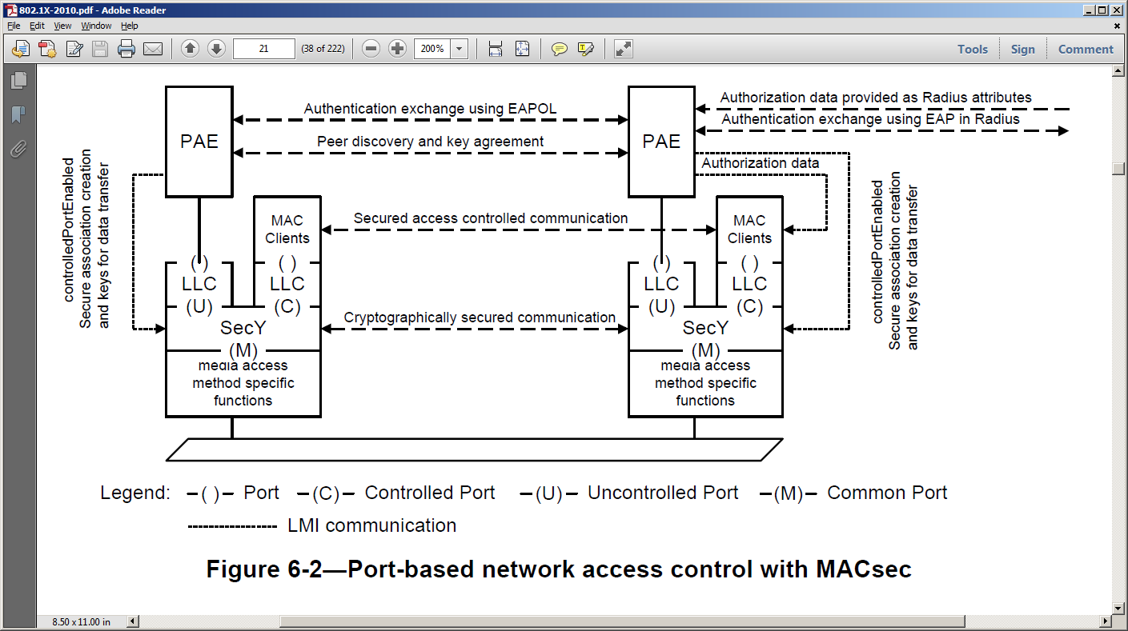
To accommodate Bridges, the model is enhanced at a Bridge Port:

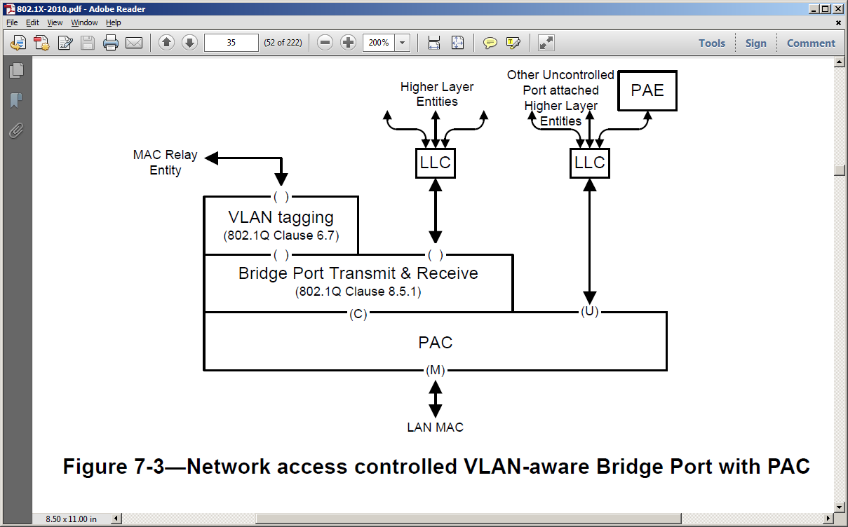
In these models (from 802.1X), the difference between the MAC Service provided to an end user (LLC) is not clearly shown as different from the service provided to a relay/forwarding function.

We look to 802.1D-2004 for these differences to appear in the modelling.

General model structure for Bridges from 802.1D-2004:

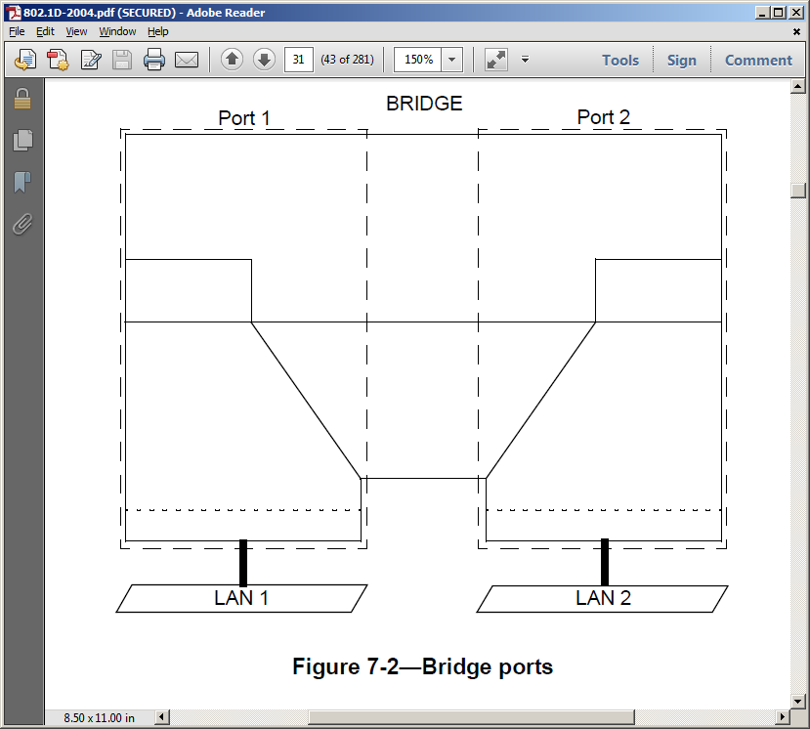

Structure filled in with service boundaries and entities labelled (note the MAC Service vs. the Internal Sublayer Service):

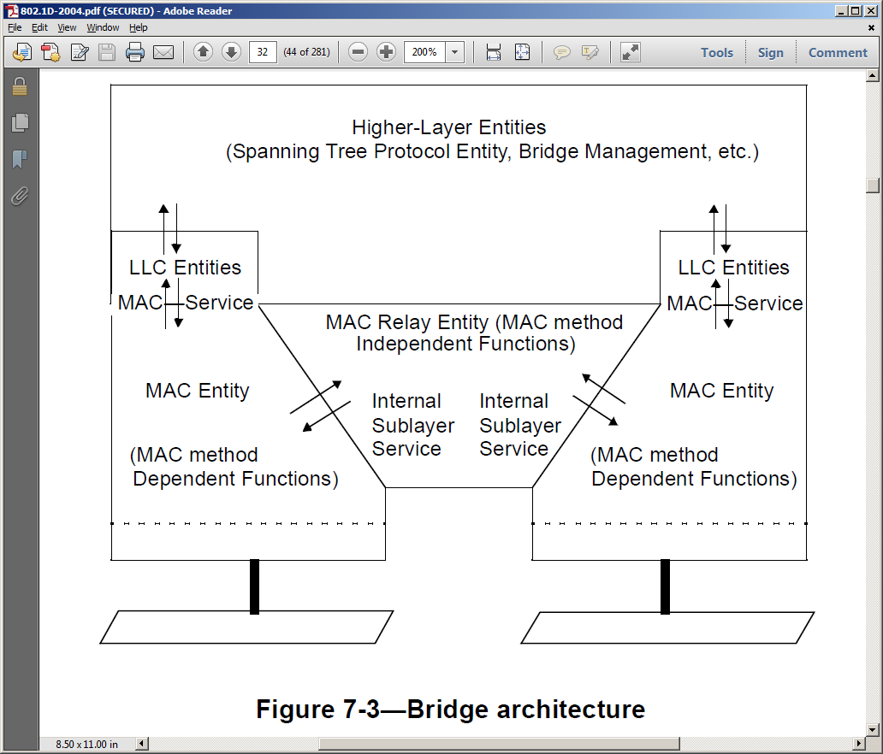

In another Figure, note the “Forwarding Process” and its associated information/databases to support the forwarding:

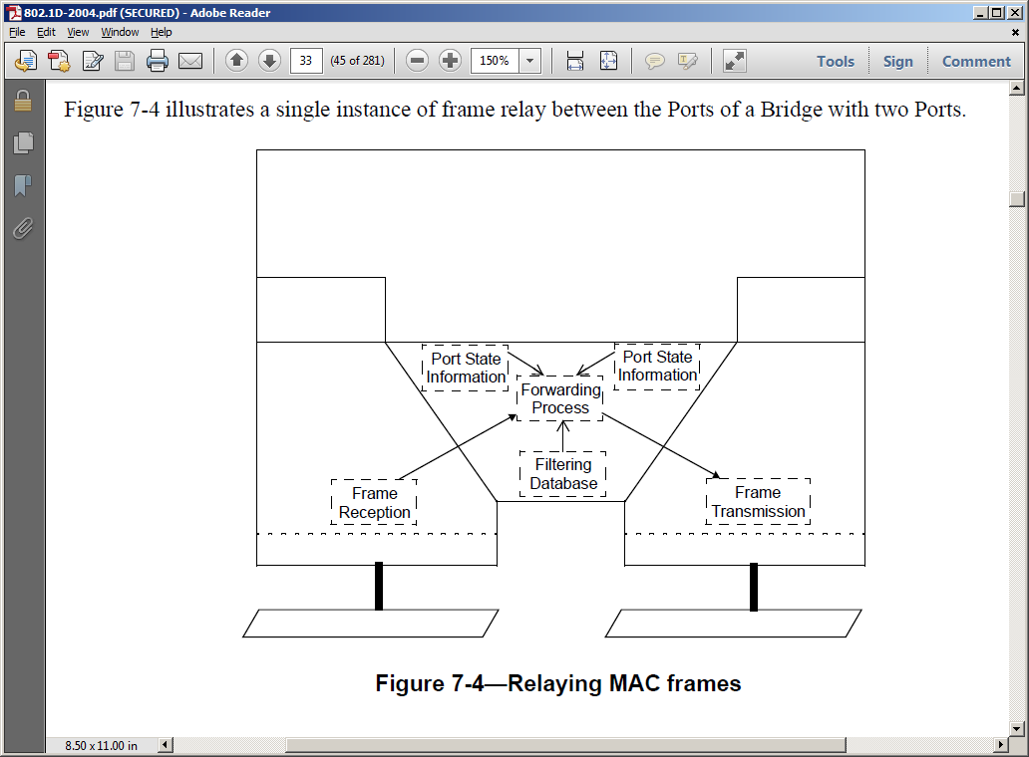

Surely, an AP/DS/Portal combination, to provide the MAC Service operation transparently to LLC, must do the same functions.

802.11-2012 models an AP thus (note the 802.1X port filtering in conjunction with the relay function):

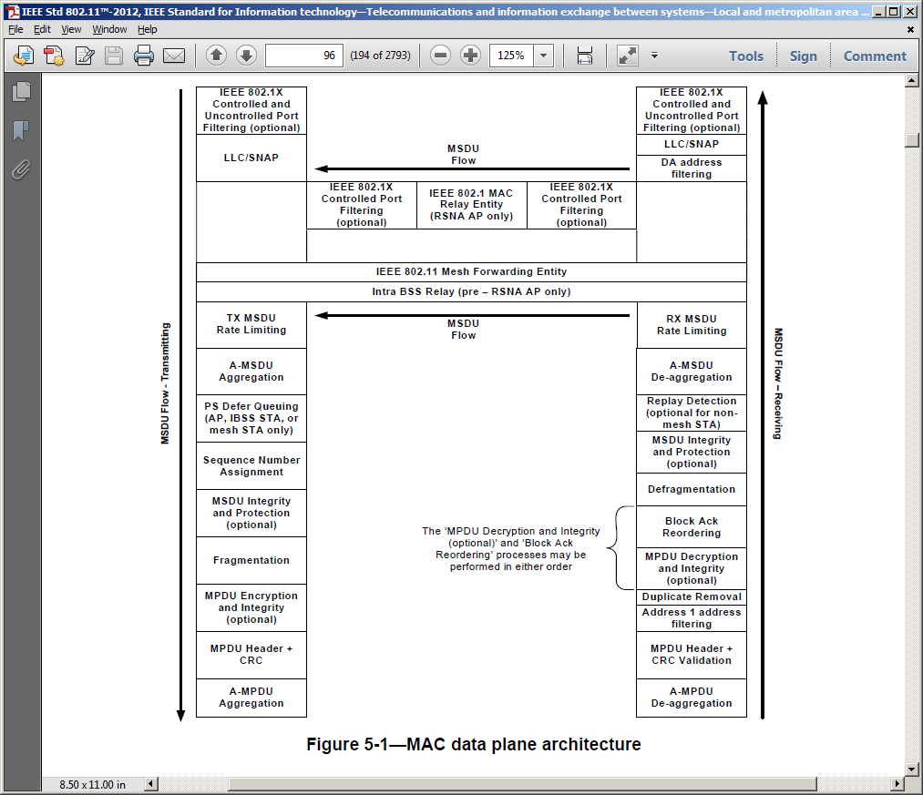

802.11 does not have a model for an AP that also shows the DS, and how the relay function accomplishes frame forwarding between BSSs within an ESS.

In prior discussions and submissions, this model of an 802.11 STA (AP or non-AP) has been incorporated into 802 O&A:

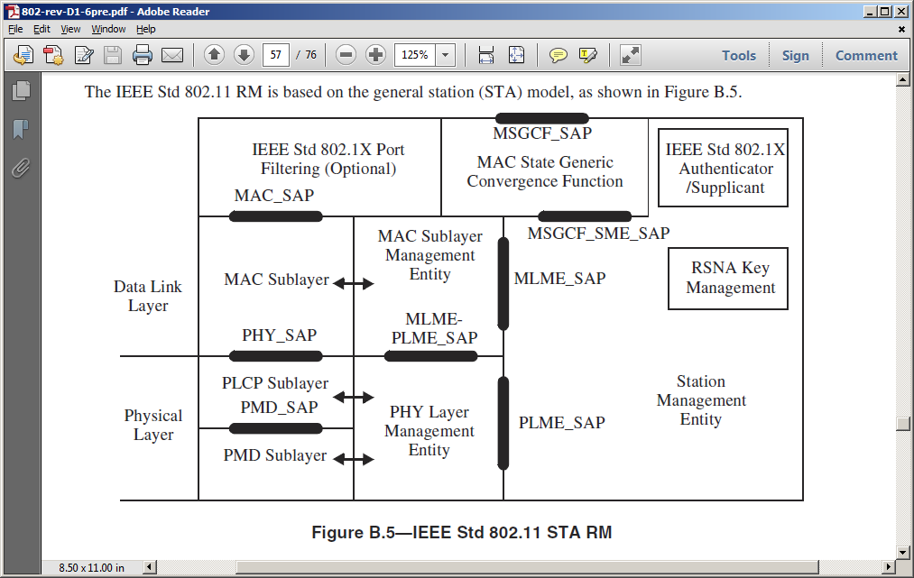

In an attempt to expand this model of a STA to specifically address the unique features of an AP’s STA, the model was enhanced with frame flow arrows, somewhat similar to those in Figure 5-1 (above), but also including that these flows might be within the AP, might be across the DS, or might be to and through a Portal:

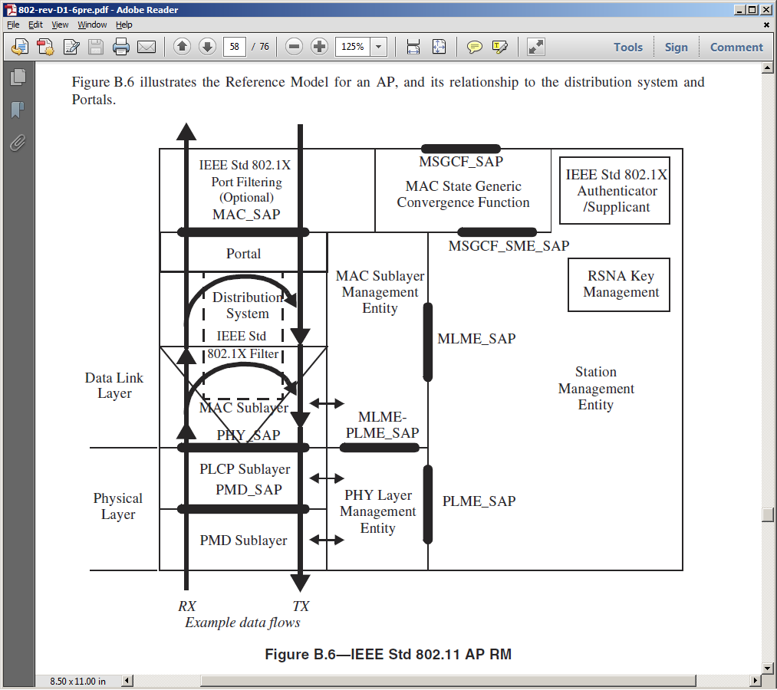

It is generally agreed that this model is too complicated to understand what the flows are trying to demonstrate.

A suggestion has been to split the model, showing a single AP’s STA, basically Figure B.5 above, with the local relay function added and shown with frame flow arrows. Then, show two APs, separated by a DS, providing frame forwarding between two STAs associated to an ESS. Finally, show an AP, DS and Portal, showing the frame forwarding to/from an integrated non-802.11 LAN.

Questions for discussion:
- Is the MAC Service provided to the relay function, the same as the MAC Service provided to LLC?
- Does the above question change if the relay function includes using the DS to get to the recipient’s AP?
- How about the Portal case?
- Is a Portal an 802 Bridge? Is the combination of AP, DS and Portal, a logical collection that together is an 802 Bridge?
- With the activities in TGak to add concepts of 802 Bridging to non-AP STAs (in an infrastructure BSS), do the APs also need concepts added to participate in the overall bridging architecture (including, for example, loop-detection)?

