IEEE P802.11
Wireless LANs
GAS Configuration sequence number-Normative-Text
Date: 2013-01-13
Author(s):
Name | Affiliation | Address | Phone | email
Lin Cai | Huawei Inc.
Eric Zhang | Huawei Inc.
George Calcev | Huawei Inc.
Abstract
This submission is a resolution to the comments #22, 58, 61.

This amendment’s baseline is P802.11ai D0.2

8.4.2.177 GAS configuration sequence number element
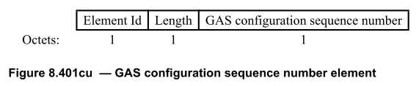
The Element Id is equal to the GAS configuration sequence number element value in Table 8-54.
The value of the Length field is a 1-octet field with a value of 1.
The GAS configuration sequence number field contains a 1-octet unsigned integer. It indicates the version number of AP’s GAS configuration information set and monotonically increment as described in 10.24.3. The AP’s GAS configuration information set refers to the information elements which can be acquired by GAS query.

10.24 WLAN interworking with external networks procedures
10.24.3 Interworking procedures: generic advertisement service (GAS)
Insert the following text at the end of 10.24.3:

The GAS configuration version number element may be included in Beacon or probe response to optimize GAS message exchange when dot11InterworkingServiceActivated is true. AP support this element shall monotonically increment the value of GAS configuration version number field by 1, when there is one or more changes in any information element or subelement in Table 8-175.

If the current received GAS configuration sequence number equals to the stored value of GAS configuration sequence number of the same AP, the STA shall not initiate a GAS query request to the AP and shall use the stored GAS information instead.

