IEEE P802.11
Wireless LANs
Higher Layer Packet Container Proposal Text
Date: 2013-03-18
Author(s):
Name | Affiliation | Address | Phone | email
Hitoshi Morioka | Allied Telesis R&D Center | 2-14-38 Tenjin, Chuo-ku, Fukuoka 810-0001 JAPAN | +81 92 771 7630 | hmorioka@root-hq.com
Hiroki  Nakano | Trans New Technology, Inc. | Sumitomo Seimei Kyoto Bldg. 8F, 62 Tukiboko-cho, Shimogyo, Kyoto 600-8492 JAPAN | +81-75-213-1200 | cas@trans-nt.com
Abstract
This document is a proposed normative text for the TGai draft and addresses higher layer setup.

2. Normative References

Insert the following new definitions into clause 2:

IETF RFC 826, An Ethernet Address Resolution Protocol -- or -- Converting Network Protocol Addresses to 48.bit Ethernet Address for Transmission on Ethernet Hardware, David C. Plummer, Nov. 1982.
IETF RFC 2131, Dynamic Host Configuration Protocol, R. Droms, Mar. 1997.
IETF RFC 4039, Rapid Commit Option for the Dynamic Host Configuration Protocol version 4 (DHCPv4), S. Park, Mar. 2005.
IETF RFC 4861, Neighbor Discovery for IP version 6 (IPv6), T. Narten, Sep. 2007.
IETF RFC 4862, IPv6 Stateless Address Autoconfiguration, S. Thomson, Sep. 2007.
IETF RFC 5227, IPv4 Address Conflict Detection, S. Cheshire, Jul. 2008.

3. Definitions, acronyms and abbreviations

3.2 Definitions specific to IEEE802.11

Insert the following new definitions into clause 3 in alphabetical order:

Higher Layer Packet (HLP): A packet used in the layer higher than IEEE802.11 MAC layer.

6. Layer management

6.3 MLME SAP interface

6.3.3 Scan

6.3.3.3 MLME-SCAN.confirm

6.3.3.3.2 Semantics of the service primitive

Insert the following row to the BSSDescriptionFromFDSet:

Name | Type | Valid Range | Description
HLP Max Wait Time | Integer | 1-100 | The maximum time for AP to wait HLP in unit of millisecond.  The parameter is present only if dot11HLPTransportDuringAssocActivated is true.

6.3.7 Associate

6.3.7.2 MLME-ASSOCIATE.request

6.3.7.2.2 Semantics of the service primitive

Change the primitive parameter list in 6.3.7.2.2 as shown:

MLME-ASSOCIATE.request(
PeerSTAAddress,
AssociateFailureTimeout,
CapabilityInformation,
ListenInterval,
Supported Channels,
RSN,
QoSCapability,
Content of FT Authentication elements,
SupportedOperatingClasses,
HT Capability,
Extended Capability,
20/40 BSS Coexistence,
QoSTrafficCapability,
TIMBroadcastRequest,
EmergencyServices,
HLP Wait Time,
HLP Container,
VendorSpecificInfo
)

Insert the following row before the VendorSpecificInfo row of the untitled table defining the primitive parameters in 6.3.7.2.2:

Name | Type | Valid range | Description
HLP Wait Time | Integer | 1-100 | The time for AP to wait HLP in unit of millisecond.  The parameter is present only if dot11HLPTransportDuringAssocActivated is true.
HLP Container | As defined in frame format | As defined in 8.x.x (HLP Container element) | This field is used for transporting higher layer packets in FILS association.  The parameter is present only if dot11HLPTransportDuringAssocActivated is true.

6.3.7.3 MLME-ASSOCIATE.confirm

6.3.7.3.2 Semantics of the service primitive

Change the primitive parameter list in 6.3.7.3.2 as shown:

MLME-ASSOCIATE.confirm(
ResultCode,
CapabilityInformation,
AssociationID,
SupportedRates,
EDCAParameterSet,
RCPI.request,
RSNI.request,
RCPI.response,
RSNI.response,
RMEnabledCapabilities,
Content of FT Authentication elements,
SupportedOpeartiongClasses,
DSERegisteredLocation,
HT Capabilities,
Extended Capabilities,
20/40 BSS Coexistence,
TimeoutInterval,
BSSMaxIdlePeriod,
TIMBroadcastResponse,
QoSMapSet,
HLP Container,
VendorSpecificInfo
)

Insert the following row before the VendorSpecificInfo row of the untitled table defining the primitive parameters in 6.3.7.3.2:

Name | Type | Valid range | Description
HLP Container | As defined in frame format | As defined in 8.x.x (HLP Container element) | This field is used for transporting higher layer packets in FILS association.  The parameter is present only if dot11HLPTransportDuringAssocActivated is true.

6.3.7.4 MLME-ASSOCIATE.indicate

6.3.7.4.2 Semantics of the service primitive

Change the primitive parameter list in 6.3.7.4.2 as shown:

MLME-ASSOCIATE.indicate(
PeerSTAAddress,
CapabilityInformation,
ListenInterval,
SSID,
SupportedRates,
RSN,
QoSCapability,
RCPI,
RSNI,
RMEnabledCapabilities,
Content of FT Authentication elements,
SupportedOperatingClasses,
DSERegisteredLocation,
HT Capability,
Extended Capability,
20/40 BSS Coexistence,
QoSTrafficCapability,
TIMBroadcastRequest,
EmergencyServices,
HLP Wait Time,
HLP Container,
VendorSpecificInfo
)

Insert the following row before the VendorSpecificInfo row of the untitled table defining the primitive parameters in 6.3.7.4.2:

Name | Type | Valid range | Description
HLP Wait Time | Integer | 1-100 | The time for AP to wait HLP in unit of millisecond.  The parameter is present only if dot11HLPTransportDuringAssocActivated is true.
HLP Container | As defined in frame format | As defined in 8.x.x (HLP Container element) | This field is used for transporting higher layer packets in FILS association.  The parameter is present only if dot11HLPTransportDuringAssocActivated is true.

6.3.7.5 MLME-ASSOCIATE.response

6.3.7.5.2 Semantics of the service primitive

Change the primitive parameter list in 6.3.7.5.2 as shown:

MLME-ASSOCIATE.response(
PeerSTAAddress,
ResultCode,
CapabilityInformation,
AssociationID,
EDCAParameterSet,
RCPI,
RSNI,
RMEnabledCapabilities,
Content of FT Authentication elements,
SupportedOpeartiongClasses,
DSERegisteredLocation,
HTCapabilities,
Extended Capabilities,
20/40 BSS Coexistence,
TimeoutInterval,
BSSMaxIdlePeriod,
TIMBroadcastResponse,
QoSMapSet,
HLP Container,
VendorSpecificInfo
)

Insert the following row before the VendorSpecificInfo row of the untitled table defining the primitive parameters in 6.3.7.5.2:

Name | Type | Valid range | Description
HLP Container | As defined in frame format | As defined in 8.x.x (HLP Container element) | This field is used for transporting higher layer packets in FILS association.  The parameter is present only if dot11HLPTransportDuringAssocActivated is true.

8. Frame formats

8.3 Format of individual frame types

8.3.3 Management Frames

8.3.3.2 Beacon frame format

Insert the following rows to the contents of Table 8-20:

Order | Information | Notes
<ANA> | HLP Max Wait Time | The HLP Max Wait Time element is present if dot11HLPTransportDuringAssocActivated is true.

8.3.3.5 Association Request frame format

Insert the following rows to the contents of Table 8-22:

Order | Information | Notes
<ANA> | HLP Wait Time | The HLP Wait Time element is present if dot11HLPTransportDuringAssocActivated is true.
<ANA> | HLP Container | The HLP Container element is present if dot11HLPTransportDuringAssocActivated is true.

8.3.3.6 Association Response frame format

Insert the following rows to the contents of Table 8-23:

Order | Information | Notes
<ANA> | HLP Container | The HLP Container element is present if dot11HLPTransportDuringAssocActivated is true.

8.3.3.10 Probe Response frame format

Insert the following rows to the contents of Table 8-27:

Order | Information | Notes
<ANA> | HLP Max Wait Time | The HLP Max Wait Time element is present if dot11HLPTransportDuringAssocActivated is true.

8.3.3.11 Authentication frame format

Insert the following rows to the contents of Table 8-28:

Order | Information | Notes
<ANA> | HLP Container | The HLP Container element is present if dot11HLPTransportDuringAssocActivated is true.

8.4 Management frame body components

8.4.2 Information elements

8.4.2.1 General

Insert the following rows to the contents of Table 8-54:

Element | Element ID | Length of indicated element (in octets) | Extensible
HLP Max Wait Time | ANA | 3
HLP Wait Time | ANA | 3

Insert the following new subclauses into clause 8.4.2:

8.4.2.a HLP Max Wait Time element

The HLP Max Wait Time element contains the maximum duration that the AP is allowed to wait HLP(s) after the AP receives Association Request. This element is transmitted in Beacon and Probe Response. The element format is shown in Figure 8-b.

 | Element ID | Length | Max Wait Time
Octets: | 1 | 1 | 1

Figure 8-b – HLP Max Wait Time element format

The Element ID field is equal to the HLP Max Wait Time value in Table 8-54 (Element IDs).

The value of the Length field is 1.

The value of the Max Wait Time field is dot11HLPMaxWaitTime in unit of millisecond.

8.4.2.c HLP Wait Time element

The HLP Wait Time element contains the duration that the non-AP STA requests the AP to wait for HLP(s). The duration is measured from the AP receives Association Request to the AP transmits Association Response. This element is transmitted in Association Request. The element format is shown in Figure 8-d.

 | Element ID | Length | Wait Time
Octets: | 1 | 1 | 1

Figure 8-d – HLP Wait Time element format

The Element ID field is equal to the HLP Wait Time value in Table 8-54 (Element IDs).

The value of the Length field is 1.

The value of the Max Time field is dot11HLPWaitTime in unit of millisecond.

Insert the following new subclauses into clause 8x.x (Secure Container):

8.x.x HLP Container element

The HLP Container element contains higher layer packets which non-AP STA intends to transfer during association. This element is transmitted in Association Request and Association Response and includes higher layer packets to be transferred. This element must be encapsulated by the Secure Container (refer x.x.x.x).

 | Element  ID | Length | Destination MAC Address
Octets: | 1 | 2 | 6
 | Source MAC Address |  |  | LLC/SNAP | HLP
Octets: | 6 |  |  | variable | variable

Figure 8-f –HLP Container element format

The Element ID field is equal to the HLP Container value in Table 8-54 (Element IDs).

The value of the Length field is 15 plus LLC/SNAP header length and HLP length.

The value of Destination MAC Address field is the destination MAC address of the HLP.

The value of Source MAC Address field is the source MAC address of the HLP.

The value of LLC/SNAP field is the LLC header and SNAP header (if applicable) of the HLP.

The HLP field contains the HLP to be transferred.

If the STA intends to transmit multiple HLPs, the STA constructs multiple HLP Container elements for each HLP.

10. MLME

Insert the following new subclause into clause 10:

10.k FILS higher layer packets transport during association

10.k.1 General

This subclause describes the procedures that provide higher layer packets transport capability during association in FILS.

10.k.2 FILS higher layer packets transport during association procedure

If dot11HLPTransportDuringAssocActivated is true, the AP transmits beacons and probe responses which include HLP Max Wait Time element with the value of dot11HLPMaxWaitTime.

If the non-AP STA receives HLP Max Wait Time element, the non-AP STA selects the value of dot11HLPWaitTime. The value of dot11HLPWaitTime shall be less than dot11AssociationResponseTimeOut and less than or equal to dot11HLPMaxWaitTime.

After exchanging FILS authentication frames, the non-AP STA may transmit HLP Wait Time element with the value of dot11HLPWaitTime and higher layer packets in HLP Container elements in Association Request as described in 8.4.2.c and 8.x.x.

When the AP receives Association Request including HLP Container elements, the AP decapsulates the HLP(s) as described in 8.x.x. The AP must not transfer the HLP(s) until the key confirmation (refer 11.11.2.4) by the AP is completed. After successful key confirmation, the AP forwards the HLP(s) to the uplink. If the key confirmation fails, the AP silently discards the HLP(s).

If the AP receives HLP(s) from the uplink before dot11HLPWaitTime passes after AP receives from non-AP STA the corresponding HLP(s) conveyed by Association Request, the AP encapsulates the HLP(s) into Association Response by HLP Container elements and transmits to the STA.

When the non-AP STA receives Association Response with HLP Container elements, the non-AP STA decapsulates the HLP(s) and generates MA-UNITDATA.indication primitive for each HLP(s).

Annex C

C.3 MIB Detail

Insert the following new items into clause C.3

Dot11StationConfigEntry ::= SEQUENCE
{
...
dot11HLPTransportDuringAssocActivated TruthValue,
dot11HLPWaitTime Unsigned32,
dot11HLPMaxWaitTime Unsigned32,
}

...

dot11HLPTransportDuringAssocActivated OBJECT-TYPE
SYNTAX TruthValue
MAX-ACCESS read-write
STATUS current
DESCRIPTION
“This is a control variable.
It is written by an external management entity.
Changes take effect for the next MLME-ASSOCIATE.request primitive.

This attribute, when true, indicates that the capability of the station
to be enabled HLP transport during association.”
DEFVAL { false }
::= {dot11StationConfigEntry n}

dot11HLPWaitTime OBJECT-TYPE
SYNTAX Unsigned32
MAX-ACCESS read-write
STATUS current
DESCRIPTION
“This is a control variable.
It is written by an external management entity.
Changes take effect for the next MLME-ASSOCIATE.request primitive.

This attribute specifies the HLP wait time to request.”
”
DEFVAL { 30 }
::= {dot11StationConfigEntry n+1}

dot11HLPMaxWaitTime OBJECT-TYPE
SYNTAX Unsigned32
MAX-ACCESS read-write
STATUS current
DESCRIPTION
“This is a control variable.
It is written by an external management entity.
Changes take effect for the next MLME-START.request primitive.

This attribute specifies the maximum HLP wait time.”
”
DEFVAL { 30 }
::= {dot11StationConfigEntry n+2}

Add new clause Annex x:

Annex x

(informative)

Example usage of FILS HLP transport during Association

x.1 DHCPv4

x.1.1 With Rapid Commit Option

By using DHCPv4 with Rapid Commit Option (RCO), IP layer can be configured in one round-trip packet exchange between a STA and a DHCP server. So it is recommended for FILS.

In this case, DHCP messages should be carried by HLP Container element in Association Request and Response as shown in Figure x-1.

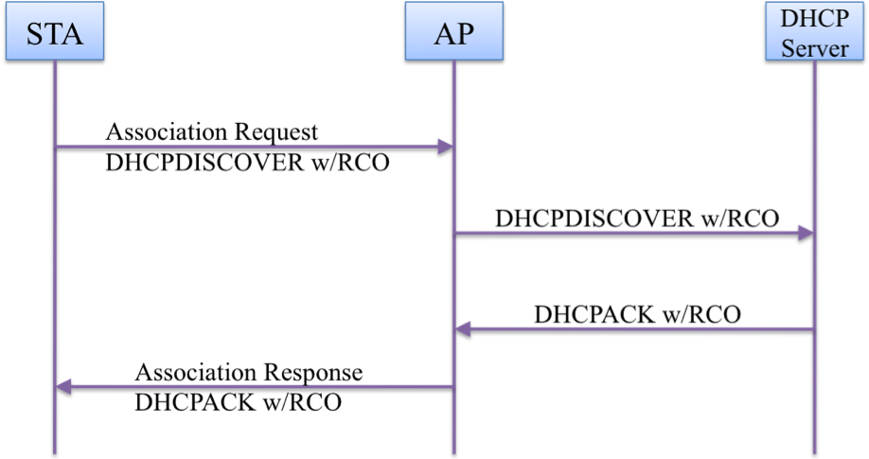
Figure x-1---- Example FILS HLP transport during association usage for DHCPv4 with Rapid Commit Option

x.1.2 Without Rapid Commit Option

In case of DHCPv4 without Rapid Commit Option, it takes two round-trip packet exchanges between a STA and a DHCP server to configure IP layer.

In this case, the first one round-trip DHCP messages should be carried by HLP Container element in Association Request and Response as shown in Figure x-2.

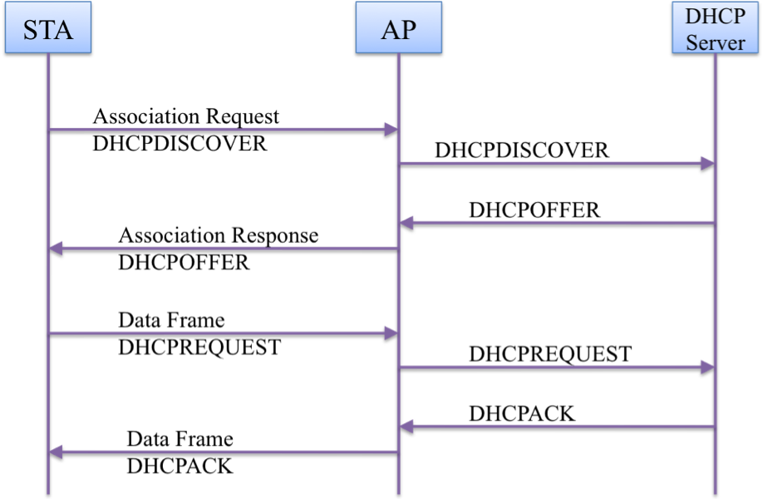
Figure x-2---- Example FILS HLP transport during association usage for DHCPv4 without Rapid Commit Option

x.2 IPv6 Stateless Address Autoconfiguration

In case of using IPv6 Stateless Address Autoconfiguration, Router Solicitation and Router Advertisement should be carried by FILS HLP transport during association as shown in Figure x-3.

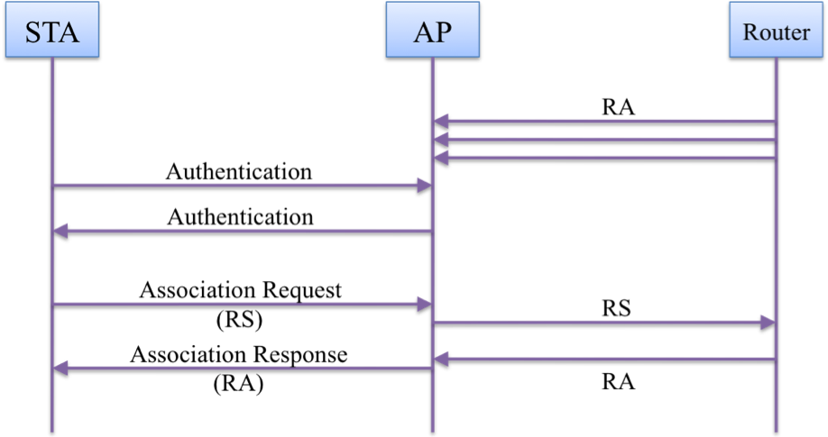
Figure x-3---- Example FILS HLP transport during association usage for IPv6 Stateless Address Autoconfiguration

x.3 ARP

To reduce ARP packet exchange, AP should transmit Gratuitous ARP packet of link-local nodes (e.g. gateway, DNS server) by FILS HLP transport during association as shown in Figure x-4.

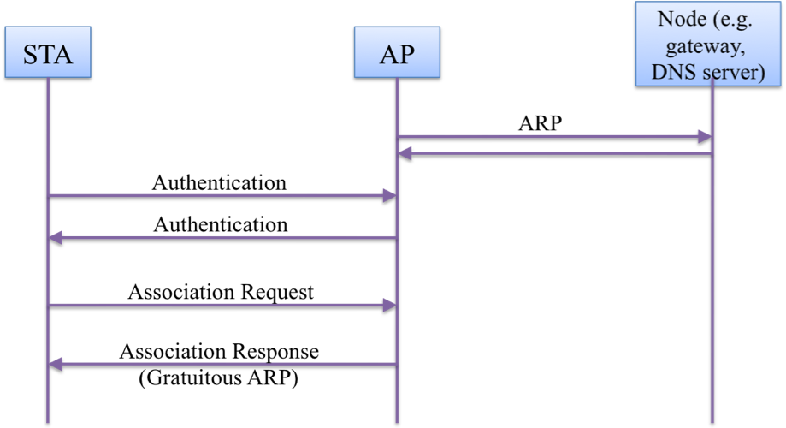
Figure x-4---- Example FILS HLP transport during association usage for ARP

x.4 NDP

To reduce NDP packet exchange, AP should transmit NA packet of link-local nodes (e.g. DNS server) by FILS HLP transport during association as shown in Figure x-5.

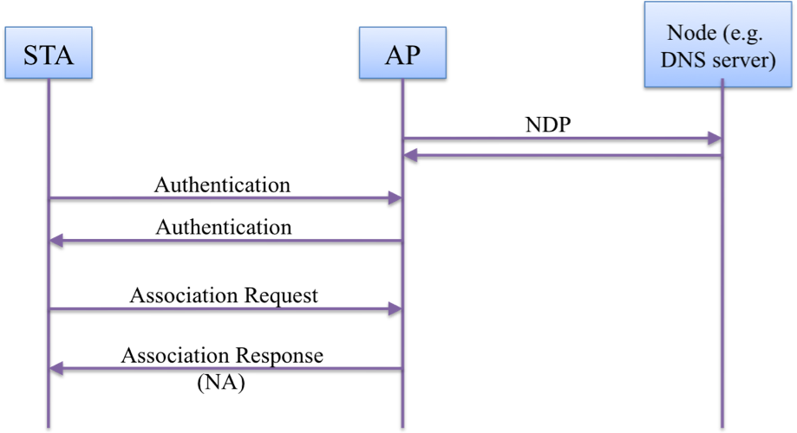
Figure x-5---- Example FILS HLP transport during association usage for NDP

