IEEE P802.11
Wireless LANs
802.11 TGac WG Letter Ballot LB190
Proposed resolutions to comments on clause 9.12
Date: 2012-11-12
Author(s):
Name | Company | Address | Phone | email
Eric Wong | Broadcom Corporation | 190 Mathilda Place, Sunnyvale, CA 94086 | +1 408 922 6672 | ewong@broadcom.com
Abstract
This submission contains proposed comment resolutions to comments received during WG letter ballot 190.

The MAC comments assigned to the author in Clause 9.12 are:

7140, 7254, 7346, 7347, 7348

The changes marked in this document are based on TGac Draft 4.0.

Revision Notes

R0 | Initial revision
R1 | After discussion with the group, except 7346 and 7347. CID 7346 approved by strawpoll, but not motioned.
R2 | Resolution for CID 7347

Comments for Clause 9.12.2

CID 7254
7254 | 140.11 | 9.12.2 | HT_MF PPDU or HT_GF PPDU are not defined (HT PPDU is). There also appears to be no reason to use these terms here. | Replace "HT_MF PPDU or HT_GF PPDU" with "HT PPDU".  If it is important to distinguish between MF and GF (doesn't appear to be the case here), use "HT PPDU with FORMAT equal to HT_MF", ...  Similar comment on line 35, page 140, line 9, page 141, line 18, page 142 | MAC

Discussion:
Agree with commenter that both HT_MF PPDU and HT_GF PPDU terms are not defined. Furthermore, the definition of HT PPDU includes both HT_MF and HT_GF. Please see excerpt from IEEE 802.11 REVmb 12.0.

“high-throughput (HT) physical layer convergence procedure (PLCP) protocol data unit (PPDU): A
Clause 20 PPDU with the TXVECTOR FORMAT parameter equal to HT_MF or HT_GF.”

Proposed resolution:
Accept. Please see changes in 11-12/1316r0 for CID 7254.

Instruction to Editor:
Please make the following changes in TGac D4.0 P140L8 under subclause 9.12.2.
An HT STA and a DMG STA indicates a value in the Maximum A-MPDU Length Exponent field in its HT
Capabilities element or DMG Capabilities element, respectively, that defines the maximum A-MPDU length
that it can receive in an HT PPDU.

Please make the following changes in TGac D4.0 P140L14 under subclause 9.12.2.
The encoding of this fieldthese fields is defined in Table 8-125 (Subfields of the A-MPDU Parameters field) for an HT STA HT PPDU, in Table 8-183u (Subfields of the VHT Capabilities Info field) for a VHT PPDU and in Table 8-183f for a DMG STA.

Please make the following changes in TGac D4.0 P140L35 under subclause 9.12.2.
An HT STA and a DMG STA shall not transmit an A-MPDU in an HT PPDU that is longer
than the value indicated by the Maximum A-MPDU Length Exponent field in the HT Capabilities element
received from declared by the intended receiver.

Please make the following changes in TGac D4.0 P141L8 under subclause 9.12.3.
is the value of the PHY Data Rate (in megabits per second) defined in Clause 21 for a DMG
STA, and for an HT STA defined in 20.6 (Parameters for HT MCSs) for
HT PPDUs and in 22.5 (Parameters for VHT-MCSs) for VHT PPDUs based on the TXVECTOR
parameters: MCS, GI_TYPE, and CH_BANDWIDTH

Please make the following changes in TGac D4.0 P142L18 under subclause 9.12.5.
MPDUs in an A-MPDU carried in an HT PPDU shall be limited to a maximum length of 4095
octets.

Please make the following changes in TGac D4.0 P221L53 under subclause 22.2.4.3.
As defined in 22.3.21 (PHY receive procedure), once a PPDU is received and detected as an
HT PPDU,

Comments for Clause 9.12.6

CID 7346
7346 | 142.39 | 9.12.6 | "A-MPDU subframes with 0 in the MPDU Length field" is not sufficiently precise | Add "and 0 in the EOF field" | MAC

Discussion:
An A-MPDU pre-EOF padding (see 9.12.2 (A-MPDU length limit rules)) is constructed for each user from
any of the following:
— A-MPDU subframes constructed from the MPDUs available for transmission that have a TID value
that maps to the primary AC
— A-MPDU subframes with 0 in the MPDU Length field and 0 in the EOF field.

Proposed resolution:
Accept.

CID 7347
7347 | 142.49 | 9.12.6 | "TXOP duration limits (see 9.19.2.2 (EDCA TXOPs)) for the primary AC" -- 1) "for the primary AC" could be read as meaning that you can violate the primary AC's TXOP Limit as long as your A-MPDU just has stuff from secondary ACs and 2) if the APEP exactly fits in the TXOP Limit then any last subframe/EOF pad could cause the TXOP Limit to be violated | Reword | MAC

Discussion:
Two issues are raised in this CID

- for the primary AC" could be read as meaning that you can violate the primary AC's TXOP Limit as long as your A-MPDU just has stuff from secondary ACs

This comment brought up a situation where there are only secondary ACs frames, but no frames from the primary AC. In addition, the secondary AC may have a smaller TXOP limit than that of primary AC. As a result, the secondary AC may violate the secondary AC TXOP limit.

Based on the quoted text on “Sharing an EDCA TXOP”, there must be traffic on the primary AC for TXOP sharing to be allowed. So the situation of having just secondary ACs traffic is not permitted.

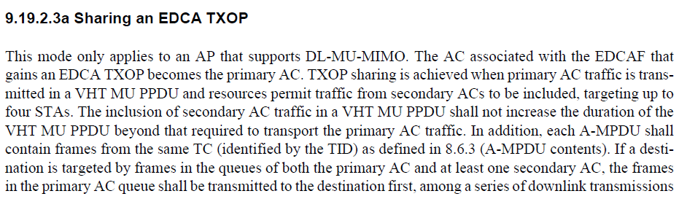

- if the APEP exactly fits in the TXOP Limit then any last subframe/EOF pad could cause the TXOP Limit to be violated
This would not happen because of the statement “each added subframe and the complete A-MPDU meet all the following” in D4.0 P142L40, and it says the TXOP limit applies to the complete A-MPDU that includes the subframe and EOF pad octets.

Proposed resolution:
Reject. The situation of just secondary ACs is not allowed under current TXOP sharing rules, since the primary AC must have traffic for the TXOP to be shared. The situation of exceeding TXOP limit by subframe/pad octets is already covered by text in the current subclause.

CID 7348
7348 | 143.39 | 9.12.6 | "pad octet" -- there might be more than one | Change to "pad octet(s)" (twice) | MAC

Discussion:
Agree with commenter.

Proposed resolution:
Revise. Please see changes in 11-12/1316r1 for CID 7348.

Instruction to Editor:
Please make the following changes in TGac D4.0 P143L39 under subclause 9.12.6.
The values of each subframe pad octet and each EOF pad octet are unspecified.

Comments for Clause 9.12.8

CID 7140
7140 | 144.04 | 9.12.8 | "necessary" is a vague "shall", which does not appear to be intended. | Replace "necessary" with "needed". | MAC

Discussion:
Agree with commenter.

— A data MPDU could indicate an Ack Policy of “Normal Ack”, which solicits an ACK immediate response. No
Block Ack agreement is needed in this case (see 8.2.4.5.4 (Ack Policy subfield)).

Proposed resolution:
Accept.

