IEEE P802.11
Wireless LANs
Suggested edits to the combined text for Active Scanning
Date: 2012-11-13
Author(s):
Name | Affiliation | Address | Phone | email
Jing-Rong Hsieh | HTC Corp. | 1F, 6-3 Baoqiang Road, Xindian district, New Taipei City, Taiwan |  | jing_hsieh@htc.com
Abstract
The submission provides suggested edits to the normative text for active scanning to implement the requirements of the SFD.

The submission implements the Specification Framework document requirements under subsection 6.2.6 Omission of Probe Response.

Instructions to Editor:
The submission includes the text of active scanning clauses
- 8.4.2.174 FILS Request Parameters element
- 10.1.4.3.5 Criteria to respond to probe request

Introduction
- In TGai SFD [Ref-2], 6.2.6 Omission of Probe Response
  - An FILS Capable AP may omit transmission of Probe Response frame to FILS capable STAs if the TBTT occurs within a predefined time interval.
  - Probe request may contain new information that would enable an AP to make the decision whether to respond to a probe request. Examples of this kind of information include:
    - Link Quality parameters
    - AP Capabilities
    - QoS Requirement
    - Address/ID

When scanning, connection manager on user device shows only the SSID with best downlink signal if there are multiple APs with the same SSIDs nearby. The same logic should be applied for filtering APs in active scan.

Background
Connection manager on user device shows only the SSID with best downlink signal in its scanning result of available networks to the user. The same logic should be applied for filtering APs in active scan considering the facts such as link asymmetry caused by Transmit Power Control, different transmit power capabilities of devices, and downlink/uplink traffic asymmetry. In [Ref-4], a high asymmetry of downlink traffic and uplink traffic is observed with an averge ratio 6:1.

In [Ref-3], it proposed that AP may choose not to respond with a unicast probe response based on the estimated RSSI of the intended probe response for the scanning STA
    - The Probe Request frame can attach the transmit power for transmitting this Probe Request frame and a desired RSSI for the STA-side (downlink)
      - Path loss can be measured
      - The RSSI of the intending probe response can be derived by utilizing the path loss and its own transmit power
    - The AP chooses not to respond if the estimated RSSI for the STA is weaker than the desired RSSI

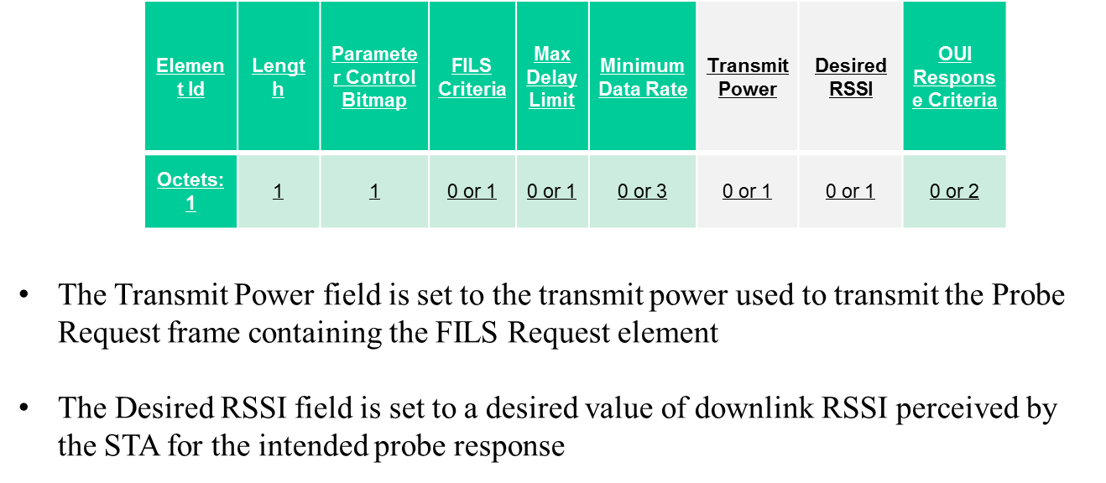

Staw-poll conducted in Palm Springs sessions:
- Do you support to utilize transmit power and desired RSSI as the link quality parameters for the AP to omit Probe Response?
Yes: 10
No:3
Abstain: 19

Proposed 802.11ai Specification Text

8.4.2.174 FILS Request Parameters element
Instructions to Editor: make the changes as marked below.

The FILS Request Parameters element in Probe Request frame are used as criteria to response with Probe Response transmission as defined in 10.1.4.3.5(Criteria to respond to probe request). The FILS Request Parameters is defined in Figure 8-ai1.

Element Id | Length | Parameter Control Bitmap | FILS Criteria | Max Delay Limit | Minimum Data Rate | Transmit Power | Desired Received Signal Strength Indicator Received Signal Strength Limit | OUI Response Criteria
Octets: 1 | 1 | 1 | 0 or 1 | 0 or 1 | 0 or 3 | 0 or 1 | 0 or 1 | 0 or 2

…

The Parameter Control Bitmap field is 1 octet in length and illustrated in Figure 8-ai2. Bits 0 to 4 of the Parameter ControlBitmap field correspond to the Parameter fields present in the IE respectively. A value of 1 in a bit indicates the corresponding parameter(s) is present, and the value of 0 indicates the corresponding parameter(s) is not present.

B0 B1 B2 B3 B4 B5 B7
FILS Criteria | Max Delay Limit | Minimum Data Rate | Link Quality Parameter Received Signal Strength Limit | OUI Response Criteria | Reserved

Bits: 1 1 1 1 1 3

Parameter Control Bitmap field

…

The Transmit Power field is set to the transmit power used to transmit the Probe Request frame containing the FILS Request Parameter element. The field is coded as a two’s complement signed integer in dBm. The maximum tolerance for the transmit power value is ± 5 dB. This tolerance is defined as the difference, in decibels, between the reported power value and the actual EIRP of the STA (when transmitting 1500 octet frames or maximum MPDU sized-frames, whichever is smaller).

The Desired Received Signal Strength Indicator (DRSSI) field is an unsigned integer. The receiver of Probe Request frame is obliged to respond, if the estimated reception power of the intended Probe Response frame is equal or higher than -90dBm + (DRSSI value * 0.5dBm). Value 255 indicates that receiver is obliged to respond regardless of the estimated reception power of the intended Probe Response frame.

The Received Signal Strength Limit (RSSL) field is an unsigned integer. The receiver of Probe Request frame is obliged to respond, if the reception power of the frame is equal or higher than -90dBm + (RSSL value * 0.5dBm). Value 255 indicates that receiver is obliged to respond regardless of the reception power of the Probe Request frame.

...

10.1.4.3.5 Criteria to respond to probe request
Instructions to Editor: make the changes as marked below.

...

STAs with dot11FILSActivated equal to true receiving a Probe Request frame with FILS Request Parameters element shall respond to Probe Request frame only if all the criteria below that are present in the corresponding Probe Request frame are met:
- The access delay as indicated by the BSS Delay Criteria field of the FILS Criteria field of the FILS Request Parameters element is less than the value as specified in the Max Delay Limit field of the FILS Criteria field of the FILS Request Parameters element as explained in 8.4.2.ai1(FILS Request Parameters element)
- The HT Support Criteria of the FILS Criteria field of the FILS Request Parameters element is set to 1 and the responding STA is HT STA.
- The VHT Support Criteria of the FILS Criteria field of the FILS Request Parameters element is set to 1 and the responding STA is VHT STA.
- The Minimum Data Rate field of the FILS Request Parameters element indicates lower data rate that can be provided over the MAC_SAP.
- The estimated reception power of the intended Probe Response frame is equal to or higher than the desired value as explained in 8.4.2.174 (FILS Request Parameters element).
5) The Received Signal Strength field of the FILS Request Parameters element indicates lower reception power limit than the reception power of the Probe Request frame as explained in 8.4.2.ai1(FILS Request Parameters element).

...

Straw-Polls and Motions
The following lists the straw-poll and motion that are intended to present to the TGai Group in Face-to-Face meeting.

Straw-poll: Do you support to incorporate the proposed text into the TGai Draft Specification Document?
Yes:
No:
Need more discussion:

Motion: To authorize the Editor to incorporate the text changes proposed in contribution 11-12-1289-01-00ai-suggested-edits-to-ai-combined-active-scanning-text to the draft TGai Specification Document.

Move:
Second:

Result: Yes: ____________; No: _________________; Abstain: _____________________

References:
- 11-12-1053-04-00ai-combined-active-scanning-text
- 11-12-0151-13-00ai-proposed-specification-framework-for-tgai
- 11-12-1052-02-00ai-response-considerations-in-active-scanning
- “A First Look at Trafﬁc on Smartphones”, Hossein Falaki et.al, IMC’10, November 1–3, 2010
- Draft P802.11ai_D0.1

