IEEE P802.11
Wireless LANs
802.11ah draft amendment proposal
Date: 2012-10-30
Author(s):
Name | Affiliation | Address | Phone | email
Ron Murias | InterDigital Communications |  | +1-403-889-1200 | ron@murias.ca
Abstract
Submission for candidate P802.11ah draft text based on the technical content in [1] and the guidelines agreed in [2].

The editing instructions are shown in bold italic. Four editing instructions are used: change, delete, insert, and replace. Change is used to make corrections in existing text or tables. The editing instruction specifies the location of the change and describes what is being changed by using strikethrough (to remove old material) and underscore (to add new material). Delete removes existing material. Insert adds new material without disturbing the existing material. Insertions may require renumbering. If so, renumbering instructions are given in the editing instruction. Replace is used to make changes in figures or equations by removing the existing figure or equation and replacing it with a new one. Editorial notes will not be carried over into future editions because the changes will be incorporated into the base standard.

This amendment’s baseline is IEEE Std 802.11™–2012, as amended by

- TBD

3. Definitions

EDITORIAL NOTE—The subclause numbering of definitions is of the form “3.ah<x>” where <x> is an increasing number. The 802.11 technical editor will assign numbers when merging this list into the baseline document.

Insert new definition 3.af1 retaining the alphabetic ordering:

3.ah1 S1G: Sub-1 GHz ...

4. Abbreviations and acronyms

Insert the following new acronym into Clause 4, while maintaining alphabetic ordering:

S1G sub 1 GHz
PLCP physical layr convergence procedure
STA station
MAC medium access control
MCS0 BPSK, ½ code rate
SUBF single-user beamforming
MU-MIMO multi-user, multiple input, multiple output
Non-TIM STA a STA that does not include its paged status in TIM
TIM STA a sta that includes its paged status in TIM

…

Insert new clause 24 as shown:

24. Sub 1 GHz (S1G) PHY specification

24.1 Introduction

Clause 24 specifies the PHY entity for a sub-1 GHz orthogonal frequency division multiplexing (OFDM) system.

24.1.1 Introduction to the S1G PHY

TBD.

24.1.2 Scope

24.1.3 S1G PHY functions

24.1.3.1 General

24.1.3.2 S1G PLCP sublayer

24.1.3.3 S1G PMD sublayer

24.1.3.4 PHY management entity (PLME)

24.2 S1G PHY service interface

24.3 S1G PLCP sublayer

24.3.1 Introduction

This subclause provides a convergence procedure where PSDUs are converted to and from PPDUs.

During transmission, the PSDU is processed (i.e. scrambled and coded) and appended to the PLCP preamble to crate a PPDU. At the receiver, the PLCP preamble is processed to aid in demodulation and delivery of the PSDU.

24.3.2 S1G PPDU format

24.3.3 Transmitter block diagram

24.3.4 Overview of the PPDU encoding process

24.3.5 Modulation and coding schemes (MCS)

The S1G PHY allows the following MCSs:
- For 1MHz, MCS0~9 as defined in 22.3.5, as well as MCS0-rep2 mode (more modes TBD).
- For >= 2 MHz, the MCS tables for BCC are the same as the corresponding tables in 22.3.5 before downclocking, i.e. same MCS exclusions for BCC as in Clause 22.3.5.

The 1 MHz PHY shall use MCS0 rep 2 as the lowest MCS rate.
- MCS0~9, same constellation sizes and coding rates as defined in Clause 22
- MCS10, BPSK, rate ½, and 2x repetition

24.3.6 PHY characteristics

24.3.6.1 Timing-related parameters

Characteristics | Value
aSlotTime | 52 us
aCCATime | 40 us
aAirPropagationTime | 6 us
aSIFSTime | 160 us

24.3.6.2 Tone plans

24.3.6.2.1 >= 2MHz PHY
The >=2MHz mode follows the same tone plans as the corresponding FFT sizes in VHT.

24.3.6.2.2 1 MHz PHY
The 1MHz tone allocations are as follows: 24 Data tones, 2 Pilot tones at tone indices +/-7, 3 Guard tones on left and 2 guard tones on right, and 1 DC tone.
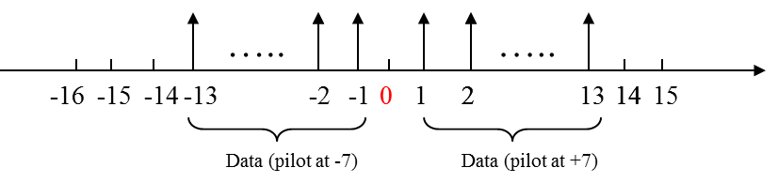
24.3.6.3 Interleaver

The S1G PHY shall use N_{col}=8, N_{rot}=2 as the 32 FFT interleaver.

24.3.7 Pilot Tones

For single stream pilots in the LTF, SIG and Data fields of short preamble packets, the first column of P matrix for multi-stream mapping is used, as below:
- For SIG field in Short Preamble Format, the transmitted pilot tone signals, in the k-th tone and n-th OFDM symbol in each 2MHz subband of the >=2MHz short preamble format SIG field is expressed as:

- For SIGA Field in >=2MHz Long Preamble Format, the transmitted pilot tone signals, in the k-th tone and n-th OFDM symbol in each 2MHz subband of the >=2MHz long preamble format SIGA field is expressed as:

- For >=2MHz LTFs in Short Preamble format, and D-LTFs in the Long preamble format, the transmitted pilot tone signals, in the k-th tone of each LTF field in the >=2MHz short preamble format, and of each D-LTF field in the >=2MHz long preamble format is expressed as:

- For >=2MHz SIGB/Data, the transmitted pilot tone signals, in the k-th tone and n-th OFDM symbol in SIGB (when applicable) and Data fields in >=2MHz PPDUs is expressed as:

[July 2012 meeting minutes, 11-12/832r2]

The pilot mapping  and values for 2/4/8/16 MHz transmissions, respectively, refer those for 20/40/80/160 MHz transmissions in section 22.3.10.10 (Pilot subcarriers) of IEEE P802.11ac™/D2.0.

- For 1MHz LTFs, the transmitted pilot tone signals, in the k-th tone and in each LTFs for 1MHz PPDU is expressed as:

- For 1MHz SIG field and Data Field, the transmitted pilot tone signals, in the k-th tone and n-th OFDM symbol of 1MHz SIG and Data fields is expressed as:

For a 1MHz transmission, two pilot tones shall be inserted in 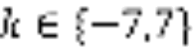. The pilot mapping for subcarrier k for symbol n shall be as specified in the following equation.

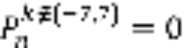
where,  is given in Table 22-20 of IEEE P802.11ac™/D2.0 and where n is the DATA symbol index.

24.3.8 S1G Preamble

In any S1G short GI packet, short GI starts from the second Data symbol, and the first Data symbol is always a long GI symbol.

The 4-bit CRC in 11ah 2MHz and 1MHz SIG(A) fields shall be calculated using the same procedure as the HTSIG field 8-bit CRC, except that the generator polynomial for the 4-bit CRC shall be G(D) = D⁴ + D + 1. The draft specification shall use the same HTSIG field 8-bit CRC in SIGB field of the >=2MHz long preamble when in MU mode.

24.3.8.1 Preambles for PHY greater than or equal to 2 MHz

For 4MHz, 8MHz, and 16MHz packets, the STF/LTF/SIG field designs are similar to the VHT 40/80/160MHz. The STF/SIG fields are repeated and phase rotated over each 2MHz subband.

The S1G PHY shall support the following rules regarding >= 2MHz preambles:
- Both short and long preambles are mandatory at the AP.
- For a STA,
  - If it supports only 1MHz/2MHz, short preamble is mandatory, and long preamble is optional (exchanged by capability fields).
  - Otherwise, both short and long preambles are mandatory.
- Any device shall be able to detect and decode SIGA field in the long preamble for CCA.

24.3.8.1.1 Short preamble

The general short preamble structure for greater than or equal to 2 MHz PHY packet is defined as in the figure below:
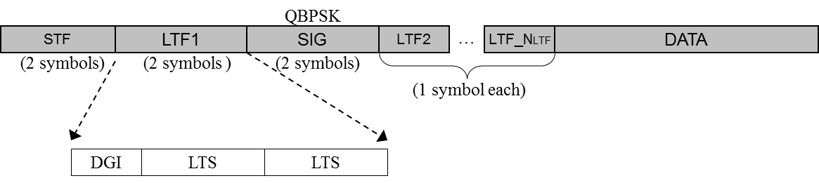

Each field is defined as follows:

- STF Field
  - Use the same tone design as in the HT PHY, i.e. in each 2MHz, STF occupies 12 non-zero tones in {±4 ±8 ±12 ±16 ±20 ±24}.
  - None-zero tones are mapped to space-time streams using the first column of P matrix, the same way as in HT GF preamble.

- LTF Fields
  - For >= 2MHz, the sign of the LTF PPDUs are the same as the VHTLTF signs for the corresponding VHT packets with the same FFT sizes.
Note: This is also applicable to the LTF1 and D-LTFs fields in the long preamble format.
  - For the LTF data tones, the mapping from N_{STS} space-time streams to N_{LTF} LTFs is the same as in the HT green field preamble, with the P matrix.

- SIG Field
  - 2 symbols, each modulated using Q-BPSK, same as in HT green field preamble.
  - 48 data tones occupying tones {-26:26} within each 2MHz subband, and modulated using MCS0.
  - Data tones are mapped to multiple space-time streams using the first column of P matrix—the same as in HT GF preamble.

- The following CSD table (to be applied Per-Per-Space-Time-Stream) shall be used for the >=2MHz Short Frame format

T_cs(n) for >=2MHz, Short Frame Format and Data portion of Long Frame Format
Total number of space-time streams | Cyclic shift (for Tx Stream n) (μs)
Total number of space-time streams | 1 | 2 | 3 | 4
1 | 0 | - | - | -
2 | 0 | -4 | - | -
3 | 0 | -4 | -2 | -
4 | 0 | -4 | -2 | -6

24.3.8.1.2 Long Preamble
The long preamble structure uses a “mixed-mode” format shown below: (long preamble)
- This frame format can be used for MU and SUBF

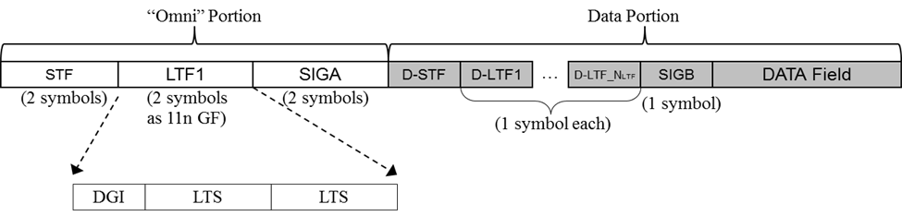
- Omni Portion
  - SIGA field has 48 data tones, occupying tones {-26:26} as in HT SIG fields
  - STF/LTF1/SIG fields applies single stream in each subcarrier (without the 1st column P matrix mapping as seen in short preamble), similar to the legacy portion of the HT MM preamble.
  - SIG field subfield definition is different from short preamble, and the two symbols in SIG field are modulated using QBPSK and BPSK respectivelyRefer to 24.3.8.3.
  - The following CSD table (to be applied Per-Antenna) shall be used for the >=2MHz Omni portion of the Long Frame format:

T_cs(n) for >=2MHz, Omni Portion of Long Frame Format
Total number of Tx antennas | Cyclic shift (for Tx Antenna n) (μs)
Total number of Tx antennas | 1 | 2 | 3 | 4
1 | 0 | - | - | -
2 | 0 | -4 | - | -
3 | 0 | -4 | -2 | -
4 | 0 | -4 | -2 | -6

- Data Portion
  - D-STF is the same as (downclocked) 11ac VHT-STF.
  - Modulation flows of D-STF, D-LTFs, and SIGB are the same as 11ac MU packets.
    - i.e. all streams for all users are trained by D-LTFs.
    - Up to 4 space-time stream across all users.
  - The following CSD table (to be applied Per-Per-Space-Time-Stream) shall be used for the >=2MHz Data portion of the Long Frame format:

T_cs(n) for >=2MHz, Short Frame Format and Data portion of Long Frame Format
Total number of space-time streams | Cyclic shift (for Tx Stream n) (μs)
Total number of space-time streams | 1 | 2 | 3 | 4
1 | 0 | - | - | -
2 | 0 | -4 | - | -
3 | 0 | -4 | -2 | -
4 | 0 | -4 | -2 | -6

24.3.8.1.3 SIG field content for >=2MHz
- 2MHz SIGA

 | Short preamble | Long preamble
 | SU | SU | MU
SU/MU Indication | - | 1 | 1
Length / Duration | 9 | 9 | 9
MCS | 4 | 4 | -
BW | 2 | 2 | 2
Aggregation | 1 | 1 | -
STBC | 1 | 1 | 1
Coding | 2 | 2 | 5
SGI | 1 | 1 | 1
GID | - | - | 6
Nsts | 2 | 2 | 8
PAID | 9 | 9 | -
Ack Indication | 2 | 2 | 2
Smoothing | 1 | - | -
Beam-change Indication | - | 1 | -
Reserved | 4 | 3 | 3
CRC | 4 | 4 | 4
Tail | 6 | 6 | 6
Total | 48 | 48 | 48

  - LENGTH/DURATION: in num of symbols when aggregation is 1, is in num of bytes when aggregation is 0, Mandate AMPDU for packet sizes > 511 bytes and for MU.
  - STBC: Same as in 11ac (Alamouti code on all streams or none).
  - Nsts: for SU (2 bits), represents 1~4 STS; for MU (8 bits), represents 0~3 STS per user for the 4 users.
  - Coding: for SU 1 bit indicates BCC/LDPC, the other bit indicates additional symbol during LDPC encoding process; for MU, 4 bits of Coding-I indicate BCC/LDPC of 4 clients, and 1 bit of Coding-II indicates whether additional symbols happens for any user when encoding LDPC (same as 11ac). [12/1102r1, September 2012 meeting minutes]
  - MCS: for SU, 4 bit MCS index; for MU, reuse 3 bits for BCC/LDPC indicator for users 2~4—similar as in 11ac VHTSIGA.
  - Aggregation: Mainly applicable for SU, reserved for MU.
  - CRC: 4 bits of CRC should be enough as shown in the Appendix
  - GID: 6-bit GID as in 11ac for MU, not needed for SU.
  - PAID: 9 bits PAID, not needed for MU.
    - Patial AID rules [12/1079r0, September 2012 meeting minutes]:
      - A STA that transmits a PPDU to an AP shall set the TXVECTOR parameter PARTIAL_AID to (dec(BSSID[39:47]) mod (2⁹-1))+1
      - AP should not assign an AID to a STA that results in the PARTIAL_AID value, as computed using Equation (9-8a) (defined in IEEE 802.11ac Draft 3.0), being equal to either (dec(BSSID[39:47]) mod (2⁹-1))+1 or (dec(Overlapping BSSID[39:47]) mod (2⁹-1))+1
  - Ack Indication: 2 bits:
      - 00: Ack
      - 01: BA
      - 10: No Ack
      - 11: a frame that is not ACK, BA or CTS.

  - Beam-change indication bit: a value of 1 indicates that Q matrix is changed; a value of 0 indicates that Q matrix is un-changed. [July 2012 meeting minutes, 11-12/825r2]
    - Note: If the beam-change indication bit in long preamble is set to 0, the receiver may do channel smoothing. Otherwise, smoothing is not recommended.
  - Short preamble bit ordering
    - 1st symbol of SIG

    - 2nd symbol of SIG
  - Long preamble, SU bit ordering
    - 1st symbol of SIG-A
    - 2nd symbol of SIG-A
  - Long preamble, MU bit ordering
    - 1st symbol of SIG-A
    - 2nd symbol of SIG-A

- For MU-MIMO transmission the 2MHz SIGB content is as shown in the following table. For SU-MIMO transmission the SIGB symbol is identical to D-LTF1. [July 2012 meeting minutes, 11-12/832r2]

 | BW (MHz)
 | 2 | 4 | 8 | 16
MCS | 4 | 4 | 4 | 4
Tail | 6 | 6 | 6 | 6
CRC | 8 | 8 | 8 | 8
Reserved | 8 | 9 | 11 | 11
Total | 26 | 27 | 29 | 29

24.3.8.1.3 NDP format
The S1G NDP format is as illustrated:
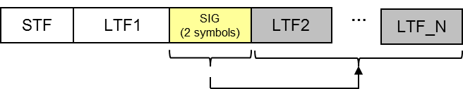
The S1G NDP format is same with 2MHz PHY short frame format defined in 23.8.1.
- The SIG field of S1G NDP shall include following fields:
  - MCS : set to 0
  - Length/Duration: set to 0
  - BW : set to the same value as the TXVECTOR parameter CH_BANDWIDTH in the preceding VHT NDP Announcement frame
  - Nsts : indicates two or more space-time streams

All NDP frames sent in >=2MHz shall support the use the short preamble format, including Short-ACK, and all future NDP short MAC frames.

24.3.8.2 Preamble for 1 MHz mode PHY

The S1G PHY shall use the following STF and LTF sequences for 32 FFT:

- STF sequence:
  - Tone index=[-12 -8 -4 4 8 12]
  - Values: [0.5, -1, 1, -1, -1, -0.5]x(1+j)x γ where γ is a normalization factor
  - γ = 2.4 for MCS0 rep2, 1.7 otherwise
- LTF sequence
  - Tone index is [-16 -15 -14 …. -1 0 1 ….. 14 15]
=[0 0 0 1 -1 1 -1 -1 1 -1 1 1 -1 1 1 1 0 -1 -1 -1 1 -1 -1 -1 1 -1 1 1 1 -1 0 0]

The S1G PHY shall have a 4 symbol packet detection section for the 1 MHz mode:
- A 3 dB power boost is only applied for 2x repetition MCS
- Have same periodicity as 2 MHz STF with following tone allocations:
  - For 2MHz {±4 ±8 ±12 ±16 ±20 ±24}
  - For 1MHz {±4 ±8 ±12}.

The S1G PHY shall have the general preamble structure for 1MHz SU open loop packet as in the figure below.
- The relationship between N_{STS} and N_{LTF} is the same as the HT PHY (for 2 through 4 streams), using the same P matrix (for 1 through 4 streams)

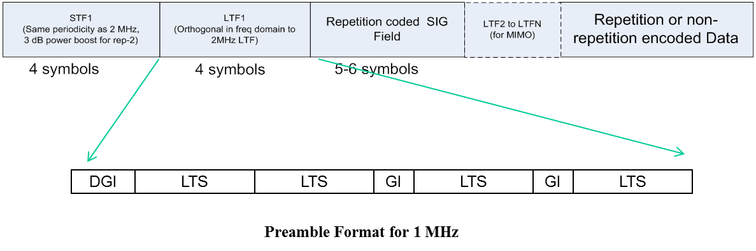
24.3.8.3 SIG field for 1 MHz PHY

SIG Field | Bits | Comments
STBC | 1 | Same as HT
Num STS | 2 | Number of space time streams for SU
SGI | 1 | Short Guard Interval
Coding | 2 | 1st bit is coding type (LDPC/BCC), 2nd bit is for LDPC N_{sym} ambiguity
MCS | 4 | MCS
Aggregation bit | 1 | Signals use of AMPDU
Length | 9 | Length field (in symbols when aggregation is ON, is in bytes when aggregation is OFF, Mandate AMPDU for packet sizes > 511 bytes
Ack Indication | 2 | 00: Ack  01: BA  10: No Ack  11: a frame that is not ACK, BA or CTS.
Smoothing | 1
Reserved | 3 | Some possible uses are MAC bits or any other new features etc. Details TBD
CRC | 4 | 4 bits of CRC should be enough
Tail | 6
Total | 36
- SIG goes at BPSK-rate ½ -rep 2
- No MU transmissions for the 1MHz mode
- No AID supported

- Bit ordering of 1 MHz SIG field:

The following CSD table (to be applied Per-Space-Time-Stream) shall be used for the 1 MHz frame format:

T_cs(n) for 1MHz Frame Format
Total number of space-time streams | Cyclic shift (for Tx Stream n) (μs)
Total number of space-time streams | 1 | 2 | 3 | 4
1 | 0 | - | - | -
2 | 0 | -4 | - | -
3 | 0 | -4 | -1 | -
4 | 0 | -4 | -1 | -5

24.3.8.3 Auto-detection between 1MHz and 2MHz and between >=2MHz short and long preambles
- Auto-detection between short and long >=2MHz preambles is facilitated by having a 90 degrees phase rotation on the 2nd SIG symbol as shown in the figure below.
- Auto-detection between 1MHz and 2MHz preambles is facilitated using two options as shown in the figure below
  - The first auto-detection method uses the property of orthogonal LTF sequences as described in 11/1482r4 and 12/0115 and defined by the orthogonality metric in Appendix-A of 12/0115.
  - The second auto-detection method is facilitated by noting that for >=2MHz short preamble and long preamble the 1st SIG symbol is always QBPSK whereas the corresponding time-wise symbol of the 1MHz preamble (in the figure below) is BPSK modulated.
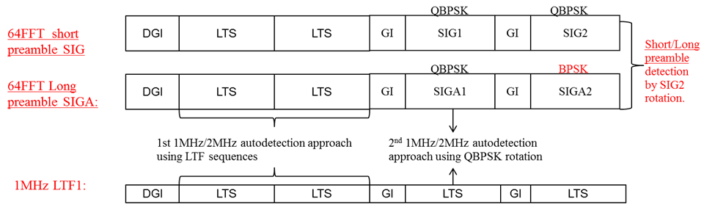

24.3.9 Transmission of PPDUs
24.3.9.1 Transmission flow for 11ah regular non-repetition MCSs
The general transmission flow for the S1G regular non-repetition MCSs is shown below.
Note: The S1G PHY uses the same Tx flow as VHT in the data tones for the data field.

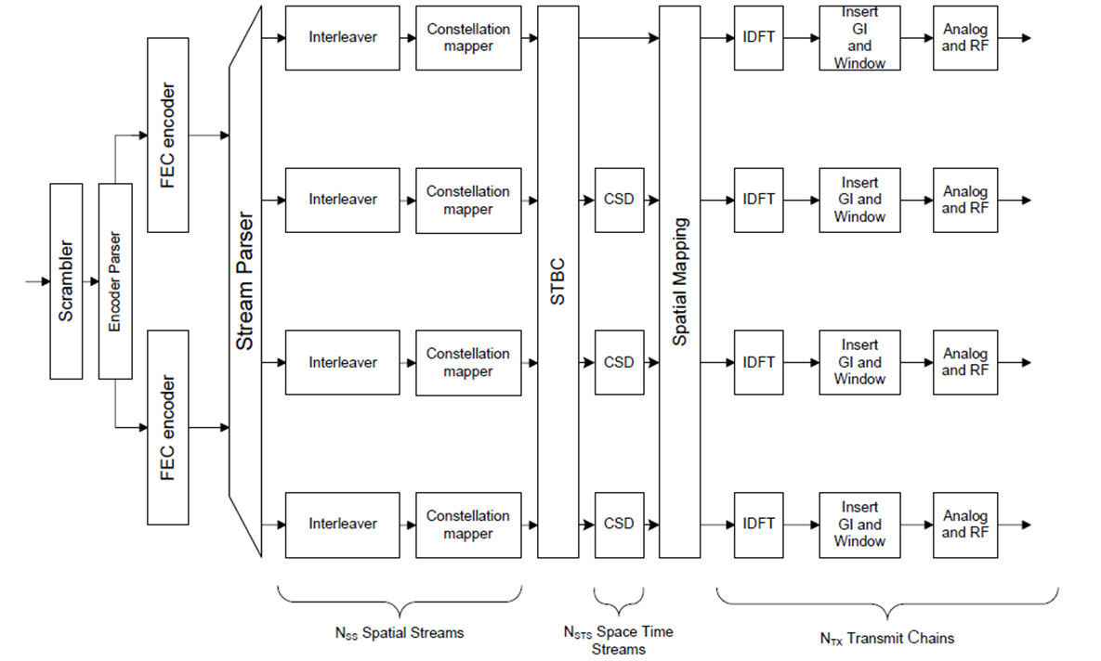

- The S1G stream parser is the same as VHT.
- The S1G encoder parser and segment parser (16MHz only) are the same as VHT; NES in the MCSs of 2/4/8/16MHz is the same as the corresponding values in VHT; and N_{ES} = 1 in all the MCSs of 1MHz.

24.3.9.2 Transmission flow for MCS0-Rep2 mode

The transmission flow for MCS0-Rep2 mode under S1G is as follows:

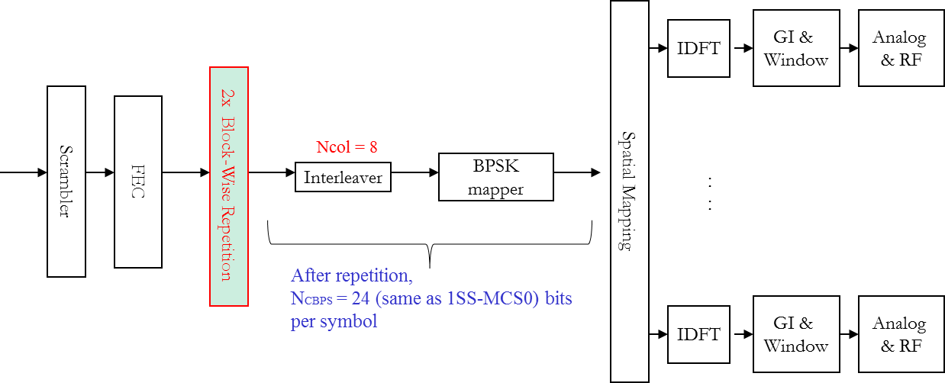
- MCS0 Rep2 is applied only for single space-time stream.
  - N_{SS}=1, no STBC
- The “2x block-wise repetition” performed on a per-OFDM symbol basis:
  - C_{out}=[C₁….C_{2NDBPS} , C₁….C_{2NDBPS} ], where [C₁….C_{2NDBPS}] are the FEC output bits per symbol.
  - Interleaver parameters are the same as regular MCS0.
- Receiver may conduct MRC combining to improve SNR.

24.3.9.3 Coding and padding

For S1G Multiuser PPDUs, the BCC padding and LDPC encoding flows are the same as the VHT PHY. For other PPDUs, padding and coding are described below.

24.3.9.3.1 BCC
The S1G BCC encoded single user PPDU shall use the following padding:

Step1: Compute NSYM:
If DURATION is indicated in SIG field: directly send NSYM in LENGTH/DURATION subfield of SIG field.

If LENGTH is indicated in SIG field: directly send PSDU_LENGTH in number of bytes in LENGTH/DURATION subfield of SIG field.

Step 2: Compute NPAD:

Step 3: Padding:

If DURATION is indicated in SIG field: Right after the PSDU data Pad the MAC AMPDU delimiters till the last integer byte of the NPAD padding bits, then pad the remaining 0~7 PHY padding bits (arbitrary1 or 0 bits)—i.e. same as 11ac padding. Scramble the PSDU and padding bits. The 6.NES BCC tails bits are added at the end of the PPDU.

If LENGTH is indicated in SIG field: Right after the PSDU data, pad the NPAD padding bits (arbitrary 1 or 0 bits). Scramble the PSDU and padding bits. The 6.NES BCC tails bits are added at the end of the PPDU.

The above BCC padding flow is illustrated by the following figure;
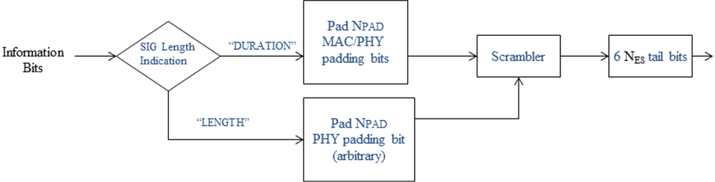

24.3.9.3.2 LDPC
The S1G LDPC encoded single user PPDU shall use the following encoding:

Step 1: Compute Npld and Navbits as in 11ac:

Step 2: Padding: compute NPAD:

If DURATION is indicated in SIG field: Right after the PSDU data, pad the MAC AMPDU delimiters till the last integer byte of the NPAD padding bits, then pad the remaining 0~7 PHY padding bits (regardless of 1 or 0 bits)—i.e. same as 11ac padding. Scramble the PSDU and Padding bits.

If LENGTH is indicated in SIG field: Right after the PSDU data, pad the NPAD padding bits (regardless of 1 or 0 bits). Scramble the PSDU and Padding bits.

Step 3: After Scrambling, conducts the regular LDPC encoding flow as in 11n spec: shortening, puncturing, repetition, and derive updated , hence the updated NSYM, .

Step 4: Setting the SIG Field:

If DURATION is indicated in SIG field: send NSYM in LENGTH/DURATION subfield of SIG field.
If LENGTH is indicated in SIG field: send PSDU_LENGTH in LENGTH/DURATION subfield of SIG field.

In both cases, if NSYM > NSYM, init, the “additional symbol in LDPC” bit in SIG is set to 1.

For 2/4/8/16MHz LDPC encoded PPDUs, after constellation mapping, apply the VHT LDPC tone mapper w.r.t. the same FFT sizes. For 1MHz LDPC encoded PPDUs, no LDPC tone mapper is applied.

24.3.10 MIMO

24.3.10.1 Spatial Multiplexing

The maximum number of space-time streams (N_{STS}) in a data PPDU transmission shall be less than or equal to 4.

24.3.10.2 Transmit Beamforming

The S1G PHY shall support, for all applicable BW, the SUBF and MU-MIMO feedback structure and protocol as specified in the following sections of IEEE P802.11ac™/D2.0, as an optional feature:
- 8.4.1.46 VHT MIMO Control field
- 8.4.1.47 VHT Compressed Beamforming Report field - contents of feedback frame
- 8.4.1.48 MU Exclusive Beamforming Report field - contents of MU frame
- 9.31.5 VHT sounding protocol
- 22.3.11 and its subsections: SU-MIMO and MU-MIMO Beamforming

24.3.10.3 Spatial Mapping Matrix
The auto-detection between 1MHz and 2MHz preambles as described in 24.3.8.3 assumes channel smoothness. It is recommended that the spatial mapping matrix Q applied to LTF1 is chosen such that it preserves the smoothness of the physical channel. This can, for example, be achieved by minimizing the amplitude and phase variation of each element of Q in successive tones.
Examples:
- The following Q may be used: Q as defined for cyclic shift diversity using the values specified in the corresponding tables.
- The following Q should not be used – antenna hopping as described in 802.11REVmb section 20.3.11.11.2 (C)-(2) - the values of Q on successive tones flip between 1 and 0.

24.3.11 Channelization

The S1G PHY shall include support for 1 MHz, 2 MHz, 4 MHz, 8 MHz, and 16 MHz PHY transmissions. An S1G STA shall support reception of 1 MHz and 2 MHz PHY transmissions.

The 2 MHz PHY transmission shall be an OFDM based waveform consisting of a total of 64 tones (including tones allocated as pilot, guard and DC). Note: This implies a tone spacing of 31.25 kHz. The tone spacing for all other bandwidths PHY transmissions shall be same as the tone spacing in the 2 MHz PHY transmission.

24.3.11.1 Region specific channelization

The S1G PHY shall include the following channelization where applicable:
- South Korea
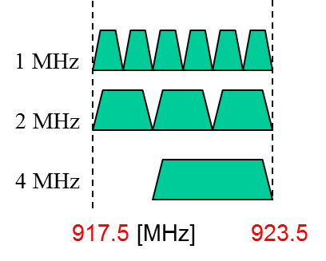
- Europe

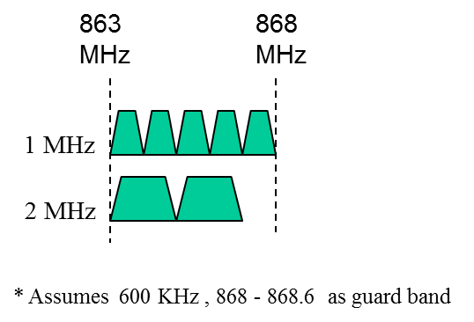

- Japan
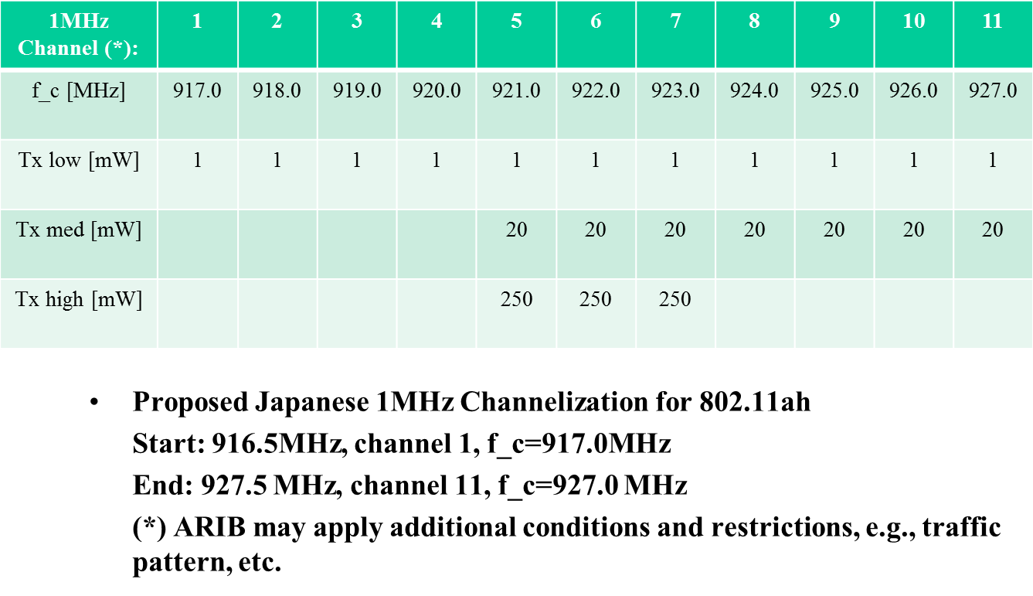

- China
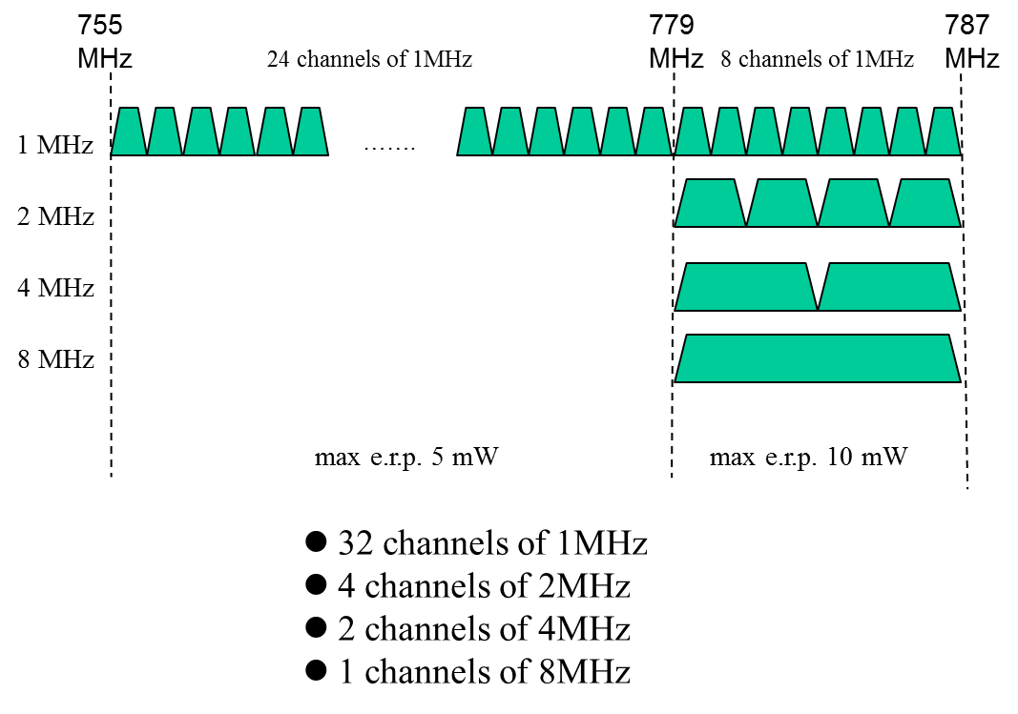
- Singapore:
- Supporting bands: 866-869 MHz, 920-925MHz
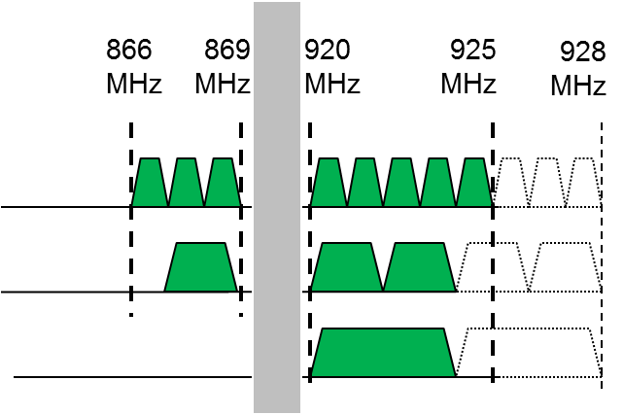
- United States
- 26 1MHz channels, 13 2MHz channels, 6 4MHz channels, 3 8MHz channels and one 16MHz channel
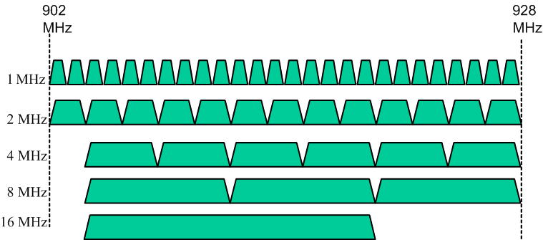

PHY and MAC management entity of S1G shall provide appropriate parameters (TBD) of PLME and MLME service primitives to support Spectrum access and Tx Control functions in order to comply to each regulatory domain.
- These appropriate parameters to be added are TBD so far, but are supposed to be a part of “behavior limit set” entry in the Annex Table which corresponds to new operating classes of S1G.

24.3.12 Transmission rules

S1G shall support the following 1 MHz transmission rules.
- In 2MHz BSS, 1MHz waveform is only allowed at the lower side.
- In 4/8/16MHz BSS, when primary 2MHz is at lower most of the overall band, then 1MHz is only allowed at upper side of the 2MHz primary channel; when primary 2MHz is at upper most of the overall band, 1MHz is only allowed at lower side of the 2MHz primary channel; when primary 2MHz is in the middle of the overall band, 1MHz waveform position is TBD.

24.3.13 Channel selection rules

Among all available channels, a new BSS should select an idle channel which can help keep maximum number of idle (available) wider bandwidth channels after it is selected (Details TBD

24.4 S1G PLME

24.5 S1G PMD sublayer

24.6 Parameters for S1G MCSs
SFD – Draft Mapping Tables

SFD | Item | Clause | Sub | Sub-sub | Notes
1 | Definitions | 1
2 | Abbreviations and Acronyms | 2
 |  | 4 | 3 | 10 | General description - Sub 1 GHz (S1G) station (STA)
3 | S1G Physical Layer | 24 |  |  | Introduction
3.3 | Modulation and Coding Scheme (MCS) | 24 | 3 | 5 | Modulation and coding schemes (MCS)
3.2.3 | Tone plans | 24 | 3 | 6 | Timing-related parameters
3.7 | S1G PLME | 24 | 3 | 6 | Timing-related parameters
3.2.1 | Preamble | 24 | 3 | 8 | S1G preamble
3.2.1.1 | PHY greater than or equal to 2 MHz | 24 | 3 | 8 | S1G preamble
3.2.1.2 | 1 MHz mode PHY | 24 | 3 | 8 | S1G preamble
3.2.2 | Transmission flow | 24 | 3 | 9 | Transmission of PPDUs
3.2.2.1 | Transmission flow for 11ah regular non-repetition MCSs | 24 | 3 | 9 | Transmission of PPDUs
3.2.2.2 | Transmission flow for MCS0-Rep2 mode | 24 | 3 | 9 | Transmission of PPDUs
3.2.2.3 | Padding | 24 | 3 | 9 | Transmission of PPDUs
3.4 | Spatial Multiplexing | 24 | 3 | 11 | MIMO
3.5 | Transmit Beamforming | 24 | 3 | 11 | MIMO
3.6 | Spatial Mapping Matrix | 24 | 3 | 11 | MIMO
3.1 | Channelization | 24 | 3 | 14 | Channelization
3.1.1 | Transmission Rules | 24 | 3 | 14 | Channelization
3.1.2 | Channel Selection Rules | 24 | 3 | 14 | Channelization
3.2 | S1G PLCP Sublayer | 24 | 3 |  | S1G PLCP Sublayer

SFD | Item | Clause | Sub | Sub-sub | Notes
4 | MAC Layer
4.1 | Power Save
4.2 | Channel Access
4.2.1 | Uplink Channel Access
4.2.2 | Downlink Buffered BU Delivery Procedure
4.2.3 | Uplink Frame Delivery Process
4.3 | Large Number of STAs Support
4.3.1 | Traffic Indication Map (TIM) operation
4.3.2 | TIM Structure
4.3.3 | TIM Encoding
4.3.4 | TIM and Page Segmentation
4.4 | Frame Formats
4.4.1 | Management Frames
4.4.1.1 | Short Beacon frame format
4.4.1.2 | NDP Probe Request frame format
4.4.1.3 | Short Beamforming Report Poll frameformat
4.4.1.4 | Short Probe Response frame format
4.4.2 | Control Frames
4.4.2.1 | Short ACK frame format
4.4.2.2 | Short Block Ack (BA) frame format
4.4.2.3 | Short CTS frame format
4.4.2.4 | NDP PS-Poll frame format
4.4.3 | Management frame body components
4.4.3.1 | Information elements
4.4.3.1.1 | Open-Loop Link Margin Link element
4.4.3.1.2 | RAW (Restricted Access Window) Parameter Set element
4.4.3.1.3 | Segment Count element
4.4.3.1.4 | TIM element
4.4.4 | MAC header compression
4.4.4.1 | Short MAC header

References

[1] 802.11ah Specification Framework Document (SFD), document IEEE 802.11-11/1137r11
[2] TGah Spec Development Process, document IEEE 802.11-12/0602r1

