IEEE P802.11
Wireless LANs
LB188-CID6558-MU-Exchange
Date: 2012-09-19
Author(s):
Name | Affiliation | Address | Phone | email
Matthew Fischer | Broadcom | 190 Mathilda Place, Sunnyvale, CA 94086 | +1 408 543 3370 | mfischer@broadcom.com
Mark RISON | CSR | CB4 0WH, UK | +44 1223 692000 | Mark.RISON@csr.com
Abstract
Proposed resolution for LB188 CID 6558 asking for text to describe the MU PPDU exchange. The proposed resolution also adds text to Annex G for the absence of definition of the MU PPDU sequence.

Revision Notes

R6:
Updated and made into joint submission.

R5:
Accept that group wants to allow all of immediate BA, delayed BA and no BA use within MU PPDU and this means that possible exchanges are expanded and so, existing timing diagram is swapped for the two alternatives.
Modfy Annex G changes to include multiple RTS-CTS exchange and explore possibility of simply modifying contents of EDCA Txop exchange definition of txop-part-requiring-ack.

R4:
Cosmetic. E.g. change BAR to BlockAckRequest. Add “frame”.

R3:
Removed statement regarding requirement for BA agreement – as this is already stated within the AMPDU contents tables in clause 8.
Changed note 2 under the new figure to not be a note.

R2:
Modified language in 9.3.2.9a, turning a part of the text into a note.
Added restriction on BA agreement type for MU STAs.
Made exchange sequence definitive (instead of “typical”)
Changed “individual MPDUs” to MPDUs

R1:
Change figure so that one STA is an AP

CID 6558

CID | Commenter | Page | Clause | Comment | Proposed Change | Resolution
6558 | Sigurd Schelstraete | 127.31 | 9.19.2.2a | The frame exchange sequence for a MU-MIMO PPDU is illustrated in Figure 9-19b, including BAs, BARs, ... This sequence is never spelt out explicitly in the text in a single place. It would be helpful to add text to clearly describe this new frame sequence.  (BTW, should this also be added in Annex G?) | Add text describing the MU-PPDU + acknowledgement frame sequence. | Revise – Tgac editor to make changes to TGac draft 3.1 as shown in document 11-12-1021r6 under the heading CID6558.

Discussion

Note that the draft says nothing about whether a potential MU recipient shall negotiate an immediate BA agreement or if alternatively, a delayed BA agreement is allowed. Group does agree that all forms of BA and lack thereof should be allowed and supported.

Also, in the case of a missing, expected BAR (e.g. a broken sequence without retry), should a recipient simply continue to wait for the BAR, or should it initiate its own TXOP for BA transfer? It seems implicit in the nature of the exchange shown in the proposed figure that an immediate BA agreement is necessary (needed to allow BA response to BAR), but because there currently is no text in D3.0 or D3.1 describing the MU exchange, this figure is only a guess at the intent of the group. BAR-ACK sequence could be allowed if the group desires. See alternate figures. If that is what is desired, then the question of when BA is sent is more interesting and the number of timing diagrams and allowed sequences increases.

Additionally, even in the context of an immediate BA agreement, i.e. assuming that only an immediate BA agreement is allowed for the MU exchange, then it appears that there is no explicit restriction in the baseline against the recipient sending a BA without a preceding solicitation in for example, the case of a broken MU exchange where later users do not receive a BAR so the behaviour of the recipient in this case remains an open question and if there is to be a restriction against such behaviour, that feels like a more generic, TGmc sort of issue, but it does have implications for the description of the allowed MU PPDU exchange sequence.

Proposed changes

TGac editor: Add the following new editing instruction, heading, text and figure to TGac Draft 3.1 immediately preceding sub-clause 9.3.4:

Add a new subclause 9.3.2.9a MU acknowledgement procedure as shown:

9.3.2.9a MU acknowledgement procedure

The acknowledgement procedure performed by a STA that receives MPDUs that were transmitted within an MU PPDU is the same as the acknowledgement procedure for MPDUs that were not transmitted within an MU PPDU.

NOTE - All MPDUs transmitted within an MU PPDU are contained within A-MPDUs and the rules specified in 8.6.3 (A-MPDU contents) ensure that there can only be an immediate response to one of them.

Responses to A-MPDUs within an MU PPDU that are not immediate responses to the MU PPDU are transmitted in response to explicit BlockAckRequest frames by the AP. Examples of MU PPDU frame exchange sequences are shown in Figure 9-9a (An example of a TXOP containing an MU PPDU transmission with an immediate acknowledgement to the MU PPDU) and Figure 9-9b (An example of a TXOP containing an MU PPDU transmission with no immediate acknowledgement to the MU PPDU).

Recovery within the TXOP that contains an MU PPDU can be performed according to the rules of 9.19.2.4 (Multiple frame transmission in an EDCA TXOP). BlockAckRequest frames related to A-MPDUs within an MU PPDU can be transmitted in a TXOP separate from the one that contained the MU PPDU.

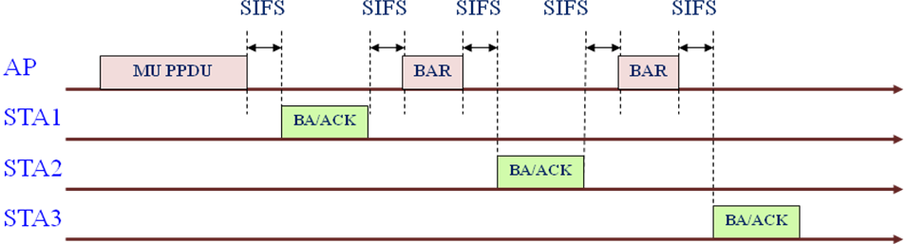

Figure 9-9a An example of a TXOP containing an MU PPDU transmission with an immediate acknowledgement to the MU PPDU

NOTE---A BlockAck frame or an ACK frame is sent in immediate response to the BlockAckReq frame for HT-immediate or HT-delayed Block Ack respectively. An ACK frame might be sent in immediate response to a VHT single MPDU in the MU PPDU.

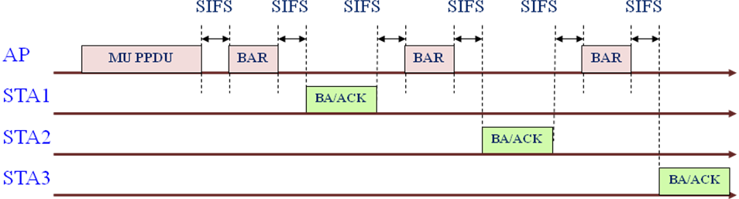

Figure 9-9b An example of a TXOP containing an MU PPDU transmission with no immediate acknowledgement to the MU PPDU

No BlockAckRequest frame should be sent to a STA in the case where the A-MPDU to that STA contained no MPDUs requiring acknowledgement.
NOTE---A BlockAckRequest frame might be sent if an earlier A-MPDU to that STA contained MPDUs requiring acknowledgement and acknowledgement has not been received, or for a Block Ack agreement other than that pertaining to the Data MPDUs in the MU PPDU.

TGac editor: Add the following text to the start of TGac Draft 3.1:

Annex G

G.1 General

This annex is obsolete as regards VHT. Consequently this annex may be removed in a future revision of this standard. This clause is no longer maintained and may not be compatible with or describe all features of this standard.

References:

