IEEE P802.11
Wireless LANs
LB188-CID6558-MU-Exchange
Date: 2012-08-20
Author(s):
Name | Affiliation | Address | Phone | email
Matthew Fischer | Broadcom | 190 Mathilda Place, Sunnyvale, CA 94086 | +1 408 543 3370 | mfischer@broadcom.com
Abstract
Proposed resolution for LB188 CID 6558 asking for text to describe the MU PPDU exchange. The proposed resolution also adds text to Annex G for the MU PPDU sequence.

Revision Notes

R4:
Cosmetic. E.g. change BAR to BlockAckRequest. Add “frame”.

R3:
Removed statement regarding requirement for BA agreement – as this is already stated within the AMPDU contents tables in clause 8.
Changed note 2 under the new figure to not be a note.

R2:
Modified language in 9.3.2.9a, turning a part of the text into a note.
Added restriction on BA agreement type for MU STAs.
Made exchange sequence definitive (instead of “typical”)
Changed “individual MPDUs” to MPDUs

R1:
Change figure so that one STA is an AP

CID 6558

CID | Commenter | Page | Clause | Comment | Proposed Change | Resolution
6558 | Sigurd Schelstraete | 127.31 | 9.19.2.2a | The frame exchange sequence for a MU-MIMO PPDU is illustrated in Figure 9-19b, including BAs, BARs, ... This sequence is never spelt out explicitly in the text in a single place. It would be helpful to add text to clearly describe this new frame sequence.  (BTW, should this also be added in Annex G?) | Add text describing the MU-PPDU + acknowledgement frame sequence. | Revise – Tgac editor to make changes to TGac draft 3.1 as shown in document 11-12-1021r4 under the heading CID6558.

Discussion

Note that the draft says nothing about whether a potential MU recipient shall negotiate an immediate BA agreement or if alternatively, a delayed BA agreement is allowed.

Also, in the case of a missing, expected BAR (e.g. a broken sequence without retry), should a recipient simply continue to wait for the BAR, or should it initiate its own TXOP for BA transfer? It seems implicit in the nature of the exchange shown in the proposed figure that an immediate BA agreement is necessary (needed to allow BA response to BAR), but because there currently is no text in D3.0 or D3.1 describing the MU exchange, this figure is only a guess at the intent of the group. BAR-ACK sequence could be allowed if the group desires. See alternate figures. If that is what is desired, then the question of when BA is sent is more interesting and the number of timing diagrams and allowed sequences increases.

Additionally, even in the context of an immediate BA agreement, i.e. assuming that only an immediate BA agreement is allowed for the MU exchange, then it appears that there is no explicit restriction in the baseline against the recipient sending a BA without a preceding solicitation in for example, the case of a broken MU exchange where later users do not receive a BAR so the behaviour of the recipient in this case remains an open question and if there is to be a restriction against such behaviour, that feels like a more generic, TGmc sort of issue, but it does have implications for the description of the allowed MU PPDU exchange sequence.

Proposed changes

TGac editor: Add the following new editing instruction, heading, text and figure to TGac Draft 3.1 immediately preceding sub-clause 9.3.4:

Add a new subclause 9.3.2.9a MU acknowledgement procedure as shown:

9.3.2.9a MU acknowledgement procedure

The acknowledgement procedure performed by a STA that receives MPDUs that were transmitted within an MU PPDU is the same as the acknowledgement procedure for MPDUs that were not transmitted within an MU PPDU.

NOTE - All MPDUs transmitted within an MU PPDU are contained within A-MPDUs and the rules specified in 8.6.3 (A-MPDU contents) ensure that there is no more than one immediate response required for an A-MPDU, and further indicate that there can only be one immediate response to an MU PPDU.

Responses to A-MPDUs within an MU PPDU that are not immediate responses to the MU PPDU are transmitted in response to explicit BlockAckRequest frames by the STA transmitting the MU PPDU. An MU PPDU frame exchange sequence is shown in Figure 9-9a (The MU PPDU acknowledgement procedure). Recovery within the TXOP can be performed according to the rules of 9.19.2.4 (Multiple frame transmission in an EDCA TXOP). BlockAckRequest frames can be transmitted in a TXOP separate from the one that contained the MU PPDU.

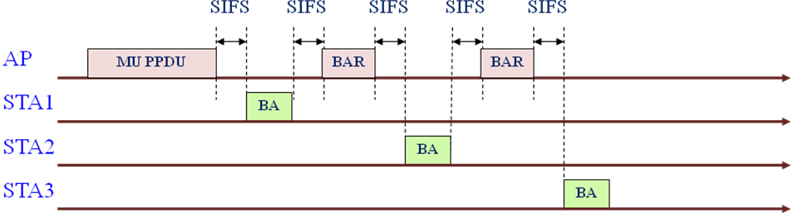

Figure 9-9a The MU PPDU acknowledgement procedure

NOTE 1 --- A BlockAck frame or an ACK frame is sent for HT-immediate or HT-delayed Block Ack respectively.

No BlockAckRequest frame should be sent to a STA in the case where the A-MPDU to that STA contained no MPDUs requiring acknowledgement.

TGac editor: Add the following new editing instructions, headings and text to TGac Draft 3.1 immediately preceding sub-clause Annex N:

Annex G

G.1 General

Add a new row to table G-1 – Attributes applicable to frame exchange sequence definition:

Attribute | Description
mu-mpdu | Frame is part of an MU PPDU

Add a new subclause G.5 VHT sequences as shown:

G.5 VHT sequences

(* This is the MU PPDU sequence *)

mu-ppdu-sequence = [(RTS[+HTC] CTS[+HTC]) | CTS+self ]
Data[+HTC]+individual +QoS +block-ack +a-mpdu+mu-mpdu
1{ Data[+HTC]+individual+QoS+implicit-bar+a-mpdu+mu-mpdu }+a-mpdu-end
BlockAck[+HTC]
1{ BlockAckReq[+HTC] BlockAck[+HTC] };

END OF Proposed Changes

Alternative choices for figure

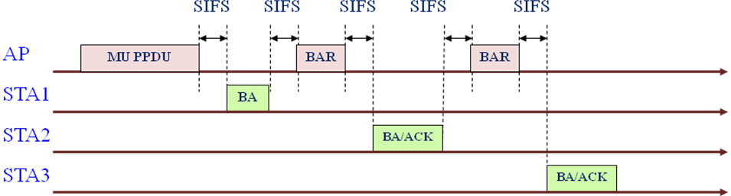

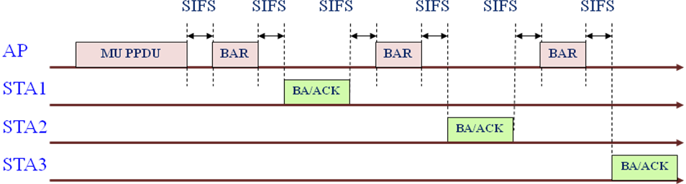

There is a need for alternate Annex G frame exchange sequence descriptions to match these exchanges, if they are to be allowed.
References:

