IEEE P802.11
Wireless LANs
LB188-CID6558-MU-Exchange
Date: 2012-08-20
Author(s):
Name | Affiliation | Address | Phone | email
Matthew Fischer | Broadcom | 190 Mathilda Place, Sunnyvale, CA 94086 | +1 408 543 3370 | mfischer@broadcom.com
Abstract
Proposed resolution for LB188 CID 6558 asking for text to describe the MU PPDU exchange. The proposed resolution also adds text to Annex G for the MU PPDU sequence.

Revision Notes

CID 6558

CID | Commenter | Page | Clause | Comment | Proposed Change | Resolution
6558 | Sigurd Schelstraete | 127.31 | 9.19.2.2a | The frame exchange sequence for a MU-MIMO PPDU is illustrated in Figure 9-19b, including BAs, BARs, ... This sequence is never spelt out explicitly in the text in a single place. It would be helpful to add text to clearly describe this new frame sequence.  (BTW, should this also be added in Annex G?) | Add text describing the MU-PPDU + acknowledgement frame sequence. | Revise – Tgac editor to make changes to TGac draft 3.1 as shown in document 11-12-1021r0 under the heading CID6558.

Discussion

TGac editor: Add the following new editing instruction, heading, text and figure to TGac Draft 3.1 immediately preceding sub-clause 9.3.4:

Add a new subclause 9.3.2.9a MU acknowledgement procedure as shown:

9.3.2.9a MU acknowledgement procedure

The acknowledgement procedure performed by a STA that receives individual MPDUs that were transmitted within an MU PPDU is the same as the acknowledgement procedure for MPDUs that were not transmitted within an MU PPDU.

All MPDUs transmitted within an MU PPDU are contained within A-MPDUs and the rules specified in 8.6.3 (A-MPDU contents) ensure that there is no more than one frame in an A-MPDU that requires an immediate response.

A STA shall not transmit, within a single MU PPDU, more than one A-MPDU that requires an immediate response. Responses to A-MPDUs within an MU PPDU that are not immediate responses are typically transmitted in response to an explicit request by the MU PPDU transmitting STA. A typical MU PPDU frame exchange sequence is shown in figure 9-9a (typical MU PPDU acknowledgement procedure).

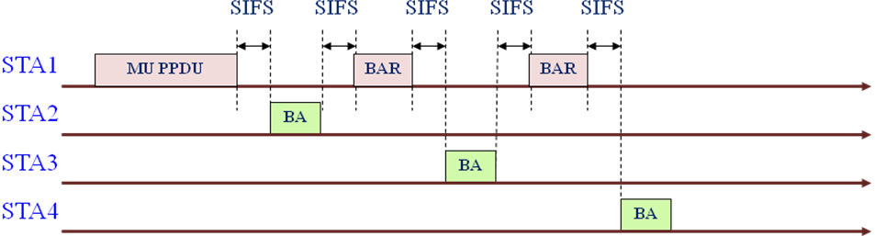

Figure 9-9a typical MU PPDU acknowledgement procedure

TGac editor: Add the following new editing instructions, headings and text to TGac Draft 3.1 immediately preceding sub-clause Annex N:

Annex G

G.1 General

Add a new row to table G-1 – Attributes applicable to frame exchange sequence definition:

Attribute | Description
mu-mpdu | Frame is part of an MU PPDU

Add a new subclause G.5 VHT sequences as shown:

G.5 VHT sequences

(* This is the MU PPDU sequence *)

mu-ppdu-sequence = [(RTS[+HTC] CTS[+HTC]) | CTS+self ]
Data[+HTC]+individual +QoS +block-ack +a-mpdu+mu-mpdu
1{ Data[+HTC]+individual+QoS+implicit-bar+a-mpdu+mu-mpdu }+a-mpdu-end
BlockAck[+HTC]
1{ BlockAckReq[+HTC] BlockAck[+HTC] };

References:

