IEEE P802.11
Wireless LANs
TVHT BSS Operation Proposal
Date: 2012-07-10
Author(s):
Name | Affiliation | Address | Phone | email
Yongho Seok | LG Electronics | 170 W. Tasman Dr.,  MS SJ-14-4, San Jose, CA 95134-1706 | +82-31-450-1947 | yongho.seok@lge.com
Abstract
Submission for candidate P802.11af draft TVHT BSS Operation text for next draft.

The editing instructions are shown in bold italic. Four editing instructions are used: change, delete, insert, and replace. Change is used to make corrections in existing text or tables. The editing instruction specifies the location of the change and describes what is being changed by using strikethrough (to remove old material) and underscore (to add new material). Delete removes existing material. Insert adds new material without disturbing the existing material. Insertions may require renumbering. If so, renumbering instructions are given in the editing instruction. Replace is used to make changes in figures or equations by removing the existing figure or equation and replacing it with a new one. Editorial notes will not be carried over into future editions because the changes will be incorporated into the base standard.

This amendment’s baseline is IEEE Std 802.11™–2012, as amended by

- Amendment 1 802.11ae-2012
- Amendment 2 802.11aa-2012
- Amendment 3 P802.11ad Draft 8.0
- Amendment 4 P802.11ac Draft 3.0

Across the globe, there are a large number of broadcast channel frequencies and rules, however in the United States, the FCC channelization rules are known and can be specified in detail. Other countries using 6 MHz broadcast channelization may allow operation above channel 51, so the global table for 6 MHz channelization states no limits.

TGaf Editor: Insert the new definitions in clause 3.3 as follows:
3. Definitions specific to IEEE 802.11 operation in some regulatory domains
primary TVHT_W MHz channel: In a TVHT_W MHz, TVHT_2W MHz, TVHT_4W MHz, TVHT_W+W MHZ or TVHT_2W+2W MHz TV high throughput (TVHT) basic service set (BSS), the TVHT_W MHz channel that is used to transmit TVHT_W MHz PPDUs. In a TVHT BSS, the primary TVHT_W MHz channel is the primary channel.
primary TVHT_2W MHz channel: In an TVHT_2W MHz, TVHT_4W MHz, or TVHT_2W+2W MHz TV high throughput (TVHT) basic service set (BSS), the TVHT_2W MHz channel that is used to transmit TVHT_2W MHz PPDUs.
secondary TVHT_W MHz channel: In a TVHT_2W MHz or TVHT_W+W MHz TV high throughput (TVHT) basic service set (BSS), the TVHT_W MHz channel not including the primary TVHT_W MHz channel, that together with the primay TVHT_W MHz channel forms the TVHT_2W MHz or TVHT_W+W Hz channel of channel of the TVHT_2W MHz or TVHT_W+W MHz TVHT BSS. In a TVHT_4W MHz or TVHT_2W+2W MHz TV high throughput (TVHT) basic service set (BSS), the TVHT_W MHz channel adjacent to the primary TVHT_W MHz channel that together forms the primary TVHT_2W MHz channel of the TVHT_4W MHz or TVHT_2W+2W MHz TVHT BSS.
secondary TVHT_2W MHz channel: In a TVHT_4W MHz or TVHT_2W+2W MHz TV high throughput (TVHT) basic service set (BSS), the TVHT_2W MHz channel not including the primary TVHT_W MHz channel, that together with the primary TVHT_2W MHz channel forms the TVHT_4W MHz or TVHT_2W+2W MHz channel of the TVHT_4W MHz or TVHT_2W+2W MHz TVHT BSS.

TGaf Editor: Insert the following rows at the end of Table 7-5:

- Channel-list parameter elements
channel-list elements | Meaning
primaryTVHT_W | For a TVHT STA, indicates that the primary TVHT_W MHz channel is busy according to the rules specified in 23.x.x.x (CCA sensitivity for signals occupying the primary TVHT_W MHz channel).
secondaryTVHT_W | For a TVHT STA, indicates that the secondary TVHT_W MHz channel is busy according to the rules specified in 23.x.x.x (CCA sensitivity for signals not occupying the primary TVHT_W MHz channel).
secondaryTVHT_2W | For a TVHT STA, indicates that the secondary TVHT_2W MHz channel is busy according to the rules specified in 23.x.x.x (CCA sensitivity for signals not occupying the primary TVHT_W MHz channel).

TGaf Editor: Insert the following paragraph and figure at the end of the 7.3.5.11.2.
For a TVHT STA, the relationship of the channel-list parameter elements to the TVHT_W MHz, TVHT_2W MHz, TVHT_4W MHz, TVHT_W+W MHz and TVHT_2W+2W MHz TVHT BSS operating channel is illustrated by example in Figure 7-af1. Note that for a TVHT_W+W MHz and TVHT_2W+2W MHz TVHT BSS the subchannels represented by secondaryTVHT_W and secondary TVHT_2W are the same as shown for the TVHT_2W MHz and TVHT_4W MHz channels except that they occur in a non-adjacent TVHT_W MHz and TVHT_2W MHz channel.
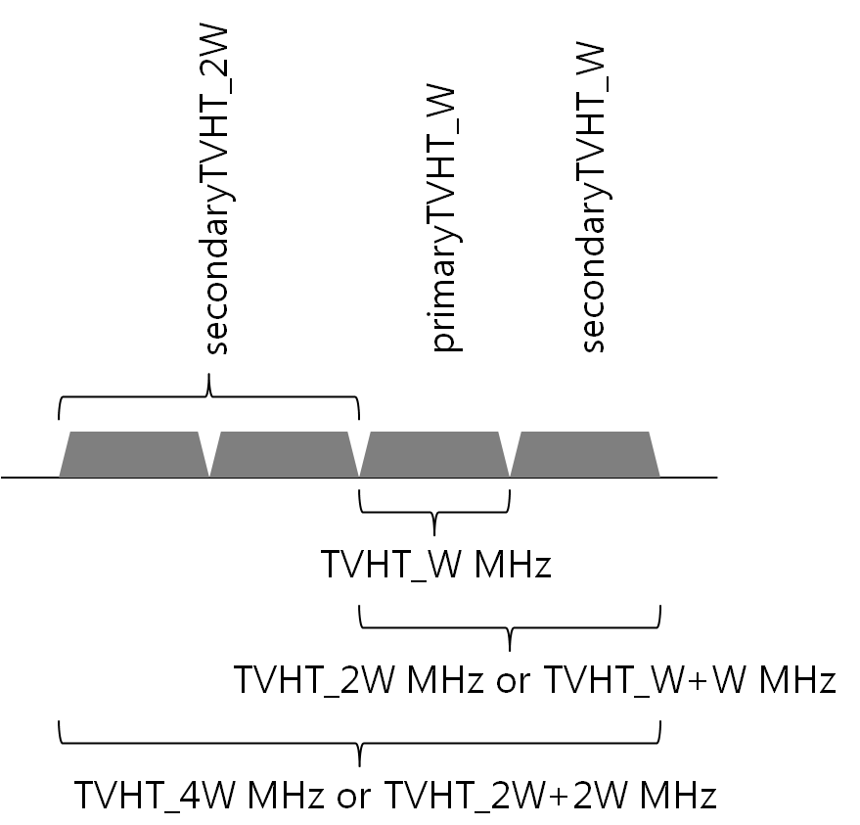
Figure 7-af1- TVHT channel-list parameter element and channel bandwidth

8.3.3.2 Beacon frame format
TGaf editor: Change the following row in Table 8-20:
Order | Information | Notes
 | TVHT Operation | The TVHT Operation element is present when the dot11TVHTOptionImplemented is true; otherwise it is not present.

8.3.3.10 Probe Response frame format
TGaf editor: Change the following row in Table 8-27:
Order | Information | Notes
 | TVHT Operation | The TVHT Operation element is present when the dot11TVHTOptionImplemented is true; otherwise it is not present.

TGaf Editor: Insert new text in 8.4.2.1 General as follows:
Table 8-54—Element IDs
Information element | Element ID | Length (in octets) | Extensible
TVHT Operation (see 8.4.2.af1) | < ANA > | 9 | Yes

TGaf Editor: Insert new subclause 8.4.2.af1 text as follows:
8.4.2.af1 TVHT Operation element
The operation of TVHT STAs in the BSS is controlled by the TVHT Operation element. The format of the TVHT Operation element is defined in Figure 8-af1.

 | Element ID | Length | TVHT Operation Information | TVHT Basic MCS Set
Octets: | 1 | 1 | 5 | 2
Figure 8-af1 - TVHT Operation element format
The Element ID field is set to the value for TVHT Operation element defined in Error: Reference source not found.
The structure of the TVHT Operation Information field is defined in Figure 8-af2.

 | Primary Channel Number | Seconday Channel Offset | Channel Width | Channel Center Frequency  Segment 0 | Channel Center Frequency  Segment 0
Octets: | 1 | 1 | 1 | 1 | 1
Figure 8-af2 - TVHT Operation Information field
The subfields of the TVHT Operation Information field are defined in Table 8-af1 (TVHT Operation Information subfields).
Table 8-af1 - TVHT Operation Information subfields
Field | Definition | Encoding
Primary Channel Number | Indicates the channel number of the primary channel. (see 10.af1.1 (Basic TVHT BSS functionality)). | Channel number of the primary channel.
Secondary Channel Offset | Indicates the offset of the secondary channel relative to the primary channel. | Set to 1 (SCA) if the secondary channel is  above the primary channel  Set to 3 (SCB) if the secondary channel is  below the primary channel  Set to 0 (SCN) if no secondary channel is present  The value 2 is reserved.
Channel Width | This field defines the BSS operating channel width (see 10.af1.1 (Basic TVHT BSS functionality)). | Set to 0 for TVHT_W operating channel width.  Set to 1 for TVHT_2W operating channel width.  Set to 2 for TVHT_W+W operating channel width.  Set to 3 for TVHT_4W operating channel width.  Set to 4 for TVHT_2W+2W operating channel width.  Values in the range 5 to 7 are reserved.
Channel Center Frequency Segment 0 | Defines the channel center frequency for a TVHT_W and TVHT_2W and TVHT_4W MHz TVHT BSS and the segment 0 channel center frequency for a TVHT_W+W and TVHT_2W+2W MHz TVHT BSS. See 23.3.14 (Channelization). | For TVHT_W MHz or TVHT_2W MHz or TVHT_4W MHz operating channel width, indicates the channel center frequency index for the TVHT_W MHz or TVHT_2W MHz or TVHT_4W MHz channel on which the TV White Space BSS operates.  For TVHT_W+W MHz or TVHT_2W+2W MHz operating channel width, indicates the channel center frequency index for the TVHT_W MHz or TVHT_2W MHz channel of frequency segment 0 on which the TVHT BSS operates.  Reserved otherwise.
Channel Center Frequency Segment 1 | Defines the segment 1 channel center frequency for a TVHT_W+W and TVHT_2W+2W MHz TVHT BSS. See 23.3.14 (Channelization). | For a TVHT_W+W MHz or TVHT_2W+2W MHz operating channel width, indicates the channel center frequency index of the TVHT_W MHz or TVHT_2W MHz channel of frequency segment 1 on which the TVHT BSS operates.  Reserved otherwise.
The TVHT Basic MCS Set field indicates the MCSs for each number of spatial streams in TVHT PPDUs that are supported by all TVHT STAs in the BSS (including IBSS). The TVHT Basic MCS Set field is a bitmap of size 16 bits; each 2 bits indicates the supported MCS set for Nss from 1 to 8. The TVHT Basic MCS Set field is defined as Rx MCS Map subfield in Error: Reference source not found

TGaf Editor: Insert a new clause 10.af1 text as follows:
10.af1 TVHT BSS operation
10.af1.1 Basic TVHT BSS functionality
The STA that is creating the BSS shall be able to receive and transmit at each of the MCS values listed in the TVHTBSSBasicMCSSet and TVHTOperationalMCSSet.
A TVHT AP declare their channel width capability in the Supported Channel Width Set subfield of the TVHT Capabilities element TVHT Capabilities Info field as described in Table 8-af1.
A TVHT AP shall set the Channel Width subfield in the TVHT Operation element TVHT Operation Information field to indicate the BSS operating channel width as shown in Table 10-af1.
Table 10-af1 - TVHT BSS operating channel width
TVHT Operation element Channel Width field | BSS operating channel width
0 | TVHT_W MHz
1 | TVHT_2W MHz
2 | TVHT_W+W MHz
3 | TVHT_4W MHz
4 | TVHT_2W+2W MHz

A TVHT STA shall determine the channelization using the TVHT Operation element TVHT Operation Information field Channel Center Frequency Segment 0 and Channel Center Frequency Segment 1 and Primary Channel offset and Secondary Channel offset subfields (see 23.3.14 (Channelization)).
A TVHT AP shall set the TVHT Operation element TVHT Operation Information field Secondary Channel Offset subfield as appropriate to the secondary TVHT_W MHz channel, if the BSS operating channel width is more than TVHT_W MHz.
A TVHT STA that is a member of a TVHT BSS shall not transmit a TVHT_W MHz TVHT PPDU on a channel other than the primary TVHT_W MHz channel of the BSS, except for a TVHT_W MHz TVHT PPDU transmission on an off-channel TDLS direct link.
A TVHT STA that is a member of a TVHT BSS with a TVHT_2W MHz, TVHT_4W MHz or TVHT_W+W MHz operating channel width shall not transmit a TVHT_2W or TVHT_W+W MHz TVHT PPDU that does not use the primary TVHT_W MHz channel and the secondary TVHT_W MHz channel of the BSS, except for a TVHT_2W, TVHT_4W or TVHT_W+W MHz TVHT PPDU transmission on an off-channel TDLS direct link.
A TVHT STA that is a member of a TVHT BSS with a TVHT_4W or TVHT_2W+2W MHz operating channel width shall not transmit a TVHT_4W or TVHT_2W+2W MHz TVHT PPDU that does not use the primary TVHT_2W MHz channel and the secondary TVHT_2W MHz channel of the BSS, except for a TVHT_4W or TVHT_2W+2W MHz TVHT PPDU transmission on an off-channel TDLS direct link.
A TVHT STA shall not transmit to a TVHT STA using a bandwidth that is not indicated as supported in the Supported Channel Width Set subfield in the VHT Capabilities element or Operating Mode Notofication fame recently received from that TVHT STA.
Except in the case of a TDLS off-channel direct-link (which is independently constrained by 10.22.6.3), a STA shall not transmit a PPDU with a TXVECTOR parameter CH_BANDWIDTH indicating a channel bandwidth that is wider than the BSS operating channel width.

