IEEE P802.11
Wireless LANs
Various comment resolutions
Date: 2012-06-06
Author(s):
Name | Affiliation | Address | Phone | email
James Gilb | Tensorcom | 5900 Pastuer Ct. #105, Carlsbad, CA 92008 | 858-229-4822 | last name at ieee dot org
Abstract
This document proposes various changes to the draft 802.11ad standard.

Introduction
All line numbers, pages and subclause numbers are from draft D8.0.

Number of subfields

Subclause 21.10.2.2.3, page 563, line 13

Comment: The TRN-R/T field has 4 N subfields only if you don't count the CE as a subfield. The CE counts as a subfield, reference 21.10.2.2.6, page 496, line 26). Thus the TRN-R/T field has 5 N subfields.

Suggested resolution: Change “4N” to “5N”

Discussion: The TRN-R/T field clearly has 5*N subfields, the only way around this would be to say “.. and that the TRN-R/T field has N CE subfields and 4N R subfields in a TRN-R and 4N T subfields in a TRN-T”, but that is much more complicated than simply stating the correct number.

21.10.2.2.3 Beam Refinement packet header fields

Editor’s instructions: replace the fourth paragraph in 21.20.2.2.3 with the following text:

A value of N in the Training Length field indicates that the AGC has 4N subfields and that the TRN-R/T field has 5N subfields.

Beam tracking illustration

Subclause 9.35.7, page 364, line 22

Comment: The figure lists initiator and responder, yet the devices switch roles as initiator and responder.

Suggested resolution: Split into two separate figures, especially because we don't want to imply that a request for TRN-R implies that a TRN-T will follow.

Discussion: The figure is shown below. One solution would be to remove the “Beam Tracking Responder” and “Beam Tracking Initiator” from the left side of the figure and list them next to the frames that are sent, switching them when the roles switch. This is shown below the original figure. This seems a little awkward. Instead, suggest splitting the figures as shown.

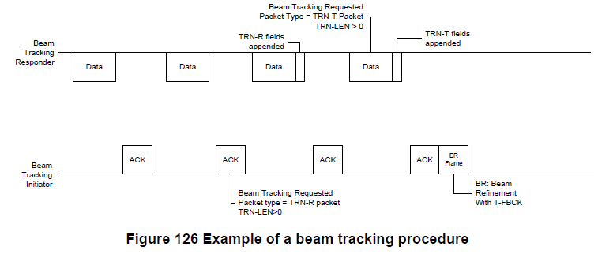
Figure modified with initiator and responder called out.
Beam Tracking
Initiator
Beam Tracking
Initiator
Beam Tracking
Responder
Beam Tracking
Responder

9.35.7 Beam tracking

Editor’s instructions: replace the figure 9-70 in 9.35.7 with the following two figures:

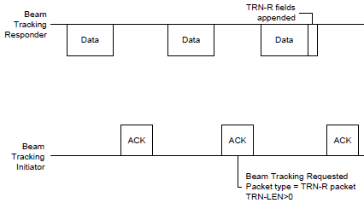
Figure 9-70: Beam tracking example with the initiator requesting TRN-R

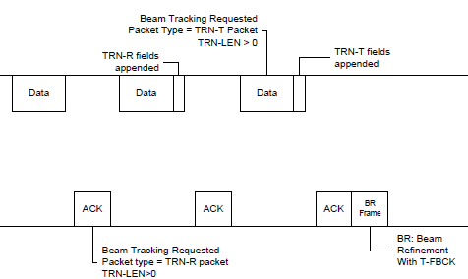
Beam
Tracking
Initiator
Beam
Tracking
Responder

Figure 9-71: Beam tracking example with the initiator requesting TRN-T

Required modes, PICS

Subclause B.4.3, page 576, line 13

Comment: Based on the published IEEE Std 802.11-2012 and this document, a compliant WiGig device would be required to implement one of the 2.4 or 5 GHz PHYs as well as the DMG PHY (e.g., you could implement FHSS (CF3) and DMG, but not DMG only). One should be able to implement a DMG device without implementing another band (this has the effect of making CF26 mandatory if CF25 is implemented).

Suggested resolution: Make CF28 DMG STA O.2 or CF25 O.2. Or is the intention that CF27 and CF28 accomplish this? If so, I hope there is text in the draft that spells this out.

B.4.3 IUT configuration

Editor’s instructions: Change the penultimate column of the row for “CF25” to be “O.2”

Multi-band, PICS

Subclause B.4.3, page 576, line 12

Comment: The logic here is slightly flawed. CF4 and CF7 are in the same band, hence at least two of CF4 and CF7 (i.e., an 802.11b STA) would technically be multi-band, but only operate in the 2.4 GHz band.

Suggested resolution: This is a little more difficult, because you have to put parentheses around (CF4 OR CF7). Or perhaps you could argue that CF7 is flawed, it refers to High-speed PHY, which occurs nowhere else in the draft. Perhaps they meant HR/DSSS PHY or even better, define High-speed PHY as the implementation of CF4 and HR/DSSS PHY and then the logic works. This needs to be fixed in the base standard anyway.

Discussion: The text says “at least two of” but then uses “OR” indicating an eqution, which would make any one of them calculate it to be true. Instead it should be a list.

B.4.3 IUT configuration

Editor’s instructions: Change the penultimate column of the row for “CF26” to be:

At least two of: (CF4 OR CF7), CF6, CF9, CF16 or CF25: O

DCF mandatory for DMG STAs, PICS

Subclause B.4.4.1, page 577, line 7

Comment: Item PC3 is listed as CF27:M, i.e., M for Non-DMG STAs. But on page 517, B4.26.1 item DMG-M7.4.1.4, DCF Access procedure is DMG-M7.4:M and going back to DMG-M7.4, this is CF25:M, i.e., mandatory for DMG functions.

Suggested resolution: Isn't DCF mandatory then for DMG STAs as well? If so, then leave DCF as M without the CF27 qualification.

Discussion: Assuming that DCF is mandatory for DMG STAs (I don’t see how this protoocol would work otherwise), then don’t make any change.

B.4.4.1 MAC protocol capabilities

Editor’s instructions: Remove the row for “PC3” in the table and the following row with ellipses, i.e. make no change to that row in the base standard.

Beam tracking cases

Subclause 9.35.7, page 364, line 16

Comment: The subclause describes only two of the four possible siturations.

Suggested resolution: Describe the case where the initiator STA requests a TRN-T packet from the responder STA and the case where the initiator STA sends a TRN-R packet with a request for receiver tracking by responder.

Discussion: There are four cases (actually 8, but let’s ignore that for now) for initiating a beam tracking (according to the description of the Packet Type field)
- TRN-T packet with Beam Tracking Request = 0
- TRN-R packet with Beam Tracking Request = 0
- Regular packet requesting receiver beam tracking
- Regular packet requesting transmitter beam tracking

Cases 3 and 4 are described in the text: cases 1 and 2 are not.

A summary of the cases is shown in the following table.
Table 1: PHY header settings for beam training
Training Length | Beam Tracking Request | Packet Type | Description | Action by receiver
0 | 0 | X | Regular packet, no training. | Normal packet response. Packet type is reserved when Training length is 0 (Table 75 and Table 79)
0 | 1 | X | Should be disallowed, but isn’t. | This could be a request for beam training, however each request requires interpreting the Packet Type field, which is reserved if the Training Length field is zero.
!= 0 | 1 | 0 | Receiver beam tracking request | Send TRN-R packet at next available opportunity.
!= 0 | 1 | 1 | Transmit beam tracking request. | Send TRN-T packet at next available opportunity.
!= 0 | 0 | 0 | TRN-R packet | Train RX antenna using packet.
!= 0 | 0 | 1 | TRN-T packet | Measure training fields to report back in feedback packet.

The second row is really a mistake, we should not allow that combination of fields, i.e., we should make Beam Tracking Request reserved when the Training Length field is zero.

The case for a non-zero Training Length field, Beam Tracking Request field set to one and Packet Type field set to one should not be allowed as there is no reason to request that a STA performs transmit beam tracking.

9.35.7 Beam tracking

Editor’s instructions: Add the following two paragraphs to 9.35.7 at an appropriate location:

A STA (beam tracking initiator) may also request a peer STA (beam tracking responder) to perform receive beam tracking by setting, in a transmitted packet, the Beam Tracking Request field to zero, the Training Length field to a non-zero value, the Packet Type field to zero, and append and append an AGC field and TRN-T subfields to the packet.

A beam tracking responder that receives a packet with the Beam Tracking Request field in the PLCP header equal to zero, the Training Length field in the PLCP header equal to a non-zero value and the Packet Type field in the PLCP header equal to zero, shall follow the rules described in 21.10.2.2 and may use the beam refinement AGC field and TRN-R subfields appended to the packet received to perform receive beam training.

Editor’s instructions: In Table 75 and Table 79, add the following sentence to the Description cell of the Beam Tracking Request row:

The Beam Tracking Request field is reserved when the Training Length field is 0.

Editor’s instructions: In Table 75 and Table 79, change the Description cell of the Packet Type row as shown (NOTE: If the editor wants to save some time and avoid future mistakes, the fields in Table 79 that have the same definition as in Table 75 should be replaced with “As defined in Table 75”):

Corresponds to the TXVECTOR parameter PACKET-TYPE.

If the Beam Tracking Request field is 0 then:
- Packet Type = 0 indicates TRN-R packet
- Packet Type = 1 indicates TRN-T packet
If the Beam Tracking Request field is 1 then:
- Packet Type = 0 indicates a receiver beam tracking request
- Packet Type = 1 indicates a transmit beam tracking request

If the Packet Type field is 1 and the Training Length field is a non-zero value, then the Beam Tracking Request field shall not be set to one.

The Packet Type field is reserved when the Training Length field is 0.

