IEEE P802.11
Wireless LANs
D0.1 Comment Resolution – CID 501
Date: May 4, 2011
Author(s):
Name | Affiliation | Address | Phone | email
Youhan Kim | Atheros |  |  | youhan.kim@atheros.com
Abstract
This document provides resolution for the following CID on TGac D0.1.

CID: 501

Comments (page and line numbers) are based on D0.1.
Proposed edits are based on D0.4.

CID | Subclause | Page | Line | Comment Type | Comment | SuggestedRemedy
501 | 22.3.20.2 | 143 | 8 | TR | The interfering signal should also be an 80+80 signal, with each segment next to one of the desired signal's segment. Ditto for non-adjacent tests in 22.3.20.3 | As in comment

Discussion:
80+80 MHz is 160 MHz split into two frequency segments. Hence it is reasonable to expect similar adjacent/non-adjacent channel rejection performance between 80+80 MHz and 160 MHz [11/0030r0].
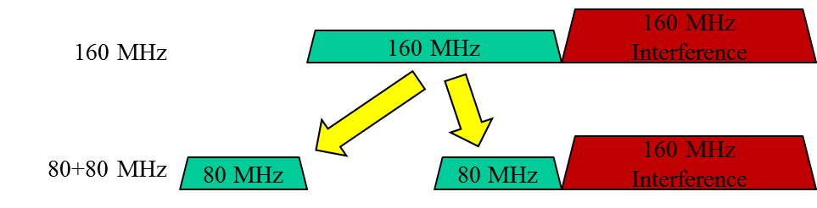

However, it may often be unclear on where to place the 160 MHz interferer next to the 80 MHz segment due to limited number of 160 MHz channels available. Hence, the current test is desiged to test with 80 MHz interference instead for ease of testing.

Note that only one of the frequency segments is subject to adjacent/non-adjacent channel interference in this test. Hence, it would be prudent to specify in the standard that the test be conducted at least twice, once with interference next to one of the frequency segments, and the second time with the interference placed next to the other frequency segment. This would ensure that both receive chains for the two frequency segments can tolerate adjacent/non-adjacent channel interferences.
80 MHz
80 MHz
80 MHz
Interf.
Test 1
80 MHz
80 MHz
80 MHz
Interf.
Test 2
Adjacent Channel Rejection

80 MHz
80 MHz
80 MHz
Interf.
Test 1
80 MHz
80 MHz
80 MHz
Interf.
Test 2
Nonadjacent Channel Rejection

Response:
COUNTER.

Proposed Resolution Text:

22.3.20.2 Adjacent channel rejection
Adjacent channel rejection for 80+80 MHz channels shall be measured by setting the desired signal’s strength 3 dB above the rate dependent sensitivity specified in Table 22-20 (Receiver(#1707) minimum input level sensitivity)(#93). Then, an interfering signal of 80 MHz bandwidth is introduced, where the center frequency of the interfering signal is placed 80 MHz away from the center frequency of the frequency segment lower in frequency of the desired signal. The power of the interfering signal is raised until 10% PER is caused for a PSDU length of 4096 octets. Let be the power difference between the interfering and desired signal. Next, the interfering signal of 80 MHz bandwidth is moved to a frequency where the center frequency of the interfering signal is 80 MHz away from the center frequency of the frequency segment higher in frequency of the desired signal. The power of the interfering signal is raised until 10% PER is caused for a PSDU length of 4096 octets. Let be the power difference between the interfering and desired signal. The smaller value between and is the corresponding adjacent channel rejection.

22.3.20.3 Nonadjacent channel rejection
Nonadjacent channel rejection for 80+80 MHz channels shall be measured by setting the desired signal’s strength 3 dB above the rate dependent sensitivity specified in Table 22-20 (Receiver(#1707) minimum input level sensitivity). Then, an interfering signal of 80 MHz bandwidth is introduced, where the center frequency of the interfering signal is placed at least 160 MHz away from the center frequency of the frequency segment lower in frequency of the desired signal. At the same time, the center frequency of the interfering signal should be at least 160 MHz away from the center frequency of the frequency segment higher in frequency of the desired signal. The power of the interfering signal is raised until 10% PER is caused for a PSDU length of 4096 octets. Let be the power difference between the interfering and desired signal. Next, the interfering signal of 80 MHz bandwidth is moved to a frequency where the center frequency of the interfering signal is at least 160 MHz away from the center frequency of the frequency segment higher in frequency of the desired signal. At the same time, the center frequency of the interfering signal should be at least 160 MHz away from the center frequency of the frequency segment lower in frequency of the desired signal. The power of the interfering signal is raised until 10% PER is caused for a PSDU length of 4096 octets. Let be the power difference between the interfering and desired channel. The smaller value between and is the corresponding nonadjacent channel rejection.

Straw Poll
Do you agree with comment resolution in 11-0639/r0?

