IEEE P802.11
Wireless LANs
Resolutions for CIDs 7151,7537, 8089 and 8108 in Explicit TxBF Comments of LB129
Date: 2008-06-18
Author(s):
Name | Company | Address | Phone | email
Joonsuk Kim | Broadcom | 190 Mathilda Place, Sunnyvale, CA 94086 | +1 408 543 3455 | joonsuk@broadcom.com
Vinko Erceg | Broadcom | 15435 Innovation Dr.  San Diego, CA 92128 | +1 858 521 5885 | verceg@broadcom.com
Matt Fischer | Broadcom | 190 Mathilda Place, Sunnyvale, CA 94086 |  | mfischer@broadcom.com
Abstract
This submission proposed resolutions to the CIDs 7151, 7537, 8089 and 8108 in LB 129.
Reference: Draft D5.0

Notice: This document has been prepared to assist IEEE 802.11. It is offered as a basis for discussion and is not binding on the contributing individual(s) or organization(s). The material in this document is subject to change in form and content after further study. The contributor(s) reserve(s) the right to add, amend or withdraw material contained herein.
CID 7151
7151 | 56.33 | 7.3.1.29 |  |  | Definition of the quantization of angles is backwards. I believe what is meant is the value k such that ((k*pi/2**(b sub psi +1) + pi/2**(b sub psi + 2)) <= Psi <= (((k+1)*pi/2**(b sub psi + 1) + pi/2**(b sub psi +2)), and similar for Phi -- where the values of Psi and Phi are already determined, and the value k is the one to be determined by the formula. The purpose of clause 7 is to define the encoding used in the field, so it should show how to take a value of Phi/Psi and determine the value to include in the Beamforming Report. | as in comment

Proposed Resolution: Reject

Reason for rejection:
The standard specification needs to specify the operation of the transmission, so that all receivers from various vendors can operate with the assumption how the packet is generated. This definition of angles describes how to find the angles for compressed feedback for Tx in order to find the steering matrix Q. So, decoding process (from k to Phi and Psi) needs to be defined when k is given in the explicit feedback report from the beamformee.

CID 7537

7537 | 302.53 | 20.3.12 |  |  | normative statement needed here | either change "replaces" to "shall replace", or make it clear that this subclause is an illustrative example of a possible algorithm

Proposed Resolution: Counter

Reason for counter: “replace” is an action verb to instruct the beamformer how to behave when beamforming is used, so it makes sense to put “shall”.

TGn Editor: on page 302, line 58, replace “the beamformer replaces x_k” with “the beamformer shall replace x_k”.

CID 8089

8089 | 173.42 | 9.19.3 |  |  | The paras starting lines 43 and 49 are inconsistent. The first one contains a "may" for sending feedback response a SIFS after the NDP. The second one contains a "shall". | Make the two consistent. Replace the second cited para with: "If the transmission of a control response frame is not required in response to the NDP request for feedback, the feedback response frame may be transmitted a SIFS after the reception of the NDP. If the feedback response frame is not transmitted a SIFS after the reception of the NDP, the feedback response frame is delayed until the beamformee’s next transmission within the TXOP

Proposed Resolution: Counter

Reason for Counter: These cases are for immediate or delayed & immediate (aggregated) feedback as a response to an NDP request for feedback. The first bullet is the case of when the transmission of a control response frame is required (i.e., delayed and immediate feedback in Table 7-43o (page 77) may apply), and the second bullet is the case when the transmission of a control response frame is not required (i.e., immediate feedback in Table 7-43o (page 77) can apply). Therefore, “may” in the first bullet and “shall” in the second bullet are the right words.

We may also need to note that the third bullet is a more detail special case description of the last sentence of the first bullet. In order to avoid any further confusion, we propose to change the order of bullets in the line 43 to 55 as follows:

TGn Editor: on page 173, replace “line 43-line55” with following.

-- If the transmission of a control response frame is required in response to the NDP request for feedback,
the control response frame is transmitted a SIFS after reception of the PPDU that elicited the
control response and the feedback response frame may be transmitted a SIFS after the reception of
the NDP. If the feedback response frame is not transmitted a SIFS after the reception of the NDP, the
feedback response frame is delayed until the beamformee’s next transmission within the TXOP.
** If the feedback response frame is not transmitted a SIFS after the reception of the NDP, and the beamformee is subsequently required to transmit an ACK or BlockAck response in the same TXOP, the feedback response may be aggregated with the ACK or BlockAck.
** If the feedback response frame is not transmitted a SIFS after the reception of the NDP, and is not transmitted as part of an aggregated ACK or BlockAck response in the same TXOP, then the feedback response frame is delayed until the beamformee’s next transmission within the TXOP.

-- If the transmission of a control response frame is not required in response to the NDP request for
feedback, the feedback response frame shall be sent a SIFS after the reception of the NDP.

-- If the immediate feedback capable beamformee does not transmit the feedback response a SIFS after
the end of the received NDP, and the beamformee is subsequently required to transmit an ACK or
BlockAck response in the same TXOP, the feedback response may be aggregated with the ACK or
BlockAck.

CID 8108

8108 | 52.38 | 7.3.1.27 |  |  | The SNR feedback value reported in the  - CSI Report fixed field (7.3.1.27 p52, l38-39)  - Non-compressed Beamforming Report fixed field (7.3.1.28 p54, l64-65)  - Compressed Beamforming Report fixed field (7.3.1.29 p58, l1-2)  is the average in dB of the SNR_dB across the carriers which is a poor performing performance indicator since if a very poor SNR is experienced on one carrier (i.e. -200dB) then the overall average will be biaised by this value. | In all the other modern standard (IEEE802.16, 3GPP LTE etc.) a capacity based or effective SNR mapping is employed. Please consider to change the metric with a better one for example:  10^(\sum_{k carriers} \log_10(1+SNR_k))  This way if a carrier has a very bad SNR the log(1+SNR) is null and does not affect the overall averaging. This will provide a far better effective SNR mapping representing an achievable throughput
Proposed Resolution: Reject

Reason for rejection:

This comment is an identical comment in LB 115 (CID 5174, 5175) which was rejected with following reason (reference: 11-07-2848r0)

[QUOTE:
For CSI feedback, the SNR report represents the pre-processing for each receive chain, which is well-represented by the current definition in D3.01 (i.e. dB value of linear average). Fading-dip in one tone should not degrade the linear average value significantly. The sugested expression, which is derived from the pre-processing SNR, does not reflect Shannon capacity.

For Non-Compressed and Compressed feedback, the SNR defined in D3.01 is geometric mean over presented subcarriers which give much simpler expression without much discrepancy from the SNR values expressed in this comment. The current expression in the draft D3.01 does not reflect true Shanon capacity but simplified approximation.

These changes have been proposed and accepted unanimously for LB 97 resolution. The previous document for this resolution for LB97 can be found in the document 07/2400r2.]

We also tried to find out the difference between two different methods of SNR definition (original in the spec and new proposal in CID8108). With 4-ray Rayleigh fading channel with delay spread of 85 nsec, the difference is usually less than 0.5dB in Figure 1. (the scale in y-axis is dB and x-axis is time stamp)

Therefore, we believe simpler version of SNR definition should be adopted for less computation in implementation when we see there are small differences from suggested SNR definition. Current definition is also being used for HSPA standards for the same reason.
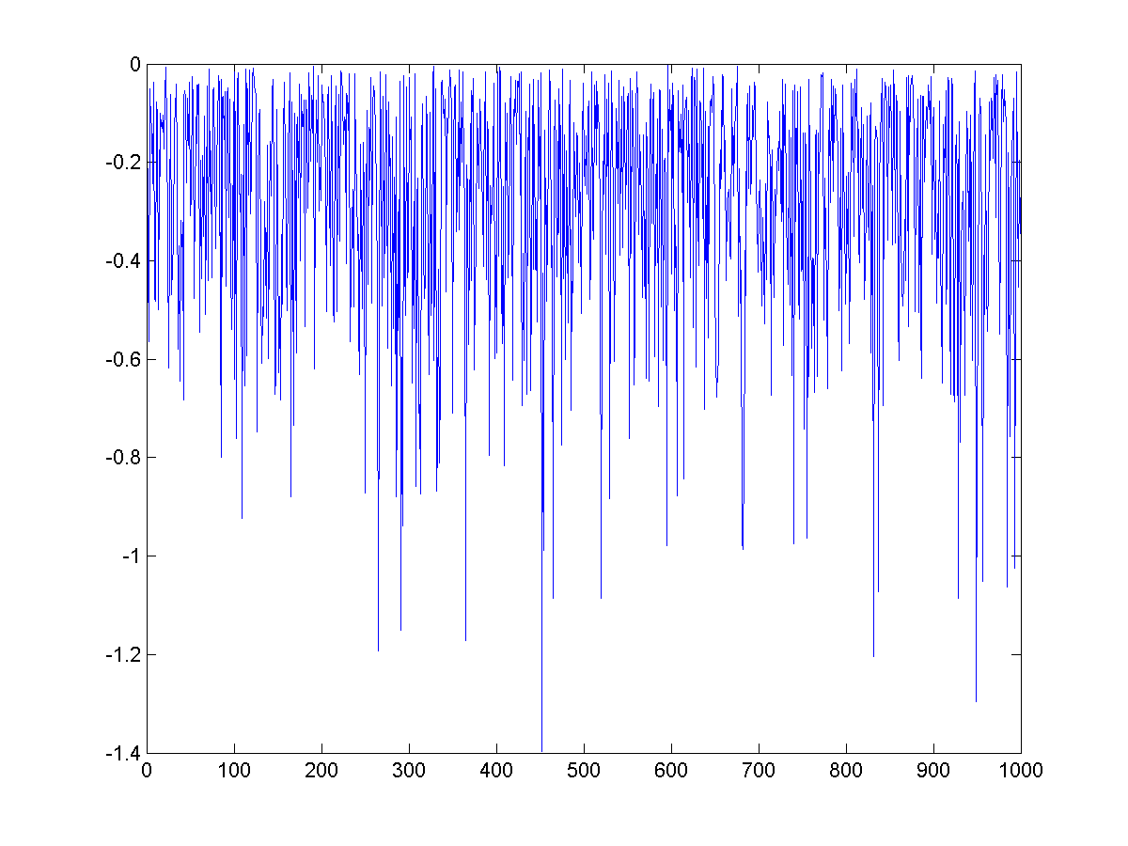
Figure 1. SNR value difference in dB scale between two SNR definition

