IEEE P802.11
Wireless LANs
802.11 TGn Submission A-MSDU in 7.2.2.1
Date: 2008-01-16
Author(s):
Name | Company | Address | Phone | email
Amit Bansal | Wipro-Newlogic |  | +49 89 12477416 | amit.bansal@wipro.com
Abstract
This document contains proposed changes to the IEEE P802.11n Draft to correct a problem found in section 7.2.2.1 regarding carrying of A-MSDU in non QoS Data types.

The changes marked in this document are based on TGn Draft version D3.02.

Problem

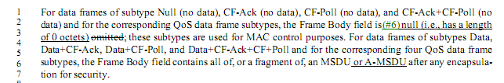

The usage of “A-MSDU” in the text above is incorrect. It does not apply to non QoS Data frames like Data, Data + CF-Ack, etc.

Proposed resolution

TGn Editor: Change subclause 7.2.2.1 on page 35, lines 4 to 7 to the following:

For data frames of subtypes Data, Data+CF-Ack, Data+CF-Poll, and Data+CF-Ack+CF+-Poll, and for the corresponding four QoS data frame subtypes, the Frame Body field contains all of, or a fragment of, an MSDU after any encapsulation for security. For data frames of subtypes QoS Data, QoS Data+CF-Ack, QoS Data+CF-Poll, and QoS Data+CF-Ack+CF-Poll the Frame Body field contains all of, or a fragment of, an MSDU or A-MSDU after any encapsulation for security.

