IEEE P802.11
Wireless LANs
Updates on Peer Link Management Protocol
Date: 2007-07-16
Author(s):
Name | Company | Address | Phone | email
Meiyuan Zhao | Intel Corp. | RNB-6-61, 2200 Mission College Blvd, Santa Clara, CA 95052 | +1-408-653-5517 | meiyuan.zhao@intel.com
Jesse Walker | Intel Corp. | JF3-206, 2111 NE 5th Ave, Hillsboro, OR 97124 | +1-503-712-1849 | jesse.walker@intel.com
W Steven Conner | Intel Corp. | JF3-206, 2111 NE 5th Ave, Hillsboro, OR 97124 | +1-503-264-8036 | w.steven.conner@intel.com
Abstract
This submission updates the Peer Link Management protocol regarding two issues:
- the inconsistency in the definition of Peer Link Management frame format.
- the mistakes and inconsistency in the specification of the finite state machine

rev: de2004-11-18

Proposed text
Update 7.3.2.61 as indicated below:
- Peer Link Management element
The Peer Link Management element is transmitted by an MP to manage a peer link with a peer MP. The format of the Peer Link Management element is shown in Pee.
Octets: 1 | 1 | 1 | 2 | 2 | 2
Element ID | Length | Subtype | Local Link ID | Peer Link ID | Reason Code
- Peer Link Management element

The Element ID is set to the value given in Error: Reference source not found for this information element.
The Subtype field specifies the type of the Peer Link Management element. There are three subtypes: Peer Link Open (0), Peer Link Confirm (1), and Peer Link Close (2). The values 3—2⁸-1 are reserved.
The Peer Link Management element with subtype 0 is referred to as Peer Link Open element. The Peer Link Management element with subtype 1 is referred to as Peer Link Confirm element. The Peer Link Management element with subtype 2 is referred to as Peer Link Close element.
The value of the Length field varies depending on the subtype of the Peer Link Management element. The Length is 7 for Peer Link Close, 3 for Peer Link Open, and 5 for Peer Link Confirm.
The Local Link ID is the integer generated by the MP to identify the link instance. This field is present for all three types of Peer Link Management elements
.
The Peer Link ID is the integer generated by the peer MP to identify the link instance. This field is not present for the Peer Link Open subtype, is present for the Peer Link Confirm subtype, and may be present for the Peer Link Close subtype.
The Reason Code field enumerates reasons for sending a Peer Link Close. It is present for the Peer Link Close subtype and is not present for Peer Link Open or Peer Link Confirm subtypes. This field enumerates the following reasons:
- MESH-LINK-CANCELLED: IEEE 802.11 SME cancels the link instance.
- MESH-MAX-NEIGHBORS: The limit of maximum of neighbors is reached.
- MESH-CONFIGURATION-POLICY-VIOLATION: The received request violates the MP’s Mesh Configuration.
- MESH-CLOSE-RCVD: The MP has received a correct Peer Link Close message (according to criteria defined in 11A.2.2).
- MESH-MAX-RETRIES: The limit of dot11MeshMaxRetries is reached.
- MESH-CONFIRM-TIMEOUT: The confirmTimer times out.

- Peer Link Open frame format
Update table s9 as indicated below:

- Peer Link Open frame body
Order | Information | Notes
 | Category
 | Action Value
 | Capability
 | Supported rates
 | Extended Supported Rates | The Extended Supported Rates element is present whenever there are more than eight supported rates, and it is optional otherwise.
 | Power Capability | The Power Capability element shall be present if dot11SpectrumManagementRequired is true.
 | Supported Channels | The Supported Channels element shall be present if dot11SpectrumManagementRequired is true.
 | RSN | The RSN information element is only present within Peer Link Open frames generated by MPs that have dot11RSNAEnabled set to TRUE.
 | QoS Capability | The QoS Capability element is present when dot11QoS-OptionImplemented is true.
 | Mesh ID | The Mesh ID information element is present when dot11MeshEnabled is true.
 | Mesh Configuration | The Mesh Configuration information element is present when dot11MeshEnabled is true.
 | Peer Link Management | The Peer Link Management information element is present only when dot11MeshEnabled is true. The subtype of the Peer Link Management Element is set to 0.
 | MSCIE | The MSCIE element is present when dot11MeshEnabled is true.
 | MSAIE | The MSAIE element is present when dot11MeshEnabled is true.
Last | Vendor Specific | One or more vendor-specific information elements may appear in this frame. This information element follows all other information elements.

- Peer Link Close frame format
Update Table s11 as indicated below:

- Peer Link Close frame body
Order | Information | Notes
 | Category
 | Action Value
 | Reason code
 | Peer Link Management | The Peer Link Management information element is present only when dot11MeshEnabled is true. The subtype of the Peer Link Management Element is set to 2.
Last | Vendor Specific | One or more vendor-specific information elements may appear in this frame. This information element follows all other information elements.

11A.2.3.3 State transitions
Update Table s41 and Figure s68 as indicated below:
Table s41—Peer Link Management Finite State Machine

 |  | To State
 |  | IDLE | LISTEN | OPN_SNT | CNF_RCVD | OPN_RCVD | ESTAB | HOLDING
From State | IDLE |  | PASOPN/ -- | ACTOPN/ (sndOPN, setR)
From State | LISTEN | CNCL / -- |  | ACTOPN/ (sndOPN, setR) |  | OPN_ACPT/ (sndOPN, sndCNF, setR)
From State | OPN_SNT |  |  | TOR1/ (sndOPN, setR) | CNF_ACPT/ (clR, setC) | OPN_ACPT/ (sndCNF) |  | CLS_ACPT, OPN_RJCT, CNF_RJCT, TOR2, CNCL/ (sndCLS, clR, setH)
From State | CNF_RCVD |  |  |  | CNF_ACPT / -- |  | OPN_ACPT / (clC, sndCNF) | CLS_ACPT, OPN_RJCT, CNF_RJCT, CNCL/ (sndCLS, clC, setH)  TOC / (sndCLS, setH)
From State | OPN_RCVD |  |  |  |  | TOR1 / (sndOPN, setR) | CNF_ACPT / clR | CLS_ACPT, OPN_RJCT, CNF_RJCT,TOR2, CNCL/ (sndCLS, clR, setH)
From State | ESTAB |  |  |  |  |  | OPN_ACPT / sndCNF | CLS_ACPT, OPN_RJCT, CNF_RJCT,CNCL/ (sndCLS, setH)
From State | HOLDING | TOH, CLS_ACPT / -- |  |  |  |  |  | OPN_ACPT, CNF_ACPT, OPN_RJCT, CNF_RJCT / sndCLS

Figure s68 Finite State Machine of Peer Link Management Protocol

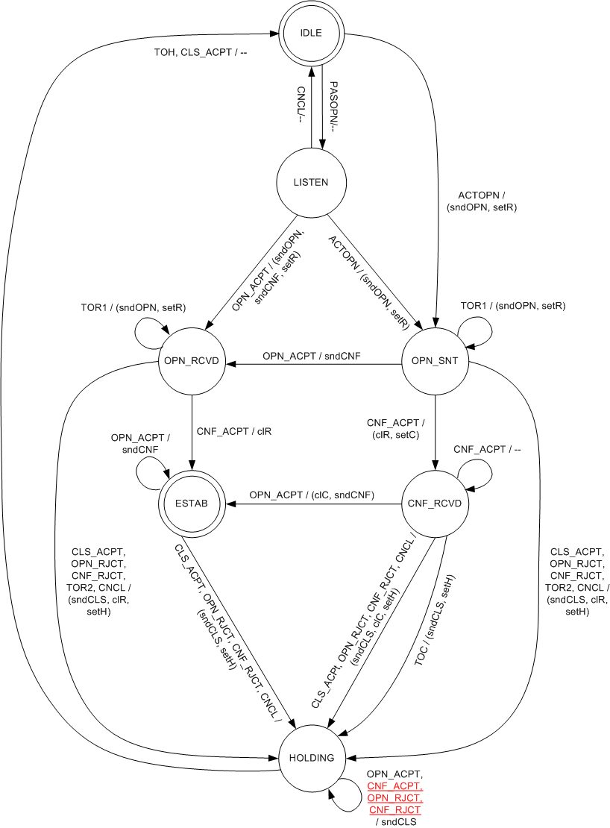

11A.2.3.10 HOLDING state
Replace text line 33—39 on page 109 with the following:
When an OPN_ACPT event occurs, the MP shall respond by resending the corresponding Peer Lik Close frame. No state transition occurs.
When a CNF_ACPT event occurs, the MP shall respond by resending the corresponding Peer link Close frame. No state transition occurs.
When any of the following four events occurs, the MP shall respond by sending the corresponding Peer Link Close frame. No state transition occurs: OPN_ACPT, CNF_ACPT, OPN_RJCT, CNF_RJCT.

