IEEE P802.11
Wireless LANs
TGp LB 92 WAVE Advertisement - Quick Beacon Proposal
Date: 2007-05-08
Author(s):
Name | Company | Address | Phone | email
Francois Simon | ARINC, Inc. | 2551 Riva Road, Annapolis, MD 21401 | 410-266-4531 | fsimon@arinc.com
W. Fisher | ARINC, Inc | 2551 Riva Road, Annapolis, MD | 410-266-4958 | wfisher@arinc.com
Abstract
There were many comments to Letter Ballot 92 about not using beacons for WAVE; this is a proposal of a beacon for WAVE use – Quick Beacon. WAVE mode supports data exchange between STAs without having to first establish a BSS. The WAVE Mode BSS (WBSS) provides for rapid establishment of a LAN, a capability required in rapidly changing communication environments.
Notice: This document has been prepared to assist IEEE 802.11. It is offered as a basis for discussion and is not binding on the contributing individual(s) or organization(s). The material in this document is subject to change in form and content after further study. The contributor(s) reserve(s) the right to add, amend or withdraw material contained herein.

Release: The contributor grants a free, irrevocable license to the IEEE to incorporate material contained in this contribution, and any modifications thereof, in the creation of an IEEE Standards publication; to copyright in the IEEE’s name any IEEE Standards publication even though it may include portions of this contribution; and at the IEEE’s sole discretion to permit others to reproduce in whole or in part the resulting IEEE Standards publication. The contributor also acknowledges and accepts that this contribution may be made public by IEEE 802.11.

Patent Policy and Procedures: The contributor is familiar with the IEEE 802 Patent Policy and Procedures <http:// ieee802.org/guides/bylaws/sb-bylaws.pdf>, including the statement "IEEE standards may include the known use of patent(s), including patent applications, provided the IEEE receives assurance from the patent holder or applicant with respect to patents essential for compliance with both mandatory and optional portions of the standard." Early disclosure to the Working Group of patent information that might be relevant to the standard is essential to reduce the possibility for delays in the development process and increase the likelihood that the draft publication will be approved for publication. Please notify the Chair <stuart@ok-brit.com> as early as possible, in written or electronic form, if patented technology (or technology under patent application) might be incorporated into a draft standard being developed within the IEEE 802.11 Working Group. If you have questions, contact the IEEE Patent Committee Administrator at <patcom@ieee.org>.
WAVE Service Advertisement – Quick Beacon Proposal

The on-demand Quick Beacon proposal allows an application or upper layers to request the transmission of one or more beacons to establish a WAVE BSS (WBSS) as needed. The Quick Beacon allows the SME to request transmission of one or more Quick Beacons sequentially if necessary. All the required information from the applications and upper layers are provided within a single Quick Beacon management frame.

Model

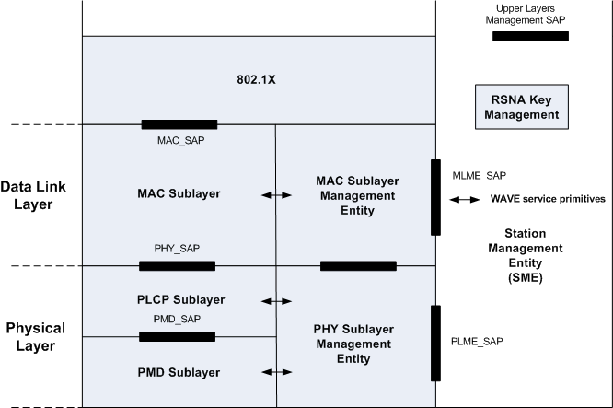

Figure 1 – WAVE Quick Beacon service related to 802.11 Model

Primitives

The following primitives are proposed at the MLME_SAP.

MLME-QUICKBEACON.request

The primitive is generated by the SME to request the MLME to advertise the presence of a WAVE BSS (WBSS).

MLME-QUICKBEACON.request
(
Timestamp,
Capability Information,
SSID,
Supported Rates,
EDCA Parameter Set,
QoS Capability (optional),
WSI,
Vendor Specific information (optional),
)

MLME-QUICKBEACON.confirm

The primitive reports the result of the MLME_QUICKBEACON.request.

MLME_QUICKBEACON.confirm

(
ResultCode
)

MLME-QUICKBEACON.indication

The primitive is sent by the MLME to the SME to indicate the reception of the Quick Beacon management frame.

MLME-QUICKBEACON.indication
(
BSSID,
SSID,
Timestamp,
Local Time
Capability Information,
BSSBasicRateSet,
OperationalRateSet,
EDCA Parameter Set,
WSI,
Transmitter MAC Address,
RCPI*,
)

* - Received Channel Power Indicator (RCPI) is a parameter introduced by TGk

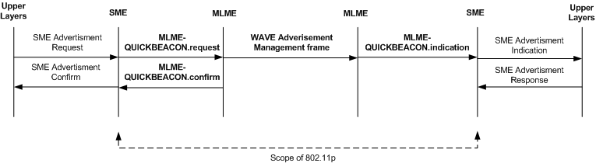

Figure 2 – WAVE Service Advertisement Primitives Flow

MLME Peer-to-Peer WAVE Advertisement Frame

In this proposal, the WAVE advertisement frame is a broadcast management frame (new) of the format defined in IEEE 802.11 REVma/9.0 – Clause 7.2.3. Within the Frame Control Field of this management frame, the Type subfield is set to 0b00 and Subtype value set to 0bxxxx, where xxxx are four bits from the Reserved Subtype values (IEEE 802.11 REVma/9.0 – Table 1) indicating a WAVE Advertisement management frame. The value 0bxxxx is to be allocated by IEEE ANA.

WAVE Advertisement frame elements

Upon receiving a MLME-QUICKBEACON.request the MLME generates a WAVE Advertisement management frame containing the following elements in Frame Body field of the frame:

- Timestamp as specified in IEEE 802.11 REVma/9.0 – Clause 7.3.1.10

- Capability Information as specified in IEEE 802.11 REVma/9.0 – Clause 7.3.1.4

- SSID as specified in IEEE 802.11 REVma/9.0 – Clause 7.3.2.1

- Supported Rates as specified in IEEE 802.11 REVma/9.0 – Clause 7.3.2.2

- EDCA Parameter Set as specified in IEEE 802.11 REVma/9.0 – Clause 7.3.2.29

- QoS Capability as specified in IEEE 802.11 REVma/9.0 – Clause 7.3.2.35. This element is optional for WAVE Advertisement.

- WSI – WAVE Service Information. This element contains WAVE management information related to configuration details to the SME that are outside the scope of the IEEE 802.11 standard. The WSI Information element requires an extended length and shall be used only in the WAVE Advertisement management frames. The WSI information element is shown in Figure 3 below. This information element ID – 0dyyy - shall be obtained from the Reserved list in IEEE 802.11 REVma/9.0 – Clause 7.3.2 – Table 26.

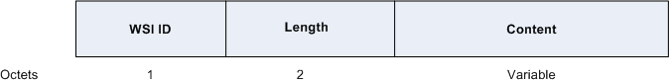

Figure 3 – WSI Information Element Format

- Vendor Specific information as specified in IEEE 802.11 REVma/9.0 – Clause 7.3.2.26. This element is optional for WAVE Advertisement.

Quick Beacon WAVE Advertisement Frame

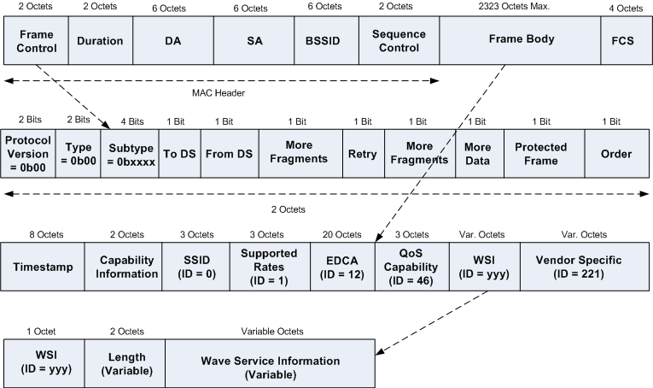

Figure 4 – Quick Beacon Advertisement Frame

Anticipated Changes in REVma/9.0 for WAVE Quick Beacon

The major changes anticipated in 802.11 REVma/9.0 are listed below. Note that these changes address the WAVE Service Advertisement only.

- Clause 3 – Definitions (WAVE, WSI)

- Clause 4 – Abbreviations & Acronyms (WAVE, WSI)

- Clause 5 – General Description ( WAVE mode and WAVE BSSs)

- Clause 7 – Frame Format
  - New Quick Beacon Management Frame
  - New Information Element (WSI)
  - WSI IE requires a 2 octet length field

- Clause 9 – WAVE Mode Operations

- Clause 10 – Layer Management – (New set of primitives for WAVE - MLME-QUICKBEACON.xxxxxxx)

- Clause 11 – MLME (Synchronization, WAVE Mode Management, Initialization of a WBSS)

- Annex A: - MIB – (addition of dot11WAVEWSI object)

References:

[1] P802.11 – REVma – D9.0

[2] Draft – P802.11p_D2_02

