IEEE P802.11
Wireless LANs
TGn LB84 Submission for improved STBC schemes CID 690
Date: 2007-01-08
Author(s):
Name | Company | Address | Phone | email
Yuli Yang | Huawei Technologies | Beijing, China | 86-10-82829016 | yangyuli@huawei.com

Abstract
This document contains proposed changes to the IEEE P802.11n Draft to address the following LB84 comments:

CID: 690

The changes marked in this document are based on TGn Draft version P802 11n D1 06.pdf.
Notice: This document has been prepared to assist IEEE 802.11. It is offered as a basis for discussion and is not binding on the contributing individual(s) or organization(s). The material in this document is subject to change in form and content after further study. The contributor(s) reserve(s) the right to add, amend or withdraw material contained herein.

Release: The contributor grants a free, irrevocable license to the IEEE to incorporate material contained in this contribution, and any modifications thereof, in the creation of an IEEE Standards publication; to copyright in the IEEE’s name any IEEE Standards publication even though it may include portions of this contribution; and at the IEEE’s sole discretion to permit others to reproduce in whole or in part the resulting IEEE Standards publication. The contributor also acknowledges and accepts that this contribution may be made public by IEEE 802.11.

Patent Policy and Procedures: The contributor is familiar with the IEEE 802 Patent Policy and Procedures <http:// ieee802.org/guides/bylaws/sb-bylaws.pdf>, including the statement "IEEE standards may include the known use of patent(s), including patent applications, provided the IEEE receives assurance from the patent holder or applicant with respect to patents essential for compliance with both mandatory and optional portions of the standard." Early disclosure to the Working Group of patent information that might be relevant to the standard is essential to reduce the possibility for delays in the development process and increase the likelihood that the draft publication will be approved for publication. Please notify the Chair <stuart.kerry@philips.com> as early as possible, in written or electronic form, if patented technology (or technology under patent application) might be incorporated into a draft standard being developed within the IEEE 802.11 Working Group. If you have questions, contact the IEEE Patent Committee Administrator at <patcom@ieee.org>.

Introduction

Interpretation of a Motion to Adopt
A motion to approve this submission means that the editing instructions and any changed or added material are actioned in the TGn Draft. This introduction, is not part of the adopted material.

Editing instructions formatted like this are intended to be copied into the TGn Draft (i.e. they are instructions to the 802.11 editor on how to merge the TGn amendment with the baseline documents).

TGn Editor: Editing instructions preceded by “TGn Editor” are instructions to the TGn editor to modify existing material in the TGn draft. As a result of adopting the changes, the TGn editor will execute the instructions rather than copy them to the TGn Draft.

CID 690

CID #690 | There is one value of the STBC field in the HT-SIG field that is never used which provides the possibility of adding an optional more advanced STBC code for better range and throughput efficiency. | Provide a new optional advanced STBC code

Proposed Resolution

TGn Editor: Modify Table n70—Constellation mapper output to spatial mapper input for STBC (Draft 1.06) as follows

Table n70—Constellation mapper output to spatial mapper input for STBC
 | HT-SIG MCS field (bits 0-6 in HT-SIG1 ) |  | HT-SIG STBC field (bits 4–5 in HT-SIG2 ) |  | Space time stream in OFDM symbol (2m) | Space time stream in OFDM symbol (2m+1)
2 | 0-7 | 1 | 1 | 1 | $\frac{\sqrt{2}h_{1}^{}}{\sqrt{{\left|h_{1}\right|}^{2}+{\left|h_{2}\right|}^{2}}}d_{k,1,2m}$ | $\frac{\sqrt{2}h_{1}^{}}{\sqrt{{\left|h_{1}\right|}^{2}+{\left|h_{2}\right|}^{2}}}d_{k,1,2m+1}$
 |  |  |  | 2 | $−\frac{\sqrt{2}h_{2}^{}}{\sqrt{{\left|h_{1}\right|}^{2}+{\left|h_{2}\right|}^{2}}}d_{k,1,2m+1}^{}$ | $\frac{\sqrt{2}h_{2}^{}}{\sqrt{{\left|h_{1}\right|}^{2}+{\left|h_{2}\right|}^{2}}}d_{k,1,2m}^{}$
3 | 8-15, 33-38 | 2 | 1 | 1 | $$d_{k,1,2m}$$ | $$d_{k,1,2m+1}$$
 |  |  |  | 2 | $$−d_{k,1,2m+1}^{}$$ | $$d_{k,1,2m}^{}$$
 |  |  |  | 3 | $$d_{k,2,2m}$$ | $$d_{k,2,2m+1}$$
4 | 8-15 | 2 | 2 | 1 | $\text{Re}\left(d_{k,1,2m}\right)+j\text{Im}\left(d_{k,2,2m}\right)$$d_{k,1,2m}$ | $\text{Re}\left(d_{k,1,2m+1}\right)+j\text{Im}\left(d_{k,2,2m+1}\right)$$d_{k,1,2m+1}$
 |  |  |  | 2 | $−\text{Re}\left(d_{k,1,2m+1}\right)+j\text{Im}\left(d_{k,2,2m+1}\right)$$−d_{k,1,2m+1}^{}$ | $\text{Re}\left(d_{k,1,2m}\right)−j\text{Im}\left(d_{k,2,2m}\right)$$d_{k,1,2m}^{}$
 |  |  |  | 3 | $\text{Re}\left(d_{k,2,2m}\right)+j\text{Im}\left(d_{k,1,2m}\right)$$d_{k,2,2m}$ | $\text{Re}\left(d_{k,2,2m+1}\right)+j\text{Im}\left(d_{k,1,2m+1}\right)$$d_{k,2,2m+1}$
 |  |  |  | 4 | $−\text{Re}\left(d_{k,2,2m+1}\right)+j\text{Im}\left(d_{k,1,2m+1}\right)$$−d_{k,2,2m+1}^{}$ | $\text{Re}\left(d_{k,2,2m}\right)−j\text{Im}\left(d_{k,1,2m}\right)$$d_{k,2,2m}^{}$
4 | 16-23, 39, 41, 43, 46, 48, 50 | 3 | 1 | 1 | $$d_{k,1,2m}$$ | $$d_{k,1,2m+1}$$
 |  |  |  | 2 | $$−d_{k,1,2m+1}^{}$$ | $$d_{k,1,2m}^{}$$
 |  |  |  | 3 | $$d_{k,2,2m}$$ | $$d_{k,2,2m+1}$$
 |  |  |  | 4 | $$d_{k,3,2m}$$ | $$d_{k,3,2m+1}$$

Appendix A

For the case of and , a new STBC scheme, which uses the channel state information at the transmitter to perform the maximum ratio transmission, is proposed.

The simulation results on BER performances comparision between the resolution scheme and the existing scheme in the draft can prove the efficiency of the resolution shceme, which is shown in Fig.1.

The results are reported for BPSK, QPSK and 16QAM modulation in the system with two transmit and one receive antennas. In every system realization, $2×{\text{10}}^{6}$ independent Monte Carlo runs are performed. According to the theoretical assumption, all flat fading channels from the transmit antennas to the receiver are assumed to satisfy the independent and identical complex Gaussian distribution, which can be expressed as
$h_{m}=\text{Normal}\left(0,\frac{1}{\sqrt{2}}\right)+\sqrt{−1}⋅\text{Normal}\left(0,\frac{1}{\sqrt{2}}\right)$, m = 1, 2.

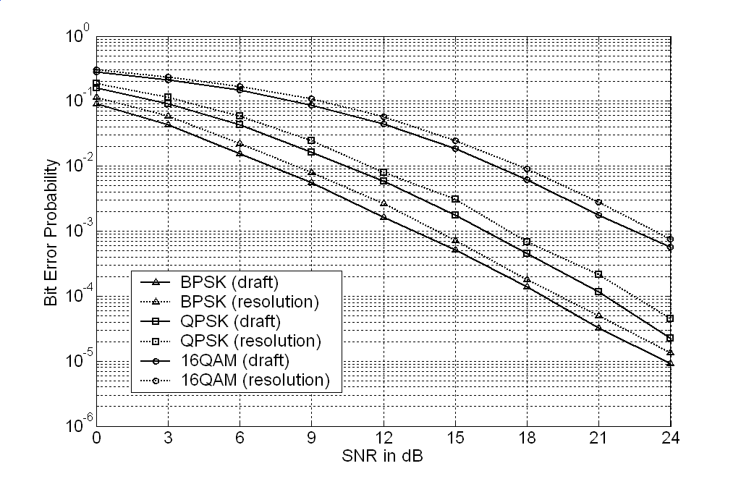
Fig.1 Simulation results on BER performance comparison between Alamouti’s scheme and the new STBC with CSIT

Appendix B

For the case of and , an improved STBC scheme is recommended, which is a kind of space-time-frequency block codes (STFBC), using coordinate interleaved designs (CID), presented in Reference [1].
An important reason behind the success of this idea is that the real part and the imagine part of a symbol pass through different fading channels, which brings the diversity gain.
In detail, an example of the design is given as follows. When , , , are allowed to take values from a QAM signal set, the transmission matrix for two transmit antennas and two channel taps is
,
where groups and are transmitted on different frequency carriers, and are the CID symbols with
,
,
.

In Fig.2, the simulation results on OFDM symbol error rate performance comparison between the Alamouti’s scheme and the STFBC scheme with CID are presented for the system with 2 transmit and 1 receive antennas. There are total 48 frequency carriers with QPSK modulation and the 2 OFDM symbol intervals are combined into a space-time group. It is obvious that the STFBC scheme with CID has better performance than the Alamouti scheme.

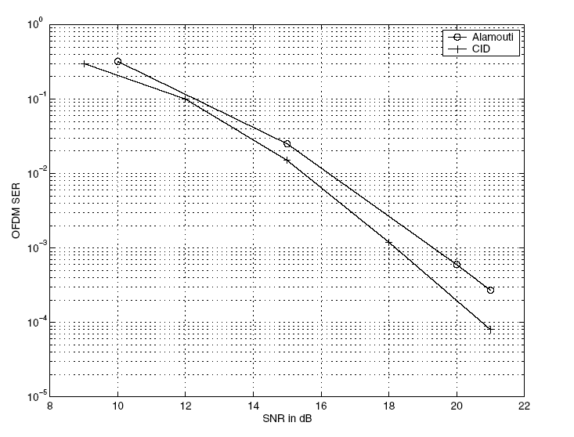
Fig.2 Simulation results on OFDM Symbol Error Rate (SER) performance between Alamouti’s scheme and STFBC scheme presented in Reference [1]

Reference

[1] R.V.Jagannadha Rao Doddi, V.Shashidhar, Md.Zafar Ali Khan and B.Sundar Rajan, “Low-complexity, full-diversity space-time-frequency block codes for MIMO-OFDM”, Proceedings of IEEE GLOBECOM, Communication Theory Symposium, Dallas, Texas, 29 Nov.-3 Dec., 2004

