IEEE P802.11
Wireless LANs
WAVE Channel Model
Date: 2006-11-12
Author(s):
Name | Company | Address | Phone | email
Lee Armstrong | Armstrong Consulting, Inc. | 132 Fomer Road  Southampton, MA 01073 | 617 620 1701 | LRA@tiac.net
Abstract
This is the final report generated by Georgia Institute of Technology describing the channel models to be used for WAVE operations in IEEE 802.11 (11p).

Notice: This document has been prepared to assist IEEE 802.11. It is offered as a basis for discussion and is not binding on the contributing individual(s) or organization(s). The material in this document is subject to change in form and content after further study. The contributor(s) reserve(s) the right to add, amend or withdraw material contained herein.

Release: The contributor grants a free, irrevocable license to the IEEE to incorporate material contained in this contribution, and any modifications thereof, in the creation of an IEEE Standards publication; to copyright in the IEEE’s name any IEEE Standards publication even though it may include portions of this contribution; and at the IEEE’s sole discretion to permit others to reproduce in whole or in part the resulting IEEE Standards publication. The contributor also acknowledges and accepts that this contribution may be made public by IEEE 802.11.

Patent Policy and Procedures: The contributor is familiar with the IEEE 802 Patent Policy and Procedures <http:// ieee802.org/guides/bylaws/sb-bylaws.pdf>, including the statement "IEEE standards may include the known use of patent(s), including patent applications, provided the IEEE receives assurance from the patent holder or applicant with respect to patents essential for compliance with both mandatory and optional portions of the standard." Early disclosure to the Working Group of patent information that might be relevant to the standard is essential to reduce the possibility for delays in the development process and increase the likelihood that the draft publication will be approved for publication. Please notify the Chair <stuart.kerry@philips.com> as early as possible, in written or electronic form, if patented technology (or technology under patent application) might be incorporated into a draft standard being developed within the IEEE 802.11 Working Group. If you have questions, contact the IEEE Patent Committee Administrator at <patcom@ieee.org>.

Final Technical Report

Small-Scale Fading Models for the IEEE 802.11p (WAVE/DSRC) Standard

Mary Ann Ingram, Guillermo Acosta, and Lu Dong

School of Electrical and Computer Engineering
Georgia Institute of Technology
Atlanta, Georgia 30332-0250

Presented to ARINC, Inc.
September 15, 2006

Project Duration:
7/11/2005 – 12/31/2006

Table of Contents

Table of Contents ii

List of Figures iii

List of Tables vi

1 Introduction 1

2 PER Test Procedure 3

3 Model Descriptions 5
3.1 VTV - Expressway Oncoming without Wall, 300m – 400m Scenario 7
3.2 RTV - Urban Canyon, 100 m Scenario 10
3.3 RTV – Expressway, 300m – 400m Scenario 17
3.4 VTV - Urban Canyon Oncoming, 100m Scenario 23
3.5 RTV - Suburban Street, 100m Scenario 28
3.6 VTV - Expressway Same Direction with Wall, 300m – 400m Scenario 37

4 Conclusion 41

References 42

Appendix 43

Details of the PER Measurement Procedure 43
A.1 Setting the IPv6 Payload Length 45
A.2 Instructions for Running the PER Test 45
A.3 PER Test Parameters 46

List of Figures
- Block diagram of the PER test setup. 4
- Photos of the PER test setup. 4
- Tap spectra for the VTV Expressway Oncoming scenario. In blue: the measured Doppler spectrum for the random part. In red: the composite or customized spectrum, which corresponds to Table 2. 8
- For the Expressway Oncoming 400m scenario, mean PER and 95% confidence intervals for -79 dBm 1000 Byte PSDU (top curves), -79 dBm, 200 Byte PSDU (middle three curves), and -76 dBm 1000 Byte PSDU (bottom curves). 9
- Roadside antenna at the intersection of Peachtree Street and Peachtree Circle. 10
- Signal envelope and deleted segments for the RTV – Urban Canyon 100m scenario. The signal level corresponds to relative power, i.e., relative to the minimum signal recorded. It does not represent RF signal power. 11
- Tap spectra for the RTV Urban Canyon 100m scenario, short model. In blue: the measured Doppler spectrum for the random part. In red: the composite or customized spectrum, which corresponds to Table 3. 13
- Tap spectra for the RTV Urban Canyon 100m scenario, long model. In blue: the measured Doppler spectrum for the random part. In red: the composite or customized spectrum, which corresponds to Table 4. 15
- RTV – Urban Canyon 100m scenario: mean PER and 95% confidence intervals for -79 dBm and 1000-Byte PSDU, short and long models. 16
- Roadside antenna on GA 78. 17
- Tap spectra for the RTV Expressway 300-400m scenario. In blue: the measured Doppler spectrum for the random part. In red: the composite or customized spectrum, which corresponds to Table 5. 19
- RTV – Expressway 300-400m scenario: mean PER and 95% confidence intervals for -79 dBm, for 200- and s1000-Byte PSDUs and vehicle speed of 140 km/hr,. 20
- RTV – Expressway 300-400m scenario: mean PER and 95% confidence intervals for -79 dBm, for 200- and s1000-Byte PSDUs and vehicle speed of 200 km/hr. 22
- Tap spectra for the VTV Urban Canyon 100m scenario, short model. In blue: the measured Doppler spectrum for the random part. In red: the composite or customized spectrum, which corresponds to Table 7. 24
- Tap spectra for the VTV Urban Canyon 100m scenario, long model. In blue: the measured Doppler spectrum for the random part. In red: the composite or customized spectrum, which corresponds to Table 8. 26
- VTV – Urban Canyon 100m scenario: mean PER and 95% confidence intervals for -79 dBm and 1000-Byte PSDU, short and long models. 27
- Roadside antenna at the intersection of Memorial Drive and Candler Road. 28
- Signal envelope and deleted segments for the RTV – Suburban Street 100m scenario. The signal level corresponds to relative power, i.e., relative to the minimum signal recorded. It does not represent RF signal power. 29
- First four tap spectra for the RTV Suburban Street 100m scenario, short model. In blue: the measured Doppler spectrum for the random part. In red: the composite or customized spectrum, which corresponds to Table 9. 31
- Second four tap spectra for the RTV Suburban Street 100m scenario, short model. In blue: the measured Doppler spectrum for the random part. In red: the composite or customized spectrum, which corresponds to Table 9. 32
- First four tap spectra for the RTV Suburban Street 100m scenario, long model. In blue: the measured Doppler spectrum for the random part. In red: the composite or customized spectrum, which corresponds to Table 10. 34
- Second four tap spectra for the RTV Suburban Street 100m scenario, long model. In blue: the measured Doppler spectrum for the random part. In red: the composite or customized spectrum, which corresponds to Table 10. 35
- Mean PER and 95% confidence intervals for -79 dBm, 1000 Byte PSDU, for the short and long Suburban Street RTV 100m scenarios. 36
- First four tap spectra for the VTV Expressway Same Direction with Wall 300-400m scenario. In blue: the measured Doppler spectrum for the random part. In red: the composite or customized spectrum, which corresponds to Table 11. 38
- Second four tap spectra for the VTV Expressway Same Direction with Wall 300-400m scenario. In blue: the measured Doppler spectrum for the random part. In red: the composite or customized spectrum, which corresponds to Table 11. 39
- Resulting PER for the Expressway Same Direction scenario. 40
- Illustration of circulator signal flow. 44
- Setting the IPv6 payload length to yield a PSDU length of 1000 Bytes 45

List of Tables
- Description of the locations for each scenario 2
- VTV - Expressway Oncoming without Wall, 300m – 400m Model 7
- RTV – Urban Canyon, 100 m Short Model 12
- RTV – Urban Canyon, 100 m Long Model 14
- RTV – Expressway, 300m – 400m 140 km/hr Model 18
- RTV – Expressway, 300m – 400m 200 km/hr Model 21
- VTV - Urban Canyon Oncoming, 100m Short Model 23
- VTV - Urban Canyon Oncoming, 100m Long Model 25
- RTV - Suburban Street, 100m Short Model 30
- RTV - Suburban Street, 100m Long Model 33
- VTV - Expressway Same Direction with Wall, 300m – 400m Model 37

Introduction
This report presents six small-scale fading models created in Phase II of the project funded by ARINC, Inc., in support of the IEEE 802.11p Wireless Access in Vehicular Environments (WAVE) / Dedicated Short Range Communications (DSRC) Standard. The purpose of this study has been to define the model to be used in the motion-related equipment certification test for the standard. The model we recommend for the test is the VTV Expressway Oncoming without Wall, because it produces the highest packet error rate (PER) among all the channels for the prototype WAVE/DSRC transceivers that were provided to Georgia Tech.
The models represent six of the environments in which the WAVE/DSRC system is expected to operate; three of them are for the vehicle-to-vehicle (VTV) link, and the other three are for the roadside-to-vehicle (RTV) link. The models are listed below in order of the PER they produced for 1000 Byte packets, from highest (worst channel) to lowest (best channel).

- VTV – Expressway Oncoming Without Wall, 300m – 400m
- RTV – Urban Canyon, 100m
- RTV – Expressway, 300m – 400m
- VTV – Urban Canyon Oncoming, 100m
- RTV – Suburban Street, 100m
- VTV – Expressway Same Direction with Wall, 300m – 400m

The model specifications are appropriate for emulation on a standard RF channel emulator, such as the SPIRENT 4500 or 5500. For the test, the WAVE/DSRC equipment is to be operated using an RF channel emulator over the specified channel for at least 5 seconds, for packets with a given PSDU size, and the packet error rate (PER) is to be recorded. For the expressway scenarios, the PSDU size is 200 Bytes. For the non-expressway scenarios, the PSDU size is 1000 Bytes. The equipment passes if the PER under the specified conditions is less than 10%.
The small-scale fading models represent multipath fading effects only and do not include path loss or lognormal shadowing.
The models are based on data which was measured in Spring 2006 at a frequency of 5.9 GHz in the metropolitan Atlanta, Georgia area. Each model corresponds to a type of environment or a “scenario,” which in turn corresponds to one or more actual locations, as shown in Table 1. A “take” is one event of driving by the location. Details on the measurement and signal processing techniques can be found in [2]. The vehicle speeds during measurement were approximately 105 km/h (65 mph) for the expressway and 32 km/h to 48 km/h (20 mph to 30 mph) for the surface streets. For the models in this report, the Doppler frequencies were scaled to be consistent with vehicle speeds of 140 km/h for the expressway and 120 km/h (72 mph) for the surface streets.
The biggest challenge in selecting locations for the measurements was finding straight roads to enable line-of-sight (LOS) conditions.
Unless otherwise noted, magnetically mounted monopole antennas were used for the measurements.

Table 1: Description of the locations for each scenario
Scenario | Date | Location | Takes
VTV - Expressway Oncoming, 300-400m | 04/19/2006 | GA 675 between exits 5 and 7 | 4
RTV - Urban Canyon 100 m | 04/24/2006 | Approach Peachtree Street at Colony Square from the North | 4
RTV - Expressway 300-400m | 04/25/2006 | Westbound GA 78 | 4
RTV - Expressway 300-400m | 04/25/2006 | Eastbound GA 78 | 4
VTV - Urban Canyon Oncoming 100 m | 04/12/2006 | Along Edgewood Avenue | 2
RTV - Suburban Street 100 m | 04/25/2006 | Four different approaches to Memorial Drive and Candler Road | 10
VTV - Expressway Same Direction With Wall, 300-400m | 04/19/2006 | Along North I-285 | 7
VTV - Expressway Same Direction With Wall, 300-400m | 04/19/2006 | West on I-20 | 6
VTV - Expressway Same Direction With Wall, 300-400m | 04/17/2006 | I-285 @ Ashford Dunwoody | 4
VTV - Expressway Same Direction With Wall, 300-400m | 04/17/2006 | GA 400 North, just north of I-285 | 4

PER Test Procedure
This section gives a high-level description of the test setup that was used to measure the PER for each model in this report. Details are provided in the Appendix.
The testing approach was based on the “ping” application of the IPv6 protocol. The test was demonstrated using two prototypes of WAVE/DSRC units (OBU and RSU) supplied by Mark IV and Transcore. Network interface programs were provided by Transcore and C++ TX and RX PER measurement programs were written at Georgia Tech. The channel models were implemented using a SPIRENT SR5500 RF Channel emulator.
A block diagram of the setup is shown in Figure 1. The RSU was configured as the the transmitter and the OBU was configured as the receiver. The ping application required a bidirectional connection. Because the channel emulator is unidirectional, a feedback path was created using isolators and circulators.
To prevent RF signal leakage between the two units, each unit was placed in a closed cardboard box. The box was lined with absorber and wrapped in aluminum foil. The two boxes are placed in different rooms with door closed during tests. Figure 2 shows the positions of channel emulator, receiver PC and the two boxes during testing.
In the sequel, the mean PER as a function of total number of packets is given for every model. The mean PER is an average of six PER traces, corresponding to six different runs of the experiment or program. Each of the traces is a sample mean that tends to converge to a value over time. However, in some cases, the converged values for the six trials are not close, indicating that the experiment was not exactly repeatable. In all but the Expressway Same Direction model, 95% confidence intervals were computed for the mean PER, assuming six trials and unknown variance, by treating the six sample means as samples themselves. This is why, in some cases, the confidence interval does not decrease with time; the confidence interval reflects the degree of non-repeatability of the PER test.
The programs enabled the specification of the PSDU length (200 Bytes or 1000 Bytes) and the fixed data rate of 6 Mbps. For this data rate, the standard specifies the power level at the input of the receiver to be -67 dBm for the certification test. For every model in this report, at -67 dBm and 1000 Bytes, the PER measured was 0%. If the number of bytes is not specified in the figure, it is 1000 Bytes. To induce errors, the power had to be decreased from -67 dBm. To compare the model PERs, so that the harshest channel could be identified, the power level was set to -79 dBm.
RSU
LNA
OBU
LNA
Circulator
Circulator
2
3
SR5500 Channel emulator
Isolator
1
Sender Application
Receiver Application
Serial
Serial
Room Wall
30dB attenuator
30dB attenuator
2
1
3
-15dBm
-40dBm~
-80dBm
About 2 meters cable from SR5500 to OBU
PER Setup Diagram
Isolator

RF
RF
Figure 1: Block diagram of the PER test setup.
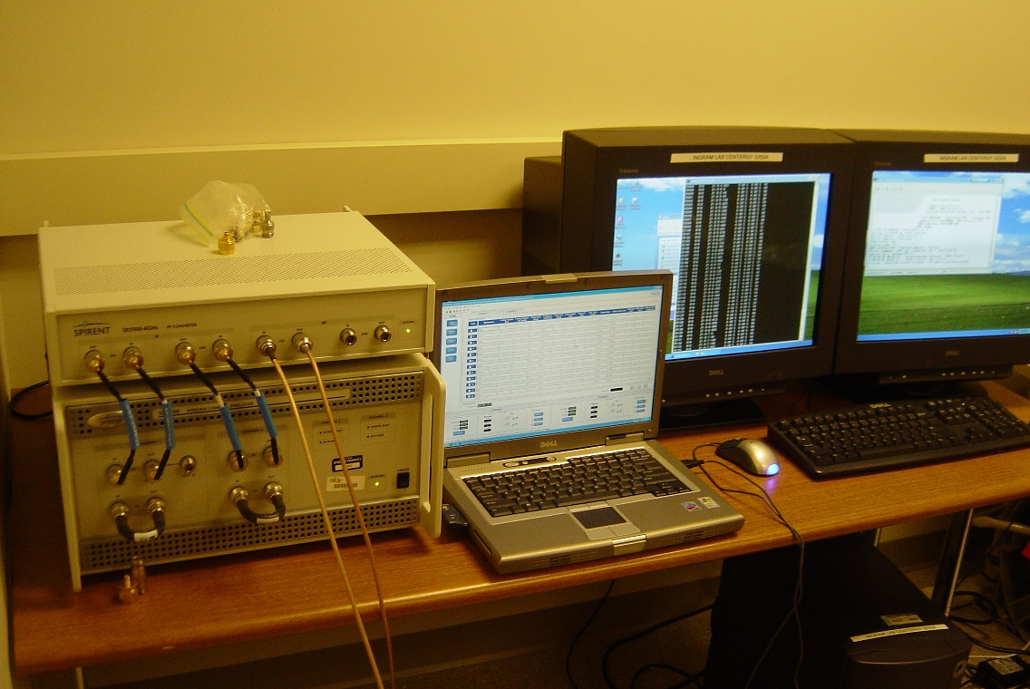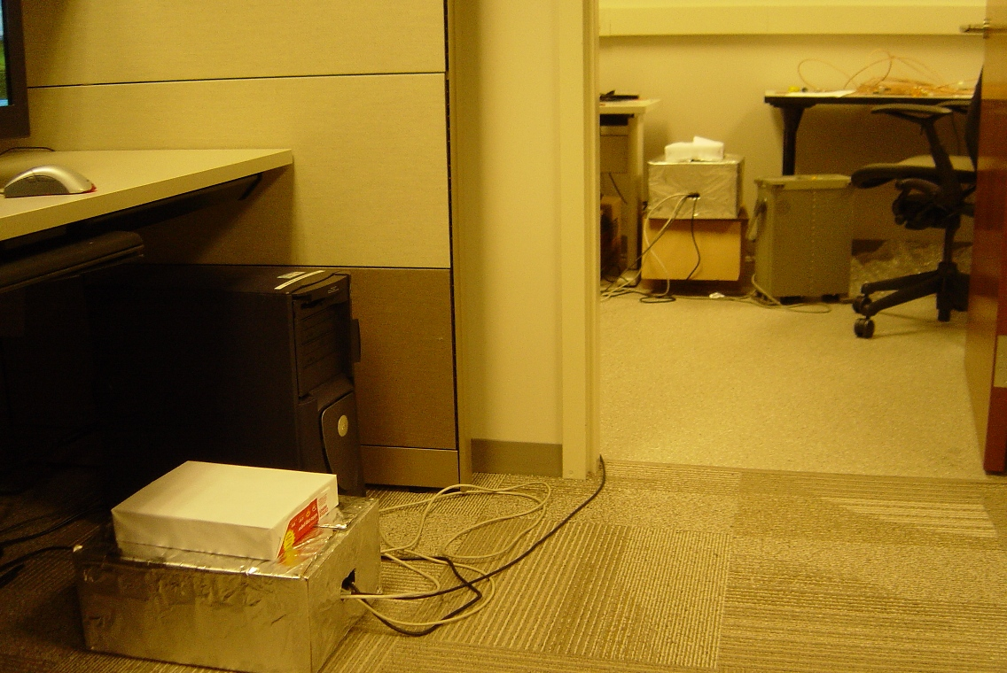
Figure 2: Photos of the PER test setup.

Model Descriptions
Each model is of the “tapped delay line” type and normalized so that the first tap power is 0 dB. In most cases, a tap is constructed from several paths of the channel emulator. This is because the choices for the spectral shapes of paths in a channel emulator are limited, and quite insufficient to describe many of the measured tap Doppler spectra. By superimposing several paths with nearly the same delay, it is possible to create a customized Doppler spectrum that fits better. To avoid problems with the channel emulator, paths comprising a single tap were separated in delay by one nanosecond. The customized Doppler spectrum is constrained to have the same total power (i.e. same area in a non-dB plot) as the measured Doppler spectrum, so that the power delay profile is preserved.
Before fitting spectral shapes to the measured spectra, the deterministic part of the Doppler spectrum, usually the LOS component, is removed [2], leaving what is termed in the report as the “random spectrum.” Both the random and customized spectra are presented below for each model, consistent with the vehicle speeds during measurement. The Doppler frequencies in the tables are scaled versions of what is presented in the figures, to scale up to the speeds specified in the standard.
Each tap spectrum fit was optimized by taking the best of five runs of the genetic algorithm. The cost function used in the genetic algorithm and for selecting the best of the five was the integrated weighted difference between the measured spectrum and the customized spectrum. The weighting function was $(f−f_{\text{peak}})^{2}$, where $f_{\text{peak}}$ is the frequency of the peak (usually very well defined) of the spectrum of the first (and strongest) tap. It is assumed that $f_{\text{peak}}$ is the recovered carrier frequency in the receiver. The cost function ensures that the inter-carrier interference (ICI) that would be produced by the customized spectrum in an OFDM receiver is as close as possible to the ICI produced by the measured spectrum [1], [2]. In some cases, it seems that the fit of the customized spectrum to the measured spectrum could be made better by simply widening or shortening a shape, however, this generally violates the equal power constraint.
In some cases, two models, “long” and “short,” are presented. The short models use a maximum of 12 paths, which is the maximum number of paths on many RF channel emulators. Some channel emulators, such as the model SR5500, have 24 paths, so they can run the “long” model, which has more than 12 paths. When given, the long model has a better fit to the measured spectrum. PER results are presented for both long and short models, so that the user can see how much they differ in terms of PER.
The parameters are named according to the Spirent SR5500 TestKit Instrument Control Software [3]. For example, “Fading Spectral Shape” is the Doppler spectrum shape, “Frequency Shift” is the center frequency of the path’s fading spectral shape, and “Fading Doppler” is the half-width of the path’s fading spectral shape. For a Rician tap, one of the paths in the customized spectrum is somewhat arbitrarily selected to be Rician and the others are set to be Rayleigh faded. The deterministic power (i.e. the numerator of the K factor) of the tap becomes the deterministic power of the Rician path. This sometimes results in a path K factor that is much higher than the tap K factor. The reader is cautioned that to compute the K factor of the tap, one must compute the denominator of the K factor by adding up the powers of all the non-impulsive path spectral shapes in that tap. “n/a” means “not applicable.” Other modeling details may be found in [2], [4].

VTV - Expressway Oncoming without Wall, 300m – 400m Scenario
This scenario was a rural expressway. “Without wall” means there was no wall separating the oncoming lanes.
Table 2: VTV - Expressway Oncoming without Wall, 300m – 400m Model
Tap No. | Path No. | Tap Power (dB) | Relative Path Loss (dB) | Delay Value (ns) | Rician K (dB) | Freq. Shift (Hz) | Fading Doppler (Hz) | LOS Doppler (Hz) | Modulation | Fad. Spec. Shape
1 | 1 | 0.0 | 0.0 | 0 | -1.6 | 1451 | 60 | 1452 | Rician | Round
1 | 2 |  | -24.9 | 1 | n/a | 884 | 858 | n/a | Rayleigh | Round
1 | 3 |  | -25.5 | 2 | n/a | 1005 | 486 | n/a | Rayleigh | Round
2 | 4 | -6.3 | -13.1 | 100 | n/a | 761 | 655 | n/a | Rayleigh | Classic 3dB
2 | 5 |  | -7.5 | 101 | n/a | 1445 | 56 | n/a | Rayleigh | Round
3 | 6 | -25.1 | -28.9 | 200 | n/a | 819 | 823 | n/a | Rayleigh | Classic 3dB
3 | 7 |  | -29.3 | 201 | n/a | 1466 | 75 | n/a | Rayleigh | Flat
3 | 8 |  | -35.6 | 202 | n/a | 124 | 99 | n/a | Rayleigh | Round
4 | 9 | -22.7 | -25.7 | 300 | n/a | 1437 | 110 | n/a | Rayleigh | Flat
4 | 10 |  | -34.4 | 301 | n/a | 552 | 639 | n/a | Rayleigh | Classic 3dB
4 | 11 |  | -27.4 | 302 | n/a | 868 | 858 | n/a | Rayleigh | Classic 6dB

Notes:
- All Taps have composite spectra. Tap One has a Rician component in the first path, and it has random spectra in the other two paths.
- This table is consistent with vehicle speeds of 140 km/hr (87 mph) and separation between transmitter and receiver vehicles of approximately 400m.

Figure 3: Tap spectra for the VTV Expressway Oncoming scenario. In blue: the measured Doppler spectrum for the random part. In red: the composite or customized spectrum, which corresponds to Table 2.
Figure 4: For the Expressway Oncoming 400m scenario, mean PER and 95% confidence intervals for -79 dBm 1000 Byte PSDU (top curves), -79 dBm, 200 Byte PSDU (middle three curves), and -76 dBm 1000 Byte PSDU (bottom curves).

RTV - Urban Canyon, 100 m Scenario
For this scenario, the transmitting antenna was mounted on a pole near the urban intersection of Peachtree Street with Peachtree Circle, as shown in Figure 5. The antenna was 6.1 m (20 feet) high. The target range was 100m.
To avoid deleterious effects from very deep fades, all segments less than a threshold were not included in the analysis. The envelope of the signal for all the measured data in this scenario is shown in the top of Figure 6. The threshold, which was arbitrarily set, is shown in blue. The stem plot in the lower part of Figure 6 indicates the deleted segments.
Both short and long models are presented in Table 3 and Table 4, respectively. As shown in Figure 9, the short model produces a slightly higher PER.

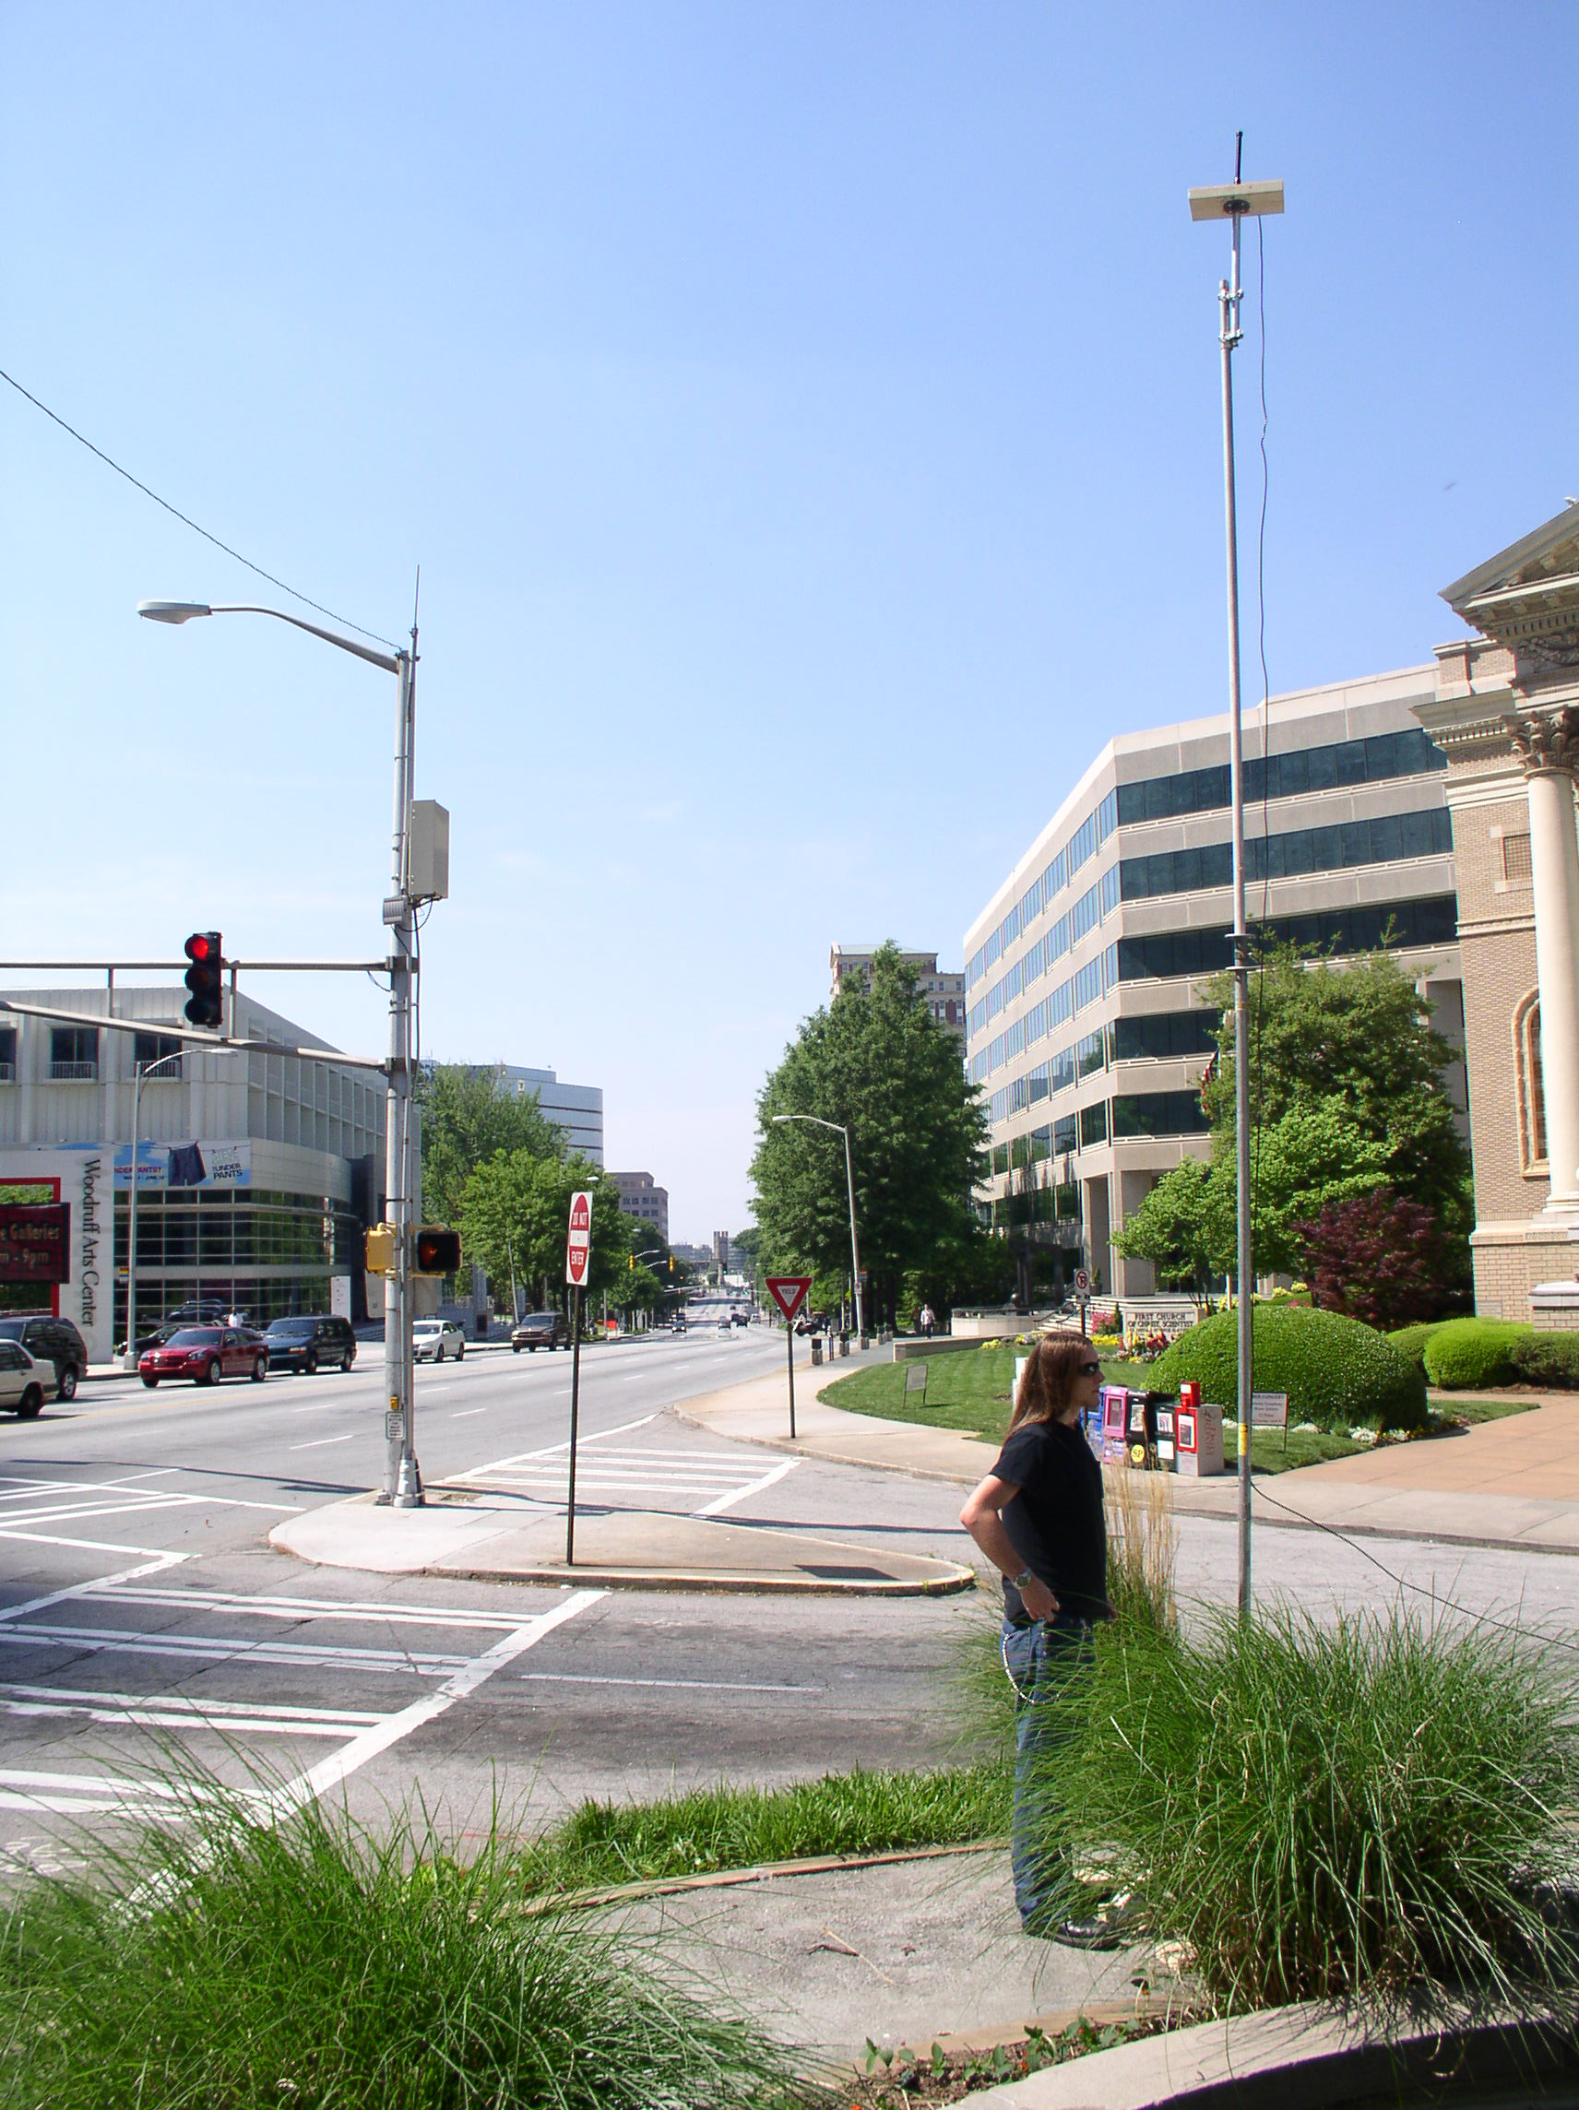
Figure 5: Roadside antenna at the intersection of Peachtree Street and Peachtree Circle.

Figure 6: Signal envelope and deleted segments for the RTV – Urban Canyon 100m scenario. The signal level corresponds to relative power, i.e., relative to the minimum signal recorded. It does not represent RF signal power.

Table 3: RTV – Urban Canyon, 100 m Short Model
Tap No. | Path No. | Tap Power (dB) | Relative Path Loss (dB) | Delay Value (ns) | Rician K (dB) | Freq. Shift (Hz) | Fading Doppler (Hz) | LOS Doppler (Hz) | Modulation | Fad. Spec. Shape
1 | 1 | 0.0 | -1.8 | 0 | 7.5 | 574 | 165 | 654 | Rician | Round
1 | 2 |  | -30.5 | 1 | n/a | -97 | 543 | n/a | Rayleigh | Classic 3dB
1 | 3 |  | -25.1 | 2 | n/a | -89 | 478 | n/a | Rayleigh | Classic 3dB
2 | 4 | -11.5 | -27.1 | 100 | n/a | -549 | 174 | n/a | Rayleigh | Round
2 | 5 |  | -17.7 | 101 | n/a | 559 | 196 | n/a | Rayleigh | Round
2 | 6 |  | -19.5 | 102 | n/a | 115 | 757 | n/a | Rayleigh | Classic 6dB
3 | 7 | -19.0 | -17.6 | 200 | n/a | 610 | 258 | n/a | Rayleigh | Classic 6dB
3 | 8 |  | -19.9 | 201 | n/a | 72 | 929 | n/a | Rayleigh | Flat
4 | 9 | -25.6 | -23.3 | 300 | n/a | 183 | 653 | n/a | Rayleigh | Classic 6dB
4 | 10 |  | -20.6 | 301 | n/a | 103 | 994 | n/a | Rayleigh | Round
5 | 11 | -28.1 | -29.8 | 500 | n/a | 720 | 220 | n/a | Rayleigh | Flat
5 | 12 |  | -28.0 | 501 | n/a | -20 | 871 | n/a | Rayleigh | Flat

Notes:
- All Taps have composite spectra. Tap One has a Rician component in the first path, and it has random spectra in the other two paths.
- Please notice the 200 ns gap between Tap Four and Tap Five.
- This table is consistent with vehicle speeds of 120 km/hr (75 mph) and separation between transmitter tower and receiver vehicle of approximately 100m.

Figure 7: Tap spectra for the RTV Urban Canyon 100m scenario, short model. In blue: the measured Doppler spectrum for the random part. In red: the composite or customized spectrum, which corresponds to Table 3.
Table 4: RTV – Urban Canyon, 100 m Long Model
Tap No. | Path No. | Tap Power (dB) | Relative Path Loss (dB) | Delay Value (ns) | Rician K (dB) | Freq. Shift (Hz) | Fading Doppler (Hz) | LOS Doppler (Hz) | Modulation | Fad. Spec. Shape
1 | 1 | 0.0 | -1.8 | 0 | 7.5 | 574 | 165 | 654 | Rician | Round
1 | 2 |  | -30.5 | 1 | n/a | -97 | 543 | n/a | Rayleigh | Classic 3dB
1 | 3 |  | -25.1 | 2 | n/a | -89 | 478 | n/a | Rayleigh | Classic 3dB
2 | 4 | -11.5 | -27.1 | 100 | n/a | -549 | 174 | n/a | Rayleigh | Round
2 | 5 |  | -17.7 | 101 | n/a | 559 | 196 | n/a | Rayleigh | Round
2 | 6 |  | -19.5 | 102 | n/a | 115 | 757 | n/a | Rayleigh | Classic 6dB
3 | 7 | -19.0 | -23.8 | 200 | n/a | 43 | 698 | n/a | Rayleigh | Classic 6dB
3 | 8 |  | -28.1 | 201 | n/a | 573 | 186 | n/a | Rayleigh | Flat
3 | 9 |  | -27.6 | 202 | n/a | -571 | 193 | n/a | Rayleigh | Round
4 | 10 | -25.6 | -33.4 | 300 | n/a | -137 | 494 | n/a | Rayleigh | Classic 6dB
4 | 11 |  | -30.5 | 301 | n/a | -573 | 211 | n/a | Rayleigh | Round
4 | 12 |  | -31.6 | 302 | n/a | 576 | 250 | n/a | Rayleigh | Round
5 | 13 | -28.1 | -48.7 | 500 | n/a | -506 | 644 | n/a | Rayleigh | Flat
5 | 14 |  | -29.9 | 501 | n/a | 575 | 162 | n/a | Rayleigh | Flat
5 | 15 |  | -38.5 | 502 | n/a | -567 | 241 | n/a | Rayleigh | Round

Notes:
- All Taps have composite spectra. Tap One has a Rician component in the first path, and it has random spectra in the other two paths.
- Please notice the 200 ns gap between Tap Four and Tap Five.
- This table is consistent with vehicle speeds of 120 km/hr (75 mph) and separation between transmitter tower and receiver vehicle of approximately 100m.

Figure 8: Tap spectra for the RTV Urban Canyon 100m scenario, long model. In blue: the measured Doppler spectrum for the random part. In red: the composite or customized spectrum, which corresponds to Table 4.
Figure 9: RTV – Urban Canyon 100m scenario: mean PER and 95% confidence intervals for -79 dBm and 1000-Byte PSDU, short and long models.

RTV – Expressway, 300m – 400m Scenario
For these measurements, the transmitting antenna was mounted on a pole off the side of the expressway, as shown in Figure 10. The antenna was 6.1 m (20 feet) high. A half-dome antenna was used for these measurements. Measurements were taken as the vehicle approached from both directions on the expressway.

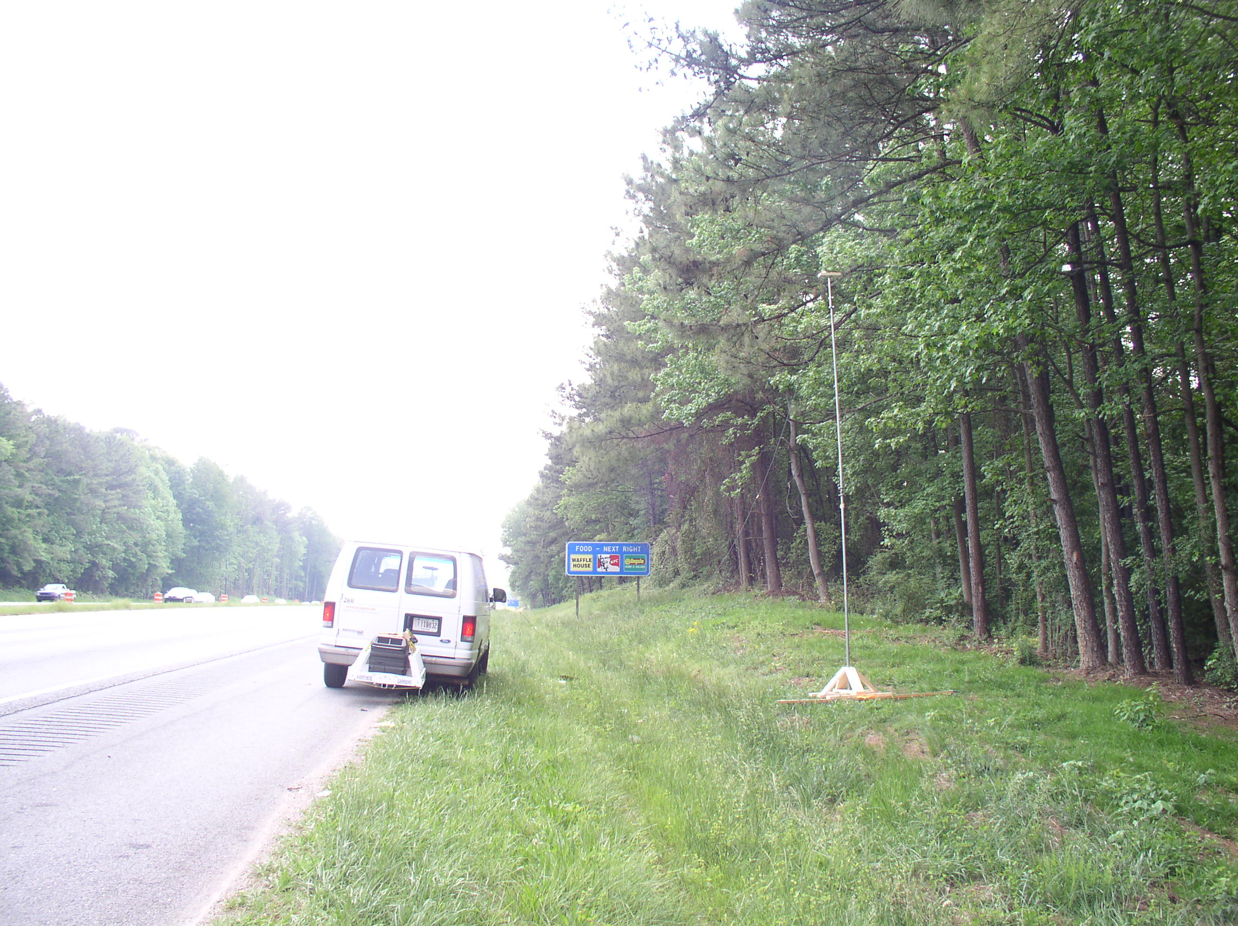
Figure 10: Roadside antenna on GA 78.

Table 5: RTV – Expressway, 300m – 400m 140 km/hr Model
Tap No. | Path No. | Tap Power (dB) | Relative Path Loss (dB) | Delay Value (ns) | Rician K (dB) | Freq. Shift (Hz) | Fading Doppler (Hz) | LOS Doppler (Hz) | Modulation | Fad. Spec. Shape
1 | 1 | 0.0 | 0.0 | 0 | -5.3 | 769 | 70 | 770 | Rician | Round
1 | 2 |  | -36.4 | 1 | n/a | -22 | 600 | n/a | Rayleigh | Round
1 | 3 |  | -30.0 | 2 | n/a | 535 | 376 | n/a | Rayleigh | Round
2 | 4 | -9.3 | -12.3 | 100 | n/a | 754 | 117 | n/a | Rayleigh | Round
2 | 5 |  | -21.7 | 101 | n/a | 548 | 424 | n/a | Rayleigh | Round
2 | 6 |  | -24.9 | 102 | n/a | -134 | 530 | n/a | Rayleigh | Flat
3 | 7 | -20.3 | -24.3 | 200 | n/a | 761 | 104 | n/a | Rayleigh | Round
3 | 8 |  | -25.4 | 201 | n/a | 88 | 813 | n/a | Rayleigh | Classic 3dB
4 | 9 | -21.3 | -26.8 | 300 | n/a | 37 | 802 | n/a | Rayleigh | Classic 6dB
4 | 10 |  | -28.5 | 301 | n/a | 752 | 91 | n/a | Rayleigh | Round
5 | 11 | -28.8 | -31.2 | 400 | n/a | 16 | 807 | n/a | Rayleigh | Classic 6dB
5 | 12 |  | -41.8 | 401 | n/a | -755 | 329 | n/a | Rayleigh | Round

Notes:
- All Taps have composite spectra. Tap One has a Rician component in the first path, and it has random spectra in the other two paths.
- This table is consistent with vehicle speeds of 140 km/hr (87 mph) and separation between transmitter and receiver vehicle of approximately 400m.

Figure 11: Tap spectra for the RTV Expressway 300-400m scenario. In blue: the measured Doppler spectrum for the random part. In red: the composite or customized spectrum, which corresponds to Table 5.
Figure 12: RTV – Expressway 300-400m scenario: mean PER and 95% confidence intervals for -79 dBm, for 200- and s1000-Byte PSDUs and vehicle speed of 140 km/hr,.

Table 6: RTV – Expressway, 300m – 400m 200 km/hr Model
Tap No. | Path No. | Tap Power (dB) | Relative Path Loss (dB) | Delay Value (ns) | Rician K (dB) | Freq. Shift (Hz) | Fading Doppler (Hz) | LOS Doppler (Hz) | Modulation | Fad. Spec. Shape
1 | 1 | 0.0 | 0.0 | 0 | -5.3 | 1101 | 100 | 1092 | Rician | Round
1 | 2 |  | -36.4 | 1 | n/a | -32 | 859 | n/a | Rayleigh | Round
1 | 3 |  | -30.0 | 2 | n/a | 766 | 538 | n/a | Rayleigh | Round
2 | 4 | -9.3 | -12.3 | 100 | n/a | 1080 | 168 | n/a | Rayleigh | Round
2 | 5 |  | -21.7 | 101 | n/a | 784 | 608 | n/a | Rayleigh | Round
2 | 6 |  | -24.9 | 102 | n/a | -192 | 759 | n/a | Rayleigh | Flat
3 | 7 | -20.3 | -24.3 | 200 | n/a | 1090 | 149 | n/a | Rayleigh | Round
3 | 8 |  | -25.4 | 201 | n/a | 126 | 1164 | n/a | Rayleigh | Classic 3dB
4 | 9 | -21.3 | -26.8 | 300 | n/a | 54 | 1148 | n/a | Rayleigh | Classic 6dB
4 | 10 |  | -28.5 | 301 | n/a | 1077 | 130 | n/a | Rayleigh | Round
5 | 11 | -28.8 | -31.2 | 400 | n/a | 24 | 1156 | n/a | Rayleigh | Classic 6dB
5 | 12 |  | -41.8 | 401 | n/a | -1081 | 470 | n/a | Rayleigh | Round

Notes:
- All Taps have composite spectra. Tap One has a Rician component in the first path, and it has random spectra in the other two paths.
- This table is consistent with vehicle speeds of 200 km/hr (124 mph) and separation between transmitter and receiver vehicle of approximately 400m.

Figure 13: RTV – Expressway 300-400m scenario: mean PER and 95% confidence intervals for -79 dBm, for 200- and s1000-Byte PSDUs and vehicle speed of 200 km/hr.

VTV - Urban Canyon Oncoming, 100m Scenario
There are short and long versions of this model, given in Table 7 and Table 8, respectively. The PER results are shown together in Figure 9.
Table 7: VTV - Urban Canyon Oncoming, 100m Short Model
Tap No. | Path No. | Tap Power (dB) | Relative Path Loss (dB) | Delay Value (ns) | Rician K (dB) | Freq. Shift (Hz) | Fading Doppler (Hz) | LOS Doppler (Hz) | Modulation | Fad. Spec. Shape
1 | 1 | 0.0 | 0.0 | 0 | 4.0 | 1145 | 284 | 1263 | Rician | Round
1 | 2 |  | -17.6 | 1 | n/a | 833 | 824 | n/a | Rayleigh | Round
2 | 3 | -10.0 | -12.9 | 100 | n/a | 707 | 871 | n/a | Rayleigh | Round
2 | 4 |  | -19.0 | 101 | n/a | 918 | 286 | n/a | Rayleigh | Classic 6dB
2 | 5 |  | -36.4 | 102 | n/a | -250 | 936 | n/a | Rayleigh | Flat
3 | 6 | -17.8 | -25.8 | 200 | n/a | 21 | 166 | n/a | Rayleigh | Round
3 | 7 |  | -21.2 | 201 | n/a | 677 | 726 | n/a | Rayleigh | Flat
3 | 8 |  | -31.6 | 202 | n/a | -188 | 538 | n/a | Rayleigh | Round
4 | 9 | -21.1 | -28.2 | 300 | n/a | 538 | 908 | n/a | Rayleigh | Round
4 | 10 |  | -28.3 | 301 | n/a | 41 | 183 | n/a | Rayleigh | Round
5 | 11 | -26.3 | -28.5 | 400 | n/a | 674 | 723 | n/a | Rayleigh | Classic 6dB
5 | 12 |  | -35.5 | 401 | n/a | -78 | 260 | n/a | Rayleigh | Round

Notes:
- All Taps have composite spectra. Tap One has a Rician component in the first path, and it has random spectra in the other two paths.
- This table is consistent with vehicle speeds of 120 km/hr (75 mph) and separation between transmitter and receiver vehicles of approximately 100m.

Figure 14: Tap spectra for the VTV Urban Canyon 100m scenario, short model. In blue: the measured Doppler spectrum for the random part. In red: the composite or customized spectrum, which corresponds to Table 7.
Table 8: VTV - Urban Canyon Oncoming, 100m Long Model
Tap No. | Path No. | Tap Power (dB) | Relative Path Loss (dB) | Delay Value (ns) | Rician K (dB) | Freq. Shift (Hz) | Fading Doppler (Hz) | LOS Doppler (Hz) | Modulation | Fad. Spec. Shape
1 | 1 | 0.0 | 0.0 | 0 | 4.0 | 1153 | 310 | 1263 | Rician | Round
1 | 2 |  | -18.3 | 1 | n/a | 827 | 449 | n/a | Rayleigh | Round
1 | 3 |  | -26.3 | 2 | n/a | 211 | 236 | n/a | Rayleigh | Flat
2 | 4 | -10.0 | -12.9 | 100 | n/a | 707 | 871 | n/a | Rayleigh | Round
2 | 5 |  | -19.0 | 101 | n/a | 918 | 286 | n/a | Rayleigh | Classic 6dB
2 | 6 |  | -36.4 | 102 | n/a | -250 | 936 | n/a | Rayleigh | Flat
3 | 7 | -17.8 | -25.8 | 200 | n/a | 21 | 166 | n/a | Rayleigh | Round
3 | 8 |  | -21.2 | 201 | n/a | 677 | 726 | n/a | Rayleigh | Flat
3 | 9 |  | -31.6 | 202 | n/a | -188 | 538 | n/a | Rayleigh | Round
4 | 10 | -21.1 | -35.6 | 300 | n/a | -68 | 198 | n/a | Rayleigh | Round
4 | 11 |  | -40.7 | 301 | n/a | -497 | 484 | n/a | Rayleigh | Round
4 | 12 |  | -25.8 | 302 | n/a | 669 | 751 | n/a | Rayleigh | Classic 6dB
5 | 13 | -26.3 | -41.9 | 400 | n/a | -759 | 491 | n/a | Rayleigh | Round
5 | 14 |  | -30.3 | 401 | n/a | 451 | 774 | n/a | Rayleigh | Round
5 | 15 |  | -31.4 | 402 | n/a | 24 | 168 | n/a | Rayleigh | Round

Notes:
- All Taps have composite spectra. Tap One has a Rician component in the first path, and it has random spectra in the two other paths.
- This table is consistent with vehicle speeds of 120 km/hr (75 mph) and separation between transmitter and receiver vehicles of approximately 100m.

Figure 15: Tap spectra for the VTV Urban Canyon 100m scenario, long model. In blue: the measured Doppler spectrum for the random part. In red: the composite or customized spectrum, which corresponds to Table 8.
Figure 16: VTV – Urban Canyon 100m scenario: mean PER and 95% confidence intervals for -79 dBm and 1000-Byte PSDU, short and long models.

RTV - Suburban Street, 100m Scenario
For these measurements, the transmitting antenna was mounted on a pole near the intersection of Memorial Drive and Columbia Drive, as shown in Figure 18. The antenna was 6.1 m (20 feet) high. The target range was 100m.

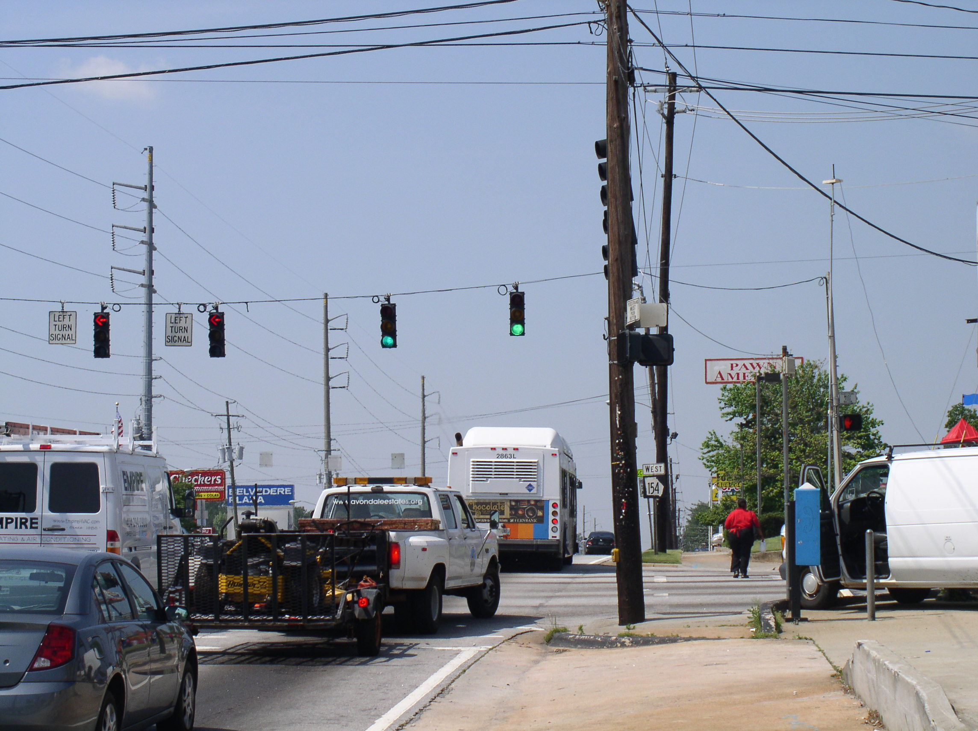
Figure 17: Roadside antenna at the intersection of Memorial Drive and Candler Road.

To avoid possible very deep fades, all segments less than a threshold were not included in the analysis. The envelope of the signal for all the measured data is shown in the top of Figure 18. The threshold is shown in blue. The stem plot in the lower part of Figure 18 indicates which segments were used and which were deleted.

Figure 18: Signal envelope and deleted segments for the RTV – Suburban Street 100m scenario. The signal level corresponds to relative power, i.e., relative to the minimum signal recorded. It does not represent RF signal power.
This model has both short and long versions specified in Table 9 and Table 10 respectively. The PER results are shown together in Figure 23.

Table 9: RTV - Suburban Street, 100m Short Model
Tap No. | Path No. | Tap Power (dB) | Relative Path Loss (dB) | Delay Value (ns) | Rician K (dB) | Freq. Shift (Hz) | Fading Doppler (Hz) | LOS Doppler (Hz) | Modulation | Fad. Spec. Shape
1 | 1 | 0.0 | 0.0 | 0 | 3.3 | 648 | 152 | 635 | Rician | Round
1 | 2 |  | -21.5 | 1 | n/a | 171 | 823 | n/a | Rayleigh | Round
2 | 3 | -9.3 | -11.8 | 100 | n/a | 582 | 249 | n/a | Rayleigh | Round
2 | 4 |  | -18.8 | 101 | n/a | -119 | 515 | n/a | Rayleigh | Classic 3dB
3 | 5 | -14.0 | -17.6 | 200 | n/a | 527 | 223 | n/a | Rayleigh | Round
3 | 6 |  | -19.9 | 201 | n/a | 62 | 802 | n/a | Rayleigh | Flat
4 | 7 | -18.0 | -23.0 | 300 | n/a | 497 | 396 | n/a | Rayleigh | Classic 6dB
4 | 8 |  | -20.8 | 301 | n/a | 87 | 851 | n/a | Rayleigh | Round
5 | 9 | -19.4 | -19.4 | 400 | n/a | 43 | 747 | n/a | Rayleigh | Round
6 | 10 | -24.9 | -24.9 | 500 | n/a | 114 | 742 | n/a | Rayleigh | Classic 6dB
7 | 11 | -27.5 | -27.5 | 600 | n/a | 38 | 746 | n/a | Rayleigh | Classic 3dB
8 | 12 | -29.8 | -29.8 | 700 | n/a | 8 | 743 | n/a | Rayleigh | Classic 3dB

Notes:
- Taps 1, 2, 3, and 4 have composite spectra. Tap One has a Rician component in the first path, and it has a random spectrum in the second path. Taps 2, 3, and 8 each comprise two paths.
- This table is consistent with vehicle speeds of 120 km/hr (75 mph) and separation between transmitter tower and receiver vehicle of approximately 100m.

Figure 19: First four tap spectra for the RTV Suburban Street 100m scenario, short model. In blue: the measured Doppler spectrum for the random part. In red: the composite or customized spectrum, which corresponds to Table 9.

Figure 20: Second four tap spectra for the RTV Suburban Street 100m scenario, short model. In blue: the measured Doppler spectrum for the random part. In red: the composite or customized spectrum, which corresponds to Table 9.
Table 10: RTV - Suburban Street, 100m Long Model
Tap No. | Path No. | Tap Power (dB) | Relative Path Loss (dB) | Delay Value (ns) | Rician K (dB) | Freq. Shift (Hz) | Fading Doppler (Hz) | LOS Doppler (Hz) | Modulation | Fad. Spec. Shape
1 | 1 | 0.0 | 0.0 | 0 | 3.3 | 648 | 152 | 635 | Rician | Round
1 | 2 |  | -21.5 | 1 | n/a | 171 | 823 | n/a | Rayleigh | Round
2 | 3 | -9.3 | -11.8 | 100 | n/a | 582 | 249 | n/a | Rayleigh | Round
2 | 4 |  | -18.8 | 101 | n/a | -119 | 515 | n/a | Rayleigh | Classic 3dB
3 | 5 | -14.0 | -17.6 | 200 | n/a | 527 | 223 | n/a | Rayleigh | Round
3 | 6 |  | -19.9 | 201 | n/a | 62 | 802 | n/a | Rayleigh | Flat
4 | 7 | -18.0 | -23.0 | 300 | n/a | 497 | 396 | n/a | Rayleigh | Classic 6dB
4 | 8 |  | -20.8 | 301 | n/a | 87 | 851 | n/a | Rayleigh | Round
5 | 9 | -19.4 | -24.5 | 400 | n/a | 645 | 125 | n/a | Rayleigh | Round
5 | 10 |  | 25.2 | 401 | n/a | 33 | 753 | n/a | Rayleigh | Flat
6 | 11 | -24.9 | -29.8 | 500 | n/a | 497 | 128 | n/a | Rayleigh | Round
6 | 12 |  | -27.9 | 501 | n/a | 12 | 634 | n/a | Rayleigh | Classic 6dB
7 | 13 | -27.5 | -30.8 | 600 | n/a | 13 | 716 | n/a | Rayleigh | Classic 6dB
7 | 14 |  | -32.8 | 601 | n/a | 485 | 315 | n/a | Rayleigh | Round
8 | 15 | -29.8 | -35.5 | 700 | n/a | 473 | 325 | n/a | Rayleigh | Flat
8 | 16 |  | -32.9 | 701 | n/a | -28 | 712 | n/a | Rayleigh | Classic 3dB

Notes:
- All Taps have composite spectra. Tap One has a Rician component in the first path, and it has a random spectrum in the second path.
- This table is consistent with vehicle speeds of 120 km/hr (75 mph) and separation between transmitter tower and receiver vehicle of approximately 100m.
Figure 21: First four tap spectra for the RTV Suburban Street 100m scenario, long model. In blue: the measured Doppler spectrum for the random part. In red: the composite or customized spectrum, which corresponds to Table 10.

Figure 22: Second four tap spectra for the RTV Suburban Street 100m scenario, long model. In blue: the measured Doppler spectrum for the random part. In red: the composite or customized spectrum, which corresponds to Table 10.

Figure 23: Mean PER and 95% confidence intervals for -79 dBm, 1000 Byte PSDU, for the short and long Suburban Street RTV 100m scenarios.

VTV - Expressway Same Direction with Wall, 300m – 400m Scenario
This scenario contains data measured at many different locations along various expressways in Atlanta, Georgia. However, all locations had a center wall between oncoming lanes.
Because of the large K factor for this model, the PER was 0% for all power levels tested. To induce errors, the deterministic parts of the Rician taps were eliminated, to emulate blocking the line-of-sight (LOS) component, without changing anything else about the model. This version of the model is called “All Rayleigh Paths.”

Table 11: VTV - Expressway Same Direction with Wall, 300m – 400m Model
Tap No. | Path No. | Tap Power (dB) | Relative Path Loss (dB) | Delay Value (ns) | Rician K (dB) | Freq. Shift (Hz) | Fading Doppler (Hz) | LOS Doppler (Hz) | Modulation | Fad. Spec. Shape
1 | 1 | 0.0 | -1.4 | 0 | 23.8 | -55 | 1407 | -60 | Rician | Round
1 | 2 |  | -5.6 | 1 | n/a | -20 | 84 | n/a | Rayleigh | Round
2 | 3 | -11.2 | -14.2 | 100 | 5.7 | -56 | 1345 | +40 | Rician | Classic 3 dB
2 | 4 |  | -14.2 | 101 | n/a | 0 | 70 | n/a | Rayleigh | Round
3 | 5 | -19.0 | -19.0 | 200 | n/a | -87 | 1358 | n/a | Rayleigh | Classic 6 dB
4 | 6 | -21.9 | -21.9 | 300 | n/a | -139 | 1397 | n/a | Rayleigh | Classic 3 dB
5 | 7 | -25.3 | -27.9 | 400 | n/a | 60 | 1522 | n/a | Rayleigh | Classic 6 dB
5 | 8 |  | -30.8 | 401 | n/a | -561 | 997 | n/a | Rayleigh | Classic 3 dB
6 | 9 | -24.4 | -24.4 | 500 | n/a | 50 | 1529 | n/a | Rayleigh | Round
7 | 10 | -28.0 | -28.0 | 600 | n/a | 13 | 1572 | n/a | Rayleigh | Round
8 | 11 | -26.1 | -31.5 | 700 | n/a | -6 | 1562 | n/a | Rayleigh | Classic 6 dB
8 | 12 |  | -28.1 | 701 | n/a | 4 | 81 | n/a | Rayleigh | Round

Notes:
- Taps 1, 2, 5 and 8 each comprises two paths. The first two taps each have both Rician and Rayleigh paths. The overall K factor is 4.0 dB for Tap 1 and -1.8 dB for Tap 2. Tap 8 comprises two Rayleigh paths.
- This table is consistent with vehicle speeds of 140 km/hr (87 mph) and separation between transmitter and receiver vehicles of approximately 400m.
Figure 24: First four tap spectra for the VTV Expressway Same Direction with Wall 300-400m scenario. In blue: the measured Doppler spectrum for the random part. In red: the composite or customized spectrum, which corresponds to Table 11.

Figure 25: Second four tap spectra for the VTV Expressway Same Direction with Wall 300-400m scenario. In blue: the measured Doppler spectrum for the random part. In red: the composite or customized spectrum, which corresponds to Table 11.

Figure 26: Resulting PER for the Expressway Same Direction scenario.

Conclusion
This report has presented six models, suitable for simulation on standard RF channel emulators, representing three VTV and three RTV environments measured in the Atlanta, Georgia metropolitan area. The models were ranked in terms of PER measured at -79 dBm with 1000-byte PSDUs, and the VTV Expressway without Wall channel had the highest measured PER. Therefore, this is the model we recommend for the certification test, because if equipment passes the certification test with this channel it is likely that it will pass the other channels as well.
Three of the models, RTV Urban Canyon, VTV Urban Canyon, and RTV Suburban Street, had both long and short versions (greater than 12 paths and less than or equal to 12 paths, respectively). Of these, the only long-short pair that produced statistically different mean PERs was the first, and for that one, the mean PERs differed by less than 0.5%. Therefore, the long-short distinction is not very important from a link performance point of view.
There were more data collected that could not be processed into models in time for this report. Those were usually longer-range or non-LOS versions of the scenarios presented. Processing these data is an objective of future research.
Another objective of future work is to continue investigations into dynamic modelling of these channels. The models presented do not represent the wide range of model variation (i.e. change in delay spreads or Doppler spreads) observed in each given scenario. The models presented give only an average of this behaviour. It is desired to segment the data according to harshness, identify models for different harshness classes, and attempt to identify the dynamics for the classes.

References
- X. Cai and G.B. Giannakis, “Bounding performance and suppressing intercarrier interference in wireless mobile OFDM,” IEEE Trans. Comm. Vol. 51, No. 12, December 2003.
- G. Acosta-Marum and M.A. Ingram, “Doubly selective vehicle-to-vehicle channel measurements and modeling at 5.9 GHz,” to appear in Proc. Wireless Personal Multimedia Communications Conference (WPMC 2006).
- http://www.spirentcom.com
- G. Acosta, K. Tokuda, and M. A. Ingram, “Measured joint Doppler-delay power profiles for vehicle-to-vehicle communications at 2.4 GHz,” in Proc. of IEEE Global Telecom. Conf., vol. 6, pp. 3813-3817, 2004.

Appendix

Details of the PER Measurement Procedure
Please refer to Figure 1 in the text for the block diagram of the PER measurement setup. The RSU was the transmitter and the OBU was the receiver. Each of them connects to a corresponding PC with serial and Ethernet cables. The serial cable was used to send commands and setup parameters to the DSRC unit. The Ethernet cable is used to transmit and receive IPV6 data.
During PER testing, the program senderapp.exe runs on the PC connected to RSU while the program receiverapp.exe runs on the PC connected to OBU. Both senderapp.exe and receiverapp.exe are configured through configure files. Configure files should be in the same folders as their respective executables. Default values are shown below.
Configuration for ReceiverApp: (ReceiverApp.exe.config)
=======================================================
"ReceiverPort" value="10020"
// Port number that is listened to. Should be identical to the one that is senderapp is using.
"WPERDuration" value="5000"
// Window size (in milliseconds). Window Packet Error Rate (WPER) is updated every 5000 ms and shows the PER experienced within the last 5 seconds.
"TraceFile" value="trace.txt"
// File name that is output with the statistics. File is overwritten if already exists.
Configuration for SenderApp: (SenderApp.exe.config)
===================================================
"Destination" value="cc::3"
// Destination's IPv6 address
"DestinationPort" value="10020"
// Port number that the packets are destined to.
"PacketSize" value="910"
// Application-level number of bytes in each packet (excludes UDP/IP/MAC headers).
"PacketInterval" value="50"
// Intertransmission time (in milliseconds).
"PacketNumber" value="100000"
// Number of packets to transmit, then the senderapp exists.

On the receiver side, the information dumped on the screen is packet sequence number, packet size, receive timestamp (in Hour: Minute: second: millisecond format), cumulative PER, Window PER and inter-arrival time (in milliseconds).
Cumulative PER is the PER calculated since the beginning (it is updated after every packet arrival). Window PER is the PER experienced in the last 5 seconds and it is updated every 5 seconds. (Remember WPER Duration was set to 5000ms.)
Because the senderapp.exe and receiverapp.exe are the IPv6 level programs, successfully running them requires two PCs that can ping each other successfully. So the channel between the transmitter and receiver should be duplex. Because SR5500 channel emulator is a unidirectional device, a feed back channel was built.
The Circulator D3C4080 and Isolator D314084 were used to realize the feed back channel. Isolator D314084 allows signals to flow only one way. Circulator D3C4080 allows signal flows only as shown below.

2
3
1

Figure 27: Illustration of circulator signal flow.
30 dB attenuators are added at the output of port 3, before the SR5500, to prevent overloading. Another 30dB attenuator is added in the reverse path to get the same noise floor.

Setting the IPv6 Payload Length
The certification test uses different PSDU lengths for different types of channels. The harsher channels will use PSDUs of length 200 Bytes, and the milder channels will use PSDU lengths of 1000 bytes. Therefore, it is necessary in the test configuration to specify the number of bytes in each packet (excludes UDP/IP/MAC headers). The calculation is shown in Figure XX. It is observed that the packet size is 910 bytes for 1000 bytes PSDU; obviously, it is 110 bytes for 200 bytes PSDU.
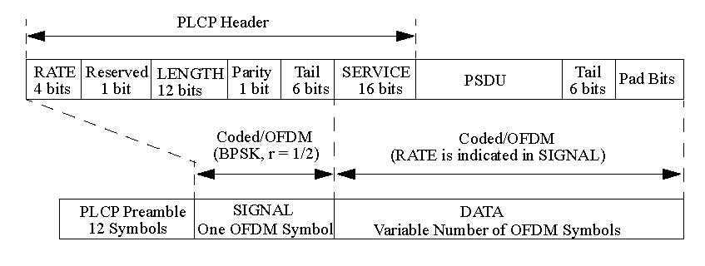
PLCP sublayer
802.11 MAC Layer
MAC Header 30 Bytes
Frame Body
1000-34=966 Bytes
FCS
4 Bytes
LLC+SNAP header 8 Bytes
Data
966-8=958 Bytes
Logical Link Control (LLC) Layer
Internet Layer
UDP Header 8 Bytes
IPv6 Header 40 Bytes
Data
958-48 = 910 Bytes
1000 Bytes
Figure 28: Setting the IPv6 payload length to yield a PSDU length of 1000 Bytes

Instructions for Running the PER Test
At the transmitter PC, run IPv6_Addr_Setup_RSU.bat to setup the IPV6 address (aa::3). Then open HyperTerminal window (located at “All Programs->Accessories->Communications”). In “Connection Description” window, type “RSU”. Next, in “Connect To” window, choose “COM1” in “Connect using” Tab. In “COM1 Properties” Window, choose setting as “9600/8/None/1/None”.
At the receiver PC, run IPv6_Addr_Setup_OBU.bat to setup the IPV6 address (cc::3). Then open HyperTerminal window (located at “All Programs->Accessories->Communications”). In “Connection Description” window, type “OBU”. Next, in “Connect To” window, choose “COM1” in “Connect using” Tab. In “COM1 Properties” Window, choose setting as “9600/8/None/1/None”.
Open MS-DOS command window on both PCs; go to the directory which has “senderapp.exe” at transmitter PC and “receiverapp.exe” at receiver PC. The folders also include corresponding configure files. Run “ping6 aa::3” at receiver PC and “Ping6 cc::3” at transmitter PC. Make sure the two PCs can successfully ping each other. Run “senderapp.exe” at transmitter PC and “receiver.exe” at receiver PC to record the PER data. The data is recorded at file “trace.txt” at receiver PC.

PER Test Parameters
Set the following parameters:

Network interface
- TX power: highest setting (-15 dBm)
- Data rate: 6 Mbps
Channel: 5.87 GHz
Sending Application
- Packet size: 910 or 110 Bytes (IPv6 payload)
- Packet interval: 50 ms
- Maximum number of packets: 10K to 100K
Receiving Application
- Moving window size: 5 seconds

