IEEE P802.11
Wireless LANs
STC with CSI feedback
Date: 2006-10-16
Author(s):
Name | Company | Address | Phone | email
Yuli Yang | Huawei Technologies | Beijing, China | 86-10-8288-2930 | yangyuli@huawei.com

Abstract

This document proposes a new STC scheme with the CSI feedback, which can obtain better BER performance and higher transmission rate than the traditional STBC system.

Notice: This document has been prepared to assist IEEE 802.11. It is offered as a basis for discussion and is not binding on the contributing individual(s) or organization(s). The material in this document is subject to change in form and content after further study. The contributor(s) reserve(s) the right to add, amend or withdraw material contained herein.

Release: The contributor grants a free, irrevocable license to the IEEE to incorporate material contained in this contribution, and any modifications thereof, in the creation of an IEEE Standards publication; to copyright in the IEEE’s name any IEEE Standards publication even though it may include portions of this contribution; and at the IEEE’s sole discretion to permit others to reproduce in whole or in part the resulting IEEE Standards publication. The contributor also acknowledges and accepts that this contribution may be made public by IEEE 802.11.

Patent Policy and Procedures: The contributor is familiar with the IEEE 802 Patent Policy and Procedures <http:// ieee802.org/guides/bylaws/sb-bylaws.pdf>, including the statement "IEEE standards may include the known use of patent(s), including patent applications, provided the IEEE receives assurance from the patent holder or applicant with respect to patents essential for compliance with both mandatory and optional portions of the standard." Early disclosure to the Working Group of patent information that might be relevant to the standard is essential to reduce the possibility for delays in the development process and increase the likelihood that the draft publication will be approved for publication. Please notify the Chair <stuart.kerry@philips.com> as early as possible, in written or electronic form, if patented technology (or technology under patent application) might be incorporated into a draft standard being developed within the IEEE 802.11 Working Group. If you have questions, contact the IEEE Patent Committee Administrator at <patcom@ieee.org>.

Contents

1 Introduction 3
2 Motivation 3
3 Main Features 3
4 Details of the Proposed Scheme 4
4.1 BS with two transmit antennas 4
4.2 BS with four transmit antennas 5
4.3 SNR comparison 7
5 Conclusion 7
Reference 7

1 Introduction
Space-time block coding (STBC) is a promising technique in multiple-antenna system, which is proposed and analyzed in [2], [3] and [4]. In the research on this technique, it is proved that the technique only achieves 1/2 of the maximum possible transmission rate for any number of transmit antennas for an arbitrary complex constellation for the input signals modulation, and only for the specific cases of two, three, and four transmit antennas, the technique can achieve, respectively, all, 3/4, and 3/4 of maximum possible transmission rate.
Moreover, the channel state information (CSI) feedback is not used in the STBC scheme. In this proposal, we will show that the further performance gain can be obtained if the CSI feedback is used in the space time coding (STC) scheme.
Based on the above mentioned, this proposal presents a new STC scheme, which uses the CSI at the transmitter and has better performance than the traditional STBC scheme.

2 Motivation
The most important background for this proposal is that the CSI feedback is an optional technique in IEEE 802.11n draft standard [1].
This proposal gives a new STC technique, which uses the CSI at the transmitter. This proposal can provide not only better BER performance but also higher transmission rate than the traditional STBC system.

3 Main Features
There are three main features that are detailed as follows.
    - Compatible to the existing CPEs. The existing CPE has no enough space to set more than two antennae to promise the independence between the fading channels. The main reason for this proposal is available is that, as the traditional STBC scheme, it do not need add antennas to the CPE because the transmit diversity is used.
    - High transmission rate. This proposal can provide higher transmission rate than the traditional STBC scheme when the system is set with more than two trasnsmit antennas.
    - Good BER performance. This proposal can provide better BER performance than the traditional STBC scheme, which is shown in Figure 1.

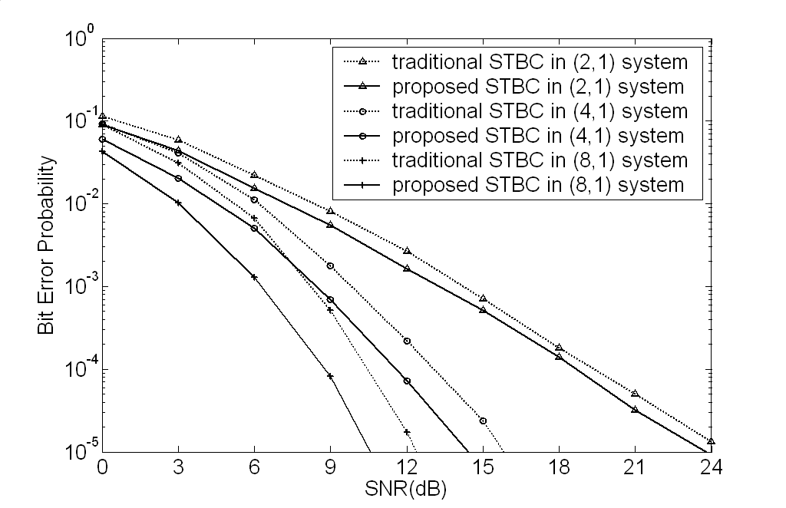
Figure 1 – BER Performance Comparisons between the proposal and the traditional STBC scheme.

From the simulation results shown in Figure 1, we can find that the proposed scheme has better BER performance than the traditional system and the distance between them becomes larger when the number of transmit antennas increases. More important, the transmission rate of the proposed system is higher than that of the traditional STBC system when there are more than two transmit antennas in the system.

4 Details of the Proposed Scheme
The multiple-antenna system is set with M transmit- and 1 receive- antennas and denoted by (M,1) system later. And, the flat fading channels from transmit antennas to the receiver are denoted, respectively, by $h_{1}$, $h_{2}$,…, $h_{M}$. These channel gain factors are independent of each other and all satisfy the complex Gaussian distribution, i.e.,
$h_{m}=\text{Normal}\left(0,\frac{1}{\sqrt{2}}\right)+\sqrt{−1}⋅\text{Normal}\left(0,\frac{1}{\sqrt{2}}\right)$, m = 1, 2, …, M. (1)
An important note in this proposal is that both the transmitter and the receiver know the channel state information.

4.1 BS with two transmit antennas
The transmission matrix for the BS with two transmit antennas is
$T_{2}=\frac{\sqrt{2}}{\sqrt{{\left|h_{1}\right|}^{2}+{\left|h_{2}\right|}^{2}}}\left(\begin{matrix}x_{1} & x_{2} \\ x_{2} & x_{1}\end{matrix}\right)\left(\begin{matrix}h_{1}^{} & 0 \\ 0 & h_{2}^{}\end{matrix}\right)$, (2)
where * denotes complex conjugate operation, and $x_{1}$ and $x_{2}$ denote the information symbols. The rows of the matrix are corresponding to the symbol periods and the columns of the matrix are corresponding to the index of the transmit antennas.
In detail, at a given symbol period, signals $\frac{\sqrt{2}h_{1}^{}}{\sqrt{{\left|h_{1}\right|}^{2}+{\left|h_{2}\right|}^{2}}}x_{1}$ and $\frac{\sqrt{2}h_{2}^{}}{\sqrt{{\left|h_{1}\right|}^{2}+{\left|h_{2}\right|}^{2}}}x_{2}$ are transmitted sepeately from antenna 1 and antenna 2. And, during the next symbol period, signals $\frac{−\sqrt{2}h_{1}^{}}{\sqrt{{\left|h_{1}\right|}^{2}+{\left|h_{2}\right|}^{2}}}x_{2}$ and $\frac{\sqrt{2}h_{2}^{}}{\sqrt{{\left|h_{1}\right|}^{2}+{\left|h_{2}\right|}^{2}}}x_{1}$ are transmitted from antenna 2 and antenna 1, respectively.
At the CPE, the corresponding received signals during the two coherent symbol periods are
$r_{1}=\frac{\sqrt{2}{\left|h_{1}\right|}^{2}}{\sqrt{{\left|h_{1}\right|}^{2}+{\left|h_{2}\right|}^{2}}}x_{1}+\frac{\sqrt{2}{\left|h_{2}\right|}^{2}}{\sqrt{{\left|h_{1}\right|}^{2}+{\left|h_{2}\right|}^{2}}}x_{2}+η_{1}$ (3)
and
$r_{2}=−\frac{\sqrt{2}{\left|h_{1}\right|}^{2}}{\sqrt{{\left|h_{1}\right|}^{2}+{\left|h_{2}\right|}^{2}}}x_{2}+\frac{\sqrt{2}{\left|h_{2}\right|}^{2}}{\sqrt{{\left|h_{1}\right|}^{2}+{\left|h_{2}\right|}^{2}}}x_{1}+η_{2}$, (4)
where $r_{1}$ and $r_{2}$ denote the received signals, and $η_{1}$ and $η_{2}$ denote the received additive white complex Gaussian noise.
The combined signals that are sent to the maximum likelihood detector are computed by
${\hat{x}}_{1}=\frac{\sqrt{2}{\left|h_{1}\right|}^{2}}{\sqrt{{\left|h_{1}\right|}^{2}+{\left|h_{2}\right|}^{2}}}r_{1}+\frac{\sqrt{2}{\left|h_{2}\right|}^{2}}{\sqrt{{\left|h_{1}\right|}^{2}+{\left|h_{2}\right|}^{2}}}r_{2}$, (5)
${\hat{x}}_{2}=\frac{\sqrt{2}{\left|h_{2}\right|}^{2}}{\sqrt{{\left|h_{1}\right|}^{2}+{\left|h_{2}\right|}^{2}}}r_{1}−\frac{\sqrt{2}{\left|h_{1}\right|}^{2}}{\sqrt{{\left|h_{1}\right|}^{2}+{\left|h_{2}\right|}^{2}}}r_{2}$. (6)
These combined signals are then sent to the maximum likelihood detector and the estimations of the original symbols can be obtained.

4.2 BS with four transmit antennas
The transmission matrix for the BS with four transmit antennas is
$T_{4}=\frac{\sqrt{4}}{\sqrt{{\left|h_{1}\right|}^{2}+{\left|h_{2}\right|}^{2}+{\left|h_{3}\right|}^{2}+{\left|h_{4}\right|}^{2}}}\left(\begin{matrix}x_{1} & x_{2} & x_{3} & x_{4} \\ −x_{2} & x_{1} & −x_{4} & x_{3} \\ −x_{3} & x_{4} & x_{1} & −x_{2} \\ −x_{4} & −x_{3} & x_{2} & x_{1}\end{matrix}\right)\left(\begin{matrix}h_{1}^{} & & & \\ & h_{2}^{} & & \\ & & h_{3}^{} & \\ & & & h_{4}^{}\end{matrix}\right)$, (7)
where * denotes complex conjugate operation, and $x_{1}$, $x_{2}$, $x_{3}$ and $x_{4}$ denote the information symbols. The rows of the matrix are corresponding to the symbol periods and the columns of the matrix are corresponding to the index of the transmit antennas.
In detail, during four coherent symbol periods, the corresponding received signals at the CPE are
$r_{1}=\frac{2}{\sqrt{{\left|h_{1}\right|}^{2}+{\left|h_{2}\right|}^{2}+{\left|h_{3}\right|}^{2}+{\left|h_{4}\right|}^{2}}}\left({\left|h_{1}\right|}^{2}x_{1}+{\left|h_{2}\right|}^{2}x_{2}+{\left|h_{3}\right|}^{2}x_{3}+{\left|h_{4}\right|}^{2}x_{4}\right)+η_{1}$, (8)
$r_{2}=\frac{2}{\sqrt{{\left|h_{1}\right|}^{2}+{\left|h_{2}\right|}^{2}+{\left|h_{3}\right|}^{2}+{\left|h_{4}\right|}^{2}}}\left(−{\left|h_{1}\right|}^{2}x_{2}+{\left|h_{2}\right|}^{2}x_{1}−{\left|h_{3}\right|}^{2}x_{4}+{\left|h_{4}\right|}^{2}x_{3}\right)+η_{2}$, (9)
$r_{3}=\frac{2}{\sqrt{{\left|h_{1}\right|}^{2}+{\left|h_{2}\right|}^{2}+{\left|h_{3}\right|}^{2}+{\left|h_{4}\right|}^{2}}}\left(−{\left|h_{1}\right|}^{2}x_{3}+{\left|h_{2}\right|}^{2}x_{4}+{\left|h_{3}\right|}^{2}x_{1}−{\left|h_{4}\right|}^{2}x_{2}\right)+η_{3}$, (10)
$r_{4}=\frac{2}{\sqrt{{\left|h_{1}\right|}^{2}+{\left|h_{2}\right|}^{2}+{\left|h_{3}\right|}^{2}+{\left|h_{4}\right|}^{2}}}\left(−{\left|h_{1}\right|}^{2}x_{4}−{\left|h_{2}\right|}^{2}x_{3}+{\left|h_{3}\right|}^{2}x_{2}+{\left|h_{4}\right|}^{2}x_{1}\right)+η_{4}$. (11)
where $r_{1}$, $r_{2}$, $r_{3}$, $r_{4}$ denote the received signals, and $η_{1}$, $η_{2}$, $η_{3}$, $η_{4}$ denote the received additive white complex Gaussian noise.
The combined signals that are sent to the maximum likelihood detector are computed by
${\hat{x}}_{1}=\frac{2}{\sqrt{{\left|h_{1}\right|}^{2}+{\left|h_{2}\right|}^{2}+{\left|h_{3}\right|}^{2}+{\left|h_{4}\right|}^{2}}}\left({\left|h_{1}\right|}^{2}r_{1}+{\left|h_{2}\right|}^{2}r_{2}+{\left|h_{3}\right|}^{2}r_{3}+{\left|h_{4}\right|}^{2}r_{4}\right)$ (12)
${\hat{x}}_{2}=\frac{2}{\sqrt{{\left|h_{1}\right|}^{2}+{\left|h_{2}\right|}^{2}+{\left|h_{3}\right|}^{2}+{\left|h_{4}\right|}^{2}}}\left({\left|h_{2}\right|}^{2}r_{1}−{\left|h_{1}\right|}^{2}r_{2}−{\left|h_{4}\right|}^{2}r_{3}+{\left|h_{3}\right|}^{2}r_{4}\right)$ (13)
${\hat{x}}_{3}=\frac{2}{\sqrt{{\left|h_{1}\right|}^{2}+{\left|h_{2}\right|}^{2}+{\left|h_{3}\right|}^{2}+{\left|h_{4}\right|}^{2}}}\left({\left|h_{3}\right|}^{2}r_{1}+{\left|h_{4}\right|}^{2}r_{2}−{\left|h_{1}\right|}^{2}r_{3}−{\left|h_{2}\right|}^{2}r_{4}\right)$ (14)
${\hat{x}}_{4}=\frac{2}{\sqrt{{\left|h_{1}\right|}^{2}+{\left|h_{2}\right|}^{2}+{\left|h_{3}\right|}^{2}+{\left|h_{4}\right|}^{2}}}\left({\left|h_{4}\right|}^{2}r_{1}−{\left|h_{3}\right|}^{2}r_{2}+{\left|h_{2}\right|}^{2}r_{3}−{\left|h_{1}\right|}^{2}r_{4}\right)$ (15)
These combined signals are then sent to the maximum likelihood detector and the estimations of the original symbols can be obtained.

4.3 SNR comparison
The received noise is assumed to be complex zero mean additive white Gaussian noise with two-sided power spectral density $σ_{N}^{2}$ in each symbol period. The signal to noise power ratio (SNR) for the traditional STBC scheme in (M,1) system is
${\text{SNR}}_{\text{traditonal}}=\frac{\sum_{m=1}^{M}{{\left|h_{m}\right|}^{2}}}{σ_{N}^{2}}$, (16)
and the SNR for the proposed STBC scheme in (M,1) system is
${\text{SNR}}_{\text{proposed}}=\frac{M\sum_{m=1}^{M}{{\left|h_{m}\right|}^{4}}}{σ_{N}^{2}\sum_{m=1}^{M}{{\left|h_{m}\right|}^{2}}}$. (17)
It is obvious that ${\text{SNR}}_{\text{proposed}}≥{\text{SNR}}_{\text{traditional}}$, that is, the proposed STBC system can obtain more SNR gain than the traditional STBC system. And therefore the BER performance of the proposed STBC system is better than that of the traditional STBC system.

5 Conclusion
In this proposal, an effective STC scheme by the use of CSIT is proposed, which can obtain better BER performance and higher transmission rate than the traditional STBC scheme for the cases of more than two transmit antennas.

Reference
- IEEE P802.11n™/D1.03
Draft Amendment to STANDARD for Information Technology -
Telecommunications and information exchange between systems -
Local and metropolitan area networks -
Part 11: Wireless LAN Medium Access Control (MAC) and Physical Layer (PHY) specifications: Amendment: Enhancements for Higher Throughput（March 2006）
- S.M.Alamouti, “A Simple Transmit Diversity Technique for Wireless Communications”, IEEE Journal on Selected Areas in Communications, vol.16, pp.1451-1458, Oct.1998.
- V.Tarokh, H.Jafarkhani, A.R.Calderbank, “Space-Time Block Codes from Orthogonal Designs”. IEEE Transactions on Information Theory. Vol.45, pp.1456-1467, July, 1999.
- V.Tarokh, H.Jafarkhani, A.R.Calderbank, “Space-time block coding for wireless communication: performance results”. IEEE J. Select. Areas Commun. Vol.17, pp.451-460, Mar,1999.
- Tao Xiaofeng, H.Harald, Yu Zhuizhuan, Qin Haiyan and Zhang Ping, “Closed loop space-time block code”, Vehicular Technology Conference 2001 Fall. IEEE VTC 54th, Volume 2, 7-11 Oct. 2001, pp.1093-1096, vol.2.

