IEEE P802.11
Wireless LANs
Video Performance
Date: July 2006
Author(s):
Name | Company | Address | Phone | email
Royce Fernald | Intel | 5200 Elam Young Pkwy MS:HF3-96  Hillsboro, OR 97124 | 503-696-4318 | royce.fernald@intel.com
Uriel Lemberger | Intel | Matam Industrial Park  PO Box 1659  Haifa 31015 Israel | +972-4-865-5701 | uriel.lemberger@intel.com
Alexander Tolpin | Intel | Matam Industrial Park  PO Box 1659  Haifa 31015 Israel | +972-4-865-5430 | alexander.tolpin@intel.com
Philip Corriveau | Intel | 5200 Elam Young Pkwy MS:HF3-96  Hillsboro, OR 97124 | 503-696-1837 | philip.j.corriveau@intel.com
Fanny Mlinarsky | Azimuth | 31 Nagog Park, Acton, MA 01720 | 978-268-9205 | fanny_mlinarsky@azimuthsystems.com
Fahd Pirzada | Dell | One Dell Way  Round Rock, TX 78682 | 512-338-4400 | fahd_pirzada@dell.com
Pratik Mehta | Dell | One Dell Way  Round Rock, TX 78682 | 512-338-4400 | pratik_mehta@dell.com
Dalton Victor | Broadcom | 190 Mathilda Place  Sunnyvale, CA 94025 | 408-922-5824 | dvictor@broadcom.com
Mark Kobayhashi | Broadcom | 190 Mathilda Place  Sunnyvale, CA 94025 | 408-543-3318 | mmk@broadcom.com

Abstract
Notice: This document has been prepared to assist IEEE 802.11. It is offered as a basis for discussion and is not binding on the contributing individual(s) or organization(s). The material in this document is subject to change in form and content after further study. The contributor(s) reserve(s) the right to add, amend or withdraw material contained herein.

Release: The contributor grants a free, irrevocable license to the IEEE to incorporate material contained in this contribution, and any modifications thereof, in the creation of an IEEE Standards publication; to copyright in the IEEE’s name any IEEE Standards publication even though it may include portions of this contribution; and at the IEEE’s sole discretion to permit others to reproduce in whole or in part the resulting IEEE Standards publication. The contributor also acknowledges and accepts that this contribution may be made public by IEEE 802.11.

Patent Policy and Procedures: The contributor is familiar with the IEEE 802 Patent Policy and Procedures <http:// ieee802.org/guides/bylaws/sb-bylaws.pdf>, including the statement "IEEE standards may include the known use of patent(s), including patent applications, provided the IEEE receives assurance from the patent holder or applicant with respect to patents essential for compliance with both mandatory and optional portions of the standard." Early disclosure to the Working Group of patent information that might be relevant to the standard is essential to reduce the possibility for delays in the development process and increase the likelihood that the draft publication will be approved for publication. Please notify the Chair <stuart.kerry@philips.com> as early as possible, in written or electronic form, if patented technology (or technology under patent application) might be incorporated into a draft standard being developed within the IEEE 802.11 Working Group. If you have questions, contact the IEEE Patent Committee Administrator at <patcom@ieee.org>.

This document defines key video metrics and outlines the methodology for conducting video performance tests.
6.21 Video Performance

6.21.1 Introduction and purpose

The purpose of this test is to measure the video streaming performance of the link between a DUT and a WLCP using unicast data frames. This test is an extension of the throughput measurements specified in sections 6.2, 6.5 and 6.6 and applies to all environments defined in section 5.

There are two primary metrics that characterize video performance: video delivery and video quality. Video delivery metrics quantify the ability of a content delivery system to supply video data to a client device its intended playback rate. Video quality metrics rate the appearance of the received video relative to the transmitted stream. In addition to the primary metrics, secondary metrics such as throughput and packet loss should be measured to correlate observed video performance with events on the wireless network. The media delivery index (MDI) expresses these secondary metrics in terms of their impact on a latency-sensitive media stream.

This test is applicable wireless clients in IBSS (Independent BSS) as well as infrastructure BSS client configurations. If an IBSS client is being tested, the results determine the ability of the client to receive a video stream from another IBSS client. In infrastructure mode, the results determine the ability of the client to receive a video stream from a media server connected to an AP.

6.21.1.1 Video Delivery

Video delivery is defined relative to perfect playback of a video stream at its target frame rate (i.e. 29.97 video frames per second for NTSC streams). Video delivery errors are visible as skips or pauses during video playback and are a result of the failure of the underlying transport medium to provide an uninterrupted video stream. Variations in the playback rate appear as dropped, repeated or out-of-sequence video frames on the DUT display device.

The video delivery error rate (VDER) is expressed as the total number of dropped, repeated and out-of-sequence video frames observed per unit time. This value represents the absolute deviation of the delivered video rate from the video stream’s intended playback rate.

6.21.1.2 Video Quality

Video quality metrics represent the visual quality difference between the transmitted video and the video displayed on the client device. Network performance has a direct impact on video quality. For instance, packet loss can cause blurring, loss of image detail and other display defects.

Video quality models are defined in terms of mean opinion scores, which reflect the level of video artifacts perceptible to a typical end user. Quality scales range from a maximum value, which represents no perceptible difference from a source clip, to a minimum value, which represents obvious, severe degradation of the image. Video quality models may be undefined for VDER values above a certain threshold.

6.21.1.3 Media Delivery Index

The media delivery index (RFC 4445) defines two secondary metrics that describe the media capacity of a network. It is important to measure MDI along with video delivery and video quality to quantify the contribution of the wireless medium to observed video performance.

MDI is composed of the media loss rate (MLR) and the delay factor (DF). MLR is a media-weighted metric that expresses the number of expected 802.11 packets dropped from a video stream. DF represents the amount of time required to drain the client buffer at the bitrate of the media stream. DF is calculated from virtual buffer VB, which is the required client buffer depth required to avoid an underrun for the interval measured. Dividing the greatest VB span by the media rate gives the worst-case buffer time needed to avoid playback disruptions.

MLR is calculated as follows:

MLR = (Packets Expected - Packets Received) / Interval in Seconds

DF is calculated as follows:

VB = |Bytes Received - Bytes Drained|
DF = (max(VB) – min(VB)) / Video Bitrate in Bytes

6.21.1.4 Methodology

In addition to the equipment defined for each environment, the test setup must include a traffic generator capable of generating video traffic and a video capture device. The WLCP is a reference AP for infrastructure BSS configurations, or a reference client for IBSS configurations. The DUT and the WLCP are configured as specified in section 5, with the addition of a video capture device connected to a display port on the DUT. (If the DUT can act as a video capture device, an external system is not required. However, an external capture device allows the tester to measure video performance without changing the DUT configuration and to compare results across platforms.)

To measure video performance, video traffic is streamed from the video traffic generator to the DUT, where it is captured by the video capture device and then analyzed for video delivery errors and video quality defects. Network traffic measured by the 802.11 traffic analyzer is used to calculate the media loss rate and the delay factor.

6.21.2 Test configuration

6.21.2.1 Resource requirements

In addition to the environment-specific resources defined in section 5, the following equipment is required to carry out this test:

- A video traffic generator capable of streaming video data through the WLCP to the DUT. The video traffic generator is a general purpose PC with video streaming software or a dedicated traffic generation device that supports video.
- A video capture device that can capture video data as it is rendered on the DUT. A capture device is a general purpose PC or specialized system with a video signal input port and the ability to save the displayed video content to non-volatile storage. (This system appears as a normal display device to the DUT.) The capture device must support the video signal format used by the DUT (i.e. DVI, VGA, s-video or HD component) and have sufficient CPU and storage resources to save uncompressed video data to its storage subsystem at the playback rate of the test media. Performance of the capture device must be verified as described in section 6.21.2.3.2 before it can be used for this test.

Optionally, a DUT may act as a video capture device if it has the ability to save a real-time copy of the video stream to non-volatile storage.

The following software applications are required to carry out this test:

- A video playback analysis application (VPAA). The video playback analysis application must be able to instrument each video frame of the test media with a unique identifier. This application must also be capable of decoding its identifier sequence from instrumented video capture files to determine if each frame was successfully delivered. Based on these measurements, the VPAA should report dropped, repeated or out-of-sequence video frames. Video frame identifiers should be content and file format independent (i.e. visible color patterns, geometric sequences or watermarks) and should be resistant to resolution, display format and color space changes that occur when video is rendered on different devices.
- A video quality analysis application (VQAA). The video quality analysis application must be able to analyze video frames for image defects and render a quality score based on a perceptual model of the video format under test. The VQAA should output a mean opinion score (MOS) that represents the expected perceptibility to a typical end user of any video artifacts it detects. VQAAs may operate by comparing the source to the displayed video data (full reference), by comparing a subset of the source to the displayed data (reduced reference) or by examining the displayed video data directly for known video artifacts (no reference). The VQAA must not be affected by the instrumentation used by the VPAA.
- A video encoder application capable of encoding the instrumented test media in the required format.
- A video capture application capable of capturing display data from the DUT.

Optionally, video playback instrumentation, compression, capture, delivery analysis and quality analysis may be implemented as part of a single application or as components of the video traffic generator or the video capture device.

The test setup is described in 6.21.2.3.

6.21.2.2 Test environment

The metrics and measurements described in this subclause apply to each of the test environments defined in section 5.

6.21.2.3 Test setup

In addition to the resources defined for each environment in section 5, a video capture device is attached to the display connector on the DUT to capture video for analysis.

Figure 64 depicts the location of the capture device in the test setup:

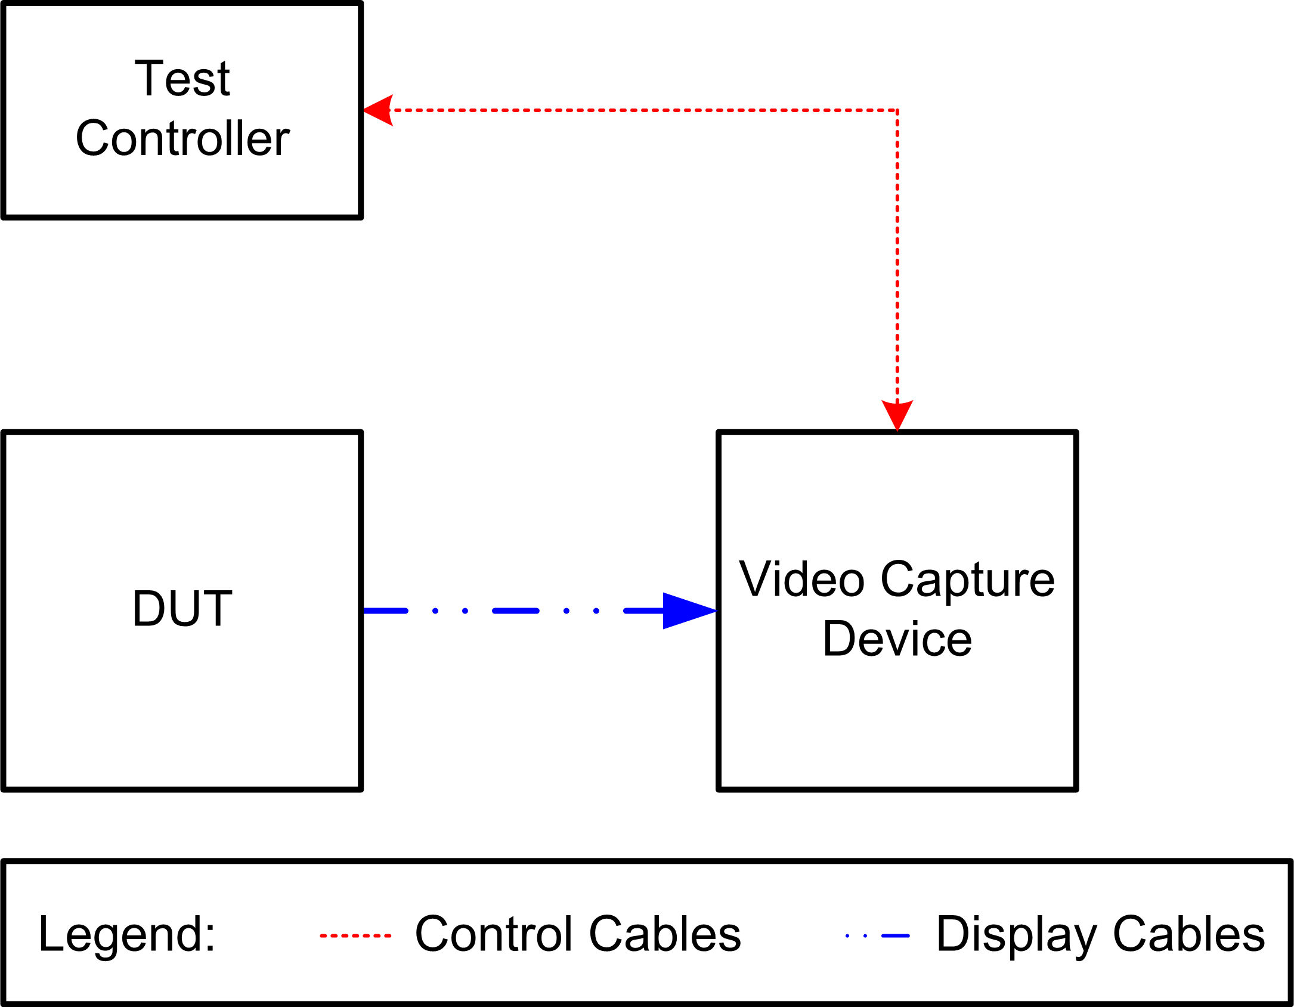

Figure 64 —Test setup for video performance measurements

The DUT receives video traffic according to the configuration defined for the test environment in section 5. Video rendered on the DUT is captured by the video capture device for processing by the video playback analysis application and the video quality analysis application. If the DUT is acting as the video capture device, no modification to the test environment is required.

6.21.2.3.1 Video Content Preparation

Video content must be prepared by the video playback analysis application before it can be used for this test. Source content is first instrumented with unique frame identifiers by the VPAA. Finally, the content is compressed and encoded in the desired format, as shown in figure 65:

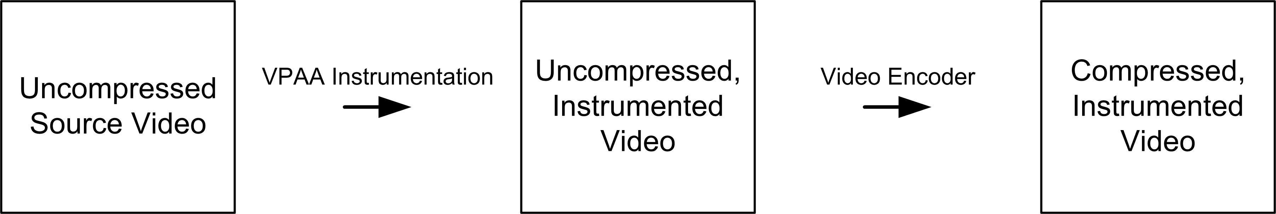

Figure 65 —Video content preparation

Instrumentation may take place on the video traffic generator or on an external system. Alternately, the video content can be instrumented in real-time if the video traffic generator supports this feature.

To measure video performance, video frames are captured from the DUT display signal by the video capture device and saved to non-volatile storage as a new video file. The video playback analysis application examines this file for the expected frame identifiers to calculate VDER, while the video quality analysis application examines the file to derive a quality score. This process is shown in figure 66:

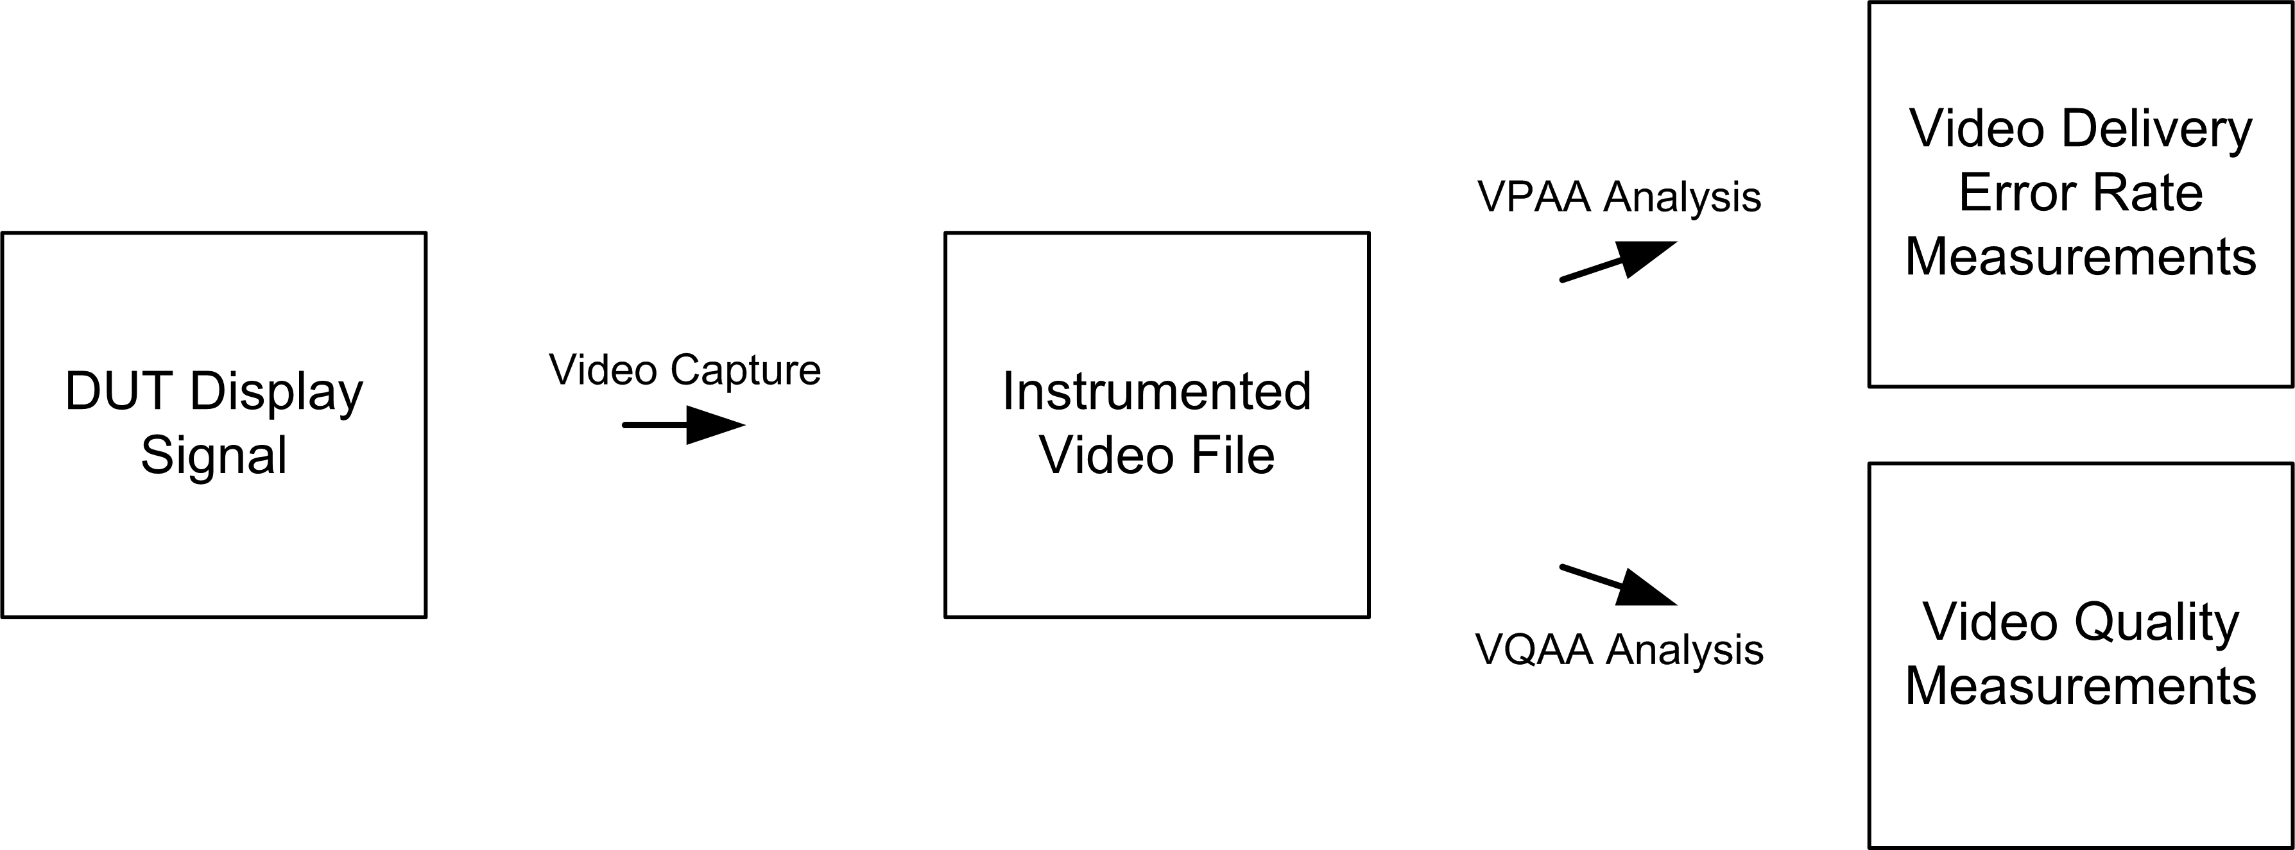

Figure 66 —Video content capture and analysis

Before the test begins, the prepared test media must be loaded on the video traffic generator. VPAA and VQAA analysis may occur on the video capture device or externally. Alternately, video delivery and video quality measurements can be performed in real-time if the video capture device supports this feature.

6.21.2.3.2 Test Calibration

To perform video performance tests, the DUT must support the video format, bitrate, network transport and streaming protocol used by the video traffic generator. In addition, an external video capture device must support the display signal format used by the DUT and support the frame rate of the test media.

The following requirements must be met:

- The DUT is able to access and display the video stream from the video traffic generator by initiating a playback request via the appropriate application protocol.
- The capture device properly saves a real-time copy of the video stream displayed on the DUT to non-volatile storage.
- The video playback analysis application is able to read the media instrumentation from the capture file.
- The video quality analysis application is able to process the capture file and the source media (if required)
Calibration of the video capture device should be performed by capturing instrumented video directly from the DUT for a period of two hours. If local DUT playback is unavailable, a non-RF data connection to the video traffic generator that exceeds the maximum physical layer rate of the wireless network may be substituted for calibration. Baseline video delivery errors detected by the capture device during DUT calibration should not exceed 0.1% of the total video frames delivered during the test. Capture devices that cannot meet this requirement should not be used for video performance tests. The maximum one-minute rolling average of the baseline video delivery error rate, the capture methodology and the video file output format should be reported with the test results. Capture device calibration must be performed each time hardware or software changes are made to the test configuration or if changes are made to the video resolution or frame rate.

A baseline video quality score should be measured using the same video file that was used for capture device calibration. This score indicates the maximum video quality expected from the DUT and should be reported with the test results.

6.21.2.4 Permissible error margins and reliability of test

Prior to beginning the test, the test equipment described above shall be calibrated, and all test software verified.

The test setup may be monitored during the test to ensure that the test conditions do not change. The expected error margins are outlined in Table 67.

 | Conducted Environment | OTA Environment
Video Delivery Error Rate | ±6% | ±20%
Video Quality MOS | ±3% | ±16%
MDI – DF | ±3% | ±16%
MDI – MLR | ±3% | ±16%

Table 67 — Permissible error margins

6.21.3 Approach

6.21.3.1 Configuration parameters

This subclause provides a list of DUT setup parameters applicable to this test.

6.21.3.1.1 Baseline configuration

The baseline DUT setup that should be configured measured and reported whenever this test is performed is as follows:

- Maximum transmit power setting for the DUT and the WLCP.
- RTS threshold set to maximum MAC frame size.
- Fragmentation threshold set to maximum MAC frame size.
- MAC QoS and service priority enabled, video traffic at high priority.
- No security (Open System authentication).
- No power management (i.e., active mode).
- Frame size set to smallest size that avoids packet fragmentation (typically 1528 octets).
- Video traffic bitrate and network transport configured to model desired application. The video frame rate must be supported by the video capture device.
- Default DUT video buffer size.
- No video content encryption.
The video traffic parameters should be reported with the test results.

6.21.3.1.2 Modifiers

The baseline DUT setup parameters may be modified as follows to enable additional trials to be performed for this test.

- MAC QoS and service priority disabled.
- MAC QoS enabled, video traffic at high priority, background traffic at low priority.
- Security usage: WEP-40, WEP-104, TKIP, CCMP.
- Power saving enabled with different profiles.
- Periodic scanning disabled.
- Alternate video traffic bitrates and/or network transports.
- DUT video buffer size.
- Video content encryption.

Only one variation should be tested at a time.

6.21.3.2 Test conditions

The test conditions used while performing this test are as follows:

- Attenuation or range parameters set per 6.2.3.2, 6.5.3.2 or 6.6.3.2.
- Duration of measurement for each attenuation or range interval (minimum 5 minutes, maximum 20 minutes).

6.21.3.3 Measurement procedure

The DUT and the video traffic generator are first set up according to the baseline configuration, using an initial combination of test conditions. Next, the DUT is associated with the WLCP. The following steps are then performed to measure the media delivery index:

- Attenuation or range is set to the minimum value as per 6.2.3.2, 6.5.3.2 or 6.6.3.2.
- The test controller has the DUT pull a video stream from the video traffic generator in the format specified in the test configuration. After the specified test duration, the client playback is stopped.
- Throughput and packet loss metrics collected by the 802.11 traffic analyzer are used to calculate the MDI score as per 6.2, 6.5, 6.6 and 6.18.
- The attenuation or range is increased by the step amount, and the above steps are repeated until the attenuation exceeds the maximum value as per 6.2.3.2, 6.5.3.2 or 6.6.3.2.

After measuring MDI, the following steps are performed to measure video delivery and video quality:

- Attenuation or range is set to the minimum value as per 6.2.3.2, 6.5.3.2 or 6.6.3.2.
- The test controller starts a capture operation on the video capture device. The test controller then has the DUT pull a video stream from the video traffic generator in the format specified in the test configuration. After the specified test duration, the video capture operation is stopped and then the client playback is stopped.
- The resulting video capture data is processed by the video playback analysis application and the video quality analysis application to determine the video delivery error rate and the video quality score.
- The attenuation or range is increased by the step amount, and the above steps are repeated until the attenuation exceeds the maximum value as per 6.2.3.2, 6.5.3.2 or 6.6.3.2.
The measured data are reported as the results for the baseline DUT configuration. After the baseline DUT configuration has been tested, the tester may repeat the process with a new configuration, until the desired number of different DUT configurations has been exercised.

6.21.3.4 Reported results

The video delivery error rate is typically reported as the sum of the dropped, repeated and out-of-sequence video frames detected during the test. These metrics may be reported individually if the goal is to measure a specific type of error. If listed individually, all metrics must be included. The reported video delivery error rate is the measured error rate minus the one-minute rolling average capture device baseline from the calibration phase (see 6.21.2.4). If this value is negative, the reported VDER should be 0. The capture device baseline should also be reported separately.

The video quality analysis application should report a MOS score for the full duration of the test clip. The baseline MOS score calculated during the calibration phase (see 6.21.2.3.2) should also be reported to indicate the upper quality bound of the DUT. The video quality model and reference type (full reference, reduced reference or no reference) used by the VQAA should be noted with the MOS score. If the video quality model is undefined for particular VDER values, this should be reported with the test results.

The media loss rate (MLR) and delay factor (DF) are computed and reported per 6.21.1.3.

The video format and the capture methodology should be reported with the results. Video format details should include, but are not limited to, video resolution, encoder, bitrate, color space and content protection scheme. The capture methodology should include details about the capture device, the device settings and the display interface used for the capture operation.

The reported results should also provide details of the transport mechanism used for the video stream (i.e. TCP, UDP, RTP, etc.).

The results should be reported as a table or a graph of video performance versus attenuation or range. Separate results should be reported for each configuration.

The results may be summarized in a table formatted according to Table 68.

Attenuation (dB) or Range (m) | Video Delivery Error Rate (Errors/minute) | Video Quality (MOS) | MDI - MLR | MDI - DF

Table 68 — Video performance reporting table

