IEEE P802.11
Wireless LANs
Video Delivery versus Attenuation in a Conducted Environment
Date: May 2006
Author(s):
Name | Company | Address | Phone | email
Royce Fernald | Intel | 5200 Elam Young Pkwy MS:HF3-96  Hillsboro, OR 97124 | 503-696-4318 | royce.fernald@intel.com
Uriel Lemberger | Intel | Matam Industrial Park  PO Box 1659  Haifa 31015 Israel | +972-4-865-5701 | uriel.lemberger@intel.com
Alexander Tolpin | Intel | Matam Industrial Park  PO Box 1659  Haifa 31015 Israel | +972-4-865-5430 | alexander.tolpin@intel.com
Philip Corriveau | Intel | 5200 Elam Young Pkwy MS:HF3-96  Hillsboro, OR 97124 | 503-696-1837 | philip.j.corriveau@intel.com
Fahd Pirzada | Dell | One Dell Way  Round Rock, TX 78682 | 512-338-4400 | fahd_pirzada@dell.com
Fanny Mlinarsky | Azimuth | 31 Nagog Park, Acton, MA 01720 | 978-268-9205 | fanny_mlinarsky@azimuthsystems.com

Abstract
Notice: This document has been prepared to assist IEEE 802.11. It is offered as a basis for discussion and is not binding on the contributing individual(s) or organization(s). The material in this document is subject to change in form and content after further study. The contributor(s) reserve(s) the right to add, amend or withdraw material contained herein.

Release: The contributor grants a free, irrevocable license to the IEEE to incorporate material contained in this contribution, and any modifications thereof, in the creation of an IEEE Standards publication; to copyright in the IEEE’s name any IEEE Standards publication even though it may include portions of this contribution; and at the IEEE’s sole discretion to permit others to reproduce in whole or in part the resulting IEEE Standards publication. The contributor also acknowledges and accepts that this contribution may be made public by IEEE 802.11.

Patent Policy and Procedures: The contributor is familiar with the IEEE 802 Patent Policy and Procedures <http:// ieee802.org/guides/bylaws/sb-bylaws.pdf>, including the statement "IEEE standards may include the known use of patent(s), including patent applications, provided the IEEE receives assurance from the patent holder or applicant with respect to patents essential for compliance with both mandatory and optional portions of the standard." Early disclosure to the Working Group of patent information that might be relevant to the standard is essential to reduce the possibility for delays in the development process and increase the likelihood that the draft publication will be approved for publication. Please notify the Chair <stuart.kerry@philips.com> as early as possible, in written or electronic form, if patented technology (or technology under patent application) might be incorporated into a draft standard being developed within the IEEE 802.11 Working Group. If you have questions, contact the IEEE Patent Committee Administrator at <patcom@ieee.org>.

This document defines the video delivery error rate performance metric and outlines the methodology for performing video delivery tests in a conducted environment.
6.21 Video Delivery versus Attenuation in a Conducted Environment

6.21.1 Introduction and purpose

The purpose of this test is to measure the video delivery error rate (VDER) of the path between a DUT and a WLCP at different attenuation levels using unicast data frames. This test is an extension of the throughput versus attenuation measurements specified in section 6.2.

The video delivery error rate is an objective video performance metric. VDER quantifies the ability of a content delivery system to supply video data to a client its intended delivery rate (i.e. 29.97 video frames per second for NTSC streams). Video delivery errors are visible as skips or pauses during video playback and are a result of the failure of the underlying transport medium to provide an uninterrupted video stream. Variations in the playback rate appear as dropped, repeated or out-of-sequence video frames on the DUT display device.

The video delivery error rate is expressed as the total number of dropped, repeated and out-of-sequence video frames observed per unit time. This value represents the absolute deviation of the delivered video rate from the video stream’s intended playback rate.

This test is applicable wireless clients in IBSS (Independent BSS) as well as infrastructure BSS client configurations. If an IBSS client is being tested, the results determine the ability of the client to receive a video stream from another IBSS client. In infrastructure mode, the results determine the ability of the client to receive a video stream from a media server connected to an AP.

The test setup is comprised of the DUT, the WLCP, a video traffic generator and a video capture device. The WLCP is a reference AP for infrastructure BSS configurations, or a reference client for IBSS configurations. The DUT and the WLCP are connected via conducted cables, which are routed through a variable attenuator. The DUT and WLCP are enclosed in RF shield enclosures. (The video traffic generator and video capture device do not require shielding.) A test controller is connected to the variable attenuator, the video traffic generator and the video capture device. Video traffic is streamed from the video traffic generator over the conducted cables to the DUT, where it is captured by the video capture device and analyzed for playback errors.

6.21.2 Test configuration

6.21.2.1 Resource requirements

The following equipment is required to carry out this test:

- A WLCP, which is a reference AP for an infrastructure BSS or a reference client for an IBSS. The
- A DUT that is capable of associating with the WLCP.
- A video traffic generator capable of streaming video data through the WLCP to the DUT. The video traffic generator is a general purpose PC with video streaming software or a dedicated video traffic generation device.
- A video capture device that can capture video data as it is rendered on the DUT. A capture device is a general purpose PC or specialized system with a video signal input port and the ability to save the displayed video content to non-volatile storage. (This system appears as a normal display device to the DUT.) The capture device must support the video signal format used by the DUT (i.e. DVI, VGA, s-video or HD component) and have sufficient CPU and storage resources to save uncompressed video data to its storage subsystem at the playback rate of the test media. Performance of the capture device must be verified as described in section 6.21.2.3.2 before it can be used for VDER testing.
- A power meter device connected to WLCP side of the RF cable, used to measure the average transmit power of the RF signal from the WLCP for each packet.
- A variable, controllable attenuator.
- An automated test controller that includes the following capabilities:
  - The ability to control the power meter.
  - The ability to control the attenuator
  - The ability to control the video traffic generator
  - The ability to control the video capture device.
- Shielded enclosures for the DUT and WLCP, each with a minimum of 95dB of isolation.
- Two calibrated combiners for the conducted connection between the antennas of the DUT and the WLCP.

The following equipment is optional, depending on the specific test objectives:

- A channel emulator (recommended for testing MIMO devices)

The following software applications are required to carry out this test:

- A video playback analysis application (VPAA). The video playback analysis application must be able to instrument each video frame of the test media with a unique identifier. This application must also be capable of decoding its identifier sequence from instrumented video capture files to determine if each frame was successfully delivered. Based on these measurements, the VPAA should report on dropped, repeated or out-of-sequence video frames. Video frame identifiers should be content and file format independent (i.e. visible color patterns, geometric sequences or watermarks) and should be resistant to resolution, display format and color space changes that occur when video is rendered on different devices.
- A video encoder application capable of encoding the instrumented test media in the required format.
- A video capture application capable of capturing display data from the DUT.

Optionally, video playback instrumentation, compression, capture and analysis may be implemented as part of a single application or as components of the video traffic generator or the video capture device.

The test setup is described in 6.21.2.3.

6.21.2.2 Test environment

The metrics and measurements described in this subclause utilize the conducted test environment described in 5.3.

6.21.2.3 Test setup

Figure 64 depicts the test setup:

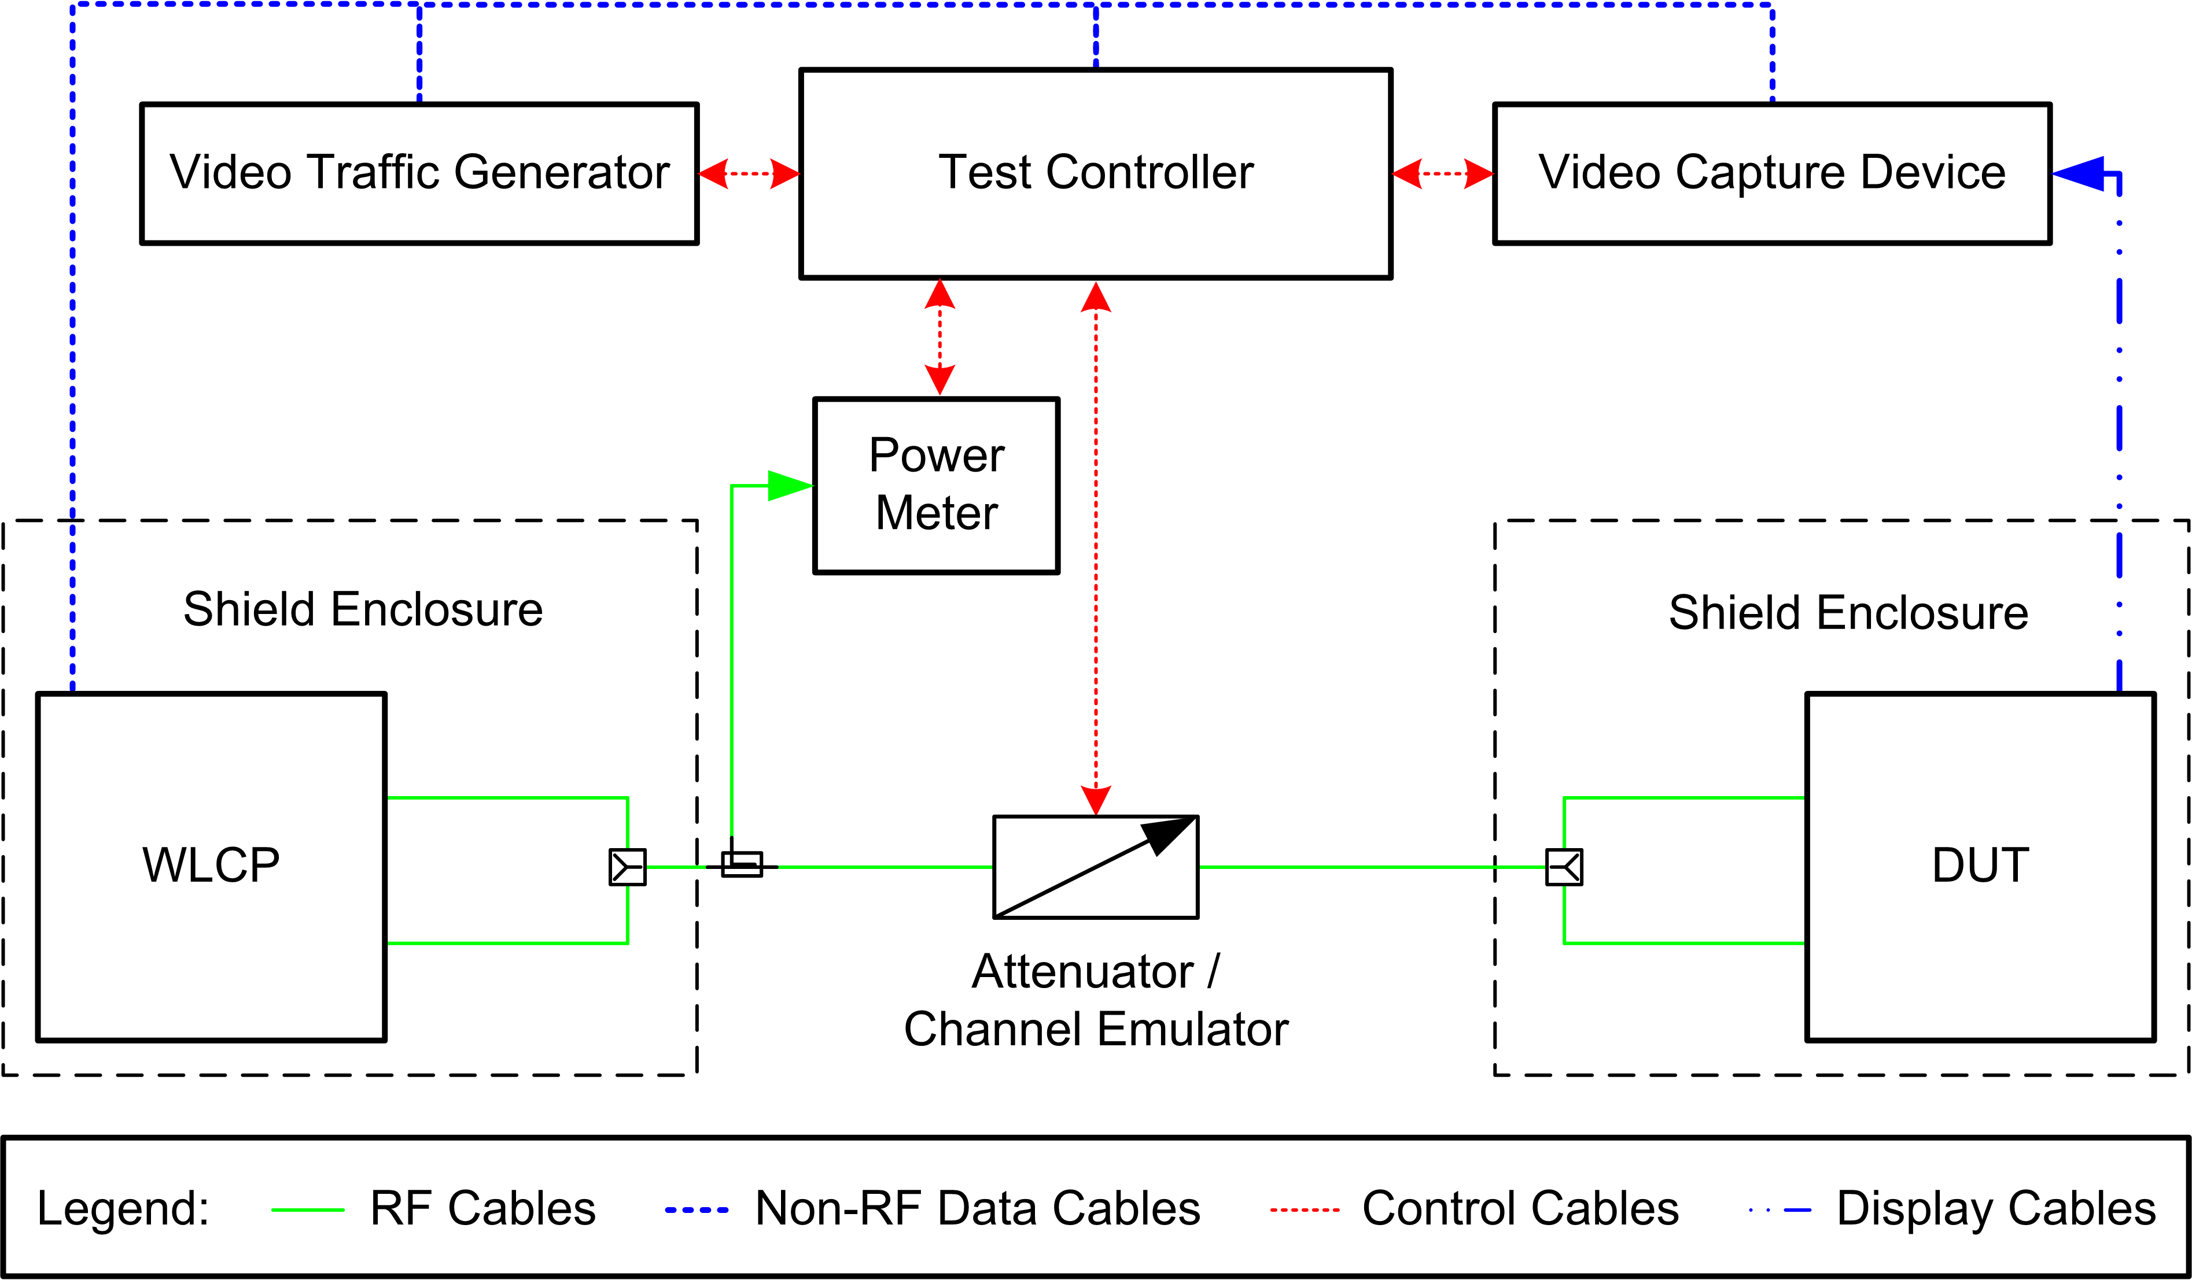

Figure 64 —Conducted test setup for video delivery versus attenuation measurements

The non-RF interface of the WLCP is connected to the video traffic generator, which streams media across the conducted connection to the DUT. Both the WLCP and the DUT are placed in shielded enclosures to isolate them from external interference and from each other. Video rendered on the DUT is captured by the video capture device for processing by the video playback analysis application.

6.21.2.3.1 Video Content Preparation

Video content must be prepared by the video playback analysis application before it can be used for this test. Uncompressed source content is first instrumented with unique frame identifiers by the VPAA. Finally, the content is compressed and encoded in the desired format, as shown in figure 65:

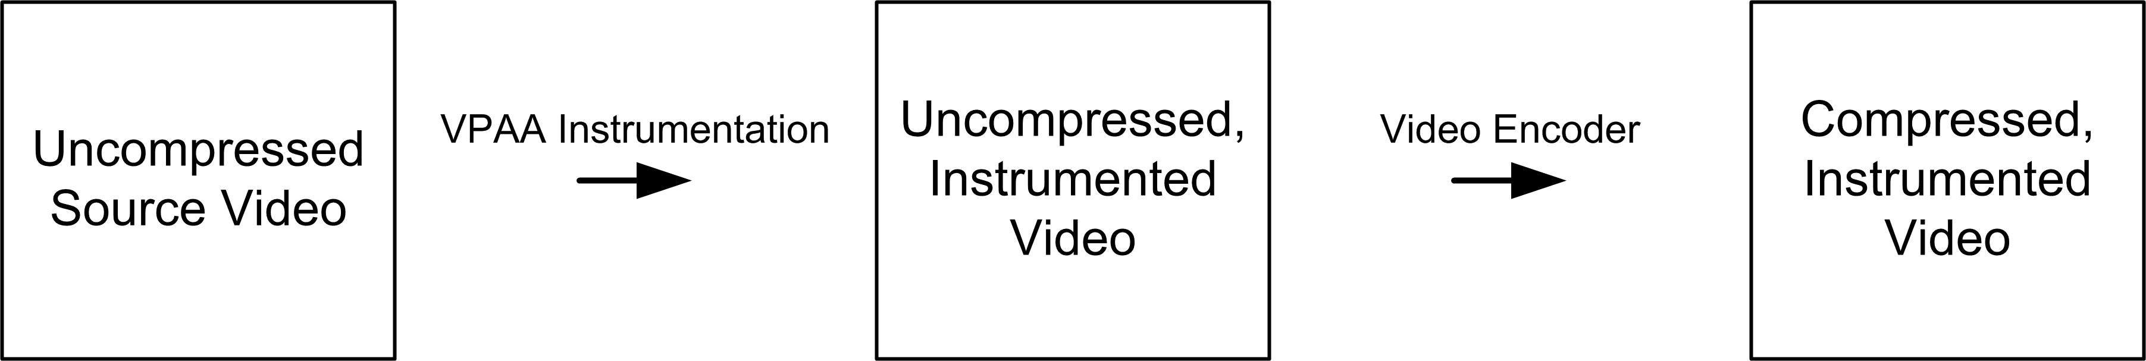

Figure 65 —Video content preparation

To measure the video delivery error rate, video frames are captured from the DUT display signal by the video capture device and saved to non-volatile storage as an uncompressed video file. The video playback analysis application examines this file for the expected frame identifiers, as shown in figure 66:

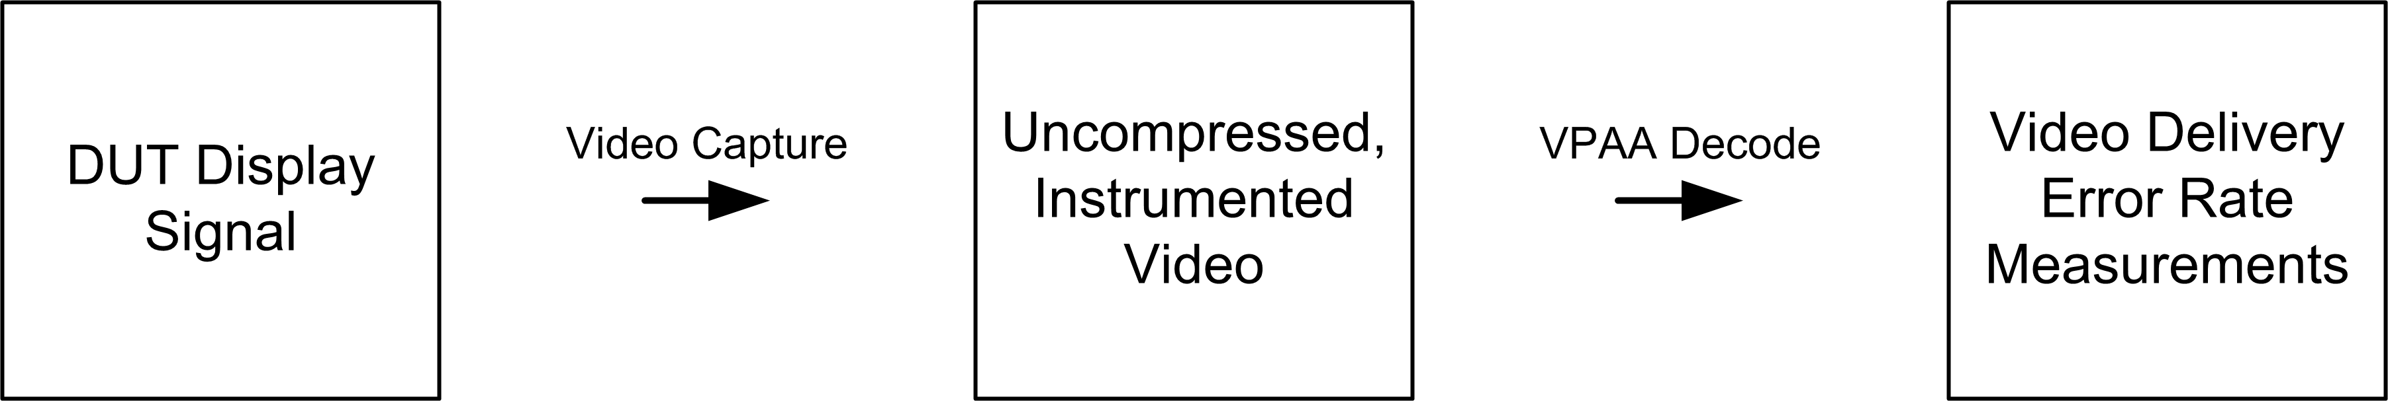

Figure 66 —Video content capture and analysis

Before the test begins, the prepared test media must be loaded on the video traffic generator. Instrumentation may take place on the video traffic generator or on an external system. VPAA analysis may occur on the video capture device or externally.

6.21.2.3.2 Test Calibration

To perform a VDER test, the DUT must support the video format, bitrate, network transport and streaming protocol used by the video traffic generator. In addition, the video capture device must support the display signal format used by the DUT and support the frame rate of the test media.

The following requirements must be met:

- The DUT is able to access and display the video stream from the video traffic generator by initiating a playback request via the appropriate application protocol.
- The capture device properly saves the DUT’s display data to non-volatile storage.
- The video playback analysis application is able to read the media instrumentation from the capture file.

Calibration of the video capture device should be performed by capturing instrumented video directly from the DUT for a period of two hours. If local DUT playback is unavailable, a non-RF data connection to the video traffic generator that exceeds the maximum physical layer rate of the wireless network may be substituted for calibration. Baseline video delivery errors detected by the capture device during DUT calibration should not exceed 0.1% of the total video frames delivered during the test. Capture devices that cannot meet this requirement should not be used for VDER tests. The maximum one-minute rolling average of the baseline video delivery error rate should be reported with the test results. Capture device calibration must be performed each time hardware or software changes are made to the test configuration or if changes are made to the video resolution or frame rate.

6.21.2.4 Permissible error margins and reliability of test

Prior to beginning the test, the test equipment described above shall be calibrated, and all test software verified.

The test setup may be monitored during the test to ensure that the test conditions do not change. The expected error margins for the test results are ±6% of the video delivery error rate measured for a specific attenuation.

6.21.3 Approach

6.21.3.1 Configuration parameters

This subclause provides a list of DUT setup parameters applicable to this test.

6.21.3.1.1 Baseline configuration

The baseline DUT setup that should be configured measured and reported whenever this test is performed is as follows:

- Maximum transmit power setting for the DUT and the WLCP.
- RTS threshold set to maximum MAC frame size.
- Fragmentation threshold set to maximum MAC frame size.
- MAC QoS and service priority enabled, video traffic at high priority.
- No security (Open System authentication).
- No power management (i.e., active mode).
- Frame size set to smallest size that avoids packet fragmentation (typically 1528 octets).
- Video traffic bitrate and network transport on video traffic generator configured to model desired application. The video frame rate must be supported by the video capture device.
- No video content encryption.

The video traffic parameters should be reported with the test results.

6.21.3.1.2 Modifiers

The baseline DUT setup parameters may be modified as follows to enable additional trials to be performed for this test.

- MAC QoS and service priority disabled.
- MAC QoS enabled, video traffic at high priority, background traffic at low priority.
- Security usage: WEP-40, WEP-104, TKIP, CCMP.
- Power save mode.
- Periodic scanning disabled.
- Alternate video traffic bitrates and/or network transports.
- Video content encryption.

Only one variation should be tested at a time.

6.21.3.2 Test conditions

The test conditions used while performing this test are as follows:

- Attenuation values: minimum, maximum and step (minimum 0 dB, maximum 100 dB, minimum step 1 dB, maximum step 5 dB).
- Duration of measurement for each attenuation (minimum 5 minutes, maximum 20 minutes).

6.21.3.3 Measurement procedure

The DUT, the video traffic generator and the video capture device are first set up according to the baseline configuration, using an initial combination of test conditions. Next, the DUT is associated with the WLCP. The following steps are then performed:

- The attenuation is set to the minimum value as per 2.3.1.3.
- The test controller starts a capture operation on the video capture device. The test controller then has the DUT pull a video stream from the video traffic generator in the format specified in the test configuration. After the specified test duration, the video capture operation is stopped and then the client playback is stopped.
- The resulting video capture data is processed by the video playback analysis application to determine the video delivery error rate.
- The attenuation is increased by the step amount, and the above steps are repeated until the attenuation exceeds the maximum value as per 2.3.1.3.
- The measured data are reported as the results for the baseline DUT configuration. Each attenuation value should be translated to DUT receive power based on measured transmit power of WLCP, cables lost and attenuation values. Results are reported as per 2.3.3.
- After the baseline DUT configuration has been tested, the tester may repeat the process with a new configuration, until the desired number of different DUT configurations has been exercised.

6.21.3.4 Reported results

The video delivery error rate is computed as the sum of the dropped, repeated and out-of-sequence video frames detected during the test. These metrics may be reported separately if the goal is to measure a specific type of error. If reported separately, all metrics must be included.

The results should be reported as a table or a graph of video delivery errors per minute versus attenuation. Separate results should be reported for each configuration.

The reported video delivery error rate is the measured error rate minus the one-minute rolling average capture device baseline from the calibration phase (see 6.21.2.4). If this value is negative, the reported VDER should be 0.

The results may be summarized in a table formatted according to Table 67.

Attenuation (dB) | Setup Path Loss (dB) | WLCP Tx Power (dBm) | Rx Input Power (dBm) | Video Delivery Error Rate (Errors/minute)

Table 67 — Video delivery versus attenuation reporting table

