IEEE P802.11
Wireless LANs
Single RIC IE
Date: 2006-04-13
Author(s):
Name | Company | Address | Phone | email
Bill Marshall | TGr Editor | 180 Park Ave, Florham Park, NJ 07932 | 973-360-8718 | wtm@research.att.com
Abstract
One proposal from LB82 was that the RIC Root and RIC Data IEs be combined into a single IE.

This submission provides details of one way that this might be done.
Notice: This document has been prepared to assist IEEE 802.11. It is offered as a basis for discussion and is not binding on the contributing individual(s) or organization(s). The material in this document is subject to change in form and content after further study. The contributor(s) reserve(s) the right to add, amend or withdraw material contained herein.

Release: The contributor grants a free, irrevocable license to the IEEE to incorporate material contained in this contribution, and any modifications thereof, in the creation of an IEEE Standards publication; to copyright in the IEEE’s name any IEEE Standards publication even though it may include portions of this contribution; and at the IEEE’s sole discretion to permit others to reproduce in whole or in part the resulting IEEE Standards publication. The contributor also acknowledges and accepts that this contribution may be made public by IEEE 802.11.

Patent Policy and Procedures: The contributor is familiar with the IEEE 802 Patent Policy and Procedures <http:// ieee802.org/guides/bylaws/sb-bylaws.pdf>, including the statement "IEEE standards may include the known use of patent(s), including patent applications, provided the IEEE receives assurance from the patent holder or applicant with respect to patents essential for compliance with both mandatory and optional portions of the standard." Early disclosure to the Working Group of patent information that might be relevant to the standard is essential to reduce the possibility for delays in the development process and increase the likelihood that the draft publication will be approved for publication. Please notify the Chair <stuart.kerry@philips.com> as early as possible, in written or electronic form, if patented technology (or technology under patent application) might be incorporated into a draft standard being developed within the IEEE 802.11 Working Group. If you have questions, contact the IEEE Patent Committee Administrator at <patcom@ieee.org>.

Change 7.3.2.46 and 8A.7 as follows:

7.3.2.46 Resource information container information element
The Resource Information Container (RIC) refers to a collection of Information Elements that are used to express a resource request in a resource request message. A RIC is also used to convey responses to the corresponding requests.

A Resource Information Container consists of a RIC information element, followed by a list of zero or more Resource Requests. Each Resource Request consists of one or more information elements that describe that resource, as shown in Figure 113R.
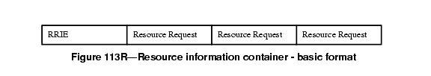

(in above figure, change RRIE to RICIE)

When multiple Resource Requests appear in a RIC, the STA's intent is that all of them be allocated. Thus an "AND" relationship exists between the Resource Requests. Information in the RIC information element identifies the boundaries between the successive Resource Requests.

Each Resource Request consists of one or more alternative Resource descriptions. Each resource alternative is describe by one information element, referred to here as a “Resource IE”.. The Resource IEs may be followed by one or more additional information elements (referred to here as "Auxiliary IEs") that provide additional information that applies to all of the alternative Resource IEs. This is shown in Figure 113S.
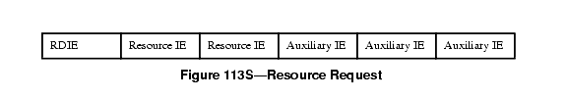

(in above figure, drop RDIE)

For example, when the resource being requested is QoS for downstream traffic, the set of TSPEC information elements may be followed by one or more TCLAS information elements and, only when multiple TCLAS information elements are present, a TCLAS Processing element. Such an example Resource Request is shown in Figure 113T.
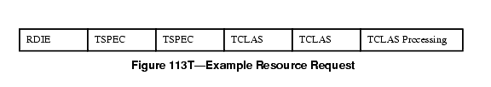

(in above figure, drop RDIE)

If there are multiple Resource IEs then these are treated as "choices" by the target AP. The AP shall attempt to allocate whatever is specified in the first Resource IE; if this fails the AP shall attempt to allocate whatever is specified in the next Resource IE instead, and so on until a successful allocation or the AP reaches the end of the Resource IE list. Thus, an "OR" relationship exists between Resource IEs that follow an RDIE, with the Resource IEs appearing in order of preference.

An example of a RIC with two resource requests, each with a single TSPEC, is given in Figure 113U.
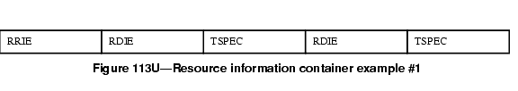

(in above figure, drop RDIEs, change RRIE to RIC IE, and add notation above the TSPECs for “Resource Request #1” and “Resource Request #2”)

An example of a RIC with one resource request, with a choice of two TSPECs, is given in Figure 113V. This indicates that the target AP can select one of the two TSPECs
.
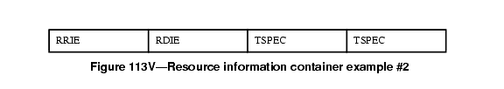

(in above figure, change RRIE to RIC IE, drop RDIE, add notation above the two TSPECs for “Resource Request #1”)

The Resource Information Container Information Element (RIC IE) is defined in Figure 113W.
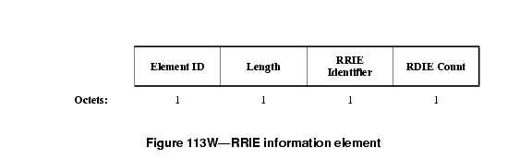

(in above figure, replace “RDIE Count” with “sequence of Resource Information fields”, change “1” below to “variable”)

When the RIC IE contains n Resource Information fields, the length field shall contain the value 2*n+1.
The RRIE Identifier contains an arbitrary value that shall be unique among outstanding resource allocation requests at a STA to enable the matching of responses to requests.

The Resource Information field is defined in Figure 113X.
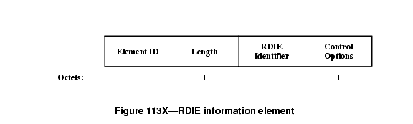

(in above figure “Resource Information field”, delete Element ID and Length, leaving only 2 octets, change RDIE Identifier to “Resource Information field Identifier”.)

The Resource Information field Identifier is an arbitrary value, chosen by the resource requestor, which uniquely identifies the Resource within the RIC. It is used in the response to refer to a specific resource allocation request.
The Control Options field is defined in Figure 113Y.

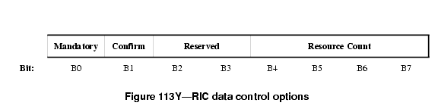

The Mandatory bit set to 1 indicates that one of the Resource IEs that constitute this resource request needs to be allocatable/allocated for the resource request to be considered successful. If the Mandatory bit is set to 0, and none of the Resource IEs is allocatable/allocated, the AP continues processing the remainder of the RIC.
The Confirm bit is used only in response messages to indicate success or failure of the allocation. It is ignored in request messages, and shall be set to zero.
The Resource Count indicates the number of alternative Resource IEs and Auxiliary IEs that constitute this resource request.

8A.7 Resource reservation procedures
8A.7.1 General
When using the reservation procedure, the STA has the option to request a resource allocation at the target AP. To request resources the STA creates a Resource Information Container (RIC) and inserts it in an appropriate request message to the target AP. The request message is sent to the target AP either directly (over-the-air), or via the Current AP (over-the-DS), according to the Fast BSS Transition procedures described in clauses 8A.3 and 8A.4. In an RSNA, resource requests and responses are exchanged only after the establishment of the PTK, and are protected by message integrity checks.
The RIC contains a complete list of resources required by the STA after the transition.
This clause contains procedures for generation of a RIC, procedures for replacing or updating existing reservations, and procedures when performing a resource reservation at (re)association time.
If the STA is performing the FT Base Mechanism, described in clause 8A.3, it shall generate a RIC and process the RIC response according to the procedures of 8A.7.2.1, performing the exchange in the (re)association request/response.
If the STA is performing a Reservation, described in clause 8A.4, it shall generate a RIC and process the RIC response according to the procedures of 8A.7.2.1, performing the exchange in the Authentication-Confirm/Authentication-Acknowledgement frames (or FT Confirm/FT Acknowledgement Action frames).
The reservation procedure shall always start with a Fast BSS Transition Request message and, if completed prior to re-association, shall be confirmed at the time of re-association. Any pre-existing reservations shall be discarded when a new reservation is made.
At the time of (re)association after a reservation, the STA shall include a confirmation RIC to indicate that the reservation should be used. If the STA fails to include the confirmation RIC or includes a new RIC when associating after a reservation (within the ReassociationDeadline) the AP shall reject the association request with reason code "Unspecified failure".
8A.7.2 Creation and handling of a resource request
8A.7.2.1 STA procedures
The resource reservation request enables a STA that is also a non-AP QSTA to reserve resources based on specified Resource IEs (e.g., TSPECs) before or at the time the STA associates with the target AP. In using TSPECs for requesting QoS resources, the TSPECs in the request need not belong to only active Traffic Streams; the STA can send TSPECs for any Traffic Stream that it intends to use after the transition, and reserve the same resources that would be reserved by a later ADDTS exchange. These Resource IEs are included in a Resource Information Container (RIC). For each Resource, the STA may provide the AP with a choice of Resource IEs in order of preference, any one of which will meet the needs of the application.
For a reservation request the STA shall construct the RIC as follows: In the RIC IE, the RIC Identifier shall contain an arbitrary value intended to enable the matching of the response to this request.
The STA shall consider the resources that it desires at the next AP. For QoS resources, each traffic stream shall be requested by a separate Resource Information field and associated TSPEC(s). The Resource Information field Identifier in the Resource Information field shall be an arbitrary value chosen by the STA that uniquely identifies the resource within the RIC. In the Control Options field, the Mandatory bit shall indicate whether the allocation of this resource is mandatory or optional; the Confirm bit shall be set to zero, and the Resource Count shall be set to the number of alternative Resource information elements and Auxiliary information elements that constitute this resource request.
Following the RIC IE, the STA shall include one or more Resource IEs that define the resources required for this Traffic Stream. When multiple TSPECs are part of a single QoS resource request, a logical "OR" relationship exists between them, and at most one of these TSPECs will be accepted by the AP. The STA shall order the Resource IEs by preference, most desired first.
A response to the reservation request is considered successful by a STA if the status code 0 is returned in the response message. This indicates that the AP has reserved one of the Resource IEs for each resource marked as "Mandatory" in the Control Options field. Resources that were not marked "Mandatory" may or may not have been reserved, as indicated by the "Confirm" bit.
If the response to the reservation request contains a status code other than 0, the STA considers that the request has failed, and that no resources are being held at the target AP.
The response from the target AP may contain a RIC, with the RIC Identifier matching the value present in the original RIC request. The Resource Information fields in the response indicate which resources were considered by the target AP and the setting of the Confirm bit indicates which Resource IEs could be reserved by the AP. If the status code of the response is zero, all the Resource IEs with the confirm bit set are reserved at the target AP. If the reservation response returns a failure code no resources are reserved by the AP but those with the confirm bit set could have been reserved. This information may be useful to the STA in formulating another reservation request.
The Resource Information field Identifier enables the STA to match the response with the request. The "confirm" bit in the Control Options is interpreted as follows:
- Confirm = '1' indicates that the resources were available when the AP processed the request. If the response has the status SUCCESS the resources will have been allocated or reserved. The RIC IE is followed by the Resource IE that was accepted.
- Confirm = '0' indicates that the resources could not be allocated. The RIC IE may be followed by a suggested Resource IE that could have been allocated.
A response to a successful resource request (other than in a (re)association request) contains the reassociation deadline. It is the responsibility of the STA to initiate a (re)association request to associate with the target AP within the specific time indicated in the resource reservation response. Failure to do so will result in the release of any resources held by the target AP.
If the STA has obtained a reservation and (re)associates prior to expiry of the ReassociationDeadline, it shall include a "confirmation RIC" in the (re)association request. The confirmation RIC contains only the RRIE, with a RIC identifier matching the RIC request that had been previously successful.
In generating the request for QoS resources for a Traffic Stream, the procedures of 11.4 shall be followed for the generation of TSPECs and inclusion of TCLAS and TCLAS Processing elements. If the TS is a downstream flow then the resource request may also include one or more TCLAS element(s) (defined in clause 7.3.2.31), and (if multiple TCLAS elements are included) a TCLAS Processing element (defined in clause 7.3.2.33). If present, the TCLAS shall appear after the corresponding TSPEC.
8A.7.2.2 AP procedures
When a Resource Information Container appears in a Request, the AP shall check its ability to allocate one resource for each Resource Request in the RIC in the order appearing in the RIC. In a (re)association request, the QoS Capability IE shall be processed prior to the QoS resource requests in the RIC.
The behavior of the AP is described in the flowchart in Figure 154L below:

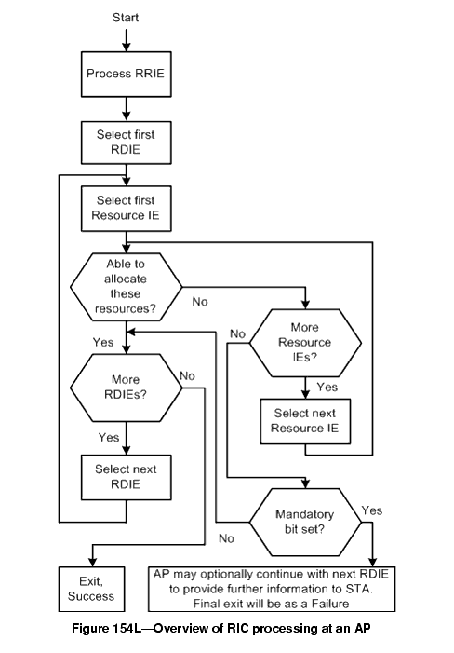

(in above figure, change all “RDIE” to “Resource Request”, and “RRIE” to “RIC IE”)

The SME examines the resource requests in the RIC. For those that require processing by the MAC layer, it generates a MLME-RESERVATION_LOCAL.request; the MAC shall respond with MLME-RESERVATION_LOCAL.response that will indicate whether the MAC has accepted the resource request or not. The SME may also send these resource requests to an external entity such as a back-end QoS module for its consideration; these procedures are beyond the scope of this specification. The acceptance of a TSPEC by the target AP results in the resource allocation for a traffic stream at the target AP.
In response to a request RIC, the AP shall construct a response RIC and include it in the response message. The RIC Identifier in the RIC IE shall match the value in the request. The response RIC shall comprise one Resource Information field for each resource that the AP has assigned or attempted to assign. The Resource Information fields shall be in the same order as in the request and the Identifier in each Resource Information field shall be the value of the Identifier in the corresponding request. The "confirm" bit in the Control Options in the Resource Information field shall be set according to the result of the allocation request as follows:
- Confirm = '1' indicates that the resources are available. If the response has the status SUCCESS the resources have been allocated or reserved. The RIC IE shall also be followed by the Resource IE that was accepted.
- Confirm = '0' indicates that the resources could not be allocated. In this case the AP may include a single Resource IE following the RIC IE indicating a suggested resource that could have been allocated. The Resource Count field shall be set to '0' or '1' depending whether the suggested Resource IE is attached.
If a mandatory resource request fails, the AP need not process requests that follow but may choose to do so in order to provide information to the STA. Absence of a Resource Information field in the response indicates that the resource request and related Resource IEs were not considered by the AP.
If the AP is unable to meet the resource request, then the AP shall indicate a failure status code in the response message. The status code provides a reason for the failure, such as if a TSPEC is invalid, if resources are unavailable, or if authentication timed out. If the request fails, any resources allocated up to the point of failure shall be released.
If the resource request included QoS resources and is successful, then the procedures for handling of TSPEC, TCLAS and TCLAS Processing elements shall be as specified in clause 11.4, and the AP shall place the Traffic Streams into the "Accepted" state. The response RIC shall contain the updated admitted TSPEC. The response TSPECs may contain information like Medium Time, etc. The RIC response may also include a Schedule information element (as defined in clause 7.3.2.34) after the admitted TSPEC. Upon (re)association, AP shall move all of the Traffic Streams from the "Accepted" state into the "Active" state.
NOTE - The above cross reference is to clause titled "TS Operation", which is anticipated to become 11.5 in later revisions of 11ma. See the Editor's Note at clause 11.5 for further information.
If the request is other than a (re)association request, the AP shall include a reassociation deadline time in the response message.
If this is a reservation, and the STA does not invoke a (re)association within the reassociation deadline, then the Traffic Streams that had been "Accepted" shall become "Inactive" and the resources shall be released.
At the point that the STA (re)associates with the target AP (within the reassociation deadline, if appropriate), the traffic streams are put into the Active state. This may be immediate if the RIC request was part of a (re)association request.
If a confirmation RIC was sent in the (re)association request, the AP shall check that a reservation with a matching RIC identifier is held for the STA. If no such reservation is valid the AP shall fail the (re)association request with a reason code of "QoS resources not available." If no confirmation RIC is present in the (re)association request and a reservation is held, the AP shall fail the (re)association request with a reason code of 32 ("Unspecified QoS-related failure".)
If the RIC request appears in the (re)association request and there is no reservation held for the STA, it is treated as a regular resource request and the above procedures apply. As a result, the (re)association response may contain RIC IEs in the response with the appropriate status code.

