IEEE P802.11
Wireless LANs
Reorganization of RIC definition and procedures
Date: 2006-04-13
Author(s):
Name | Company | Address | Phone | email
Bill Marshall | TGr Editor | 180 Park Ave, Florham Park, NJ 07932 | 973-360-8718 | wtm@research.att.com
Abstract
Several comments in LB82 suggested that the informative text in 7.3.2.46 would be better placed somewhere else.

This submission reorganizes the RIC definition in 7.3.2.46 and the RIC procedures in 8A.7 to move all of the examples to the latter clause. It also adds better explanation of the RIC responses, and confirmation RICs.
Notice: This document has been prepared to assist IEEE 802.11. It is offered as a basis for discussion and is not binding on the contributing individual(s) or organization(s). The material in this document is subject to change in form and content after further study. The contributor(s) reserve(s) the right to add, amend or withdraw material contained herein.

Release: The contributor grants a free, irrevocable license to the IEEE to incorporate material contained in this contribution, and any modifications thereof, in the creation of an IEEE Standards publication; to copyright in the IEEE’s name any IEEE Standards publication even though it may include portions of this contribution; and at the IEEE’s sole discretion to permit others to reproduce in whole or in part the resulting IEEE Standards publication. The contributor also acknowledges and accepts that this contribution may be made public by IEEE 802.11.

Patent Policy and Procedures: The contributor is familiar with the IEEE 802 Patent Policy and Procedures <http:// ieee802.org/guides/bylaws/sb-bylaws.pdf>, including the statement "IEEE standards may include the known use of patent(s), including patent applications, provided the IEEE receives assurance from the patent holder or applicant with respect to patents essential for compliance with both mandatory and optional portions of the standard." Early disclosure to the Working Group of patent information that might be relevant to the standard is essential to reduce the possibility for delays in the development process and increase the likelihood that the draft publication will be approved for publication. Please notify the Chair <stuart.kerry@philips.com> as early as possible, in written or electronic form, if patented technology (or technology under patent application) might be incorporated into a draft standard being developed within the IEEE 802.11 Working Group. If you have questions, contact the IEEE Patent Committee Administrator at <patcom@ieee.org>.

Change 7.3.2.46 and 8A.7 as follows:

7.3.2.46 Resource information container information elements
The Resource Information Container (RIC) refers to a collection of Information Elements that are used to express a resource request in a resource request message. A RIC is also used to convey responses to the corresponding requests.

A Resource Information Container consists of a RIC Root information element, followed by a list of zero or more Resource
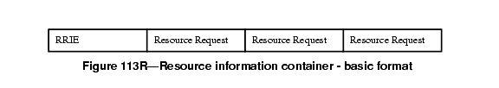

Requests. Each Resource Request comprises an RIC Data information element, followed by one or more information elements that describe that resource. See 8A.7 for examples.
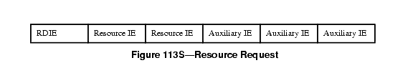

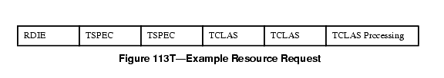

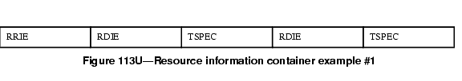

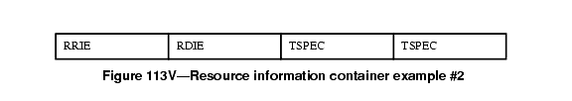

7.3.2.46.1 RIC root information element (RRIE)
The Resource Information Container Root Information Element (RRIE) is defined in Figure 113W.
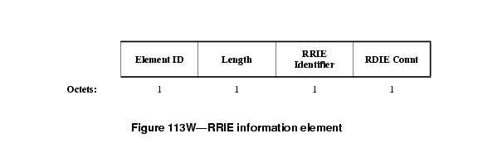

The length field shall contain a value 2.
The RRIE Identifier contains an arbitrary value that shall be unique among outstanding resource allocation requests at a STA to enable the matching of responses to requests.
The RDIE Count contains the number of RDIEs in this RIC.
7.3.2.46.2 RIC data information element (RDIE)
The Resource Information Container Data Information Element (RDIE) is defined in Figure 113X.
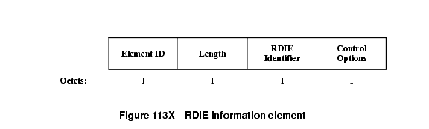

The length field shall contain a value 2.
The RDIE Identifier is an arbitrary value, chosen by the resource requestor, which uniquely identifies the RDIE within the RIC. It is used in the response to refer to a specific resource allocation request.
The Control Options field is defined in Figure 113Y.

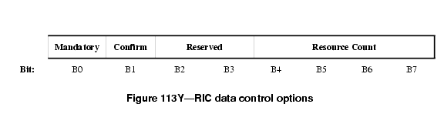

The Mandatory bit set to 1 indicates that one of the Resource IEs that follow the RDIE needs to be allocatable/allocated for the resource request to be considered successful. If the Mandatory bit is set to 0, and none of the Resource IEs is allocatable/allocated, the AP continues processing the remainder of the RIC.
The Confirm bit is used only in response messages to indicate success or failure of the allocation. It is ignored in request messages, and shall be set to zero.
The Resource Count indicates the number of alternative Resource IEs that follow this RDIE. Auxiliary IEs are not included in the Resource Count.

8A.7 Resource reservation procedures
8A.7.1 General
When using the reservation procedure, the STA has the option to request a resource allocation at the target AP. To request resources the STA creates a Resource Information Container (RIC) and inserts it in an appropriate request message to the target AP. The request message is sent to the target AP either directly (over-the-air), or via the Current AP (over-the-DS), according to the Fast BSS Transition procedures described in clauses 8A.3 and 8A.4. In an RSNA, resource requests and responses are exchanged only after the establishment of the PTK, and are protected by message integrity checks.

The RIC contains a complete list of resources required by the STA after the transition.

This clause contains procedures for generation of a RIC at a STA and procedures for processing a RIC and generating a reply at an AP.

The reservation procedure always starts with a Fast BSS Transtion Request message. Any pre-existing reservations shall be discarded when a new reservation is initiated.

If the STA is performing the FT Base Mechanism, described in clause 8A.3, it shall generate a RIC and process the RIC response according to the procedures of 8A.7.2.1, performing the exchange in the (re)association request/response.

If the STA is performing a Reservation, described in clause 8A.4, it shall generate a RIC and process the RIC response according to the procedures of 8A.7.2.1, performing the exchange in the Authentication-Confirm/Authentication-Acknowledgement frames (or FT Confirm/FT Acknowledgement Action frames).

At the time of (re)association after a reservation, the STA shall include a confirmation RIC to indicate that the reservation should be used. If the STA fails to include the confirmation RIC or includes a new RIC when associating after a reservation (within the ReassociationDeadline) the AP shall reject the association request with reason code "Unspecified failure".

Insert the following sub-clause, renumbering the figures, tables, and following subclauses as necessary (changebars in this MSWord document note the changes from 7.3.2.46 of 11r-D2.0):

8A.7.1A Resource Information Container
The Resource Information Container (RIC) refers to a collection of Information Elements that are used to express a resource request or response.

When used in making a request,

a Resource Information Container has one RRIE and a list of one or more Resource Requests, as shown in Figure 113R.

(in above figure, change caption to “Resource information container – basic request format”)

When multiple Resource Requests appear in a RIC, the STA's intent is that all of them be allocated. Thus an "AND" relationship exists between the Resource Requests.

Each Resource Request consists of an RDIE followed by one or more alternative Resource descriptions. Each resource alternative is described by one information element, referred to here as a “Resource IE”. The Resource IEs may be followed by one or more additional information elements (referred to here as "Auxiliary IEs") that provide additional information that applies to all of the alternative Resource IEs.

(Note – the table of resource types and lists of possible IEs, from another submission, would be placed here)

If there are multiple Resource IEs then these are treated as "choices" by the target AP. The AP shall attempt to allocate whatever is specified in the first Resource IE; if this fails the AP shall attempt to allocate whatever is specified in the next Resource IE instead, and so on until a successful allocation or the AP reaches the end of the Resource IE list. Thus, an "OR" relationship exists between Resource IEs that follow an RDIE, with the Resource IEs appearing in order of preference.

An example of a Resource Request, consisting of both Resource information elements and Auxiliary information elements, is shown in Figure 113S.

For example, when the resource being requested is QoS for downstream traffic, the set of TSPEC information elements may be followed by one or more TCLAS information elements and, when multiple TCLAS information elements are present, a TCLAS Processing element. Such an example Resource Request is shown in Figure 113T.

An example of a RIC with two resource requests, each with a single TSPEC, is given in Figure 113U.

An example of a RIC with one resource request, with a choice of two TSPECs, is given in Figure 113V. This indicates that the target AP can select one of the two TSPECs
.

When sent by an AP in response to a resource request, the Resource Information Container consists of an RRIE with the RRIE identifier matching the RRIE identifier in the request. The RRIE is followed by a list of zero or more Resource Responses, indicating the Resource Requests that were examined by the AP. The basic format of a Response RIC is shown in Figure XX1.
(New figure XX1 “Resource information container – basic response format”, sequence of four items, RRIE, “Resource Response” *3)

Each Resource Response consists of an RDIE with the RDIE identifier matching the RDIE identifier in the request, in the same order as the RDIEs appeared in the request. The RDIE is followed by zero or one Resource IEs. .If the request was not successful (as indicated in the RDIE status), then the AP may include a suggestion that could have been successful. If the resource request was successful, then the particular Resource IE (of the alternatives given by the STA) is included in the response, as modified by the AP during the processing of the reservation request. The Resource IE in the response may be followed by one or more additional Auxiliary IEs that provide additional information. For example, when the resource being requested is QoS for upstream traffic, the TSPEC information element may be followed by a Schedule element.

An example of a response RIC with two QoS resource responses, each with a single TSPEC and Schedule element, is given in Figure XX2.
(New figure XX2 “Example QoS resource information container response”, sequence of seven items, RRIE, RDIE, TSPEC, Schedule, RDIE, TSPEC, Schedule)
In a reassociation exchange following a resource reservation, the STA includes a Confirmation RIC in the reassociation request, and the AP includes a Confirmation RIC in the reassociation response. The confirmation RIC consists of an RRIE with RRIE Identifier matching the RRIE Indentifier of the earlier request, and RDIE Count of zero.

Change 8A.7.2 as follows:

8A.7.2 Creation and handling of a resource request
8A.7.2.1 STA procedures
The resource reservation request enables a STA to reserve resources based on specified Resource IEs (e.g., TSPECs) before or at the time the STA associates with the target AP. In using TSPECs for requesting QoS resources, the TSPECs in the request need not belong to only active Traffic Streams; the STA can send TSPECs for any Traffic Stream that it intends to use after the transition, and reserve the same resources that would be reserved by a later ADDTS exchange. These Resource IEs are included in a Resource Information Container (RIC). For each Resource, the STA may provide the AP with a choice of Resource IEs in order of preference, any one of which will meet the needs of the application.

For a reservation request the STA shall construct the RRIE as follows: the RRIE Identifier shall contain an arbitrary value intended to enable the matching of the response to this request. The "Count of RDIEs" field shall contain the number of RDIEs present in the RIC.

The STA shall consider the resources that it desires at the next AP. For QoS resources, each traffic stream shall be requested by a separate RDIE and associated TSPEC(s). The RDIE Identifier in the RDIE shall be an arbitrary value chosen by the STA that uniquely identifies the RDIE within the RIC. In the Control Options field, the Mandatory bit shall indicate whether the allocation of this resource is mandatory or optional; the Confirm bit shall be set to zero, and the Resource Count shall be set to the number of alternative Resource information elements that follow.

Following each RDIE, the STA shall include one or more Resource IEs that define the resources required for this Traffic Stream. When multiple TSPECs follow an RDIE as part of a single QoS resource request, a logical "OR" relationship exists between them, and at most one of these TSPECs will be accepted by the AP. The STA shall order the Resource IEs by preference, most desired first.

A response to the reservation request is considered successful by a STA if the status code 0 is returned in the response message. This indicates that the AP has reserved one of the Resource IEs in each RDIE marked as "Mandatory" in the Control Options field. Resource IEs in RDIEs that were not marked "Mandatory" may or may not have been reserved, as indicated by the "Confirm" bit.

If the response to the reservation request contains a status code other than 0, the STA considers that the request has failed, and that no resources are being held at the target AP.

The response from the target AP may contain a RIC, with the RRIE Identifier matching the value present in the original RIC request. The RDIEs in the response indicate which resources were considered by the target AP and the setting of the Confirm bit indicates which Resource IEs could be reserved by the AP. If the status code of the response is zero, all the Resource IEs with the confirm bit set are reserved at the target AP. If the reservation response returns a failure code no resources are reserved by the AP but those with the confirm bit set could have been reserved. This information may be useful to the STA in formulating another reservation request.

The RDIE Identifier in the RDIE enables the STA to match the response with the RDIE in the request. The "confirm" bit in the RDIE Control Options is interpreted as follows:
- Confirm = '1' indicates that the resources were available when the AP processed the request. If the response has the status SUCCESS the resources will have been allocated or reserved. The RDIE may be followed by the Resource IE that was accepted.
- Confirm = '0' indicates that the resources could not be allocated. The RDIE may be followed by a suggested Resource IE that could have been allocated.
A response to a successful resource request (other than in a (re)association request) contains the reassociation deadline. It is the responsibility of the STA to initiate a (re)association request to associate with the target AP within the specific time indicated in the resource reservation response. Failure to do so will result in the release of any resources held by the target AP.

If the STA has obtained a reservation and (re)associates prior to expiry of the ReassociationDeadline, it shall include a "confirmation RIC" in the (re)association request. The confirmation RIC contains only the RRIE, with a RIC identifier matching the RIC request that had been previously successful.

In generating the RDIE for QoS resources for a Traffic Stream, the procedures of 11.4 shall be followed for the generation of TSPECs and inclusion of TCLAS and TCLAS Processing elements. If the TS is a downstream flow then the RDIE may also include one or more TCLAS element(s) (defined in clause 7.3.2.31), and (if multiple TCLAS elements are included) a TCLAS Processing element (defined in clause 7.3.2.33). If present, the TCLAS shall appear after the corresponding TSPEC.

8A.7.2.2 AP procedures

When a Resource Information Container appears in a Request, the AP shall check its ability to allocate one resource for each RDIE in the RIC in the order appearing in the RIC. In a (re)association request, the QoS Capability IE shall be processed prior to the QoS resource requests in the RIC.

The behavior of the AP is described in the flowchart in Figure 154L below:

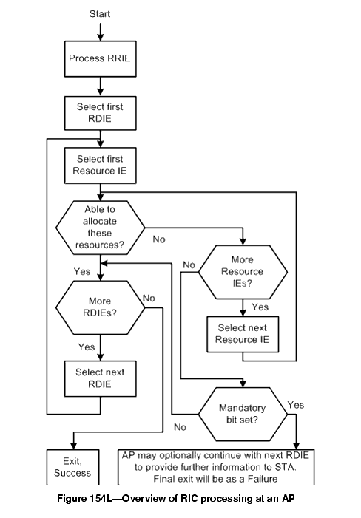

The SME examines the resource requests in the RIC. For those that require processing by the MAC layer, it generates a MLME-RESERVATION_LOCAL.request; the MAC shall respond with MLME-RESERVATION_LOCAL.response that will indicate whether the MAC has accepted the resource request or not. The SME may also send these resource requests to an external entity such as a back-end QoS module for its consideration; these procedures are beyond the scope of this specification. The acceptance of a TSPEC by the target AP results in the resource allocation for a traffic stream at the target AP.

In response to a request RIC, the AP shall construct a response RIC and include it in the response message. The RRIE Identifier in the RRIE shall match the value in the request. The response RIC shall comprise one RDIE for each resource that the AP has assigned or attempted to assign. The RDIEs shall be in the same order as in the request and the RDIE Identifier in each RDIE shall be the value of the RDIE Identifier in the corresponding RDIE in the request. The "confirm" bit in the Control Options in the RDIE shall be set according to the result of the allocation request as follows:
- Confirm = '1' indicates that the resources are available. If the response has the status SUCCESS the resources have been allocated or reserved. The RDIE shall also be followed by the Resource IE that was accepted.
- Confirm = '0' indicates that the resources could not be allocated. In this case the AP may include a single Resource IE following the RDIE indicating a suggested resource that could have been allocated. The Resource Count field shall be set to '0' or '1' depending whether the suggested Resource IE is attached.

If a mandatory resource request fails, the AP need not process RDIEs that follow but may choose to do so in order to provide information to the STA. Absence of an RDIE in the response indicates that the RDIE and related Resource IEs were not considered by the AP.

If the AP is unable to meet the resource request, then the AP shall indicate a failure status code in the response message. The status code provides a reason for the failure, such as if a TSPEC is invalid, if resources are unavailable, or if authentication timed out. If the request fails, any resources allocated up to the point of failure shall be released.

If the resource request included QoS resources and is successful, then the procedures for handling of TSPEC, TCLAS and TCLAS Processing elements shall be as specified in clause 11.4, and the AP shall place the Traffic Streams into the "Accepted" state. The response RIC shall contain the updated admitted TSPEC. The response TSPECs may contain information like Medium Time, etc. Each RDIE may also include a Schedule information element (as defined in clause 7.3.2.34) after the admitted TSPEC. Upon (re)association, AP shall move all of the Traffic Streams from the "Accepted" state into the "Active" state.

NOTE - The above cross reference is to clause titled "TS Operation", which is anticipated to become 11.5 in later revisions of 11ma. See the Editor's Note at clause 11.5 for further information.

If the request is other than a (re)association request, the AP shall include a reassociation deadline time in the response message.

If this is a reservation, and the STA does not invoke a (re)association within the reassociation deadline, then the Traffic Streams that had been "Accepted" shall become "Inactive" and the resources shall be released.

At the point that the STA (re)associates with the target AP (within the reassociation deadline, if appropriate), the traffic streams are put into the Active state. This may be immediate if the RIC request was part of a (re)association request.

If a confirmation RIC was sent in the (re)association request, the AP shall check that a reservation with a matching RIC identifier is held for the STA. If no such reservation is valid the AP shall fail the (re)association request with a reason code of "QoS resources not available." If no confirmation RIC is present in the (re)association request and a reservation is held, the AP shall fail the (re)association request with a reason code of 32 ("Unspecified QoS-related failure".)

