IEEE P802.11
Wireless LANs
Proposed text for frame forwarding on 802.11s
Date: 2005-06-15
Author(s):
Name | Company | Address | Phone | email
Hiroshi Furukawa | Kyushu University | Hakozaki 6-10-1, Higashi-ku, Fukuoka 812-8581, Japan | +81-92-642-4072 | furuhiro@is.kyushu-u.ac.jp
Yukinori Higa | Kyushu Univerisity | Hakozaki 6-10-1, Higashi-ku, Fukuoka 812-8581, Japan | +81-92-642-3891 | higa@mobcom.is.kyushu-u.ac.jp
Ray-Guang Cheng | National Taiwan University of Science and Technology Taipei | No. 43, Sec. 4, Keelung Rd., 106, Taipei, TAIWAN, R.O.C. | +886-2-27376371 | crg@mail.ntust.edu.tw
Jen-Shun Yang | Industrial Technology Research Institute | K100, CL/ITRI Rm. 505, Bldg. 51, 195 Sec. 4, Chung Hsing Rd. Chutung, Hsinchu 310, Taiwan | +886-3-5914616 | jsyang@itri.org.tw
Abstract
This document specifies a text proposal of a frame forwarding scheme for WLAN meshs.
Notice: This document has been prepared to assist IEEE 802.11. It is offered as a basis for discussion and is not binding on the contributing individual(s) or organization(s). The material in this document is subject to change in form and content after further study. The contributor(s) reserve(s) the right to add, amend or withdraw material contained herein.

Release: The contributor grants a free, irrevocable license to the IEEE to incorporate material contained in this contribution, and any modifications thereof, in the creation of an IEEE Standards publication; to copyright in the IEEE’s name any IEEE Standards publication even though it may include portions of this contribution; and at the IEEE’s sole discretion to permit others to reproduce in whole or in part the resulting IEEE Standards publication. The contributor also acknowledges and accepts that this contribution may be made public by IEEE 802.11.

Patent Policy and Procedures: The contributor is familiar with the IEEE 802 Patent Policy and Procedures <http:// ieee802.org/guides/bylaws/sb-bylaws.pdf>, including the statement "IEEE standards may include the known use of patent(s), including patent applications, provided the IEEE receives assurance from the patent holder or applicant with respect to patents essential for compliance with both mandatory and optional portions of the standard." Early disclosure to the Working Group of patent information that might be relevant to the standard is essential to reduce the possibility for delays in the development process and increase the likelihood that the draft publication will be approved for publication. Please notify the Chair <stuart.kerry@philips.com> as early as possible, in written or electronic form, if patented technology (or technology under patent application) might be incorporated into a draft standard being developed within the IEEE 802.11 Working Group. If you have questions, contact the IEEE Patent Committee Administrator at <patcom@ieee.org>.
Table of Contents

1. General information of the proposal 2
2. Coverage of the proposal on the minimum functional requirements 3
3. References 4
4. Overview 4
5. Definition, abbreviations and acronyms 4
6. Mesh Frame Formats 7
6.1. Mesh Management Frame Formats 7
6.2. Mesh Control Frame Formats 7
6.2.1. Mesh Path Reservation Acknowledgement 8
6.2.2. Forwarding Failure Detection 8
6.2.3. Forwarding Pause 8
6.2.4. Forwarding Resume Request 8
6.2.5. Request for IPT Termination Message 8
6.2.6. Request for Return Frames 9
6.3. Mesh Data Frame Format 9
7. Mesh Unicast Procedures 9
7.1. Normal Mode 10
7.2. Intermittent Periodic Transmit Mode 10
7.2.1. IPT transport session and IPT period 11
7.2.2. Procedures of IPT 11
7.2.2.1. Equalization of Frame length 11
7.2.2.2. Mesh Path Reservation 11
7.2.2.2.1. Beacon frame for reservation 11
7.2.2.2.2. Mesh Path Reservation Acknowledgement 12
7.2.2.2.3. Reservation time out 12
7.2.2.2.4. Reservation Extension 12
7.2.2.3. Frame Forwarding 12
7.2.2.3.1. DCF access procedure in IPT mode 12
7.2.2.3.2. Frame transmission of Source MP 13
7.2.2.3.3. Frame Forwarding at Intermediate MP 13
7.2.2.3.4. Forwarding Failures and Resolution 13
7.2.2.3.5. Forced termination of IPT mode 15
7.2.2.3.6. Bidirectional frame forwarding 15
7.2.2.4. Mesh Path Release 15

General information of the proposal

Number | Name | Definition | Coverage  (Yes/No) |  | Notes | References
AD1 | Reference submissions | A list of IEEE 802 submissions related to the proposal, both documents and presentations. |  | Yes |  | Section 3
AD2 | Simulation and/or experimental methodology | Any proposal submission that includes simulation results must include a description of the simulation methodology used for mesh simulations. The simulation methodology documentation should provide enough information to, in principle, reproduce the simulation (e.g., including node positions, traffic and propagation model (including PHY assumptions), packet sizes, etc.). |  | No

Coverage of the proposal on the minimum functional requirements
Functions specified by this proposal are listed on the following minimum functional requirements.

Number | Category | Name | Coverage  (Complete /Partial/ None) | Notes | References
FR1 | TOPO_RT_FWD | Mesh Topology Discovery | None
FR2 | TOPO_RT_FWD | Mesh Routing Protocol | None
FR3 | TOPO_RT_FWD | Extensible Mesh Routing Architecture | None
FR4 | TOPO_RT_FWD | Mesh Broadcast Data Delivery | None
FR5 | TOPO_RT_FWD | Mesh Unicast Data Delivery | Complete | Two modes are defined: Normal mode and Intermittent Periodic Mode.
FR6 | TOPO_RT_FWD | Support for Single and Multiple Radios | Partial | Single radio is supported. Multiple radios would be also applicable.
FR7 | TOPO_RT_FWD | Mesh Network Size | Partial | Although no specific descriptions are defined, up to 32 nodes and more are supported by the proposed Mesh Unicast.
FR8 | SECURITY | Mesh Security | None
FR9 | MEAS | Radio-Aware Routing Metrics | None
FR10 | SERV_CMP | Backwards compatibility with legacy BSS and STA | Partial | The backwards compatibility is maintained for the operation of Mesh Unicast
FR11 | SERV_CMP | Use of WDS 4-Addr Frame or Extension | Partial | The proposed Mesh Unicast adapts the WDS 4-Addr Frame for control and data frames.
FR12 | DISC_ASSOC | Discovery and Association with a WLAN Mesh | None
FR13 | MMAC | Amendment to MAC with no PHY changes required | Complete | No PHY changes are required by this proposal
FR14 | INTRWRK | Compatibility with higher-layer protocols | None | No check was done, but the compatibility will be held for the proposed Mesh Unicast

References

[1] ANSI/IEEE Std 802.11, 1999 Edition
[2] IEEE802.11-04/1477r4, “Terms and Definitions for 802.11s”
[3] IEEE802.11-04/1174r13, “IEEE802.11 TGs Functional Requirements and Scope”
[4] IEEE802.11-05/375r0, “A high speed packet relay irrespective of hop counts”
[5] IEEE802.11-05/0392r2, “Ripple: A Distributed Medium Access Protocol for Wireless Mesh Networks”

Overview
The proposal specifies a Mesh Unicast procedure and some essential functions relating to the Mesh Unicast. The proposed Mesh Unicast consists of Normal mode and Intermittent Periodic mode. The latter is based on the idea disclosed by [4] and [5] that achieves higher relay efficiency. The proposed procedure is enabled on the normal DCF mode specified in [1] and hence easy implementation of the proposal would be realized. The proposal assumes that a Mesh Path Selection method and channel allocation method for each Mesh Link on a Mesh Path are given.

Definition, abbreviations and acronyms

WLAN Mesh – A WLAN Mesh (previously known as ESS Mesh) is an IEEE 802.11-based WDS which is part of a DS, consisting of a set of two or more Mesh Points interconnected via IEEE 802.11 links and communicating via the WLAN Mesh Services. A WLAN Mesh may support zero or more entry points (Mesh Portals), automatic topology learning and dynamic path selection (including across multiple hops).

WLAN Mesh Services – The set of services provided by the WLAN Mesh that support the control, management, and operation of the WLAN Mesh, including the transport of MSDUs between Mesh Points within the WLAN Mesh. WLAN Mesh Services supplement DSS (Distribution System Services).

Mesh Point - Any IEEE 802.11 entity that contains an IEEE 802.11–conformant Medium Access Control (MAC) and Physical Layer (PHY) interface to the Wireless Medium (WM), that is within a WLAN Mesh, and that supports WLAN Mesh Services. (See Figure 2.)

Mesh AP - Any Mesh Point that is also an Access Point. (See Figure 2.)

Mesh Portal - A point at which MSDUs exit and enter a WLAN Mesh to and from other parts of a DS or to and from a non-802.11 network. A Mesh Portal can be collocated with an IEEE 802.11 portal.

Mesh Link - A bidirectional IEEE 802.11 link between two Mesh Points.

Mesh Path - A concatenated set of connected Mesh Links from a source Mesh Point to a destination Mesh Point.

Mesh Path Selection – The process of selecting Mesh Paths.

Path Metric – Criterion used for Mesh Path Selection.

Mesh Topology – A graph consisting of the full set of Mesh Points and Mesh Links in a WLAN Mesh.

Mesh Neighbor - Any Mesh Point that is directly connected to another Mesh Point with a Mesh Link.

Mesh Unicast - Frame forwarding mechanism for transporting MSDUs to an individual Mesh Point within a WLAN Mesh.

Mesh Multicast - Frame forwarding mechanism for transporting MSDUs to a group of Mesh Points within a WLAN Mesh.

Mesh Broadcast - Frame forwarding mechanism for transporting MSDUs to all Mesh Points within a WLAN Mesh.

Mesh Management Message – Message defined for managing and operating the mesh. The message is sent between Mesh Points, e.g. for path determination, neighbor discovery, topology discovery, etc. This definition of message is intended to be generic and does not specify the form of conveyor.

Mesh Control Message - Message defined for controlling access to the WM (Wireless Media) used for communication among Mesh Points.

Mesh Unicast Acknowledgment – An acknowledgement sent back from destination Mesh Point to source Mesh Point of a mesh path for a unicast message.

Authenticated Mesh Point – A Mesh Point that has been authenticated as a valid participant in the WLAN Mesh. The authentication is with repect to a common policy determined by a single administrative entity.

Mesh Identifier – A unique identifier for a WLAN Mesh.

Mesh Discovery - A method to discover one or more WLAN Meshes.

Mesh neighbourhood – A set of Mesh neighbours of a mesh point.

Mesh Performance Metric – A criterion used to evaluate the performance of the Mesh.

Mesh Link Metric – A criterion used to characterize the performance/quality/eligibility of a mesh link as a member of a mesh path. A mesh link metric may be used in a computation of a path metric.

Connected Mesh – The status of the WLAN Mesh in which all Mesh Points that are participating members of a WLAN Mesh are reachable.

Disconnected Mesh – The status of the WLAN Mesh in which a subset of Mesh Points that are participating members within the WLAN Mesh are not reachable. It is also called a partitioned Mesh.

Mesh Association - The service used to establish the Mesh Point membership within a WLAN Mesh. Mesh association is independent from STA association to an AP.

Mesh Member – An associated Mesh Point.

Mesh Member Set – The set of associated Mesh Points within a WLAN Mesh.

Mesh Service Area - The conceptual area within which members of a WLAN Mesh may communicate.

Mesh Coordination Function (MCF) - A logical function used to coordinate access of the Mesh Points (MPs) on the WM. The MCF is used for communication among MPs.

Intermittent Periodic Transmit (IPT) - A mode of Mesh Unicast. A source node sends source frames intermittently and periodically with some transmit period defined by IPTIFS.

Intermittent Periodic Transmit (IPT) Transport Session - A Mesh Unicast Data burst originated by a source MP, its transmission in IPT mode of Mesh Unicast is defined as an IPT transport session.

Intermittent Periodic Transmit (IPT) Period - Transmission time from the beginning of an IPT transport session to the end of the IPT transport session is defined as IPT period.

Intermittent Periodic Transmit (IPT) Inter Frame Space (IPTIFS) – A variable and environment dependent Inter Frame Space (IFS) for carrier detection in IPT mode of Mesh Unicast is defined as Intermittent Periodic Transmit IFS (IPTIFS).

AP | Access Point
BSS | Basic Service Set
DS | Distribution System
DSS | Distribution System Services
ESS | Extended Service Set
IEEE | Institute of Electrical and Electronics Engineers
MAC | Media Access Control
MCF | Mesh Coordination Function
MP | Mesh Point
MSDU | MAC Service Data Unit
PHY | Physical Layer
STA | Station
WDS | Wireless Distribution System
WLAN | Wireless Local Area Network
WM | Wireless Media
IPT | Intermittent Periodic Transmit
IPTIFS | Intermittent Periodic Transmit Inter Frame Space
IPTFL | Intermittent Periodic Transmit Frame Length
MPRAM | Mesh Path Reservation Acknowledgement Message
FFDM | Forwarding Failure Detection Message
FPM | Forwarding Pause Message
FRRM | Forwarding Resume Request Message
RITM | Request for IPT Termination Message
RRFM | Request for Return Frames Message
RMA | Receiving Mesh Point Address
TMA | Transmitting Mesh Point Address
DMA | Destination Mesh Point Address
SMA | Source Mesh Point Address
EID | Estimated IPT Duration
BWT | Bidirectional frame forwarding Waiting Time
DIPTIFS | Delta IPTIFS

Mesh Frame Formats
This section defines Mesh Frame Formats for management, control and data frames. Mesh Frame Format is based on those defined in the original 802.11 specification[1] and details are defined in the following clauses.

Mesh Management Frame Formats
[No additional management messages are required for this proposal.]

Mesh Control Frame Formats
Mesh Control Frame Format is illustrated in Table 1.
Table 1 Mesh Control Frame Format
Octets: 2 | 2 | 6 | 6 | 6 | 6 |  | 4
Frame Control | Duration | Address 1 | Address 2 | Address 3 | Address 4 | Frame Body | FCS
Frame Control and Address 1 ~ 4 fields and their settings for some contents are depicted by Table 2 and Table 3.
Table 2 Contents of Frame Control field for Mesh Control Frame
Bit # | B0~B1 | B2~B3 | B4~B7 | B8 | B9 | B10 | B11 | B12 | B13 | B14 | B15
Field | Protocol Version | Type | Subtype (TBD) | To DS | From DS | More Frag | Retry | Per Mgt | More Data | WEP | Order
Setting |  | 01 | 1001 | 1 | 1

Table 3 Contents of Address fields for Mesh Control Frame
Address 1 | Address 2 | Address 3 | Address 4
Receiving MP Address (RMA) | Transmitting MP Address (TMA) | Destination MP Address (DMA) | Source MP Address (SMA)

Duration and FCS fields are set as those defined in the original 802.11 specification [1].
Different content of Frame Body is defined for respective Mesh Control Frames as described in the following clauses.

Mesh Path Reservation Acknowledgement
Mesh Path Reservation Acknowledgement message (MPRAM) is used for Mesh Unicast in IPT mode by a destination MP to acknowledge the completion of mesh path reservation to a source MP that initiated the reservation. Frame body in 1 octet is used for MPRAM as shown in Table 4.
Table 4 Frame Body for Mesh Path Reservation Acknowledgement
Bit # | B0~B7
Setting | 00000000

Forwarding Failure Detection
Forwarding Failure Detection Message (FFDM) is used for Mesh Unicast in IPT mode to notify frame forwarding failure to a source MP. Frame body in 3 octets is used for FFDM as shown in Table 5.
Table 5 Frame Body for Forwarding Failure Detection Message
Bit# | B0~B7 | B8~B11 | B12~B23
Setting | 00000000 | Fragment Number for failed Mesh data frame | Sequence Number for failed Mesh data frame

Forwarding Pause
Forwarding Pause Message (FPM) is used for Mesh Unicast in IPT mode to indicate pause of frame transmissions at a source MP due to frame transmission failures on a mesh path. Frame body in 1 octet is used for FPM as shown inTable 6.
Table 6 Frame Body for Forwarding Pause Message
Bit # | B0~B7
Setting | 00000001

Forwarding Resume Request
Forwarding Resume Request Message (FRRM) is used for Mesh Unicast in IPT mode for a destination MP to request a source MP to resume frame forwarding. Frame body in 1 octet is used for FRRM as shown in Table 7.
Table 7 Frame Body for Forwarding Resume Request
Bit # | B0~B7
Setting | 00000010

Request for IPT Termination Message
Request for IPT Termination Message (RITM) is used for Mesh Unicast in IPT mode for a MP to request a source MP to terminate the current IPT transport session.
Table 8 Frame Body for Request for IPT Termination
Bit # | B0~B7
Setting | 00000100

Request for Return Frames
Request for Return Frame Message (RRFM) is used for Mesh Unicast in IPT mode for a source MP to request a destination MP to send return frames. It contains the latest IPTIFS used in the source MP. Frame body in 3 octet is used for RRFM as shown in Table 9.
Table 9 Frame Body for Request for Return Frame
Bit # | B0~B7 | B8~B23
Setting | 00000100 | The latest IPTIFS

Mesh Data Frame Format
Mesh Data Frame format is the same as those defined for conventional data frame of [1] and shown as in Table 10.

Table 10 Mesh Data Frame Format
Octets: 2 | 2 | 6 | 6 | 6 | 2 | 6 |  | 4
Frame Control | Duration | Address 1 | Address 2 | Address 3 | Sequence Control | Address 4 | Frame Body | FCS

Frame Control and Address 1 ~ 4 fields and their settings for some contents are depicted by Table 11 and Table 12.

Table 11 Contents of Frame Control Fields for Mesh Data frame
Bit # | B0~B1 | B2~B3 | B4~B7 | B8 | B9 | B10 | B11 | B12 | B13 | B14 | B15
Field | Protocol Version | Type | Subtype (TBD) | To DS | From DS | More Frag | Retry | Per Mgt | More Data | WEP | Order
Setting |  | 10 | 1000 | 1 | 1

Table 12 Contents of Address fields for Mesh Control Frame
Address 1 | Address 2 | Address 3 | Address 4
Receiving MP Address (RMA) | Transmitting MP Address (TMA) | Destination MP Address (DMA) | Source MP Address (SMA)

Mesh Unicast Procedures
Two modes of Mesh Unicast Procedures are defined, i.e. Normal Mode and Intermittent Periodic Transmit (IPT) Mode. Descriptions of the procedures assume that frame forwarding between a source MP and a destination MP. Multiple Mesh Paths connecting the source MP and the destination MP shall be used for the Normal mode. In the IPT mode, a single Mesh Path between the source MP and the destination MP is applied by Mesh Path reservation. A Mesh Path can change from in one IPT period to in another IPT period even for the same combination of the source MP and the destination MP, though a single Mesh Path does not change for a single period of IPT mode.

Normal Mode
Mesh Unicast Normal Mode is carried out at each MP applying DCF on given Mesh Paths. The Mesh Path selection method itself is described in [TBD].
The RTS/CTS handshake can be applied for the Mesh Unicast Normal Mode.
DMA and SMA fields of the source data frame are respectively set to the destination MP and the source MP for all the MPs on the mesh path. On the other hand, RMA and TMA fields are appropriately set for each MP on the mesh path.

Intermittent Periodic Transmit Mode
When a large number of Mesh Unicast frames destined for a single destination MP exists at a source MP, the source MP can activate Intermittent Periodic Transmit (IPT) mode for fast frame delivery. IPT is more effective as the number of hop counts increases.
With IPT, the source MP sends the source unicast frames intermittently and periodically with variable and environment dependent Inter Frame Space (IFS) defined as Intermittent Periodic Transmit IFS (IPTIFS). The larger the IPTIFS, the fewer is the collisions due to interference on a Mesh Path, however excessive value of IPTIFS reduces relay efficiency. The IPT procedure to be described in this section automatically finds a minimum amount of transmit period and thus frame forwarding efficiency can be maximized.
Terminologies used for the IPT procedure are defined in Figure 1.
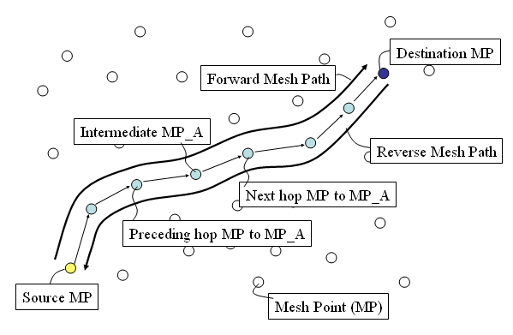
Figure 1 Terminologies for IPT procedure
The IPT mode is carried out on a single Mesh Path between the source MP and the destination MP. The Mesh Path selection method itself and channel allocation of each Mesh Link is described in [TBD].
The IPT procedure consists of three major steps, i.e. Mesh Path reservation between the source MP and the destination MP, Frame Forwarding and Mesh Path Release.
The objective of the Mesh Path reservation is for silencing neighbouring MPs along the Mesh Path and hence exclusive occupancy of WM before frame forwarding starts. The frame forwarding is defined how each MP on the reserved Mesh Path sends or forwards frames with IPTIFS and how an adequate setting of IPTIFS at a source MP is found. The Mesh Path Release is for finalizing IPT mode and releasing the reserved Mesh Path.

IPT transport session and IPT period
Transmission of Mesh Unicast Data Frames originated by a source MP is defined as an IPT transport session. Transmission time from the beginning of an IPT transport session to the end of the IPT transport session is defined as IPT period.
A Mesh Path can change from in one IPT period to in another IPT period even for the same combination of the source MP and the destination MP, though a single Mesh Path does not change for a single IPT period.
During an IPT period, each MP on the reserved Mesh Path only handles frames relating to the IPT transport session.

Procedures of IPT

Equalization of Frame length
Source frames to be sent shall be equalized to make their length uniform. This length is defined as IPT Frame Length (IPTFL). Such equalization is beneficial to maximize relay efficiency.

Mesh Path Reservation
The objective of the Mesh Path reservation is for silencing neighbouring MPs along a Mesh Path and hence exclusive occupancy of WM before frame forwarding starts.

Beacon frame for reservation
Normal Beacon frame for the PCF access [1] is reused at MPs for the Mesh Path Reservation. The CF parameter set defined within such a Beacon frame is used to reserve the Mesh Path. A Beacon frame is initiated by the source MP and forwarded by intermediate MPs along the forward Mesh Path until reaching it to the destination MP. When an intermediate MP receives the Beacon frame transmitted by the preceding hop MP, the MP forwards a Beacon frame with the same CF parameter set to the next hop MP.
CFPMaxDuration of the CF parameter set in the Beacon frame is set to Estimated IPT Duration (EID) defined as the number of TUs estimated to send source frames. EID is set not so as to exceed the maximum allowable value of CFPMaxDuration even when long IPT duration is actually required. If long IPT duration is required, another beacon frame is sent for extension of reservation period as described in 7.2.2.2.4.
DA and SA fields of the Beacon frame are respectively set to the destination MP and the source MP in all the MPs on the mesh path. On the other hand, RA and TA fields are appropriately set for each MP on the mesh path.
At the time of starting a Mesh Path reservation, if an intermediate MP or the destination MP is handling other ongoing transport sessions including IPT sessions or transport sessions in Normal mode, it can choose two ways: (a) the MP suspends these transport sessions and forwards a beacon frame to the next hop MP for handling the new IPT transport session. (b) the MP waits until the end of the ongoing transport session and after that it forwards a beacon frame for handling the new IPT transport session.

Mesh Path Reservation Acknowledgement
The destination MP sends Mesh Path Reservation Acknowledgement Message (MPRA) control frame upon reception of a Beacon Frame for reservation originated by a source MP. MPRA control frame is forwarded back to the source MP along the reverse Mesh Path.

Reservation time out
If no MPRA control frame is received by a MP (source MP or intermediate MPs) after waiting for its requested EID, the reservation process is time out. The MP is forced to terminate the IPT transport session and exits IPT mode of operation.

Reservation Extension
During the IPT mode, no additional beacon frames other than the initial beacon frame shall be sent along the forward Mesh Path. This can be simply realized by setting a beacon interval greater than EID.
However, if the mesh path reservation is needed to be extended, the source MP shall send a new Beacon frame with a new CF parameter set such that the Beacon frame interrupts transmission of source data frames in IPT mode of operation: the new Beacon frame is forwarded by the intermediate MPs along the forward Mesh Path according to the IPT frame forwarding. In this case, a dummy time space is given after the Beacon frame so as to be total time length of the Beacon frame and the time space equal to IPTFL.

Frame Forwarding
Frame forwarding is initiated after completion of the Mesh Path Reservation, hence completion of reception of Mesh Path Reservation Acknowledgement at the source MP. All MPs on the reserved Mesh Path take the DCF access procedure in their frame transmissions.

DCF access procedure in IPT mode
It is desirable to take aCWmin value as smaller as possible in terms of increasing relay efficiency. For example, aCWmin value of 1 shall be taken in the initial attempt of source frame transmission and then the value shall take 3 if the initial attempt fails. For further attempts, aCWmin value shall take 7, 15, 31 … and up to aCWmax according to the conventional DCF procedure.
In case of IPT, the amount of deferment for detection of clear channel is defined as Intermittent Periodic Transmit Inter Frame Space (IPTIFS) which is different from DIFS for the conventional DCF access. Furthermore, different IPTIFS is applied to the source MP and the other MPs.
The IPT access in contrast to the Normal mode is shown in Figure 2.
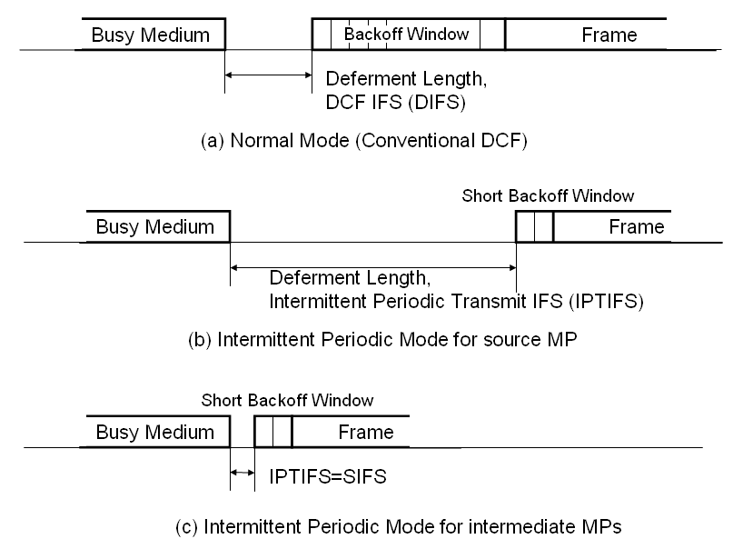
Figure 2 IPT access in contrast to the Normal Mode
DMA and SMA fields of the source data frame are respectively set to the destination MP and the source MP in all the MPs on the mesh path. On the other hand, RMA and TMA fields are appropriately set for each MP on the mesh path.
RTS/CTS handshake should not be applied to mesh frame forwarding in IPT mode. The Mesh Path Reservation overrides the RTS/CTS handshake and thus the RTS/CTS handshake will cause some deterioration of frame forwarding efficiency.

Frame transmission of Source MP
A source MP sends source frames according to the DCF procedure with IPTIFS and the short CWmin value.
The initial value of IPTIFS for the source MP shall be set to (IPTFL + SIFS + ACK duration + SIFS)*2. IPTIFS is adaptively searched in the frame forwarding procedure to be described in the next clauses.
If there is a record of IPTIFS previously used for the same destination MP and the same mesh path, the record shall be used as the initial value of IPTIFS for the purpose of fast IPTIFS search.

Frame Forwarding at Intermediate MP
An intermediate MP sends source frames according to the DCF procedure with IPTIFS and the short CWmin value. IPTIFS for the intermediate MPs is set to SIFS. If an intermediate MP receives a frame sent by the preceding hop MP, the frame is immediately forwarded to the next hop MP.

Forwarding Failures and Resolution
Resolution procedure for frame forwarding failures on a Mesh Path is illustrated in Figure 3.
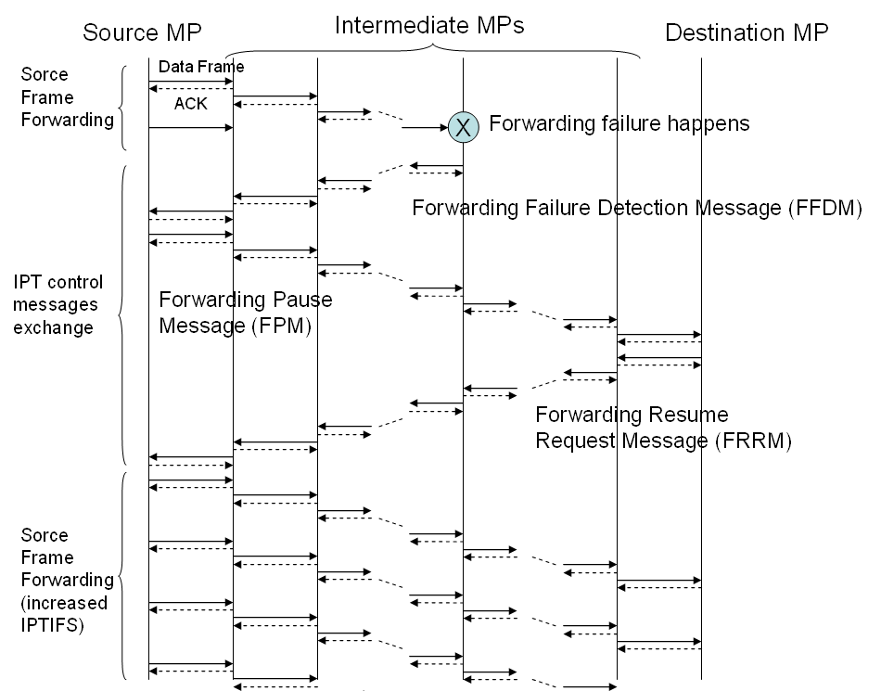
Figure 3 IPT control messages exchange for resolution of frame forwarding failures
If a frame forwarding failure happens at a MP, the MP immediately sends back Forwarding Failure Detection Message (FFDM) to the source MP along the reverse Mesh Path. The intermediate MPs put priority on sending the FFDM on the reverse Mesh Path and thus they immediately forward the FFDM upon reception of it even when they already have forwarding frames.
When each MP on the reverse Mesh Path receives FFDM, it stops frame forwarding procedure for the current IPT transport session and clears transmission buffer for the IPT transport session immediately. FFDM includes the sequence number of the data frame failed in transmission.
When the source MP receives FFDM, it stops sending source frames and sends a Forwarding Pause Message (FPM) to the destination MP to indicate the pause of frame transmissions to all the MPs on the mesh path. No priority is put on the FPM forwarding at the MPs. When each MP on the forward Mesh Path receives FPM and if it still stores some data frames for the same IPT transport session, it stops frame forwarding procedure for the IPT transport session and clears transmission buffer for the IPT transport session immediately.
After the destination MP receives the FPM, which means that it knows no buffered data frames for the IPT transport session on the reserved Mesh Path, the destination MP sends a Forwarding Resume Request Message (FRRM) along the reverse Mesh Path to request the source MP to resume frame forwarding.
During the transmission pause period, the source MP increases its IPTIFS by Delta IPTIFS (DIPTIFS). If the updated IPTIFS exceeds a maximum value of IPTIFSmax, then IPTIFS is forced to be this maximum value. With the increased IPTIFS, the source MP resumes to send source frames from the one that is informed by FFDM.

Forced termination of IPT mode
If no ACK is received by a MP after transmission of a data frame, the MP sends Request for IPT Termination Message (RITM) to the source MP. High priority of RITM forwarding is put on the intermediate MPs. If a source MP receives RITM, it immediately goes to the Mesh Path Release process described in 7.2.2.4.

Bidirectional frame forwarding
When the source MP expects to receive return data frames from the destination MP, the source MP sends a Request for Return Frames Message (RRFM) at the end of the source data frame. RRFM includes the value of the latest IPTIFS. Upon reception of RRFM at the destination MP, the forward Mesh Path alternates with the reverse Mesh Path and vice versa. This means that the destination MP and the source MP respectively become a new source MP and a new destination MP after the RRFM forwarding. The new source MP sets its initial IPTIFS to the one that is informed by the RRFM. Before or during IPT frame forwarding, the new source MP shall take a Mesh Path Reservation or an extension of Mesh Path reservation if needed.
If no data frames are received at the new destination MP for a certain limit of time defined by Bidirectional frame forwarding Waiting Time (BWT), the new destination MP terminates the IPT period and goes to the Mesh Path Release process described in 7.2.2.4.

Mesh Path Release
Upon completion of the source frames forwarding, the destination MP sends CF-End control frame to indicate the frame forwarding completion and also to release the reserved Mesh Path. This signal means the end of IPT mode.

