IEEE P802.11
Wireless LANs
TGV Location Discussion
Date: 2005-05-15
Author(s):
Name | Company | Address | Phone | email
Joe Decuir | MCCI | 18814 SE 42nd St  Issaquah, WA 98027 | +1 425 603-1188 | joe@mcci.com
Abstract
This document explores location-based technologies under development in 802.15, with respect to ‘location based management’ in doc. IEEE 802.11-05/00224r1. These are quoted from relevant documents in 802.15 TG3a and TG4a.
Notice: This document has been prepared to assist IEEE 802.11. It is offered as a basis for discussion and is not binding on the contributing individual(s) or organization(s). The material in this document is subject to change in form and content after further study. The contributor(s) reserve(s) the right to add, amend or withdraw material contained herein.

Release: The contributor grants a free, irrevocable license to the IEEE to incorporate material contained in this contribution, and any modifications thereof, in the creation of an IEEE Standards publication; to copyright in the IEEE’s name any IEEE Standards publication even though it may include portions of this contribution; and at the IEEE’s sole discretion to permit others to reproduce in whole or in part the resulting IEEE Standards publication. The contributor also acknowledges and accepts that this contribution may be made public by IEEE 802.11.

Patent Policy and Procedures: The contributor is familiar with the IEEE 802 Patent Policy and Procedures <http:// ieee802.org/guides/bylaws/sb-bylaws.pdf>, including the statement "IEEE standards may include the known use of patent(s), including patent applications, provided the IEEE receives assurance from the patent holder or applicant with respect to patents essential for compliance with both mandatory and optional portions of the standard." Early disclosure to the Working Group of patent information that might be relevant to the standard is essential to reduce the possibility for delays in the development process and increase the likelihood that the draft publication will be approved for publication. Please notify the Chair <stuart.kerry@philips.com> as early as possible, in written or electronic form, if patented technology (or technology under patent application) might be incorporated into a draft standard being developed within the IEEE 802.11 Working Group. If you have questions, contact the IEEE Patent Committee Administrator at <patcom@ieee.org>.

Introduction
IEEE 802.11-05-0224r2 addresses several classes of possible requirements for 802.11 TGv. One of the categories cited is ‘location based management’ Historically, IEEE 802.11 has not featured location awareness.
Meantime, recent work in 802.15, particularly TG4a, has location awareness as a requirement. The purpose of this contribution is to provide an overview, and a discussion with respect to 802.11 radios.
The location work in 802.15 TG4a is developed with respect to the applications of interest: sensor arrays, industrial applications, short range personal array networks. The application of managing a set of 802.11 devices will likely be different.

References
- 802.15 TG4a PAR
- 15-04-0581-05-004a-ranging-subcommittee-final-report.doc
- 15-04-0438-00-004a-near-field-ranging-algorithm.ppt
- 15-04-0564-00-004a-signal-strength-based-ranging.ppt
- 15-04-0572-00-004a-tdoa-localization-techniques.ppt
- 15-04-0573-00-004a-two-way-time-transfer-based-ranging.ppt
- 15-05-0234-00-004a-tdoa-ranging.ppt
- 15-05-0563-00-004a – Angle of Arrival
- 15-03-0541-00-003a-technical-editor-contribution-ieee-formatted-draft-text-fh-ofdm-proposal.pdf
- 15-04-0050-00-003a-ranging-with-mb-ofdm.ppt

Meaning of location awareness

There are two levels of location awareness:
- one dimensional location = range from another device
- multi-dimensional location = location in 2D or 3D

One dimensional location measurement is called Ranging in 802.15. There are several possible mechanisms, as discussed below.

Two or three dimensional measurement is either relative (e.g. a sensor array detecting its configuration) or absolute (e.g. a device measures range to 3 or more devices with known locations. In 802.15, devices with known locations are called anchors.

If a device has the ability to determine the direction of received signals, two or three dimensional location awareness can also be implement with angles-of-arrival from anchor locations.

Ranging methods
In our discussions last year, the primary mechanisms considered were:
- Signal strength
- Time of flight
- Near field
- Angle of Arrival

Signal strength looks simple. It is easy to start with, because the abilty to measure signal strength is a common feature for radios. The mechanisms can use the same carrier signals used for control and date traffic. There are several issues:
- there needs to be a method to calibrate signal strength vs distance.
- the antennas used are rarely spherically isotropic, so that calibration needs direction.
- multipath effects will make another device look closer than it is.
- in an environment with multiple devices active simultaneously, signal strenght needs to isolate a particular signal bound by time and frequency.
- any inband interference, from similar devices or other sources, also distorts measurements.

Time of flight is more complicated, but it has some advantages. Again, it uses the same carrier signals as used for data and control traffic. In principle, these means require a few new elements from the PHY:
- The ability to generate an easily detected and delineated timing reference signal.
- The ability to detect that signal and measure its time of arrival.
- The abiltity to distinguish the LOS signal from any NLOS signals.

The advantages with respect to signal strength based methods is two-fold:
- the calibration of flight time vs distance is simple: the speed of light
- measuring the time of arrival of a particular signal distinguishes it from that of all the other signals that might be detectable.

Conversely, the challenges of time based ranging are:
- calibrating the delays through the PHYs, which may be much larger than the times-of-flight
- multipath effects make ranges appear farther than they are (opposite of signal strength).
- the resolution of the time-of-arrival is inversely proportional to the bandwidth of the signal

Near field mechanisms exploit the differences between magnetic fields and electric fields at close range; there are 1/r² and 1/r³ terms that can be used to resolve for range. They typically require a different signal from the carriers used for control and data.

Angle of arrival methods need multiple antennas. Currently, these are unusual. MIMO will change that.
However, for a device to use arrival angles for location, it has to have calibrated its own orientation, a very unusual feature in todays devices…

Given these constraints, 802.15 TG4a has chosen to focus on time-of-arrival based methods.
Because of the bandwidth effect, the are only developing ranging for use with the new UWB carrier, not with the older narrow band carriers (e.g. ISM band).

2D/3D Location

Location can be determined relatively, or absolutely. For the applications of interest to TG4a an important metrics are is power consumption, and scalability.

For an array of peer devices, a straightforward method, TOA (time-of-arrival), can be used. See the following figure quoted from 15-05-0234-00-004a.

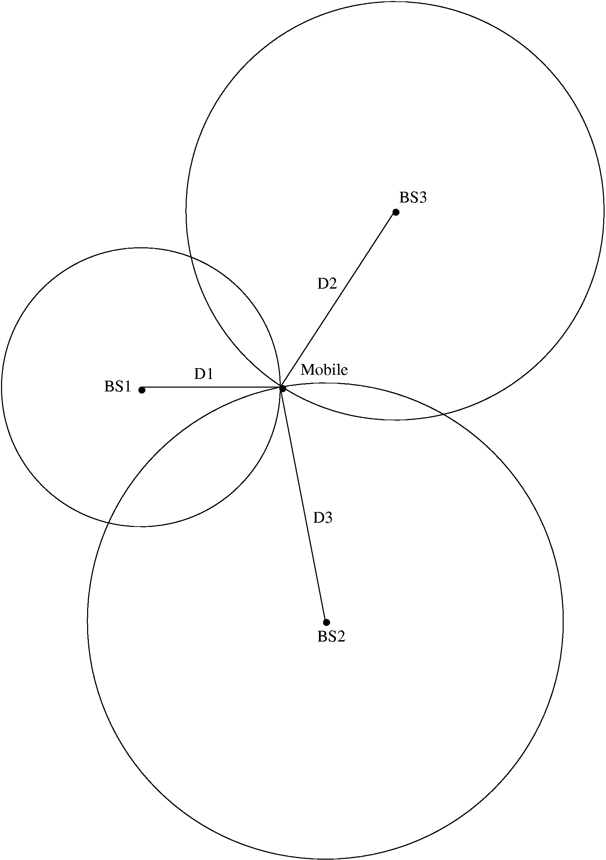
Mobile (x_{m},y_{m})
Anchor 2 (x_{A2},y_{A2})
Anchor 3 (x_{A3},y_{A3})
Anchor 1 (x_{A1},y_{A1})
Positioning from TOA
3 anchors with known positions (at least) are required to retrieve a 2D-position from 3 TOAs
Measurements
Estimated Position
Specific Positioning Algorithms

If the array is self configuring, measureing relative positions, they may all measure ranges to every other node. For a small array, this is tractable, but the number of measurments is O(n). Therefore, for large arrays is becomes intractably chatty and power consumptive. However, it still works if the large arrays use a handful of anchor nodes, and the larger array is tracked with respect to those anchors.

Discussion

The ultility of 1D, 2D or 3D location in 802.11 TGv depends on the applications. I am not an expert.
I would speculate that the main utility would be for management of assocation:
- which AP is the mobile device closest to?
- is it moving or stationary?
- can we take advantage of range to minimize transmit power?

However, applications of 802.15 TG4a to 802.11 radios will face a major limitation: the narrow bandwidth of the 802.11 carriers will result in relatively great time-of-flight uncertainty, and therefore the measurements may be too imprecise to be useful.

