IEEE P802.11
Wireless LANs
Response to Call For Proposal for P802.11n
Date: November, 2004
Authors: Hervé Bonneville, Bruno Jechoux, Romain Rollet
Mitsubishi ITE.
1, allee de Beaulieu, 35700 Rennes, France
Phone: +33-2 23 45 58 58
Fax: +33-2 23 45 58 59
e-Mail: {bonneville,jechoux,rollet}@tcl.ite.mee.com
Alexandre Ribeiro Dias, Stéphanie Rouquette-Léveil, Markus Muck, Marc de Courville, Sébastien Simoens, Jean-Noël Patillon, Karine Gosse
Motorola Labs
Parc les Algorithmes – Saint Aubin – 91193 Gif sur Yvette Cedex - France
Phone: +33 1 69 35 77 00
Fax: +33 1 69 35 77 01
e-Mail: {ribeiro,rouquet,muck,courvill,simoens,patillon,gosse}@crm.mot.com
Brian Classon, Keith Blankenship
Motorola Labs
1301 E. Algonquin Rd, Schaumburg, IL 60196, USA
Phone : +1 847 576 5675
Fax : +1 847 538 4593
e-Mail: Brian.Classon@motorola.com, keithb@labs.mot.com

Contributors:

Hervé Bonneville | Mitsubishi
Bruno Jechoux | Mitsubishi
Romain Rollet | Mitsubishi
Loic Brunel | Mitsubishi
Christophe Mangin | Mitsubishi
Alexandre Ribeiro Dias | Motorola Labs
Stéphanie Rouquette-Léveil | Motorola Labs
Markus Muck | Motorola Labs
Marc de Courville | Motorola Labs
Sébastien Simoens | Motorola Labs
Jean-Noël Patillon | Motorola Labs
Karine Gosse | Motorola Labs
Keith Blankenship | Motorola Labs
Brian Classon | Motorola Labs

Abstract

This document is a response to Call For Proposal for P802.11n standard referenced by [5]. It includes Functional Requirements table, comparison criteria response and a technical overview.

At MAC level the proposal defines a new access scheme called ECCF (Extended Centralised Coordination Function) allowing a great efficiency and a strong QoS support in all scenarios while keeping backward compatibility. It is based on a fast, dynamic and accurate resource allocation obtained by using a MAC time frame, a centralised allocation process and a resource request / grant scheme to perform allocation in uplink.
At PHY level several new features are defined including a multiple antenna extension based on combinations of Spatial Division Multiplexing and Space Time Block Coding. Two new OFDM modulators are defined using 104 data subcarriers among 128, one operating in the 20MHz bandwidth with a guard interval length of 1.6µs and the other one operating in the 40MHz bandwidth with a guard interval length of 0.8µs. An additional puncturing pattern introducing a 5/6 code rate and new frequency and spatial interleavers are also considered. Optionally, Turbo Codes are proposed as an advanced coding scheme. In order to maximize the system efficiency in a given context (SNR, interference, etc.), an enhanced link adaptation scheme is defined: it is important that the destination STA feedback some information on the current link quality to the source. In combination with this feature, the feedback of various link quality indicators to the source is available (e.g. the receiver output Shannon capacity indicator).

Presentation material is composed of the following elements:
- 11-04-1370-00-000n-mitmot-tgn-complete-proposal-response is the response to functional requirements, comparison criteria table. It includes also a technical overview (this document),
- 11-04-1372-00-000n-mitmot-tgn-complete-proposal-detailed-description is the detailed technical description of the proposal ,
- 11-04-1371-00-000n-mitmot-tgn-complete-proposal-sim-results includes all detailed simulation results in spread sheets format,
- 11-04-1369-00-000n-mitmot-tgn-complete-proposal-presentation is the proposal presentation

Table of Content

1. References 5
2. Functional requirements table 7
3. Comparison criteria table 7
3.1 Additional disclosures 7
3.2 Comparison Criteria 8
3.3 Detailed Simulation results 13
3.3.1 CC 18 through CC24 13
3.3.1.1 Scenario1 13
3.3.1.2 Scenario1bis 14
3.3.1.3 Scenario 4 14
3.3.1.4 Scenario 6 15
3.3.1.5 Scenario 6bis 16
3.3.2 CC15 (scenarios 17, 18 and 19) 16
3.3.3 CC27-28 16
3.3.4 CC59 (AWGN PER performance) 17
3.3.5 CC67 (PER performance in non AWGN channels) 18
3.3.5.1 Channel model B 19
3.3.5.2 Channel model D 21
3.3.5.3 Channel model E 24
3.3.6 CC67.2 (Offset compensation) 26
3.3.6.1 Impact of carrier frequency offset and symbol clock offset at 10%PER in channel E (NLOS) 26
3.3.6.2 Impact of carrier frequency offset and symbol clock offset on PER using an SNR of 50dB in channel E (LOS) 27
4. Other simulation results 28
4.1 MAC efficiency comparison 28
4.2 Non-QoS goodput 29
4.3 Maximum goodput in point to point configuration 30
4.4 Delays 30
4.5 Mixed traffic handling 31
4.6 Additional PHY simulations 31
4.6.1.1 Packet error rate curves versus distance and ideal MAC throughput 31
5. Simulation conditions and hypothesis 34
5.1 System simulations 34
5.1.1 Simulation parameters 34
5.1.2 PHY abstraction 34
5.1.3 Disclosure for Physical Layer Impairments 35
6. Rationales & Objectives 36
6.1 Need for a new access scheme 36
6.2 Requirements for a CE compatible WLAN 36
6.2.1 Application requirements 36
6.2.2 Environment requirements 37
6.3 MAC features 37
6.4 Some conclusions 38
6.4.1 QoS support 39
6.4.2 Compatibility 39
6.4.3 Efficient resource usage 39
6.4.4 Versatility 39
6.4.5 Flexibility 39
6.4.6 Easy Implementation 39
7. Technical overview 40
7.1 MAC technical overview 40
7.1.1 Presentation 40
7.1.2 Frame structure 40
7.1.3 MTF description 41
7.1.4 MPDU 42
7.1.5 MPDU overhead reduction 42
7.1.6 Aggregation at PHY level 42
7.1.7 Segmentation and Reassembly 43
7.1.8 MAC Time Frame structure example 43
7.1.9 Resource management and flow differentiation 44
7.2 PHY technical overview 44
7.2.1 Introduction 44
7.2.2 MIMO-OFDM nPLCP sublayer 45
7.2.2.1 RATE-dependent parameters 45
7.2.2.2 Timing related parameters 47
7.2.2.3 Space-Time Coding (STC) 49
Annex A: Abbreviations and acronyms and definitions 51

Table list
Table 3-1: Performance summary for scenario 1 14
Table 3-2: Performance summary for scenario 1bis 14
Table 3-3: Performance summary for scenario 4 15
Table 3-4: Performance summary for scenario 6 15
Table 3-5: Performance summary for scenario 6bis 16
Table 7-1 - Rate-dependent parameters for 2 transmit antennas and 48 data subcarriers in 20MHz bandwidth 45
Table 7-2 - Rate-dependent parameters for 2 transmit antennas and 104 data subcarriers in 20MHz bandwidth 45
Table 7-3 - Rate-dependent parameters for 2 transmit antennas and 104 data subcarriers in 40MHz bandwidth 46
Table 7-4 - Rate-dependent parameters for 3 or 4 transmit antennas and 48 data subcarriers in 40MHz bandwidth 46
Table 7-5 - Rate-dependent parameters for 3 or 4 transmit antennas and 104 data subcarriers in 20MHz bandwidth 47
Table 7-6 - Rate-dependent parameters for 3 or 4 transmit antennas and 104 data subcarriers in 40MHz bandwidth 47
Table 7-7 - Timing-related parameters for 48 data subcarriers in 20MHz bandwidth 47
Table 7-8 - Timing-related parameters for 104 data subcarriers in 20MHz bandwidth 48
Table 7-9 - Timing-related parameters for 104 data subcarriers in 40MHz bandwidth 48
Table 7-10 - Timing-related parameters for 104 data subcarriers in 40MHz bandwidth 48
Table 7-11 - Parameters of the multiple antenna transmit schemes 49

Table of figures
Figure 3-1: Maximum achievable MAC goodput (CC27/28) 17
Figure 3-2 - PER performance for AWGN channel and 2x2 antenna configuration 17
Figure 3-3 - PER performance for AWGN channel and 3x3 antenna configuration 18
Figure 3-4 - PER performance for AWGN channel and 4x4 antenna configuration 18
Figure 3-5 - PER performance for channel model B and 2x2 antenna configuration 19
Figure 3-6 – 2x2 Avg PHY throughput for channel B 19
Figure 3-7 - PER performance for channel model B and 3x3 antenna configuration 19
Figure 3-8 – 3x3 Avg PHY throughput for channel B 19
Figure 3-9 - PER performance for channel model B and 4x4 antenna configuration 20
Figure 3-10 – 4x4 Avg PHY throughput for channel B 20
Figure 3-11 - PER performance for channel model B and 2x4 antenna configuration 20
Figure 3-12 – 2x4 Avg PHY throughput for channel B 20
Figure 3-13 - PER performance for channel model B and 3x2 antenna configuration 20
Figure 3-14 – 3x2 Avg PHY throughput for channel B 20
Figure 3-15 - PER performance for channel model B and 4x2 antenna configuration 21
Figure 3-16 – 4x2 Avg PHY throughput for channel B 21
Figure 3-17 - PER performance for channel model D and 2x2 antenna configuration 21
Figure 3-18 – 2x2 Avg PHY throughput for channel D 21
Figure 3-19 - PER performance for channel model D and 3x3 antenna configuration 22
Figure 3-20 – 3x3 Avg PHY throughput for channel D 22
Figure 3-21 - PER performance for channel model D and 4x4 antenna configuration 22
Figure 3-22 – 4x4 Avg PHY throughput for channel D 22
Figure 3-23 - PER performance for channel model D and 2x4 antenna configuration 22
Figure 3-24 - PER performance for channel model D and 3x2 antenna configuration 23
Figure 3-25 - PER performance for channel model D and 4x2 antenna configuration 23
Figure 3-26 - PER performance for channel model E and 2x2 antenna configuration 24
Figure 3-27 – 2x2 Avg PHY throughput for channel E 24
Figure 3-28- PER performance for channel model E and 3x3 antenna configuration 24
Figure 3-29 – 3x3 Avg PHY throughput for channel E 24
Figure 3-30 - PER performance for channel model E and 4x4 antenna configuration 24
Figure 3-31 – 4x4 Avg PHY throughput for channel E 24
Figure 3-32 - PER performance for channel model E and 2x4 antenna configuration 25
Figure 3-33 - PER performance for channel model E and 3x2 antenna configuration 25
Figure 3-34 - PER performance for channel model E and 4x2 antenna configuration 25
Figure 3-35: Average PER vs SNR for 2x2 Antenna Configuration with Link Adaptation on channel B 26
Figure 3-36 - Offset impact in 2x2 antenna configuration 26
Figure 3-37 - Offset impact in 3x3 antenna configuration 27
Figure 3-38 - Offset impact in 4x4 antenna configuration 27
Figure 4-1: MAC efficiency versus PER 28
Figure 4-2: TCP throughput versus PER in scenarios 1 and 1bis 29
Figure 4-3: TCP throughput versus PER in scenario 4 29
Figure 4-4: TCP throughput versus PER in scenarios 6 and 6bis 29
Figure 4-5: MAC efficiency vs. PHY throughput 30
Figure 4-6: Delay distribution (scenario 1) 30
Figure 4-7: VoIP Throughput Performance 31
Figure 4-8: VoIP Distribution Delay while multiplexing 32 VoIP sessions and 1 TCP 31
Figure 4-9 - 2x2 average PER for channel B 32
Figure 4-10 – 2x2 ideal MAC throughput for channel B 32
Figure 4-11- 2x2 average PER for channel D 32
Figure 4-12 – 2x2 ideal MAC throughput for channel D 32
Figure 4-13 - 3x3 average PER for channel B 32
Figure 4-14 – 3x3 ideal MAC throughput for channel B 32
Figure 4-15 - 3x3 average PER for channel D 33
Figure 4-16 – 3x3 ideal MAC throughput for channel D 33
Figure 4-17 – 4x4 average PER for channel B 33
Figure 4-18 – 4x4 ideal MAC throughput for channel B 33
Figure 4-19 - 4x4 average PER for channel D 33
Figure 4-20 – 4x4 ideal MAC throughput for channel D 33
Figure 7-1: Extended MAC structure 40
Figure 7-2: Frame structure 41
Figure 7-3: Alternative frame structure 41
Figure 7-4: MAC Time Frame structure 41
Figure 7-5: MPDU general structure 42
Figure 7-6: MPDU structure example with data blocks transmitted to 2 stations 42
Figure 7-7: Segmentation And Reassembly (SAR) sub-layer 43
Figure 7-8: MTF structure example 43
Figure 7-9 - Transmission of 1 spatial stream on 2 antennas 49
Figure 7-10 - Transmission of 2 spatial streams on 3 antennas 49
Figure 7-11 - Transmission of 2 spatial streams on 4 antennas 50
Figure 7-12 - Transmission of 3 spatial streams on 4 antennas 50

References
- 11-04-1370-00-000n-mitmot-tgn-complete-proposal-response
- 11-04-1372-00-000n-mitmot-tgn-complete-proposal-detailed-description
- 11-04-1369-00-000n-mitmot-tgn-complete-proposal-presentation
- 11-04-1371-00-000n-mitmot-tgn-complete-proposal-sim-results
- IEEE 802 11-03/858r7, Call for Proposals for P802.11n
- IEEE 802 11-03/813r12, Functional requirements
- IEEE 802 11-03/814r30, TGn Comparison Criteria
- IEEE 802 11-03/802r23, TGn Usage Models

Functional requirements table

Number | Name | Coverage (Yes/No) | Results Reference
R1 | Single Link HT rate supported | Yes | See 4.3
R2 | HT rate supported in 20MHz channel | Yes | Since we have a MAC efficiency of about 80%, this requirement is achieved with a PHY rate of 120 Mbit/s, which can be reached in a 20 MHz band with a 2x2 antenna configuration and a 64 QAM 5/6 code.
R3 | Supports 5GHz bands | Yes
R4 | .11a backwards compatibility | Yes | This proposal addresses a modification to the IEEE802.11a-1999 specification and therefore inherently enables to use all .11a PHY modes.
R5 | .11g backwards compatibility | Yes | All .11g PHY modes can be used.
R6 | Control of support for legacy STA from .11n AP | Yes
R7 | .11e QoS support | Yes | EDCA and HCCA can be used without any modification.
R8 | Spectral Efficiency | Yes | For 100 Mbps throughput, a PHY rate of 120 Mbps in a 20 MHz channel is employed. The corresponding spectral efficiency is 6 bits per second per Hz.
R9 | Compliance to PAR | Yes

Comparison criteria table

Additional disclosures

Number | Name | Disclosure
AD1 | Reference submissions
AD2 | TCP Model Parameters | Reno based.  TCP window sizes:  - Set to 64 Kbytes in scenario 1, 6  - Set to 192 Kbytes in scenarios 4, 4bis, 1bis and 6bis
AD3 | MAC simulation methodology | We defined scenarios 1bis and 6bis with fully backlogged TCP traffic.  See 5 for additional details.
AD4 | MAC simulation occupied channel width | All simulations have been made with a 20 MHz channelization.

Comparison Criteria

Number | Name | Disclosure
CC2 | Regulatory compliance | The PHY mode proposed are using a 20MHz channelization as for the classical IEEE802.11a-1999 specification with the same spectrum mask and therefore is by nature regulatory compliant.
CC3 | List of goodput results for usage models 1,4 and 6. | Referred to as Metric 1 in CC20:  Scenario 1: 81.83 Mbit/s (average PHY data rate: 106.26 Mbit/s)  Scenario 4: 129.81 Mbit/s (average PHY data rate: 178.19 Mbit/s)  Scenario 6: 63.09 Mbit/s (average PHY data rate: 68.87 Mbit/s)  Note: hereafter results for scenarios 1, 4 and 6 with fully backlogged TCP sources (denoted 1bis, 4bis and 6bis). TCP flows use as much bandwidth as available.  Scenario 1bis: 105.47 Mbit/s (average PHY data rate: 138.78 Mbit/s)  Scenario 6bis: 103.36 Mbit/s (average PHY data rate: 154.81 Mbit/s)
CC6 | PHY complexity | The following parameters will be taken into account:  ,  Estimated gate count of PHY implementation  ,  Estimated calculation power in Million Instructions Per Second  ,  Estimated complexity of digital filters  ,  Estimated clock rate  Complexity estimates are given relatively to a typical IEEE802.11a/g implementation supporting all modes including the QAM-64 mode delivering 54Mbits/s on top of the PHY layer. For the IEEE802.11n modes only the 2x2 SDM mandatory mode is considered for PHY complexity assessment. Only the digital part of the transceiver is considered below.  TGn TX implementation requires some complexity for ST interleaving.  TGn RX implementation will typically lead to a parallelized Maximum-Likelihood decoder and MMSE based separation of parallel streams (higher complexity can be considered).  TGn calculation power requirements approximately scale with the output data rates (i.e. up to 4.3x for fastest optional mode).  No additional filtering constraints are expected for TGn implementations.  Depending on the level of architectural parallelization, the clock rate is expected to be approx. 1.5x higher.  Note that the above complexity estimates are preliminary results that can be further refined depending on the chosen implementation architecture.
CC7 | MAC processing complexity | Complexity similar to 802.11e (including HCCA)
CC11 | Backward compatibility with 802.11-1999 (Rev 2003) and 802.11g | - The AP broadcasts beacons legacy devices can decode.  - DCF access method is not modified at all inside the Contention Periods, thus legacy devices are not affected and can fully inter-operate  - HCCA and EDCA, as defined in .11e, can be used without modification  - See chapter 7 in general, paragraph 7.1.2 more specifically
CC15 | Sharing of medium with legacy devices | Case 1: TGn stations use PHY 3x3 64QAM¾ with 3 spatial streams in one 20 MHz channel (162 Mbit/s). Legacy station uses 64 QAM¾.  Metric T1 (scenario 17): 100.00 Mbit/s  Metric T2 (scenario 18): 30.00 Mbit/s  Metric T3 (scenario 19): 100.00 Mbit/s  Metric T4 (scenario 19): 7.20 Mbit/s  See 3.3.2 for details.
CC18 | HT Usage Models Supported (non QoS) | Note: hereafter results for scenario 1 and 6 with reduced set of PHY modes  Scenario 1:  Goodput per non-QoS flow: see [4]  Average PHY data rate: 106.26 Mbit/s  Aggregate goodput for non-QoS flows: 29.31 Mbit/s  Ratio for non-QoS flows: 94.54 %  Scenario 6:  Goodput per non-QoS flow: see [4]  Average PHY data rate: 91.60 Mbit/s  Aggregate goodput for non-QoS flows: 18.21 Mbit/s  Ratio for non-QoS flows: 91.06 %  Note: hereafter results for scenarios 1, 4 and 6 with complete set of PHY modes. Scenario 1 and 6 uses fully backlogged TCP sources (denoted as 1bis and 6bis) so that TCP flows use as much bandwidth as available.  Scenario 1bis:  Goodput per non-QoS flow: see [4]  Average PHY data rate: 138.78 Mbit/s  Aggregate goodput for non-QoS flows: 55.95 Mbit/s  Ratio for non-QoS flows: 170.80 % (*)  Scenario 4:  Goodput per non-QoS flow: see [4]  Average PHY data rate: 178.19 Mbit/s  Aggregate goodput for non-QoS flows: 120.66 Mbit/s  Ratio for non-QoS flows: 26.75 %  Scenario 6bis:  Goodput per non-QoS flow: see [4]  Average PHY data rate: 154.81 Mbit/s  Aggregate goodput for non-QoS flows: 58.49 Mbit/s  Ratio for non-QoS flows: 292.44 % (*)  (*) The reference TCP throughput of 30 Mbit/s has been used, which explains the value greater than 100%.
CC19 | HT Usage Models Supported (QoS) | Scenario 1:  PLR of each QoS flow: see [4]  Nb of QoS flows satisfying the objectives: 17  % of QoS flows satisfying the objectives: 100 %  Scenario 4:  PLR of each QoS flow: see [4]  Nb of QoS flows satisfying the objectives: 18  % of QoS flows satisfying the objectives: 100 %  Scenario 6:  PLR of each QoS flow: see [4]  Nb of QoS flows satisfying the objectives: 39  % of QoS flows satisfying the objectives: 100 %
CC20 | BSS Aggregate Goodput at the MAC data SAP | Scenario 1 Scenario 6  Average PHY data rate (Mbit/s) 106.26 91.60  Metric 1 (Mbit/s) 81.83 63.09  Metric 2 (Mbit/s) 81.83 63.09  Metric 4 (Mbit/s) 81.83 63.09  Note: hereafter results for scenarios 1, 4 and 6 with complete set of PHY modes. Scenario 1 and 6 uses fully backlogged TCP sources (denoted as 1bis and 6bis) so that TCP flows use as much bandwidth as available.  Scenario 1bis Scenario 4 Scenario 6bis  Average PHY data rate (Mbit/s) 138.78 178.19 154.81  Metric 1 (Mbit/s) 105.47 129.81 103.36  Metric 2 (Mbit/s) 105.47 129.81 103.36  Metric 4 (Mbit/s) 105.47 129.81 103.36  Detailed results are presented in document [4].
CC24 | MAC Efficiency | Scenario 1: 77.01 %  Scenario 6: 68.87 %  Note: hereafter results for scenarios 1, 4 and 6 with complete set of PHY modes. Scenario 1 and 6 uses fully backlogged TCP sources (denoted as 1bis and 6bis) so that TCP flows use as much bandwidth as available.  Scenario 1bis: 76.00 %  Scenario 4: 72.85 %  Scenario 6bis: 66.77 %  Detailed results are presented in document [4].
CC27  CC28 | Throughput / Range | Maximum distance allowing a MAC throughput of 100 Mbit/s:  4x4 3x3 2x2  Channel B: 30 m 24 m 15 m  Channel D: 38 m 31 m 19 m  Detailed results are presented in section 3.3.3
CC46 | MAC Compatibility and parameters | No options of 802.11a/b/d/e/g/h/i/j are required.
CC47 | MAC extensions | We define a new access method called Extended Centralised Coordinator Function (ECCF), which is an extension of HCCA.  This access scheme takes place in the CFP period. Alternatively, it can happen during any period of time AP reserves in the same way .11e defines periods for HCCA. Both methods assure a full backward compatibility with legacy 802.11 and its extensions .e, .h, .i and others.  It is based on a centralised resource management, with on-demand resource requests.  An overview is given in 7, while document [4] gives a detailed description.
CC51 | Data rates | Refer to section 7.2.2.1 for a detailed description of the data rates supported by this proposal and to section 7.2.2.3 for the associated space time codes used to achieve these data rates. More specifically the RATE-dependent parameters for 2 transmit antennas shall be set according to Table 7-6 for 48 data subcarriers and according respectively to Table 7-7 for 104 data subcarriers using 20MHz bandwidth. Contellations BPSK, QPSK, 16QAM and 64QAM are mandatory, 256QAM is optional. The 104 data subcarrier modes are optional as well. With 48 data subcarriers, the minimum and maximum data rates achievable are 6Mbps (BPSK constellations) and 216Mbps (256QAM constellations) respectively. With 104 data subcarriers, the minimum and maximum data rates achievable are 6.5Mbps (BPSK constellations) and 234Mbps (256QAM constellations) respectively in the 20MHz bandwidth mode and 13Mbps (BPSK constellations) and 468Mbps (256QAM constellations) respectively in the 40MHz bandwidth mode.
CC42 | Preambles | The preamble defined in this proposal (nPLCP) is described in the technical specification [2]. This preamble includes short training symbols (nSTS) and long training symbols (nLTS). The nSTS sequence is chosen from a limited alphabet in time domain, assuring suitable spectral properties and low-cross-correlation values between the sequences assigned to each TX antenna.  The nLTS is similar to the LTS defined in the IEEE802.11a standard, except that a total of 56 subcarriers are actually modulated instead of 52 for the 20MHz bandwidth modes; for 40MHz bandwidth modes, 112 among a totality of 160 subcarriers are used. This is done in order to ensure accurate channel estimation when a 128-point IFFT/FFT is used for data transmission (since a total of 112 subcarriers – including pilot tones - are modulated in that case). This nLTS long training preamble is used for channel estimation, and it can be multiplied by (-1) from one antenna to another, in order to ensure mitigation of all channels (usually, a Walsh-Hadamard weighting matrix is used).  The duration of the nPLCP preamble is equal to 24µs, which corresponds to an increase of 8µs compared to the IEEE802.11a preamble. However, in the IEEE802.11a standard, a 4µs SIGNAL field is always inserted prior to data transmission, while it is not required in this proposal. Hence the duration increase is reduced to 4µs. This extension of the preamble is due to the duplication of the long training signal (compared to the IEEE802.11a one), required to ease mitigation of all channels.  The cyclic-autocorrelation of the short training symbol (STS) is represented in [2].
CC51.5 | Channelisation | The proposal has mandatory support for 20 MHz bandwidth and share the same channelization as the one defined by IEEE802.11a-1999 document. A 40MHz bandwidth mode with 128 subcarriers (112 subcarriers among 128 are used) is optional.
CC52 | Spectral Mask | This proposal uses the same spectral mask for 20MHz bandwidth modes as defined in the IEEE802.11a-1999 specification document which is recalled in the following figure.  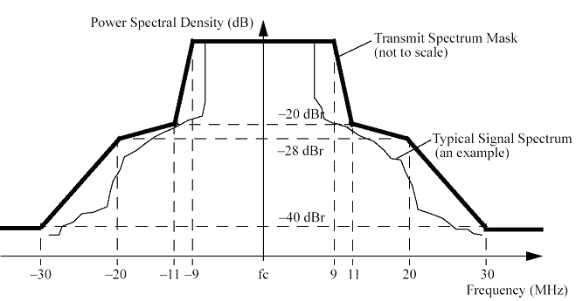
CC58 | HT Spectral Efficiency | For 100 Mbps throughput, a PHY rate of 120 Mbps in a 20 MHz channel is employed. The corresponding spectral efficiency is 6 bits per second per Hz.
CC59 | AWGN PER performance | The detailed simulation results for this comparison criterion are given in section 3.3.4
CC67 | PER performance in non AWGN channels | The detailed simulation results for this comparison criterion are given in section 3.3.5
CC67.2 | Offset Compensation | The detailed simulation results for this comparison criterion are given in section 3.3.6
CC80 | Required changes to 802.11 PHY | The required changes to the physical layer specification IEEE 802.11a-1999 are: i) a multiple antenna extension and ii) a second OFDM modulation. The channel bandwidth considered at this stage is limited to the current 20MHz bandwidth. In order to allow a larger peak data rate QAM256 constellation support is considered as an optional mode.  In order to achieve higher data rates than IEEE802.11a, this proposal uses multiple antennas, enabling the transmission of 1, 2 or 3 parallel spatial streams, depending on the transceiver configuration and capabilities (number of transmit and receive antennas at the AP and STA).  In this proposal, it is mandatory that the transmitter has a minimum of 2 antennas scaling up for the optional modes to 4 antennas, and the receiver has a minimum of two antennas (possibly more). Several schemes are detailed combining Spatial Division Multiplexing (SDM) and Space Time Block Coding (STBC). The emphasis is given on simple (e.g. limited arithmetical complexity) open loop modulation techniques that target either an increase of peak data rate (SDM) or enhancement of the robustness of the link (STBC) or a mix of the two using a hybrid approach.  wo new optional OFDM modulators are defined using 104 data subcarriers among 128:  - One operating with 20MHz bandwidth (corresponding to a subcarrier frequency spacing of 156,25kHz) with a guard interval length of 1.6µs.  - The other one operating in the 40MHz bandwidth with a guard interval length of 0.8µs. In both cases 8 pilot subcarriers are defined for a total number of 112 used subcarriers. Doubling the guard interval duration to 1.6µs compared to the standard mode enables to absorb larger multipath delays to cope both with long channels common in large environments (open space, limited outdoor) and also to better account for the transmit and receive filters inherently present in the WLAN devices.  Note that since the number of useful carriers is more than doubled and the guard time duration doubled, this enables an enhancement of the total PHY rate of 8% compared to 64 carrier modes.  With 48 data subcarriers, the minimum and maximum data rates achievable are 6Mbps (BPSK constellations) and 216Mbps (256QAM constellations) respectively. With 104 data subcarriers, the minimum and maximum data rates achievable are 6.5Mbps (BPSK constellations) and 234Mbps (256QAM constellations) respectively in the 20MHz bandwidth mode and 13Mbps (BPSK constellations) and 468Mbps (256QAM constellations) respectively in the 40MHz bandwidth mode.  Due to the modified nature of the preambles, a modified synchronization unit must be implemented (including low-complexity correlator designs).

Detailed Simulation results

CC 18 through CC24

Scenario1
In this scenario, all stations use either MIMO 3x3 64QAM¾ (Ns=2) or 2x2 16QAM3/4 (Ns=1). 2x2 mode is used for portable terminals (VoIP, game controller...). These PHY modes are more robust than required and by using them, the cell is fully loaded which allows to calculate the efficiency (CC24). The average PHY data rate is 105 Mbit/s and is the lower data rate that allow the system to fulfil scenario's requirements.

The number of contention interval (CTI) per MTF (sub-frame) is equal to 3.

Detailed results are presented in [4] while Table 3-1 summarises them.

Scenario 1: Performance Summary
PER |  | 0 | 10-2 | 3.10-2 | 5.10-2 | 10-1 | 1,5.10-1
Name | Unit | Value | Value | Value | Value | Value | Value
Aggregated goodput for non-QoS flows (CC18) | Mbit/s | 31.30 | 29.30 | 26.09 | 23.22 | 17.75 | 13.00
Ratio for non-QoS flows (CC18) | % | 100 | 94.54 | 84.19 | 74.91 | 57.26 | 41.96
Aggregated goodput for QoS flows | Mbit/s | 52.523 | 52.523 | 52.523 | 52.523 | 52.523 | 52.522
Number of QoS flows satisfying the objectives (CC19) |  | 17 | 17 | 17 | 17 | 17 | 17
% of QoS flows satisfying the objectives (CC19) | % | 100 | 100 | 100 | 100 | 100 | 100
Total aggregate goodput (metric 1 of CC20) | Mbit/s | 83.83 | 81.83 | 78.62 | 75.75 | 70.27 | 65
Metric 2 of CC20 | Mbit/s | 83.83 | 81.83 | 78.62 | 75.75 | 70.27 | 65
Metric 3 of CC20 | Mbit/s | 83.83 | 81.83 | 78.62 | 75.75 | 70.27 | 65
Average PHY rate | Mbit/s | 106.55 | 106.26 | 105.73 | 105.21 | 104.16 | 103.19
MAC efficiency (CC24) | % | 78.68 | 77.01 | 74.36 | 71.99 | 67.47 | 63.50
Table 3-1: Performance summary for scenario 1

As robust PHY modes are used, a PER of 1% is considered as a mean value in normal conditions. Values corresponding to this PER are reported in Comparison Criteria table.

Packet Loss Rate are 0 for all flows except for the video gaming one when PER is above 10%.

Scenario1bis
Scenario 1 has been slightly modified to have in any case a full physical medium. For that purpose, the local file transfer source has been unleashed, letting TCP source occupying as bandwidth as available. Indeed, with the fully backlogged TCP traffic, we obtain a simulation of maximum system performances.

Physical MIMO modes range from 36 Mbit/s (2x2, 16 QAM3/4, Ns=1) up to 180 Mbit/s with a 3x3 antennas configuration and modulation 64QAM5/6(Ns=3). They have been selected upon the distance of each station pair. The average PER is extracted from PHY simulations.

Scenario 1bis: Performance Summary
Name | Unit | Value
Aggregate goodput for non-QoS flows (CC18) | Mbit/s | 55.95
Ratio for non-QoS flows (CC18) | % | 170.80
Aggregate goodput for QoS flows | Mbit/s | 52.52
Number of QoS flows satisfying the objectives (CC19) |  | 17
% of QoS flows satisfying the objectives (CC19) | % | 100
Total aggregate goodput (metric 1 of CC20) | Mbit/s | 105.47
Metric 2 of CC20 | Mbit/s | 105.47
Metric 3 of CC20 | Mbit/s | 105.47
Average PHY rate | Mbit/s | 138.78
MAC efficiency (CC24) | % | 76.00
Table 3-2: Performance summary for scenario 1bis

Detailed results are presented in [4].

Scenario 4
Scenario 4 has been kept unmodified since defined TCP sources are sufficient to fully load the cell. Physical MIMO modes range from 108 Mbit/s (2x2, 16 QAM3/4, Ns=2) up to 180 Mbit/s with a 3x3 antennas configuration and modulation 64QAM5/6 (Ns=3). They have been selected upon the distance of each station pair. The average PER is extracted from PHY simulations.

The number of contention interval (CTI) per MTF (sub-frame) is equal to 6.

Scenario 4: Performance summary
Name | Unit | Value
Aggregate goodput for non-QoS flows (CC18) | Mbit/s | 120.66
Ratio for non-QoS flows (CC18) | % | 26.75
Aggregate goodput for QoS flows | Mbit/s | 9.15
Number of QoS flows satisfying the objectives (CC19) |  | 18
% of QoS flows satisfying the objectives (CC19) | % | 100
Total aggregate goodput (metric 1 of CC20) | Mbit/s | 129.81
Metric 2 of CC20 | Mbit/s | 129.81
Metric 3 of CC20 | Mbit/s | 129.81
Average PHY rate | Mbit/s | 178.19
MAC efficiency (CC24) | % | 72.85
Table 3-3: Performance summary for scenario 4

Detailed results are presented in [4].

Scenario 6

In this scenario, all stations use either MIMO 3x3 64QAM2/3 (Ns=2) or 2x2 64QAM5/6 (Ns=1). 2x2 mode is used for VoIP terminals. These PHY modes are more robust than required and by using them, the cell is fully loaded which allows to calculate the efficiency (CC24). The average PHY data rate is 91.60 Mbit/s and is the lower data rate that allow the system to fulfil scenario's requirements.

The number of contention interval (CTI) per MTF (sub-frame) is equal to 6.

Detailed results are presented in [4] while Table 3-4 summarises them.

Scenario 6: Performance Summary
PER |  | 0 | 10-2 | 3.10-2 | 5.10-2 | 10-1 | 1,5.10-1
Name | Unit | Value | Value | Value | Value | Value | Value
Aggregate goodput for non-QoS flows (CC18) | Mbit/s | 20.06 | 18.21 | 14.56 | 11.58 | 5.88 | 1.06
Ratio for non-QoS flows (CC18) | % | 100 | 91.06 | 72.82 | 57.88 | 29.32 | 5.29
Aggregate goodput for QoS flows | Mbit/s | 44.875 | 44.875 | 44.875 | 44.875 | 44.875 | 44.875
Number of QoS flows satisfying the objectives (CC19) |  | 39 | 39 | 39 | 39 | 39 | 39
% of QoS flows satisfying the objectives (CC19) | % | 100 | 100 | 100 | 100 | 100 | 100
Total aggregate goodput (metric 1 of CC20) | Mbit/s | 64.93 | 63.09 | 59.44 | 56.45 | 50.74 | 45.93
Metric 2 of CC20 | Mbit/s | 64.93 | 63.09 | 59.44 | 56.45 | 50.74 | 45.93
Metric 3 of CC20 | Mbit/s | 64.93 | 63.09 | 59.44 | 56.45 | 50.74 | 45.93
Average PHY rate | Mbit/s | 91.68 | 91.60 | 91.39 | 91.17 | 90.68 | 90.14
MAC efficiency (CC24) | % | 70.82 | 68.87 | 65.04 | 61.92 | 55.96 | 50.96
Table 3-4: Performance summary for scenario 6

As robust PHY modes are used, a PER of 1% is considered as a mean value in normal conditions. Values corresponding to this PER are reported in Comparison Criteria table.

Scenario 6bis
Scenario 6bis has been slightly modified to have in any case a full physical medium. For that purpose, the local file transfer sources have been unleashed, letting TCP sources occupying as bandwidth as available. Indeed, with the fully backlogged TCP traffic, we obtain a simulation of maximum system performances.

Physical MIMO modes range from 48 Mbit/s (2x2, 64 QAM2/3, Ns=1) up to 180 Mbit/s with a 3x3 antennas configuration and modulation 64QAM5/6 (Ns=3). They have been selected upon the distance of each station pair.

Scenario 6bis: Performance Summary
Name | Unit | Value
Aggregate goodput for non-QoS flows (CC18) | Mbit/s | 58.49
Ratio for non-QoS flows (CC18) | % | 292.44
Aggregate goodput for QoS flows | Mbit/s | 44.88
Number of QoS flows satisfying the objectives (CC19) |  | 39
% of QoS flows satisfying the objectives (CC19) | % | 100
Total aggregate goodput (metric 1 of CC20) | Mbit/s | 103.36
Metric 2 of CC20 | Mbit/s | 103.36
Metric 3 of CC20 | Mbit/s | 103.36
Average PHY rate | Mbit/s | 154.81
MAC efficiency (CC24) | % | 66.77
Table 3-5: Performance summary for scenario 6bis
Detailed results are presented in [4].

CC15 (scenarios 17, 18 and 19)

For scenario 18, we made a theoretical analysis considering a 802.11a station using the 64 QAM physical mode that give a throughput of 54 Mbit/s to the MAC. The goodput of 30 Mbit/s is the theoretical best case goodput a legacy MAC is able to offer.

In case 1, we suppose that the TGn AP and the TGn stations use a PHY mode 3x3 64QAM3/4 with 3 spatial streams on one 20 MHz channel, giving a throughput above the PHY of 162 Mbit/s with an average PER of 3%.
Simulation of scenario 17 gives following results:
Goodput: 100.00 Mbit/s
Frame occupancy: 76 %

Thus the AP reserves 24% of the time for legacy devices, leading to results of scenario 19:
Goodput for HT station: 100.00 Mbit/s
Goodput for Legacy station: 7.20 Mbit/s

We supposed in example above that the AP give the priority to TGn station. Since ECCF is a centralised resource allocation scheme, any other sharing is possible. Thus, the AP is able to split the superframe according to different factors, the number of associated legacy and TGn stations for example.

CC27-28
We performed some simulations to determine the MAC goodput vs. the distance using a MIMO 3x3 configuration on a 20MHz channel. In these simulations, a single UDP source is defined: traffic is emitted from the STA to the AP and the packet length is 1500 octets. PHY modes are selected using PHY results presented in section 4.6.1.1 and only mandatory PHY modes are used (i.e. we do not considered the 256QAM3/4 modulation). Results are detailed in [4] in the tab named “ScenarioXVI”.

Figure 3-1: Maximum achievable MAC goodput (CC27/28)

CC59 (AWGN PER performance)

Here we present the PER versus SNR curves for 5 or more data rates and the following antenna configurations:
- 2x2 (Figure 3-2 - PER performance for AWGN channel and 2x2 antenna configuration)
- 3x3 (Figure 3-3 - PER performance for AWGN channel and 3x3 antenna configuration)
- 4x4 (Figure 3-4 - PER performance for AWGN channel and 4x4 antenna configuration).

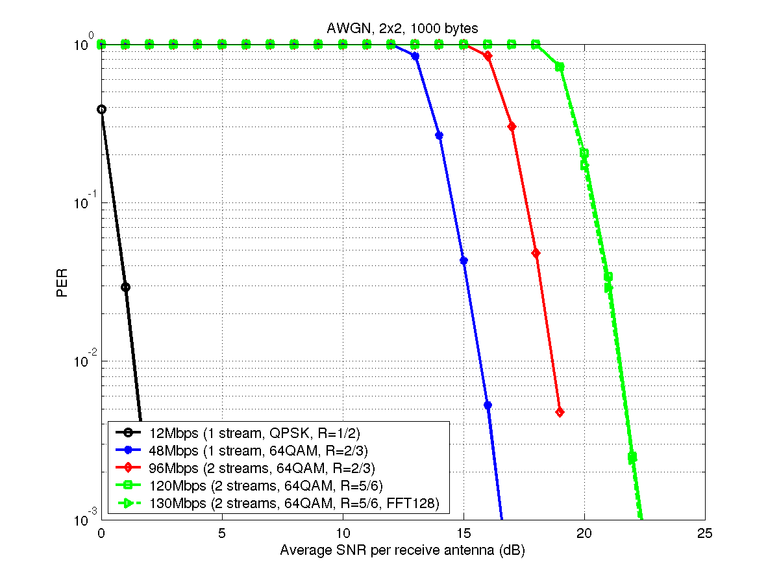
Figure 3-2 - PER performance for AWGN channel and 2x2 antenna configuration

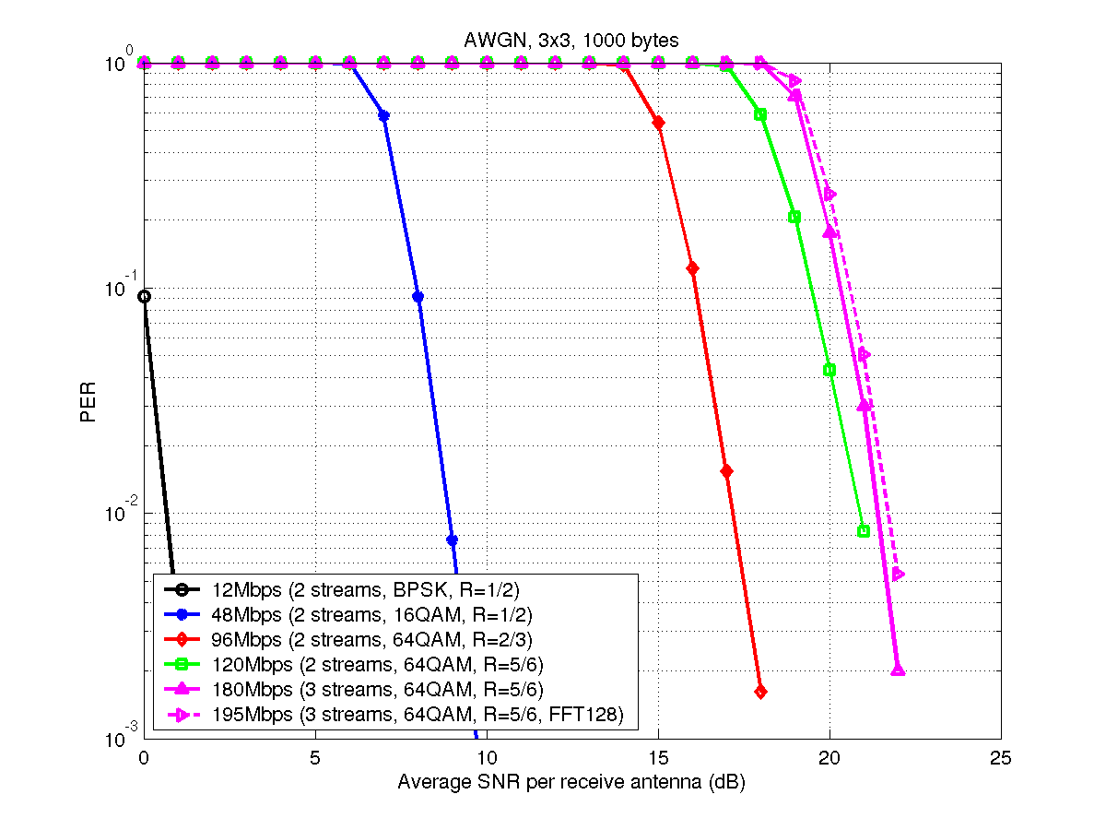
Figure 3-3 - PER performance for AWGN channel and 3x3 antenna configuration

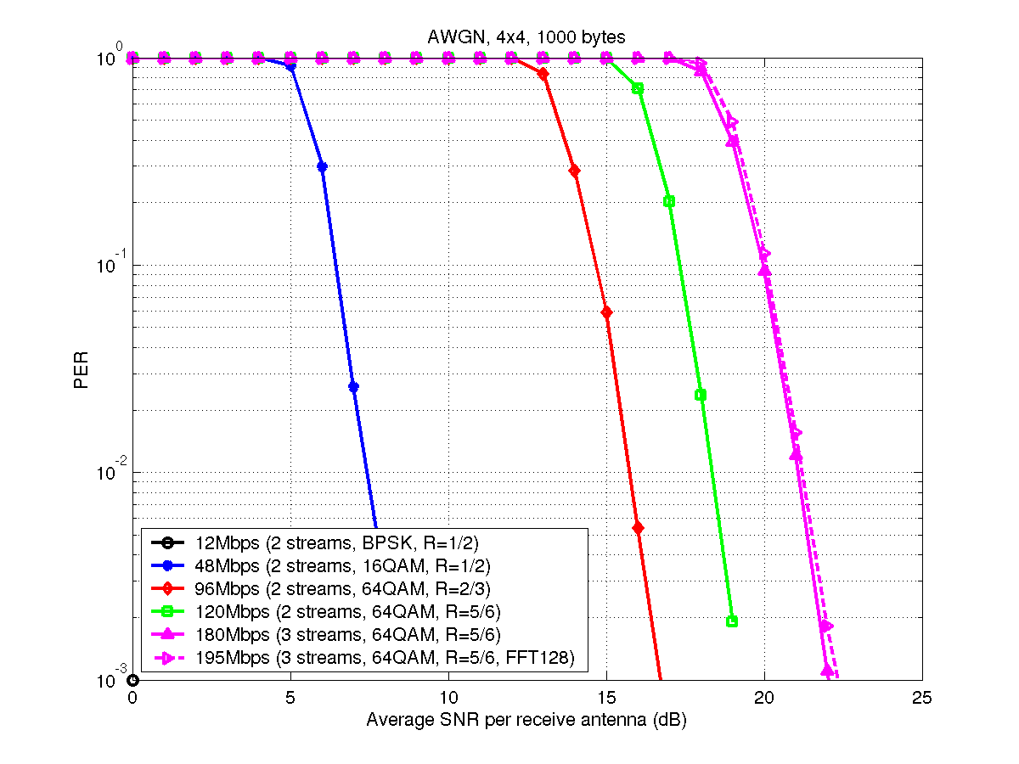
Figure 3-4 - PER performance for AWGN channel and 4x4 antenna configuration

CC67 (PER performance in non AWGN channels)

In this section we present the PER performance and the throughput of various modes in channels B, D and E. with impairments 1 to 6, for the following configurations:
- 2x2
- 3x3
- 4x4
- 2x4
- 3x2
- 4x2
Note that for simplicity of presentation the rate adaptation is based on long term average SNR. Much better performance can be achieved with more sophisticated Link Adaptation. Of course, the average PER obtained by this link adaptation technique can be high at cross-points, since the Link Adaptation algorithm does not take into account a PER target, as illustrated on Figure 3-35. The Average PER vs SNR for this link adaptation algorithm can be directly read on the already provided Average PER figures, therefore we do not provide all the plots.

Channel model B
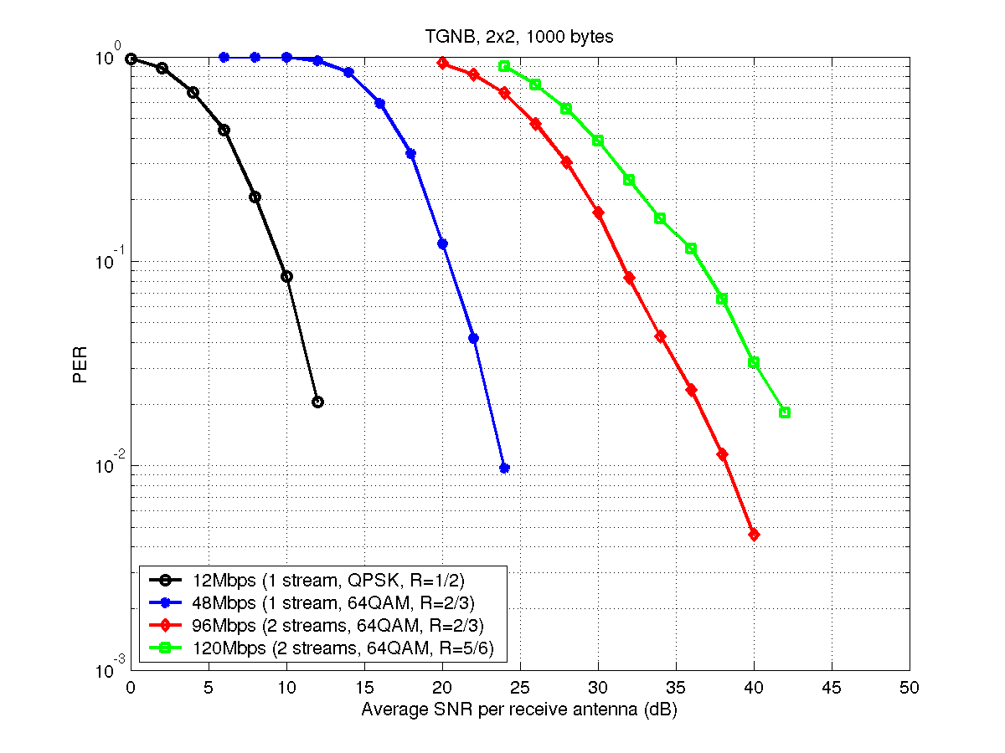  Figure 3-6 - PER performance for channel model B and 2x2 antenna configuration | 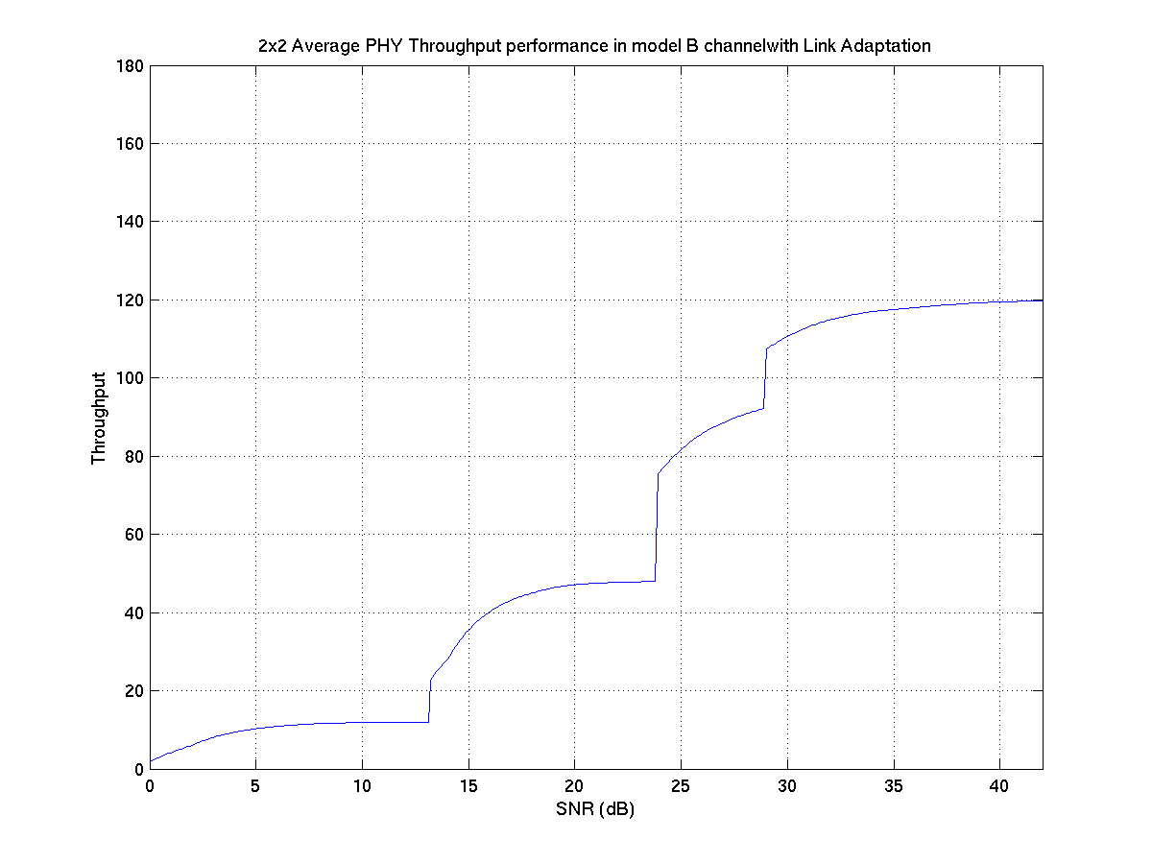  Figure 3-5 – 2x2 Avg PHY throughput for channel B
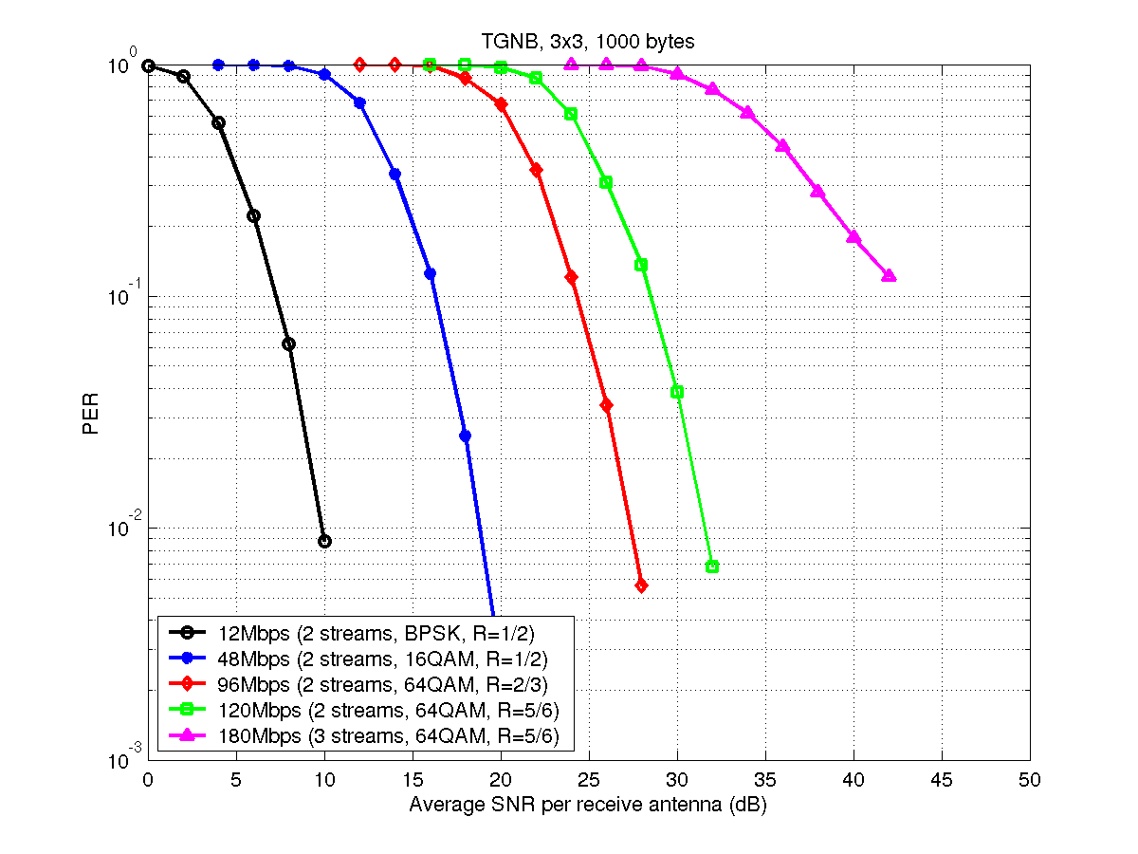  Figure 3-7 - PER performance for channel model B and 3x3 antenna configuration | 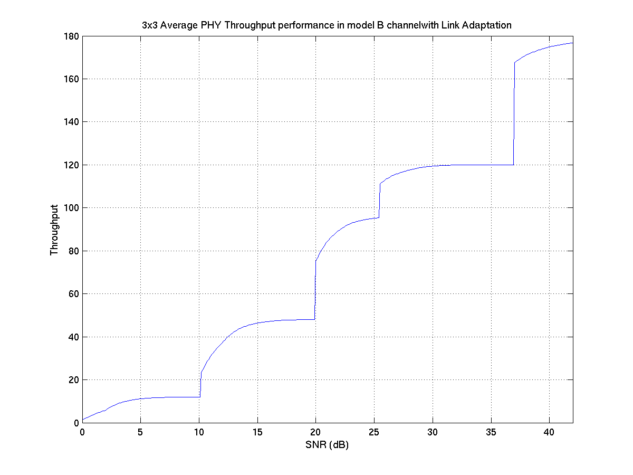  Figure 3-8 – 3x3 Avg PHY throughput for channel B
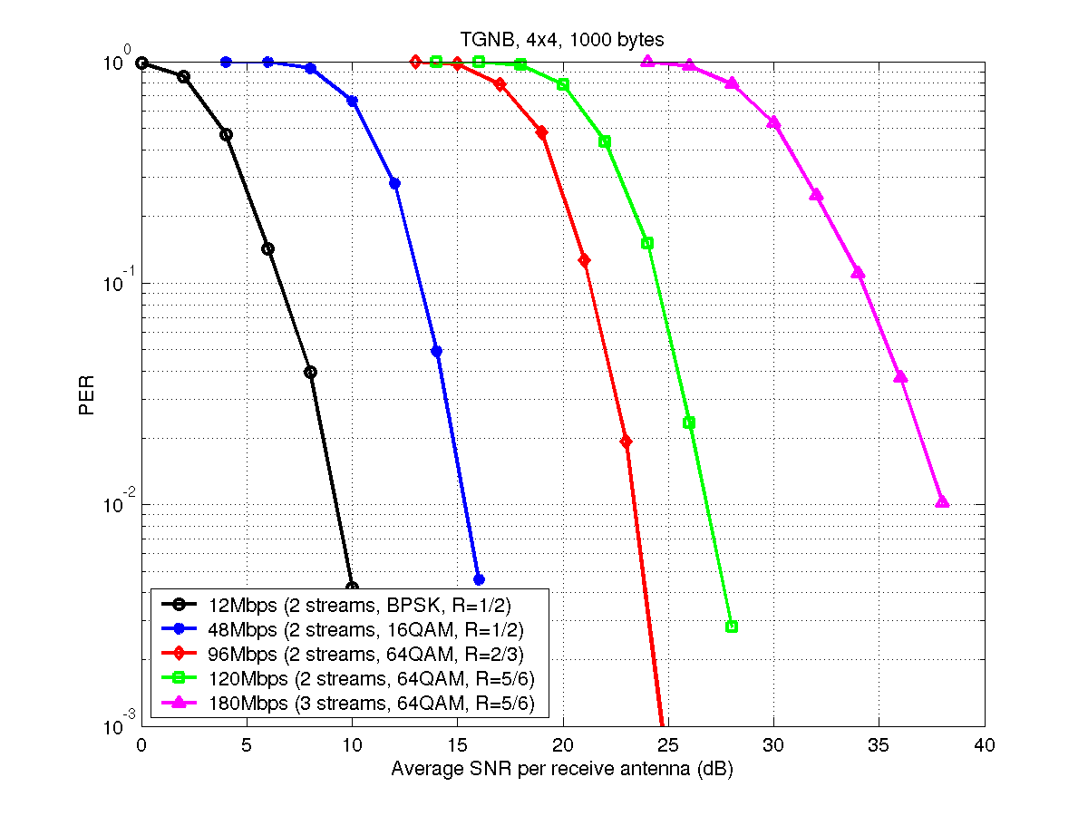  Figure 3-9 - PER performance for channel model B and 4x4 antenna configuration | 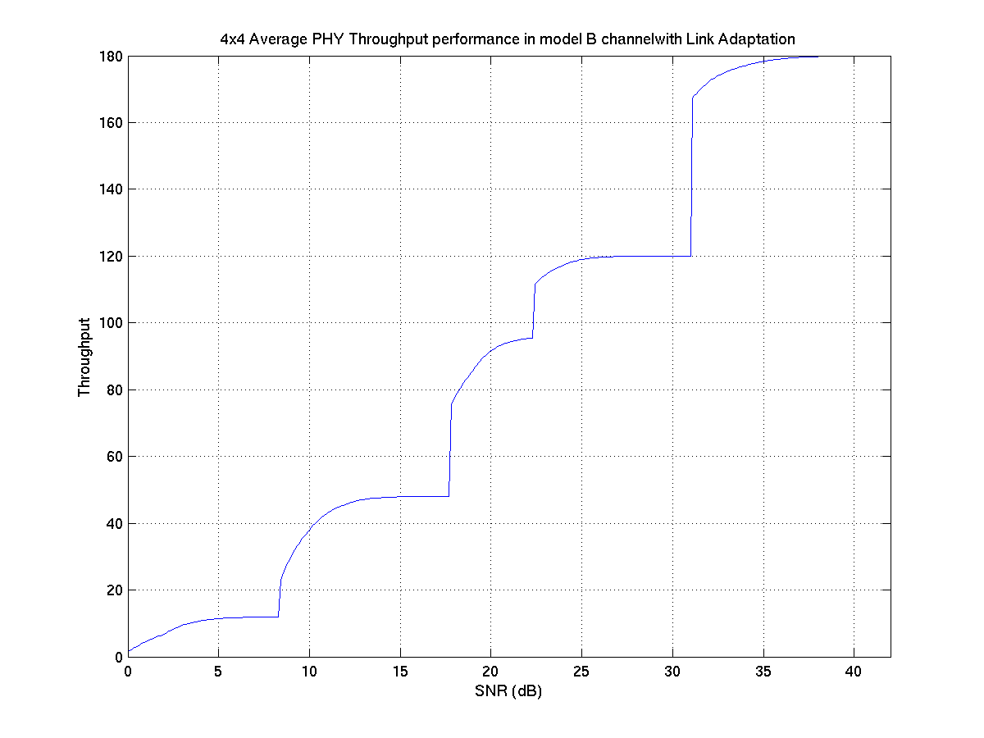  Figure 3-10 – 4x4 Avg PHY throughput for channel B
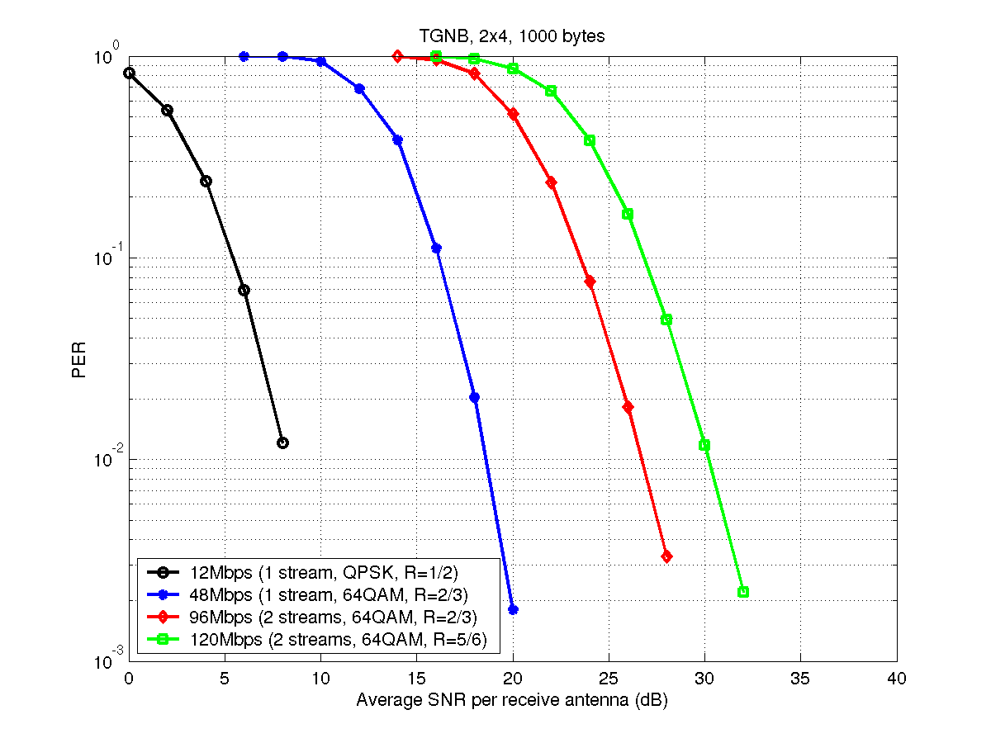  Figure 3-11 - PER performance for channel model B and 2x4 antenna configuration | 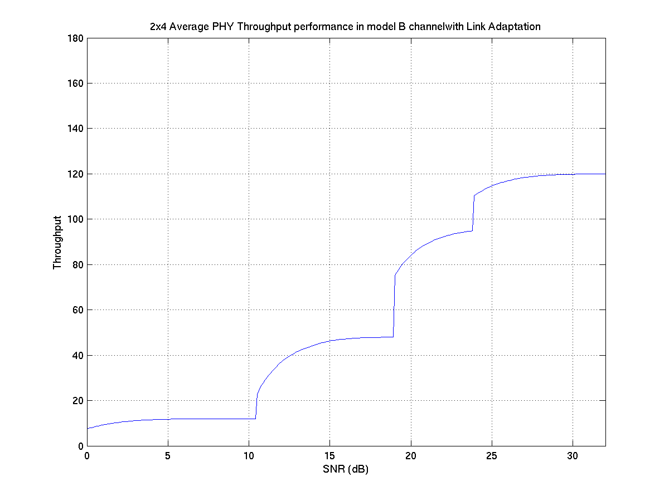  Figure 3-12 – 2x4 Avg PHY throughput for channel B
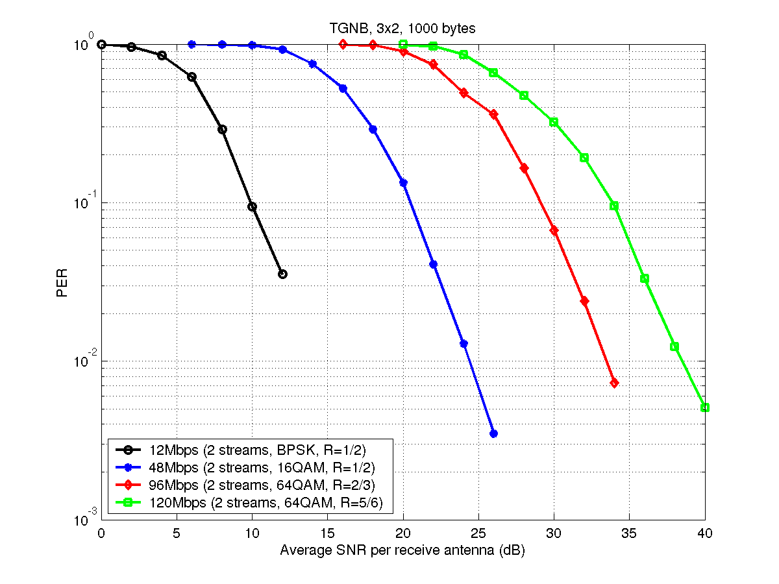  Figure 3-13 - PER performance for channel model B and 3x2 antenna configuration | 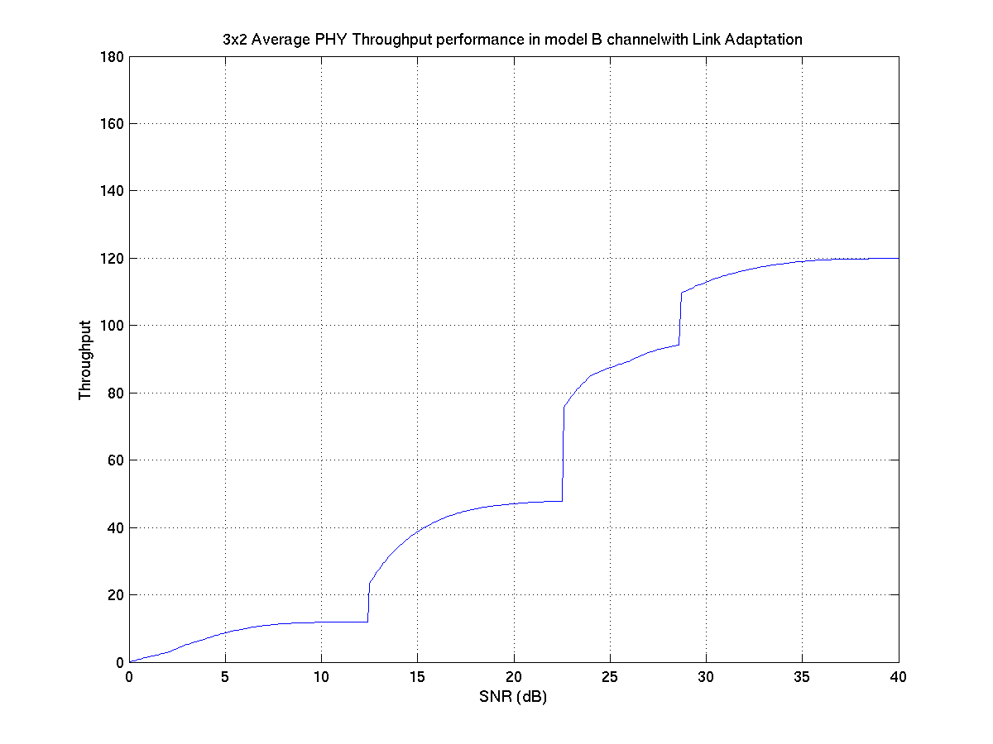  Figure 3-14 – 3x2 Avg PHY throughput for channel B
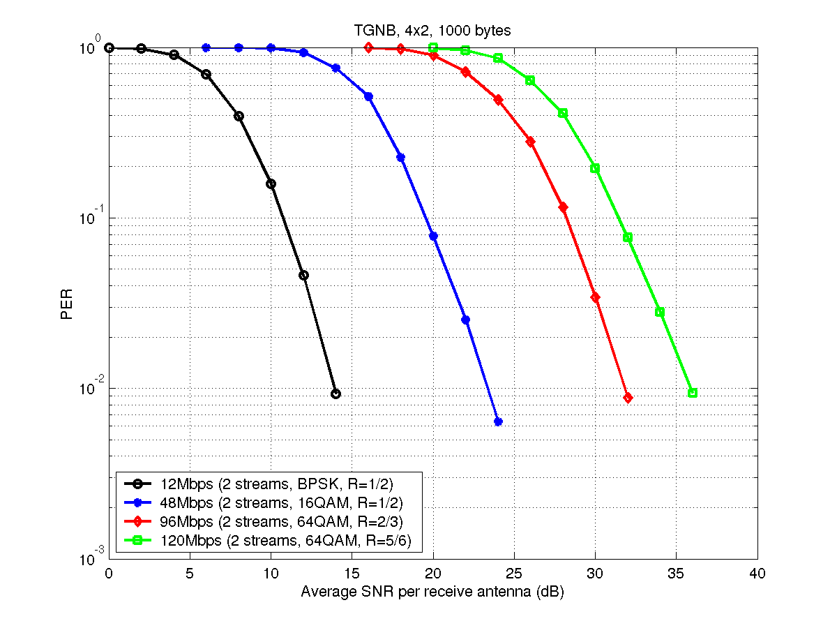  Figure 3-15 - PER performance for channel model B and 4x2 antenna configuration | 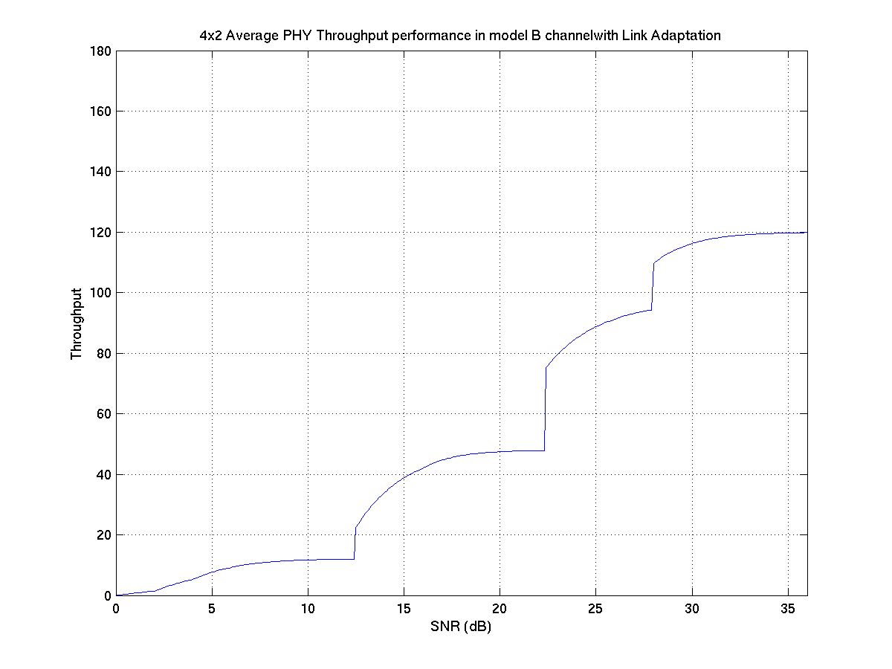  Figure 3-16 – 4x2 Avg PHY throughput for channel B

Channel model D
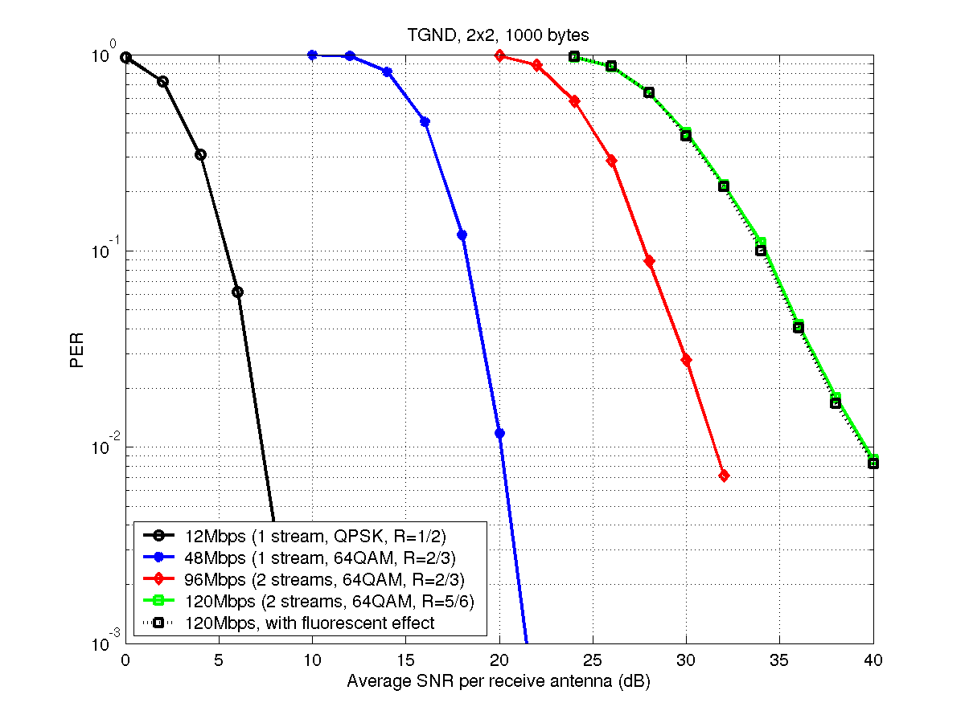  Figure 3-17 - PER performance for channel model D and 2x2 antenna configuration | 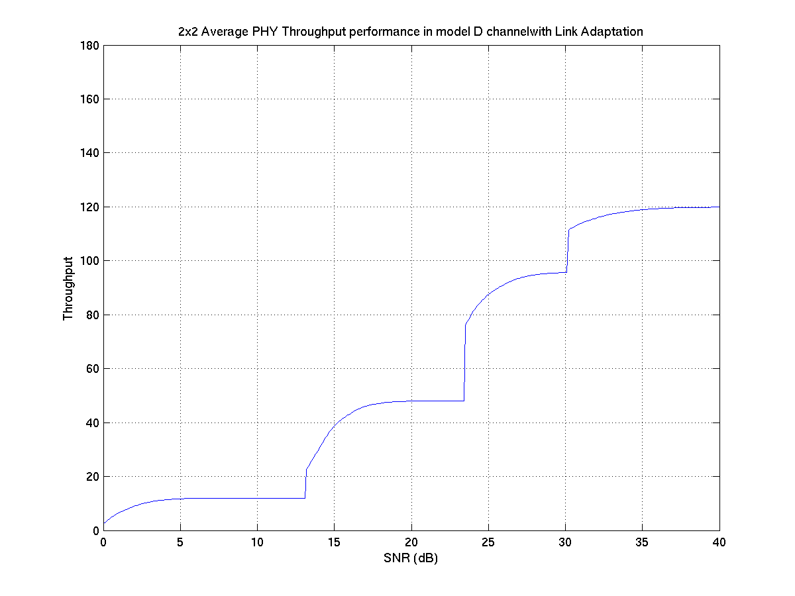  Figure 3-18 – 2x2 Avg PHY throughput for channel D
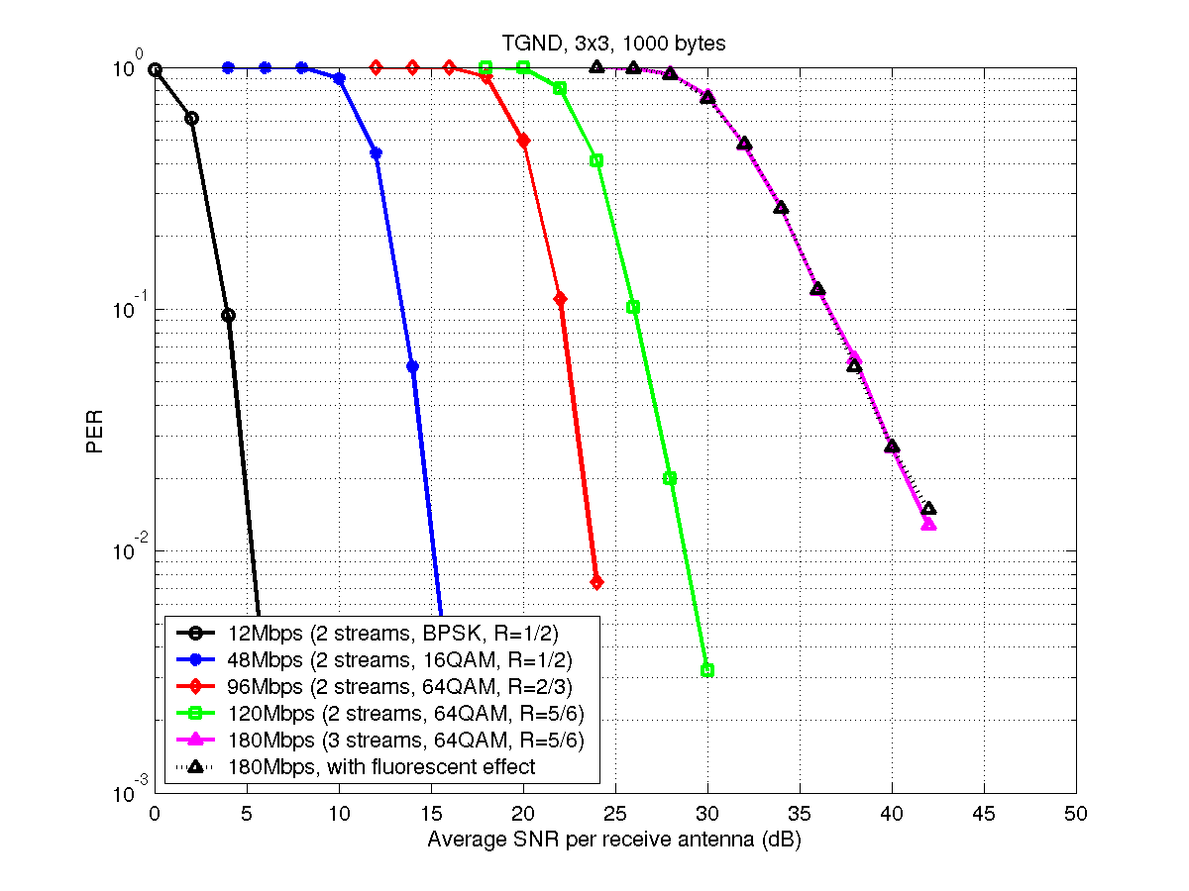  Figure 3-19 - PER performance for channel model D and 3x3 antenna configuration | 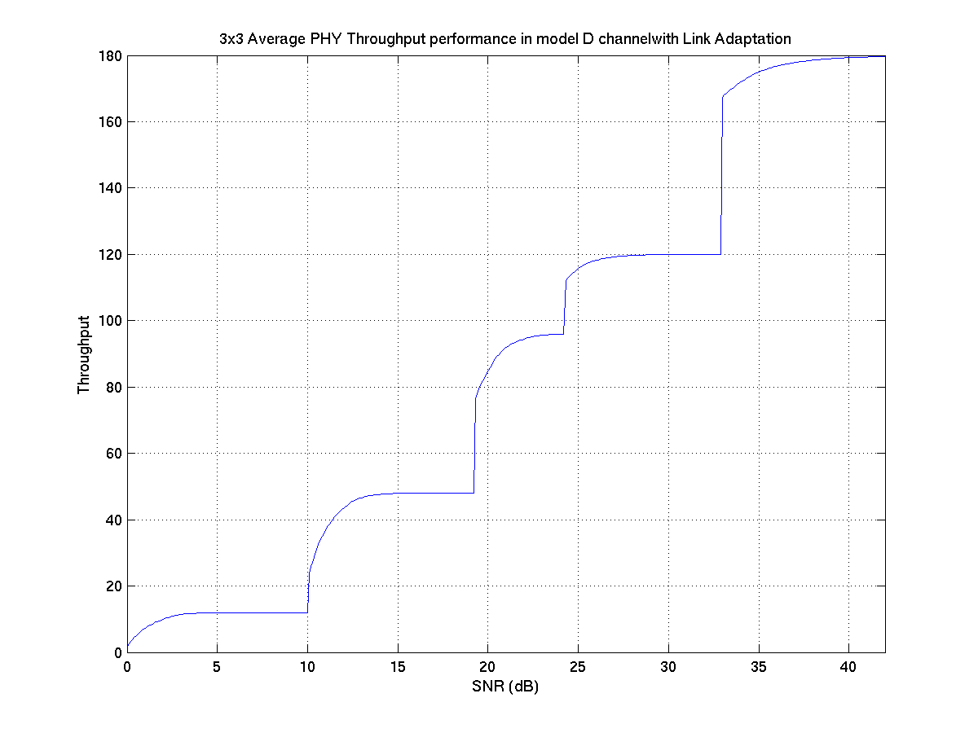  Figure 3-20 – 3x3 Avg PHY throughput for channel D
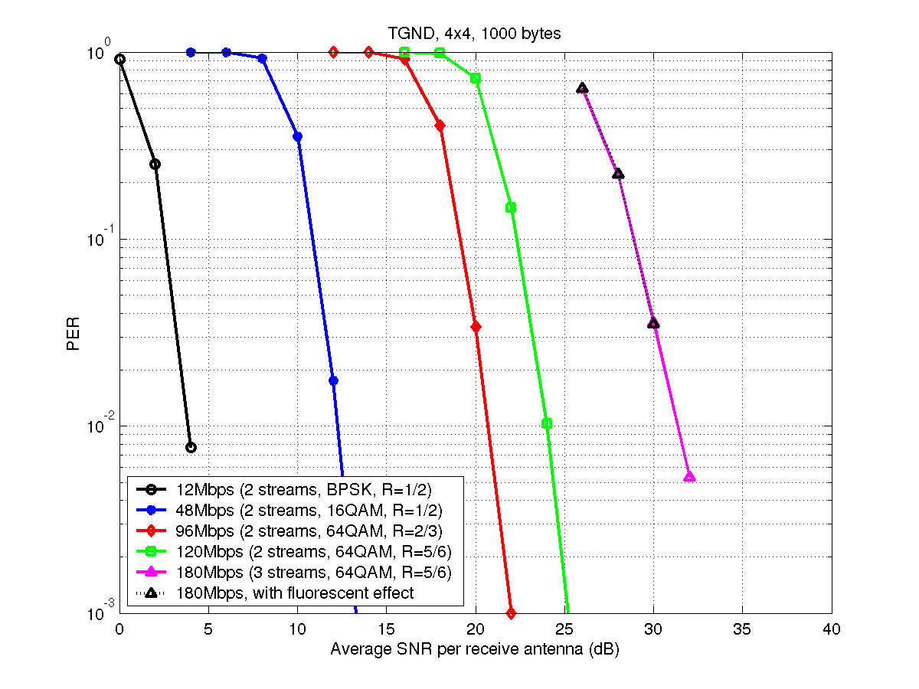  Figure 3-21 - PER performance for channel model D and 4x4 antenna configuration | 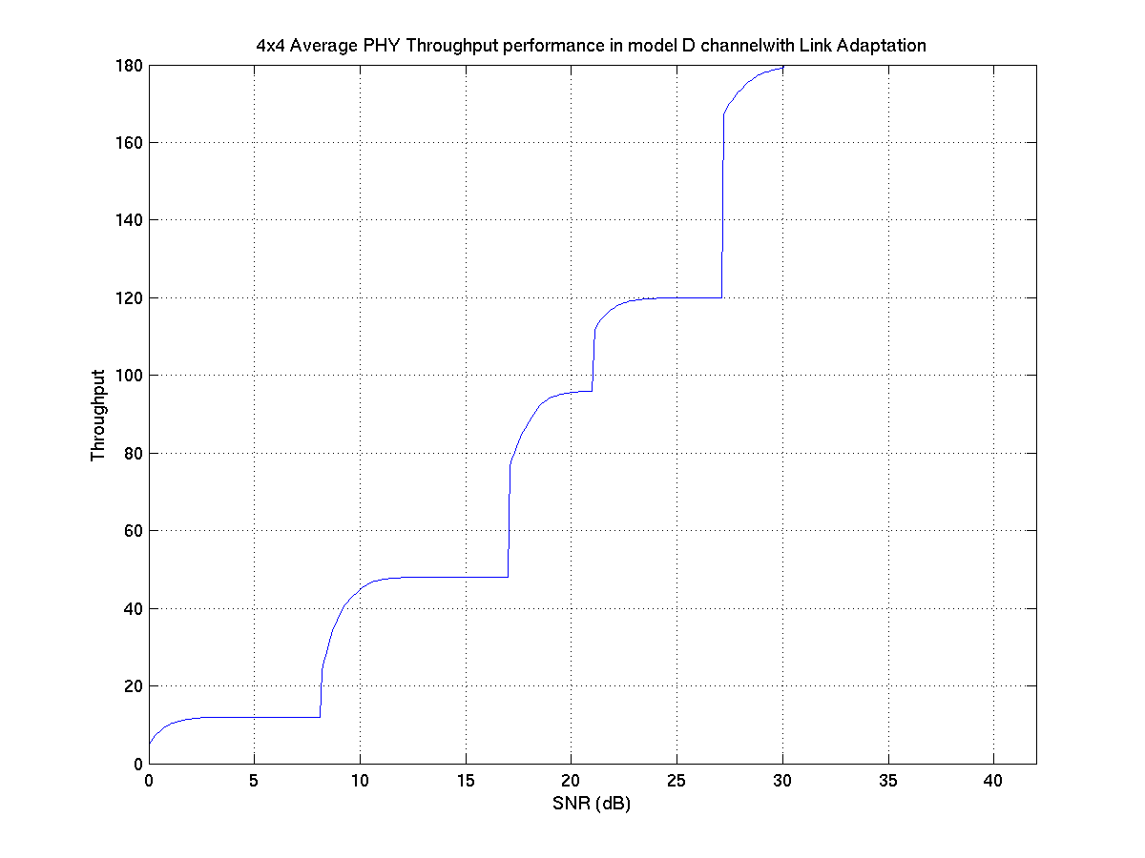  Figure 3-22 – 4x4 Avg PHY throughput for channel D
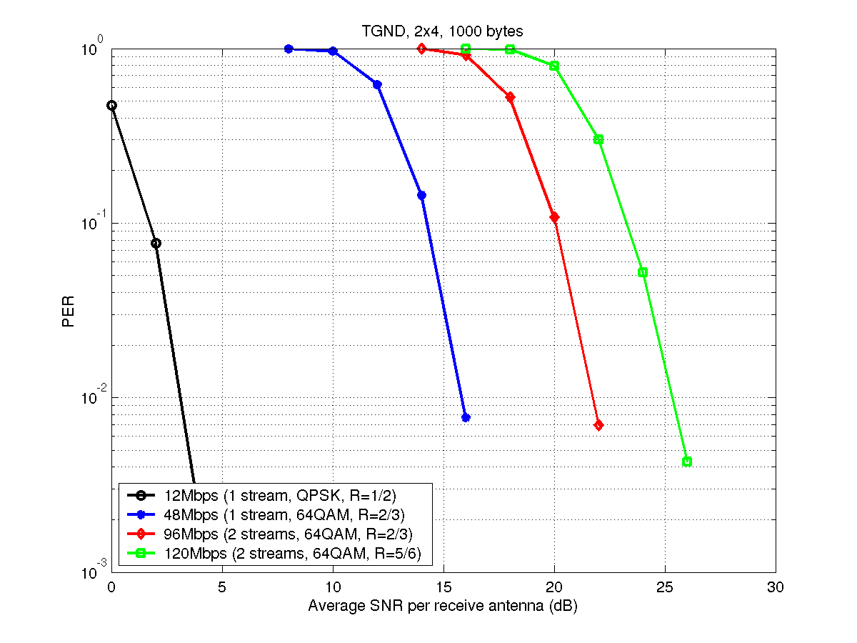
Figure 3-23 - PER performance for channel model D and 2x4 antenna configuration
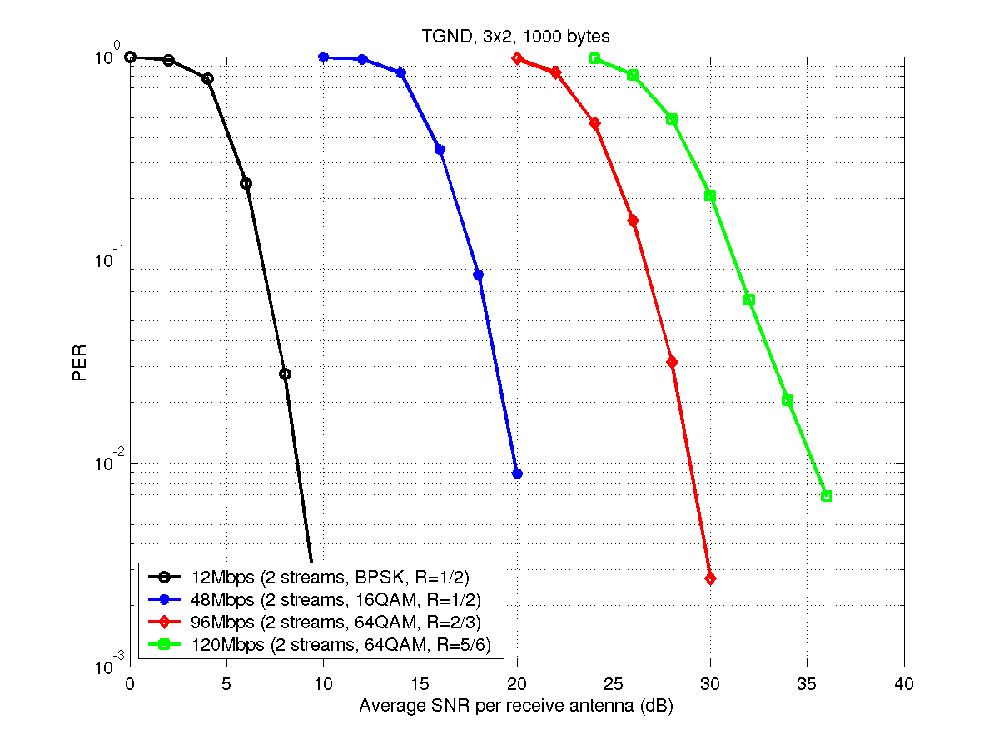
Figure 3-24 - PER performance for channel model D and 3x2 antenna configuration
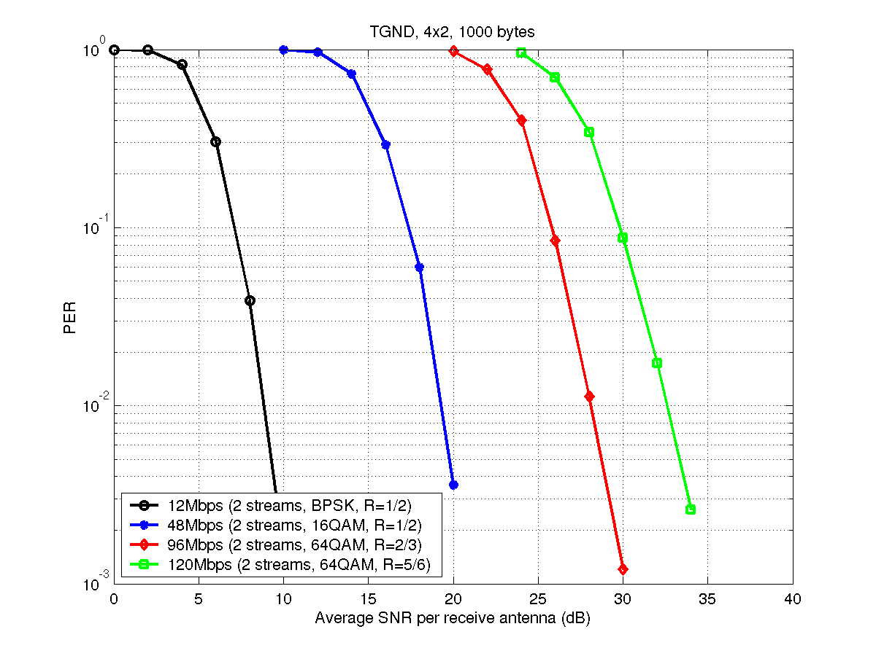
Figure 3-25 - PER performance for channel model D and 4x2 antenna configuration

Channel model E
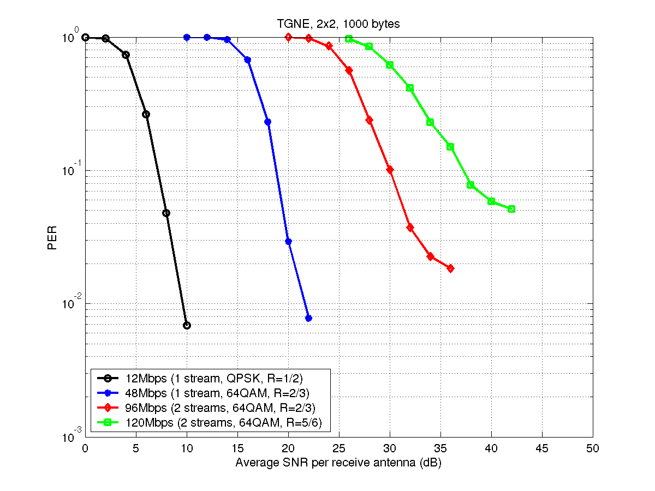  Figure 3-26 - PER performance for channel model E and 2x2 antenna configuration | 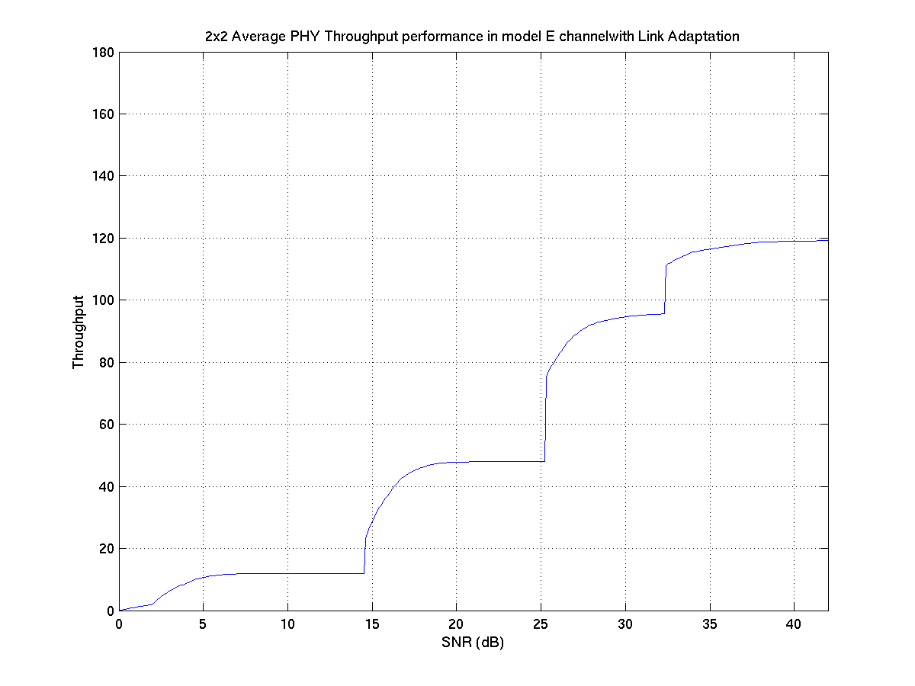  Figure 3-27 – 2x2 Avg PHY throughput for channel E
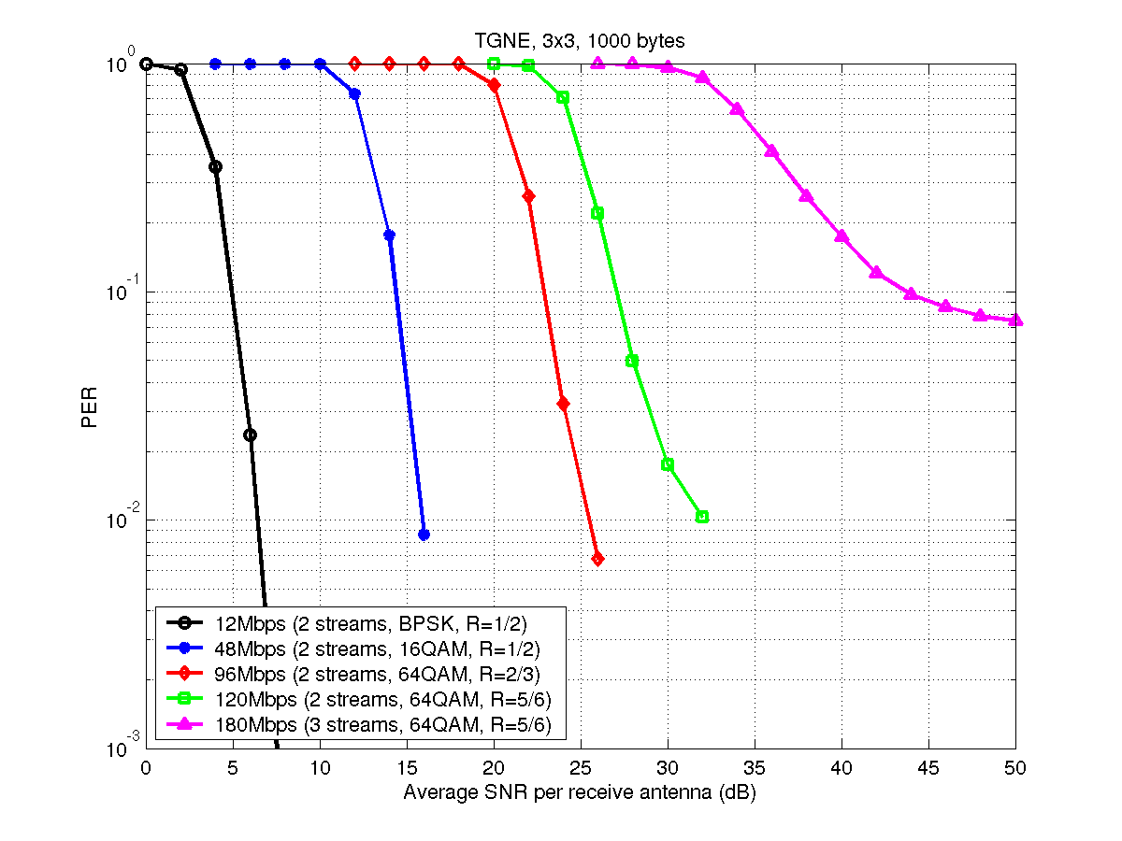  Figure 3-28- PER performance for channel model E and 3x3 antenna configuration | 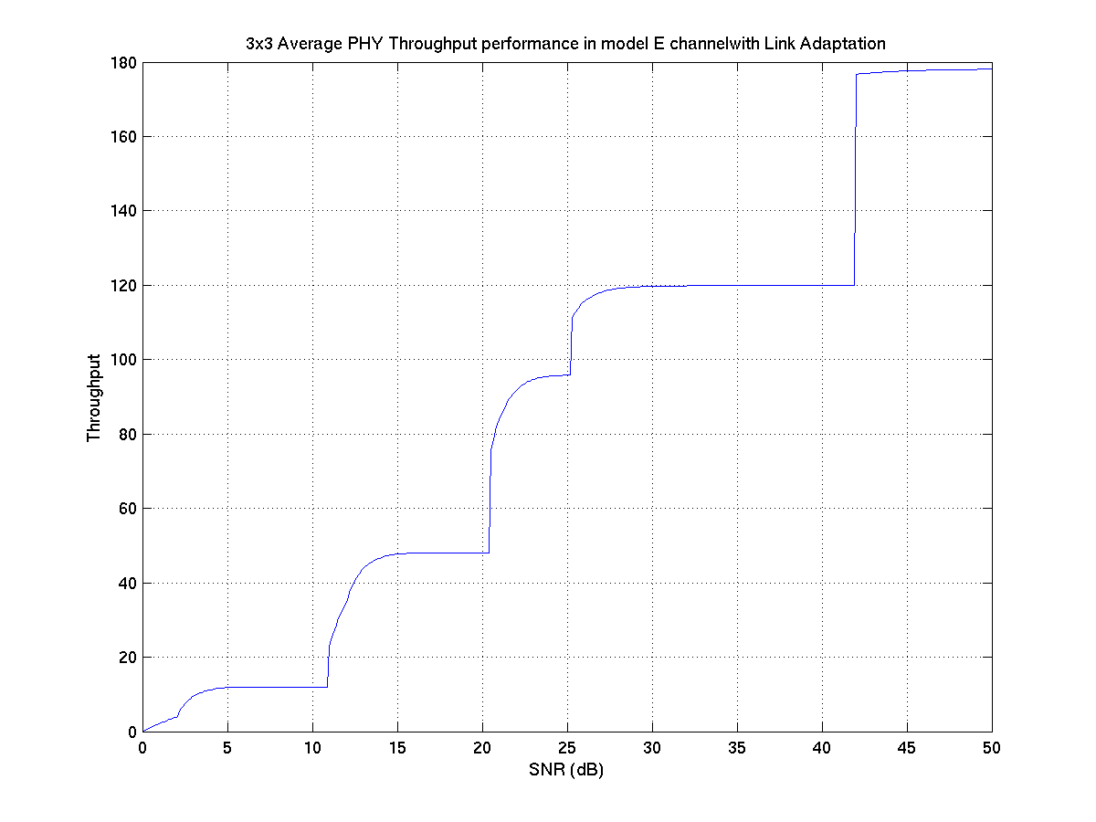  Figure 3-29 – 3x3 Avg PHY throughput for channel E
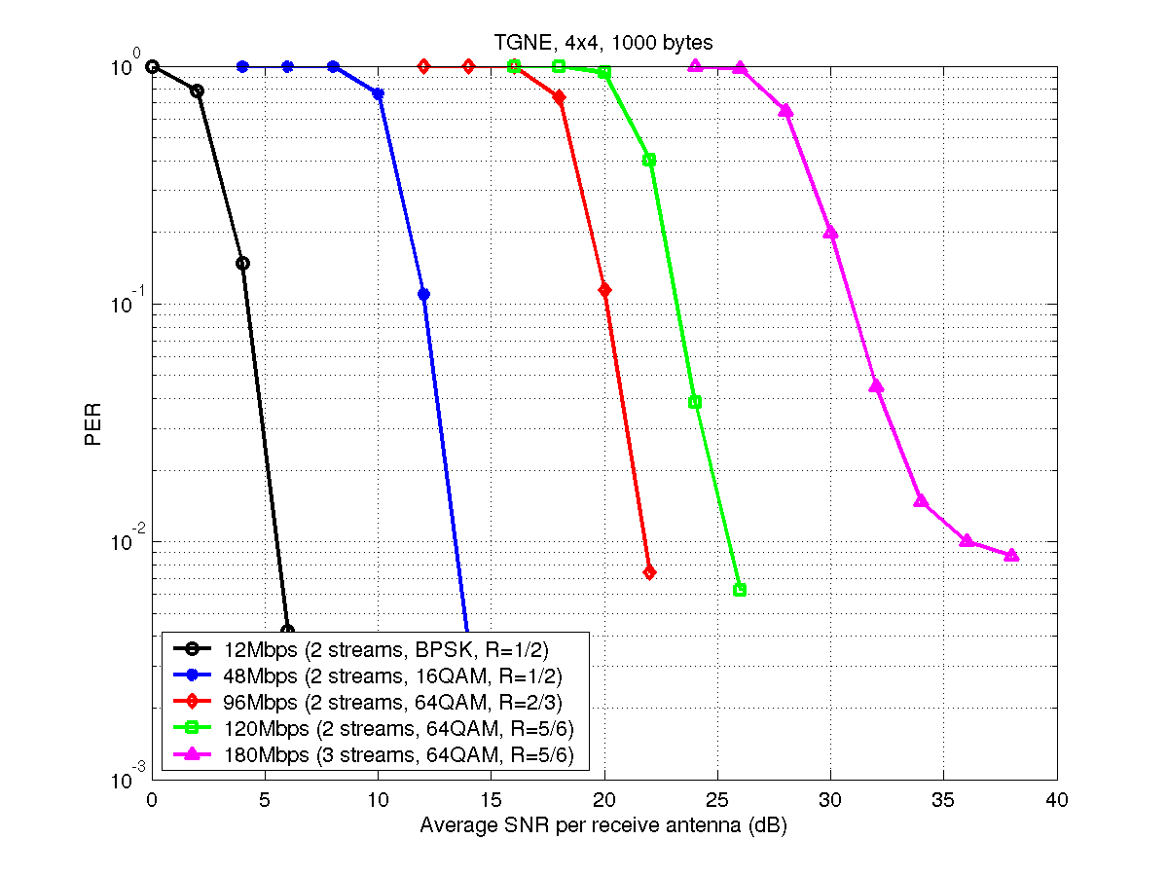  Figure 3-30 - PER performance for channel model E and 4x4 antenna configuration | 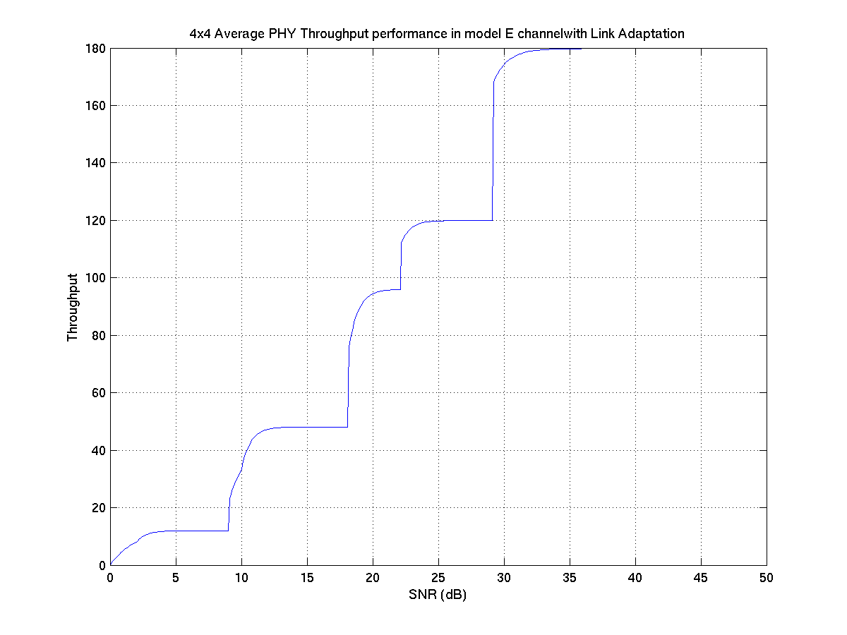  Figure 3-31 – 4x4 Avg PHY throughput for channel E
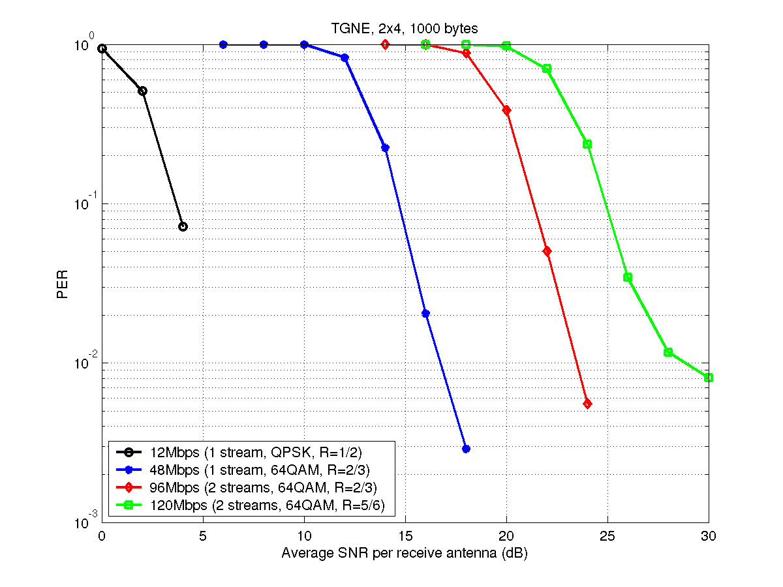
Figure 3-32 - PER performance for channel model E and 2x4 antenna configuration
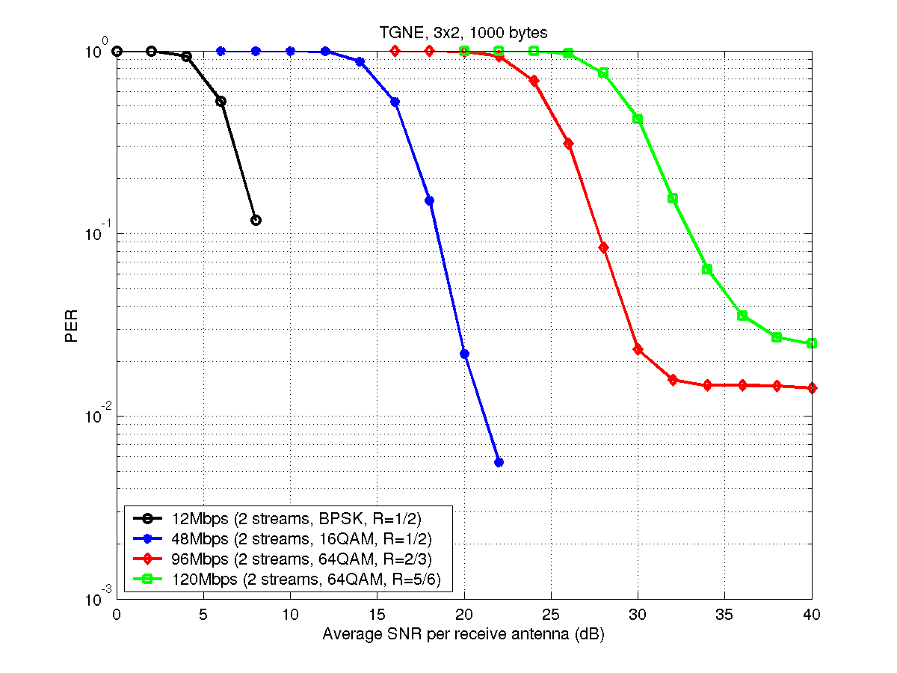
Figure 3-33 - PER performance for channel model E and 3x2 antenna configuration
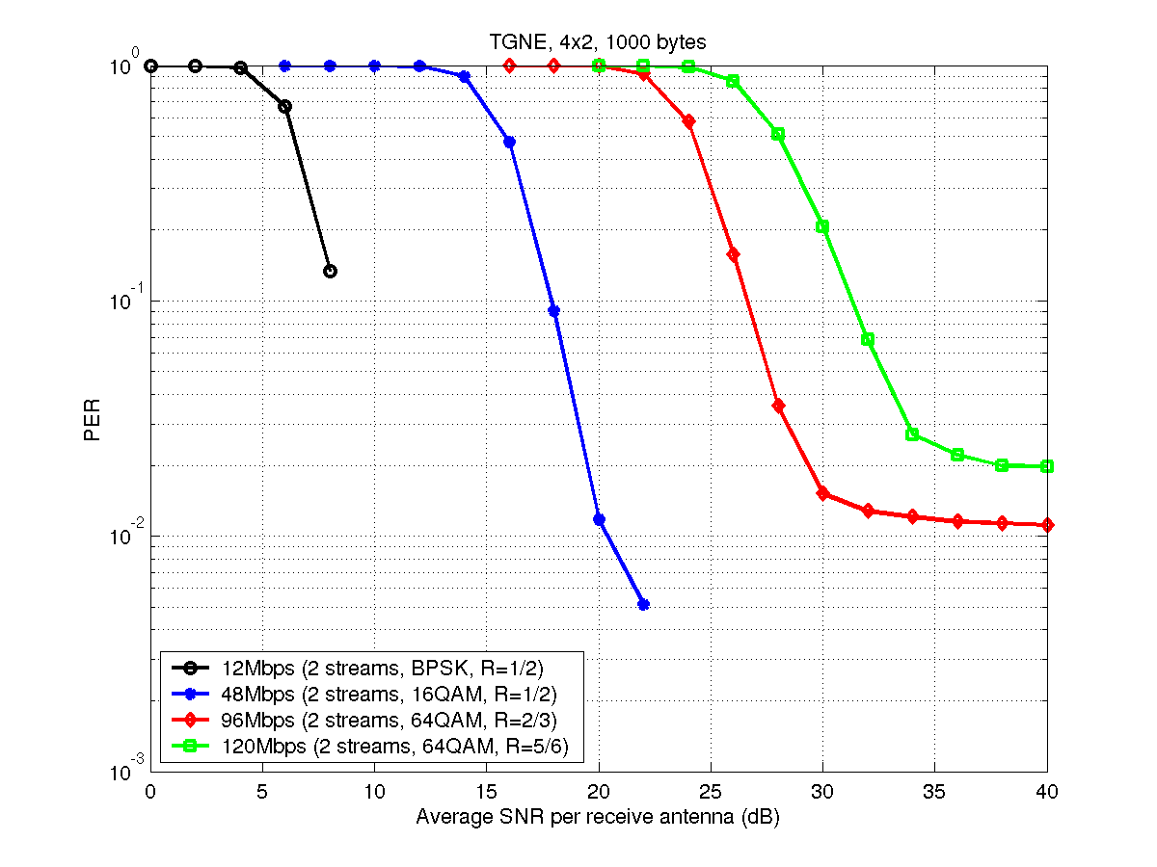
Figure 3-34 - PER performance for channel model E and 4x2 antenna configuration

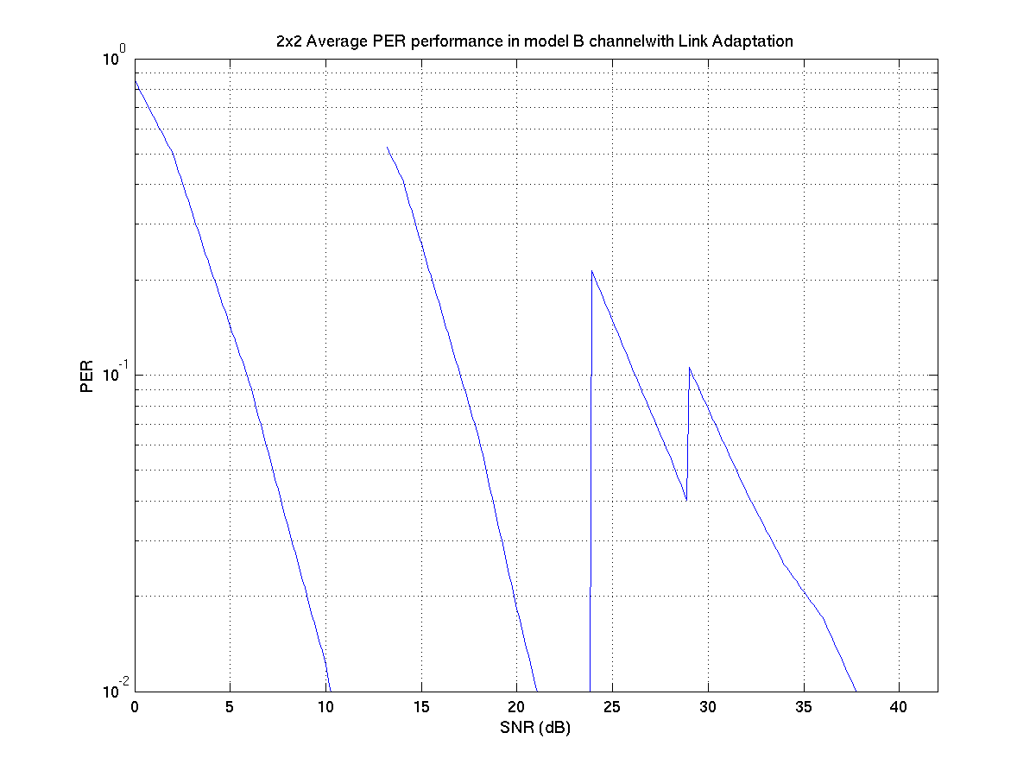
Figure 3-35: Average PER vs SNR for 2x2 Antenna Configuration with Link Adaptation on channel B

CC67.2 (Offset compensation)

Impact of carrier frequency offset and symbol clock offset at 10%PER in channel E (NLOS)

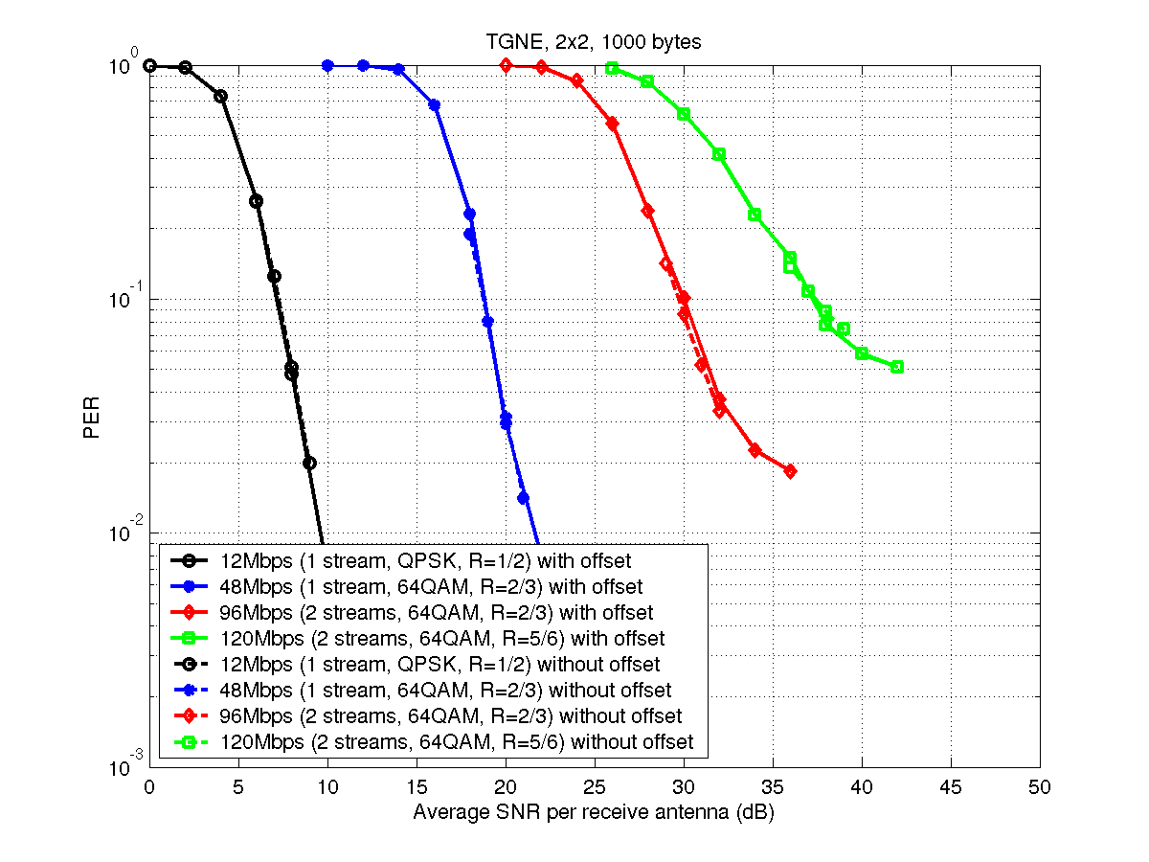
Figure 3-36 - Offset impact in 2x2 antenna configuration
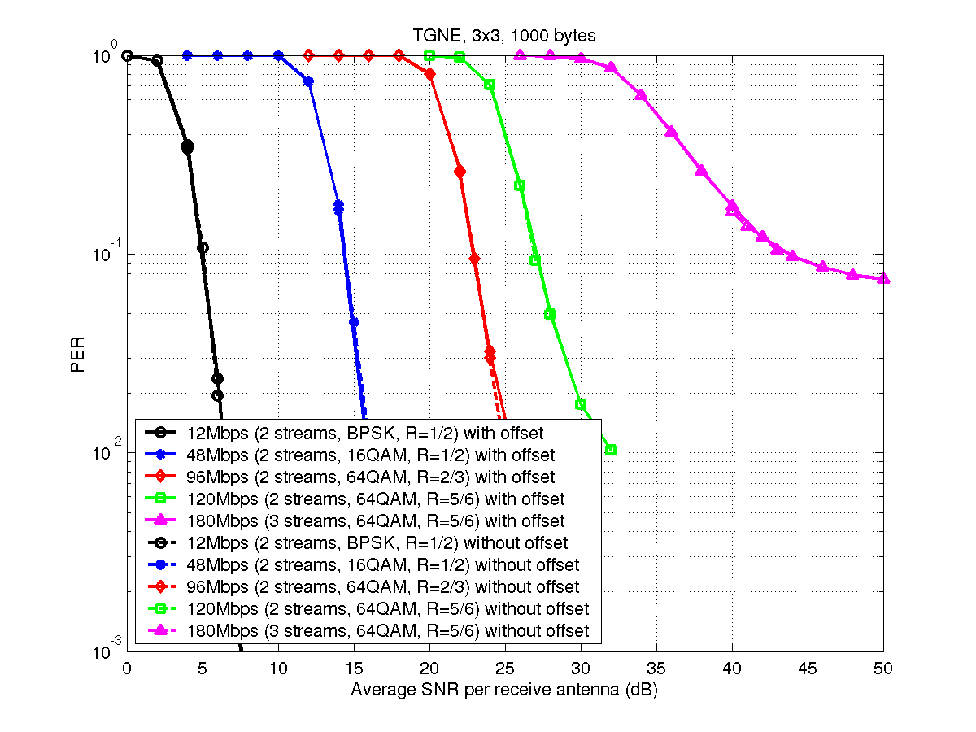
Figure 3-37 - Offset impact in 3x3 antenna configuration
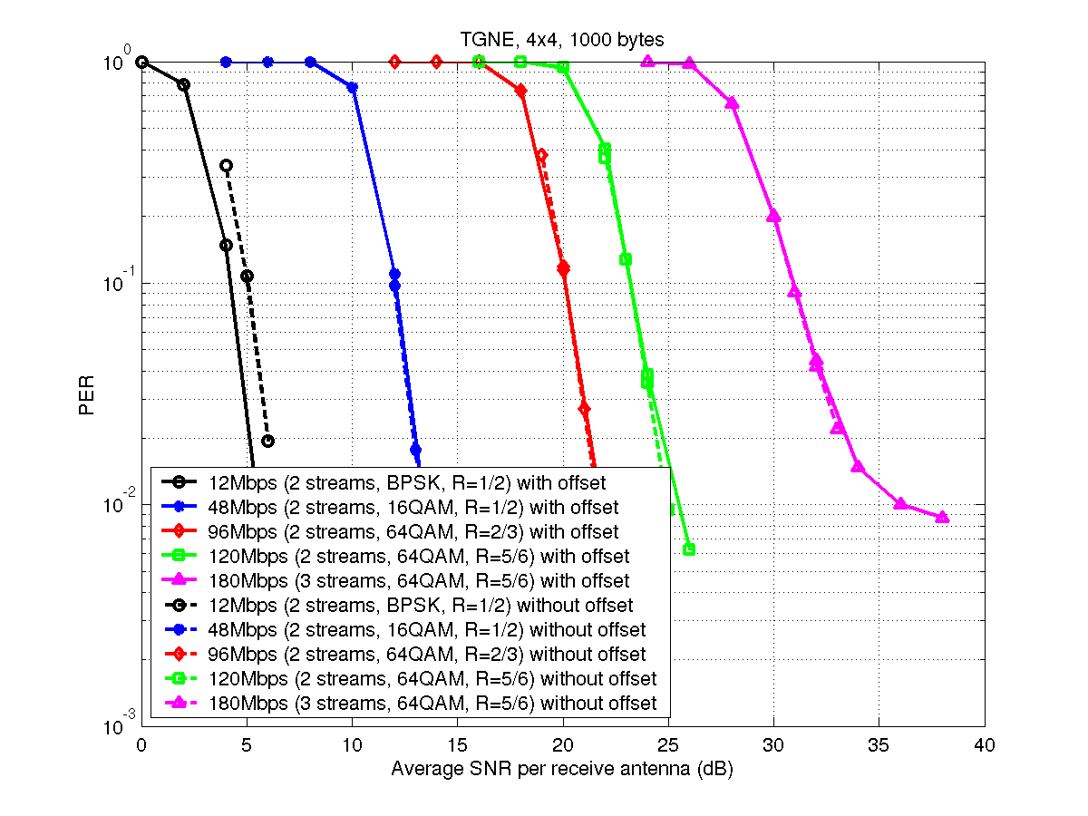
Figure 3-38 - Offset impact in 4x4 antenna configuration

Impact of carrier frequency offset and symbol clock offset on PER using an SNR of 50dB in channel E (LOS)

Antenna configuration | Data rate (Mbits/s) | PER when  carrier offset = -40ppm | PER when  carrier offset = 0ppm | PER when  carrier offset =+40ppm
2x2 | 12Mbps | 0.0003 | 0.0003 | 0.0002
2x2 | 48Mbps | 0.0016 | 0.0016 | 0.0018
2x2 | 96Mbps | 0.0039 | 0.0037 | 0.0042
2x2 | 120Mbps | 0.0297 | 0.0183 | 0.0298

Antenna configuration | Data rate (Mbits/s) | PER when  carrier offset = -40ppm | PER when  carrier offset = 0ppm | PER when  carrier offset =+40ppm
3x3 | 12Mbps | 0.0002 | 0.0001 | ~0
3x3 | 48Mbps | 0.0006 | 0.0006 | 0.0005
3x3 | 96Mbps | 0.0041 | 0.0041 | 0.0043
3x3 | 120Mbps | 0.0043 | 0.0045 | 0.0050
3x3 | 180Mbps | 0.0963 | 0.0617 | 0.0974

Antenna configuration | Data rate (Mbits/s) | PER when  carrier offset = -40ppm | PER when  carrier offset = 0ppm | PER when  carrier offset =+40ppm
4x4 | 12Mbps | ~0 | ~0 | ~0
4x4 | 48Mbps | 0.0001 | 0.0001 | 0.0001
4x4 | 96Mbps | 0.0016 | 0.0016 | 0.0019
4x4 | 120Mbps | 0.0021 | 0.0021 | 0.0022
4x4 | 180Mbps | 0.0023 | 0.0024 | 0.0029

Other simulation results

MAC efficiency comparison

Figure 4-39 presents the MAC efficiency achieved with the previously presented scenarios.

Figure 4-39: MAC efficiency versus PER

MAC efficiency decreases smoothly when PER raises. It remains at a high level even in very harsh radio condition, i.e. even for PER values as high as 1.5 10⁻¹ (for 134 bytes-long packets).

Non-QoS goodput
This section contains figures relative to the throughput achieved for the TCP flows in the different scenarios.
Even with high PER values and the traffic mix defined in the scenarios, the system is able to sustain a high level of TCP traffic.

Figure 4-40: TCP throughput versus PER in scenarios 1 and 1bis | Figure 4-41: TCP throughput versus PER in scenario 4
Figure 4-42: TCP throughput versus PER in scenarios 6 and 6bis

Maximum goodput in point to point configuration
Figure 4-43: MAC efficiency vs. PHY throughput
An extra simulation has been performed where a single UDP source is defined and the most efficient PHY modes (3x3 256QAM3/4, Ns=3) is used to transmit data. Traffic is emitted from the AP to the STA and the packet length is 1500 octets.
On Figure 4-43, results show the high goodput that is reached by the system when only one STA is associated to the cell and when radio conditions are perfect. For instance, for a realistic PER of 3.10⁻², the efficiency is 82.7% resulting in a MAC goodput of 178.5Mbit/s.

Delays
Figure 4-44 gives the cumulative distribution function of transmission delays in scenario 1 for TCP and VoIP flows in various channel conditions (different PER).

Even when the medium is full radio condition very harsh, VoIP traffics experience delays that are always below 20 ms which results in a 0% Packet Loss Rate.
Figure 4-44: Delay distribution (scenario 1)

Mixed traffic handling

To assess system capacity to handle a large amount of mixed traffic, we defined a new scenario.
We considered 1 TCP data flow, able to fully backlog the medium, transmitted using 3x3_64QAM 2/3 (Ns=3) MIMO mode at 144 Mbit/s, and VoIP sessions, each one having duplex traffic (2 x 96 kbit/s) and using either 2x2 64QAM2/3 (Ns=1) or 2x2_16QAM½ (Ns=1) MIMO modes. We increase the number of VoIP sessions and report how the TCP traffic and the MAC efficiency are impacted.

Figure 4-45: VoIP Throughput Performance | Figure 4-46: VoIP Distribution Delay while multiplexing 32 VoIP sessions and 1 TCP

Figure 4-45 and Figure 4-46 report simulation results. The system is able to handle correctly 32 VoIP sessions while offering room for at least 65 Mbit/s of TCP traffic. For 64 VoIP sessions, TCP traffic still remains higher than 18Mbit/s. While the number of VoIP sessions increases, the MAC efficiency ranges from 78% to 55%.

Additional PHY simulations

Packet error rate curves versus distance and ideal MAC throughput
The PER curves versus distance that have been used to derive the answer to CC27 and CC28 are provided below for channel B and D and antenna configurations 2x2, 3x3, 4x4. For each of set of curves is associated the maximum achievable MAC rate as a function of the distance as an upper bound of what can be accomplished.
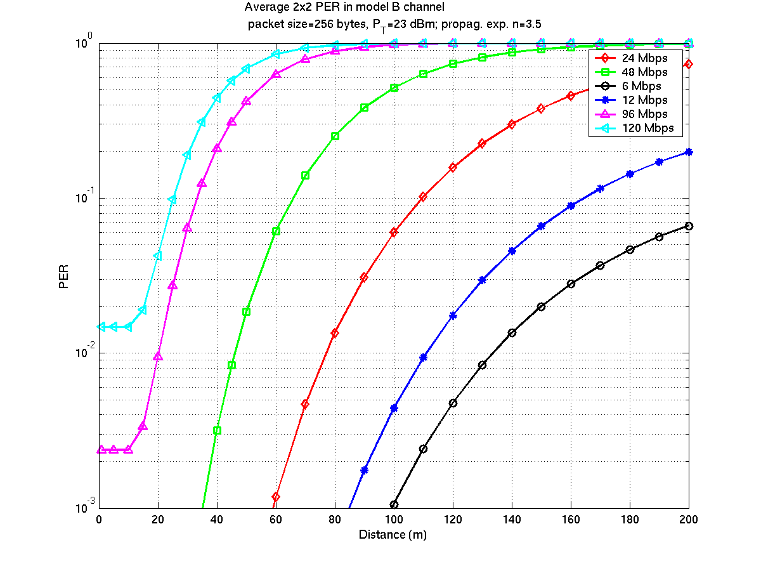  Figure 4-47 - 2x2 average PER for channel B | 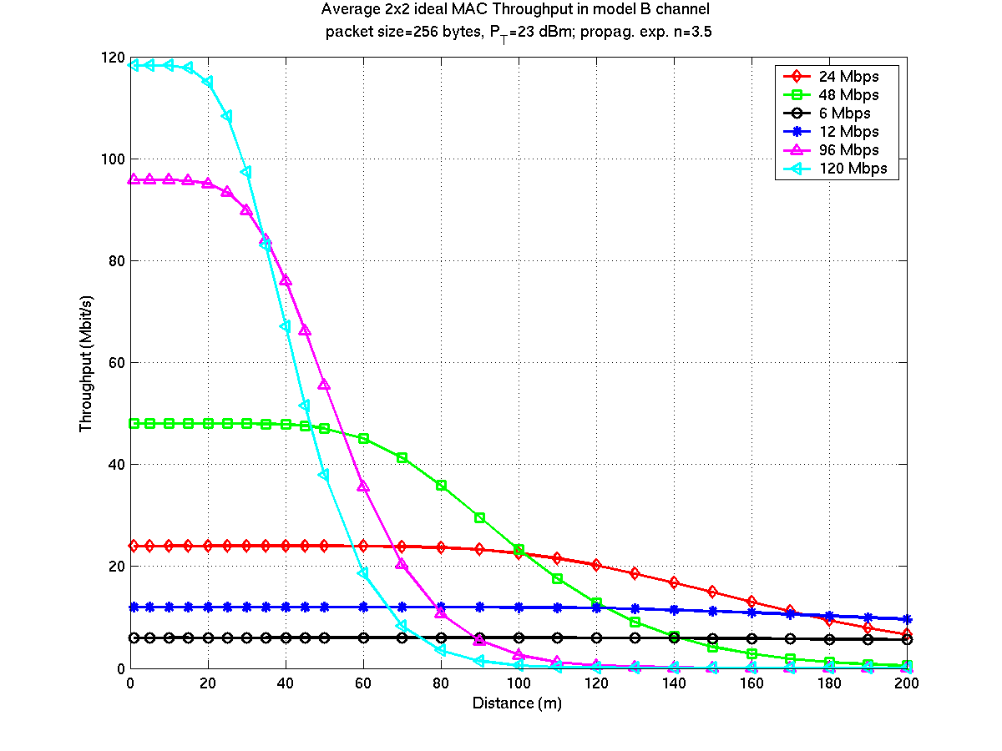  Figure 4-48 – 2x2 ideal MAC throughput for channel B
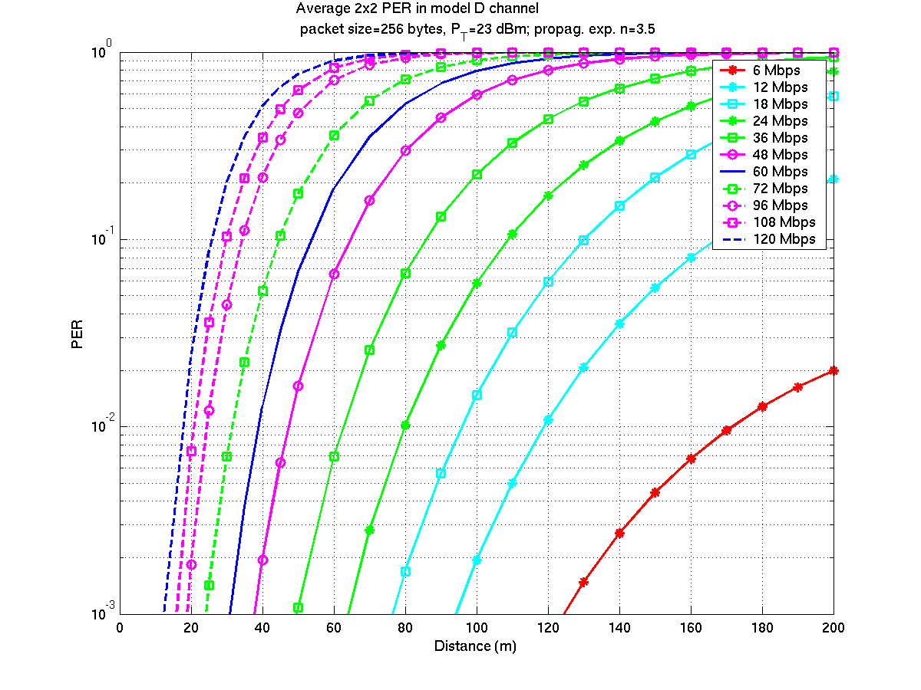  Figure 4-49- 2x2 average PER for channel D | 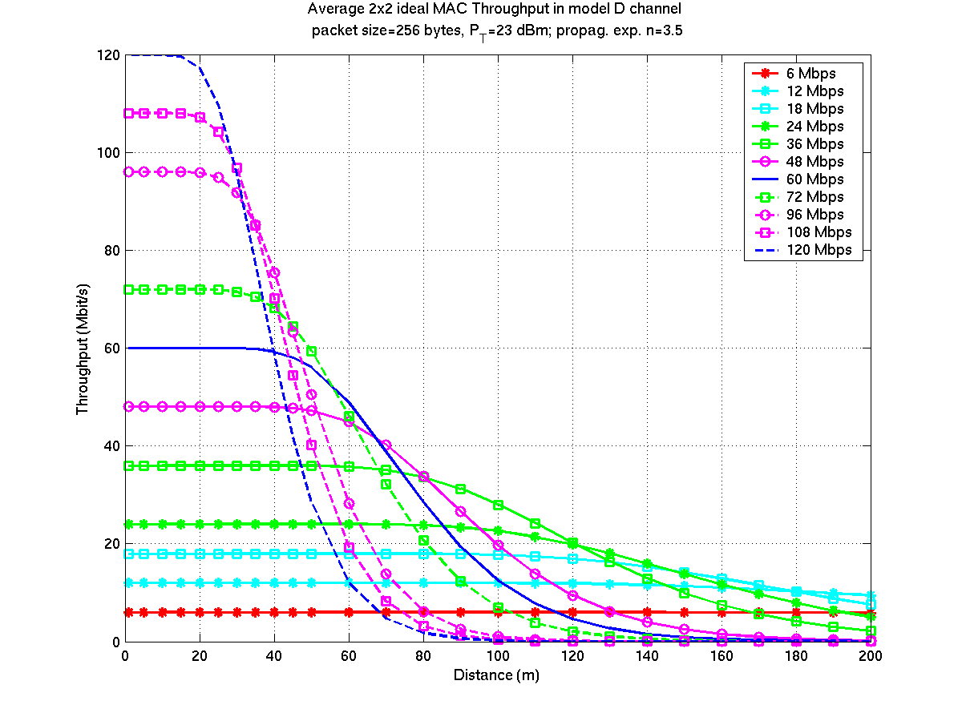  Figure 4-50 – 2x2 ideal MAC throughput for channel D
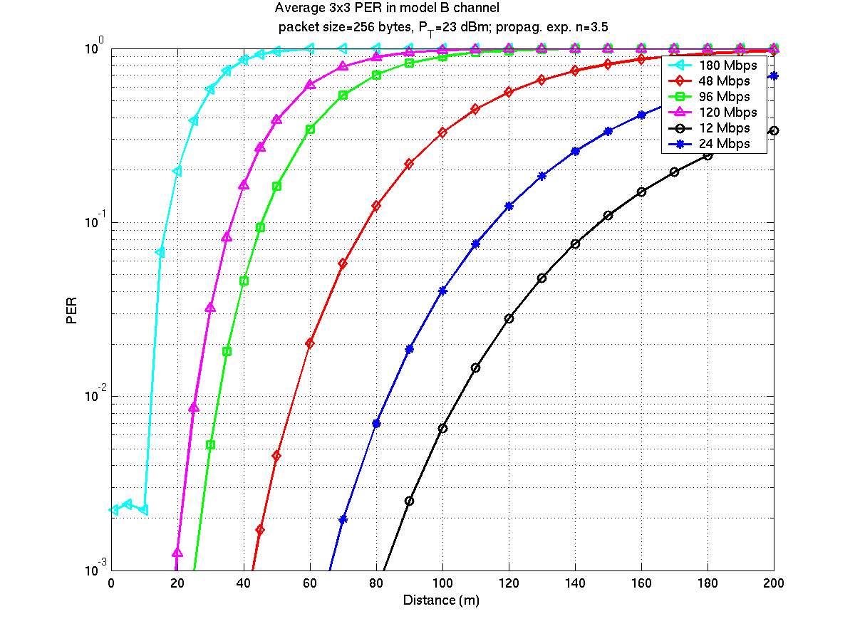  Figure 4-51 - 3x3 average PER for channel B | 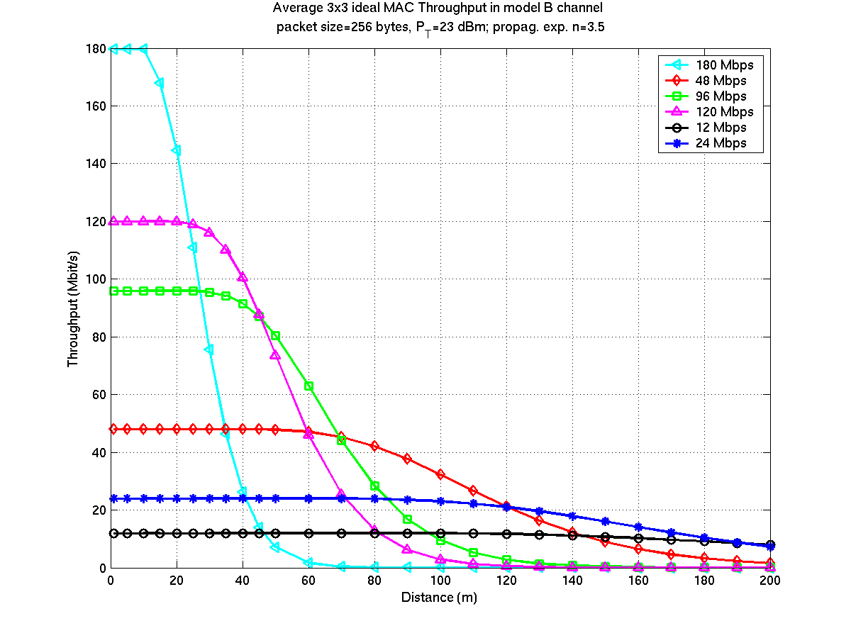  Figure 4-52 – 3x3 ideal MAC throughput for channel B
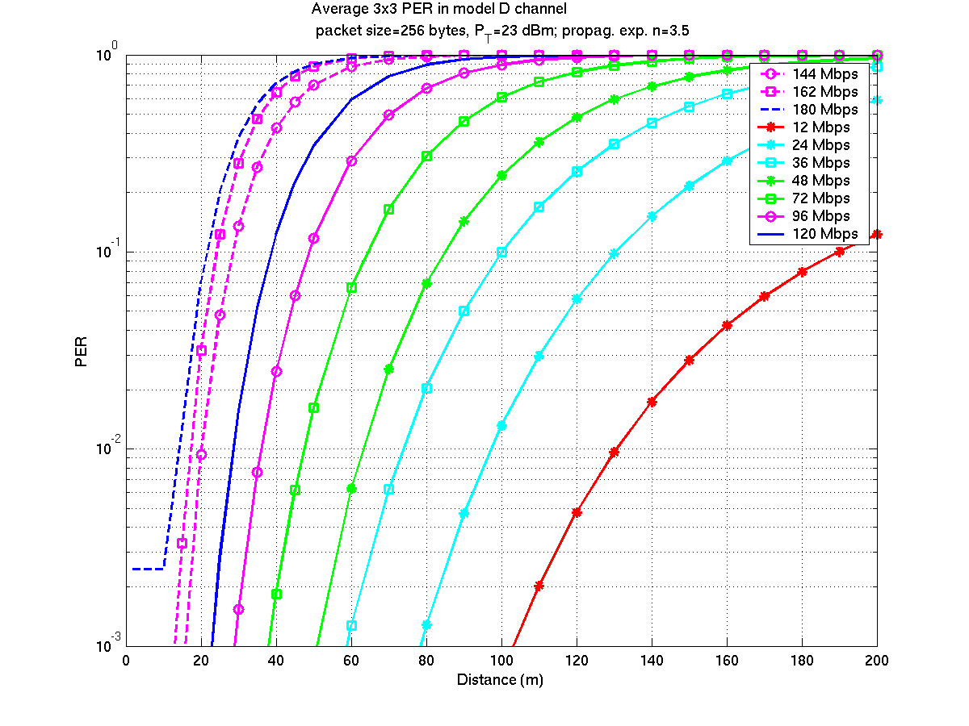  Figure 4-53 - 3x3 average PER for channel D | 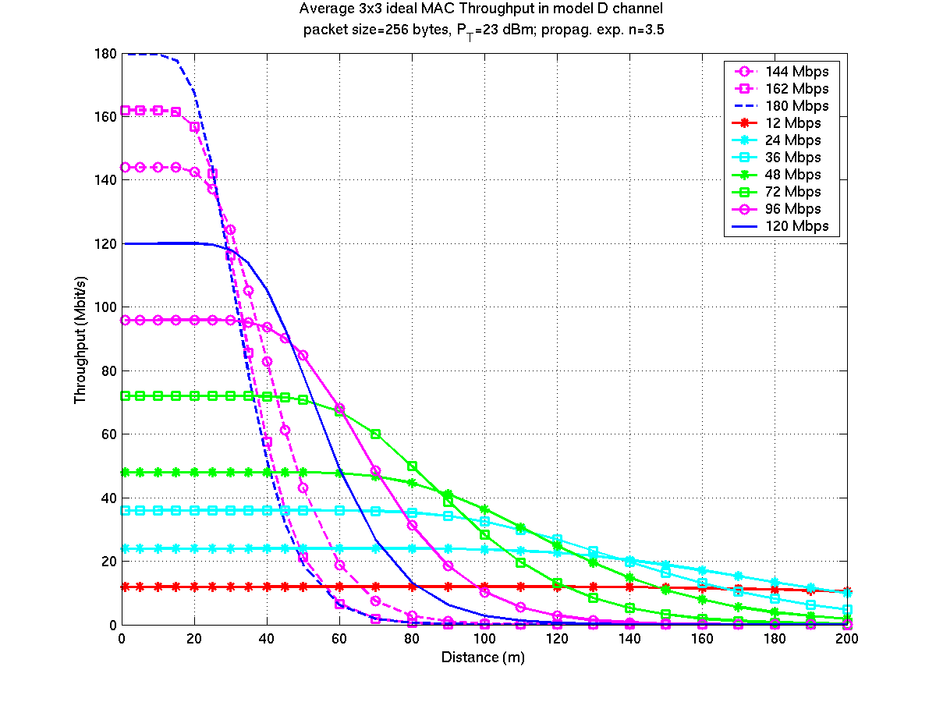  Figure 4-54 – 3x3 ideal MAC throughput for channel D
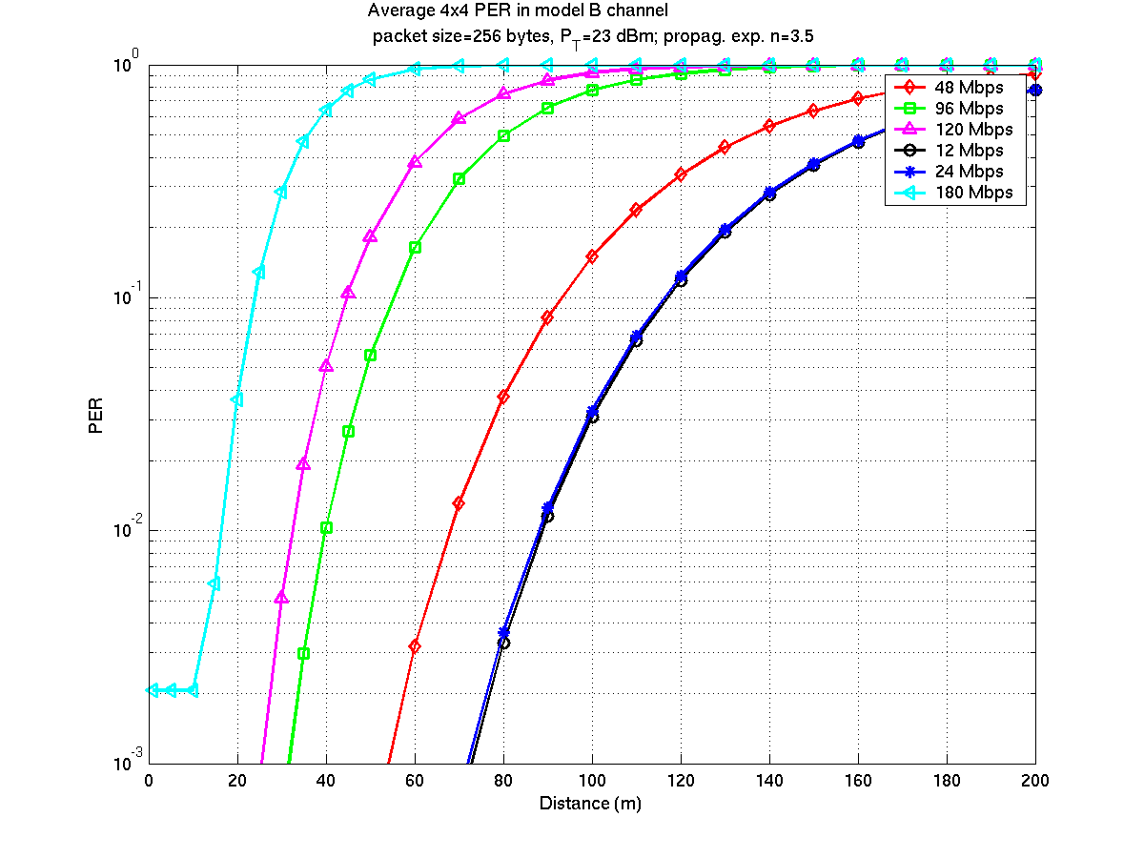  Figure 4-55 – 4x4 average PER for channel B | 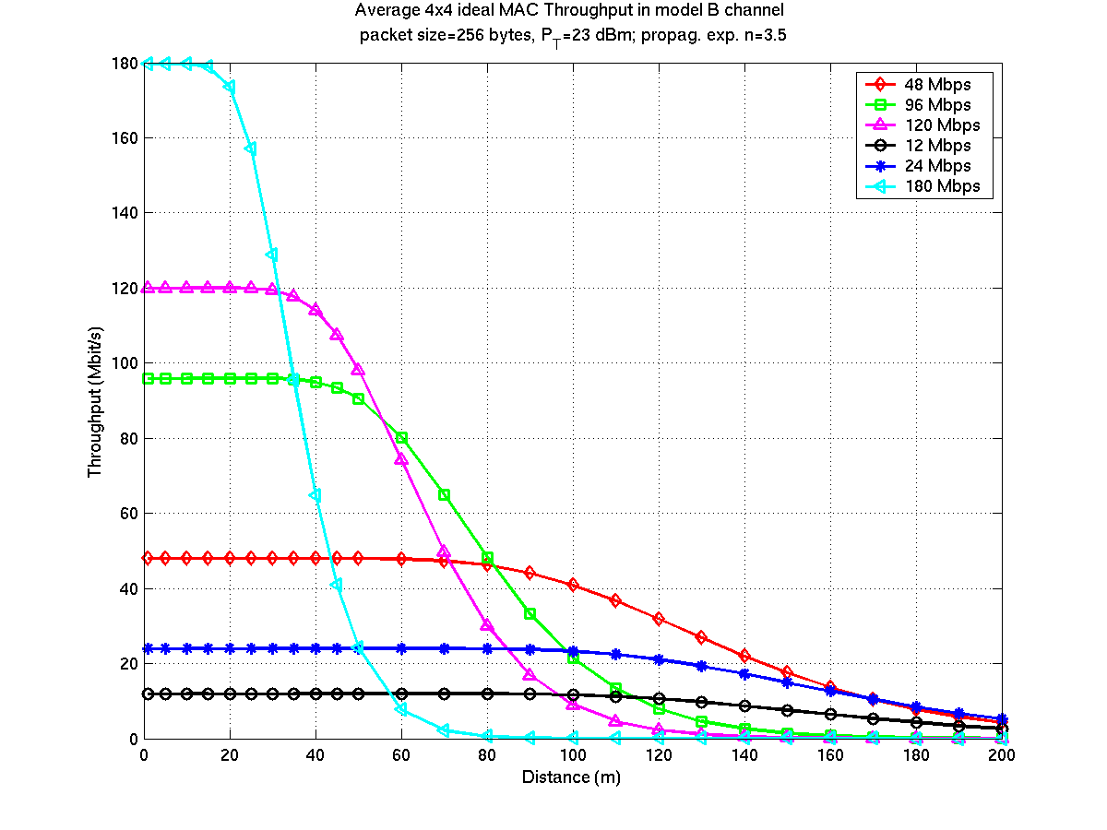  Figure 4-56 – 4x4 ideal MAC throughput for channel B
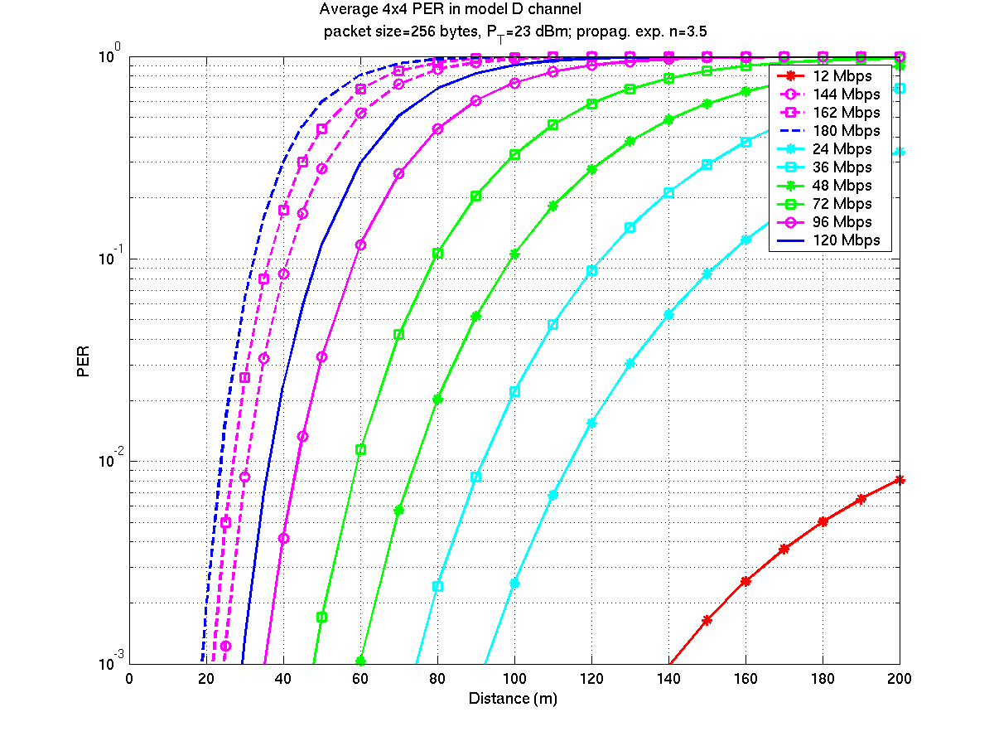  Figure 4-57 - 4x4 average PER for channel D | 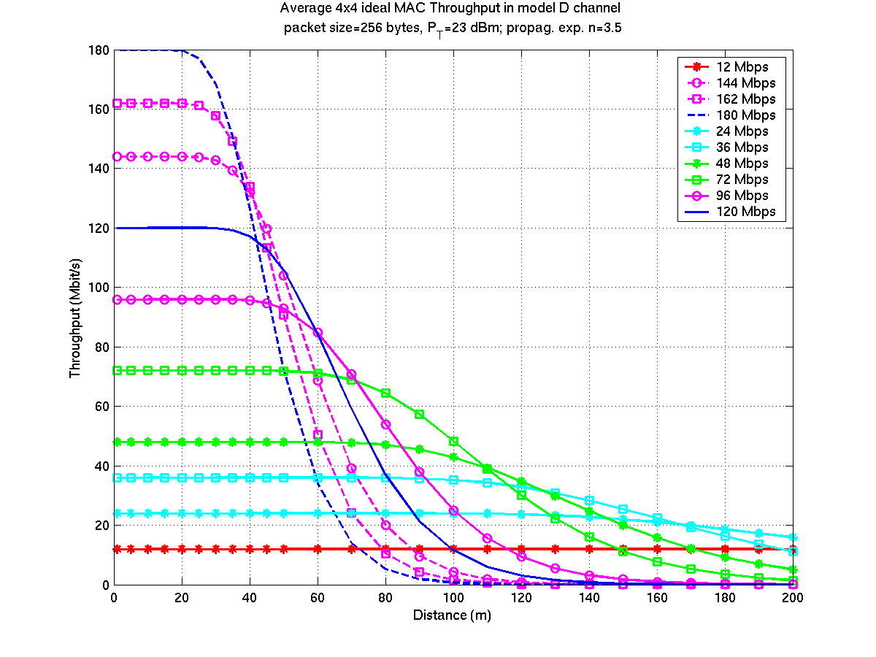  Figure 4-58 – 4x4 ideal MAC throughput for channel D

Simulation conditions and hypothesis

System simulations
The system simulations have been performed on a C/C++ simulator modelling the MAC layer and the PHY layer abstraction. It is connected to a TCP/IP stack (Reno type, window size 64K or 192K), and is fed by a flow generator on top of it.

The MAC efficiency definition given in the CC is relevant only for a 100% medium occupancy, i.e. if the aggregated throughput of all sources is greater than the system capacity. With the MAC efficiency we are able to show up, this is not achieved in original scenarios such as number 1 and 6.

Thus, we ran two sets of simulations:
- The first one, referred by scenario numbers 1 and 6, uses the minimal PHY mode that fulfils scenarios' requirements.
- In the second set, for each scenario, MIMO PHY modes are selected depending on range. We modified slightly scenarios 1 and 6 to remove the throughput limitation of "Local file transfer" sources and numbered them 1bis and 6bis. Indeed, TCP sources take all the remaining bandwidth and give a good metric of maximum system performances.

In order to assess the system behaviour against PER, we simulated scenarios 1bis, 4 and 6bis using a constant PER value for all flows and making the PER ranging from 0 to 1.5 10⁻¹. Detailed results can be found in [4] under tabs named "Scenario Ibis – PER", "Scenario 4 – PER", and "Scenario VIbis – PER" respectively. See also chapter 4.

Simulation parameters
- Unique MAC configuration: no knob activation nor parameter tuning depending on the context or scenario
- MAC, EC and segmentation overhead fully taken into account
- Dynamic resource allocation based on requests from STA
- Simple Round Robin scheduler (per priority level), 2 priority classes
- No contention period, 2 ms long MTF
- PHY burst limited to 1ms
- 2, 4 or 6 CTIs per MTF according to scenarios
- PHY modes considered for control frames:
- Beacon BPSK SISO (6 Mbit/s)
- PGPM and CTI broadcast in QPSK1/2 2x2 1 spatial streams (12 Mbit/s)
- Other control frames: 3x3 16QAM1/2 2 spatial streams (48 Mbit/s) or 2x2 16QAM1/2 1 spatial stream (24 Mbit/s)
- Simulated time: 3 to 20 min.

PHY abstraction
The PHY abstraction (link adaptation, error model and impairments) have been modelled as follows.

- Link adaptation:
The simulations are processed with an elementary and static link adaptation model, which selects the PHY mode with respect to the average SNR at the receiver from results presented in 4.6.1.1. This is a simple model, parameterised with very conservative hypothesis. The corresponding average PER is reported in detailed simulation results.
For scenario 1 and 6, PHY modes more robust than required have been statically selected, so that the system is fully loaded with traffic defined in the legacy IEEE usage mode. A resulting PER target of 10⁻² is considered in this case.
Whatever the scenario is, for a given data flow, the same PHY rate is applied on the entire simulation duration (i.e. dynamic rate adaptation is not simulated).

- Error model:
- Error distribution: The simulator uses a uniformly distributed error model. The accuracy of such model might differ depending on the considered PHY as the error behaviour depends on several factors such as link adaptation, channel characteristics and PHY design, but it must be noted that this error model is the most stressful for the MAC. Indeed, the performances we disclose correspond to a minimum bound.
- PER value: All PER values applies to short packets (134 bytes or less).

Disclosure for Physical Layer Impairments

Number | Name | Disclosure
IM 1 | PA Non-linearity | - EIRP was +17 dBm. Equal power was transmitted by all antennas in each configuration. Each antenna was assumed to have a gain of 0 dB.  - Except as noted we assumed each TX path had an amplifier with Psat = +25 dBm. Total power was +17 dBm. Thus the backoff is 11 dB for 2 TX antennas, 12.8 dB for 3 TX antennas, and 14 dB for 4 TX antennas  - Psat = +25 dBm
IM 2 | Carrier Frequency Offset | -13.675 ppm as specified.
IM 4 | Phase Noise | As specified in the Comparison Criteria.
IM 5 | Noise Figure | A 10 dB noise figure was included in all MAC level simulations. This IM is not relevant for the PHY simulation results, since these are plotted as a function of SNR.
IM 6 | Antenna Configuration | As specified in the Comparison Criteria.

Rationales & Objectives
Applications that are targeted in TGn's PAR include, in addition to typical data-oriented ones, high QoS demanding services like audio/video streaming, high definition video, or VoIP. Moreover, the CFP requires an aggregate throughput of 100 Mbit/s measured at top of the MAC Service Access Point, obtained in a 20 MHz radio bandwidth. These constraints clearly imply the definition of a new physical layer, but include also the MAC in the enhancement loop. We present hereafter the rational and the objectives we had in mind when designing 802.11 MAC's improvements to make it able to cope efficiently with such a mix of traffic flows with a highly variable QoS requirements.

Need for a new access scheme
While EDCA can hardly be used for STAs with QoS constraints (VoIP & multimedia terminals for example) due to the absence of guaranty on the medium access delay and to the high probability of collision in scenarios with an important number of STAs, HCCA can be foreseen as a solution for QoS Support. Its central controller allocating TxOP in a contention free manner via a polling scheme is expected to ensure bound medium access delay.
However HCCA scheme suffers from severe weaknesses. Its polling can be based either on timers or on instant resource needs.
A polling scheme based on timers faces several challenges since it has to deal with traffics that are generally VBR (pure CBR flows are very rare, even voice traffic is not because of the Operating System and network jitters). The non-synchronism between packet arrival and resources allocation leads to delay and resource waste. Finally the Resource Manager needs to know the traffic profile of each flow. This information is usually unknown by the application itself, and even in case it has this knowledge, there is anyway no standard mean to transmit it to the RM.

- Getting traffic profiles is difficult and can be implemented only for very specific applications. Timer based polling is not efficient

Alternately a STA can indicate its resource needs during polling via piggybacking (QoS Control)
However such a mechanism does not work properly for VBR applications and for medium bandwidth demanding applications, i.e. up to a few Mbit/s in case of TGn. Indeed, the source queue may be emptied in one shot and then there is no more traffic to request resource for at piggy backing time. Moreover, due to MPDU overhead and to the station-by-station polling protocol itself, this access scheme is not efficient when flow number increases and can't be used for elastic streams.

- HCCA piggybacking is not efficient for low bit rate or bursty applications

To be efficient, resource shall be allocated by a centralised controller from indications sent by STAs via short Resource Requests signaling messages. There is then no resource wasting and the system can adapt quickly to flow variations. Resource Requests messages shall be sent either via in-band signaling or via a dedicated contention period to provide short allocation latency at low signaling cost. Such a mechanism can deal efficiently with any type of traffic, from the most stringent one like VoIP to the most elastic one like TCP.

- HCF does not provide such a mechanism

Requirements for a CE compatible WLAN

Application requirements

- Throughput constraints
There are an infinite number of possible applications in a WLAN and it is quite hard to define exactly the required throughput for each of them. Some applications such as video streaming may require very high throughput up to 25Mbit/s without strong delay constraint (the “usual” zapper can tolerate delays below few hundred ms) while some others will require low bit rates with stringent delay constraints (video conferencing, voice over IP). At last, some classes of applications are able to adapt their data rate according to the network state (TCP, some video codecs). Link and PHY layer shall be able to adapt efficiently to this applications diversity. Moreover, the data rate produced by most of the applications is far from constant and the range of required throughputs is very wide. For instance, a MPEG/2 video stream encoded at a mean data rate of 8 Mbit/s may include peaks above 15 Mbit/s, and still periods below 6 Mbit/s, depending on the scenes and on the encoder. This characteristic of WLAN applications implies a WLAN system able to cope with high throughput range, bursty traffic, while being able to guaranty low transmission delay.

- Error rate
Numerous applications do not support errors. This is the case for traffic output from most of video coders, like MPEG2, but it is true also TCP traffic. Indeed, TCP considers any packet loss as a congestion indication, and automatically reduces its window size, leading to a strong decrease of throughput. Thus, it is mandatory to have methods able to provide an error-free data stream.
These methods can be based either on ARQ, or on Link Adaptation, or, more probably, based on both. Anyway, the consequence is a variable consumption of PHY resources among time in all cases. Thus, from the MAC perspective, which goal is to manage PHY resources, CBR flows do not exist.

- Latency
A low latency (small delay transmission) shall be guarantied for “real-time” applications (voice, video conferencing). Even video streaming has delay constraints, around a few hundreds of ms, to allow a quick control and a smooth zapping. As the WLAN is likely to be only a part of the crossed network, the delay constraint applied to the WLAN Link Layer is stronger than the final maximum delay the application can support.
This constraint has an impact on the resource allocation (MAC) and the EC mechanisms (ARQ). A maximum latency of a few ms is tolerable.

Environment requirements

- BSS load
Unlike cellular networks, the load of a BSS may stay at a very high level during long periods of time. Therefore, some efficient MAC and EC protocols are required to optimise the PHY resource usage and to maximise the throughput at application level. The overhead produced by each layer (EC, MAC, and PHY) shall be severely limited as they correspond to a waste of the available PHY data rate. PHY overhead is particularly significant for low bit rate applications and for MAC/EC signalling flows, as the amount of time taken by symbols required for time synchronisation and channel estimation processing take up a fixed time period whatever the payload is.

- Home environment
In the home environment, both terminals associated in a cell may need to communicate (for instance, DVD/camcorder with TV). For applications with high data rate, the most efficient way to perform that operation is to open a direct communication between both terminals. Thus the access scheme shall offer efficient direct mode communications.

- Hot spot environment
Hotspots cells are characterised by a potentially great number of low bit rate data flows (essentially generated by low bit rate applications), mixed with an also potentially great number of high bit rate data flows. As mentioned before, low bit rate flows introduce heavy PHY overhead in OFDM systems and creates a real problem when their number becomes important.. Moreover, the system shall be able to cope with this big mix traffic with different profiles and different requirements.

MAC features

- Dynamic, fast and accurate resource allocation
A fast and dynamic allocation shall be performed in Down Link and Up Link.
Fast allocation shall ensure a low latency especially when ARQ is used (fast retransmission) or when adaptive transmission (fast PHY modes change) is applied. Applications can support a minimum latency of a few milliseconds, which allows using a MAC based on a frame of several milliseconds. Such a MAC frame will allow using a fast ARQ mechanism even for real-time services with strong delay constraint.

Dynamic and accurate allocation shall be performed according to the needs of each terminal, on a per-service basis.. Due to the variable data rate of application sources and to the EC mechanism, the amount of required PHY resource is variable. These variations may be weak (0→10%) or more important, up to 100%. Furthermore, some flows such as MAC/EC signalling need few sporadic resources.

MAC and PHY layers shall be able to adapt dynamically (based on a few ms frame) with a fine accuracy in order to save PHY resource.

Resources shall be shared between all the terminals of the cell: unused resource shall be re-allocated to terminals that can use it. For instance, some terminals may not use all the PHY resource that has been reserved when the service has been opened. Then, the remaining unused bandwidth can be freely re-allocated to terminals that can use it (TCP applications).

- Support of Error Control mechanisms
EC mechanisms such as ARQ require signalling resource in the reverse direction. At MAC level, terminals need also to indicate to the Resource Manager their resource needs for uplink user traffic and to report the radio downlink quality. These signalling flows are low bit-rate with quite strong delay constraint. For terminals that have user traffic in both directions, the resource for signalling may be aggregated to the traffic (piggy-backing). However, for unidirectional applications, these flows have the same profile as delay constrained low bit rate services

- Support of Link Adaptation
A link adaptation mechanism brings a rough, medium long-term, adaptation of the PHY to the channel while the ARQ can be considered as a fast, fine tuning link adaptation used on top of the long term one. Thus both mechanisms are complementary and shall be used in conjunction.

- Support of direct transmission between
PHY and MAC shall support this feature to avoid an expensive relay procedure, especially for high data rate flows. Similarly to DL and UL cases, the amount of resources that must be transmitted is variable along the time. The resource allocation shall be performed dynamically with a fine accuracy, which involves again a dynamic repartition between DL, UL and direct transmission.

- Power consumption
MAC mechanisms that are based on the usage of a TDM frame with resource announcements offer more possibilities to reduce the power consumption. Indeed, a station has not to stay awake all the time and to listen and decode all packets present on the medium. It knows at each time-frame when it has traffic to receive, and when it will be able to transmit. Then the station may switch off several parts of its hardware.
Since the access scheme has no collision, the probability to have to retransmit a packet is lower, due only to errors in the channel. The average power consumption is then reduced compared to access schemes with collisions.
Moreover, the centralised resource allocation mechanism and the resource announcement make low-power consumption modes available for stations communicating in direct mode without the need of specific signalling.

- PHY efficiency
With a MIMO-based PHY layer, preambles for time synchronisation and channel estimation are necessary equal or longer then the one used for SISO modes. With the increase of PHY data rate, preamble time can become a preponderant part of transmission time. So can become all fixed dead times like guard times and radio turn-around times. It is a necessity to severely minimise their impact.
A first mean to overcome these issues is to aggregate data packets at PHY level, while keeping data units handled by the MAC short. Thus, PHY burst length can be maximised, Packet Error Rate minimised, and retransmissions cost maintained low.
An additional response is given by the centralised resource control scheme with resource announcement, where the Resource Manager is able to allocate resources in a way to minimise all these dead times.

Some conclusions

The design of our new access scheme for the MAC was driven by the following goals: Offering an effective QoS to various types of applications, in different types of environments, and relaxing the pressure on the PHY layer by improving MAC efficiency, while dealing with backward compatibility issues with legacy 802.11 MAC. Another objective was to achieve these goals with a low complexity, easily implementable solution.

QoS support
The most efficient way for QoS delivery and optimisation of resource usage in a wireless LAN is obtained with a fast, dynamic (≈ms) and accurate resource allocation obtained by using a MAC time frame, a centralised allocation process and a resource request / grant scheme to perform allocation in uplink. Indeed, the system is able to adapt to the application needs in the time. Inside a MAC frame, the available PHY resources are shared among the different services in order to respect the QoS constraints attached to each of them.

Compatibility
A full compatibility with legacy 802.11 systems is ensured by including the enhanced MAC access scheme inside the legacy superframe (use of the CFP or alternatively the CAP as defined in 802.11e).

Efficient resource usage
To provide a robust support of emerging applications, 802.11n systems must have the capacity to sustain high load, this even in bad channel conditions. Aggregation at PHY level (several MPDUs in a single PPDU) coupled with short MAC-PDUs and an optimised fast selective repeat ARQ using low cost signalling allows a much better MAC efficiency while ensuring robustness.

Versatility
Thanks to a MAC access scheme based on an accurate centralised on-demand allocation scheme, the AP knows precisely the current resource needs of the STAs, which can then be fulfilled with a single scheduler without relying on any context dependent knob or tuning. It allows an easy deployment of 11n systems with a high level of QoS whatever the context is, in particular for home environment where the end user doesn’t necessarily have system administrator abilities.

Flexibility
Beyond CBR traffic (if any), this access scheme is able to handle all kind of bursty and elastic traffic flows. Its fast and flexible resource request and access grant mechanisms have been especially designed to support bursty and elastic traffics in a very efficient way.

Easy Implementation
An accurate centralised on-demand allocation scheme strongly relaxes the pressure on the scheduler, which can then be very simple (we use round robin per priority). This, coupled with the fixed size MAC time frame lead to an easy implementation.
Furthermore, a MAC based on the usage of a fixed duration frame is profitable to implement advanced MAC power saving schemes and more efficient PHY synchronisation algorithms since each receiver knows when it shall receive data.

Technical overview

MAC technical overview

Presentation
An overview of the extended MAC stack we have defined, named ECCF (Extended Centralised Coordination Function) is described in Figure 7-59.

Figure 7-59: Extended MAC structure
The MAC SAP is kept identical to the one defined by legacy 802.11 while the PHY SAP may be modified according to the capabilities of the PHY layer. The MAC layer is constituted of two convergence sub-layers, LLC Convergence Sub-Layer (LLCCS) and Segmentation and Re-assembly (SAR), and two transfer sub-layers, MAC Intermediate Sub-Layer (MIS) and MAC Lower Sub-layer (MLS).
The LLCCS sub-layer maintains the MAC SAP consistency. The MIS embeds the core transfer function of the MAC layer and is based on short fixed-size transfer units. The MIS also integrates the Error and Flow Control functions. The SAR sub-layer performs the adaptation between the variable size packet provided by the LLCCS and the transfer units managed by the MIS. The MLS sub-layer is in charge of building 802.11 compatible MPDUs from MIS transfer unit and signalling information, and delivers them to the PHY layer. In addition, it can implement the encryption support functions.
Backward compatibility is an important issue since the number of already installed devices is now tremendous. Nevertheless, this important issue shall not undermine the effort deployed to enhance the MAC; otherwise new requirements are likely to be impossible to be satisfied. Moreover, each time the legacy functions are modified, it raises a possible backward compatibility issue even if designed carefully. Thus we have preferred to keep the legacy MAC as is, assuring a full backward compatibility, and to add a dedicated function able to cope with new requirements.

This stack conveys a MAC architecture based on:
- Fixed MAC time frame (MTF)
- Connection-less
- Centralised resource management
Short and fixed size MAC data transfer units
- Low latency Error Correction (Selective Repeat ARQ)
- Aggregation at PHY level

Frame structure
The ECCF mode (see Figure 7-60) can operate concurrently with HCCA and EDCA schemes within the same cell. The legacy MAC super frame is kept. The super frame started with a beacon compatible with legacy MAC that includes additional parameters relative to the new access scheme. Contention Periods (CP) and Contention Free Periods (CFP) alternate in time and room is introduced in the latter for the new access method. A Radio Resource Manager (RRM) is responsible to determine the duration of each period according to various traffic considerations.
The ECCF implements a contention-free access method based on short TDMA/TDD of fixed duration, called MAC Time Frame (MTF). Each CFP may include any number of them, selected by the RRM.
Figure 7-60: Frame structure

Alternatively (Figure 7-61), ECCF can be inserted into a CAP generated by the HC using mechanisms defined in the 802.11e extension. The RRM reserves a CAP by contending for the medium with its high priority and then by sending a CF-Poll data frame for itself. CAP is split by the RRM into successive MTFs of fixed duration, each being described by a PGPM broadcast at the beginning of the MTF.
.

Figure 7-61: Alternative frame structure

MTF description
Resource scheduling is performed on a per MTF basis. Time Intervals (TI) of variable duration are dynamically allocated to stations. These allocations are broadcast by the RRM at the beginning of each MTF in the so-called Periodic Grouped Polling (PGPM) structure (see Figure 7-62). For each TI, the RRM indicates the station the slot is granted to for transmission, and the list of stations that are a traffic destination.
Figure 7-62: MAC Time Frame structure

MPDU
Each Time Interval, including TI number #0, is constituted of one variable length MAC PDU. This is the data unit that is exchanged between MAC and PHY layers, as in legacy 802.11.
A MPDU is composed of a header, a signalling part dedicated to in-band signalling and an optional data part all of them being of variable length. The header describes the MPDU's content, the signalling part is the place for resource requests, error control signalling and data block descriptors. A dedicated check sequence protects header and signalling trunks, two crucial pieces. The data part may aggregate all data blocks sent by a station.

MPDU overhead reduction
Still in the process of reducing overheads, a new format has been defined for MPDUs (Figure 7-63). The header is shortened down to two octets, the first one assuring a compatibility with legacy 802.11 MAC-PDU frame. This enhancement requires a new protocol version identifier, inserted in the Protocol Version field of this first octet.

Figure 7-63: MPDU general structure

Aggregation at PHY level
In Legacy IEEE 802.11 MAC, a substantial amount of time is taken by PHY preambles for channel estimation. This amount is going to rise with the coming of more sophisticated PHY like MIMO which requests more precise channel estimation. Moreover, the cost in time of these preambles compared to the time spent in data transmission becomes overwhelming when considering very high performance PHY layers. Consequently, lengthening PHY bursts is a necessity.
In our architecture, each MPDU is the data unit exchanged with the PHY and corresponds to one PHY burst. When present, its data part (Figure 7-64) is composed of one or several data blocks, each of them described in the header by a Data Part Descriptor (DPD). Each data block includes aggregated data packets intended for a single destination station.
The ability to aggregate packets from one originator to one or several destination nodes allows having long PHY bursts, thus limiting PHY overhead. Nevertheless, the MPDU structure lets the possibility to use a separate PHY mode for each individual data block.
Figure 7-64: MPDU structure example with data blocks transmitted to 2 stations

Segmentation and Reassembly
A common way of lengthening PHY burst is to aggregate traffic at MAC SAP. This approach has several severe drawbacks. Packet Error Rate increases quickly with packet length, leading to poor performances in realistic conditions, while at the same time repeating long packets costs considerable bandwidth waste. We took another approach by designing a segmentation and reassembly mechanism at MAC level. MAC handles small or medium size packets, which help keeping the PER low when radio condition worsened and allows the definition of a fast and resource-thrifty ARQ mechanism to recover from remaining errors let by the PHY layer. The system is then more robust against errors, more efficient in terms of bandwidth and delay.
Figure 7-65 gives an overview of the Segmentation and Re-assembly (SAR) sub-layer introduced to perform adaptation between LLC and MAC. It allows adapting the variable packets coming from / to LLC interface to fixed size elements that are the data unit the error control deal with. To limit overhead inherent to padding, several different sizes, two for example, are defined.
A short header is added to each segment to hold signalling relative to segmentation. It is composed of a sequence number, numbering SAR-SDUs and a segment sequence number. Each segment is postfixed with an individual check sequence.
Figure 7-65: Segmentation And Reassembly (SAR) sub-layer

MAC Time Frame structure example
Figure 7-66 gives an example of a MTF with four stations. Resource manager has allocated a TI to Station #1 for data transmission to stations #2 and #3, and another to station #3 which wants to transmit to station #4. The Radio Resource Manager listens to all the traffic. CTA and CTB portions correspond to contention based access.
Station #1 transmits its data in one MPDU. Station #4 transmits signalling only, a Resource Request sent to the RRM and an ARQ feedback to station #3. For the sake of simplicity, the example below shows stations transmitting either data or signalling. Nevertheless, in band signalling is always possible.

Figure 7-66: MTF structure example

Resource management and flow differentiation
PHY resources are allocated with a contention-free, centralised scheme, under the responsibility of the Radio Resource Manager. Each station shall request resource to the RRM before any transmission via a Resource Request message sent in the signalling part of MPDUs (in-band signalling).
A contention access procedure is used for initial requests. It is based on a slotted aloha procedure. The RRM acknowledges the contention accesses in the next emitted PGPM.
The RRM doesn't need to manage connections: PHY resources are allocated per station, per priority. Each station schedules its own flows within each Time Interval that was granted to it.

PHY technical overview

Introduction
This document presents modifications to the physical layer specification IEEE 802.11a-1999. The main modifications are i) a multiple antenna extension, ii) new preamble designs and iii) a second OFDM modulation. The channel bandwidth considered at this stage is limited to the current 20MHz bandwidth for the mandatory modes; a 40MHz bandwidth mode is optional relying on a 128-point-FFT. In order to allow a larger peak data rate QAM256 constellation support is considered.

In order to achieve higher data rates than IEEE802.11a, this proposal uses multiple antennas, enabling the transmission of 1, 2 or 3 parallel spatial streams, depending on the transceiver configuration and capabilities (number of transmit and receive antennas at the AP and STA).
In this proposal, it is mandatory that the transmitter has a minimum of 2 antennas scaling up for the optional modes to 4 antennas, and the receiver has a minimum of two antennas (possibly more). An important feature of this proposal is that the multiple antenna transmit schemes recommended are designed for supporting asymmetric antenna configurations between the transmitter and receiver in order to accommodate various classes of devices (possibly discriminated by complexity/size/power consumption criteria) such as access point, laptop, PDA, phone in order to cope with various constraints possibly limiting the number of antenna supported. For that purpose, several schemes are detailed combining Spatial Division Multiplexing (SDM) and Space Time Block Coding (STBC). The emphasis is given on simple (e.g. limited arithmetical complexity) open loop modulation techniques that target either an increase of peak data rate (SDM) or enhancement of the robustness of the link (STBC) or a mix of the two using a hybrid approach. In that way, this proposal achieves four major goals:
- provide new OFDM PHY modes for delivering higher data rates
- improve also support of lower data rate modes for enhancing range or link quality of IEEE802.11a modes but also supporting services requiring small packet size such as VoIP
- allow short term implementation and deployment for mandatory modes
- focus on open loop solution to avoid protocol overhead consumed in feedback signalization

A second OFDM modulation is introduced as an option in order to further increase the achievable data rates; the main characteristics of this second OFDM modulation are 128 subcarriers in a 20MHz bandwidth (corresponding to a subcarrier frequency spacing of 156,25kHz) with 104 data subcarriers (and 8 pilot subcarriers for a total number of used subcarriers of 112). An optional 40MHz bandwidth mode with a corresponding number of data-sub-carriers and a corresponding FFT size is defined.
For the 20MHz bandwidth mode with 128 subcarriers, the duration of the guard time is also doubled (1.6μs) enabling to absorb larger multipath delays to cope both with long channels common in large environments (open space, limited outdoor) and also to better account for the transmit and receive filters inherently present in the WLAN devices. Note that for 20MHz channel, since the number of useful carriers is more than doubled and the guard time duration doubled, this enables an enhancement of the total PHY rate of 8% compared to 64 carrier modes.
With 48 data subcarriers, the minimum and maximum data rates achievable are 6Mbps (BPSK constellations) and 216Mbps (256QAM constellations) respectively. With 104 data subcarriers, the minimum and maximum data rates achievable are 6.5Mbps (BPSK constellations) and 234Mbps (256QAM constellations) respectively in the 20MHz bandwidth mode and 13Mbps (BPSK constellations) and 468Mbps (256QAM constellations) respectively in the 40MHz bandwidth mode.

The same nPLCP preamble is used for both OFDM modulations: 64 and 128 subcarriers in 20MHz. This nPLCP preamble is defined in time domain for the nSTS part and in frequency domain for the nLTS part: 56 out of 64 subcarriers in 20MHz (the additional used subcarriers are introduced to handle the slight bandwidth increase obtained when considering 112 subcarriers among 124 in a 20MHz) and 112 out of 128 carriers for 40MHz. Note that the highest achievable data rate modes are obtained by exploiting the optional 256-QAM symbol constellation.

Note that other functional blocks such as scrambler, convolutional encoder and mapping are unchanged with respect to IEEE 802.11a-1999.

MIMO-OFDM nPLCP sublayer

RATE-dependent parameters

The RATE-dependent parameters for 2 transmit antennas shall be set according to Table 7-6 for 48 data subcarriers and according respectively to Table 7-7 and Table 7-8 for 104 data subcarriers using 20MHz and 40MHz bandwidths. Contellations BPSK, QPSK, 16QAM and 64QAM are mandatory, 256QAM is optional. The 104 data subcarrier modes are optional as well.
Note that:
- these modes support asymetric antenna configurations: the number of received antennas has to be greater or equal than the number of spatial streans (N_{s}) and determines the modes supported by the device
- the specific space time coding schemes used for the modes displayed are detailed section 7.2.2.3.
- optional modes are grey highlighted in the following tables.
- all the devices have to be able to decode all the modes where the number of spatial streams is lower or equal than the number of receive antennas in the device. For example a device with two receive antennas has to be able to decode all 2 transmit antenna modes as well as 3 and 4 transmit antenna modes with 2 spatial streams.
- It is required for a device to exploit all its antennas in transmission even for optional modes.

Table 7-6 - Rate-dependent parameters for 2 transmit antennas and 48 data subcarriers in 20MHz bandwidth
Data rate (Mbits/s) | Number of spatial streams (N_{S}) | Modulation | Coding rate (R) | Coded bits per subcarrier per stream (N_{BPSC}) | Coded bits per OFDM symbol (N_{CBPS}) | Data bits per OFDM symbol (N_{DBPS}) | Number of data subcarriers (N_{SD})
6Mbps | 1 | BPSK | 1/2 | 1 | 48 | 24 | 48
12Mbps | 1 | QPSK | 1/2 | 2 | 96 | 48 | 48
18Mbps | 1 | QPSK | 3/4 | 2 | 96 | 72 | 48
24Mbps | 1 | 16QAM | 1/2 | 4 | 192 | 96 | 48
36Mbps | 1 | 16QAM | 3/4 | 4 | 192 | 144 | 48
48Mbps | 1 | 64QAM | 2/3 | 6 | 288 | 192 | 48
60Mbps | 1 | 64QAM | 5/6 | 6 | 288 | 240 | 48
72Mbps | 2 | 16QAM | 3/4 | 4 | 192 | 144 | 48
96Mbps | 2 | 64QAM | 2/3 | 6 | 288 | 192 | 48
108Mbps | 2 | 64QAM | 3/4 | 6 | 288 | 216 | 48
120Mbps | 2 | 64QAM | 5/6 | 6 | 288 | 240 | 48
144Mbps | 2 | 256QAM | 3/4 | 8 | 384 | 288 | 48

Table 7-7 - Rate-dependent parameters for 2 transmit antennas and 104 data subcarriers in 20MHz bandwidth
Data rate (Mbits/s) | Number of spatial streams  (N_{S}) | Modulation | Coding rate (R) | Coded bits per subcarrier per stream (N_{BPSC}) | Coded bits per OFDM symbol (N_{CBPS}) | Data bits per OFDM symbol (N_{DBPS}) | Number of data subcarriers (N_{SD})
6.5Mbps | 1 | BPSK | ½ | 1 | 104 | 52 | 104
13Mbps | 1 | QPSK | ½ | 2 | 208 | 104 | 104
19.5Mbps | 1 | QPSK | ¾ | 2 | 208 | 156 | 104
26Mbps | 1 | 16QAM | 1/2 | 4 | 416 | 208 | 104
39Mbps | 1 | 16QAM | 3/4 | 4 | 416 | 312 | 104
52Mbps | 1 | 64QAM | 2/3 | 6 | 624 | 416 | 104
65Mbps | 1 | 64QAM | 5/6 | 6 | 624 | 520 | 104
78Mbps | 2 | 16QAM | 3/4 | 4 | 416 | 312 | 104
104Mbps | 2 | 64QAM | 2/3 | 6 | 624 | 416 | 104
117Mbps | 2 | 64QAM | 3/4 | 6 | 624 | 468 | 104
130Mbps | 2 | 64QAM | 5/6 | 6 | 624 | 520 | 104
156Mbps | 2 | 256QAM | 3/4 | 8 | 832 | 624 | 104

Table 7-8 - Rate-dependent parameters for 2 transmit antennas and 104 data subcarriers in 40MHz bandwidth
Data rate (Mbits/s) | Number of spatial streams  (N_{S}) | Modulation | Coding rate (R) | Coded bits per subcarrier per stream (N_{BPSC}) | Coded bits per OFDM symbol (N_{CBPS}) | Data bits per OFDM symbol (N_{DBPS}) | Number of data subcarriers (N_{SD})
13Mbps | 1 | BPSK | 1/2 | 1 | 104 | 52 | 104
26Mbps | 1 | QPSK | 1/2 | 2 | 208 | 104 | 104
39Mbps | 1 | QPSK | 3/4 | 2 | 208 | 156 | 104
52Mbps | 1 | 16QAM | 1/2 | 4 | 416 | 208 | 104
78Mbps | 1 | 16QAM | 3/4 | 4 | 416 | 312 | 104
104Mbps | 1 | 64QAM | 2/3 | 6 | 624 | 416 | 104
130Mbps | 1 | 64QAM | 5/6 | 6 | 624 | 520 | 104
156Mbps | 2 | 16QAM | 3/4 | 4 | 416 | 312 | 104
208Mbps | 2 | 64QAM | 2/3 | 6 | 624 | 416 | 104
234Mbps | 2 | 64QAM | 3/4 | 6 | 624 | 468 | 104
260Mbps | 2 | 64QAM | 5/6 | 6 | 624 | 520 | 104
312Mbps | 2 | 256QAM | 3/4 | 8 | 832 | 624 | 104

The RATE-dependent parameters for 3 or 4 transmit antennas shall be set according to Table 7-9 for 48 data subcarriers, Table 7-10 for 104 data subcarriers in 20MHz and Table 7-11 for 104 data subcarriers in 40MHz.

Table 7-9 - Rate-dependent parameters for 3 or 4 transmit antennas and 48 data subcarriers in 40MHz bandwidth
Data rate (Mbits/s) | Number of spatial streams  (N_{S}) | Modulation | Coding rate (R) | Coded bits per subcarrier per stream (N_{BPSC}) | Coded bits per OFDM symbol (N_{CBPS}) | Data bits per OFDM symbol (N_{DBPS}) | Number of data subcarriers (N_{SD})
12Mbps | 2 | BPSK | 1/2 | 1 | 48 | 24 | 48
24Mbps | 2 | QPSK | 1/2 | 2 | 96 | 48 | 48
36Mbps | 2 | QPSK | 3/4 | 2 | 96 | 72 | 48
48Mbps | 2 | 16QAM | 1/2 | 4 | 192 | 96 | 48
72Mbps | 2 | 16QAM | 3/4 | 4 | 192 | 144 | 48
96Mbps | 2 | 64QAM | 2/3 | 6 | 288 | 192 | 48
120Mbps | 2 | 64QAM | 5/6 | 6 | 288 | 240 | 48
144Mbps | 3 | 64QAM | 2/3 | 6 | 288 | 192 | 48
162Mbps | 3 | 64QAM | 3/4 | 6 | 288 | 216 | 48
180Mbps | 3 | 64QAM | 5/6 | 6 | 288 | 240 | 48
216Mbps | 3 | 256QAM | 3/4 | 8 | 384 | 288 | 48

Table 7-10 - Rate-dependent parameters for 3 or 4 transmit antennas and 104 data subcarriers in 20MHz bandwidth
Data rate (Mbits/s) | Number of spatial streams  (N_{S}) | Modulation | Coding rate (R) | Coded bits per subcarrier per stream (N_{BPSC}) | Coded bits per OFDM symbol (N_{CBPS}) | Data bits per OFDM symbol (N_{DBPS}) | Number of data subcarriers (N_{SD})
13Mbps | 2 | BPSK | 1/2 | 1 | 104 | 52 | 104
26Mbps | 2 | QPSK | 1/2 | 2 | 208 | 104 | 104
39Mbps | 2 | QPSK | 3/4 | 2 | 208 | 156 | 104
52Mbps | 2 | 16QAM | 1/2 | 4 | 416 | 208 | 104
78Mbps | 2 | 16QAM | 3/4 | 4 | 416 | 312 | 104
104Mbps | 2 | 64QAM | 2/3 | 6 | 624 | 416 | 104
130Mbps | 2 | 64QAM | 5/6 | 6 | 624 | 520 | 104
156Mbps | 3 | 64QAM | 2/3 | 6 | 624 | 416 | 104
175.5Mbps | 3 | 64QAM | 3/4 | 6 | 624 | 468 | 104
195Mbps | 3 | 64QAM | 5/6 | 6 | 624 | 520 | 104
234Mbps | 3 | 256QAM | 3/4 | 8 | 832 | 624 | 104

Table 7-11 - Rate-dependent parameters for 3 or 4 transmit antennas and 104 data subcarriers in 40MHz bandwidth
Data rate (Mbits/s) | Number of spatial streams  (N_{S}) | Modulation | Coding rate (R) | Coded bits per subcarrier per stream (N_{BPSC}) | Coded bits per OFDM symbol (N_{CBPS}) | Data bits per OFDM symbol (N_{DBPS}) | Number of data subcarriers (N_{SD})
26Mbps | 2 | BPSK | 1/2 | 1 | 104 | 52 | 104
52Mbps | 2 | QPSK | 1/2 | 2 | 208 | 104 | 104
78Mbps | 2 | QPSK | 3/4 | 2 | 208 | 156 | 104
104Mbps | 2 | 16QAM | 1/2 | 4 | 416 | 208 | 104
156Mbps | 2 | 16QAM | 3/4 | 4 | 416 | 312 | 104
208Mbps | 2 | 64QAM | 2/3 | 6 | 624 | 416 | 104
260Mbps | 2 | 64QAM | 5/6 | 6 | 624 | 520 | 104
312Mbps | 3 | 64QAM | 2/3 | 6 | 624 | 416 | 104
351Mbps | 3 | 64QAM | 3/4 | 6 | 624 | 468 | 104
390Mbps | 3 | 64QAM | 5/6 | 6 | 624 | 520 | 104
468Mbps | 3 | 256QAM | 3/4 | 8 | 832 | 624 | 104

Note that the data rates given in Table 7-6 through Table 7-11 are the largest integer values not exceeding the exact data rates.

Timing related parameters
Table 7-12, Table 7-13 and Table 7-14 are the lists of timing parameters associated with the OFDM modulations covering the two bandwidths of interest: 20MHz and 40MHz.

Table 7-12 - Timing-related parameters for 48 data subcarriers in 20MHz bandwidth
Parameter | Value
N_{SD}: Number of data subcarriers | 48
N_{SP}: Number of pilot subcarriers | 4
N_{ST}: Number of subcarriers, total | 52 (N_{SD}+N_{SP})
Δ_{F}: Subcarrier frequency spacing | 0.3125MHz (=20MHz/64)
T_{FFT}: IFFT/FFT period | 3.2μs (1/Δ_{F})
T_{GI}: GI duration | 0.8μs
T_{SYM}: Symbol interval | 4μs (T_{GI} +T_{FFT})

Table 7-13 - Timing-related parameters for 104 data subcarriers in 20MHz bandwidth
Parameter | Value
N_{SD}: Number of data subcarriers | 104
N_{SP}: Number of pilot subcarriers | 8
N_{ST}: Number of subcarriers, total | 112 (N_{SD}+N_{SP})
Δ_{F}: Subcarrier frequency spacing | 0.15625MHz (=20MHz/128)
T_{FFT}: IFFT/FFT period | 6.4μs (1/Δ_{F})
T_{GI}: GI duration | 1.6μs
T_{SYM}: Symbol interval | 8.0μs (T_{GI} +T_{FFT})

Table 7-14 - Timing-related parameters for 104 data subcarriers in 40MHz bandwidth
Parameter | Value
N_{SD}: Number of data subcarriers | 104
N_{SP}: Number of pilot subcarriers | 8
N_{ST}: Number of subcarriers, total | 112 (N_{SD}+N_{SP})
Δ_{F}: Subcarrier frequency spacing | 0.3125MHz (=40MHz/128)
T_{FFT}: IFFT/FFT period | 3.2μs (1/Δ_{F})
T_{GI}: GI duration | 0.8μs
T_{SYM}: Symbol interval | 4.0μs (T_{GI} +T_{FFT})

Table 7-15 details the timing parameters associated with the 20MHz bandwidth preamble, for 2, 3 and 4 transmit antennas.

Table 7-15 - Timing-related parameters for 104 data subcarriers in 40MHz bandwidth
Parameter | Value
N_{ST}: Number of subcarriers, total | 56
Δ_{F}: Subcarrier frequency spacing | 0.3125MHz (=20MHz/64)
T_{FFT}: IFFT/FFT period | 3.2μs (1/Δ_{F})
T_{PREAMBLE}: nPLCP preamble duration | 24μs (T_{SHORT}+2×T_{LONG})
T_{GI2}: Training symbol GI duration | 1.6μs (T_{FFT}/2)
T_{SYM}: Symbol interval | 4μs (T_{GI} +T_{FFT})
T_{SHORT}: nSTS short training sequence duration | 8μs (10×T_{FFT}/4)
T_{LONG}: nLTS long training sequence duration | 8μs (T_{GI2}+2×T_{FFT})
Note that the same preamble is used for both OFDM modulations considered, i.e. with 64 and 128 subcarriers in 20MHz bandwidth. Note also that the preamble is defined with the T_{FFT} corresponding to 64 subcarriers in 20MHz, and uses 56 subcarriers in order to have the same signal bandwidth as with 112 subcarriers among 128 in 20MHz.
In the case of 40MHz bandwidth modes, a new preamble needs to be defined.

Space-Time Coding (STC)
The multiple antenna schemes that will be used to transmit the symbols from 2, 3 or 4 antennas rely on Spatial Division Multiplexing (SDM) or on Space-Time Block Coding (STBC). Each multiple antenna scheme is characterized by N_{S}, the number of spatial streams transmitted in parallel, and by N_{SPTB}, the number of symbols per multiple antenna transmit block. The number of receive antennas determines the maximum number of spatial streams that can be transmitted.
Recall that:
- all the devices have to be able to decode all the modes where the number of spatial streams is lower or equal than the number of receive antennas in the device. For example a device with two receive antennas has to be able to decode all 2 transmit antenna modes as well as 3 and 4 transmit antenna modes with 2 spatial streams.
- It is required for a device to exploit all its antennas in transmission even for optional modes.

Table 7-16 - Parameters of the multiple antenna transmit schemes
Number of transmit antennas (NTX) | Multiple antenna scheme | Number of spatial streams (NS) | Number of symbols per transmit block (NSPTB)
2 | STBC | 1 | 2
2 | SDM | 2 | 2
3 | STBC | 2 | 4
3 | SDM | 3 | 3
4 | STBC | 2 | 4
4 | STBC | 3 | 6

The space-time block codes are illustrated in Figure 7-67, Figure 7-68, Figure 7-69 and Figure 7-70. These space-time block codes are applied on each data subcarrier. On these figures, the right column is first transmitted on the channel, and then the left column is transmitted.

Figure 7-67 - Transmission of 1 spatial stream on 2 antennas
Figure 7-68 - Transmission of 2 spatial streams on 3 antennas
Figure 7-69 - Transmission of 2 spatial streams on 4 antennas

Figure 7-70 - Transmission of 3 spatial streams on 4 antennas

Annex A: Abbreviations and acronyms and definitions

AKV | Acknowledgement Vector
AP | Access Point
ARQ | Automatic Repeat reQuest
BM | Bit Map
BPSK | Binary Phase-Shift Keying
CBC | Cipher-Block Chaining
CBC-MAC | CBC Message Authentication Code.
CC | Convolutional Encoder
CCM | Counter mode with CBC-MAC
CFP | Contention Free Period
CP | Contention Period
CS | Cyclic Shift
CTI | Contention Time Interval
DC | Direct Current
DCF | Distributed Coordination Function
Dx | Data Field x
EC | Error Control
ECCF | Extended Centralised Coordination Function
EFC | Error and Flow Control
ETF | ECCF Time Frame
FFT | Fast Fourier Transform
GI | Guard Interval
IFFT | Inverse Fast Fourier Transform
LDPC | Low-Density-Parity Check Code
LLCCS | Logical Layer Control Convergence Sub-layer
LSN | LLCCS Sequence Number
LTS | Long Training Sequence
LTT | LLCCS Translation Table
MAC | Medium Access Control Layer
Mbps | Millions of bits per second
MDB | MLS Data Block
MIMO | Multiple Input Multiple Output
MIS | MAC Intermediate Sub-layer
MLS | MAC Lower Sub-layer
MPDU | MAC Packet Data Unit
MSF | MAC Super Frame
MT | Mobile Terminal
NAV | Network Allocation Vector
nDx | Data Field x, IEEE802.11n specific
nLTS | Long Training Sequence, IEEE802.11n specific
nPLCP | Physical Layer Convergence Procedure, IEEE802.11n specific
nPPDU | PLCP Protocol Data Unit, IEEE802.11n specific
nSIG | Signal Field, IEEE802.11n specific
nSTS | Short Training Sequence, IEEE802.11n specific
OFDM | Orthogonal Frequency Division Multiplexing
PDU | Protocol Data Unit
PGPM | Periodic Grouped Polling MPDU
PHY | PHYsical Layer
PLCP | Physical Layer Convergence Procedure
PPDU | PLCP Protocol Data Unit
PS-STA | Power Saving Station
QAM | Quadrature Amplitude Modulation
QoS | Quality of Service
QPSK | Quadrature Phase-Shift Keying
RLC | Radio Link Control
RRC | Radio Resource Control
RRM | Radio Resource Manager
SAR | Segmentation and Re-Assembly
SDM | Spatial Division Multiplexing
SDU | Service Data Unit
SID | Short STA Identifier
SIG | Signal Field
SSN | Segment Sequence Number
STA | Station
STBC | Space Time Block Code
STS | Short Training Sequence
TI | Time Interval
TLV | Type-Length Value
WLAN | Wireless Local Area Network

Definitions

Adaptation of IEEE802.11 abbreviations to IEEE802.11n contex: Common IEEE802.11 abbreviations are preceded by a ‘n’, e.g. nPLCP is the Physical Layer Convergence Procedure, IEEE802.11n specific.

