IEEE P802.11
Wireless LANs
Partial Proposal (Physical Layer) for extending the 802.11-1999 standard.
Date: November 4th, 2004
Authors: Patrik Eriksson, Anders Edman, Christian Kark
Wavebreaker AB,
Bredgatan 34, SE-602 21, Norrkoping, Sweden.
Phone: +46 11 36 36 00
Fax: +46 11 36 36 01
e-Mail: patrik.eriksson@wavebreaker.se
Scott Leyonhjelm (Editor), Mike Faulkner, Melvyn Pereira, Jason Gao, Aaron Reid, Tan Ying.
Australian Telecommunication Co-operative Research Centre,
P.O Box 14428, Melbourne, Vic 8001, Australia.
Phone: +61 3 9688 4247
Fax: +61 3 9688 4058
e-Mail: scott.leyonhjelm@vu.edu.au
Partial Proposal Key Feature Summary
A "High Throughput" physical layer extension to the 802.11-1999 standard that demonstrates physical layer data rates of up to 216Mbps in 20MHz bandwidth and demonstrates throughputs in excess of 100Mbps at the MAC SAP is proposed in documents:
- 11-04-0928-01-000n-wavebreaker-802-11n-partial-proposal and
- 11-04-0929-02-000n-wavebreaker-802-11n-partial-proposal presentation.
All structures are simple extensions to the existing standard whilst the key features of this proposal are
- Fast Rate Adaptation on a per stream and per frame basis
Fast rate adaptation of the wireless link ensures the best utilisation of a given transmit opportunity. Figure 1 illustrates that compared to no rate adaptation, fast rate adaptation requires 4dB and 10dB lower SNR for a PER of 10% in a 2*2 or 3*3 MIMO system, respectively. This comes at a very low implementation cost and has a small impact on MAC efficiency, 4 signalling bits per spatial stream are required in both forward and reverse link. Rate adaptation is also advantageous during a transmission of multiple frames if an interferer presents itself during the transmission, or if the channel changes.
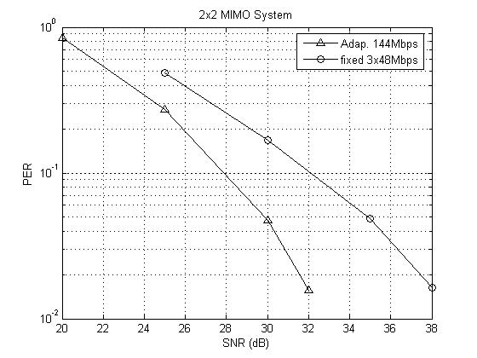 | 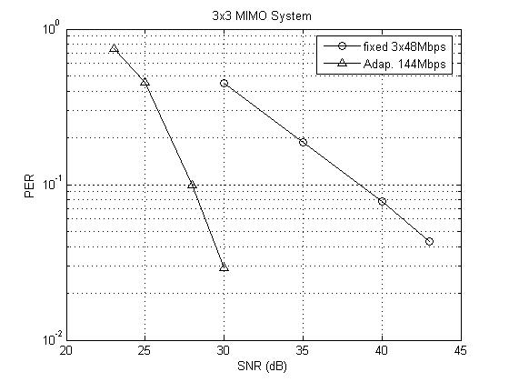
Figure 1: 3x3, Channel B, CC67, IM2 (frequency offset) was not activated, synchronisation and channel estimation ideal. Rate Adaptation turned on (triangle), Rate Adaptation turned off (circle). Note that 256QAM is assumed as the highest order modulation

- Frames transmitted with no legacy or MIMO specific training sequences (preambles)
This scheme provides significant increase in the MAC efficiency without increasing the frame size which is good for low latency traffic such as voice. Compared to 802.11a RTS/CTS transmission with at least 5 data frames of length 1.5kbytes, more than 25% improvement in MAC efficiency occurs (61% vs 47% refer to slide 9 in 11-04-0929/r2).

It should be noted that (see pages 16-19 in 11-04-0928/r1)
- Channel Tracking is assumed in this proposal for multi-frame transmission. Decision directed or other tracking schemes will follow the slow variations in the channel and remove the need for any further channel training.

The Doppler on the channel detemines the period over which a channel estimate is valid. For the 802.11n channels, with addional MSE limited to less than -32dB, this is (see pages 16-19 in 11-04-0928/r1):
0.75ms (190 symbols); channels A,B,C,D, E, F
0.65ms (160 symbols); channels (D, E) + fluorescent light effect,
0.35ms ( 88 symbols); channel F + high speed 40kph Doppler component.
There is no need to have channel estimates more often than these times.

The above maximum period requirement for channel estimates can be prolonged even further with channel tracking. The additional power consumption is small since tracking need not be invoked all the time. The additional complexity of channel tracking is low. It should also be noted that MAC proposals specifying frames longer than the above times are likey to require channel tracking in any case.

- Timing and Synchronisation. The first STS and LTS sets up the timing grid for the rest of the forward (reverse) transmission. Packets must always be transmitted on a symbol boundary. The receiver therefore knows that a transmission will start on a timing grid quantized to 4us (one symbol period).

- Signal symbol (part of signal field) transmitted between MIMO training sequences and MIMO
data
The information concerning the format of the MIMO data could be transmitted after the MIMO training sequences. This increases the available time for inverting the channel estimate and therefore helps to minimise the hardware complexity i.e. it reduces the peak signal processing load and buffering requirements. This is considered important given the complexity of the channel inversion is a significant part of MIMO systems, especially for antenna configuration of 3 and 4 antennas, refer to slide 6 in 11-04-0929/r2

