IEEE P802.11
Wireless LANs
AP Architecture Thoughts
Date: 19th October 2004
Author: Mike Moreton
STMicroelectronics
Mike.Moreton@st.com
Abstract
This document is a summary of some thoughts relating to AP architecture for discussion in the AP Architecture Ad-Hoc Group. It is not a complete model – just a description of my current understanding, and some suggestions for filling in the holes.

This document only considers data flows – no management or configuration.

Summary of 802.11 1999 Architecture

The above diagram represents my understanding of the basic 802.11 AP architecture building blocks, and how they are used to create APs and the DS.

Any frame received from the MAC is passed to the DS. It is then forwarded to the appropriate MAC, be it remote or local. The DS is constructed from the collection of APs and the DSM (Distribution System Medium – the physical medium used to connect APs).

Non-802.11 endpoints must be connected to an “integrated LAN” which is connected to the DS via a “Portal”. The “Integration Function” lives within the “Portal” – it seems very difficult to make any useful distinction between the “Integration Function” and the “Portal”.

The Missing Blocks
The light blue boxes in the previous diagram don’t appear to have any name in the 802.11 architecture. It’s clear that there are a number of functions they have to carry out:

- Access Function for DSM
- Forwarding between different 802.11 MACs present in this AP (e.g. dual band AP)
- Use of the DSM for forwarding to remote MACs
- Maintenance of STA location information
- Forwarding to portals

It seems sensible to allocate blocks for these functions. The following diagram adds two new blocks, “DSM Access”, and “802.11 MAC Relay Entity” that in combination provide these functions.

Note that the 802.11 MAC Relay Entity is similar in concept to the 802.1D MAC Relay Entity – more about that in a later section.

Adding LLC
LLC and the protocols that sit on top of it are missing from the above diagram. Adding it makes the diagram a bit crowded, so the following diagram is the only time I’ll attempt to include them.

This position of the LLC is copied from the 802.1D standard – the diagram on the next page was clipped by Darwin Engwer. Presumably, in 802.1D LLC needs to be at this position in the diagram so that Higher Layer Entities (such as STP) know which port a frame came from – it can’t be another virtual port off the MAC Relay Entity. While we could do it differently for 802.11 1999 which doesn’t have any concept of link specific LLC level configuration protocols, a little foreknowledge of 802.11i stops us going down that route…

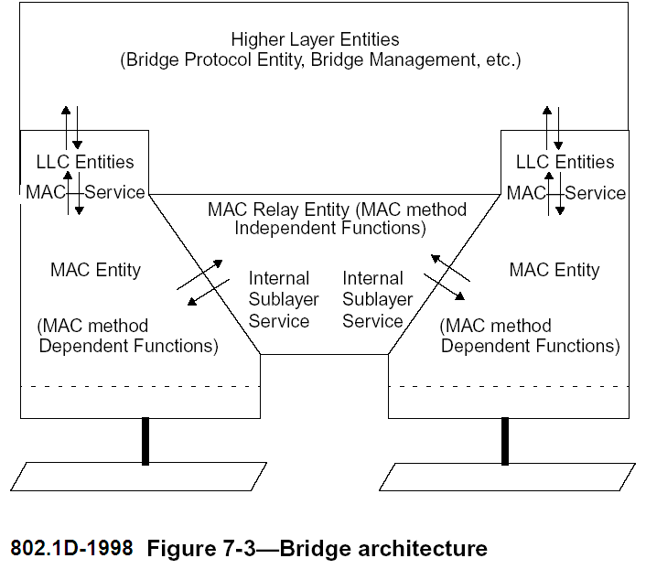

Using 802.1 as an 802.11 1999 DSM
It is relatively easy to model an 802.1 LAN as an 802.11 1999 DSM – all you have to do is replace “DSM Access” with the appropriate MAC. However, once you’ve done this, it becomes clear that the 802.11 MAC Relay Entity can be made indistinguishable from an 802.1 MAC Relay Entity.

In both cases, the Relay Entity has a number of ports, and forwards frames between them based on location information it learns from the source addresses of frames received from those ports. In the 802.11 case, a “port” can be either an 802.11 BSS, or the DSM Access function.

The one awkward feature is what happens for frames forwarded between STAs in the same BSS. A standard 802.1D MAC Relay Entity is not going to copy frames back to the port they came from, so either we modify the Relay Entity, or we say that in this case the MAC does the forwarding. Such a function needs to be part of the DS, as frames to be forwarded like this are marked as “ToDS”.

I’m going to break my promise and repeat the LLC diagram. If you look at the first one carefully, it’s clear that there needs to be some function at the top of the MAC that decides whether to forward a received frame to the LLC or to the Relay Entity. It’s logical to consider the forwarding of frames within the BSS as part of the same function (call it “Frame Routing”) – rather than being sent to the LLC or to the Relay Entity, they get sent back out on the wireless medium. (Of course, for broadcast or multicast frames, a copy of the frame gets sent in all three directions.)

Once you’ve gone for a standard 802.1D MAC Relay Entity, the “DSM Access” function becomes just the normal MAC for the LAN in question, and the Portal becomes a null function, which means you can have a “virtual integrated LAN”, and in practice connect the non-802.11 endpoint directly to the DSM.

Changes in 802.11i
802.11i requires the use of 802.1X. 802.1X is a port based access control mechanism that enables or disables access on a port by port basis. The architecture described previously in this document views an 802.11 BSS as a single port, so something has to change if we’re to use 802.1X to enable or disable access on a STA by STA basis.

802.11i actually creates a virtual port for each STA (at association time in a BSS), and then uses encryption with individual keys to effectively ensure that frames are limited to the ports in question. While a STA can physically receive a frame on a different virtual port to the one it’s attached to, it’s of no practical use as the STA can’t decrypt it.

802.1X can then be run on the virtual port in question, to enable or disable access to an individual STA.

Of course, in reality encryption is only turned on after 802.1X authentication completes. This is not a problem, as access is only granted after encryption is turned on. Before encryption is turned on, a third party STA can access the virtual port, but accessing an un-authorised virtual port is hardly a problem as such a STA could easily create its own un-authorised virtual port.

I guess I ought to mention the vexed question of “where is the Controlled/Uncontrolled Port?”. The answer to this is that both are concepts rather than actual functions, and are implemented by the connecting together, or not, of other functions. Uncontrolled Port frames can never be forwarded, so in the following picture the authorizing of the Controlled Port reduces to the point at which the connection between Frame Routing and the Relay Entity is made – the port exists before then, but traffic can’t be forwarded to or from it. There’s also some similar stuff involving LLC/SNAP, but that doesn’t appear in this diagram…

One impact of this is that intra-BSS forwarding is carried out by the 802.1D MAC Relay Entity, not the Frame Routing function.

The above diagram would work just fine if it wasn’t for multicast/broadcast.

From a security purist perspective, what should really happen is that a copy of each broadcast frame should be sent to each port, then each copy should be encrypted with the pairwise key to limit its scope to the port in question, and then the multiple copies should be transmitted. This provides a number of security benefits (better replay detection, easy revocation etc), and would fit nicely with the 802.1 model, but it’s not what happens because it’s very wasteful of that valuable resource, air time.

What actually happens is that a single copy of the frame is broadcast encrypted with a group key that all the STAs in the BSS know. And if a pairwise key defines an individual virtual port for the transferring of unicast traffic, it’s logical to think of the group key as defining an additional virtual port used for broadcast traffic. [Note that only the AP uses this port – STAs send broadcast frames by unicasting them to the AP for relay.]

Note that these multiple virtual ports actually share the same MAC, as the MAC address (RA for transmitted frames, TA for received) identifies the port, and the MAC address is validated by the process of encryption and decryption.

So reality is more like:

There is an issue with this – a standard 802.1D MAC relay entity doesn’t understand unicast only and broadcast only ports. One option would be to enhance 802.1D to include these concepts. An alternative approach is presented in the next section.

If 802.1D is enhanced to support these port types, then an additional enhancement to the MAC Relay Entity makes sense. When 802.11 creates a unicast only port, it can supply the MAC Relay Entity with the address of the STA for which the port was created, and so it would seem logical for the MAC Relay Entity to update its forwarding tables with this new address immediately, rather than waiting to learn it.

I would venture that this new port type only makes sense where it is a virtual port created within a shared broadcast LAN, and that such virtual port creation is bound to include knowledge of the MAC address (because that’s how you identify the port). So connection of a unicast only port to a MAC Relay Entity should always require that the MAC Relay Entity be informed of the MAC address associated with it.

An Alternative Approach to Modeling 802.11i
Once you have accepted the concept in the previous section of multiplexing and demultiplexing between the MAC and the virtual ports based on MAC address, then one possible enhancement is to have a shared frame routing function as follows:

What does this mean?

As far as the 802.1D MAC Relay Entity is concerned, the port always exists and is authorised, and frame forwarding works as for any other 802.1D based LAN. Unicast ports are created at association, but are only connected to the Frame Routing function when the controlled port is authorised.

While this model does mean that the 802.1D MAC Relay Entity does not need to change, it does have some impact on the rest of the 802.1D model. Unfortunately LLC still needs a separate port view as the 802.1X controlled port state can be different for each port. This means an inconsistency in the 802.1D model that would still need to be resolved. So while this model may appear attractive at first, I don’t think it’s the right way forward.

One example of how things can get really complicated with this is Spanning Tree Protocol. STP runs on top of LLC, and so would see the multiple port model. But when it comes to enabling/disabling ports, this would normally be done by connecting/disconnecting ports from the Relay Entity, which sees the combined port. While there are ways round this, the whole thing is getting messy.

In summary, I feel this alternative adds more complexity than it removes.

A Word about STP…
If we revert to the model where the 802.1D Relay Entity is aware of (and is modified to support) the unicast only and broadcast ports, then STP should never disable either of these new port types. That’s reasonably obvious as such port types are used for direct connection of end stations, not for bridges.

So what do you do if you do want to connect a bridge using 802.11 (i.e. WDS)?

The answer is to model a WDS link as a conventional LAN port rather than one of the special 802.11 ports.

Now STP can run independently on each of the WDS links, and the system behaves as you would expect.

Of course, this has implications for how WDS handles broadcast frames – a separate copy has to be sent down each WDS port, encrypted with the pairwise key, rather than WDS clients picking up a copy of the broadcast sent encrypted with the group key. That’s unavoidable if you want STP to be able to enable/disable individual ports (unless you invent a whole new protocol…).

DS Services

DSM Access and 802.11 MAC Relay Definition
Consider the following fraction from one of the diagrams above:

An earlier section said that the combination of 802.11 MAC Relay Entity and DSM Access provided the following functions:

- Access Function for DSM
- Forwarding between different 802.11 MACs present in this AP (e.g. dual band AP)
- Use of the DSM for forwarding to remote MACs
- Maintenance of STA location information
- Forwarding to portals

How are these services provided by the two blocks? In determining the answer to this question, we should bear in mind that it is desirable to make the 802.11 MAC Relay Entity as close to an 802.1D MAC Relay Entity.

So the service provided by the combination of DSM Access and DSM should be one of MSDU delivery. Given the MSDU, along with its source address, destination address and priority, the DSM Access Function and DSM should deliver the MSDU to the appropriate remote 802.11 MAC Relay Entity or Portal, along with indication of the source address, destination address, and priority.

Note that LLC is not terminated – it’s end to end. However a DSM Access function to a network such as Ethernet may extract the LLC/SNAP header and encapsulate the information it contains in the Ethertype field instead, as this is indistinguishable to the remote Relay Entity.

In general it is possible for the DSM to use a different addressing scheme, a different frame format or segmentation, or any differences in protocol it likes, as long as it can provide the MSDU delivery service to the Relay Entity.

The 802.11 MAC Relay Entity has to keep track of which MAC Addresses are locally associated, and which are accessible via the DSM. This is essentially a standard 802.1D learning function – but see more on this in a later section.

Association
802.11 1999 says: “At any given instant, a STA may be associated with no more than one AP. This ensures that the DS may determine a unique answer to the question, “Which AP is serving STA X?”.

Note that the requirement of a single association is placed on the STA, and is a pre-requisite for correct operation of the DS. The corollary is that the DS may not function correctly if the STA associate with more than one AP at once.

A DSM constructed using an 802 family LAN has no real concept of association, and hence can’t enforce the single AP association rule. However, it can route frames to the AP with which the STA is associated using standard bridge learning techniques. As long as the STA is associated with only one AP, an 802 family DS can answer the question given at the beginning of this section.

What happens at reassociation?

802.11F recommends that an AP send out a broadcast frame spoofed with the source address of the client, which will update the address tables of all the bridges in this domain.

As Bill Arbaugh and Bernard Aboba have pointed out, there is a problem with this. In 802.11, association is currently not authenticated, so this makes possible a remote “denial of service” attack. One possible solution is for the STA to send out this spoofing frame, as it will only be able to do this once the controlled port has been authenticated, but if APs were to stop spoofing now, then existing clients might stop working.

Previously I suggested the creation of two new port types to be supported by the 802.1D MAC Relay Entity. One of these was a unicast only port that would be connected to the MAC Relay Entity when the controlled port is authenticated, at which point the address of the station would also be supplied.

It hence seems logical to place the “spoofing” requirement on the 802.1D MAC Relay Entity whenever a unicast only port is connected.

More on the Portal
Previously I said that it was difficult to distinguish between the Portal and the Integration Function it contained. This section is an attempt to make that distinction.

The DSM Access function can be identical to that found in the AP. The Relay Entity is very simple – all it has to do is forward MSDUs from one side to the other.

The Integration Function provides as MSDU delivery service to the Relay Entity. As there is no requirement for the integrated LAN to be from the 802 family, or even to use the same addressing, a significant conversion function may be required.

Consider the case where only a single station is connected to the integrated LAN (i.e. there is a separate integrated LAN for each station), and the portal is integrated into the station.

If the service provided to the Station Function is 802 MSDU transfer, then in practice the Station Function can be connected directly to the DSM Access Function, which provides this service. This change will be invisible outside the station.

Furthermore, if the DSM is an 802 family LAN, then the DSM Access function is merely the 802 MAC in question – in this case the integrated station needs no special functionality to support the portal function.

So any end station connected to an 802 Family LAN used as the DSM is indistinguishable from a combined Portal, Integrated LAN, plus station, even though the internal implementation is much simpler.

