IEEE P802.11
Wireless LANs
Title
Throughput of 802.11e, assuming 802.11a, 802.11b, or 802.11g physical layers
Date: September 14, 2004
Author: Todor Cooklev and Vishal Shah
San Francisco State University
1600 Holloway Ave. San Francisco CA 94132
Phone: +1-415-338-3946
Fax: +1-925-377-6700
e-Mail: tcooklev@sfsu.edu
Abstract

The throughput depends on both the PHY and MAC layers. It is important to estimate what exactly is the throughput when the physical layer is 802.11a, 802.11b, or 802.11g, and the MAC layer is 802.11e. In other words, how does providing QoS change the throughput for each of the three physical layers? In this paper we provide answers to this problem. The maximum achievable throughput and minimum delay involved in data transfers are determined for the different priority levels. The obtained results have further significance for the design of high-throughput protocols for wireless LAN.

I. INTRODUCTION
IEEE 802.11 consists of two layers: medium-access control (MAC) layer and a physical (PHY) layer [1]. Six different physical layers have been standardized: three within the original 802.11 [2], and three additional: 802.11a [3], 802.11b [4], and 802.11g [6]. It is recognized that the actual throughput depends not only on the physical layer. It depends on both the MAC layer and on the PHY layer. Therefore it is important to estimate what exactly is the throughput that the MAC and PHY combination will produce. The problem, what is the exact throughput when the MAC protocol is 802.11e, and the PHY is 802.11a, 802.11b, or 802.11g, has not been answered. This is the problem that is answered in this paper. Section II is devoted tp the medium access protocol of IEEE 802.11 and the novel 802.11e. In Section III, the new analytic formulae for the throughput of 802.11e are derived. Then, in sections IV, V and VI, it is analysed the throughput performance of 802.11e with the three different physical layers of interest here – 802.11a, 802.11b, and 802.11g. In section VII the throughput upper limit is analysed. Section VIII deals with the delay lover limits in the data transfer due to the overhead time delays involved. The paper concludes with summary in section IX.

II. IEEE 802.11 MEDIUM ACCESS
It is well known that the medium-access protocol of 802.11 is carrier-sense multiple accesses with collision avoidance (CSMA/CA) [2]. Stations can transmit frames after they detect that the medium is available for a period equal to the distrobuted interframe space (DIFS)+backoff interval. The backoff interval is a random number with a uniform distribution between 0 and CW-1, where CW is the contention window. After any unsuccessful transmission, the CW is doubled, up to a certain limit. 802.11e introduced traffic prioritization. IEEE 802.11e is using a standard called IEEE Std 802.1D-1998, Annex H.2, which adds three bits to the packet header and gives the LAN the capability to recognize eight levels of priority. Priority 7 is the highest priority and priority 1 is the lowest priority, with priority 0, which is used for best effort traffic, ordered between priority 3 and priority 2. The resulting default ordering is {7, 6, 5, 4, 3, 0, 2, 1}, as shown in Table 1. IEEE 802.11e also introduces a prioritized channel access mechanism, called Enhanced distributed channel access (EDCA). The EDCA is also a contention-based channel access mechanism that uses Arbitration Interframe Space (AIFS) instead of DIFS. Prior to each transmission a station will defer until the medium is determined to be idle without interruption for a period of time equal to the arbitration IFS for that queue (AIFS[i]). Note that AIFS [i] is a time variable, assigned either by a management entity, or by the AP. It is equal to the integer AIFSN [i] multiplied by the slot time plus SIFS:

. (1)
The integer AIFSN must be greater than 2 for stations, and greater than 1 for the AP. In this way the AP has a higher priority for this channel access mechanism. The values of AIFSN for the different access categories is advertised in the beacons and probe response frames transmitted by the AP. A typical example is given in Table 1. Not only AIFSN, but also the contention window values are different for each priority level. According to the EDCA, service differentiation is achieved through varying the length of the contention window, and/or varying the duration a station may transmit after it acquires channel access. Note that the slot time and the contention window values depend on the physical layer that is used. Therefore the MAC layer is not entirely independent of the physical layer.
Another change brought by 802.11e is the introduction of negotiable acknowledgements. The IEEE 802.11 standard prior to 802.11e required an acknowledgement for every frame. IEEE 802.11e makes acknowledgments negotiable. Such negotiable acknowledgments lead to a more efficient utilization for the available channel and enable such applications a reliable multicast. According to 802.11e there is normal acknowledgment, no acknowledgment, and block acknowledgment. Normal acknowledgment is as in the legacy 802.11, where every packet is acknowledged. Clearly, no acknowledgment is used whenever acknowledgment is not required. This could be appropriate for delay-sensitive traffic. According to block acknowledgement a group of packets is acknowledged at once. This allows a certain number of packets to be transmitted, each separated by a SIFS period. The number of packets is determined by the maximum length of the transmission opportunity. This improves latency and jitter. In this paper we analyse the throughput performance assuming the cases of normal acknowledgment and no acknowledgment.

III. THROUGHPUT ESTIMATION
The EDCA, defined by 802.11e, is another implementation of CSMA. According to the EDCA stantions start the backoff procedure after waiting first for a time period equal to the AIFS. The backoff time period can be calculated by multiplying the slot time, T_{SLOT}, with the size of contention window. Since the backoff time has uniform distribution, the expected value will be . The transmission time of the data can be given as T_{D_DATA}. The transmission time of the acknowledgement frame can be given by T_{D_ACK}. An acknowledgement is transmitted T_{SIFS} after the data is received. In addition, there is the propagation delay. Therefore we have

, (2)
if an acknowledgment is required. According to 802.11e there may be no acknowledgement. In this case
. (3)
In formulae (2) and (3) the minimum value of the contention window is used, because it is assumed that transmissions do not result in errors. If there are errors, at the next transmission attempt the contention window doubles, increases and the throughput decreases. Clearly, only is useful time, the other time periods represent protocol overhead. Therefore the throughput, measured in bits per second, is given by
. (4)
Therefore the throughput as a function of the traffic category is
, (5)
where L_{DATA} is the payload in bytes, and is either as in (2) or (3) depending on whether an acknowledgment is required or not.
It must be noted that this is the throughput only as a result of the channel access procedure. While the throughput for all physical layers is given by these equations, for each physical layer and T_{D_ACK} will be different. The physical layers will introduce additional overhead (their own preambles and headers), which will reduce the throughput. This is examined in the following sections.

IV. THROUGHPUT OF IEEE 802.11e + 802.11a
The 802.11a physical layer adds a preamble and a header to the packet. The total preamble is =16 long. This preamble consists of short and long training OFDM symbols. The preamble is required for detection, coarse and fine synchronization, and carrier offset estimation. The header that follows the preamble comprises one OFDM symbol, and therefore takes =4 . After the header, the packet is transmitted using a variable number of OFDM symbols. However, there is additional physical layer protocol overhead, consisting of 16 bits for the service field, 6 tail bits, and a certain number of pad bits, to make the total number of OFDM symbols integer. The number 16+6+8*28++pad bits divided by the number of data bits per symbol must be an integer. The number of data bits per symbol is 24, 36, 48, 72, 96, 144, 192, and 216 bits, correspondingly for the data rates of 6, 9, 12, 18, 24, 36, 48, and 54 Mb/s. Therefore the time to transmit a 802.11a packet is
. (6)
Formula (6) takes into account the MAC overhead of 28 bytes, which includes the MAC header and the FCS. is the time to transmit one OFDM symbol. If a normal acknowledgement is required, then this acknowledgment will be transmitted SIFS after the end of the data transmission. The normal acknowledgement takes 14 bytes. The time to transmit the acknowledgment is
. (7)
Note that the acknowledgment is transmitted at the control rate, which may be different than the data rate of the packet. The control rate always must be smaller than or equal to the data rate. The control rate in 802.11a is 6, 12, and 24 Mb/s. Therefore in (7) can be 24, 48, or 96, and can be different from in (6). Therefore the 134 bits in the acknowledgment in 802.11a require 6, 3, or 2 OFDM symbols, if it is transmitted at 6, 12, or 24 Mb/s, correspondingly. As a result takes 44 , 32 , or 28 , correspondingly.
In our simulations we assume that the channel is perfect, i.e. there are no transmission errors. We also assume that stations have always data to transmit. If these assumptions are not true, the throughput will decrease. Furthermore it is assumed that the priority level is constant, i.e. there is no dynamic change of priority. Using these assumptions the throughput simulations have been carried out for all 8 different traffic categories. Figure 2 to Figure 9 show the throughput results for all eight traffic categories when an acknowledgment is required. Clearly throughput strictly increases with priority level. This increase depends on the data rate. At the lowest data rate of 6 Mb/s, throughput does not increase much - from 5.43 Mb/s to 5.62 Mb/s for the lowest to highest traffic categories, correspondingly. Since the achievable data rate depends on distance, the effects of 802.11e will be minimal at distances over which physical layer communication will be at 6 Mb/s. In other words, the effects of prioritization at distances over which communication is at 6 Mb/s are minimal. At the highest data rate of 54 Mb/s, where there is more room for throughput improvement, the increase is more pronounced – approximately 20 %. Not requiring acknowledgment has a substantial effect on throughput, illustrated by Figure 10 to Figure 17, for the same eight priority levels. Again, for the lowest data rate of 6 Mb/s, for same priority level the absense of acknowledgment improves throughput by approximately 5 %. For the highest data rate, for the same priority level the improvement is approximately 20 %. By comparing Figure 8 with Figure 10 it is seen that priority level 6 with acknowledgment achieves the approximately same throughput as priority level 1 without an acknowledgment. From Figure 17 it is seen that overall 802.11e results in substantial improvement in throughput, i.e. 802.11e can be called a high-throughput amendment. Since the throughput cannot exceed the data rate, another conclusion is that the room for further throughput improvement is relatively small.

V. THROUGHPUT OF IEEE 802.11e + 802.11b
802.11b is a single-carrier physical layer, achieving data rates of 5.5 and 11 Mb/s, in addition to the data rates of 1 and 2 Mb/s of the original 802.11. There are two preambles: long, which is mandatory and short, which is optional. The long preamble length in bits is 144 bits, and in time is 144 , since it is sent at 1Mb/s. If the long preamble is used, then the header is also according to the original 802.11. The short preamble is provided in the standard precisely to increase the throughput. Therefore it is important to analyze the throughput when the short preamble is used. (This is not done in [5]). The short preamble is 72 bits at 1 Mb/s, or 72 . If the short preamble is used, the header is transmitted at 2 Mb/s, or in time 24 . Therefore for 802.11b there are two sets of physical layer parameters: =144 , = 48 , and = 72 , = 24 . The MAC data that follows the header is transmitted at 2, 5.5, or 11 Mb/s. The actual data rate used is denoted in the header. Therefore the transmission time for 802.11b is
,
and the time to transmit an acknowledgment, if required, is
.
Note that again the acknowledgment is transmitted at the control rate, which is smaller than or equal to the data rate of the packet. The 14 bytes of the acknowledgment can be transmitted at a data rate of either 1 or 2 Mb/s. Using the values given in the table above, the throughput performance for all 8 priority levels can be determined. For conciseness, this time simulations have been carried out only for one Traffic Category from each Access Category (AC). There is very small difference in throughput results of the TCs of the same Access Category. The results are given in Figure 18 to Figure 21 for the long preamble when an acknowledgment is required, and in Figure 22 to Figure 25 for the case without an acknowledgment. The comparable results for the short preamble are shown in Figure 26 to Figure 29 with acknowledgments, and Figure 30 to Figure 33 without acknowledgments. The short preamble improves throughput by about 8 % at the maximum data rate of 11 Mb/s compared with the long preamble, for the same priority level. The absence of acknowledgment improves throughput by 11 % to 13 % for same priority level, where the improvement by 13 % pertains for the higher priority levels. It is seen that again, 802.11e exhausts the opportunity for further throughput improvement when the physical layer is 802.11b.

VI. THROUGHPUT OF IEEE 802.11e + 802.11g
Almost as soon as 802.11b and 802.11a were approved, work began on another physical layer for operation in the 2.4 GHz band. The requirement was at least to double the data rate of 802.11b, while achieving backwards compatibility with 802.11b. Another motivation was the change in FCC regulations. While previous regulations required spread-spectrum technology in the 2.4 GHz band, the new regulations allow any digital modulation to be used. IEEE 802.11g has one mandatory physical layer and two optional physical layers. In this section we evaluate the throughput only for the mandatory physical layer of 802.11g. The mandatory physical layer is in principal identical to 802.11a, but works in the 2.4 GHz band. Thus it is of considerable interest to compare the throughput offered by 802.11e and 802.11g vs. the throughput offered by 802.11e and 802.11a. 802.11g is the first standard for wireless data communications in the 2.4 GHz band which is not using spread-spectrum technology. Since 802.11a was standardized before 802.11g, and it was widely understood technology, the investment in 802.11a could be leveraged by using the same physical layer, and only changing the frequency band of operation. One small difference between 802.11a and 802.11g is that the SIFS for 802.11a is and the SIFS for 802.11g is . 802.11a uses to allow enough time for the time-consuming convolutional decoding. To give 802.11g equipment the same time to perform convolutional decoding, an 802.11g packet is followed by of silence. The duration field of every packet includes this signal extension. This is called a virtual extension of SIFS. IEEE 802.11g specifies two slot times – 20 and optionally 9 . Again, the purpose of providing the short slot time is to increase the throughput. Therefore it is important to analyze what this increase is for 802.11e. With these assumptions, for conciseness the simulations have been done for one Traffic category from different Access Categories (ACs). On Figure 34 to Figure 37 are shown the throughput results for the priority levels 2, 3, 5, and 7, when the slot time is 20 . From these figures it is seen that the throughput of 802.11g is lower than that of 802.11a, especially at a low priority level. The absense of acknowledgment illustrated in Figure 38 to Figure 41 again results in throughput improvement of about 20 %. 802.11g provides lower throughput than 802.11a, even with a shorter slot time, as illustrated in Figure 42 to Figure 45, and Figure 46 to Figure 49. It is interesting that 802.11e improves the performance of 802.11g more than it improves the performance of 802.11a. Comparing Figure 11 and Figure 42 it is seen that for priority level 2 the throughput of 802.11a is more than 10 % higher at the higher data rates. However, a comparison between Figure 17 and Figure 45 shows that at priority level 7, the difference in throughput between 802.11a and 802.11g with the shorter slot time is small. As a result if the short slot time is used, the performance of 802.11g , while still inferior to 802.11a, approaches that of 802.11a.

VII. THROUGHPUT UPPER LIMIT FOR IEEE 802.11e EDCF
One question worth asking is what will happen if the data rate that the physical layer provides is increased to infinity. Since the packet length is limited to 2304 bytes to maintain compatibility with Ethernet, then the transmission of the actual data will take negligible amount of time. In the paper [5] the throughput upper limit is derived for the original 802.11 MAC and the 802.11a and 802.11b physical layers. However, in deriving the throughput upper limit the authors of [5] assume that there still is a preamble and a header, transmitted according to 802.11a and 802.11b, i.e. transmitted at 6 Mb/s in the case of 802.11a and 1 or 2 Mb/s in the case of 802.11b. This assumption is justified if backward compatibility at the physical layer is required. Therefore
.
Now assuming that the MAC protocol is 802.11e the throughput upper limit can be calculated. If backward compatibility at the physical layer and acknowledgment are required, the throughput upper limit as a function of the priority level is
However, according to 802.11e an acknowledgment may not be required. From the above analysis one can readily notice that not requiring an acknowledgment can have a substantial effect on throughput. If an acknowledgment is not required then the throughput upper limit is
.
Backwards compatibility is desirable so that legacy equipment can work with new equipment in a network. Legacy devices will decode the preamble and header and will not initiate transmissions as a result of the virtual carrier sense mechanism. The throughput achievable by new devices is lower. Therefore as the data rate goes to infinity it is not very efficient to have backwards compatibility at the physical layer. Vendors are aware of this tradeoff. It is also desirable to “turn-off” backwards compatibility to achieve higher throughput, for example when only new devices participate in the network. Backwards compatibility can also be provided at a higher layer, e.g. the MAC layer. If backwards compatibility at the physical layer is “turned-off” then it can be assumed that the preamble and the header will also be transmitted at a data approaching infinity. Then, if an acknowledgment is still required the throughput upper limit is
,
and if an acknowledgment is not required the limit is
.
These are more useful estimates of the throughput limit, compared with the paper [5], considering that in the next several years 802.11 will standardize new physical layers providing data rates in the order of 1 Gb/s. These physical layers will operate under the 802.11e MAC protocol, which is exactly the case analyzed here.
The throughput limit is a function of the packet size and the traffic category. While the throughput limit does not depend on the data rate, it depends on certain physical layer parameters such as SIFS and slot time values. Figure 50 shows the throughput limit for 802.11a and 802.11e. In other words it shows the throughput limit if the data rate of 802.11a is increased from 54 Mb/s to infinity for the data portion of the packet. This is not very efficient and was abandoned by 802.11n. As shown in Figure 51 not requiring acknowledgment improves the throughput substantially, especially at the highest priority levels. Abandoning backwards-compatibility at the physical layer improves the throughput even more than not requiring acknowledgments, as shown in Figure 52. These can be combined to achieve the maximum throughput improvement, as shown in Figure 53. Figure 54 to Figure 59 show the throughput limit results for 802.11b. One conslusion from these figures is that 802.11a is much better positioned to take advantage of the higher data rates. Figure 60 to Figure 67 show the throughput limit results for 802.11g. The conclusion is once again that 802.11g in all cases provides worse throughput than 802.11a, although that 802.11e improves 802.11g more than it does 802.11a.

VIII. MINIMUM DELAY AND DELAY LOWER LIMIT
It is also of interest to analyze the minimum delay that 802.11e provides. It is independent of the data rate, and moreover it is also independent of the payload size. The minimum delay as a function of the traffic category is
.
The delay lower limit can be calculated in a manner similar to the calculation of the throughput upper limit. As the data rate approaches infinity will consist of only preamble and header time periods in the backwards-compatible case. Therefore the delay lower limit is
.
In the high-throughput case the preamble and the header are also transmitted at a data rate that approaches infinity. Then the delay lower limit is
.
Table 70 to Table 76 show the delay lower limits for both cases assuming the three different physical layers considered here.

IX. CONCLUSION
In this paper, we have analysed the throughput provided by the IEEE 802.11e EDCA mechanism. The results have significance for the technical development within IEEE 802.11, especially for the high-throughput study group 802.11n. The results show that 802.11e provides this high throughput. This is achieved mainly by prioritization and by making acknowledgments optional. As a conclusion it can be said that the objective of 802.11n to achieve high-throughput is made considerably easier by 802.11e.
Within the CSMA mechanism, it seems that the only way to improve throughput even more is to reduce SIFS and the slot time. These time periods are limited by the Rx-Tx and Tx-Rx turnaround times of the RF circuitry, and the time to perform clear channel assessment. This further throughput improvement can be obtained by improving semiconductor and RF circuit technologies, which may be able to reduce the turnaround time periods. The time to perform clear channel assessment may be shortened by using simpler algorithms. For example, a not very precise, but simple way to perform clear channel assessment is to perform energy thresholding.

REFERENCES
- T. Cooklev, Wireless communication standards: A study of IEEE 802.11, 802.15, and 802.16, IEEE Press, New York, NY 2004.
- IEEE Std. 802.11, 1999 Edition, (R2003) (ISO/IEC 8802-11:1999) IEEE Standard for Information Technology – Telecommunications and Information Exchange between Systems – Local and Metropolitan Area Network – Specific Requirements – Part 11:Wireless LAN Medium Access Control (MAC) and Physical Layer (PHY) Specifications.
- IEEE Std. 802.11a – 1999 (R2003) (ISO/IEC 8802-11:1999/Amd 1:2000(E)), Information Technology – Telecommunications and Information Exchange between Systems – Local and Metropolitan Area Network – Specific Requirements – Part 11:Wireless LAN Medium Access Control (MAC) and Physical Layer (PHY) Specifications – Amendment 1: High-speed Physical Layer in the 5 GHz band.
- IEEE Std. 802.11b – 1999 (R2003) Supplement to 802.11-1999, Wireless LAN MAC and PHY specifications: Higher-speed Physical Layer (PHY) extension in the 2.4 GHz band.
- IEEE 802.11e, IEEE Draft Amendment to Standard for Information Technology – Telecommunications and Information Exchange between Systems – Local and Metropolitan Area Network – Specific Requirements – Part 11:Wireless LAN Medium Access Control (MAC) and Physical Layer (PHY) Specifications: Medium Access Control (MAC) Quality of Service (QoS) Enhancements.
- IEEE 802.11g-2003, IEEE Standard for Information Technology – Telecommunications and Information Exchange between Systems – Local and Metropolitan Area Network – Specific Requirements – Part 11:Wireless LAN Medium Access Control (MAC) and Physical Layer (PHY) Specifications – Amendment 4: Further High-Speed Physical Layer Extension in the 2.4 GHz Band.

SIFS
ACK
DIFS
DIFS
CW
DATA

DATA 1
Ack 1
Ack 0

Figure 1 DCF timing diagram
Table 1 Priority to Access Category Mapping and CW values
Priority  (Traffic category) | Traffic type  (Access category) | AIFSN
Lowest  1  2 | Background (BK) – aperiodic data  - | 7  6
0  3 | Best effort (BE) – aperiodic data  Excellent effort (EE) – isochronous data | 3  2
4  5 | Controlled load  Video (VI) – periodic | 3  2
6  7  Highest | Voice (VO) – periodic  Network control (NC) | 2  1

Table 2 Timing parameters for 802.11b, 802.11a and 802.11g
Parameter | 802.11b | 802.11a | 802.11g
SIFS duration, | 10 | 16 | 10 (with virtual extension of )
Slot time, | 20 | 9 | 20 or 9
, time slots | 31 | 15 | 15

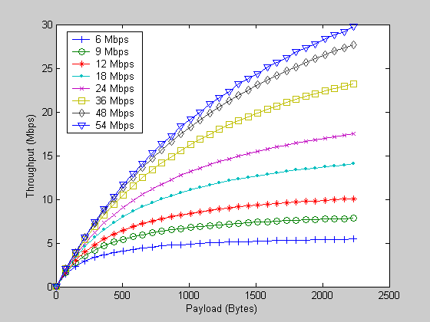

Figure 2. Throughput for 802.11a TC1

Table 3 Throughput results for 802.11a TC1
For 2304 bytes payload
Data Rate (Mbps) | Throughput (Mbps)
6 | 5.43
9 | 7.83
12 | 10.05
18 | 14.04
24 | 17.50
36 | 23.24
48 | 27.72
54 | 29.75

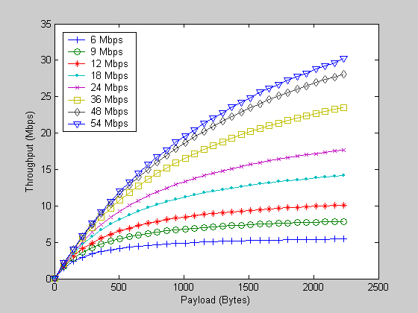
Figure 3 Throughput for 802.11TC2

Table 4 Throughput results for 802.11a TC2
For 2304 bytes payload
Data Rate (Mbps) | Throughput (Mbps)
6 | 5.45
9 | 7.86
12 | 10.11
18 | 14.14
24 | 17.66
36 | 23.52
48 | 28.11
54 | 30.20

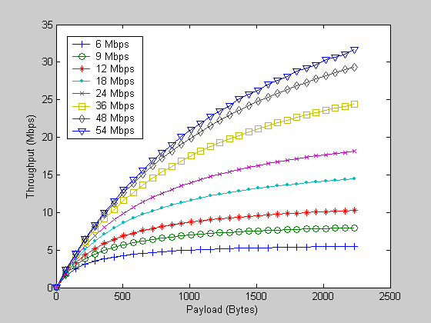
Figure 4 Throughput for 802.11a TC0

Table 5 Throughput results for 802.11a TC0

For 2304 bytes payload
Data Rate (Mbps) | Throughput (Mbps)
6 | 5.50
9 | 7.96
12 | 10.26
18 | 14.45
24 | 18.15
36 | 24.39
48 | 29.36
54 | 31.65

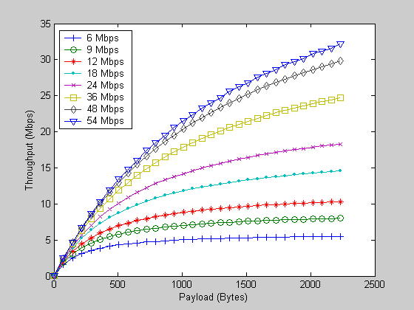

Figure 5 Throughput for 802.11a TC3

Table 6 Throughput results for 802.11a TC3
For 2304 bytes payload
Data Rate (Mbps) | Throughput (Mbps)
6 | 5.51
9 | 7.99
12 | 10.32
18 | 14.55
24 | 18.31
36 | 24.69
48 | 29.80
54 | 32.16

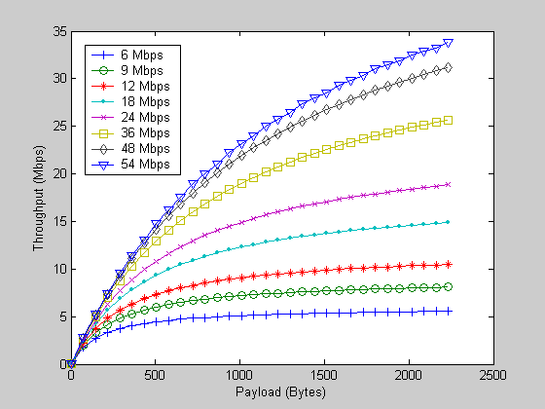

Figure 6 Throughput for 802.11a TC4

Table 7 Throughput results for 802.11a TC4
For 2304 bytes payload
Data Rate (Mbps) | Throughput (Mbps)
6 | 5.56
9 | 8.09
12 | 10.48
18 | 14.88
24 | 18.83
36 | 25.65
48 | 31.20
54 | 33.80

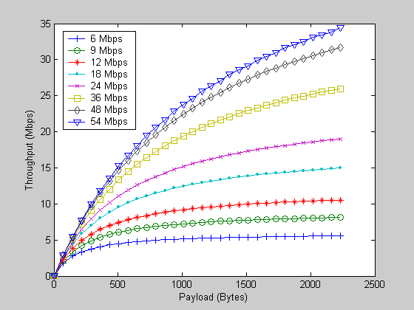

Figure 7 Throughput for 802.11a TC5

Table 8 Throughput results for 802.11a TC5
For 2304 bytes payload
Data Rate (Mbps) | Throughput (Mbps)
6 | 5.58
9 | 8.12
12 | 10.54
18 | 14.99
24 | 19.01
36 | 25.98
48 | 31.70
54 | 34.39

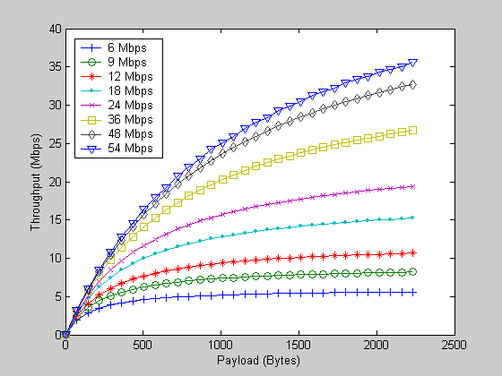

Figure 8 Throughput for 802.11a TC 6

Table 9 Throughput results for 802.11a TC6

For 2304 bytes payload
Data Rate (Mbps) | Throughput (Mbps)
6 | 5.61
9 | 8.19
12 | 10.65
18 | 15.22
24 | 19.39
36 | 26.68
48 | 32.75
54 | 35.62

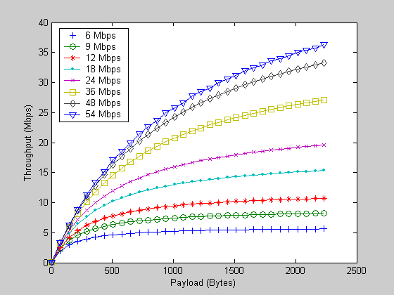

Figure 9 Throughput for 802.11a TC 7

Table 10 Throughput results for 802.11a TC 7
For 2304 bytes payload
Data Rate (Mbps) | Throughput (Mbps)
6 | 5.62
9 | 8.22
12 | 10.70
18 | 15.34
24 | 19.58
36 | 27.05
48 | 33.20
54 | 36.27

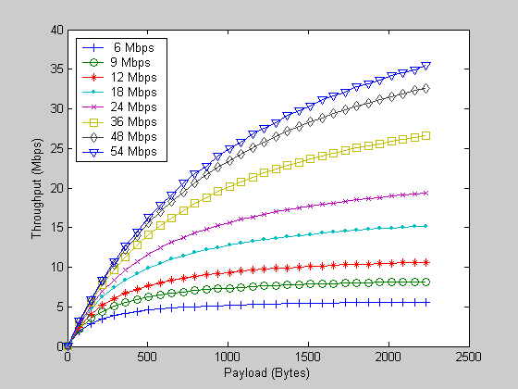

Figure 10 Throughput for 802.11a TC1 without acknoledgment

Table 11 Throughput results for 802.11a TC1 without acknoledgment
For 2304 bytes payload
Data Rate (Mbps) | Throughput (Mbps)
6 | 5.60
9 | 8.18
12 | 10.64
18 | 15.20
24 | 19.34
36 | 26.60
48 | 32.63
54 | 35.48

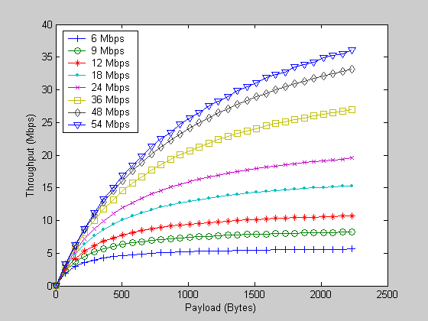
Figure 11 Throughput for 802.11TC2 without acknoledgment

Table 12 Throughput results for 802.11a TC2 without acknoledgment
For 2304 bytes payload
Data Rate (Mbps) | Throughput (Mbps)
6 | 5.62
9 | 8.22
12 | 10.69
18 | 15.31
24 | 19.53
36 | 26.97
48 | 33.17
54 | 36.13

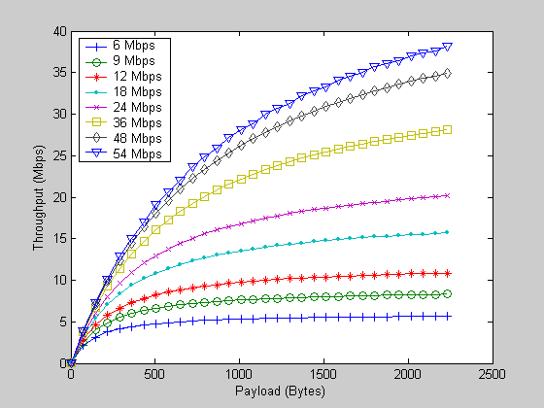

Figure 12 Throughput for 802.11a TC0 without acknowledgment

Table 13 Throughput results for 802.11a TC0 without acknowledgment

For 2304 bytes payload
Data Rate (Mbps) | Throughput (Mbps)
6 | 5.67
9 | 8.32
12 | 10.87
18 | 15.68
24 | 20.13
36 | 28.11
48 | 34.93
54 | 38.21

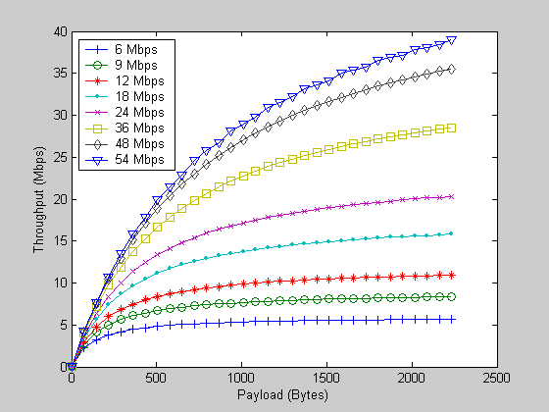

Figure 13 Throughput for 802.11a TC3 without acknowledgment

Table 14 Throughput results for 802.11a TC3 without acknowledgment
For 2304 bytes payload
Data Rate (Mbps) | Throughput (Mbps)
6 | 5.68
9 | 8.35
12 | 10.93
18 | 15.80
24 | 20.34
36 | 28.51
48 | 35.55
54 | 38.96

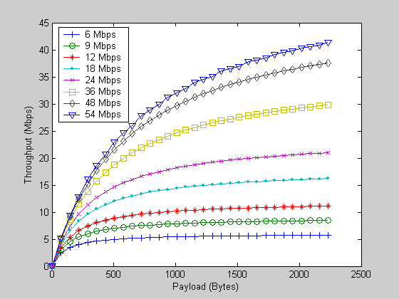

Figure 14 Throughput for 802.11a TC4 without acknowledgment

Table 15 Throughput results for 802.11a TC4 without acknowledgment
For 2304 bytes payload
Data Rate (Mbps) | Throughput (Mbps)
6 | 5.73
9 | 8.46
12 | 11.11
18 | 16.19
24 | 20.98
36 | 29.80
48 | 37.57
54 | 41.40

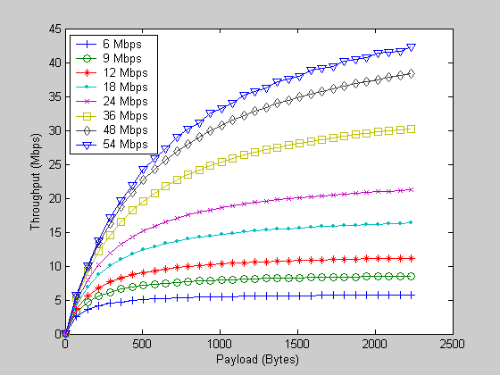

Figure 15 Throughput for 802.11a TC5 without acknowledgment

Table 16 Throughput results for 802.11a TC5 without acknowledgment

For 2304 bytes payload
Data Rate (Mbps) | Throughput (Mbps)
6 | 5.75
9 | 8.50
12 | 11.18
18 | 16.32
24 | 21.20
36 | 30.25
48 | 38.29
54 | 42.28

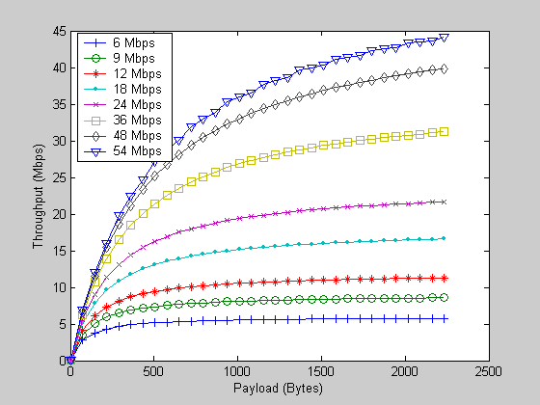

Figure 16 Throughput for 802.11a TC 6 without acknowledgment

Table 17 Throughput results for 802.11a TC6 without acknowledgment

For 2304 bytes payload
Data Rate (Mbps) | Throughput (Mbps)
6 | 5.78
9 | 8.57
12 | 11.30
18 | 16.60
24 | 21.67
36 | 31.20
48 | 39.83
54 | 44.16

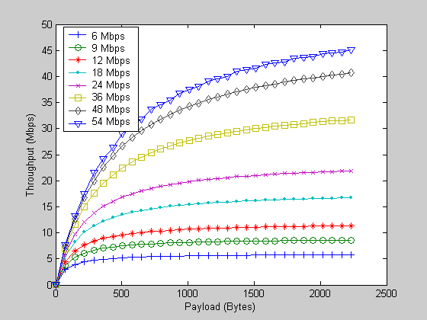

Figure 17 Throughput for 802.11a TC 7 without acknowledgment

Table 18 Throughput results for 802.11a TC 7 without acknowledgment
For 2304 bytes payload
Data Rate (Mbps) | Throughput (Mbps)
6 | 5.80
9 | 8.61
12 | 11.37
18 | 16.73
24 | 21.91
36 | 31.70
48 | 40.65
54 | 45.17

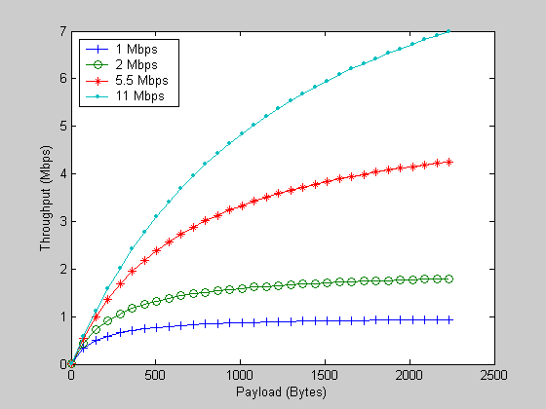
Figure 18 Throughput for 802.11b with long preamble, TC1

Table 19. Throughput results for 802.11b with long preamble, TC1

For 2304 bytes payload
Data Rate (Mbps) | Throughput (Mbps)
1 | 0.94
2 | 1.79
5.5 | 4.25
11 | 6.99

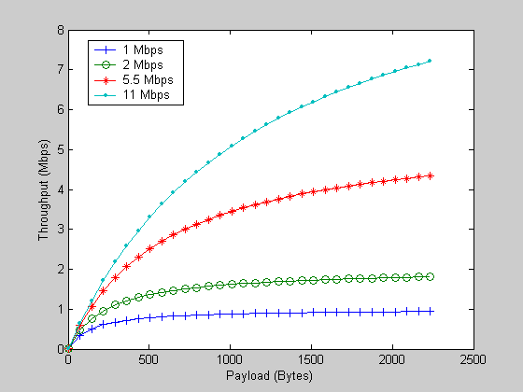

Figure 19 Throughput for 802.11b with long preamble, TC0

Table 20 Throughput results for 802.11b with long preamble, TC0

For 2304 bytes payload
Data Rate (Mbps) | Throughput (Mbps)
1 | 0.94
2 | 1.81
5.5 | 4.33
11 | 7.21

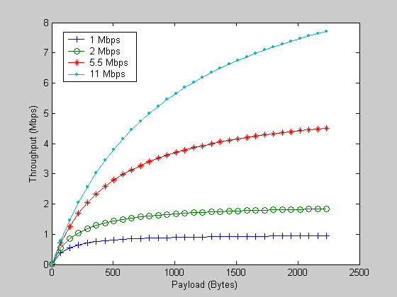

Figure 20 Throughput for 802.11b with long preamble, TC4

Table 21. Throughput results for 802.11b with long preamble, TC4
For 2304 bytes payload
Data Rate (Mbps) | Throughput (Mbps)
1 | 0.95
2 | 1.84
5.5 | 4.51
11 | 7.71

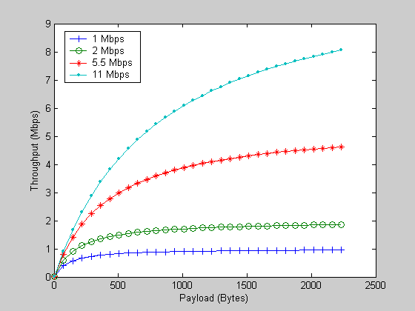

Figure 21. Throughput for 802.11b with long preamble, TC6

Table 22. Throughput results for 802.11b with long preamble, TC6
For 2304 bytes payload
Data Rate (Mbps) | Throughput (Mbps)
1 | 0.95
2 | 1.86
5.5 | 4.63
11 | 8.06

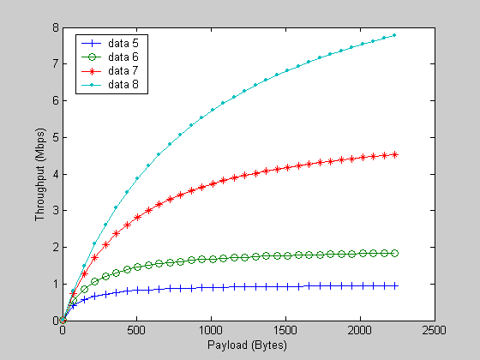

Figure 22 Throughput for 802.11b with long preamble, without acknowledgment, TC1

Table 23. Throughput results for 802.11b with long preamble, without acknowledgment, TC1

For 2304 bytes payload
Data Rate (Mbps) | Throughput (Mbps)
1 | 0.95
2 | 1.84
5.5 | 4.53
11 | 7.78

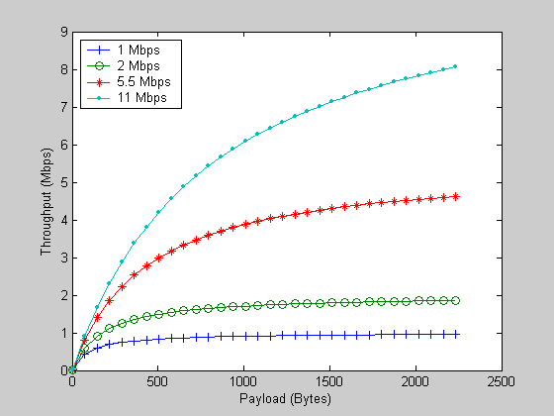

Figure 23 Throughput for TC0 802.11b with long preamble, without acknowledgment, TC0

Table 24 Throughput results for 802.11b with long preamble, without acknowledgment, TC0
For 2304 bytes payload
Data Rate (Mbps) | Throughput (Mbps)
1 | 0.96
2 | 1.86
5.5 | 4.63
11 | 8.06

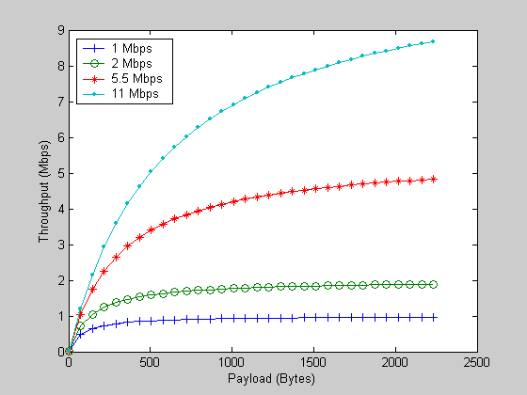

Figure 24 Throughput for 802.11b TC 4

Table 25 Throughput results for 802.11b with long preamble, without acknowledgment, TC4
For 2304 bytes payload
Data Rate (Mbps) | Throughput (Mbps)
1 | 0.97
2 | 1.89
5.5 | 4.83
11 | 8.68

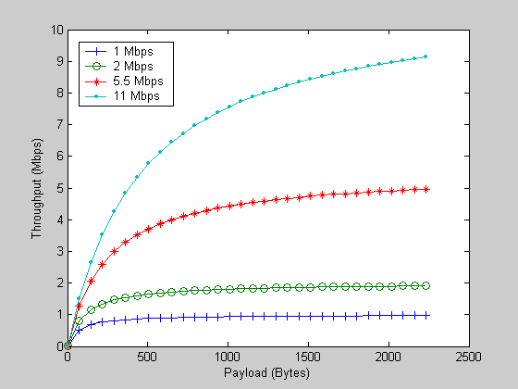

Figure 25 Throughput for 802.11b with long preamble, without acknowledgment, TC6

Table 26 Throughput results for 802.11b with long preamble, without acknowledgment, TC6
For 2304 bytes payload
Data Rate (Mbps) | Throughput (Mbps)
1 | 0.97
2 | 1.91
5.5 | 4.96
11 | 9.13

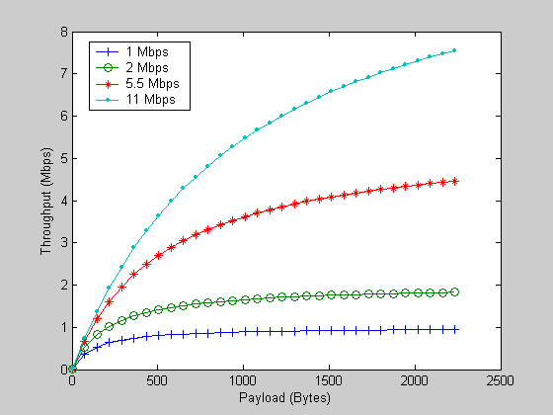

Figure 26 Throughput for 802.11b with short preamble (T_{Preamble}= 72 microsec, T_{H_PHY}=24 microsec), TC1

Table 27 Throughput results for 802.11b with short preamble, TC1

For 2304 bytes payload
Data Rate (Mbps) | Throughput (Mbps)
1 | 0.95
2 | 1.83
5.5 | 4.46
11 | 7.55

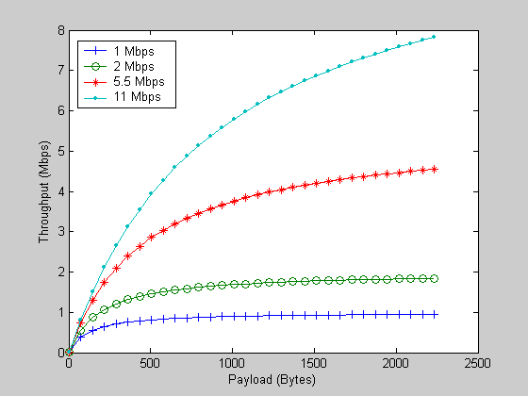

Figure 27 Throughput for 802.11b with short preamble, TC0

Table 28 Throughput results for 802.11b with short preamble, TC0

For 2304 bytes payload
Data Rate (Mbps) | Throughput (Mbps)
1 | 0.95
2 | 1.84
5.5 | 4.55
11 | 7.82

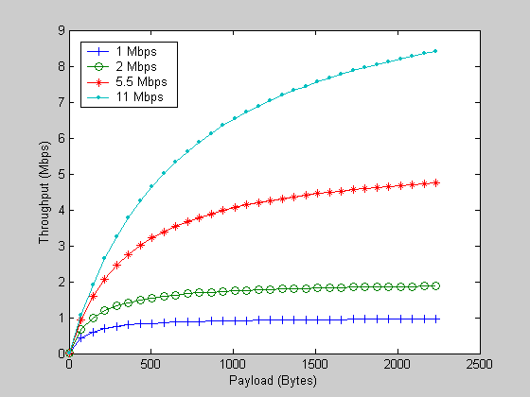

Figure 28 Throughput for 802.11b with short preamble, TC4

Table 29 Throughput results for 802.11b with short preamble, TC4
For 2304 bytes payload
Data Rate (Mbps) | Throughput (Mbps)
1 | 0.96
2 | 1.88
5.5 | 4.74
11 | 8.41

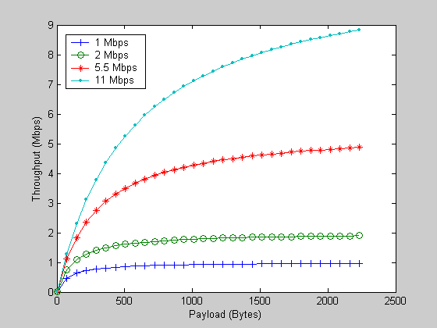

Figure 29 Throughput for 802.11b with short preamble, TC6

Table 30 Throughput results for 802.11b with short preamble, TC6

For 2304 bytes payload
Data Rate (Mbps) | Throughput (Mbps)
1 | 0.96
2 | 1.90
5.5 | 4.87
11 | 8.82

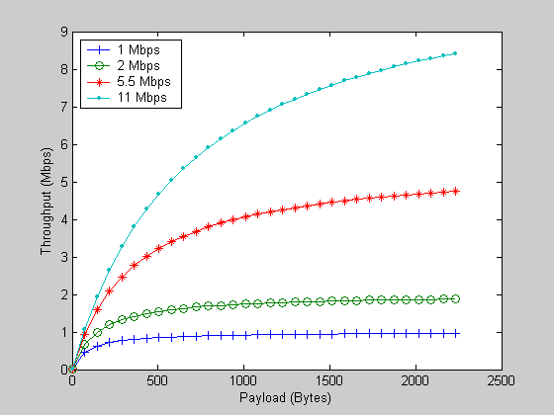

Figure 30 Throughput for 802.11b with short preamble and no acknowledgment, TC 1

Table 31 Throughput results for 802.11b with short preamble and no acknowledgment, TC1.

For 2304 bytes payload
Data Rate (Mbps) | Throughput (Mbps)
1 | 0.96
2 | 1.86
5.5 | 4.65
11 | 8.11

Figure 31 Throughput for 802.11b with short preamble and no acknowledgment, TC 0

Table 32 Throughput results for 802.11b with short preamble and no acknowledgment, TC0
For 2304 bytes payload
Data Rate (Mbps) | Throughput (Mbps)
1 | 0.96
2 | 1.88
5.5 | 4.74
11 | 8.42

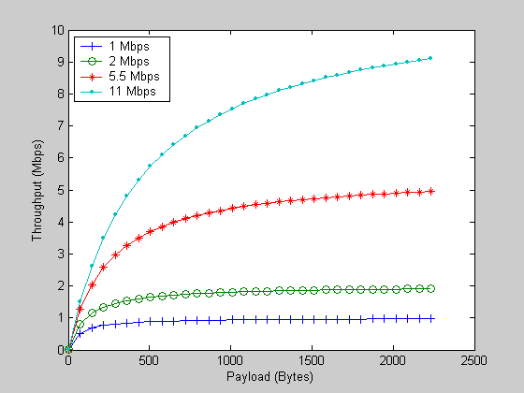

Figure 32 Throughput for 802.11b with short preamble and no acknowledgment, TC 4

Table 33 Throughput results for 802.11b with short preamble and no acknowledgment, TC4

For 2304 bytes payload
Data Rate (Mbps) | Throughput (Mbps)
1 | 0.97
2 | 1.91
5.5 | 4.95
11 | 9.11

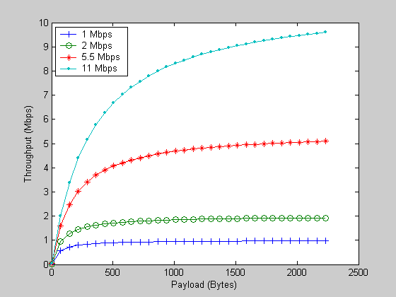

Figure 33 Throughput for 802.11b with short preamble and no acknowledgment, TC 6

Table 34 Throughput results for 802.11b with short preamble and no acknowledgment, TC6

For 2304 bytes payload
Data Rate (Mbps) | Throughput (Mbps)
1 | 0.98
2 | 1.93
5.5 | 5.10
11 | 9.60

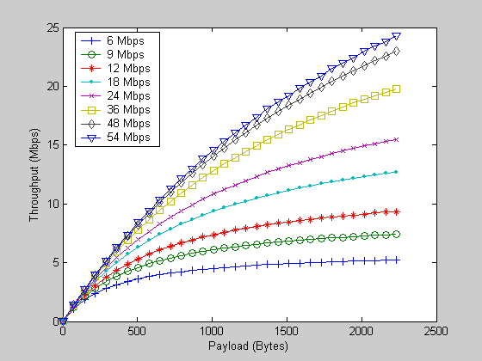

Figure 34 Throughput for 802.11g assuming T_{SLOT} = 20 microsec, TC 2.

Table 35 Throughput results for 802.11g assuming T_{SLOT} = 20 microsec, TC 2.
For 2304 bytes payload
Data Rate (Mbps) | Throughput (Mbps)
6 | 5.23
9 | 7.40
12 | 9.35
18 | 12.71
24 | 15.48
36 | 19.81
48 | 22.96
54 | 24.34

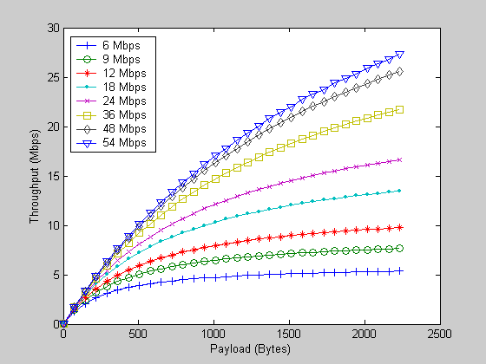

Figure 35 Throughput for 802.11g assuming T_{SLOT} = 20 microsec, TC 3.

Table 36 Throughput results for 802.11g assuming T_{SLOT} = 20 microsec, TC 3.

For 2304 bytes payload
Data Rate (Mbps) | Throughput (Mbps)
6 | 5.35
9 | 7.65
12 | 9.76
18 | 13.47
24 | 16.63
36 | 21.73
48 | 25.60
54 | 27.32

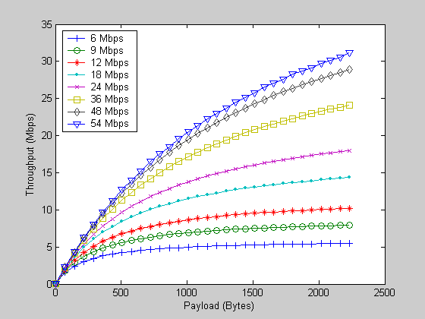

Figure 36 Throughput for 802.11g assuming T_{SLOT} = 20 microsec, TC5.

Table 37 Throughput results for 802.11g assuming T_{SLOT} = 20 microsec, TC5.

For 2304 bytes payload
Data Rate (Mbps) | Throughput (Mbps)
6 | 5.48
9 | 7.93
12 | 10.21
18 | 14.34
24 | 17.97
36 | 24.08
48 | 28.91
54 | 31.12

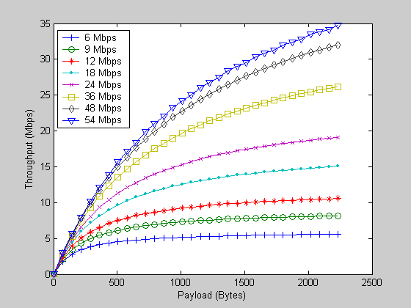

Figure 37 Throughput for 802.11g assuming T_{SLOT} = 20 microsec, TC7.

Table 38 Throughput results for 802.11g assuming T_{SLOT} = 20 microsec, TC7.

For 2304 bytes payload
Data Rate (Mbps) | Throughput (Mbps)
6 | 5.59
9 | 8.14
12 | 10.57
18 | 15.06
24 | 19.13
36 | 26.19
48 | 32.01
54 | 34.75

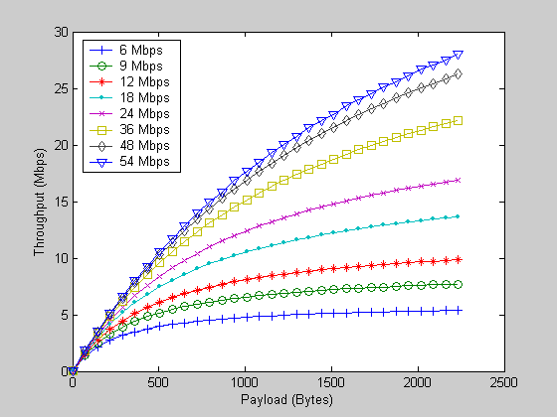
Figure 38 Throughput for 802.11g assuming T_{SLOT} = 20 microsec and no acknowledgment,TC 2.

Table 39 Throughput results for 802.11g assuming T_{SLOT} = 20 microsec and no acknowledgment, TC2.

For 2304 bytes payload
Data Rate (Mbps) | Throughput (Mbps)
6 | 5.38
9 | 7.71
12 | 9.85
18 | 13.65
24 | 16.90
36 | 22.19
48 | 26.23
54 | 28.04

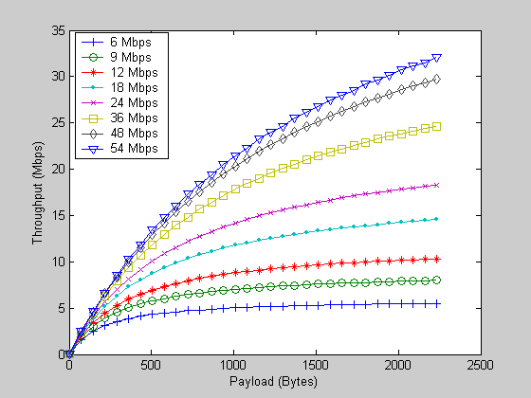

Figure 39 Throughput for 802.11g assuming T_{SLOT} = 20 microsec and no acknowledgment, TC3.

Table 40. Throughput results for 802.11g assuming T_{SLOT} = 20 microsec and no acknowledgment, TC3.

For 2304 bytes payload
Data Rate (Mbps) | Throughput (Mbps)
6 | 5.51
9 | 7.99
12 | 10.31
18 | 14.54
24 | 18.29
36 | 24.64
48 | 29.72
54 | 32.07

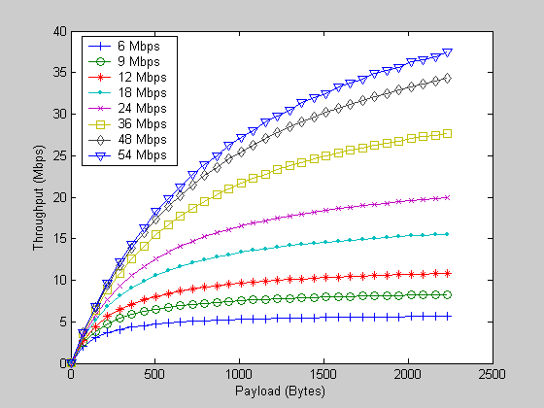

Figure 40 Throughput for 802.11g assuming T_{SLOT} = 20 microsec and no acknowledgment, TC 5.

Table 41. Throughput results for 802.11g assuming T_{SLOT} = 20 microsec and no acknowledgment, TC5.
For 2304 bytes payload
Data Rate (Mbps) | Throughput (Mbps)
6 | 5.65
9 | 8.28
12 | 10.81
18 | 15.55
24 | 19.92
36 | 27.70
48 | 34.29
54 | 37.45

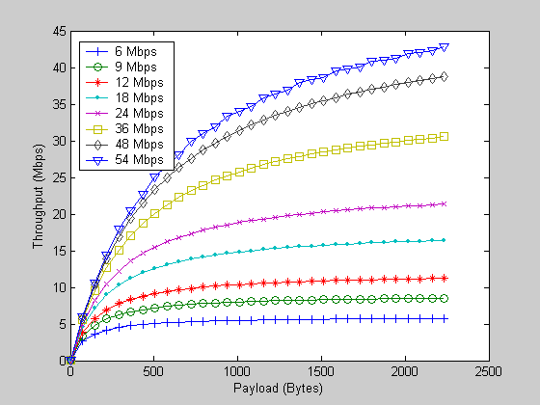

Figure 41 Throughput for 802.11g assuming T_{SLOT} = 20 microsec and no acknowledgment, TC 7.

Table 42. Throughput results for 802.11g assuming T_{SLOT} = 20 microsec and no acknowledgment, TC7.

For 2304 bytes payload
Data Rate (Mbps) | Throughput (Mbps)
6 | 5.76
9 | 8.52
12 | 11.21
18 | 16.40
24 | 21.34
36 | 30.54
48 | 38.75
54 | 42.84

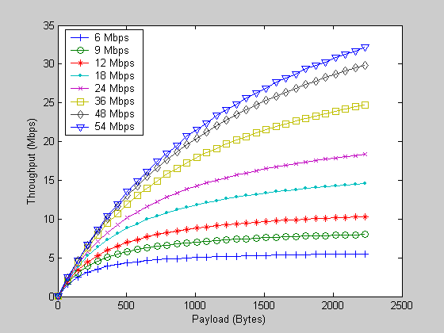

Figure 42 Throughput for 802.11g assuming T_{SLOT} = 9 microsec and no acknowledgment.
for TC 2.

Table 43 Throughput results assuming the physical layer is 802.11g with T_{SLOT} = 9 microsec and no acknowledgment, TC2.

For 2304 bytes payload
Data Rate (Mbps) | Throughput (Mbps)
6 | 5.52
9 | 7.99
12 | 10.32
18 | 14.57
24 | 18.33
36 | 24.73
48 | 29.85
54 | 32.22

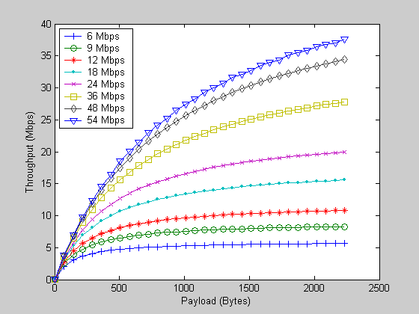

Figure 43 Throughput assuming the physical layer is 802.11g with T_{SLOT} = 9 microsec and no acknowledgment, TC 3

Table 44 Throughput assuming the physical layer is 802.11g with T_{SLOT} = 9 microsec and no acknowledgment, TC 3.

For 2304 bytes payload
Data Rate (Mbps) | Throughput (Mbps)
6 | 5.66
9 | 8.29
12 | 10.82
18 | 15.58
24 | 19.97
36 | 27.80
48 | 34.45
54 | 37.65

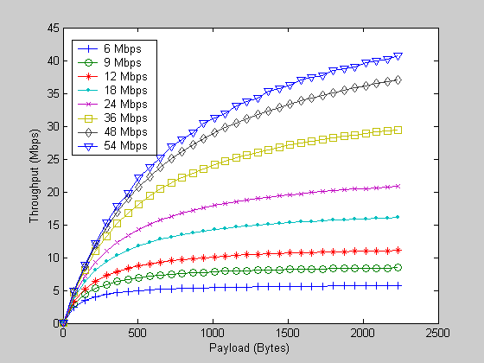

Figure 44 Throughput results assuming the physical layer is 802.11g with T_{SLOT} = 9 microsec and no acknowledgment, TC 5.

Table 45 Throughput results assuming the physical layer is 802.11g with T_{SLOT} = 9 microsec and no acknowledgment, TC 5.

For 2304 bytes payload
Data Rate (Mbps) | Throughput (Mbps)
6 | 5.72
9 | 8.43
12 | 11.07
18 | 16.09
24 | 20.81
36 | 29.45
48 | 37.02
54 | 40.74

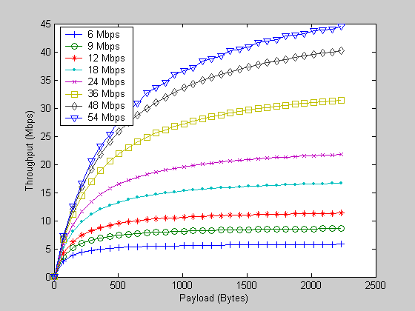

Figure 45 Throughput results assuming the physical layer is 802.11g with T_{SLOT} = 9 microsec and no acknowledgment, TC 7.

Table 46 Throughput results assuming the physical layer is 802.11g with T_{SLOT} = 9 microsec and no acknowledgment, TC 7.

For 2304 bytes payload
Data Rate (Mbps) | Throughput (Mbps)
6 | 5.79
9 | 8.58
12 | 11.33
18 | 16.66
24 | 21.77
36 | 31.42
48 | 40.19
54 | 44.60

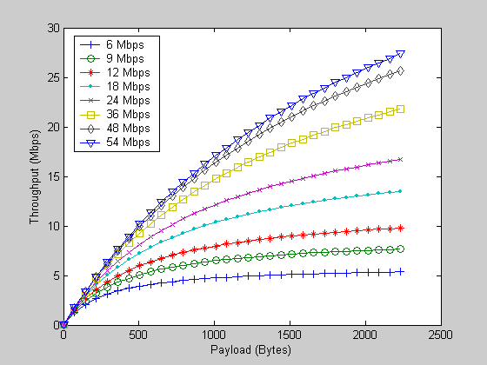

Figure 46 Throughput results assuming the physical layer is 802.11g with
T_{SLOT} = 9 microsec, TC 2

Table 47. Throughput results assuming the physical layer is 802.11g with
T_{SLOT} = 9 microsec, TC 2.

For 2304 bytes payload
Data Rate (Mbps) | Throughput (Mbps)
6 | 5.36
9 | 7.66
12 | 9.77
18 | 13.50
24 | 16.67
36 | 21.80
48 | 25.69
54 | 27.42

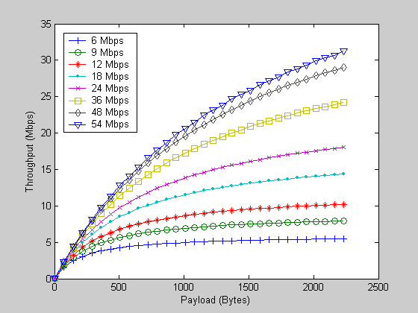

Figure 47 Throughput results assuming the physical layer is 802.11g with
T_{SLOT} = 9 microsec, TC 3.

Table 48 Throughput results assuming the physical layer is 802.11g with
T_{SLOT} = 9 microsec, TC 3.

For 2304 bytes payload
Data Rate (Mbps) | Throughput (Mbps)
6 | 5.49
9 | 7.93
12 | 10.22
18 | 14.37
24 | 18.02
36 | 24.16
48 | 29.02
54 | 31.26

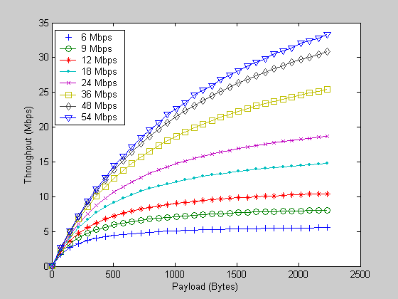

Figure 48. Throughput results assuming the physical layer is 802.11g with
T_{SLOT} = 9 microsec, TC 5.

Table 49. Throughput results assuming the physical layer is 802.11g with
T_{SLOT} = 9 microsec, TC 5.

For 2304 bytes payload
Data Rate (Mbps) | Throughput (Mbps)
6 | 5.55
9 | 8.06
12 | 10.44
18 | 14.79
24 | 18.70
36 | 25.39
48 | 30.83
54 | 33.36

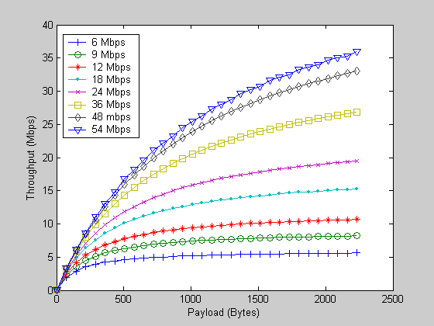

Figure 49 Throughput results ssuming the physical layer is 802.11g with T_{SLOT} = 9 microsec, TC 7.

Table 50 Throughput results ssuming the physical layer is 802.11g with T_{SLOT} = 9 microsec, TC 7.

For 2304 bytes payload
Data Rate (Mbps) | Throughput (Mbps)
6 | 5.62
9 | 8.20
12 | 10.68
18 | 15.28
24 | 19.47
36 | 26.84
48 | 32.99
54 | 35.91

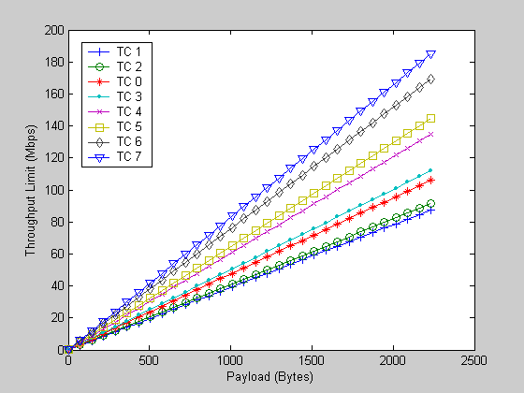

Figure 50. Throughput limit results for 802.11a and 802.11e with acknowledgment

Table 51. Throughput limit results at 2304 bytes payload for 802.11a and 802.11e with acknowledgment
Traffic Category | Throughput Limit (Mbps)
1 | 87.36
2 | 91.38
0 | 106.02
3 | 112
4 | 134.82
5 | 144.65
6 | 169.33
7 | 185.12

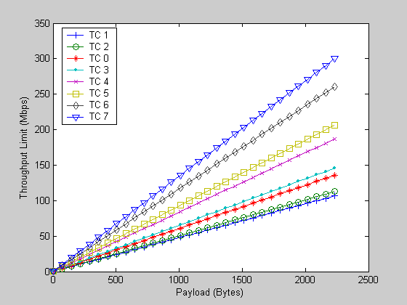

Figure 51. Throughput limit results for 802.11a and 802.11e without acknowledgment

Table 52. Throughput limit results at 2304 bytes payload for 802.11a and 802.11e without acknowledgment
Traffic Category | Throughput Limit (Mbps)
1 | 106.65
2 | 112.71
0 | 135.85
3 | 145.83
4 | 187.06
5 | 206.52
6 | 260.79
7 | 300.24

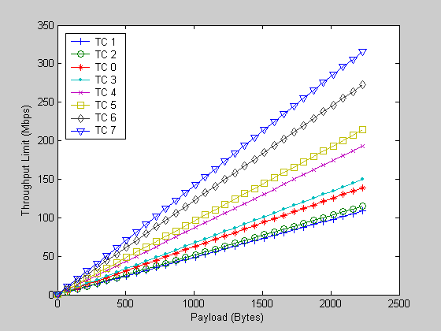

Figure 52. Throughput limit results for 802.11a and 802.11e with acknowledgment, assuming the preamble is sent also at an infinitely high data rate

Table 53. Throughput limit results at 2304 bytes payload for 802.11a and 802.11e with acknowledgment, assuming the preamble is sent also at an infinitely high data rate
Traffic Category | Throughput Limit (Mbps)
1 | 108.6
2 | 114.88
0 | 139.02
3 | 149.49
4 | 193.12
5 | 213.94
6 | 272.73
7 | 316.18

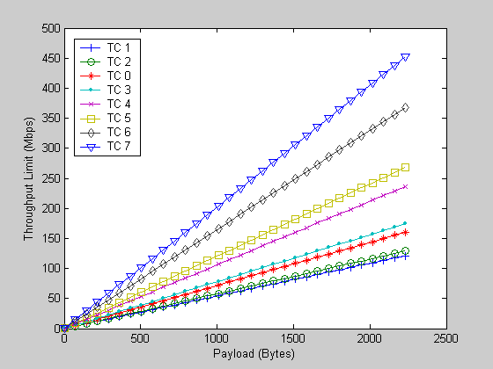

Figure 53. Throughput limit results for 802.11a and 802.11e without acknowledgment, assuming the preamble is sent also at an infinitely high data rate

Table 54. Throughput limit results at 2304 bytes payload for 802.11a and 802.11e without acknowledgment, assuming the preamble is sent also at an infinitely high data rate
Traffic Category | Throughput Limit (Mbps)
1 | 121.11
2 | 128.98
0 | 160.22
3 | 174.28
4 | 236.61
5 | 268.63
6 | 368.33
7 | 452.25

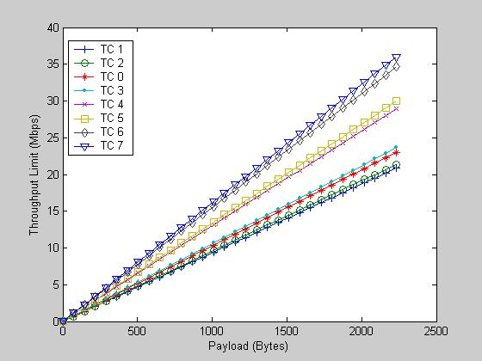

Figure 54. Throughput limit results for 802.11b and 802.11e with acknowledgment and long preamble

Table 55. Throughput limit results at 2304 bytes payload for 802.11b and 802.11e with acknowledgment and long preamble
Traffic Category | Throughput limit (Mbps)
1 | 20.87
2 | 21.37
0 | 23.02
3 | 23.63
4 | 29
5 | 29.97
6 | 34.62
7 | 36.02

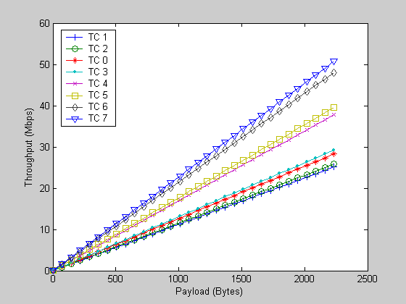

Figure 55. Throughput limit results for 802.11b and 802.11e with acknowledgment, using
a short preamble

Table 56. Throughput limit results at 2304 bytes payload for 802.11b and 802.11e with acknowledgment, using a short preamble
Traffic Category | Throughput limit (Mbps)
1 | 25.09
2 | 25.82
0 | 28.27
3 | 29.19
4 | 37.85
5 | 39.52
6 | 48.02
7 | 50.75

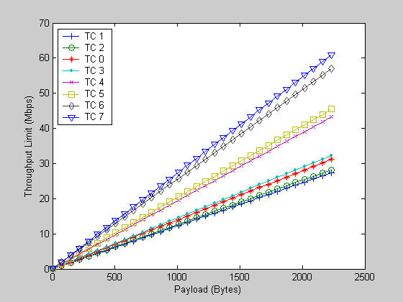

Figure 56. Throughput limit results for 802.11b and 802.11e without acknowledgment.

Table 57. Throughput limit results at 2304 bytes payload for 802.11b and 802.11e without acknowledgment.
Traffic Category | Throughput limit (Mbps)
1 | 27.36
2 | 28.22
0 | 31.18
3 | 32.30
4 | 43.25
5 | 45.46
6 | 57.07
7 | 60.97

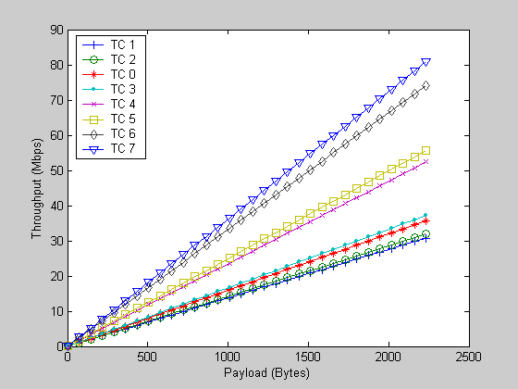

Figure 57. Throughput limit results for 802.11b with a short preamble.
and 802.11e without acknowledgment.

Table 58. Throughput limit results at 2304 bytes payload for 802.11b with a short preamble.
and 802.11e without acknowledgment,.
Traffic Category | Throughput limit (Mbps)
1 | 30.75
2 | 31.84
0 | 35.66
3 | 37.14
4 | 52.39
5 | 55.65
6 | 74.12
7 | 80.83

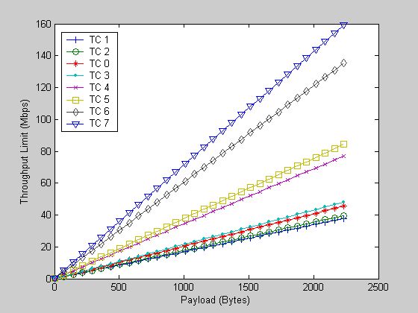

Figure 58. Throughput limit results for 802.11b and 802.11e with acknowledgment, assuming the preamble is also sent at an infinite data rate.

Table 59. Throughput limit results at 2304 bytes payload for 802.11b and 802.11e with acknowledgment, assuming the preamble is also sent at an infinite data rate.

Traffic Category | Throughput limit (Mbps)
1 | 37.85
2 | 39.52
0 | 45.57
3 | 48.02
4 | 77.00
5 | 84.26
6 | 135.53
7 | 159.50

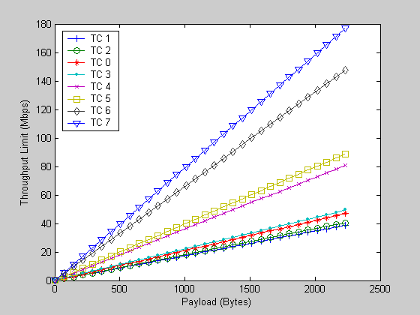

Figure 59. Throughput limit results for 802.11b and 802.11e without acknowledgment, assuming the preamble is also sent at an infinite data rate.

Table 60. Throughput limit results at 2304 bytes payload for 802.11b and 802.11e without acknowledgment, assuming the preamble is also sent at an infinite data rate.
Traffic Category | Throughput limit (Mbps)
1 | 38.75
2 | 40.51
0 | 46.89
3 | 49.49
4 | 80.83
5 | 88.87
6 | 147.64
7 | 176.87

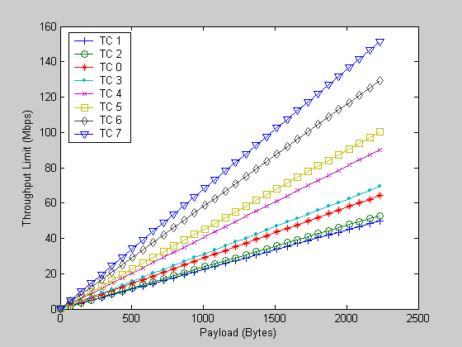

Figure 60 Throughput limit results for 802.11g and 802.11e with acknowledgment.

Table 61. Throughput limit results at 2304 bytes payload for 802.11g and 802.11e with acknowledgment.
Traffic Category | Throughput limit (Mbps)
1 | 49.90
2 | 52.85
0 | 64.26
3 | 69.24
4 | 90.22
5 | 100.36
6 | 129.45
7 | 151.39

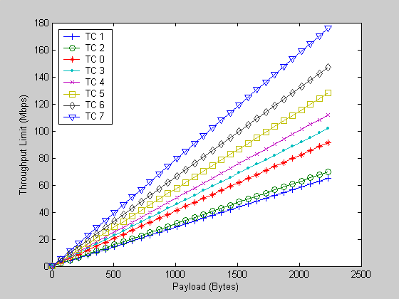

Figure 61 Throughput limit results for 802.11g and 802.11e with acknowledgment, assuming
the slot time is 9 microsec.

Table 62 Throughput limit results at 2304 bytes payload for 802.11g and 802.11e with acknowledgment, assuming the slot time is 9 microsec.
Traffic Category | Throughput limit (Mbps)
1 | 64.84
2 | 69.92
0 | 98.38
3 | 101.79
4 | 112
5 | 128.06
6 | 147.03
7 | 176

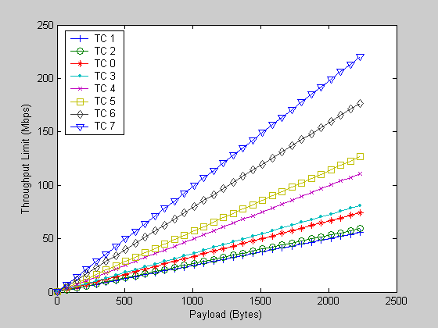

Figure 62 Throughput limit results for 802.11g and 802.11e without acknowledgment.

Table 63 Throughput limit results at 2304 bytes payload for 802.11g and 802.11e without acknowledgment.
Traffic Category | Throughput limit (Mbps)
1 | 55.65
2 | 59.35
0 | 74.12
3 | 80.83
4 | 110.96
5 | 126.70
6 | 176.87
7 | 220.54

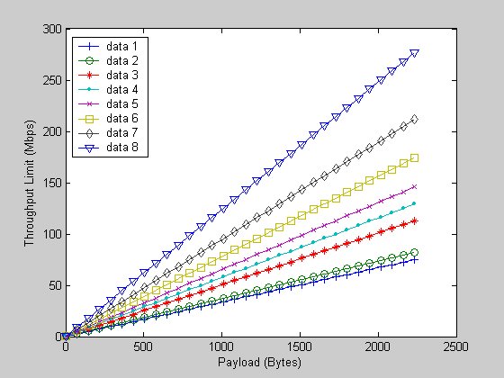

Figure 63 Throughput limit results for 802.11g and 802.11e without acknowledgment, and slot time equal to 9 microsec.

Table 64 Throughput limit results at 2304 bytes payload for 802.11g and 802.11e without acknowledgment, and slot time equal to 9 microsec.
Traffic Category | Throughput limit (Mbps)
1 | 74.90
2 | 81.76
0 | 112.71
3 | 128.98
4 | 145.83
5 | 174.28
6 | 211.41
7 | 276.96

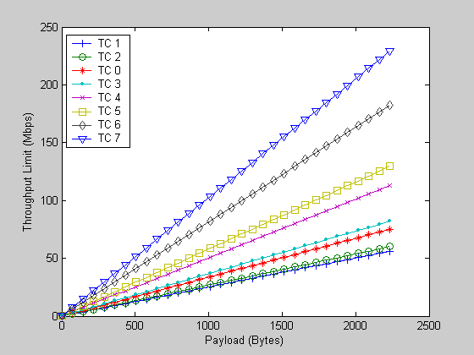

Figure 64. Throughput limit for 802.11g and 802.11e with acknowledgment, assuming the preamble is also sent at an infinite data rate.

Table 65. Throughput limit results at 2304 bytes payload for 802.11g and 802.11e with acknowledgment, assuming the preamble is also sent at an infinite data rate.
Traffic Category | Throughput limit (Mbps)
1 | 56.18
2 | 59.95
0 | 75.06
3 | 81.95
4 | 113.06
5 | 129.45
6 | 182.29
7 | 229.03

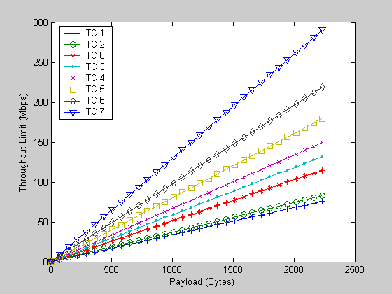

Figure 65 Throughput limit for 802.11g assuming the slot time is 9 microsec., and 802.11e with acknowledgment, assuming the preamble is also sent at an infinite data rate.

Table 66. Throughput limit at 2304 bytes payload for 802.11g assuming the slot time is 9 microsec., and 802.11e with acknowledgment, assuming the preamble is also sent at an infinite data rate.
Traffic Category | Throughput limit (Mbps)
1 | 75.86
2 | 82.90
0 | 114.88
3 | 131.84
4 | 149.49
5 | 179.54
6 | 219.19
7 | 290.47

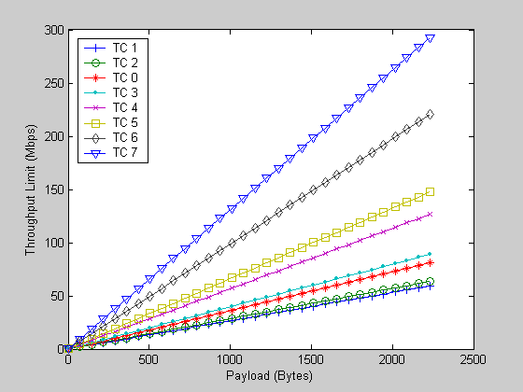

Figure 66. Throughput limit for 802.11g and 802.11e without acknowledgment, assuming the preamble is also sent at an infinite data rate, and the slot time is 20 microsec.

Table 67. Throughput limit at 2304 bytes payload for 802.11g and 802.11e without acknowledgment, assuming the preamble is also sent at an infinite data rate, and the slot time is 20 microsec.
Traffic Category | Throughput limit (Mbps)
1 | 59.35
2 | 63.57
0 | 80.83
3 | 88.88
4 | 126.70
5 | 147.64
6 | 220.54
7 | 292.85

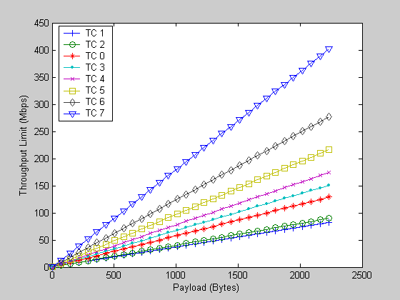

Figure 67. Throughput limit for 802.11g and 802.11e without acknowledgment, assuming the preamble is also sent at an infinite data rate, and the slot time is 9 microsec.

Table 68. Throughput limit at 2304 bytes payload for 802.11g and 802.11e without acknowledgment, assuming the preamble is also sent at an infinite data rate, and the slot time is 9 microsec.
Traffic Category | Throughput limit (Mbps)
1 | 81.76
2 | 89.96
0 | 128.98
3 | 150.75
4 | 174.28
5 | 216.53
6 | 276.96
7 | 401.44

Table 69. Delay Lower Limit for 802.11a and 802.11e in the backwards-compatible case
TC | Minimum Delay (milisec)
0 | 0.168
1 | 0.159
2 | 0.132
3 | 0.123
4 | 0.096
5 | 0.087
6 | 0.069
7 | 0.060

Table 70 Delay Lower Limit for 802.11a, when the preamble and the header are sent at a data rate, approaching infinity

TC | Minimum Delay (milisec)
0 | 0.148
1 | 0.139
2 | 0.112
3 | 0.103
4 | 0.076
5 | 0.067
6 | 0.049
7 | 0.040

Table 71 Delay Lower Limit for 802.11b and 802.11e in the backwards-compatible case

TC | Minimum Delay (milisec)
0 | 0.653
1 | 0.633
2 | 0.573
3 | 0.553
4 | 0.413
5 | 0.393
6 | 0.313
7 | 0.293

Table 72 Delay Lower Limit for 802.11b when the preamble and the header are sent at a data rate, approaching infinity

TC | Minimum Delay (milisec)
0 | 0.461
1 | 0.441
2 | 0.381
3 | 0.361
4 | 0.221
5 | 0.201
6 | 0.121
7 | 0.101

Table 73 Delay Lower Limit for 802.11g and 802.11e in the backwards-compatible case
TC | Minimum Delay (milisec)
0 | 0.321
1 | 0.301
2 | 0.241
3 | 0.221
4 | 0.161
5 | 0.141
6 | 0.101
7 | 0.081

Table 74 Delay Lower Limit for 802.11g when the preamble and the header are sent at a data rate, approaching infinity

TC | Minimum Delay (milisec)
0 | 0.301
1 | 0.281
2 | 0.221
3 | 0.201
4 | 0.141
5 | 0.121
6 | 0.081
7 | 0.061

Table 75 Delay Lower Limit for 802.11g and 802.11e in the backwards-compatible case
with slot time equal to 9 microseconds.

TC | Minimum Delay (milisec)
0 | 0.239
1 | 0.219
2 | 0.159
3 | 0.139
4 | 0.123
5 | 0.103
6 | 0..085
7 | 0.065

Table 76 Delay Lower Limit for 802.11g when the preamble and the header are sent at a data rate, approaching infinity, and a slot time, equal to 9 microseconds.

TC | Minimum Delay (milisec)
0 | 0.219
1 | 0.199
2 | 0.139
3 | 0.119
4 | 0.103
5 | 0.083
6 | 0.065
7 | 0.045

