IEEE P802.11
Wireless LANs
Physical (PHY) layer and Medium Access Control (MAC) layer Proposal for IEEE 802.11n
Date: September 1, 2004
Author: Andreas F. Molisch, Daqing Gu, Jinyun Zhang, Neelesh Mehta
Mitsubishi Electric Research Laboratories (MERL)
201 Broadway, Cambridge, MA 02139, U.S.A.
Phone: 617-621-7558 Fax: 617-621-7550
Email: (molisch, dgu, jzhang, mehta)@merl.com

Yukimasa Nagai, Hiroyoshi Suga, Fumio Ishizu, Keishi Murakami
Mitsubishi Electric Corporation
5-1-1 Ofuna, Kamakura Kanagawa, Japan, 2478501
Phone: +81-467-41-2488 Fax: +81-467-41-2519
Email: (yuki-n, hsuga, ishizu, kmurak)@isl.melco.co.jp
Jianxuan Du, Georgia Institute of Technology, (jxdu@ece.gatech.edu)
Jeffrey (Zhifeng) Tao, Polytechnic University, (jefftao@photon.poly.edu)
Yuan Yuan, University of Maryland, College Park, (yuanyuan@cs.umd.edu)
Ye (Geoffrey) Li, Georgia Institute of Technology, (liye@ece.gatech.edu)

Abstract

This document proposes a number of add-on techniques for meeting the performance requirements of 802.11n systems. We assume a baseline system using a layered (BLAST-like) MIMO-OFDM physical layer, and an 802.11e-based MAC. We then present a variety of techniques that greatly enhance the efficiency of that baseline system, without significantly increasing the complexity. For the PHY, those techniques encompass (1) statistical rate allocation for the different layers, (2) RF-preprocessing combined with antenna selection, and (3) quasi-block-diagonal low-density parity check (LDPC) codes. Those techniques, which can be used separately or jointly, reduce the SNR requirements on the PHY layer by several dB. Furthermore, we introduce several new MAC techniques for improving the efficiency of a 802.11e-type MAC: (1) frame aggregation at both MSDU level and PSDU level, with a novel internal collision resolution scheme and an original solution to potential collision of multiple BlockACKs (2) adaptive distributed channel access (ADCA), a CSMA/CA scheme that takes advantage of adaptive batch transmission and opportunistic selection of high rate stations, (3) sequential coordinated channel access (SCCA), which combines the multipoll and CSMA-alike backoff to reduce the overhead associated with polling and achieve higher efficiency, and (4) efficient BlockACK, which streamlines the legacy BlockACK frame defined in IEEE 802.11e. Those schemes can increase the efficiency by up to 100 % of the legacy IEEE 802.11 MAC. The MAC schemes can be combined with any PHY, and vice versa.
Table of Contents
Executive Summary 5
Part I: Physical (PHY) Layer Proposal 7
1. Introduction 7
1.1 A Brief Introduction to MIMO-OFDM Systems 8
1.1.1 Demand for High Throughput Wireless Systems 8
1.1.2 MIMO Wireless Communication 8
1.1.3 Layered Structures 10
1.2 Baseline System: System Overview 11
1.3 Proposed schemes for performance improvement 13
1.3.1 Statistical rate allocation 13
1.3.2 Joint RF-baseband preprocessing 14
1.3.3 Quasi-block-diagonal LDPC coding 15
2 Statistical Rate Allocation 17
2.1 Proposed Rate Allocation for Layered Systems 17
2.2 Background and motivation 18
2.3 Derivation of the algorithm 18
2.4 Simulation Results 21
3 Joint RF-Baseband Processing with Antenna Selection for Lower Complexity MIMO Systems 23
3.1 Proposed Solution 23
3.1.1 Phase-only Solution Amenable to Variable Phase-Shifters Implementation 25
3.2 Background and motivation 25
3.3 Derivation of the Algorithm 27
3.3.1 Channel Model 27
3.3.2 FFT-Based Pre-processing 27
3.3.3 Time-Invariant Pre-processing for spatial multiplexing 27
3.3.4 Instantaneous Channel State-based RF pre-processing 28
3.3.5 Phase-shift Only Approximations for RF Pre-processing 28
3.3.6 Beam Patterns of FFT and channel statistics based solution 29
3.4 Simulation Results 30
3.5 Robustness to RF hardware non-idealities and selection non-idealities 32
4 Quasi-Block Diagonal LDPC 33
4.1 Proposed QBD-LDPC for Layered Systems 33
4.2 Background and Motivation 35
4.3 General Description of the QBD LDPC code 35
4.4 Encoding and Decoding of QBD-LDPC Space-time codes 36
4.4.1 Encoding 36
4.4.2 Decoding 36
4.5 Simulation Results 38
5 Conclusions 39
Part II: Medium Access Control (MAC) Layer Proposal 43
6 Introduction 43
6.1 Background 43
6.2 MAC System Overview 44
6.3 Proposed Schemes for Performance Improvement 46
6.3.1 Frame Aggregation at MSDU and/or PSDU Level 46
6.3.2 Adaptive Distributed Channel Access (ADCA) 46
6.3.3 Sequential Coordinated Channel Access (SCCA) 47
6.3.4 Efficient BlockACK 47
7 Frame Aggregation at MSDU and/or PSDU Level 48
7.1 Frame Aggregation Mechanism in Contention Period 49
7.1.1 Aggregation at Level 1 (AL-1) 49
7.1.2 Aggregation at Level 2 (AL-2) 51
7.2 Frame Aggregation Mechanism in Contention Free Period 53
7.3 Acknowledgement Scheme 53
7.3.1 Contention Period 53
7.3.2 Contention Free Period 56
7.4 ADDAL Management Procedure 57
7.5 Discussion 59
8 Adaptive Distributed Channel Access (ADCA) 60
8.1 Basic Algorithm 60
8.2 Adaptive Batch Transmission and Block Acknowledgement 61
8.3 Opportunistic Selection of High-Rate STAs 61
8.4 Quality of Service 62
8.5 Backward Compatibility and Implementation Issues 62
8.6 Performance Evaluations 62
8.6.1 MAC Throughput Gain 63
8.6.2 Effect of Multirate Transmissions 64
8.6.3 Impact of Parameters 64
8.6.4 IEEE 802.11n Usage Model and Simulation Results 67
8.6.5 Impact of Physical Channel Error 68
8.6.6 Augmentation with Other Technologies 68
9 Sequential Coordinated Channel Access (SCCA) 70
9.1 Basic Algorithm 70
9.1.1 Resource Reservation 70
9.1.2 Resource Allocation 71
9.1.3 Data Transmission 71
9.1.4 Resource Renegotiation 73
9.1.5 Resource Relinquishment 74
9.2 Quality of Service 74
9.3 Backward Compatibility and Implementation Issues 75
9.4 Performance Evaluation 75
9.4.1 Throughput Performance 75
9.4.2 Impact of Increased Maximum Packet Size 76
10 Frame Format 78
10.1 ADCA-Related Frames 78
10.2 SCCA-Related Frames 78
10.2.1 Resource Request (RRQ) 79
10.2.2 Resource Allocation (RAL) 80
10.2.3 Resource Relinquishment (RRL) 81
11 Efficient BlockACK 83
11.1 New BlockACK Frame Format 83
11.2 Effect of BlockACK on Rate Adaptation 84
12 Conclusion 86
Appendix 89

Executive Summary

The goal of the 802.11n task group (TGn) is the development of a new standard that allows wireless communications with data rates in excess of 100MBits/s at the MAC SAP to SAP. This high data rate shall be achieved while using only 20MHz of bandwidth. This task requires the development of a physical layer with high spectral efficiency, as well as a high-efficiency MAC protocol.

Building on the success of 802.11a/g, we feel that the new PHY and MAC should be an evolution of the current standard, reusing as many aspects as possible. On the other hand, the ambitious task set in the PAR and the selection criteria document, requires innovative solutions. In this document, we provide a range of add-on techniques that provide considerable performance enhancements to well-established methods, while leading only to minimal increase in the complexity. Those techniques can work in combination with many of the anticipated “baseline” (full) proposals to 802.11n.

For the PHY layer, it is anticipated that any baseline proposal will be a layered (BLAST) MIMO-OFDM scheme, with 2×2 antennas as mandatory minimum configuration. For such a scheme, we present the following innovations:
- Statistical data rate allocation,
- Joint radio frequency (RF)-baseband processing for antenna selection, and
- Quasi-block diagonal low-density parity-check (QBD-LDPC) codes.
These techniques can be used, individually or jointly, in conjunction with any layered MIMO-OFDM scheme.

For the MAC layer, our basis is the 802.11e standard, to which we add several key improvements
- Frame aggregation at MSDU and/or PSDU levels substantially reduces the overhead associated with data transmission. This frame aggregation proposal also provides a novel internal collision resolution mechanism within one station and an original solution to the potential collision of multiple BlockACKs. It is worthwhile to note that the frame aggregation can be applied to both contention period and contention free period.
- Adaptive distributed channel access (ADCA) used in the contention period is a highly efficient CSMA/CA-based random access protocol that uses adaptive batch transmission and opportunistic selection to improve channel efficiency.
- Sequential coordinated channel access (SCCA) operates during the contention free period (CFP). To significantly reduce the overhead and improve overall throughput, it combines multipoll with CSMA-alike channel access and eliminates the per-packet polling message.
- Efficient BlockACK fulfills the same functionality of the legacy BlockACK initially defined in IEEE 802.11e, but in a more flexible and bandwidth efficient manner.

These schemes lead to an increase in the MAC efficiency of several tens of percent, and a reduction of the required signal-to-noise ratio (for the PHY) of several dB, while adding only minimal complexity. All the techniques can be combined or used separately; furthermore, the MAC schemes can be used in conjunction with any PHY, and vice versa. They thus seem ideally suited for inclusion in the upcoming standard.

Part I: Physical (PHY) Layer Proposal

Introduction
Wireless LANs, and specifically the IEEE 802.11 standard, are among the greatest wireless success stories of recent years. Building on that experience, taskgroup 802.11n will develop a standard that can provide data rates in excess of 100Mbit/s in a 20MHz band. It seems certain that multiple input multiple output (MIMO) systems will be the basis for these systems, as only these provide the spectral efficiency mandated by the standard. Furthermore, given that the 802.11a standard already employs Orthogonal Frequency Division Multiplexing (OFDM) to achieve higher data rates, the 802.11n physical layer is widely expected to be based on MIMO-OFDM technology.

MIMO systems have been studied now for almost 20 years, and a large number of papers have been published on the topic. On one hand, theoretical investigations into the ultimate performance limits (information-theoretic capacity) abound (for an overview, see, e.g., [32][33][34][35]. On the other hand, reduced-complexity schemes based on layered structures that are suitable for practical implementation have been suggested, and also demonstrated [36]. These schemes transmit information over space and time using one-dimensional codecs and leverage the knowledge and the near-capacity performance that these codecs now achieve. While layered structures do require lower complexity to implement and provide lower costs, they do not achieve the full capacity offered by MIMO systems.

It is anticipated that a number of proposals for 802.11n will be based on those layered structures, e.g., VBLAST. The goal of our presentation is to present add-on techniques that improve the performance while adding little additional complexity. The techniques can be combined with essentially all currently known MIMO techniques, and are thus suitable for the inclusion in a final standard independent of which “baseline” is actually chosen. These techniques are:
- statistical data rate allocation,
- joint radio frequency (RF)-baseband processing for antenna selection, and
- quasi-block diagonal low-density parity-check (QBD-LDPC) codes.
Each technique, or a combination of them, can be used as a supplement to the conventional layered systems.

The rest of the document is organized the following way. Section 1 provides a brief introduction to MIMO-OFDM, and the “generic” layered MIMO-OFDM system that we use as a baseline. We then give a summary of the essential principles of our proposed techniques. Sections 2-4 provide more details of our three techniques. Each section starts out with a “concise” description (a suggestion of text that could be included in a standards draft), followed by more extensive explanations of the background, derivation of key theoretical results, and simulation results that show the performance gains of our techniques. A summary wraps up the conclusions about the advantages of our techniques.

A Brief Introduction to MIMO-OFDM Systems
This section gives a general introduction to MIMO-OFDM systems. The knowledgeable reader can skip this section and go directly to Sec. 1.2, which describes the considered baseline system, and Sec. 1.3, which introduces our new techniques for the performance improvement.

Demand for High Throughput Wireless Systems
There has been increasing demand for the wireless link capability for both office and home applications. There exist two major IEEE standards for wireless LAN, IEEE 802.11a/g and 802.11b. IEEE 802.11b radios transmit at 2.4 GHz and send data up to 11 Mbps using direct sequence spread spectrum. In contrast, IEEE 802.11a(g) radios transmit at 5 (2.4) GHz and provide data rates up to 54 Mbit/s using Orthogonal Frequency Division Multiplexing (OFDM). Although 802.11a supports a much higher rate than 11b, it operates over a relatively shorter range. In addition, even the 54 Mbit/s physical layer throughput may not be able to meet the increasing demand of high-bandwidth applications, such as wireless digital TV, etc. As a result, in the IEEE 802.11n standard requires at least 100 Mbit/s MAC-MAC SAP in a 20 MHz channel. Backward compatibility with the legacy 802.11a devices is also desired.

The requirement of the 100Mbit/s within a 20MHz band at the MAC actually poses two challenges: one is to provide a physical layer with very high spectral efficiency; the other one is the creation of a high-efficiency MAC, in order that the data rates delivered by the physical layer are actually preserved by the MAC. The latter goal can be solved by techniques that are presented in Part II of this contribution; the former goal is best approached by the use of MIMO systems.

MIMO Wireless Communication
Multiple input multiple output (MIMO) wireless systems that employ multiple antenna elements at the transmitter and receiver are a very promising solution to achieve the high data rates without any increase in the required bandwidth -- all the signals are transmitted at the same frequency and the spatial characteristics of the wireless channel are exploited to recover the signal at the receiver.

The multiple antennas in MIMO systems can be exploited in two different ways. One is the creation of a highly effective antenna diversity system that provides robustness against the time-varying nature of the wireless channel. The other is the use of the multiple antennas for the transmission of several parallel data streams to increase the capacity of the system. These techniques can also be combined with each other – an approach that is especially useful in asymmetric MIMO systems that have an unequal number of antenna elements at the transmitter and the receiver.

Antenna diversity at the receiver is well-known, and has been studied for more than 50 years. The different signal copies are linearly combined, i.e., weighted and added. If we have receive antenna elements, the diversity order, which describes the effectiveness of diversity in avoiding deep fades, is . In other words, the diversity order is related to the slope of the SNR distribution at the combiner output. The multiple antennas also increase the average SNR seen at the combiner output. The study of transmit diversity is much more recent, starting in the 1990s. When the channel is known to the transmitter, we can again "match" the multiple transmitted signal copies to the channel, resulting in the same gains as for receiver diversity. If the channel is unknown at the transmitter, other strategies, like delay diversity or space-time-coding, have to be used. In that case we can achieve a high diversity order, but not also improve the average SNR. The logical next step is the combination of transmit and receive diversity. It has been demonstrated that with transmit and receive antennas, a diversity order of can be achieved [37].

An alternative way of exploiting the multiple antenna elements is the so-called "spatial multiplexing" or "BLAST" approach. Different data streams are transmitted (in parallel) from the different transmit antennas and are separated at the receiver. That these data streams can be separated is intuitively explained by the fact that the signal from each transmit antenna has a unique spatial signature by which the receiver can differentiate it from the signals of the other transmit antennas. The multiple receive antenna elements are used for separating the different data streams at the receiver. We have combinations of the transmit signals. If the channel is well-behaved, so that the received signals represent linearly independent combinations, we can recover the transmit signals as long as . The advantage of this method is that the data rate can be increased by a factor min(,) without requiring any additional spectral resources, whatsoever. This makes this approach ideally suited for the requirements of 802.11n.

The mathematical model for the transmission can be described as follows: At the transmitter, the data stream enters an encoder, whose outputs are forwarded to the transmit antennas. The signals are subsequently upconverted to passband, amplified by a power amplifier, and filtered to meet spectral mask requirements. The received signal is the superposition of all transmitted signals distorted by the channel. For the mathematical description, we omit these stages, as well as their equivalents at the receiver, which allows us to treat the whole problem in equivalent baseband. From the antennas, the signal is sent through the mobile radio channel. We denote the matrix of the channel as
whose entries are the attenuations (transfer functions) from the -th transmit to the -th receive antenna. The channel also adds white Gaussian noise, which is assumed to be independent among the receiver antenna elements.
.
The received signal vector is
,
where y is a $N_{r}×1$ received signal vector, x is an $N_{t}×1$ transmitted signal vector, G is an $N_{r}×N_{t}$ equivalent channel response matrix, and n is the $N_{r}×1$ zero-mean white Gaussian channel noise vector with variance ${N_{0}}/2$ per dimension.

The information-theoretic capacity of the system is given as
where is the identity matrix, is the mean signal-to-noise ratio (SNR) per receiver branch, and is the correlation matrix of the transmit data (for uncorrelated data, it is a diagonal matrix with entries that describe the power distribution among the antennas). The distribution of the power among the different eigenmodes (or antennas) depends on the availability and extent of channel-state information (CSI) at the transmitter.

The above description was valid for flat-fading channels. Propagation channels in 802.11n are frequency selective (delay dispersive), as the system bandwidth is considerably larger than the typical coherence bandwidth of the channel [38]. For this reason OFDM is used (as in 802.11a), which divides the available bandwidth into a number of subchannels, each of which is flat-fading. MIMO transmission can then be used on each of the subchannels separately. Therefore, an understanding of MIMO in flat-fading channels also provides an understanding of most of the principles of MIMO-OFDM.

One important difference is that the frequency-selective channels provide an inherent frequency diversity. This diversity is exploited if the transmitted data are coded not on a tone-by-tone basis, but rather jointly encoded [39], [40] over all the tones or at least a subset of them. Such a joint encoding allows a full exploitation of the capacity, which is given (capacity per unit frequency) as
where is the bandwidth of the considered system. This equation implies that frequency selectivity offers additional diversity that increases the slope of the capacity cumulative distribution function (cdf).

Layered Structures
The promise of high data rates has spurred efforts by numerous researchers to design a practical system that approaches the capacity of MIMO systems with reasonable complexity. The main challenge in MIMO systems is the exponential increase in the decoding complexity of the optimal space-time architecture with the number of transmit antennas.

Layered structures have been shown to be a good trade-off between performance and complexity [41]. These provide a way of generating signals in multi-antenna systems such that the receiver is able to significantly reduce the space-time interference. Furthermore, only one-dimensional codecs, for which capacity approaching codes are now available, are used as building blocks and help avoid the exponential growth in complexity with the number of spatial dimensions.

In layered systems, such as vertical Bell Labs layered space-time structure (V-BLAST), first proposed by Foschini [3-5], the input data stream is demultiplexed, independently coded using 1-dimensional coding, and simultaneously sent via different transmit antennas. In this document, the terms substream and layer are used interchangeably. To detect each substream, linear processing according to zero-forcing (ZF) or minimum mean square-error (MMSE) criteria is used to null the undetected substreams in the received signal. The contribution of detected substreams is subtracted by decision-directed successive interference cancellation (SIC). With the simplicity of linear processing and the nonlinear SIC process, the complexity of decoding signals in a MIMO system is dramatically reduced, becoming approximately linear with the number of spatial data streams.

Let us now give a mathematical decription: the encoding in a layered system is straightforward, since each transmitter sends its (demultiplexed) data substream independently. For the decoding, without loss of generality assume the ith element of x,denoted as $x_{i}$ , is the signal from the ith layer, corresponding to the ith column of G, denoted as.

For the decoding of the i-th layer, we first perform Linear Nulling:
$z_{j}=w_{j}^{H}y$, $j=i,i+1,$
where the $N_{r}×1$ unit-norm weight vector $w_{j}$ nulls signals from all other undecoded layers and is computed according to zero-forcing or MMSE criterion.
Subsequently, we perform Interference Cancellation:
$${\tilde{z}}_{j}=z_{j}−\sum_{i<j}{w_{j}^{H}g_{i}{\hat{x}}_{i},j=i,i+1},$$
where ${\hat{x}}_{i}$'s are the reconstructed signals of already decoded layers.

Baseline System: System Overview
In this section, we describe a “baseline” MIMO-OFDM system that uses the MIMO techniques that are currently available and are very popular. It is based on 2 transmit and 2 receive antennas, with a very simple layered structure (independent data streams from the 2 transmit antennas), and successive interference cancellation at the receiver. The description below can be easily generalized to other systems with different numbers of transmit and receive antennas.

Figure 1 gives the system diagram gives the block diagram for this system. The incoming data stream is first demultiplexed into two parallel streams, each of which is encoded separately, interleaved, and modulated into a QAM constellation (the size of the constellation will be discussed below). The resulting symbols are then OFDM-modulated. This last step entails a serial-parallel conversion, insertion of guard and pilot tones, IFFT (inverse fast Fourier transformation), and prepending of a cyclic prefix. Note that in an actual transmitter, the resulting signal is upconverted, amplified, and bandpass filtered; these steps are omitted in our equivalent baseband model.

In the receiver, the signals from the antenna elements are first bandpass-filtered, amplified, downconverted, lowpass-filtered, and A/D converted. Again, all the above steps are not included in the block diagram of the equivalent baseband model. Then, an FFT is performed on the resulting data stream, and the cyclic prefix of OFDM is stripped off. Subsequently, a layered detection is performed on the signal streams. As discussed in Sec. 1.1.3, linear processing is used to eliminate (or mitigate) the interference from stream 1 to stream 2; serial interference cancellation is then used to eliminate the interference from stream 1 to stream 2. Note that we use the decoded (and re-encoded) data for the interference cancellation, in order to minimize error propagation. The “cleaned-up” data streams are then de-interleaved and multiplexed to give the original data stream. The system is open-loop, which means no instantaneous channel state information (CSI) is needed at the transmitter and no explicit feedback mechanism is required for this purpose.

Figure 1. A 2x2 baseline MIMO-OFDM system.

For our baseline system, we assume that a number of modulation alphabets and code rates are available. The same modulation alphabets and code rates will also be used in the later sections on our schemes for evaluating performance improvements. Standard convolutional coding is used with an additional puncture rate to support a code rate of 7/8. The mandatory use of convolutional codes also guarantees simple backward compatibility with legacy devices.

Table 1. Supported data rates for each layer in a layered MIMO system.
Modulation | Code Rate | Data Rate (bits/subcarrier) | Layer Rate (Mbps)
BPSK | ½ | ½ | 6
BPSK | 2/3 | 2/3 | 8
BPSK | ¾ | ¾ | 9
QPSK | ½ | 1 | 12
QPSK | 2/3 | 4/3 | 16
QPSK | ¾ | 3/2 | 18
16QAM | ½ | 2 | 24
16QAM | 2/3 | 8/3 | 32
16QAM | ¾ | 3 | 36
64QAM | 2/3 | 4 | 48
64QAM | ¾ | 9/2 | 54
64QAM | 7/8 | 21/4 | 63

For the baseline system, we assume that the rates are chosen dependent on the current SNR and other channel quality measures, but that the modulation alphabet and the code rate are identical for all tones as well as for all transmission antennas (i.e., there is no adaptive modulation).

Proposed schemes for performance improvement
The baseline scheme described above can provide quite good results, but has some bottlenecks that prevent it from fully exploiting the capabilities of MIMO-OFDM. Based on the basic layered structure, we propose three technologies that can further enhance system performance. It should be noted that each of these technologies, while delivering significant performance improvement over the basic layered system, requires only a small modification, or even no modification, of the conventional layered structure.

Statistical rate allocation
Figure 2. Transmitter structure of a 2x2 layered system with statistical rate allocation

One of the problems of a layered scheme is that the layer that is to be detected first is more error-prone due to the loss of signal energy by nulling. Optimal detection ordering, in which the layers are decoded in the decreasing order of their signal to noise rations, alleviates this problem to some extent. However, even with optimal detection ordering, the scheme of Sec. 1.2 can achieve only a portion of the system capacity. It is preferable to choose the data rate for each layer dependent on the channel state. However, instantaneous channel knowledge is difficult to come by – it needs to be made available to the transmitter before the channel decorrelates.

Therefore, we suggest selecting the data rates of the different layers based on the expected detection order of that layer and the channel statistics, which change at a much slower rate and are easier to obtain than instantaneous channel knowledge. As we can see from Fig. 2, the changes in the transmitter architecture are rather small; all it needs to do is allow for different rates for the two data streams.

The receiver structure can be the same as the conventional one. The key step here is the identification of the channel statistic, which is easy as the receiver estimates the channel anyway), and the computation of the optimum rates, which can be done in closed form. As explained further in Sec. 2, it hardly increases the complexity of the system while resulting in a gain of several dB.

Joint RF-baseband preprocessing
A major issue with MIMO is the increased complexity, and thus cost, due to the large number of RF chains and A/D converters that it requires. A promising solution is the hybrid-selection scheme, where the "best" out of antenna signals are chosen (at either one or both link ends), downconverted, and processed. This reduces the number of required RF chains from to and thus leads to significant savings. From our discussion in Sec. 1.1, we can deduce that hybrid selection at the transmitter with will give good performance, as it does not reduce the number of possible data streams [42]. However, there is a considerable loss in “beamforming gain” of the system, as the maximum SNR gain is limited by the number of RF chains, not the number of antenna elements.

Our suggestion is to perform a preprocessing of the signals in the RF domain, in order to recover this beamforming gain. As can be seen from Fig. 3, this preprocessing is just an RF module that can be put on the transmitter side between the frequency upconverter (which follows the OFDM modulator), and the antenna elements (note that there are more antenna elements than frequency upconverters). No further changes are required in either the transmitter or the receiver structure, though the channel estimation sequence might require small modifications.

The details of the preprocessing block are described in Sec. 4. Essentially, we use an array of RF phase shifters to better match the transmit signals at the (many) antenna elements to the channel. Thus, while the number of data streams stays constant, the SNR is considerably improved. The choice of the phase shifts can be based either on the channel statistics, or on the instantaneous channel state information. Even hardwiring the preprocessor to be a FFT Butler matrix has been shown to lead to significant performance gains [43].
Figure 3a. Transmitter structure of a layered system with joint RF-baseband processing.

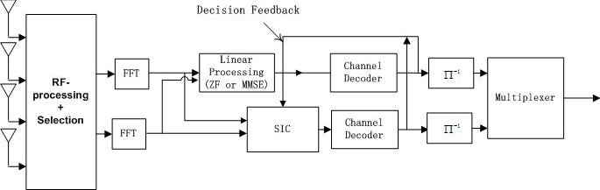
Figure 3b. Receiver structure of a layered system with joint RF-baseband processing.

Quasi-block-diagonal LDPC coding
Unless ideal rate allocation is used, layered structures do not provide optimum capacity. This is intimately related to the fact that the encoding of the data is done separately for each of the streams. On the other hand, this separate encoding is preferable as it considerably simplifies the complexity of the decoder.
Figure 4. System diagram for a layered system with QBD-LDPC.

We now propose a scheme that performs a joint encoding of the different data streams, while adding only minimal complexity to the decoding process. This scheme is based on the properties of LDPC (low-density parity check) codes. Judiciously chosen parity check bits introduce correlation between consecutive layers, so that the layers can be decoded successfully with the help of information from later layers. We shall demonstrate in Sec. 4 that this structure does perform better than layered space-time structures, especially with higher-order modulation alphabets and over frequency-selective channels.

Figure 4 shows a block diagram of the transmitter for this scheme. As the bits from one substream influence the encoding of the other substream, there are differences between it and the baseline structure described earlier. The receiver remains essentially unchanged, and can be implemented using belief-propagation [45]. However, some message passing between the two data streams is required.

Statistical Rate Allocation
In this section, we describe in more detail the statistical rate allocation for our system. We start out with a concise description of the system that we propose for inclusion in the standard. We then provide more background information.

Proposed Rate Allocation for Layered Systems
The data rate of each layer is set differently depending on the detection order of that layer and the channel statistics, according to the block diagram of Fig. 5. Below is the proposed algorithm for statistical data rate allocation.

Figure 5. Transmitter structure of a 2x2 layered system with statistical rate allocation.

Statistical Data Rate Allocation
- From past observations, compute the mean $η_{l}$ and variance $σ_{l}^{2}$ of different layer capacities, which are given by
$C_{l}={\text{log}}_{2}\text{det}\left(I_{N_{r}}+\frac{\text{SNR}}{N_{t}}G_{\left(l−1\right)}G_{{\left(l−1\right)}^{H}}\right)−{\text{log}}_{2}\text{det}\left(I_{N_{r}}+\frac{\text{SNR}}{N_{t}}G_{\left(l\right)}G_{{\left(l\right)}^{H}}\right)$, (2.1)
where G_{(l)} is a submatrix of G of the form
$G_{\left(l\right)}=\left[\begin{matrix}g_{l+1} & g_{l+2} & ⋯ & g_{N_{t}}\end{matrix}\right]$ , and $g_{l}$is the lth column of G. .
- Given a total nominal data rate C_{T}, determine the optimum data rate for layer l as $u_{l}^{}≈η_{l}+\frac{σ_{l}}{\sum{σ_{m}}}\left(C_{T}−\sum_{m=1}^{M}{η_{m}}\right)$
- Choose from the supported data rates the maximum rate $c_{l}^{}$ that is less than or equal to$u_{l}^{}$.
- If there is no such $c_{l}^{}$ (when $u_{l}^{}$ is negative or too small), choose $c_{l}^{}$ to be the lowest supported data rate.

Note that in the system described, we may use different modulations for different layers depending on the chosen data rates. Instead of a rate criterion, the total data rate may instead be chosen according to other desired criteria, for example, one based on outage probability.

Note that the above specification is written in a general way. The details of the implementation (e.g., from which data fields the channel submatrices G_{(l)} are obtained), depends on the final version of the standard. In order to show the flexibility and general applicability of the approach, we use the above, general, description method.

Background and motivation

In a “standard” layered system, as used for our baseline, the input data is evenly divided into several substreams, so that all layers have the same data rate. As a result, the layers to be first detected are more error-prone due to the loss of signal energy by nulling. From the information theory point of view, it can be explained by the fact that the channel capacity for the layer after processing does not support the given data rate with a high probability. Some attempts have been made in the literature to circumvent this problem, e.g., by ordering the detection of the layers according to their SNRs. While this leads to some performance improvements, it remains a fact that layered systems with equal data rates can only achieve a portion of the system capacity. That motivates us to adjust the data rate for each layer so that the channel quality after layer processing can successfully support the transmission of the given data rate with high probability.

An interesting fact has been discovered in Refs. [6, 7]: if we properly select the data rate for each layer, the sum of capacities of all layers (with perfect SIC) is exactly equal to the instantaneous open-loop capacity. To achieve the open-loop capacity, instantaneous data-rate feedback is needed; in other words, the data rates depend on the small-scale fading. However, for an 802.11n system, the channel is highly frequency selective, so that the small-scale fading, taken over the whole system bandwidth, averages out approximately; in other words, the wideband pathloss shows only small variations due to small-scale fading. Consequently, we can approach the open-loop channel capacity by statistically determining the data rate for each layer with a small backoff penalty.

Our approach is to minimize the overall outage probability given the total data rate with the statistical information of the channel.

Derivation of the algorithm
It has been shown in [6-8] that, in order to achieve the open loop capacity, the instantaneous data rate for layer l should be chosen as
$C_{l}={\text{log}}_{2}\text{det}\left(I_{N_{r}}+\frac{\text{SNR}}{N_{t}}G_{\left(l−1\right)}G_{{\left(l−1\right)}^{H}}\right)−{\text{log}}_{2}\text{det}\left(I_{N_{r}}+\frac{\text{SNR}}{N_{t}}G_{\left(l\right)}G_{{\left(l\right)}^{H}}\right)$,
where
$$G_{\left(l\right)}=\left[\begin{matrix}g_{l+1} & g_{l+2} & ⋯ & g_{N_{t}}\end{matrix}\right]$$
and $g_{l}$is the lth column of G.. Furthermore, it has been observed by various researchers that the distribution of the capacity of a MIMO channel can be accurately approximated by a Gaussian distribution at medium and high SNR's [9, 10]. Thus the instantaneous capacity of each layer,C_{l}, is also Gaussian distributed,
$C_{l}\text{\sim }N\left(η_{l},σ_{l}^{2}\right)$,
where $η_{l}$ and $σ_{l}^{2}$ are the mean and variance of the capacity of layer l, respectively. Note that this approximation is also valid for the frequency-selective case; we only have to sum up all the data rates of the subcarriers for each layer and compute the corresponding first and second moments. The variance of the data rates is reduced compared to the flat-fading case.

Instead of dynamically changing the data rate for each layer, we fix the data rate of layer l to $u_{l}$. To minimize $P_{\text{out}}$, the outage probability of a layered system, we maximize the probability that no layers have data rates greater than their respective layer capacities, i.e., we minimize
$1−P_{\text{out}}=\prod_{l=1}^{M}{\int{\frac{1}{\sqrt{2π}σ_{l}}e^{−\frac{{\left(t−η_{l}\right)}^{2}}{2σ_{l}^{2}}}\text{dt}}}$,
subject to the constraint that the total data rate is fixed,
$\sum_{l=1}^{M}{u_{l}=C_{T}}$.

eWe now derive the optimum data rate for each layer. Let x_{l} denote the difference between the expected rate and the actual rate:
$x_{l}=u_{l}−η_{l}$.
By setting up the equivalent Lagrangean, we try to find stationary points of the following expression
$J=\text{log}\left(\prod_{l=1}^{M}{\int{\frac{1}{\sqrt{2π}σ_{l}}e^{−\frac{t^{2}}{2σ_{l}^{2}}}\text{dt}}}\right)−λ\left(\sum_{l=1}^{M}{x_{l}}+\sum_{l=1}^{M}{η_{l}}−C_{T}\right)$.
We can easily verify that the stationary points satisfy
$$−\frac{e^{−\frac{x_{l^{2}}}{2σ_{l}^{2}}}}{\int{\frac{1}{\sqrt{2π}σ_{l}}e^{−\frac{t^{2}}{2σ_{l}^{2}}}\text{dt}}}=λ,\begin{matrix} & l=1,2,⋯,M\text{.}\end{matrix}$$

For small x_{l}, the denominator is approximately equal to 1, since
$\int{\frac{1}{\sqrt{2π}σ_{l}}e^{−\frac{t^{2}}{2σ_{l}^{2}}}\text{dt}}1,\begin{matrix} & x_{l}\end{matrix}σ_{l}\text{<<}0$.
Therefore, we have
$x_{l}^{}≈\frac{σ_{l}}{\sum{σ_{m}}}\left(C_{T}−\sum_{m=1}^{M}{η_{m}}\right)$,
and the optimum data rate for layer l is
$u_{l}^{}≈η_{l}+\frac{σ_{l}}{\sum{σ_{m}}}\left(C_{T}−\sum_{m=1}^{M}{η_{m}}\right)$.
The outage probability for layer l, P_{l}, is then given by
$P_{l}^{}=\int{\frac{1}{\sqrt{2π}σ_{l}}e^{−\frac{t^{2}}{2σ_{l}^{2}}}\text{dt}}=\int{\frac{1}{\sqrt{2π}}e^{−\frac{t^{2}}{2}}\text{dt}}$,
and is the same for all layers. Thus, the minimum overall outage probability is achieved when each layer has the same layer outage probability. Define the normalized capacity margin as
$ϕ\overset{Δ}{=}\frac{\left(\sum{η_{m}}−C_{T}\right)}{\sum{σ_{m}}}$.
The optimum overall outage probability is then
$P_{\text{out}}^{}=1−\prod_{l=1}^{M}{\left(1−P_{l}^{}\right)}=1−{\left(\int{\frac{1}{\sqrt{2π}}e^{−\frac{t^{2}}{2}}\text{dt}}\right)}^{M}$,
which states the interesting fact that the minimum overall outage probability of a layered system is uniquely determined by the normalized capacity margin.

From the results above, the statistical method given in Section 2.1 can be used for determining the data rate allocation in follwing two different ways:
- given a certain total data rate, the data rates for each layer can be determined so that the total outage probability (and thus necessity for retransmission) is minimized.
- Given a desired outage probability, the optimum data rates on each layer can be determined so that the total data rate is maximized.

There are a few practical issues to be addressed.
- In practical communication systems, we only have a limited number of combinations of modulation and coding rate so that the supported data rates $c_{1}<c_{2}<⋯<c_{N}$ are discrete, N is the number of supported data rates. We solve this problem by chosing the data rate that is closest (but smaller than) to the optimum data rates u. If no data rate lies below the optimum, we chose the smallest supported data rate.
- The Gaussian distribution has a negative tail, making the analysis inapplicable for the low SNR case since the $u_{l}^{}$ 's may be negative. This is not an issue in our case, since the required SNRs are fairly high (around 20dB) for high-data-rate transmission.

The approach proposed above can also be applied to the cases where the association of transmit antennas with layers is not fixed.

Simulation Results
To demonstrate the performance of rate allocation, a 2x2 layered system with statistical rate allocation is simulated. The 802.11 TGn channel model ‘B’ is used [38]. The OFDM symbol structure conforms to the 802.11a PHY standard in the 5 GHz band. Perfect channel estimation and synchronization is assumed. 1000 bytes of data is transmitted in each packet.

The proposed system is compared with a 2x2 conventional layered system with equal rate allocation. In the conventional system, the 2 substreams, each consisting of data streams with 64QAM modulation and rate 3/4 convolutional coding are sent simultaneously, resulting in a total data rate of 108 Mbps. To make the comparison reasonable, the nominal total information rate, as input to the rate allocation algorithm, is set such that the resultant total information rate after rate allocation is as close to t the conventional system as possible. The rate allocation is optimized for the lowest SNR such that the overall outage probability is below 1%. The optimized rates are as follows:

Table 2 Optimized data rates for different layers.
Detection order | Modulation | Code rate | Data rate (bits/subcarrier) | Layer data rate (Mbps)
Layer 1 | 16QAM | ¾ | 3 | 36
Layer 2 | 64QAM | 7/8 | 21/4 | 63

Figure 6 WER of a 2 x 2 layered system with statistical data rate allocation, 1000B packet

Figure 7 Effective throughput vs. SNR for a 2 x 2 layered system with statistical data rate allocation, 1000B packet.

Figure 8 Effective throughput vs. range for a layered system with statistical data rate allocation, 1000B packet.

Therefore, the total data rate for 1% outage is 99 Mbps, as compared to the ideal 108 target. In Figure 6, the WER’s of the proposed system and the conventional layered system are shown. For a WER of 10%, the proposed system provides an SNR gain of over 5dB.

Figure 7 and 8 draw the effective throughput curve with respect to SNR and range, respectively. The range is calculated with 17dBm total transmit power. The proposed algorithm provides about 5 m range improvement for the same effective throughput.

Joint RF-Baseband Processing with Antenna Selection for Lower Complexity MIMO Systems

Again, this section starts with a concise description of the proposed solution. Background and explanation are given in the subsequent sections.

Proposed Solution
The transmitter and receiver structures for a 4 transmit antenna system with joint RF-baseband processing at the transmitter followed by selection is illustrated in Figure 9a and Figure 9b, respectively. Despite fewer RF chains being used, data rates close to that of a 4x2 system are achievable. When it is used at the receiver side, the receiver structure is similarly defined.

Receiver side:
The received signal y, which contains the signals from the N_{r} antenna elements, is passed through a RF pre-processing matrix M. The output of the matrix is then passed through a L_{r} out of N_{r} switch that selects L_{r} streams. The resulting L_{r} data streams are processed by the receiver in a conventional way, i.e., the same way as data streams in systems without antenna selection.
Figure 9a. The transmitter structure of a layered system with joint RF-baseband processing.

Figure 9b. The receiver structure of a layered system with joint RF-baseband processing.

Transmitter side:
A sequence of steps is in the reverse order to the one given above. The L_{t} data streams are sent through a D/A converter and upconverted, as in a “conventional” system (without antenna selection. A routing switch then connects these L_{t} signals to the appropriate L_{t} inputs of an N_{t}xN_{t} preprocessing matrix M (The rest of the inputs to M are 0). The outputs of processing matrix are transmitted by the N_{t} transmit antennas.

As a special case, the switch can be “frozen” in one position (i.e., be time-invariant); this is equivalent to having a L_{t}xN_{t} preprocessing matrix.
The proposed choice of the values for the elements of the preprocessing matrix on the receiver side is given below. Similar steps hold for the proposed transmitter side processing also.

For a system with spatial multiplexing, L_{r} out of the $N_{r}$ outputs of the pre-processor are selected for down-conversion at the receiver. The modified received vector, $\overset{˘}{y}$, after pre-processing and selection is
$\overset{˘}{y}=\text{MGx}+\text{Mn}$.

- When the matrix M is required to be time-invariant, it is to be chosen as an FFT (Butler) matrix. The position of the switch can adapt to the instantaneous or average channel state, in such a way that the information-theoretic capacity (or a suitable approximation thereof) of the processed data streams is maximized [18]. The choice of the algorithm for the adaptation of the switch position can be left to the implementer.
- When the RF pre-processing matrix is based on channel statistics, the optimal channel-statistics-only-dependent pre-processing matrix is given by where $v_{l}$ is the singular vector of the receive correlation matrix, R, corresponding to its lth largest singular value. If the switch can adapt to the instantaneous channel state, and the switch position is again chosen in such a way that the capacity is maximized. If the switch is in a time-invariant position, then it should be chosen to select the L first columns from the matrix M.
- When the RF elements are tuned to the instantaneous channel state, the optimal pre-processing matrix is of the form M = BR:
$$R=\left[v_{1} v_{2}…v_{L}\right]$$
where v_{i} is the singular vector associated with the i^{th} largest singular value of the channel matrix. B is any full rank LxL matrix. Unlike the previous two cases, the L_{r}/N_{r} switch is no longer necessary as M itself adjusts to the instantaneous channel state.

Phase-only Solution Amenable to Variable Phase-Shifters Implementation
A simple algorithm exists to determine a phase-only approximation, $φ$, to M as follows:
1. The elements of $φ$ are of the form
$$φ_{\text{ij}}=a_{\text{ij}}\text{exp}(j\text{arg}(M_{\text{ij}}))$$
where a_{ij} is a switch that can take only two values 0 or 1.

The a_{ij} are determined as follows:
- Sort the N_{r} elements of the ith column vector $m_{i}$ of M in the descending order of absolute values, to get the ordered set , where and [k] denotes the index of the kth largest entry.
Define $q_{i}=\frac{φ_{i}^{H}m_{i}}{\left\|φ_{i}\right\|}$, such that $φ_{i}$ has exactly l non-zero entries at the position j=[1], …, [l]. Therefore, $q_{\text{il}}=\frac{\sum{\left|m_{i\left[k\right]}\right|}}{\sqrt{l}},$
- Select $l_{\text{max}}$ such that $q_{{\text{il}}_{\text{max}}}$ is maximum.
- Then, $a_{\text{ij}}$ is given by
$a_{\text{ij}}=\left\{\begin{matrix}1 & \text{if j}=[1],\text{.}\text{.}\text{.},[l_{\text{max}}] \\ 0 & \text{otherwise}\end{matrix}\right.$.

Background and motivation
While multiple antennas can substantially improve the bit rates for spatial diversity as well as spatial multiplexing [3] system, an important factor limiting their wide spread adoption is the increased system and hardware complexity that they entail. The signal received (transmitted) at each antenna element requires a separate Low Noise Amplifier (Power Amplifier), demodulator (modulator), and an A/D converter (D/A converter), which are expensive. Furthermore, the sophisticated signal processing required for realizing the high rates achievable by MIMO techniques can be prohibitive for systems with large number of antenna elements.

While additional antenna elements (patch or dipole antennas) are usually inexpensive, and the additional digital signal processing becomes ever cheaper, the RF elements are expensive and a critical cost factor (Note that those elements are not included in the block diagram Fig. 1, as they do not influence the baseband model.). MIMO systems with transmit and receive antennas require ( complete RF chains at the transmitter and the receiver, respectively, including amplifiers, converters, and modulators.

These issues motivate the recent popularity of antenna selection schemes that “optimally” choose a subset from all the antenna elements for processing, and therefore maximally benefit from the multiple antenna diversities [12]. For diversity transmission, the hybrid selection and MRC (Maximum Ratio Combining) approach, known as HS-MRC, optimizes the combiner output SNR. Such approaches have been studied for several years and are well established today. Recent studies have also started looking at antenna selection for spatial multiplexing systems. For example, the algorithm and performance analysis of antenna selection combined with space-time coding was recently addressed in [11]. To avoid repetition, we shall focus on the receiver in the following discussion. Analogous arguments hold for the transmitter, as well.

Despite their great advantages in terms of cost reduction, antenna selection schemes suffer from performance loss. While the diversity order (defined as the slope of the cdf of the SNR at small values), is determined by the number of antenna elements, the average SNR gain is determined by the number of RF chains. Due to the directional nature of the multipath propagation, the signals at the antenna array are correlated, so that the average SNR gain has a large impact on the system performance. In most practical MIMO channels, depending on the angular spectrum of the multipath components, the performance of conventional selection systems can reduce to that of a L_{r}-antenna system, losing all advantages of having additional antenna elements. Even in uncorrelated channels, the performance degradation (due to smaller average SNR) can be significant when only a small portion of the antenna elements is selected. A detailed description and evaluation of antenna selection algorithms is given in [15, 16]. The main drawback of such traditional approaches is that the major load of signal processing is done after the switch, while the operation in the RF domain is a pure L out of N_{r} switch.

RF pre-processing at the receiver addresses this problem by introducing a linear pre-processing matrix, M, in the RF domain. This is followed by down-conversion and selection, if necessary, and finally combining in the baseband. We will show below that the RF pre-processing matrix, as we show, requires only variable phase shifters and adders to implement. With the rapid improvements in microwave IC technology, the design and fabrication of these variable phase shifters is now inexpensive [21, 22].

The RF pre-processing can be tailored to the channel state information (CSI) assumptions and the RF hardware capabilities:

- The simplest solution is to use a FFT Butler matrix as the preprocessing matrix. This gives excellent results when the angle of arrival matches the direction of the beams. For other angles of arrival, while the gains are promising, they are not optimal.
- The pre-processing matrix can be designed based on the small-scale fading averaged channel statistics. These depend on large-scale parameters such as the mean angle of arrival, angular spread, etc. Compared to short term fading, which decorrelates between distances that are of the order of wavelengths, the large-scale parameters only decorrelate over distances that are of the order of tens of meters. Furthermore, large-scale parameters are approximately independent of frequency, which facilitates implementation in frequency-selective channels.
- If the RF elements can be tuned faster, the pre-processing matrix can also be designed based on the instantaneous channel state.

Derivation of the Algorithm
We now present the optimal time-invariant solutions for both spatial diversity system and spatial multiplexing system. For a linear diversity system, the optimal matrix that maximizes the average output SNR at the receiver can be expressed in terms of the eigenspace of the covariance matrix of the scaled largest left singular vector of the channel matrix. For a correlated channel, we show that RF pre-processing even with one demodulator (demod) chain leads to the same performance as a full complexity (FC) receiver that uses N_{t} demod chains. For the spatial multiplexing system, the optimal matrix that maximizes the Ergodic capacity is the conjugate transpose of the eigenvectors of channel correlation matrix corresponding to its largest eigenvalues. The derivations and proofs can be found in [46].

Channel Model
The widely used Kronecker correlation channel model is adopted for deriving the optimal pre-processing matrix. The channel matrix G is given by
$G=R^{\frac{1}{2}}G_{w}T^{\frac{1}{2}}$,
where the entries of $G_{w}$ are independent and identically distributed (i. i. d.) complex Gaussian entries with unit variance and $R∈C^{N_{r}×N_{r}}$ and $T∈C^{N_{t}×N_{t}}$ are the receiver and transmitter correlation matrices, respectively.

FFT-Based Pre-processing
The output of the FFT can be regarded as ”beams” oriented into different directions in space. Each beam implicitly has a beamforming gain proportional to the dimension of the FFT, which is N_{r}. In a strongly correlated channel, the scheme just picks the strongest beam, and is thus as good as MRC. When the PAS is uniform, the FFT has no effect on the performance: selecting the best L beams and combining them with maximum ratio combining gives the same performance as selecting the best L_{r} antenna signals.

Time-Invariant Pre-processing for spatial multiplexing
For a system with spatial multiplexing, L out of the $N_{r}$ outputs of the pre-processor are selected for down-conversion. The modified received vector, $\overset{˘}{y}$, after pre-processing and selection is
.
This is then passed through a selection switch S_{L} of size L_{r}xN_{r}. (S_{L} is a principal submatrix of a permutation matrix, and its elements are either 1 or 0. Furthermore, each row and column of S_{L} consists of at most one non-zero element.) For such a system, the ergodic capacity is
.
We now state the optimal pre-processing matrix, $M_{\text{TI}}$, that maximize the ergodic capacity. The optimal $L×N_{r}$ time-invariant pre-processing matrix, $M_{\text{TI}}$, that maximizes a lower bound on the ergodic capacity of the system, is of the form [46]
,
where v_{i} is the singular vector of the ith largest singular value of the receive covariance matrix R_{r}.

Instantaneous Channel State-based RF pre-processing
For a MIMO system according to Fig. 6(a), the RF pre-processing is designed to maximize the mutual information between the two ends of the system as follows:
,
The optimum choice is [20]
where u_{1,} …, u_{L} are the eigenvectors of G, and B is any LxL full rank matrix. The optimum capacity achieved then is
$C=\sum{{\text{log}}_{2}\left(1+\frac{ρ}{N_{t}}λ_{i}^{2}\right)}$.
The optimal matrix R projects the observations into the eigenspaces of G⁺G associated with the L largest singular values. If the desired number of demodulators is less than the rank of G, we always have a loss in capacity compared to a full complexity receiver with N_{r} demodulator chains. However, when L = k_{H}, the rank of the channel, RF pre-processing can always achieve the capacity of a full complexity receiver.

Phase-shift Only Approximations for RF Pre-processing
The matrices derived above for channel statistics-based and instantaneous channel state-based solutions, consist of complex elements with arbitrary amplitudes. While amplitude adjustments in the RF domain are possible, power efficient designs are expensive. In contrast, design and fabrication of variable phase-shifters are considerably cheaper and feasible. Therefore, a phase-only approximation to these is more desirable. We propose the following simple algorithm for determining a phase-only version. The results show that the performance loss is completely negligible.

Under the constraint of phase-only pre-processing, we propose using phase matrix $Φ$ for M, where such that for each i, $φ_{i}$ is closest to $m_{i}$, the ith column of M, in angle. Thus, the received signals, to the extent possible, still add coherently. Each element $φ_{\text{ij}}$ tracks the phase of $M_{\text{ij}}$, the (i,j)th element of M, with an additional option that it can be switched off. Therefore,
$φ_{\text{ij}}=a_{\text{ij}}e^{j\text{arg}\left(M_{\text{ij}}\right)}$,
where the switch $a_{\text{ij}}$ is 0 or 1. The algorithm to compute the phase approximation of the pre-processing matrix has been specified in Section 3.1.2.

Beam Patterns of FFT and channel statistics based solution
The beam patters of the FFT Butler matrix, and the channel statistics based solution for two different channels are plotted (as a function of the AoA) in Fig. 10, Fig. 11 and Fig. 12. The number of antenna elements is 4 and the antenna element spacing is ½ wavelength. The mean angle of arrival is 45 degrees inn Fig. 11 and 60 degrees in Fig. 12.

It can be seen that the beam pattern of the statistics based solution adapts to the mean AoA and to the angle spread (not shown in the figure) at the receiver. In results not shown here, we also found that it adapts to the presence of multiple clusters in the radio environment and even to the power distribution among the clusters.
Figure 10: Beampattern of channel statistics-based RF pre-processing matrix for 45 degree angle of arrival (4 transmit antennas, 15 degree angular spread)

Figure 11: Beampattern of channel statistics-based RF preprocessing matrix for 60 degree mean angle of arrive (15 degree angular spread, 4 transmit and receive antennas)

Figure 12: Fixed beampattern of Butler FFT RF pre-processing matrix

Simulation Results
We now simulate the performance of a 4x2 layered system with joint RF-baseband processing. The TGn channel models ‘B’ and ‘D’ are simulated. The structure of an OFDM symbol conforms to the 802.11a PHY standard in the 5GHz band. Perfect channel estimation and synchronization are assumed. The channel is assumed to be constant during the transmission of each packet. Two out of the four antennas at the transmitter are selected for transmitting two separate substreams, each with 64QAM modulation and rate 3/4 convolutional coding. The net information rate is therefore 108 Mbps. A 1000B packet is sent during each transmission.

Figure 13. WER of a 2(4)x2 layered system with joint RF-baseband processing and antenna selection, 1000B packet.
Figure 13 gives the WER performance of the proposed system. The WER performance of a conventional 2x2 layer system is also provided for comparison. It is seen that for a WER of 10%, the proposed system gives a SNR gain of 4.4 dB and 4.0 dB, respectively, for channel models ‘B’ and ‘D’.

Figure 14 Effective throughput vs. SNR for a 2(4) x 2 layered system with joint RF-baseband processing and antenna selection, 1000B packet.

Figure 15 Effective throughput vs. range for a a 2(4) x 2 layered system with joint RF-baseband processing and antenna selection, 1000B packet.

Figures 14 and 15 give the successful throughput as a function of SNR and range, respectively. The total transmit power is restricted to 17dBm. It is obvious that the joint RF-baseband significantly enhances the effective throughput at a given SNR. Equivalently, it increases the range of the system for the same effective throughput.

Robustness to RF hardware non-idealities and selection non-idealities
Preliminary investigations indicate that the performance loss is negligible even with 2-bit phase quantization (angles vary only in steps of 90 degrees), and a large calibration error of up to 10 degrees [48]. The proposed architecture is also robust to imperfect channel estimation, which can cause errors in the values chosen for the RF elements.

Quasi-Block Diagonal LDPC

Proposed QBD-LDPC for Layered Systems
The system structure of a layered system with QBD-LDPC is shown in Figure 16. The key point is that now the encoding of different substreams is correlated, instead of being independent as in conventional layered systems. However, this joint encoding of the input stream is done in a block diagonal fashion to facilitate low complexity decoding algorithms at the receiver. At the receiver side, the basic layer processing is kept the same, but two layers are simultaneously processed to decode the current layer.
Figure 16. System diagram for a layered system with QBD-LDPC.

In our proposal, the different layers are jointly encoded; the parity check matrix for a 2x2 antenna system is sketched in Figure 17. The detection order is from layer 1 to layer Nt.
Figure 17. Parity-check matrix structure for QBD-LDPC space-time codes.

The encoding is carried out sequentially.
- For layer 1, encode the input data substream such that $b_{1}$, the output codeword for layer 1 satisfies $H_{1}b_{1}=0$;
- For layer $i=\begin{matrix}2, & ⋯ & N_{t}\end{matrix}$, encode the corresponding input data such that $b_{i}$, the output codeword for layer i satisfies $H_{2}b_{2}=C_{1}b_{1}$.

Iterative decoding is used for detecting each layer. To detect layer i:

- Use layer processing, separate the desired signal from the observed signal for bother layer i and i+1.
- Compute the aposteriori information from the output of the layer processing.
- Use the sum-product algorithm to decode both layer i and i+1.
- Terminate the iteration when those parity checks involving only detected layers and the current layer are satisfied.
- The portion belonging to layer i is the output of the decoder for layer i.
- Else, go to 2.

The structure of the decoder is shown in Figure 18. Note that one characteristic of LDPC is that the iteration can be terminated as soon as all parity checks are satisfied. In our case, we terminate the iteration when those parity checks involving only detected layers and the current layer are satisfied. Take layer 1, for example. We stop the belief propagation when
$H_{1}b_{1}=0$,
is satisfied and the parity checks in
$C_{1}b_{1}+H_{2}b_{2}=0$,
are only used for exchange of information between undetected layers to improve the detection performance.
Figure 18. Decoder for QBD-LDPC space-time codes.

After the current layer has been successfully decoded, the LLR's of the bits in the layer is set to $+∞$ or $−∞$ depending on their values to avoid ambiguity that may cause performance loss in the detection of later layers.

Background and Motivation
An important factor determining the MIMO system performance is the error correction code used to encode the data. Near-capacity achieving codes are now available for single input single output (SISO) systems. LDPC codes, originally developed by Gallager [23] and revived in recent years are a type of capacity-approaching codes. They have also been studied for MIMO fading channels in [49] [50]. Furthermore, LDPC codes are especially well suited for implementation in integrated circuits due to their inherent parallelizeability.

Iterative decoding is used at the receiver to retrieve the transmitted data. The Tanner graph representation of the code, in which each bit is a variable node and is interconnected to other nodes by edges depending on the parity check matrix, is one example. The challenge with iterative decoding in MIMO systems is the extraction of a posteriori probabilities of bits from the observed signal vector, which is the superposition of all transmitted signals. The derivation of the a posteriori probabilities requires an exhaustive search of all possible signal combinations. The decoding complexity increases exponentially with the number of transmit antennas and is far too complex to be implemented in real time. While List (Sphere) decoding can dramatically reduce this complexity, a large list size is still required to achieve good performance for systems with high-order modulation.

As discussed in Section 1.1.3, layered structures, such as BLAST, use 1-dimensional codes to avoid this complexity. The decoding can then simply be carried out by linear nulling and decision-feedback interference-cancellation. However, this comes at the price of error propagation. The layers to be first detected, which usually have low signal-to-noise ratio (SNR) due to loss of signal power by linear nulling, are more likely to be incorrectly decoded. While, optimally determining the detection order makes a big difference for flat fading channels, its advantages are diminished in frequency-selective channels, such as those encountered in 802.11n environments. This is because the signals transmitted from the same antenna will experience different fades at different frequencies.

We therefore propose a space-time structure based on LDPC, which differs from the conventional layered structure proposed in [3] by introducing correlation between consecutive layers. Therefore, information from later layers can be used to successfully decode a given layer. This helps improve the detection performance of the current layer, which is critical in preventing the error propagation in decision-feedback interference cancellation detectors.

Furthermore, efficient linear processing can still be used at the receiver. The parity check matrix for the proposed LDPC code has a lower block triangular structure.

General Description of the QBD LDPC code
The parity check matrix structure of binary QBD-LDPC for a MIMO system with 2 transmit and 2 receive antennas is illustrated in Figure 11. The entire matrix is denoted as H and any valid binary codeword b satisfies
$\text{Hb}=0$.
Each layer has the same length of codeword but the code rates may be different for different layers, which implies the numbers of the information bits may be different. In addition to the layer-specific blocks along the main diagonal, H₁ and H₂, the sparse connection matrices, $C_{i}$, link two consecutive layers i and i+1 as a channel for exchange of information. Therefore, when layer i is being detected, the next layer i+1 will also contribute to its decoding. In other words, when decoding layer i, $H_{i}$, $H_{i+1}$, and $C_{i}$ form a smaller subcode where only the bits related to $H_{i}$ with higher degrees are to be decoded at the current stage. (The decoding of layer i+1 will be carried out later, with better channel quality after canceling the interference from layer i, and with more protection, since layer i+2 will contribute to the decoding.)

Another consideration in the design of the blocks H₁, H₂, C₁, and C₂, it to use irregular LDPC code designs. This is because, the decisions on the variable nodes with higher degrees in the corresponding Tanner graph, tend to converge faster. These are detected first and help in decoding the rest [29]. Note that the introduction of connection matrices adds degrees (in the Tanner graph) to the variable nodes (bits) in the layer I, and better protects these bits.

Encoding and Decoding of QBD-LDPC Space-time codes

In this section, we discuss in detail the encoding and decoding of the proposed space-time structure.

Encoding

Let n be the length of the codeword for every layer. Let the number of parity check bits for layer i be denoted by r_{i}, and the $\left(n−r_{i}\right)×1$ vector of input information bits be denoted by u_{i}.

The encoding of layer 1 is straightforward. By Gaussian elimination on the matrix H₁, we get
${\text{WH}}_{1}=\left(\begin{matrix}P_{1} & I_{r_{1}}\end{matrix}\right)$,
where W is a $r_{1}×r_{1}$ full rank matrix carrying out Gaussian elimination on $H_{1}$, $P_{1}$ is a $r_{1}×\left(n−r_{1}\right)$ matrix and $I_{r_{1}}$ is an $r_{1}×r_{1}$ identity matrix. The transmitted systematic codeword for layer 1 is given by $b_{1}={\left(\begin{matrix}u_{1}^{T} & {\left(P_{1}u_{1}\right)}^{T}\end{matrix}\right)}^{T}$.

For higher layers, $i$(i>1), performing Gaussian elimination on H_{i}, we have
$W_{i}H_{i}=\left(\begin{matrix}P_{i} & I_{r_{i}}\end{matrix}\right)$.
The systematic codeword for layer i can then be formed from
$b_{i}={\left(\begin{matrix}u_{i}^{T} & {\left(P_{i}u_{i}+W_{i}C_{i−1}b_{i−1}\right)}^{T}\end{matrix}\right)}^{T}$.
It is clear that from the encoding operations above that with a non-zero $C_{i−1}$, part of the information about layer $i−1$ is injected into the codeword of layer $i$.

Decoding
Without loss of generality, we can assume the i^{th} element of x, denoted as $x_{i}$, is the signal from the ith layer. Therefore, $x_{i}$ corresponds to the i^{th} column of G, denoted as$g_{i}$.

We now show how layer i is decoded. Note that the conventional layer processing is carried out for layer i and layer i+1 and the decoders for both the layers are active.

LDPC decoding (belief propagation)
After linear processing and interference cancellation, the LDPC code is decoded like a 1-dimensional code at each stage.

Soft information:
The log-likelihood ratio (LLR) is defined as
$L\left(a\right)\overset{Δ}{=}\text{ln}\left(\frac{p\left(a=1\right)}{p\left(a=0\right)}\right)$.
Then the soft information from the demodulator is
$L_{\text{zb}}\left(b_{k}\right)=\text{ln}\frac{\sum_{b:b_{k}=1}{p\left(z|b\right)e^{\sum{L_{\text{bz}}\left(b_{l}\right)}}}}{\sum_{b:b_{k}=0}{p\left(z|b\right)e^{\sum{L_{\text{bz}}\left(b_{l}\right)}}}}$, $j=i,i+1$,
where b is the bit vector mapped to signal constellation $x_{j}$,
$$V_{k}=\left\{l|\begin{matrix}l≠k & \text{and} & x_{l}=1\end{matrix}\right\},$$

and the probability is given by
$p\left(z|b\right)=\frac{1}{{πN}_{0}}e^{−\frac{1}{N_{0}}{\left|{\tilde{z}}_{j}−w_{j}^{H}g_{j}x_{j}\right|}^{2}},j=i,i+1$.

The soft output from the demodulator is then sent to the sum-product decoder.

Message update rules:
The message update at the variable node is
$\begin{aligned}\sum_{c_{j}≠c_{l}}{}c_{j}∈Ω\left(b_{k}\right)\end{aligned}$,
where $Ω\left(b_{k}\right)$ denotes the set of nodes that are neighbors of $b_{k}$ when the code structure of LDPC is expressed as a Tanner graph. The message update at the check node is
$L_{\text{cb}}\left(\begin{matrix}b_{k}, & c_{l}\end{matrix}\right)=L\left(\sum_{b_{j}∈Ω\left(c_{l}\right){}_{k}}{b_{j}}\right)$,
which can be implemented efficiently by forward-backward algorithm using the property
$L\left(a+b\right)=\text{ln}\frac{e^{L\left(a\right)}+e^{L\left(b\right)}}{1+e^{L\left(a\right)+L\left(b\right)}}$,
or by the algorithm in [30]. Note that the message passing is performed between layer i and i+1, as well as within each layer.

Then the message passed to soft demodulator as a priori information is
$$L_{\text{bz}}\left(b_{k}\right)=\sum_{c_{l}∈Ω\left(b_{k}\right)}{L_{\text{cb}}\left(b_{k},c_{l}\right)}\text{.}$$
The LLR for tentative decision is
$\text{LLR}\left(b_{k}\right)=L_{\text{zb}}\left(b_{k}\right)+\sum_{c_{l}∈Ω\left(b_{k}\right)}{L_{\text{cb}}\left(\begin{matrix}b_{k}, & c_{l}\end{matrix}\right)}=L_{\text{zb}}\left(b_{k}\right)+L_{\text{bz}}\left(b_{k}\right)$.
Iteration termination
The iterations for a given layer are terminated as soon as all the parity checks the detected layers and the layer to be detected are satisfied. For example, layer 1’s iterations are stopped when .

Simulation Results
The QBD-LDPC with the specified parameters is generated by a modified version of progressive edge growth construction algorithm [1] E. Telatar, "Capacity of multi-antenna Gaussian channels," European Transactions on Telecommunctions, vol. 10, pp. 585-595, 1999.. H₁ and H₂ are first generated progressively to maximize the global girth of the corresponding Tanner graph. Then the number of bits involved in each parity check equation in C₁ is set to 2, thereby, introducing connection between the two layers. The girth is also maximized at the addition of each edge.

The channel parameters conforming to IEEE 802.11 TGn channel model ‘F’ are generated by [38]. The OFDM symbol structure specified by the IEEE 802.11a PHY standard in the 5GHz band is adopted. Perfect channel estimation and synchronization are assumed. The channel stays constant during each transmission (quasi-static). The codeword length of each layer is 1152 bits corresponding to 4 OFDM symbols and the code rate for each layer is 1/2. Therefore, the data rate of the simulated system is 72 Mbps.

Figure 19 WER of a 2x2 layered system with QBD-LDPC.

Conclusions
Layered structure is a promising architecture for implementing MIMO transmission and thus a good candidate for future high throughput wireless communication systems. We proposed statistical rate allocation, joint RF-baseband processing with antenna selection, and QBD-LDPC for performance enhancement of the conventional layered MIMO systems. The advantages of these proposed technologies are shown by simulation results. We demonstrated that gains on the order of 4dB (for statistical rate allocation), 4dB (for antenna selection), and 0.5dB (for quasi-block-diagonal LDPC codes) can be achieved with our techniques; these gains allow to provide high data rates over larger ranges, which is important for customer acceptance of future products. In addition, all these technologies requires little or small modification of the conventional layered system, making the incorporation of one or a combination of these technologies simple.

References
[1] E. Telatar, "Capacity of multi-antenna Gaussian channels," European Transactions on Telecommunctions, vol. 10, pp. 585-595, 1999.
[2] G. J. Foschini and M. J. Gans, "On the limits of wireless communications in a fading environment when using multiple antennas," Wireless Personal Communications, vol. 6, pp. 315-335, 1998.
[3] G. J. Foschini, "Layered space-time architecture for wireless communications in a fading environment when using multi-element antennas," Bell Labs Technical Journal, pp. 41-59, 1996.
[4] P. W. Wolniansky, G. J. Foschini, G. D. Golden, and R. A. Valenzuela, "V-BLAST: An architecture for realizing very high data rate over the rich-scattering wireless channel," presented at URSI Int. Symp. Signals, Systems, and Electronics, Pisa, Italy, 1998.
[5] H. E. Gamal and J. A. R. Hammons, "A new approach to layered space-time coding and signal processing," IEEE Trans. Inform. Theory, vol. 47, pp. 2321-2334, 2001.
[6] M. K. Varanasi and T. Guess, "Optimum decision feedback multiuser equalization with successive decoding achieves the total capacity of the Gaussian multiple-access channel," presented at IEEE Asilomar Conference on Signals, Systems, and Computers, 1997.
[7] S. T. Chung, A. Lozano, and H. Huang, "Approaching eigenmode BLAST channel capacity using V-BLAST with rate and power feedback," presented at IEEE VTC 2001, 2001.
[8] A. Lozano, "Capacity-approaching rate function for layered multi-antenna architectures," IEEE Trans. Wireless Commun., vol. 2, pp. 616-620, 2003.
[9] P. J. Smith and M. Shafi, "On a Gaussian approximation to the capacity of wireless MIMO systems," presented at IEEE ICC 2002, 2002.
[10] M. A. Kamath, B. L. Hughes, and X. Yu, "Gaussian approximations for the capacity of MIMO Rayleigh fading channels," presented at IEEE Asilomar Conference on Signals, Systems, and Computers, 2002.
[11] A. F. Molisch, M. Z. Win, and J. H. Winters, "Capacity of MIMO Systems with Antenna Selection," presented at ICC, Helsinki, Finland, 2001.
[12] A. F. Molisch and M. Z. Win, “MIMO systems with antenna selection”, IEEE Microwave Magazine, vol 5, issue 1, 46-56, March 2004..
[13] R. S. Blum and J. H. Winters, "On optimum MIMO with Antenna Selection," presented at IEEE ICC, Anchorage, AK, 2003.
[14] A. Ghrayeb and T. M. Duman, "Performance analysis of MIMO systems with antenna selection over quasi-fading channels," presented at IEEE Symp. Inf. Theory, 2002.
[15] R. W. Heath, "Antenna Selection for Spatial Multiplexing Systems with Linear Receivers," IEEE Commun. Lett., vol. 5, pp. 142-144, 2001.
[16] I. Bahceci, T. M. Duman, and Y. Altunbasak, "Antenna Selection for Multiple-Antenna Transmission Systems: Performance Analysis and Code Construction," IEEE Trans. Inform. Theory, pp. 2669-2681, 2003.
[17] D. A. Gore and A. J. Paulraj, "MIMO Antenna Subset Selection with Space-Time Coding," IEEE Trans. Signal Processing, vol. 50, pp. 2580-2588, 2002.
[18] A. Gorokhov, D. Gore, and A. Paulraj, "Receive Antenna Selection for MIMO Flat-Fading Channels: Theory and Algorithms," IEEE Trans. Inform. Theory, vol. 49, pp. 2687-2696, 2003.
[19] A. F. Molisch, X. Zhang, S. Y. Kung, and J. Zhang, "FFT-based hybrid antenna selection schemes for spatially correlated MIMO channels," presented at IEEE PIMRC, Beijing, China, 2003.
[20] X. Zhang, A. F. Molisch, and S. Y. Kung, "Variable-Phase-Shift-Based RF-Baseband Codesign for MIMO Antenna Selection," submitted to IEEE Trans. Signal Processing.
[21] T. Ohira, "Analog Smart Antennas: An Overview," presented at IEEE PIMRC, Lisboa, Portugal, 2002.
[22] S. Denno and T. Ohira, "Modified Constant Modulus Algorithm for Digital Signal Processing Adaptive Antennas With Microwave Analog Beamforming," IEEE Trans. Antenna and Propagation, pp. 850-857, 2002.
[23] R. G. Gallager, Low-Density Parity-Check Codes. Cambridge, MA: MIT Press, 1963.
[24] D. J. C. MacKay, "Good error-correcting codes based on very sparse matrices," IEEE Trans. Inform. Theory, vol. 45, pp. 399-431, 1999.
[25] Y. Kou, S. Lin, and M. P. C. Fossorier, "Low-density parity-check codes based on fininte geometries: a rediscovery and new results," IEEE Trans. Inform. Theory, vol. 47, pp. 2711-2736, 2001.
[26] S. Y. Chung, G. D. F. Jr., T. J. Richardson, and R. Urbanke, "On the design of low-density parity-check codes within 0.0045 dB of the Shannon limit," IEEE Commun. Lett., vol. 5, pp. 58-60, 2001.
[27] T. J. Richardson, M. A. Shokrollahi, and R. Urbanke, "Design of capacity-approaching irregular low-density parity-check codes," IEEE Trans. Inform. Theory, vol. 47, pp. 619-637, 2001.
[28] M. G. Luby, M. Mitzenmacher, M. A. Shokrollahi, and D. A. Spielman, "Improved low-density parity-check codes using irregular graphs," IEEE Trans. Inform. Theory, vol. 47, pp. 585-598, 2001.
[29] S. Y. Chung, T. J. Richardson, and R. Urbanke, "Analysis of sum-product decoding of low-density parity-check codes using a Gaussian approximation," IEEE Trans. Inform. Theory, vol. 47, pp. 657-670, 2001.
[30] X. Y. Hu, E. Eleftheriou, D. M. Arnold, and A. Dholakia, "Efficient implementations of the sum-product algorithm for decoding LDPC codes," presented at IEEE GLOBECOM, 2001.
[31] A. Gorokhov, D. Gore, A. Paulraj, “Receive Antenna Selection for MIMO Flat-Fading Channels: Theory and Algorithms,” IEEE Trans. Inform. Theory, Vol. 49, No. 10, pp. 2687–2696, Oct. 2003.
[32] Paulraj et al. 2003 A. Paulraj, D. Gore and R. Nabar, Multiple antenna systems, Cambridge University Press, Cambridge, U.K., 2003
[33] Gesbert et al. 2003 D. Gesbert, M. Shafi, D. Shiu, P. J. Smith, and A. Naguib, “From Theory to Practice: An Overview of {MIMO} Space – Time Coded Wireless Systems,”, IEEE Journal on Selected Areas in Communications, vol 21, 281—302, 2003.
[34] Calderbank et al. 2004, S. N. Diggavi, N. Al-Dhahir, A. Stamoulis, and A. R. Calderbank, “Great Expectations: The Value of Spatial Diversity in Wireless Networks”, Proc. IEEE, vol. 92, 219-270, 2004.
[35] Molisch 2004 A. F. Molisch and F. Tufvesson, „MIMO capacity and measurements“, in T. Kaiser (ed.), “Smart antennas – state of the art”, EURASIP publishing, 2004, in press.
[36] Rupp et al. 2003 A. Adjoudani and E. C. Beck and A. P. Burg and G. M. Djuknic and T. G. Gvoth, and D. Haessig and S. Manji and M. A. Milbrodt and M. Rupp and D. Samardzija and A. B. Siegel and T. Sizer and C. Tran and S. Walker and S. A. Wilkus and P. W. Wolniansky, Prototype experience for MIMO BLAST over third-generation wireless system, IEEE J. Selected Areas Comm., vol. 21, 440-451, 2003
[37] Andersen 2000 J. B. Andersen, “Array gain and capacity for known random channels with multiple element arrays at both ends”, IEEE Journal Selected Areas Comm. Vol. 18, 2172—2178, 2000.
[38] 11n channel model V. Erceg, L. Schumacher, P. Kyritsi, A. F. Molisch, D. Baum, et al., “TGn channel models”, IEEE 802.11-03/940r4, May 2004.
[39] H. Boelcskei and A. Paulraj, ” Space-Frequency Coded Broadband {OFDM} Systems, Proc. Wireless Comm. Network Conf., 1-6, 2000.
[40] Molisch et al. 2001 A. F. Molisch, M. Z. Win, and J. H. Winters, “ Space-time-frequency-coding for MIMO-OFDM systems ”, IEEE Comm. Lett. 6, Sept. 2002, 370-372 (2002).
[41] Foschini et al. 2003 G. J. Foschini, D. Chizhik, M. J. Gans, C. Papadias and R. A. Valenzuela, “Analysis and performance of some basic space-time architectures”, IEEE J. Selected Areas Comm. Vol. 21, 303-320, 2003.
[42] Molisch et al. 2003 SP A. F. Molisch, M. Z. Win, and J. H. Winters, „Reduced-complexity transmit/receive diversity systems“, IEEE Proc. Signal Proc, special issue on MIMO., 51, 2729-2738 (2003)..
[43] Zinying A. F. Molisch and X. Zhang, „FFT-based Hybrid Antenna Selection Schemes for spatially correlated MIMO channels“, IEEE Comm. Lett., 8, 36-38 (2004).
[44] Xu, "Source code for progressive edge growth parity-check matrix construction."
[45] X. Y. Hu, E. Eleftheriou, D. M. Arnold, and A. Dholakia, “Efficient implementations of the sum-product algorithm for decoding LDPC codes,” GLOBECOM 2001, vol. 2, pp. 25–29, Nov. 2001.
[46] P. Sudarshan, N. B. Mehta, A. F. Molisch, and J. Zhang, "Channel Statistics-Based Joint
RF-Baseband Design for Antenna Selection for Spatial Multiplexing," To appear in IEEE Globecom 2004, Dallas, TX.
[47] P. Sudarshan, N. B. Mehta, A. F. Molisch, and J. Zhang "Spatial Diversity and Channel Statistics-Based RF-Baseband Co-design for Antenna Selection," To appear in IEEE VTC 2004 (Fall), Los Angeles, CA.
[48] P. Sudarshan, N. B. Mehta, A. F. Molisch, and J. Zhang " Antenna Selection with RF Pre-Processing: Robustness to RF- and Selection- Non-Idealities," To appear in IEEE RAWCON2004, Atlanta, GA.
[49] P. Meshkat and H. Jafarkhani, “Space-time low-density parity-check codes,” Signals, Systems and Computers, Conference Record of the Thirty-Sixth Asilomar Conference on, vol. 2, pp. 1117–1121, Nov. 2002.
[50] B. Lu, X. Wang, and K. R. Narayanan, “LDPC-based space-time coded OFDM systems over correlated fading channels: performance analysis and receiver design,” IEEE Trans. Commun., vol. 50, pp. 74–88, Jan. 2002.

Part II: Medium Access Control (MAC) Layer Proposal

Introduction

Background
Since the ratification of the initial IEEE 802.11 standard [1] in 1999, the IEEE 802.11 wireless local area networks (WLANs) have been widely deployed in the field and embraced tremendous commercial success. Subsequently, three major physical layer amendments, namely IEEE 802.11b, IEEE 802.11a, and IEEE 802.11g, were published in order to boost the physical layer data rate up to 11Mbps, 54Mbps and 54Mbps, respectively.

Originally, the IEEE 802.11 WLAN was designed to provide a wireless alternative to the legacy IEEE 802.3 Ethernet, and hence mainly targeted the data application. As the data rate grows, however, more and more multimedia applications start to be transported over WLANs.
Unfortunately, even the state-of-art IEEE 802.11 WLAN available in the market nowadays falls short to deliver enterprise-class traffic (e.g., VoIP) or consumer electronics (CE) traffic (e.g., HDTV, video streaming), which either has a stringent quality of service (QoS) requirement and/or demands high bandwidth (e.g., at the magnitude of 100Mbps). As shown in [2] and [3], the current IEEE 802.11 WLAN fails to carry a large number of simultaneous duplex voice streams, due to the tradeoff between quality of service (QoS) requirement and the protocol efficiency of VoIP applications. It is also evident at the upfront that 54Mbps is far from sufficient to support HDTV traffic, which usually requires at least 20Mbps per stream.

To assure that IEEE 802.11 WLAN can meet the demand of future applications, two task groups (TG), namely IEEE 802.11 Tge [4] and IEEE 802.11 TGn [5], have been established to address the existing problems. The Task Group e (TGe) primarily focuses on enhancing the QoS support at the medium access control (MAC) layer, while the Task Group n (TGn) intends to boost the network throughput over 100Mpbs at the MAC service access point (SAP).

For an IEEE 802.11 TGn proposal to fulfill this goal, a pure increase of the physical data rate is not the panacea, if the current MAC protocol is not improved. Using a classic Markov chain model proposed in [5], the MAC layer throughput for IEEE 802.11 DCF mode without RTS/CTS can be accurately computed. The IEEE 802.11a parameters are used in the calculation and listed in Table 1. The results shown in Figure 1 clearly demonstrate that the achievable MAC SAP throughput grows more and more slower as the physical layer data rate increases. In fact, the curve for MAC layer throughput that corresponds to infinite physical layer rate almost overlaps with that corresponds to the 21600Mbps physical layer data rate. This reveals that there is an inherent throughput limit imposed by the legacy IEEE 802.11MAC protocol.

It has been proved in [7] that a theoretical upper limit for throughput and lower limit for delay does exist, no matter how fast the physical layer can transmit. The culprit of this limit is found to be the low efficiency of the current MAC layer protocol. It is further shown in [8] that the current IEEE 802.11 MAC layer protocol efficiency even drops, when the physical data rate grows. As a consequence, it is essential to optimize the legacy MAC in parallel with the physical layer protocol, in order to reach the 100Mbps throughput.

SIFS | 16μs | PLCP preamble | 20μs
DIFS | 34μs | PLCP header | 4μs
Slot time | 9μs | CWMin | 31
ACK size | 14btyes | CWMax | 1023
MAC header | 28bytes | AIFS | 34μs
Table 1: IEEE 802.11a parameters.

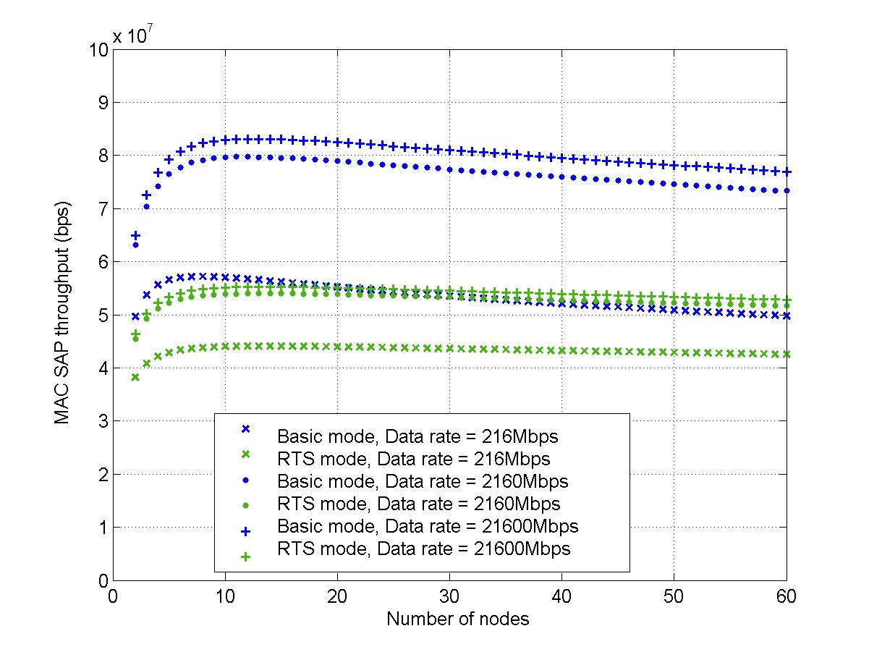
Figure 1: Throughput limit of current IEEE 802.11 MAC protocol.

MAC System Overview
For the MAC layer, we propose four core technologies, each of which can be used indepdently or jointly to form a system.

We first propose a frame aggregation mechanism at MSDU and/or PSDU level. The aggregation can substantially improve the channel efficiency by reducing overheads associated with each data transmission. This scheme can be applied to both contention period (e.g., DCF, EDCA, and ADCA) and contention free priod (e.g., PCF, HCCA, and SCCA). It is worthwhile to note that this frame aggregation scheme also provides a novel internal collision resolution mechanism within one station and an original solution to potential collision of multiple BlockACKs.

Secondly, we introduce two new high performance channel access methods, namely the adaptive distributed channel access (ADCA) and the sequential coordinated channel access (SCCA). The two novel access mechanisms not only meet the 100Mbps MAC SAP throughput requirement, but also provide flexibility and QoS capability, maintains simplicity and backward compatibility. Figure 2 depicts the logic position where these two channel access schemes should reside in the protocol stack of legacy IEEE 802.11.

Distributed Coordination Function (DCF)

Adaptive
Distributed
Channel
Access
(ADCA)

Sequential
Coordinated
Channel
Access
(SCCA)
MAC Extent

Point
Coordinated
Function
(PCF)

HCF
Contention
Access
(EDCA)

HCF
Controlled
Access
(HCCA)
Figure 2: Proposed protocol stack.

The ADCA used in the contention period is a highly efficient CSMA/CA-based random access protocol, which is backward compatible with the DCF mode of IEEE 802.11 and the EDCA mode of IEEE 802.11e.

B
E
A
C
O
N

SCCA

CAP

C
F
E
N
D

ADCA

ADCA

SCCA

ADCA

B
E
A
C
O
N

B
E
A
C
O
N

C
F
E
N
D

CFP
CP
CFP
Superframe

Figure 3: Superframe structure.

The sequential coordinated channel access (SCCA) method operates during the contention free period (CFP). In contrast to the current IEEE 802.11e HCCA scheme, where channel access is coordinated in a centralized fashion, SCCA provides fully distributed access for each station with the help of a central coordinator.

Our MAC protocol retains the temporal structure of superframe. As shown in Figure 3, the channel access alternates between a contention period (CP) and a contention-free period (CFP). In each superframe, the access point (AP) first sends a beacon to start the new superframe, and then the SCCA channel access mode follows. The AP terminates the contention-free period by broadcasting a CFEnd message. Afterwards, the contention period begins, during which ADCA is used to access the channel. Similar to IEEE 802.11e, CAP period is allowed to exist within the contention period

Finally, we present a new BlockACK mechanism, which improves the bandwidth efficiency of the legacy BlockACK initially defined in IEEE 802.11e. The new BlockACK can fulfil the same function by using far less bits.

The entire MAC layer proposal is organized as follows. A very brief overview on each technology is provided in section 6.3. The frame aggregation is then introduced in section 7. The ADCA and SCCA MAC mechanisms are explained in details in section 8 and 9, respectively. The new messages used in our proposed MAC protocols are defined in section 10. Section 11 will present the bandwidth-efficient BlockACK frame format design. Some discussion on how the BlockACK may fail any rate adaptation algorithm is also offered in section 11. Finally, the conclusion thought is provided in section 12.

Proposed Schemes for Performance Improvement

Frame Aggregation at MSDU and/or PSDU Level
The frame aggregation at MSDU and/or PSDU level intends to increase the number of data frames transmitted at each channel access time, and hence reduces the significant overhead associated with the data transmission in the legacy IEEE 802.11 standard. The aggregation can be applied in both contention period and contention free period to improve the bandwith efficiency of the corresponding channel access period. To further exploit the intrinsit feature of frame aggregation, an aggregate BlockACK scheme is also devised, based upon the legacy BlockACK mechanism defined in IEEE 802.11e. The new BlockACK scheme proves to provide the same acknowledgement service with more flexibility and less channel resources. Potential collision of multiple BlockACK messages corresponding to the frames encapsulated in the aggregated frame has been resolved, by using a smart CSMA-alike but collision free approach. Furthermore, the aggregation at PSDU level also leads to a better solution to the internal collision encountered by multiple parallel backoff entities within a single IEEE 802.11e station. Finally, to ensure the backward compatibility, proper management procedure is also specified.

Adaptive Distributed Channel Access (ADCA)
The ADCA is designed based upon IEEE 802.11e EDCA mode and therefore is intrinsically backward compatible with the access category (AC) based QoS support specified in IEEE 802.11e. The IEEE 802.11e draft also defines a contention free burst (CFB) mode, in which a batch of frames can be transmitted by one station (STA), with only a SIFS period between one frame and the ACK for the proceeding frame. The overhead associated with the per frame deferral and per frame backoff is therefore avoided. Furthermore, a series of frames can be acknowledged by a sinlge ACK, which is called BlockACK in IEEE 802.11e. The ADCA takes full advantage of these two efficiency improvement schemes. In addition, it introduces an adaptive batch transmission, in conjunction with an opportunistic selection of high-rate hosts, to further reduce the MAC overhead and improve the overall channel throughput.

The ADCA mechanism can be easily integrated with other technologies such as MSDU and/or MPDU level frame aggregation, plus frame size enlargement to boost the channel efficiency.

Sequential Coordinated Channel Access (SCCA)
The sequential coordinated channel access (SCCA) operates in the contention-free period and seeks to achieve highly efficient channel utilization while providing each data stream parameterized QoS. Combining the advantages of both multipoll and CSMA-alike random access, the SCCA mechanism inherits the flexibility and simplicity of the legacy polling scheme, while significantly reduces the overhead and improves overall throughput by eliminating the per packet polling messages.

Since STAs access channel in a CSMA-alike, but collision free manner, the adaptive batch transmission and opportunistic selection of high rate STAs can also be applied in the SCCA mechanism. Moreover, frame aggregation and large frame size can further lift the efficiency improvement achieved by SCCA.

Efficient BlockACK
Effcicient BlockACK mechanism can fulfill the acknowledgement functionality in a more flexible and bandwidth efficient manner. By using a special bitmap in the BlockACK message, far less number of bits is needed to convey the same amount of information in the BlockACK frame in the Efficient BlockACK scheme.

Obviously, the Efficient BlockACK can be used both in ADCA and SCCA. Moreover, it is in fact applicable to any channel access mechanism that requires explicit acknowledgement.

Frame Aggregation at MSDU and/or PSDU Level
In the current IEEE 802.11 wireless local area networks, a data payload received from the logic link control (LLC) layer is attached with headers and trailers at various layers before it gets transmitted on the air. For example, in IEEE 802.11a standard, each MAC service data unit (MSDU) is appended with a 30-byte-long MAC header and a 4-byte-long frame check sequence (FCS) trailer to form the MAC layer protocol data unit (MPDU). The same MPDU, once handed over to the physical layer, is then called physical layer service data unit (PSDU). A 1-symbol-long physical layer convergence procedure (PLCP) header, a 12-symbol-long PLCP preamble and proper tail bits and pad bits are attached to the PSDU to finally generate the bit stream PPDU (i.e., physical layer protocol data unit) for transmission. The relationships among MSDU, MPDU, PSDU and PPDU are illustrated in Figure 4.

LLC
MAC
PHY
MSDU
MPDU
PSDU
PPDU

Figure 4: Relationship among MSDU, MPDU, PSDU and PPDU.

More overheads are caused by the distributed coordination function (DCF), which is the prevailing channel access method specified in IEEE 802.11. Assume that the acknowledgement is on a per-frame basis, the possible overheads associated with a frame transmission include, but not limited to, the following items: MAC header, physical layer header (PLCP header), PLCP preamble, proper backoff, DIFS time, SIFS time, and ACK.

To reduce the overhead and increase the channel efficiency, we hereby propose a highly efficient and flexible frame aggregation scheme.

The proposed frame aggregation can occur at two levels, namely the MSDU level and PSDU level. At the MSDU level, frames with identical destination address can be aggregated into a single MPDU with proper auxiliary fields inserted into the resulted aggregation. In contrast, MPDU frames with different destination addresses can be transmitted in an aggregated manner at the PSDU level, sharing a single PLCP preamble. Thus, excessive overheads at both MSDU level (e.g., MAC header for each MSDU) and PSDU level (e.g., PLCP preamble) can be eliminated and a substantial increase in efficiency can be achieved.

Note that the aggregation at each level can be used together or separately. Hence, this two level aggregation can operate flexibly, based upon the applications and real traffic scenarios.

Also, the frame aggregation is used in conjunction with a smart acknowledgement mechanism, in which BlockACK messages from multiple receivers are delivered to the sender in a CSMA-alike but collision free manner. Thus, potential collision of multiple block acknowledgement messages is resolved, while high efficiency is still maintained.

Moreover, our frame aggregation scheme can support multiple priorities of traffic in the contention period, and thus provides a better solution to the internal collision problem encountered in IEEE 802.11e.

Last but not the least, a simple management procedure is defined in the proposal to guarantee the backward compatibility of our frame aggregation mechanism with the legacy IEEE 802.11/802.11e system 7.5.

Although the frame aggregation mechanism applies both for contention period and contention free period, the detailed operation rules slightly vary. The aggregation for contention and contention free periods are first explained in section 7.1 and section 7.2, respectively. The new BlockACK scheme designed for frame aggregation is then explained in section 7.3. Furthermore, the management procedure associated with aggregation is specified in section 7.4. Finally, some discussions are offered in section

Frame Aggregation Mechanism in Contention Period

Aggregation at Level 1 (AL-1)
For sake of simplicity, the frame aggregation occurring at the MSDU level is hereafter referred to as the aggregation at level 1 (AL-1).

For the MSDU frames temporarily placed in the priority queue, decision is made whether the AL-1 frame aggregation can be applied or not, based upon whether the data frames are destined to the same station and belong to the same traffic class. If both the destination address and TID are identical, then all these frames can be encapsulated into the same MPDU, with each frame appended with its own AL-1 header and AL-1 FCS.

The frame format of the aggregation at level 1 (AL-1) is illustrated in Figure 5. Multiple MSDU frames are carried in the aggregated frame body field, which can be of variable length, as long as the maximum total size doesn’t exceed the limit imposed by the physical layer and the corresponding transmission duration limit specified by transmission opportunity (TXOP) is honored. The MAC header format is identical to that defined for IEEE 802.11e, except that the sequence control field is replaced by starting sequence control field and represents the sequence number and fragment number of the first MSDU payload in the aggregated frame body field. Note that the starting sequence control field follows the same format of the sequence control field specified in IEEE 802.11. Since each frame within the frame body is protected individually by its own FCS, there is no need to have an FCS to cover the entire MPDU.
Frame
Control
Duration
/ID
Addr1
Addr2
Starting Sequence
Control
Addr4
Addr3
QoS
Control
Aggregated
Frame Body
MAC header

Figure 5: Frame format of aggregation at level 1 (AL-1).

The QoS control field is shown in Figure 6, in which the reserved bit B7 is set to 1 when the MPDU has aggregated multiple MSDUs inside.

B4
TID
EOSP (HC) ||
0/1 (Non-HC)
ACK
Policy
Reserved
TXOP || Reserved ||
Queue size
B0 B3
Bit
B5 B6
B8 B15
B7

Figure 6: QoS control field in the MAC header.

Figure 7 shows the internal structure of the aggregated frame body. Each MSDU payload is associated with a corresponding AL-1 header and an FCS. The FCS is calculated in the same fashion as that defined in IEEE 802.11. Note that this FCS covers each individual MSDU payload only.
FCS
1
MSDU
1
AL-1
Hdr 1
MSDU
2
AL-1
Hdr 2
MSDU
n
AL-1
Hdr n
FCS
2
FCS
n
. . .

Figure 7: Format of the aggregated frame body field.

The details of the AL-1 header are further expanded in Figure 8. The AL-1 header is of 4 bytes long and contains 4 different components, namely length subfield, more MSDU subfield, reserved subfield and sequence control subfield.
b0
b10
b11
b15
b16
b32
Length
Reserved
Sequence Control
More MSDU
b12

Figure 8: Frame format of aggregation level 1 header (AL-1).

The length subfield indicates the total number of bytes in the immediately succeeding MSDU payload with which this AL-1 header is associated. It is of 11-bit long and hence can support a maximum length of 2048 bytes for each MSDU payload. With the information of length of each MSDU payload, the receiver can compute the ending position of the current MSDU plus its AL-1 header and FCS. Bit 11 in the AL-1 header signals to the receiver whether there is more MSDU following the current one or not. The bit 12 to bit 15 are reserved for future extension. Sequence control is the last subfield within the AL-1 header and contains a fragment number and a sequence number, which follows the pattern specified in IEEE 802.11/11e. After each MSDU payload is received from LLC, the MAC layer assigns a sequence number to it. This sequence number is unique within each traffic ID (TID). With the help of this sequence control, each MSDU within the level 1 aggregation can still be acknowledged individually, as explained in the section 7.3.

Aggregation at Level 2 (AL-2)
The frame aggregation at the PSDU level is defined as level 2 aggregation. For sake of brevity, we will refer to level 2 aggregation as AL-2.

Regardless of the destination addresses, TIDs and transmission rates, all the PSDUs within a station are qualified for AL-2, as long as they are scheduled for transmission at the same time.

In MAC layer, since each frame received from LLC has a unique TID, it contends for the channel following the EDCA channel access method defined in IEEE 802.11e with a set of QoS parameters corresponding to that particular TID. Once the frame wins the channel contention, level 2 aggregation can be applied. Basically, all the frames within the same queue can be aggregated with the winning frame at the PSDU level and transmitted together, as long as the TXOP for that TID is honored.

If the backoff counter for frames of different TIDs decrement to zero simultaneously within a station, an internal collision occurs. In the IEEE 802.11e, internal collision is resolved by letting the highest priority involved in the collision transmit. Other lower priority frames are considered as being collided and a new backoff procedure is scheduled for each of them. In AL-2, however, the frames involved in the internal collision can also be aggregated at the PSDU level and get transmitted along with the winning frames. Note that for lower priority, only the frames involved in the collision are valid for aggregation, while the frames in the priority queue in which the winning frame is stored are also qualified for aggregation with the winning frame.

The format of the level 2 aggregation is defined in Figure 9. The entire PPDU is started with a common PLCP preamble, which is followed by a series of PLCP headers and the corresponding PSDUs. The PPDU is ended with a tail and pad field. The PLCP preamble, tail and pad are identical to those specified in IEEE 802.11a.

…
PLCP
Preamble
PLCP

Hdr 1
PSDU

1
Tail
Pad
PLCP

Hdr 2
PSDU

2
PLCP

Hdr n
PSDU

n
1 OFDM symbol
PLCP
Hdr n+1
Aggregated
BlockACK
Request

Figure 9: Frame format of aggregation at level 2.

Since each PSDU can be destined to different station, the transmission rate for that PSDU may not be the same as the rate for the following PSDU. Hence, one OFDM symbol may need to be inserted between the PSDU and the PLCP header for the succeeding PSDU so that the transmitter can have sufficient time to make proper adjustment. This OFDM symbol should have a unique pattern so that the receiving station can use it as a special delimiter to physically distinguish the start of one PLCP header from the end of the previous PSDU frame. However, the insertion of this additional OFDM symbol is not always necessary. If the two consecutive PSDU frames use the same transmission rate, this symbol could be removed.

The last PSDU and the corresponding PCLP header (i.e., PLCP header n+1) are always used for the acknowledgement control purpose and their functions will be elaborated in section 7.3.

PSDU j (j < n) carries real data and PCLP header j is associated with PSDU j. The PLCP header j (j ≤ n+1) is depicted in Figure 10. The rate, parity and tail fields are identical to those defined in IEEE 802.11a. The 13-bit-long length field is used to indicate the length of the corresponding PSDU. The original PLCP header defined in IEEE 802.11a contains a one bit reserved field and a 12-bit-long length field. Note that we have merged the 12-bit-long length field with that reserved bit to create the new length field in Figure 10 so that it becomes capable of supporting maximum frame size of 8192 bytes. With this constraint, the maximum size of aggregation at level 1 plus the corresponding MAC header and trailer then cannot exceed 8192 bytes.

Rate
4bits
Length
13bits
Parity
1bit
Tail
6bits
Service
16bits

Figure 10: Frame format of PLCP header.

0
1
2
3
4
5
6
7
8
9
10
11
12
13
14
15
Scrambling
Initialization
Reserved
AL-2
parameter

Figure 11: Service field format.

AL2 Parameter | Explanation
00 | Without level 2 aggregation
01 | With level 2 aggregation. Both the current PSDU and the succeeding one have the same transmission rate.
11 | With level 2 aggregation. Transmission rate needs to be changed after the current PSDU.
10 | Reserved
Table 2: Possible values of AL-2 parameter field.

The structure of 16-bit-long service field is further explained in Figure 11. We use the two reserved bits in IEEE 802.11a service field (i.e., Bit 7 and Bit 8) to represent the AL-2 parameters. All possible values and the corresponding meanings are listed in Table 2. With the help of AL-2 parameter field, the receiver can tell whether the level 2 aggregation is in use in the received frame and whether the following PSDU in the same PPDU has the same transmission rate as the one used for the PSDU being received. This information can also implicitly indicate whether there will be an OFDM symbol delimiter after the end of the current PSDU.

Frame Aggregation Mechanism in Contention Free Period
For contention free period (e.g., HCCA), a parameterized channel access method is followed, in which transmission opportunity (TXOP) is assigned on a per traffic stream (TS) basis. If the transmission opportunity allocated to a traffic stream at a specific time cannot be completely consumed, the TS simply forfeits the unfinished TXOP so that the next scheduled TS can start its TXOP. Therefore, aggregation of frames with different TIDs becomes inappropriate. Moreover, since each TS is mapped with a unique pair of source and destination addresses, the aggregation of frames with different destination addresses is also against the fundamental principle of parameterized traffic transmission. So, only the frame aggregation at level 1 (i.e., MSDU level) should be the valid operation in the contention free period.

The AL-1 aggregation in contention free period can use the same frame format as that defined in Figure 5, Figure 6, Figure 7 and Figure 8 for level 1 aggregation in contention period. One major difference from the AL-1 for contention period is that BlockACK request frame should be aggregated with the corresponding data at AL-1 level for contention free period instead of at AL-2 level, since no aggregation at PSDU level is defined in this case. More details about acknowledgement mechanism will be explained in section 7.3.

Acknowledgement Scheme

Contention Period
As mentioned in the previous section, the last aggregated PSDU and its PLCP header are used to implement aggregate BlockACK Request function. The frame format of this PSDU is depicted in Figure 12. The receiver address (RA) is set to a broadcast address so that every station in the network should receive this frame and decode its frame body. Transmitter address (TA) is the transmitter’s MAC address. The duration field covers all the BlockACK request messages aggregated within the Aggregated BlockACK Request Frame Body.
Frame
Control
Duration
RA
TA
Aggregated BlockACK
Request Frame Body
MAC header

Figure 12: Frame format for aggregated BlockACK request

The aggregated BlockACK request frame body contains at least one BlockACK request element, each of which has an internal structure as shown in Figure 13. Regardless of the actual destination of individual BlockACK request element, the basic transmission rate is used to transmit all the BlockACK elements so that high reliability can be assured.

Duration
BAR
Control
Block ACK Starting
Sequence Control (TID_{j})
FCS
Octets
2
2
2
4
…
2
Block ACK Starting
Sequence Control (TID_{k})
RA
6

Figure 13: Frame format of a BlockACK request element.

Each receiving station can at most correspond to one such element in the aggregated BlockACK request frame body. The duration field and FCS here only take care of one individual BlockACK request element. The receiver address (RA) is the MAC address of the receiving station. One BlockACK request element can contain up to four BlockACK starting sequence number. The details of BlockACK request control field are further shown in Figure 14.
b2
IBV
TID Bitmap
Reserved
b5
b6
b11
b12
b15
Type
b0
b1

Figure 14: Format of BlockACK request control.

The 2-bit type field indicates the type of BlockACK session that is ongoing. The possible values of type field are shown in Table 3.

Bit0 – Bit1 | Explanation
00 | Legacy BlockACK
01 | BlockACK for frame aggregation in contention period
11 | BlockACK for frame aggregation in contention free period
10 | Streamlined BlockACK without frame aggregation
Table 3: Possible values of type field.

The TID bitmap field has 4 bits and each of which represents the presence or absence of the starting sequence control field for a TID. For instance, if bit 2 is 1, it implies that the TID 0 in station TA requests a BlockACK from the receiver RA for a set of frames, the first one of which has the sequence control field as BlockACK Starting Sequence Control (TID0). The number of ‘1’s in the TID Bitmap field is equal to the number of BlockACK Starting Sequence Control fields contained in the BlockACK request element. With this information, the receiver can then infer how long the BlockACK request element will be. The next IBV field stands for initial backoff value, which notifies the receiver after how many backoff time slots can it start to transmit the BlockACK frame.

After the transmission of aggregated frame is completed, a station replies with a BlockACK message, if it detects its corresponding BlockACK element in the last PSDU of the received aggregated frame. To send the BlockACK, the station must set the initial value of the backoff counter to the IBV retrieved from the corresponding BlockACK request element. Then, all the stations that have correctly decoded their IBV value backoff for IBV number of slots before it transmits the corresponding BlockACK. Each BlockACK accesses the channel following a CSMA-alike approach. Since a station starts the backoff a SIFS time after the channel becomes idle, the BlockACK has the highest priority in contending for the channel and no collision between BlockACK with other type of frames will arise. Moreover, all BlockACK invoked by the reception of PSDUs aggregated in the same PSDU are assigned with different number of backoff slots before they can be sent. Hence, the potential collisions among these BlockACK frames are also eliminated. Hence, different receivers can acknowledge the MSDUs contained in the same aggregated frame in a collision free manner. If a receiver fails to detect its BlockACK request in the aggregated frame, it obviously will not transmit BlockACK. However, this only incurs negligible loss of one SLOT time to the channel resource. Therefore, this scheme is highly efficient and error robust.

S
I
F
S

S
I
F
S

BlockACK
from STA k
Transmission of an
aggregated frame
BlockACK
from STA k+1
S
L
O
T
S
L
O
T

Figure 15: Illustration of BlockACK frames transmission from multiple receivers.

It is worthwhile to note that there is no other specific reason to defer for a SIFS period, except for the constraint set aside by the physical layer technology. If the physical layer can switch from reception to transmission in a time (e.g., X microseconds), which is shorter than the SIFS interval, the BlockACK can defer only X microseconds before its backoff.

We have revised the BlockACK message initially defined in the IEEE 802.11e to support the new functions. The format of the new BlockACK is shown in Figure 16.
Frame
Control
Duration
RA
TA
BA
Control
Block ACK
Starting Sequence
Control (TID_{j})
BlockACK
Bitmap
6
Octets
2
2
6
2
2
2xN
…
Block ACK
Starting Sequence
Control (TID_{k})
2
FCS
4

Figure 16: Frame format of revised BlockACK.
The revised BlockACK message is similar to that defined in IEEE 802.11e, except that acknowledgement to traffic of multiple TIDs can be included in the single BlockACK. The BA control field is illustrated in Figure 17.
b2
NAK
TID Bitmap
Reserved
b5
b6
b7
b15
Type
b0
b1

Figure 17: Format of BA Control field.

The TID Bitmap field has the same meaning as that defined for BlockACK request element. The NAK bit is used to signal whether a positive or negative acknowledgement is used. The rest of the bits are reserved for future extension.

The BlockACK Bitmap field has also undergone a significant overhaul to enhance its support to multiple TIDs and improve its channel efficiency as well.

. . .
M 1-byte-long relative sequence number = M Bytes
Relative Sequence
Number (6bits)
Encoded TID
(2bits)
Relative Sequence
Number (6bits)
Encoded TID
(2bits)

Figure 18: Frame format of BlockACK Bitmap field.

As shown in Figure 18, the BlockACK bitmap consists of multiple relative sequence numbers, each of which further contains one relative sequence number and encoded TID. The relative sequence number is a binary number computed in the following manner.

Relative sequence number = (Sequence number of TID x – Starting sequence number of TID x)
Equation 1

The encoded TID is the binary expression of the TID associated with the data frame of relative sequence number. Since only four priorities exist in the contention period, two bits are sufficient.

Since frame aggregation inclines to create very large frames, the need for frame fragmentation, which is an opposite operation, is diminishing. It is reasonable to assume that no frame fragmentation should be performed after the frame aggregation. Therefore, the fragment number in the original sequence control field is omitted in the new design.

Instead of including a fixed length BlockACK bitmap, we can selectively acknowledge all the successfully or incorrectly received data frames, whichever has less number. A simple analysis can demonstrate that only one fourth of the resource in term of bits is needed by the new BlockACK bitmap to fulfill the same function, compared with the legacy BlockACK bitmap defined in IEEE 802.11e. That is, the following inequality holds:

Size(New BlockACK Bitmap) ≤ Size(legacy BlockACK Bitmap)
Equation 2

Contention Free Period
The BlockACK request and BlockACK frames defined in section 7.3.1 can be used directly for frame aggregation in contention free period, only with minor modification. The format of the BlockACK request frame is identical to that defined in IEEE 802.11e, except that the BA field should assume the following form.

b2
Reserved
Block Size
TID
b7
b8
b11
b12
b15
Type
b0
b1

Figure 19: Format of the BA/BAR field of the BlockACK frame.

As explained before, the type field can indicates that the ongoing BlockACK is for the frame aggregation within contention free period. The block size field, which is of 6 bits, stores the number of frames that request acknowledgement. The TID field then tells which traffic stream the BlockACK is associated with.

For BlockACK frame, only the BlockACK bitmap and the BAR fields are different from what has been specified in IEEE 802.11e. The BAR field is also defined in Figure 19. Based upon the argument that it is not reasonable to perform frame fragmentation and frame aggregation at the same time, we assume that no frame fragmentation should occur during the frame aggregation process. Hence, the new BlockACK bitmap only contains a variable size of bitmap, each bit of which tells whether a frame is successfully or incorrectly received. For instance, if bit0 of the bitmap is ‘1’, it implies that the frame with sequence number (start sequence number + 0) has been successfully received, provided the block size in the BA/BAR field is greater than 0. For implementation purpose, the size of the BlockACK bitmap should be aligned in the unit of byte, which implies that padding bits should be appended to the bitmap, if the number of frames requesting acknowledgement is not a multiple of 8.

ADDAL Management Procedure
A station intends to use the frame aggregation mechanism for the transmission of data frames to its peer should first check if the intended peer station is capable of participating in frame aggregation mechanism by discovering and examining the reserved bit (i.e., bit 7) in the QoS control field in the MAC header. If the intended peer station is capable of participating, the originator sends an ADDAL request frame, indicating the intent to set up an aggregation at level 1 and/or level 2. The information contained in the ADDAL request frame is advisory and may be changed by the recipient. The receiving station shall respond with an ADDAL response frame. The receiving station, which is the intended peer, has the option of accepting or rejecting the request. When the station accepts, it indicates the maximum size of the frame aggregation that it can support. If the receiving station rejects the request, then the originator shall not use the frame aggregation mechanism.

If the frame aggregation is being set up, the originator can still renegotiate the maximum aggregation size with the intended recipient by using ADDAL request and response action management frames again.

We introduce a new category 4 for frame aggregation. The action field values for ADDAL request and ADDAL response are listed in Table 4.

Action Field Value | Meaning
0 | ADDAL request
1 | ADDAL response
2-255 | Reserved
Table 4: Frame aggregation action field values.

Both the ADDAL request and ADDAL response share the same frame format, which is defined in Table 5.

Order | Meaning
1 | Category
2 | Action
3 | Dialog token
4 | Frame aggregation parameter set
Table 5: ADDAL request.

The Category field is set to 4, which represents frame aggregation. The Action field is set to 0 and 1 to represent ADDAL request and response, respectively. The dialog token field is set to a non-zero value chosen by the station. The frame aggregation parameter set is defined in Figure 20.

Aggregation Level
Maximum aggregation
frame size/Reserved
TID/Reserved
b0
b1
b2
b11
b12
b15

Figure 20: Format of the frame aggregation parameter set.

The format of aggregation level field is further explained in Table 6.

Bit 0 – Bit 1 | Meaning
00 | No frame aggregation
01 | Frame aggregation at level 1 only (i.e., MSDU level)
11 | Frame aggregation at level 2 only (i.e., PSDU level)
10 | Frame aggregation at both level 1 and level 2 (i.e., both MSDU and PSDU level)
Table 6: Frame aggregation parameter set.

When the frame aggregation at level 1 is supported, the maximum aggregation frame size indicates the maximum aggregation size that the originator desires or the intended recipient can support, and the TID field represents the TID, for which the frame aggregation is negotiated for. Otherwise, bit2 to bit15 are reserved for future extension.

Discussion
The channel condition in the wireless environment is highly volatile. When wireless link quality degrades, a large frame size can entail higher loss than a smaller frame. Hence, it is desirable to have an appropriate dynamic frame size adjustment method according to the underlying channel condition. In the meantime, some rate adaptation algorithm may be running in each station, which also adjust he transmission rate with respect to the instantaneous channel condition. Hence, it is important to guarantee that the aggregation frame size adaptation method should operate in harmony with the rate adaptation algorithm. The specific algorithm for frame aggregation size adaptation is beyond the scope of this invention.

Regarding the backward compatibility, the ADDAL request and ADDAL response frames are only exchanged when the originator detects the bit 7 of the QoS field in the header of the MAC frame from the intended peer is set to 1. In case the intended recipient does not support frame aggregation, regular frame formation and transmission rules are followed. Hence, backward compatibility is always guaranteed.

Adaptive Distributed Channel Access (ADCA)
In this section, the adaptive distributed channel access protocol will be presented. The basic algorithm is first introduced in 8.1. Then, more elaborations on the adaptive batch transmission and block acknowledgement are provided in section 8.2, and opportunistic selection of high-rate STAs is explained in section 8.3. The service differentiation and issues related to implementation are discussed in section 8.4 and 8.5, respectively. Finally, the simulation results are presented in section 8.6.

Basic Algorithm
The ADCA uses a reference parameter set (RPS) and a credit counter set (CCS) for each AC to regulate channel access within CSMA/CA. Each host periodically receives a RPS, which comprises of reference rate (R_{f}), reference packet size (S_{f}), and reference batch size (B_{f}). The RPS is announced and adjusted dynamically by the AP in its beacon frames. An STA also maintains CCS to record its current channel access credit and handle variable packet sizes. With RPS and CCS, each STA independently determines whether it is eligible for transmission after winning channel contention. When the transmission rate of a STA is greater than the reference rate R_{f} specified in the RPS, it is eligible for channel access. It can transmit several back-to-back packets in a batch once succeeding in channel contention, as long as the corresponding TXOP assigned to it is observed. Both regular ACK and BlockACK can be used, whichever considered appropriate.

When the rate of a STA is lower than R_{f}, it has to first compute the time it is allowed to occupy the channel as (B_{f} S_{f} /S_{f}). If this time is sufficient for the STA to send at least one frame, it will transmit immediately upon winning the channel access. Otherwise, it has to wait and accumulate access credit for accessing the channel. Once its credit exceeds a threshold K, it can then transmit at least one packet when it succeeds in channel contention.
When the STA joins the WLAN
1 Initialize values for Sf, Rf and Bf according to received Beacon Frame;
2 credit(low) = 0;
3 K is an implementation dependent threshold.

When win the channel contention
1 /* R, S are stations' data rate and packet size */
2 if R ≥ Rf
3 Transmit up to Bf number of packets;
4 else /* for low-rate stations R < Rf, keep proportional fairness for them */
5 B = (Bf*Sf/Rf)*(R/S)
6 if (B < 1) and (credit(low) < K)
7 credit(low) += 1;
8 resume backoff procedure;
9 else
10 Transmit up to max{B, 1} number of packet
11 credit(low) = 0;
Figure 21: Pseudo code for ADCA.

In summary, the ADCA uses an adaptive batch packet transmission and block ACK to reduce protocol overhead. It opportunistically favors high-rate hosts that are in good channel condition and provides temporal fair access for them as in single-rate legacy MAC. The ADCA also ensures a minimum fair share for low-rate STAs in that it provides proportional temporal fairness for these hosts in long term. The pseudo code for the ADCA is shown Figure 21.

Adaptive Batch Transmission and Block Acknowledgement
To reduce protocol overhead, the ADCA allows multiple back-to-back packet transmissions between AP and STA. To coordinate the batch transmission, the AP advertises three parameters R_{f}, S_{f}, and B_{f}. These three parameters state that, given a specified time, for a STA transmitting at rate R_{f}, it can potentially send a batch of B_{f} consecutive packets at most, each of which is S_{f}-bytes long. During each batch transmission for a given STA, the consecutive B_{f} packets are separated only by the smallest time interval SIFS. This is in sharp contrast to the legacy IEEE 802.11 MAC, in which two consecutive packet transmissions are separated by the time of DIFS plus a random contention backoff and possibly the optional RTS/CTS exchange. This way, batch transmission significantly reduces the MAC overhead. The choice of B_{f} reflects the average channel coherence time for STAs in the local basic service set (BSS).

The above batch transmission is adaptive to each STA’s current rate. When a STA is operating below the reference rate R_{f}, its batch size or access probability is adjusted in proportional to its current transmission rate.

In order to further reduce the MAC overhead, we also use block ACK via the parameter A_{f}, which is negotiated between two communicating STAs according to their perceived channel conditions. In the ADCA, a BlockACK frame is sent back to the sender for a block of A_{f} number of back-to-back transmitted packets, instead of per-packet ACK in the current 802.11 MAC. If some packets in the block are not received correctly, the sender selectively retransmits the corrupted packets indicated by the block ACK packet. This further reduces the protocol overhead of the current MAC.

Opportunistic Selection of High-Rate STAs
The ADCA preferentially grants those STAs under best channel conditions for channel contention, while restraining others that perceive poor channel.

Specifically, for high-rate hosts with rates R ≥ R_{f}, ADCA allows them access channel immediately after they win channel contention. For low-rate STAs with rates R < R_{f}, it can transmit the number of frames that can fit into the time duration of (B_{f}S_{f}/R_{f}). If this time duration is not even sufficient for a single frame, the STAT will defer their channel access and control their access probability by using a credit counter credit(low). This credit counter is incremented each time a low-rate STA wins the channel contention, but not access channel to transmit packets. When its accumulated credit reaches a certain threshold K and it succeeds in channel contention, the low-rate STA can transmit a batch of max{B, 1} packets.

The above design balances between maximizing overall channel throughput, by providing high-rate STAs currently in good conditions with higher access probability and providing minimum share of the channel access for low-rate STAs to avoid starvation. It, therefore, provides minimum fair share to each STA and additionally maximizes channel throughput.

In the above design, we also handle the issue of variable packet size. When the packet size is different from S_{f}, the batch size and the credit counters will also be re-calibrated by S/S_{f}.

Quality of Service
The ADCA achieves service differentiation by using four access categories of 802.11e. It prioritizes traffic with different QoS requirements in terms of throughput and latency via several access categories (ACs). Each AC has its own backoff value. A higher-priority AC has smaller backoff value, whereas lower-priority AC has larger backoff ones. Therefore, the higher-priority AC always has preference over channel access. This mechanism is similar to the EDCA defined in IEEE 802.11e draft.

Backward Compatibility and Implementation Issues
It is evident that ADCA is backward compatible with both the DCF of IEEE 802.11 and EDCA of IEEE 802.11e, respectively. To implement ADCA, only minor changes need to be made.

In the ADCA, each AC can have its own RPS settings that can be adjusted depending on the current system performance and channel condition. The AP manages the RPS settings and adjusts it dynamically. The RPS configuration is broadcast in the period beacon frame. The format of the new beacon frame will be described in section 10.1.

In the ADCA, each STA may adapt its current transmission rate depending on its perceived SNR. The ADCA can work with any rate adaptation mechanism, e.g., Auto Rate Fallback (ARF) [10].

Performance Evaluations

SIFS | 16μs | AIFS[AC0, 1] | 54μs
DIFS | 34μs | CWMin[AC0, 1] | 31
Slot time | 9μs | CWMax[AC0, 1] | 1023
ACK size | 14btyes | AIFS[AC2] | 43μs
MAC header | 28bytes | CWMin[AC2] | 15
Peak data rate | 216Mbps | CWMax[AC2] | 500
Basic data rate | 24Mbps | AIFS[AC3] | 34μs
PLCP preamble | 20μs | CWMin[AC3] | 7
PLCP header | 4μs | CWMax[AC3] | 100
Table 7: PHY/MAC parameters used in the simulation.
To evaluate the performance of ADCA, we have implemented it in NS-2 simulator [11]. The PHY and MAC layer parameters used in the simulation are listed in Table 7. The PHY layer parameters are based upon our physical layer proposal described before.

MAC Throughput Gain
The throughput performance of ADCA at different PHY layer rates is compared with the DCF of IEEE 802.11. In the simulation, there are five STAs, each carrying a UDP traffic in AC0 at 40Mbps to the AP, with 1280 bytes in each packet. In ADCA, we set (S_{f} /R_{f})* B_{f} as 3ms, with R_{f} as 216Mbps and S_{f} as 1280 bytes, in order to enable batch transmission. A_{f} is set to 3 to have an acknowledgement every three packets transmission. Figure 22 depicts the throughput of both ADCA and the DCF, as the physical layer transmission rate grows from 24Mbps to 216Mbps.
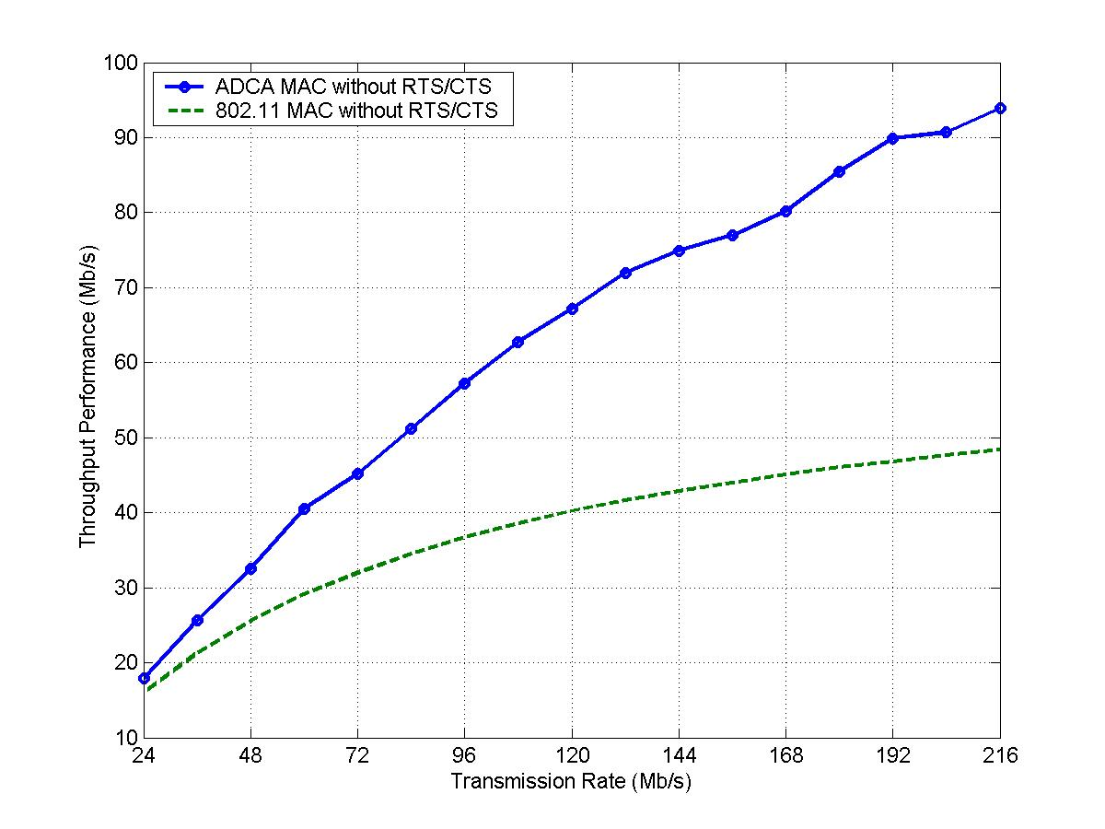
ADCA without RTS/CTS
802.11 without RTS/CTS

Figure 22: Throughput vs. transmission rate.

It can be clearly seen in the figure that the MAC layer throughput increases for both ADCA and DCF, as the physical layer rate grows. The MAC layer throughput in the legacy MAC case only increases by 204% as the physical layer rate increases from 24Mbps to 216Mbps. ADCA, in contrast, improves the MAC layer throughput by 450% in the same settings. Moreover, the throughput of ADCA almost obtains a linear growth with respect to the physical layer rate, whereas the throughput increases sublinearly in IEEE 802.11MAC. ADCA therefore is more efficient with the high capacity physical layer. Our study further shows that, the overhead incurred by the physical layer preamble and header is the limiting factor for the throughput of ADCA.

Effect of Multirate Transmissions
ADCA can adaptively exploit the channel conditions experienced by different STAs to further improve the aggregate network throughput. Consider a simulation setting with ten STAs, each carrying a UDP flow to the AP. Five STAs are transmitting at 216Mbps, and each UDP source rate is 20Mbps. The remaining five STAs are transmitting at a lower rate of 54Mbps, and each UDP source rate is 5Mbps. The reference packet size is 1280 bytes, the batch transmission interval (S_{f} /R_{f})* B_{f} is 3ms, and A_{f} is set to 1.

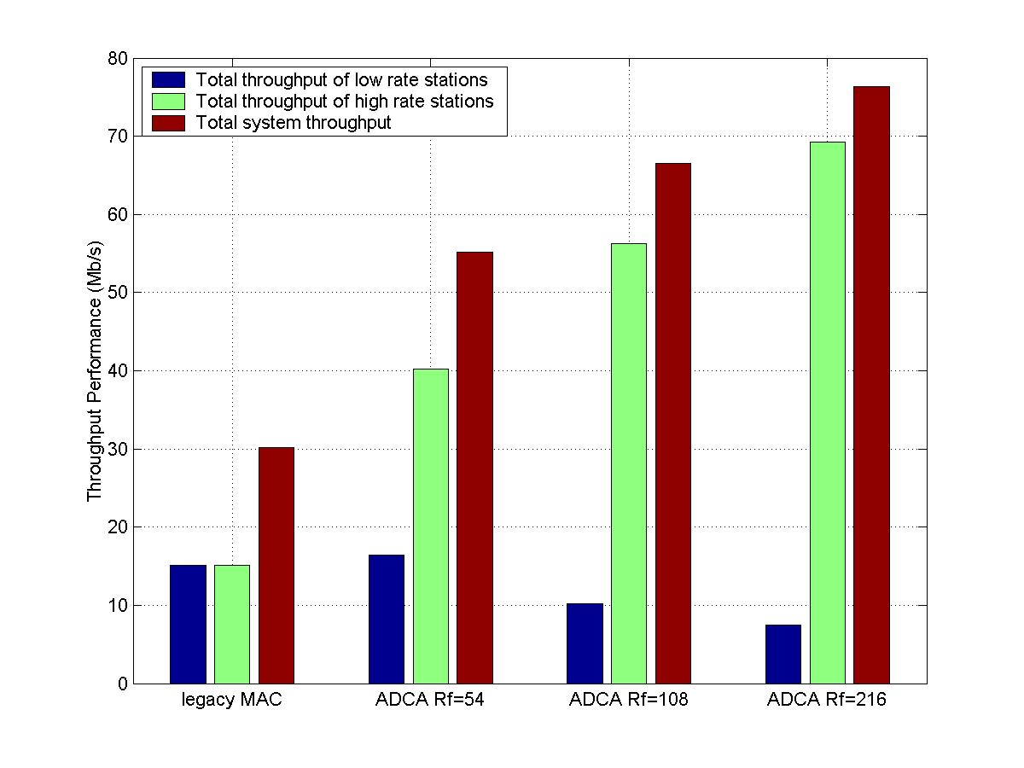
Figure 23: Throughput vs. R_{f}.

The Figure 23 shows the aggregate throughput performance for high-rate STAs, low-rate STAs, and all STAs, respectively. The high-rate STAs can increasingly exploit their good channel conditions and high transmission rates in ADCA by accessing the channel longer than the low-rate STAs to improve the overall channel throughput. This is realized by increasing a single parameter R_{f}. When R_{f} is set as 54Mbps, temporal fairness is achieved among all STAs, which brings 83% throughput gain compared with the 802.11 MAC, which penalizes high-rate STAs to achieve long-term throughput fairness. When R_{f} is further increased to 108Mbps and 216Mbps, respectively, ADCA acquires 121% and 154% overall throughput gains compared with the legacy MAC. In these cases, the access time by low-rate STAs decreases proportionally. By limiting the access probability for low-rate STAs, ADCA provides more transmission opportunities for high-rate STAs that perceive good channels. This feature, enabled by tuning one single parameter R_{f}, is important for high-speed wireless LANs to mitigate the severe throughput degradation incurred by low-rate STAs and to take advantage of channel dynamics.

Impact of Parameters
In this section, the impact of two RPS parameters on the performance of ADCA is studied. We consider five STAs, each carrying one UDP traffic source in AC0 and transmitting at their peak rate 216Mbps to the AP. The UDP sources generate packets of 1280 bytes at a rate of 40Mbps. As the channel will be saturated by these five flows, we evaluate the impact of parameter B_{f} and A_{f} on channel efficiency while keeping R_{f} at 216Mbps and S_{f} at 1280 bytes.

- Batch size B_{f}:
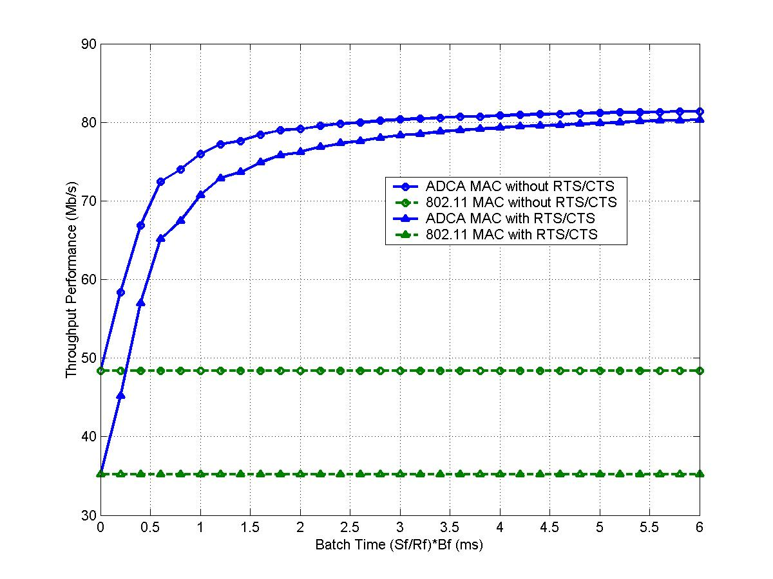
Figure 24 and Figure 25 depict the throughput and the mean delay for both ADCA and the legacy MAC as the parameter B_{f} varies. In this case, A_{f} is set to 1. We observe that without RTS/CTS handshake, ADCA results in significant throughput gain compared with the 802.11 MAC in the range of 14.5% to 68% as the batch transmission interval (S_{f} /R_{f})* B_{f} increases from 0.2ms to 6ms. The batch transmission begins to take major impact when the batch transmission interval grows larger than 1ms. The average delay is simultaneously reduced by about 50% as B_{f} increases. ADCA achieves such gains primarily by reducing the overhead incurred by deferral and backoff procedures of the MAC.
ADCA without RTS/CTS

802.11 without RTS/CTS

ADCA with RTS/CTS

802.11 with RTS/CTS

Figure 24: Throughput vs. B_{f}

Furthermore as we turn on RTS/CTS handshake, which is the recommended practice to handle large packet size, we achieve even greater throughput gain by as high as 128% and reduce the mean delay about 55% compared with the legacy MAC. On the other hand, turning on RTS/CTS in the legacy MAC results in 27.4% throughput degradation and around 39% mean delay increase, compared with the case of no RTS/CTS. However, turning on RTS/CTS only has minor effect on ADCA.

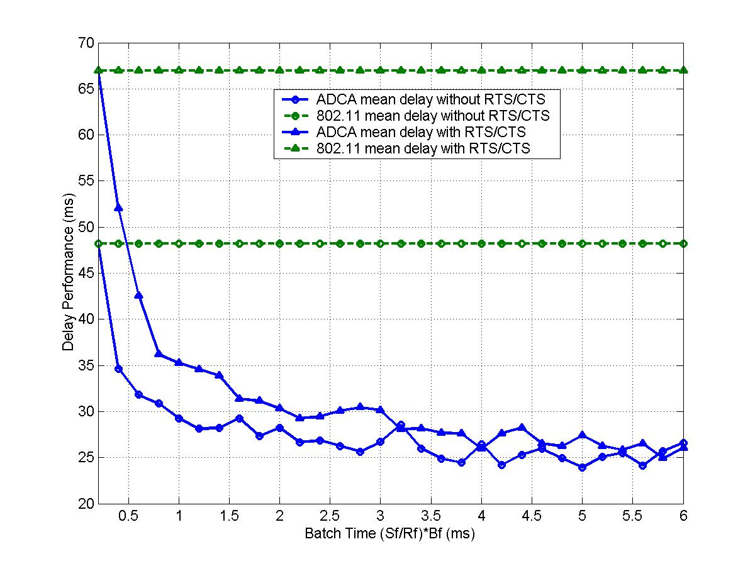
ADCA delay with RTS/CTS

ADCA delay without RTS/CTS

802.11 delay without RTS/CTS

802.11 delay with RTS/CTS

Figure 25: Mean delay vs. B_{f}

- Block acknowledgement frequency A_{f}:
We now study the impact of A_{f} on the performance of our ADCA design. Here, we keep (S_{f} /R_{f})* B_{f} as 3ms. The throughput and mean delay for ADCA and the legacy MAC vs. the parameter A_{f} are shown in Figure 26 and Figure 27, respectively.
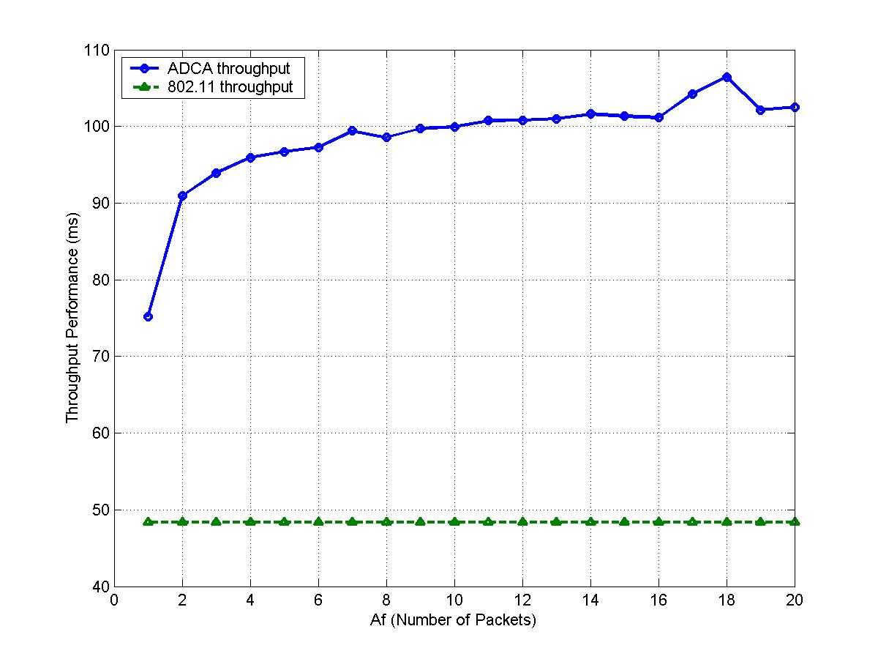
ADCA throughput

802.11 throughput

Figure 26: Throughput vs. A_{f}

The results indicate that, increasing parameter A_{f} can further increase the MAC layer throughput over 100Mbps. The throughput gain obtained by increasing A_{f} can be 112% over 802.11 DCF. In the meantime, the average delay has been reduced by approximately 40%.

In addition, we see that significant throughput gain can be achieved while A_{f} is set to 2 or 3. Therefore, even STAs adopting small value for A_{f} according to their channel conditions can utilize this parameter to greatly improve their throughput and delay performance.

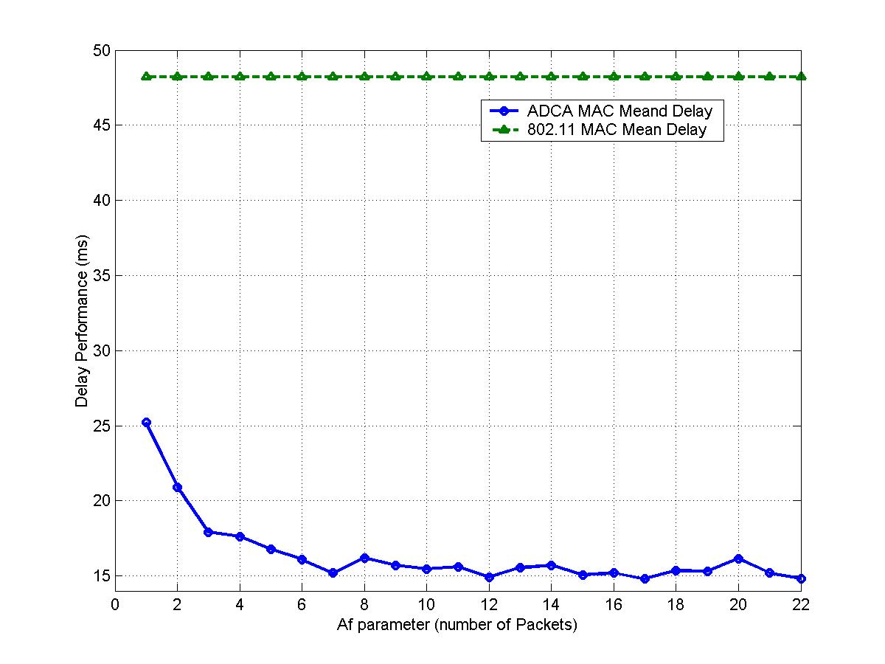
ADCA Mean Delay

802.11 Mean Delay

Figure 27: Mean Delay vs. A_{f}

IEEE 802.11n Usage Model and Simulation Results
A series of documents have been released by IEEE 802.11n to facilitate proposal evaluation and comparison. Among them, the wireless LAN usage model [12] specifies the scenario and parameters with which the simulation should be performed.

We have simulated our ADCA mode for several mandatory usage models to demonstrate the performance that ADCA can achieve. The detailed results are provided in section . The usage models that we have covered include home, IBSS residential and large enterprise. The results, listed in Table 13, Table 14, and Table 15, clearly reveal that the throughput and delay performance of ADCA meet the requirement set by IEEE 802.11n task group.

Impact of Physical Channel Error
Wireless channel are known to be error-prone. To study the negative effect the channel error places on the throughput, we further simulate the ADCA with a uniform error model. That is, we assume all the stations perceive the same channel condition and have the same probability to experience the errors. Even though this assumption is not realistic, the simulation results do provide some insight on how ADCA can perform under the harsh environment.

As shown in Figure 28, for a uniform packet error rate (PER) of 5%, ADCA still can achieve a throughput of 102.83Mbps. Note that if the channel is error free, the maximum throughput of ADCA obtained in the same settings is 108.26Mbps.
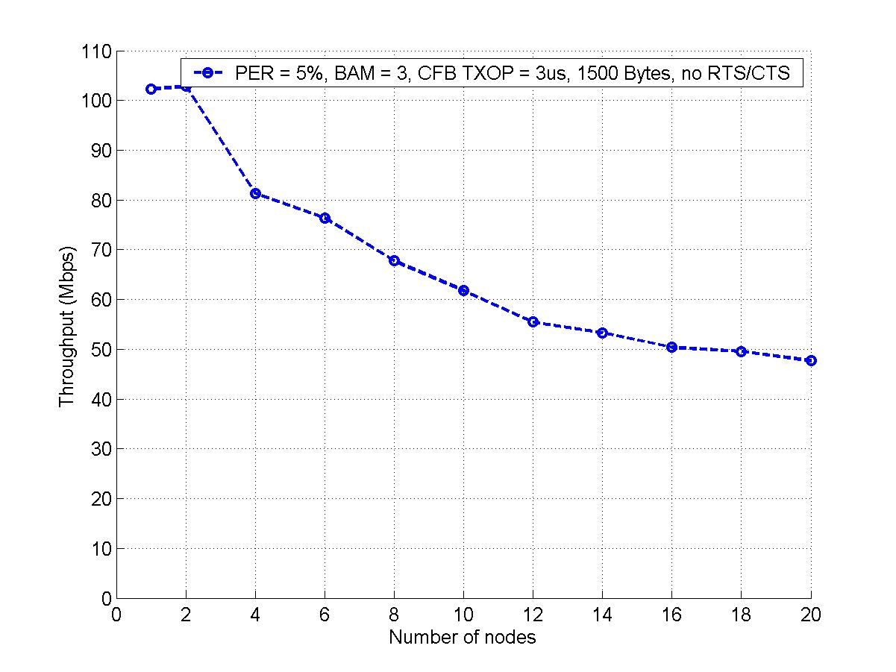
Figure 28: Effect of channel errors.

Augmentation with Other Technologies
As demonstrated above, the ADCA can achieve an impressive performance, even under unrealistically tough physical environment. Nevertheless, if ADCA is augmented with other technologies, it can provide a throughput up to 170Mbps (or higher), which represents a MAC efficiency of 78.7% (or higher)

For instance, the frame aggregation at MSDU level or PSDU level, plus the enlargement of the maximum frame size, can be easily incorporated into the ADCA mechanism to further improve the channel efficiency.

We briefly investigate the potential gain by increasing the frame size in the simulation from 1000 bytes to 8000 bytes. For sake of simplicity, we only simulate the smallest network, in which only 1 STA communicates with the AP. As shown in Figure 29, even though the achievable MAC layer throughput increases in a sublinear manner as the frame size grows, the incremental gain in the throughput is still considerable. It is also worthwhile to note that a packet error rate (PER) of 5% has been imposed in the simulation. Thus, ADCA, with augmentation of such technologies as frame aggregation and frame size enlargement, can achieve a throughput of 170Mbps or higher, even in the presence of harsh physical channel conditions.

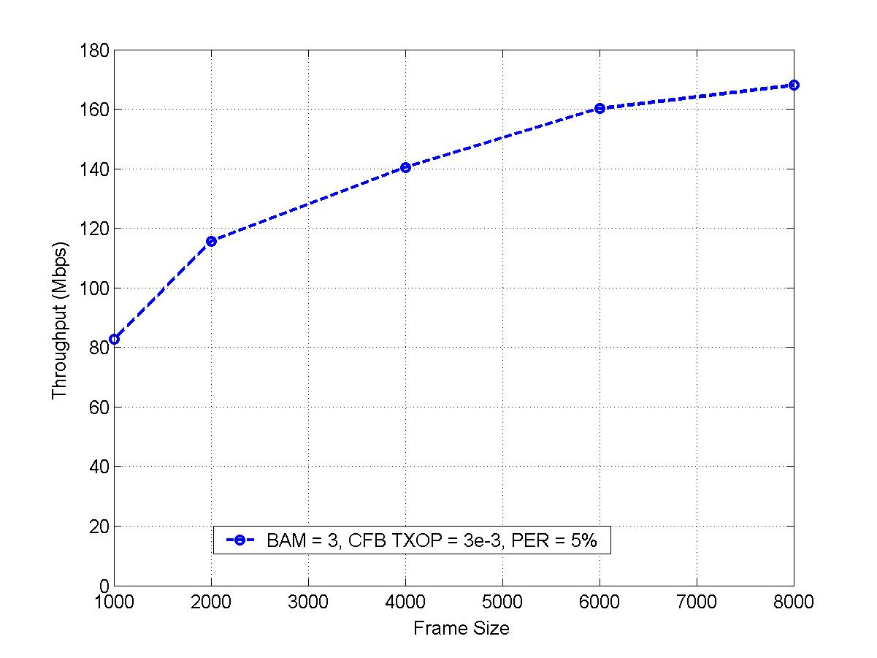
Figure 29: Effect of increasing frame size.

In a typical network scenario where multiple STAs contend for channel access, collisions may become more costly, especially when ADCA is used along with frame size enlargement and frame aggregation. In this case, it is strongly recommended to turn on the RTS/CTS mechanism, so that the excessive degradation in throughput performance due to collisions can be avoided.

Sequential Coordinated Channel Access (SCCA)
In this section, the SCCA mechanism will be introduced. First, the basic SCCA mechanism is presented in section 9.1, and the QoS support is discussed in section 9.2. Backward compatibility and implementation issue are then explained in section 9.3. Performance evaluation is finally provided in section 9.4.

Basic Algorithm
The SCCA scheme can be divided into five distinct phases, namely resource reservation, resource allocation, data transmission, resource renegotiation and resource relinquishment, which are illustrated in Figure 30, Figure 32 and Figure 33, respectively. Basically, a STA reserves the channel resource first in the contention period. The SCCA controller then performs admission control and notifies all the admitted requesting STAs by sending a broadcast message a PIFS time after the beacon that signals the start of the contention free period. Those flows that have received the resource allocation should then set their initial backoff counter to the value assigned to them in that broadcast message and begin to access the channel in a CSMA-alike manner. Once the backoff counter decrements to zero, the flow can occupy the channel no more than dynamic transmisstion time (TXDT), which is also retrieved from the broadcast message.

Resource Reservation
In the resource reservation phase, a STA must send a resource request (RRQ) message to the SCCA controller in the contention period prior to the SCCA period that the STA desires to transmit. Note that the SCCA controller can be collocated with the AP.

The RRQ message should be treated as a management frame with the highest priority in STA. Therefore, the transmission and the subsequent retransmissions, if necessary, must contend for channel access with the parameter set for the management frame. The acknowledgement to the RRQ message should be sent on a per-packet basis. It is strongly recommended to disable BlockACK for the RRQ message. If no ACK is received in time for RRQ frame, the requesting STA follows the retransmission policy defined in the legacy 802.11. Nevertheless, the requesting STA can cease the retransmission attempt, whenever it considers it too late to schedule the traffic any longer, even when the retry limit of the RRQ message has not been exceeded. The STA should forsake the retransmission attempt, if it receives a resource allocation message (RAL) at the beginning of the SCCA period. This type of retransmission mechanism is called schedule-driven retransmission in this document.

Based upon the resource request information received in the ADCA period and other accessory information, the SCCA controller properly schedules the channel access sequence and duration of each requesting STA. For instance, the AP can monitor the actual consumption of the bandwidth resources and record the transmission time used by each data stream. According to the collected usage statistics, the AP can use the access credit/debit counters to police aggressive data streams and compensate the under-served flows. Nevertheless, both the accessory information and the selection of the scheduling algorithm are implementation dependent.
Resource Relinquishment (RRL)
ACK
STA
SCCA Controller
Beacon
Resource Allocation (RAL)
SIFS
Resource Relinquishment
SIFS
SCCA Period
. . .
. . .
Figure 30: Resource reservation and allocation process.

Resource Allocation
For resource allocation, the SCCA controller distributes the bandwidth allocation information by broadcasting a resource allocation message (RAL) a SIFS period after the delivery of regular beacon. The RAL message contains both the sequence index value (SIV) that specifies the channel access precedence, and the duration scheduled (i.e., TXDT) for each requesting STA. Neither acknowledgement, nor retransmission is needed for RAL signaling message. And since the legacy beacon message has already set up the NAV value appropriately for all the STA associated with the access point (AP), this RAL message is simply discarded by the legacy STAs who do not understand the new signaling message. For those STAs that support SCCA, they should retrieve the sequence index value (SIV) and dynamic transmission time (TXDT) values from the broadcast RAL message.

Data Transmission
Once every STA receives the broadcast RAL message, the SCCA data transmission phase starts, in which each requesting STA accesses the channel in a CSMA-alike, with collision free manner. A SIFS time after the successful reception of RAL message, the SCCA-compatible STAs will start backoff, with the initial backoff counter value set to the retrieved SIV value. The station consistently senses the channel and decrements its backoff counter if the channel is found idle for a time slot. Once the backoff counter reaches zero, the station begins transmission. If the channel is busy, the station then freezes its backoff counter and waits the channel to be idle again. After winning the channel access right, each data stream can transmit up to TXDT duration.

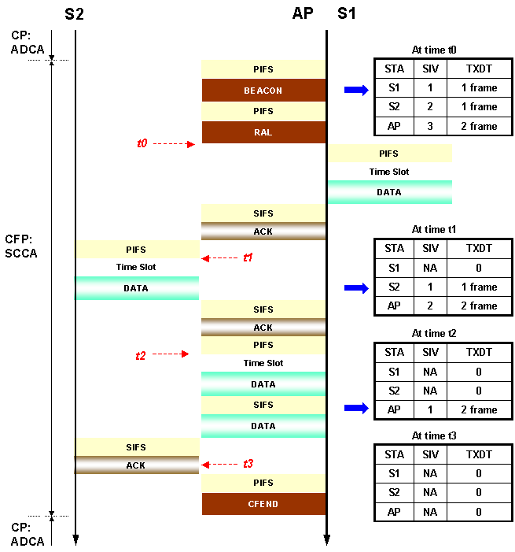

Figure 31: Example: Sequential coordinated channel access.

As illustrated in Figure 31, for example, stream 1 (S1) and stream 2 (S2) have a SIV value of 1 and 2, respectively. And AP itself is assigned with an SIV of 3. Hence, the S1 starts its transmission one time slot plus a PIFS idle period after the transmission of RAL message. Once S1 grabs the channel, it can continuously transmit up to TXDT duration. The S2 in the meantime sets its NAV and stops counting down its backoff counter. A PIFS period after the channel is sensed idle again, the S2 resumes decrementing the backoff counter. Since its counter has already become 1 at this time, it only needs to wait for another time slot, before it can transmit its data. The AP starts to transmit a PIFS plus a slot time after S2 completes. Once all the scheduled transmission has completed, or whenever the AP considers necessary, the AP broadcasts a CF-End message to terminate the contention free period and all the stations enter the contention period hereafter. The CF-End message is transmitted a PIFS time after the channel becomes idle.

Note that if contention free burst (CFB) mode is supported, an SCCA-compatible STA can continuously transmit data frames, with a SIFS interval between two consecutive frames, as long as the predefined ACK policy is observed and the allocated TXDT period is not exceeded.

Our SCCA method can also handle occasionally idle data streams. If all data streams from SIVn to SIVm (n < m) are idle, then the next data stream with SIVm+1 accesses the channel after at most (m-n+1) time slots.

Resource Renegotiation
If the STA that has received SIV and TXDT would like to modify the traffic profile previously submitted to the SCCA controller, it can renegotiate the bandwidth reservation by sending another RRQ message to update the record kept at the SCCA controller, which then will perform proper scheduling again. This process is called resource renegotiation and is illustrated in Figure 32. The requesting STA can submit the renegotiation request during either the contention period or the contention free period, even though the example of resource renegotiation provided in Figure 32 occurs in the contention free period.

Data
from
STA x
Data
ACK
STA
SCCA Controller
Beacon
Resource Allocation (RAL)
SIFS
SCCA Period
. . .
. . .
Resource Request (RRQ)

Figure 32: Resource renegotiation process.

Resource Relinquishment
After an STA decides to release the bandwidth allocated to it, the STA should send a resource relinquishment (RRL) message either in the contention period or in the contention free period. The SCCA controller, upon receiving the RRL, removes the corresponding STA from the resource allocation table that it maintains. Note that Figure 33 is for illustration purpose only and does not imply that RRL message can only be transmitted during the contention free period.

Various policies related to the signaling messages are briefly summarized in Table 8.

Name | Acronym | Priority | ACK policy | Retransmission policy
Resource Request | RRQ | Management | Per frame basis | Schedule-driven
Resource Allocation | RAL | Management | Per frame basis | No retransmission
Resource Relinquishment | RRL | Management | Per frame basis | No retransmission
Table 8: Policies related to the signaling messages.

Figure 33: Resource relinquishment process.
Resource Relinquishment (RRL)
ACK
STA
SCCA Controller
Beacon
Resource Allocation (RAL)
SIFS
Resource Relinquishment
SIFS
SCCA Period
. . .
. . .

Quality of Service
The quality of service issue has been addressed explicitly in the SCCA mechanism. Basically, the SCCA inherits the parameterized QoS concept from IEEE 802.11e HCCA mode. In fact, as reflected in the SCCA signaling messages in section 10.2, the SCCA scheme as well as the signaling procedure associated with it fully support per flow channel resource reservation. Obviously, the scheduling algorithm employed at the SCCA controller plays an important role in determining the eventual QoS performance perceived by each requesting STA. However, the design of the scheduling algorithm is beyond the scope of this document and is left implementation dependent.

Backward Compatibility and Implementation Issues
Since the SCCA resource allocation (RAL) signaling message is transmitted after the regular beacon, the legacy STAs that do not support SCCA should set their NAV according to the received beacon and thus will not interfere or interrupt the subsequent SCCA operations. Therefore, SCCA is backward compatible with the legacy IEEE 802.11 PCF or IEEE 802.11e HCCA.

As suggested in the previous description, only three new signaling messages of the management type are defined in the MAC protocol, whose frame format is designed based upon the ADDTS request, ADDTS response and DELTS messages in IEEE 802.11e. Thus, the introduction of these three messages only entails minor modification of the current implementation. The details of the newly defined signaling messages can be found at section 10.2.

Performance Evaluation
Similar to ADCA, we also use ns-2 simulator to study the performance of SCCA. The PHY and MAC layer parameters used in the simulation are listed in Table 7.

It is evident that the performance of SCCA protocol depends on an array of other issues, such as the scheduling algorithm implemented at the SCCA controller, the information set based upon which the scheduling decision is made, etc. However, all these issues are left as implementation dependent.

Therefore, we primarily focus on investigating the performance of the core SCCA mechanism, in which only the resource allocation and data transmission are implemented, while for the time being the resource reservation is assumed static, scheduling is considered perfect and resource relinquishment is ignored. Without being influenced by other noise factors, the performance of core SCCA mechanism can be evaluated in a clean manner. No simulation results for the usage model and simulation scenarios pertaining to SCCA will be provided in this document.

Throughput Performance
The simulation results obtained thereby is depicted in Figure 34. The blue solid line corresponds to the case where contention free burst and block ACK are both enabled, while the green dashed line represents the case where neither feature is turned on. Clearly, SCCA readily meets the 100Mbps requirement, when we only have a burst size of 25 frames.

Since the resource reservation signaling is deemed static and the corresponding overhead is neglected, the increase of number of nodes admitted into the SCCA period amortizes the signaling overhead entailed by beacon, CFEnd, and resource allocation. In the meantime, the BlockACK mechanism can average out the overhead caused by ACK. So the throughput performance eventually reaches the unsurpassable limit imposed by the overhead caused by SIFS. This explains why the throughput curve goes up as the number of nodes increases, rather than going down as in the ADCA case.

In a full implementation of SCCA protocol, however, the net throughput is expected to be lower than the simulation results shown in Figure 34, due to the additional overhead that has been ignored in the current simulation implementation. Moreover, imperfect scheduling may also have negative impact on the throughput performance.
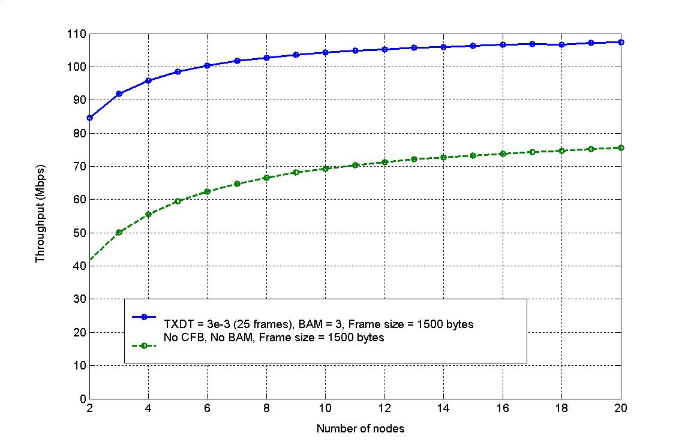
Figure 34: SCCA throughput performance.

Impact of Increased Maximum Packet Size
Similar to the case in ADCA, an increase in the frame size boosts the throughput far above 100Mbps, which is confirmed by our analysis results. As shown in Figure 35, even when there are no advanced features such as contention free burst (CFB) or blockACK mode (BAM) enabled, the increase of frame size itself can easily push the throughput up to 160 Mbps.

Note that the simulation results presented here are obtained in the physical channel with 5% packet error ratio (PER).

If we further exploit the power of contention free burst (CFB) and BlockACK, along with other augmentation technologies such as frame aggregation, the observable throughput is expected to be even higher.
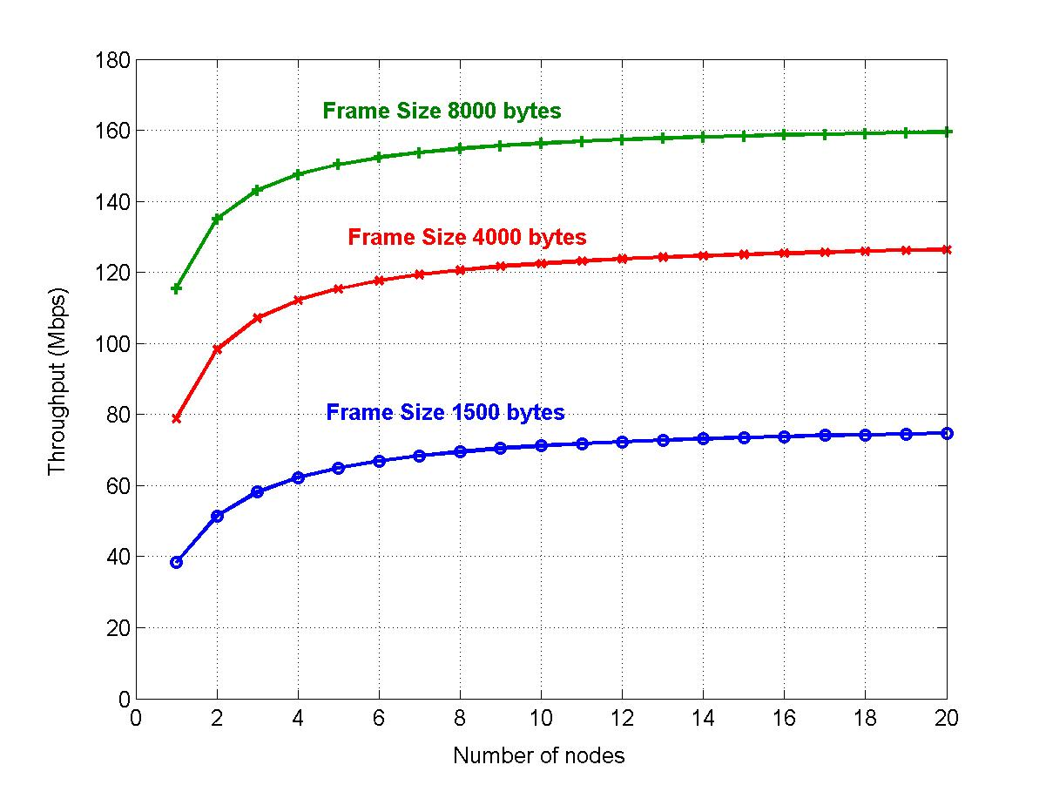
Figure 35: The effect of larger frame size.

Frame Format
In section 10.1, we explain the modification made to the beacon frame as required by ADCA. The new signaling messages defined for SCCA are introduced in section 10.2. Furthermore, we have spotted some deficiencies in the current BlockACK frame format design and suggested several improvements in section 11.

ADCA-Related Frames
In ADCA, each AC has its own RPS settings that can be adjusted depending on the current system performance and channel condition. The AP manages each RPS. The RPS configuration is included in the periodic Beacon frame, announced to each STA in its BSS by the AP. Figure 36 shows the EDCA Parameter Set Element [4] in the Beacon frame, which adjusts the parameters for each AC.
1
1
Element
ID (12)
Length
(18)

Reserved
Octet
1
1
QoS
Info
AC_BE
Parameter
Record
AC_BK
Parameter
Record
AC_VI
Parameter
Record
AC_VO
Parameter
Record
4
4
4
4
Figure 36: EDCA parameter set element.

AC parameter record in 802.11e includes field for AIFS, CWmin, CWmax and TXOP limit for a given AC. As shown in Figure 37, we extend the AC Parameter record format to include fields for parameters in RPS. The newly added fields are shown in dotted lines.

1
1
ACI/
AIFSN
ECWmin/
ECWmax
TXOP
Limit
Octet
2
1
Reference
Packet Size
(S_{f})
Reference
Data Rate
(R_{f})
Reference
Batch Size
(B_{f})
1
1

Figure 37: Extended parameter record for ADCA.

The reference packet size field is 1 byte long and can indicate the reference packet size up to 8192, with granularity of 32 bytes. The 1-byte-long reference data rate field can represent at most 256 different rates, which obviously leaves sufficient space for future protocol extension to even higher rates. The format of reference batch size field is identical to that of TXOP limit field. .

SCCA-Related Frames
A common format of the signaling messages for SCCA is shown in Figure 38. Three signaling messages only have different frame body, as described below. In order to ensure the backward compatibility and lower the additional implementation complexity, the RRQ, RAL and RRL management frames are purposefully designed to be similar to the ADDTS request, ADDTS response and DELTS frames defined in [4].

Frame
Control
Duration
DA
SA
BSSID
Sequence
Control
Frame
Body
FCS
MAC Header
2
2
6
6
6
2
4
Figure 38: Common format for signaling messages.

Resource Request (RRQ)
The format of the RRQ message frame body is shown in Table 9. The category field is set to 1 and action field is set to 3 to represent RRQ. The dialog token is contained in the received upper layer primitive that causes the frame to be sent. A list of all used action field value is provided in Table 10.

Order | Information
1 | Category
2 | Action
3 | Dialog Token
4 ~n | Multi-TSPEC
Table 9: RRQ frame format.

Action field value | Meaning
0 | ADDTS request
1 | ADDTS response
2 | DELTS
3 | RRQ
4 | RAL
5 | RRL
4 ~ 255 | Reserved
Table 10: QoS action field values.

The Multi-TSPEC element is a variable length field and contains the QoS parameters of multiple traffic streams (TSs). The format of Multi-TSPEC is shown in Figure 39.

Octet
Element
ID
Length
TSPEC
Bitmap
1
TSPEC
1
TSPEC
n
. . .
1
1
2
x
y
TSPEC
Bitmap
n
2

Figure 39: Frame format of Multi-TSPEC.

The element ID is set to 0x26 and the length field indicates the total number of individual TSPEC that this Multi-TSPEC contains. The TSPEC Bitmap k indicates the internal structure of the corresponding kth TSPEC. A complete TSPEC field is depicted in Figure 40.
TS
Info
Nominal
MSDU
Size
Maximum
MSDU
Size
Minimum
Service
Interval
Inactivity
Interval
Suspension
Interval
Service
Start
Time
Mean
Data
Rate
Peak
Data
Rate
Maximum
Burst
Size
Delay
Bound
Minimum
PHY
Rate
Surplus
Bandwidth
Allowance
Medium
Time
Minimum
Data
Rate
Maximum
Service
Interval
3
2
2
4
4
4
4
4
4
4
4
4
4
4
2
2
Octet

Figure 40: Frame format of a complete TSPEC.

If a TSPEC is complete, it should have 16 subfields. Since not all the subfields will show up all the time, instead of putting “unspecified (0x0)” in the field that the STA does not have any information about, we simply do not include that subfield in the TSPEC field. To mark the absence of a particular subfield, the TSPEC Bitmap sets the corresponding bit to 0. For 16 subfields within TSPEC, 2 bytes are sufficient for the TSPEC Bitmap. Moreover, some degree of saving can be achieved, as long as at least one subfield is omitted, since the smallest subfield has 2 bytes. The meaning of each subfield is the same as that defined in IEEE 802.11e. The TS is identified by the TSID and Direction subfields contained in the TS Info field. The access policy within the TS Info is set to 0x0 for SCCA period.

Note that the same RRQ message is used in both resource request and the resource renegotiation procedures. It is under the discretion of the SSCA controller to interpret the received RRQ message as a resource request or resource renegotiation.

Resource Allocation (RAL)
The format of the RAL message frame body is shown in Table 11. The category field is set to 1 and action field is set to 4 to represent RAL. The dialog token is contained in the received upper layer primitive that causes the frame to be sent. A list of all used action field value is provided in Table 10.

Order | Information
1 | Category
2 | Action
3 | Dialog Token
4 ~n | Multi-Schedule
Table 11: RRQ frame format.

The format of Multi-Schedule field is shown in . The element ID should be 0x27. The length field represents the number of Multi-Schedule element that follows.
1
2
Element
ID
Length
Multi-Schedule
Element 1
Multi-Schedule
Element n
…
14
14

Figure 41: Format of Multi-Schedule field.

The structure of the multi-schedule element is then shown in Figure 42. The sequence index value (SIV) component is the initial backoff counter value assigned to each requesting STA. This value essentially determines the sequence in which each STA should access the channel. The association ID (AID) field contains the AID of the STA to which this reservation allocation belongs.

2
2
4
2
2
Schedule
Info
SIV
Service
Interval
TXDT
Specification
Interval
AID
2

Figure 42: Format of multi-schedule element subfield

The Schedule Info subfield, which is shown in Figure 43, is identical to that defined by IEEE 802.11e.
Bit 0
Bit 1 - 4
Bit 5 - 6
Bit 7 - 15
Reserved
TSID
Direction
Reserved

Figure 43: Format of Schedule Info subfield.

The AID, along with the TSID and direction field in the Schedule Info subfield, can uniquely identify a flow. All other fields and subfields inherit the definition from IEEE 802.11e.

Resource Relinquishment (RRL)
The format of RRL message is defined in Table 12.

Order | Information
1 | Category
2 | Action
3 ~ n | RRL element
Table 12: RRL frame format.

A RRL message has a category value of 1 and action value of 5. The frame body of the RRL message has multiple RRL element subfields, which is depicted in .
TS Info
5 Bytes
AID
2
3

Figure 44: Resource relinquish element (RRL) format.

The TS Info subfield is shown in Figure 45. The meaning of each component within this subfield is the same as that defined in IEEE 802.11e.

Bit 1 - 4
Bit 5 - 6
Bit 7 - 8
Bit 9
Bit 10
TSID
Direction
Access
Policy
Aggre-gation
APSD
Traffic
Type
Bit 0
Bit 14 - 15
Bit 16
Bit 17 - 23
TS Info
ACK Policy
Schedule
Reserved
User
Priority
Bit 11 - 13
Figure 45: TS Info subfield.

Similarly, the AID, the TSID and direction field in the Schedule Info subfield, are used to uniquely identify a flow to terminate.

Efficient BlockACK

New BlockACK Frame Format
The BlockACK frame specified in IEEE 802.11e contains a fixed length BlockACK bitmap field of 128 bytes. Hereby, we propose a streamlined version of BlockACK bitmap field, which can fulfill the same goal with only 6.25% (e.g., 8 bytes) of the size of the original BlockACK bitmap field or even less. This new BlockACK only needs minor modification of the current BlockACK frame format and hence is backward compatible. The new bitmap that we propose is shown in Figure 46.

The new Bitmap consists of at most 8-byte-long sequence number bitmap. Each bit of the sequence number bitmap field indicates whether a particular frame has been successfully/unsuccessfully received. The relative position of the bit represents the sequence number. For instance, if the least significant bit of this bitmap field is set to 1, it implies that the frame with sequence number (BlockACK starting sequence number + 0) has been successfully delivered. The number of bits in the bitmap should be the number of frames requesting acknowlegement. For implementation purpose, it is required to insert padding bits to make the bitmap a multiple of 8 bits.

Sequence Number
Bitmap

Figure 46: The BlockACK bitmap defined in Flexebo.

There is no fragment number associated with each sequence number in the BlockACK bitmap, since we believe that fragmentation will be rarely used in IEEE 802.11n. In fact, as frame aggregation and increase of maximum frame size become the prevailing technology, fragmentation in wireless LAN, which is an opposite technology to the formers, will vanish quickly in the new standard. Hence, it is reasonable to assume that sequence number by itself is sufficient in supporting orderly frame delivery and proper frame acknowledgement.

It is possible that the BlockACK is requested before exactly 64 frames have been transmitted. However, the bitmap field by itself does not have adequate logic to distinguish the case where a frame has not been transmitted, from the case where that frame has been successfully or unsuccessfully transmitted. Thus, we use some reserved subfields of BAR/BA fields in the BlockACKReq/BlockACK to resolve this potential problem.

Figure 47 illustrates the BAR/BA field defined for the new BlockACK mechanism. As specified in Table 3, the first two bits (i.e., b0 to b1) are the type field and will be set to 0x2, when this streamlined version of BlockACK is used. The block size field, starting from b2 and ending at b7, indicates how many packets are to be acknowledged in the BlockACK message. The block size field is designed to be 6-bit-long, because we assume that the largest block size supported is 64, which is the same as that in the legacy BlockACK. However, since there are still 4 bits reserved for future extension, the new BA/BAR can readily support block acknowledgement to more than 64 frames by using these reserved bits.

b2
Reserved
Block Size
TID
b7
b8
b11
b12
b15
Type
b0
b1

Figure 47: Format of the BA/BAR field of the BlockACK frame.

Obviously, the new BlockACK only uses at most 8-byte-long bitmap, instead of 128-byte-long in the legacy BlockACK, but still achieves the same functionality, as long as all the frames in the block have continuous sequence number and no fragmentation is present. Note that the bitmap field is not necessarily limited to only 8 bytes. In fact, it is straightforward to extend the new BlockACK to support acknowledgement to more than 64 by lengthening the BlockACK bitmap field.

Effect of BlockACK on Rate Adaptation
Variations in the wireless channel condition can be caused by many factors, which include fading, attenuation, interference from other radiation resources, interference from other IEEE 802.11 devices associated with other access point (AP). All the channel condition variations can be categorized as being either transient, or persistent.

A station (STA) may achieve high throughput, if it transmits at the high data rate. However, if the channel condition is poor, the high transmission rate will result in high packet error rate (PER). Since the garbled packets need to be retransmitted, the high PER eventually may cost more bandwidth than the initial high transmission rate can save. The rate adaptation [14][15] [16] is used to select an appropriate transmission rate dynamically so that the throughput can be maximized under varying physical channel conditions. A good rate adaptation algorithm should react properly to both the transient and persistent variations.

The successful/unsuccessful frame delivery is indicated by the reception/lack of an acknowledgement to the previously transmitted frame at the sender. Note that the loss of a data frame may be caused by harsh channel condition, or by collisions of multiple simultaneous transmissions. However, it is expected that the IEEE 802.11n would strongly recommend to turn on the RTS/CTS mechanism so that the potential bandwidth waste caused by the collision can be minimized, especially when the frame size is increased to four or even eight kilobytes and various packet aggregation and contention free burst mechanisms are adopted in IEEE 802.11n. In this case, therefore, it is valid to assume that an erroneous transmission can be directly inferred by the lack of proper acknowledgement message.

The introduction of BlockACK mechanism may have unexpected effect on the legacy rate adaptation algorithm. On one hand, the BlockACK mechanism achieves high protocol efficiency, but at the expense of forsaking the capability of reflecting the instantaneous physical channel condition. This may inadvertently leave the legacy rate adaptation algorithm operating improperly, because it will be no longer valid to use the BlockACK message to infer the transient channel variation. On the other, it becomes possible for the transmitting STA to obtain a collective view of the channel condition variation within certain time scale from the BlockACK bitmap.

Therefore, the legacy rate adaptation algorithm may need to be redesigned to dynamically adjust the transmission rate and block size of the BlockACK so that high MAC protocol efficiency can be achieved, while performance of rate adaptation can still be guaranteed.

However, since the rate adaptation algorithm is implementation dependent in IEEE 802.11 standard, the corresponding solution to this serious problem then also becomes implementation dependent. Based upon the auto rate fallback (ARF) [14] we propose a new rate adaptation algorithm called auto rate fallback with adaptive BlockACK (Aurafab), which addresses this issue particularly for ARF rate adaptation algorithm.

Conclusion
In this document, we have proposed four major technologies for IEEE 802.11n MAC. The first one is a multilevel frame aggregation, which substantially reduces the overhead associated with each frame transmission. The frame aggregation also provides a new internal collision resolution algorithm and a novel solution to potential collision of multiple BlockACKs. The second technology is the adaptive distributed channel access (ADCA), which is used in the contention period of IEEE 802.11. ADCA uses adaptive batch transmission and opportunistic selection to significantly improve the channel efficiency. The third one is sequential coordinated channel access (SCCA), which operates during the contention free period (CFP). The SCCA inherits the flexibility and simplicity of the legacy polling scheme, while tremendously reduces the overhead and improves overall throughput by eliminating the polling messages. As confirmed by simulation and analysis, both ADCA and SCCA can readily satisfy 100Mbps MAC SAP throughput required by IEEE 802.11n functional requirement. Moreover, the two mechanisms are inherently backward compatible and entail little additional implementation complexity. It is also worthwhile to note that both technologies can easily integrate with other augmentation technologies such as frame aggregation and enlarged frame size. Finally, we propose a new frame format for BlockACK message, which can save more bandwidth, yet still retain the original functionality. Also, we have pointed out the potential failure of rate adaptation caused by the enabling of BlockACK mechanism. However, due to the fact that rate adaptation algorithm is implementation dependent, no further solution is discussed in this document.

References
- IEEE 802.11, “Wireless LAN Medium Access Control (MAC) and Physical Layer (PHY) Specifications”, Standard, IEEE, August, 1999

- S. Garg, M. Kappes, “An Experimental Study of Throughput for UDP and VoIP Traffic in IEEE 802.11b Networks, “ Proceeding of IEEE Wireless Communication and Networking (WCNC) 2003

- S. Garg, M. Kappes, “Can I Add a VoIP Call?”, Proceeding of IEEE International Conference on Communications (ICC) 2003

- IEEE 802.11e, “Wireless LAN Medium Access Control (MAC) and Physical Layer (PHY) Specifications: Medium Access Control (MAC) Enhancements for Quality of Service (QoS)”, Draft v6, IEEE, November 2003

- Official website of IEEE 802.11 http://grouper.ieee.org/groups/802/11/

- G. Bianchi, “Performance Analysis of the IEEE 802.11 Distributed Coordination Function,” IEEE Journal on Selected Areas in Communications (JSAC), Vol 18, Issue 3, March 2000

- Y. Xiao, J. Rosdahl, “Throughput and Delay Limits of IEEE 802.11,” IEEE Communication Letters, Vol 6, Number 8, August 2002

- J. Jun, P. Peddabachagari, M. Sichitiu, “Theoretical Maximum Throughput of IEEE 802.11 and its Applications,” Proceeding of the 2nd IEEE International Symposium on Network Computing and Applications 2003 (NCA’03)

- Sadeghi, V. Kanodia, A. Sabharwal, and E. Knightly, “Opportunistic Media Access for Multirate Ad Hoc Networks,” Mobicom 2002.

- A. Kamerman, L. Monteban, “WaveLAN II: A High-Performance Wirelss LAN for the Unlicensed Band,” Bell Lab Technical Journal, pages 118-133, Summer 1997.

- The Network Simulator (NS2): http://www.isi.edu/nsnam/ns/

- “IEEE P802.11 Wireless LANs Usage Models”, IEEE 802.11-3/802r23, May 2004.

- IEEE 802.11e, “Wireless LAN Medium Access Control (MAC) and Physical Layer (PHY) Specifications: Medium Access Control (MAC) Enhancements for Quality of Service (QoS)”, Draft v6, IEEE, November 2003

- A. Kamerman, L. Montehan, “WaveLAN-II: A High-Performance Wireless LAN for the Unlicensed Band,” Bell Lab Technical Journal, pages 134-140, April, 1998

- G. Holland, N. Vaidya, P. Bahl, “A Rate-Adaptive MAC Protocol for Multi-hop Wireless Networks,” in Proc. of ACM MOBICOM, Atlanta, September, 2002.

- M. Lacage, H. Manshaei, T. Turletti, “IEEE 802.11 Rate Adaptation: A Practical Approach,” INRIA Research Report, May, 2004

Appendix
Simulation Results for ADCA Mode

Scenario 1: Home

Flow | Src | Dst | Application | Type | MSDU | Mean Rate |  | Max Delay (ms) |  | AC | Notes
 |  |  |  |  |  | Req | Sim | Req | Sim | AC | Notes
1 | AP | S1 | HDTV | CBR/UDP | 1500 | 19.2M | 18.8M | 200 | 108 | VI
2 | AP | S3 | HDTV | CBR/UDP | 1500 | 24M | 23.6M | 200 | 107 | VI
3 | AP | S4 | SDTV | CBR/UDP | 1500 | 4M | 3.9M | 200 | 82 | VI
4 | AP | S4 | Internet file | TCP | 300 | 1M | 1.9K | N/A | 423 | BE | FTP
5 | AP | S7 | VoIP | CBR/UDP | 12 | 96K | 136.5K | 30 | 50 | VO
6 | AP | S8 | VoIP | CBR/UDP | 12 | 96K | 133.6K | 30 | 45 | VO
7 | AP | S9 | VoIP | CBR/UDP | 12 | 96K | 127.1K | 30 | 41 | VO
8 | AP | S10 | Internet streaming video | UDP | 512 | 2M | 2.1M | 200 | 84 | VI
9 | AP | S11 | MP3 audio | UDP | 418 | 128K | 130.3K | 200 | 27 | VI
10 | S1 | AP | HDTV Display | CBR/UDP | 64 | 60k | 62.7K | 100 | 159 | VI
11 | S3 | AP | HDTV Display | CBR/UDP | 64 | 60k | 64.5K | 100 | 170 | VI
12 | S4 | S10 | Local file transfer | CBR/TCP | 1500 | 30M | 24.8K | N/A | 4936 | BE | FTP
13 | S5 | S6 | Video Phone | CBR/UDP | 512 | 500K | 405.7K | 100 | 179 | VI

Flow | Src | Dst | Application | Type | MSDU | Mean Rate |  | Max Delay (ms) |  | AC | Notes
 |  |  |  |  |  | Req | Sim | Req | Sim | AC | Notes
14 | S6 | S5 | Video Phone + Internet Upload | CBR/UDP | 512 | 500K | 343.1K | 100 | 159 | VI
15 | S7 | AP | VoIP | CBR/UDP | 12 | 96K | 125.6K | 30 | 86 | VO
16 | S8 | AP | VoIP | CBR/UDP | 12 | 96K | 122.2K | 30 | 110 | VO
17 | S9 | AP | VoIP | CBR/UDP | 12 | 96K | 114.9K | 30 | 163 | VO
18 | S10 | AP | Video Console + Internet Entertain-ment | CBR/UDP | 512 | 1M | 837.9K | 50 | 69 | VI
19 | S11 | S10 | Video Gaming Controller | CBR/UDP | 50 | 500K | 622.6K | 16 | 128 | VI

Table 13: Results for home usage model.

Scenario 2: Residential IBSS

Flow | Src | Dst | Application | Type | MSDU | Mean Rate |  | Max Delay (ms) |  | AC | Notes
 |  |  |  |  |  | Req | Sim | Req | Sim | AC | Notes
1 | S2 | S3 | Local file transfer | TCP | 1500 | 30M | 11K | N/A | N/A | BE | FTP
2 | S4 | S5 | Video phone | CBR/UDP | 512 | 0.5M | 366.3K | 100 | 2.4 | VI
3 | S5 | S4 | Video phone | CBR/UDP | 512 | 0.5M | 377.4K | 100 | 37.1 | VI
4 | S6 | S7 | Video phone | CBR/UDP | 512 | 0.5M | 368.1K | 100 | 2.1 | VI
5 | S7 | S6 | Video phone | CBR/UDP | 512 | 0.5M | 367.5K | 100 | 38.9 | VI
6 | S10 | S1 | P2P DV audio/video | CBR/UDP | 1024 | 28.8M | 25.9M | 200 | 1.5 | VI
7 | S11 | S8 | Controller to console | CBR/UDP | 50 | 0.5M | 489.6K | 16 | 2.3 | VI
8 | S12 | S8 | Controller to console | CBR/UDP | 50 | 0.5M | 515.2K | 16 | 2.3 | VI
9 | S13 | S8 | Controller to console | CBR/UDP | 50 | 0.5M | 486.9K | 16 | 2.8 | VI
10 | S14 | S8 | Controller to console | CBR/UDP | 50 | 0.5M | 488.0K | 16 | 2.4 | VI
11 | S15 | S9 | Content download | TCP | 1500 | 11M | 32K | N/A | 0 | BE | FTP

Table 14: Results for IBSS residential usage model.

Scenario 4: Large Enterprise

Flow | Src | Dst | Application | Type | MSDU | Mean Rate |  | Max Delay (ms) |  | AC | Notes
 |  |  |  |  |  | Req | Sim | Req | Sim | AC | Notes
1 | AP | S1 | Internet file | TCP | 300 | 1M | 3.6K | N/A | 6246 | BE | Telnet
2 | AP | S2 | Internet file | TCP | 300 | 1M | 1.4K | N/A | 1573 | BE | Telnet
3 | AP | S3 | Internet file | TCP | 300 | 1M | 2.3M | N/A | 475 | BE | Telnet
4 | AP | S4 | Internet file | TCP | 300 | 1M | 775.4K | N/A | 891 | BE | Telnet
5 | AP | S5 | Internet file | TCP | 300 | 1M | 1.2M | N/A | 1337 | BE | Telnet
6 | AP | S6 | Internet file (download large email attachment) | TCP | 300 | 10M | 1.2K | N/A | 24 | BE | Telnet
7 | AP | S7 | Video conferen-cing | CBR/UDP | 512 | 1M | 1.0M | 100 | 15 | VI
8 | AP | S8 | Video conferen-cing | CBR/UDP | 512 | 1M | 1.0M | 100 | 13 | VI
9 | AP | S9 | Internet streaming video + MP3 audio | UDP | 512 | 2M | 2.0M | 200 | 15 | VI | The UM doesn’t specify whether it is CBR or not
10 | AP | S10 | Internet streaming video + MP3 audio | UDP | 512 | 2M | 2.0M | 200 | 14 | VI | The UM doesn’t specify whether it is CBR or not
11 | AP | S11 | Local file transfer | TCP | 1500 | 30M | 4.6K | N/A | 112 | BE | FTP

Flow | Src | Dst | Application | Type | MSDU | Mean Rate |  | Max Delay (ms) |  | AC | Notes
 |  |  |  |  |  | Req | Sim | Req | Sim | AC | Notes
12 | AP | S12 | Local file transfer | TCP | 1500 | 30M | 11.7K | N/A | 185 | BE | FTP
13 | AP | S13 | Local file transfer | TCP | 1500 | 30M | 26.6K | N/A | 24 | BE | FTP
14 | AP | S14 | Local file transfer | TCP | 1500 | 30M | 0.8M | N/A | 0 | BE | FTP
15 | AP | S15 | Local file transfer | TCP | 1500 | 30M | 46.5K | N/A | 184 | BE | FTP
16 | AP | S16 | Local file transfer | TCP | 1500 | 30M | 21.9K | N/A | 136 | BE | FTP
17 | AP | S17 | Local file transfer | TCP | 1500 | 30M | 20.8K | N/A | 184 | BE | FTP
18 | AP | S18 | Local file transfer | TCP | 1500 | 30M | 15.3K | N/A | 99 | BE | FTP
19 | AP | S19 | Local file transfer | TCP | 1500 | 30M | 4.0M | N/A | 21 | BE | FTP
20 | AP | S20 | Local file transfer | TCP | 1500 | 30M | 12.5M | N/A | 0.185 | BE | FTP
21 | AP | S25 | VoIP | CBR/UDP | 12 | 96K | 129.0K | 30 | 8 | VO
22 | AP | S26 | VoIP | CBR/UDP | 12 | 96K | 129.4K | 30 | 8 | VO
23 | AP | S27 | VoIP | CBR/UDP | 12 | 96K | 151.6K | 30 | 8 | VO
24 | AP | S28 | VoIP | CBR/UDP | 12 | 96K | 150.2K | 30 | 26 | VO
25 | AP | S29 | VoIP | CBR/UDP | 12 | 96K | 151.7K | 30 | 13 | VO
26 | AP | S30 | VoIP | CBR/UDP | 12 | 96K | 152.3K | 30 | 14 | VO

Flow | Src | Dst | Application | Type | MSDU | Mean Rate |  | Max Delay (ms) |  | AC | Notes
 |  |  |  |  |  | Req | Sim | Req | Sim | AC | Notes
27 | S1 | AP | Click on web link | TCP | 64 | 256K | 6.7K | N/A | 27 |  | Telnet
28 | S2 | AP | Click on web link | TCP | 64 | 256K | 48.7K | N/A | 57 |  | Telnet
29 | S3 | AP | Click on web link | TCP | 64 | 256K | 2.0K | N/A | 21 |  | Telnet
30 | S4 | AP | Internet file transfer | TCP | 1000 | 5M | 1.1M | N/A | 49 |  | FTP
31 | S5 | AP | Uploading large email attachment | TCP | 1500 | 10M | 2.5M | N/A | 271 |  | FTP
32 | S6 | AP | Click on web link | TCP | 64 | 256K | 85.5K | N/A | 28 |  | Telnet
33 | S7 | AP | Video conferencing | CBR/UDP | 512 | 1M | 804.7K | 100 | 29
34 | S8 | AP | Video conferencing | CBR/UDP | 512 | 1M | 783.6K | 100 | 25
35 | S21 | AP | Local file transfer | TCP | 1500 | 30M | 1.2M | N/A | 50 |  | FTP
36 | S22 | AP | Local file transfer | TCP | 1500 | 30M | 0.6M | N/A | 91 |  | FTP
37 | S23 | AP | Local file transfer | TCP | 1500 | 30M | 0.6M | N/A | 16 |  | FTP
38 | S24 | AP | Local file transfer | TCP | 1500 | 30M | 1.9M | N/A | 29 |  | FTP

Flow | Src | Dst | Application | Type | MSDU | Mean Rate |  | Max Delay (ms) |  | AC | Notes
 |  |  |  |  |  | Req | Sim | Req | Sim | AC | Notes
39 | S25 | AP | VoIP | CBR/UDP | 12 | 96K | 80.6K | 30 | 22
40 | S26 | AP | VoIP | CBR/UDP | 12 | 96K | 104.8K | 30 | 14
41 | S27 | AP | VoIP | CBR/UDP | 12 | 96K | 108.7K | 30 | 12
42 | S28 | AP | VoIP | CBR/UDP | 12 | 96K | 83.1K | 30 | 15
43 | S27 | AP | VoIP | CBR/UDP | 12 | 96K | 89.3K | 30 | 20
44 | S28 | AP | VoIP | CBR/UDP | 12 | 96K | 87.1K | 30 | 18

Table 15: Results for large enterprise usage model.

