IEEE P802.11
Wireless LANs
IEEE 802.11 TGn
Enhancements of 802.11a/g-based MIMO-OFDM System

August 13, 2004
Begonya Otal, Francesc Dalmases, Job Oostveen, Joerg Habetha,
Monisha Ghosh, Pen C. Li, Ronald Rietman, TK Tan
Philips
1109 McKay Drive, M/S: 48A-SJ, San Jose, CA 95131, USA
Phone: +1 408-474-5619
e-Mail: pen.li@philips.com

Abstract
We believe that high data rate, better robustness and extended coverage are the key factors to enable a the heterogeneous consumer multimedia network. We present 128-FFT in 20MHz and MMRA to improve the data throughput efficiency while providing an evolutional path into 40MHz. Advanced coding schemes such as concatenated RS plus extended 1/4 CC are also discussed which improve the robustness and extend the coverage while keeping the complexity low. The embedded signalling technique provides a seamless transition for the legacy devices to coexist with high-throughput 11n devices ensuring maximum backward compatibility.

All features we proposed here are fully compliant with the 802.11n PAR.

Table of Contents
Contributors 1
Table of Contents 2
1 Introduction 6
2 System Description 7
2.1 MIMO-OFDM System 7
2.2 PPDU format 7
3 128-point FFT in 20MHz 8
3.1 Data Mapping 8
3.2 HT-LTF format 8
3.2.1 Option 1: Single symbol 9
3.2.2 Option 2: Concatenated double symbol 9
3.2.3 Option 3: Disjointed double symbol 9
3.3 Channel estimation 10
3.4 Peak to average ratio (PAR) 12
3.5 Effect of phase noise 12
3.6 Interleaving and parsing 13
4 Advanced Coding Schemes 15
4.1 RS encoding 15
4.1.1 RS Coding and 128-fft in 20 MHz 16
4.1.2 Overall performance of the 128-fft system and RS coding with impairments. 17
4.2 Extended Convolutional Code 18
4.2.1 Introduction 18
4.2.2 Procedure of finding the generator 18
4.2.3 Performance analysis 18
5 Embedded Signaling 20
5.1.1 Introduction 20
5.1.2 Description 20
5.1.3 Performance 21
5.1.4 Complexity 23
6 Multiple MCS and Receiver Aggregation (MMRA) 24
6.1 Introduction and functional description 24
6.2 MMRA frame formats 25
6.3 Power saving scheme 26
6.4 Performance analysis 27
6.4.1 Reference system: Single MCS Multiple Receiver Aggregation (SMRA) 27
6.4.2 Evaluation methodology 30
6.4.3 Considered scenarios for time efficiency evaluation 32
7 Summary 36

List of Tables
Table 1: Fields of HT-SIG MMRA Part 25
Table 2: Elements of DATA-PSDU 26
Table 3: Fields of PSDU Header MPDU 28
Table 4: Overhead comparison between SMRA and MMRA 28

List of Figures
Fig. 1: An .11a/g based MIMO-OFDM System with 2 spatial streams 7
Fig. 2: PPDU format 7
Fig. 3: Inputs and Outputs of IFFT for a 20 MHz Channel 8
Fig. 4: Single symbol preamble 9
Fig. 5: Concatenated double symbol preamble 9
Fig. 6: Disjoined double symbol preamble 9
Fig. 7: Channel estimation comparison for 2x2, rate ¾ 64QAM, 20 MHz, model B 11
Fig. 8: Channel estimation comparison for 2×2, rate 3/4 64QAM, 20 MHz, model D 11
Fig. 9: Channel estimation comparison for 2×2, rate 3/4 64QAM, 20 MHz, model E 12
Fig. 10: Empirical CDF 12
Fig. 11: Comparison between 128-FFT and 64-FFT, 2×2, 3/4 64QAM 20MHz, model E, phase noise = −100dbc/Hz, frequency offset = 1.56kHz 13
Fig. 12: Interleaver comparison, 2×2, 3/4 64QAM, 128-FFT, 20 MHz, model E 14
Fig. 13: Advanced Coding 15
Fig. 14: Reed-Solomon overhead 15
Fig. 15: RS performance in Model B 16
Fig. 16: RS performance comparison for Model D 16
Fig. 17: RS performance comparison for model E 17
Fig. 18: Overall performance of 128-FFT system with RS encoding 17
Fig. 19: Performance of different codes using BPSK in AWGN 18
Fig. 20: Performance of ¼ CC in Model E 19
Fig. 21: Performance of ¼ CC in Model D 19
Fig. 22: Constellation diagram for embedded signaling 20
Fig. 23: Encoding of the embedded bits 21
Fig. 24: Bit error rate versus SNR for embedded signalling in a flat fading channel 22
Fig. 25: Bit error rate versus SNR for embedded signalling in a Rayleigh fading channel (50ns delay spread) 22
Fig. 26: Exemplary scenario for m multiple rate and receiver aggregation 24
Fig. 27: Format of MMRA part in HT-SIG and aggregated PSDU-DATA 25
Fig. 28: Active/sleep states with MMRA scheme 27
Fig. 29: SMRA in 3 station example 28
Fig. 30: Active/sleep states with SMRA scheme 29
Fig. 31: Efficiency of MMRA and SMRA in scenario 1 33
Fig. 32: Efficiency of MMRA and SMRA in scenario 2 33
Fig. 33: Efficiency of MMRA and SMRA in scenario 3 34
Fig. 34: Efficiency of MMRA and SMRA in scenario 1 35

Introduction
With the strict requirement of backward compatibility in mind, there are a few things that can be done to achieve the 100Mbps throughput as required by the 802.11n PAR. Among those widely known are: increased bandwidth, increased data tones, increased spatial streams, enlarged constellation, shortened guard interval, increased coding rate, better MAC efficiency, etc.
In this proposal, we will investigate a few techniques that can further increase the system efficiency and extend the coverage based on an .11a-based MIMO-OFDM system. We start off by considering a 128-FFT in 20MHz. Not only does it boost the data rate by 11% comparing to a 64-FFT-based system in 20MHz, it also offers an evolution path into a 128-FFT system for 40MHz.
To further improve the efficiency, we also present a MAC-level technique which for discussion purpose within this document we have called Multiple MCS Rate Aggregation (MMRA). Targeting the heterogeneous consumer multimedia network, MMRA maximally utilizes the bandwidth by aggregating packets for different users at their own optimum modulation and coding scheme. It thus best facilitates the foreseeable scenario where an AP at home serving as the media server distributes throughout the whole house multimedia files from as small as a single MP3 music to as large as a MPEG-2 movie.
To ensure full coverage at home at low complexity, a Reed-Soloman-Convolutional-Code (RS-CC) concatenated coding scheme will be presented where the CC is extended to ¼ rate from the original ½ rate CC of .11a/g. Both codes are well known in the industry. Their implementation complexity is minimal compared to other advanced coding techniques while offering significant performance advantages. We believe both higher data rate and extended coverage are crucial in enabling the multimedia heterogeneous network for the consumer market.
Realizing that the legacy .11a/g SIGNAL field won’t be able to sustain the coverage or robustness provided by this more powerful RS-CC coding, we also propose embedding a high-throughput packet indicator in the .11a/g SIGNAL header. Only new .11n devices will know of the indicator’s existence and have the ability to detect it. This allows a seamless transition from legacy devices.
After this introduction, the rest of this document is organized as follows. Section 2 is the System Description, where an overview of the system will be provided. Since 128-FFT in 40MHz is quite straightforward, Section 3 will only discuss 128-FFT in 20MHz. Various preamble designs will be considered and their performance results will be shown. The effects of phase noise will also be discussed in detail. Section 4 is the advanced coding which includes concatenated RS-CC and the extended Convolutional Code from ½ to ¼. Embedded signalling is in Section 5 and MMRA is in Section 6. A summary will be provided in Section 7.

System Description

MIMO-OFDM System
We assume that the MAC and PHY have the same structure as specified in 802.11. The PHY is assumed to be a MIMO-OFDM system based the .11a/g OFDM system. A system with 2 spatial streams is depicted in Fig. 1.
Fig. 1: An .11a/g based MIMO-OFDM System with 2 spatial streams

PPDU format
We envisioned a PPDU format illustrated in Fig. 2. While maintaining the preamble (L-STF, L-LTF) and signal field (L-SIG) of .11a/g, the embedded signalling technique is utilized in the L-SIG for the purpose of applying advanced MIMO and MCS on the high-throughput signal field (HT-SIG1 and HT-SIG2). This technique will be explained in detail in Section 5.
After HT-SIG0, 128-FFT is used whether the bandwidth is 20MHz or 40MHz. HT-SIG1 and HT-SIG2 are protected by the most robust MCS, which in our case is RS+1/4CC with BPSK modulation. The MMRA part (see section 6) in the HT-SIG field is either encoded with the most robust MCS or with a higher MCS. In the latter case the MCS of the MMRA part is also included in the HT-SIG.

PPDU FORMAT | L-STF | L-LTF | L-SIG | HT-SIG0 | HT-STF | HT-LTF | HT-SIG1 | HT-SIG2 | DATA
Duration (us) | 8 | 8 | 4 | 4 | 2.4 | 7.2x | 8 | variable | variable
Bandwidth (MHz) | 20 | 20 | 20 | 20 | 20/40 | 20/40 | 20/40 | 20/40 | 20/40
FFT size | 64 | 64 | 64 | 64 | 128 | 128 | 128 | 128 | 128
Embedded signalling | no | no | yes | no | no | no | no | no | no
Modulation | BPSK | BPSK | BPSK | BPSK | BPSK | BPSK | BPSK | BPSK | variable
Coding | n/a | n/a | 1/2 cc | repetitive or RS+¼CC | n/a | n/a | RS+1/4CC | RS+1/4CC | variable
# of spatial streams | single | single | single | single | multiple | multiple | multiple | multiple | multiple
Fig. 2: PPDU format

128-point FFT in 20MHz
The use of 128-point FFT in 20 MHz increases the OFDM symbol time from 3.2usec to 6.4 us. By keeping the GI at 0.8us, the data rate compared to 64-FFT, keeping all other modulation and coding the same, is increased by 11%. This allows a PHY rate of 120Mbps using a 2 x 2 MIMO system with rate ¾ coding and 64QAM. With a reduced GI of 0.4usec, the rate increases to 127Mbps. In addition to increasing the data rate, the longer symbol time of the 128-fft system makes it less sensitive to timing errors and longer delay-spread channels. In this section we will describe the various aspects of the 128-point FFT MIMO system.

Data Mapping
Let us number the 128 tones from 1 to 128. Data and pilot symbols are mapped to tones (3:53) and (77:127). Tone nos. 1, 2 and 128 are zero, corresponding to 3 nulls at DC. Tone nos. 54 to 76 correspond to band-edge nulls. This assignment keeps the same spectral mask as the 64-fft system. There are 6 pilot tones at tone nos. 11, 29, 47, 83, 101 and 119. The mapping of the input of the 20MHz channel to a 128-point IFFT is illustrated in Fig. 3.

Fig. 3: Inputs and Outputs of IFFT for a 20 MHz Channel

HT-LTF format
The basic HT-LTF is shown in Fig. 4. Two antennae are multiplexed onto a single 128-point OFDM symbol of duration 6.4 usec. A 1.6 usec GI is appended to the symbol for a total length of 8.0 usec. The two antennae are tone interleaved on alternate tones as follows:
Antenna 1:
Tone no.: [1 2 3 4 5 6 …… 51 52 53 54 55 ….. 75 76 77 78 79 …….. 125 126 127 128]
Value: [0 0 a₁ 0 a₂ 0 …….a₂₅ 0 a₂₆ 0 0 ……. 0 a₂₇ 0 a₂₈ 0 ………… 0 a₅₂ 0 0]
Antenna 2:
Tone no.: [1 2 3 4 5 6 …… 51 52 53 54 55 ….. 75 76 77 78 79 …….. 125 126 127 128]
Value: [0 0 0 a₁ 0 a₂ …...0 a₂₅ 0 a₂₆ 0 ……0 0 a₂₇ 0 a₂₈ ……… a₅₁ 0 a₅₂ 0 ]
This scheme uses 52 tones per antenna for training. Antenna 1 uses every other tone in the range (3:53) and (76:126) while Antenna 2 uses every other tone in the range (4:54) and (77:127). Thus tones 54 and 76 have no data symbols, but do have training symbols. These symbols can be 12dB down as compared to the other tones, and hence do not affect the spectrum appreciably. The presence of these symbols during the training period only, helps the channel estimation for large delay spread channels (> 100ns) using only one 8usec128-point OFDM symbol per antenna pair. This is the same time duration that is currently used by the 802.11a system for channel estimation for a single antenna. Thus one can avoid increasing the overhead for channel estimation by using the band-edge tones in the manner described above. For 3 or 4 transmit antennae, 2 OFDM symbols will be used with all antennae being tone-interleaved on both symbols.
Three possible options exist for the training symbol. These are described below, along with their pros and cons.

Option 1: Single symbol
Fig. 4: Single symbol preamble
Pros:
- Low overhead.
- Channel delay spread unto 1.6usec can be estimated.
Cons:
- No additional fine frequency correction possible

Option 2: Concatenated double symbol
Fig. 5: Concatenated double symbol preamble
Pros:
- Fine frequency correction possible
- Channel delay spread unto 1.6usec can be estimated with 3 dB better MSE performance as compared to Option 1
Cons:
- Larger overhead.

Option 3: Disjointed double symbol
Fig. 6: Disjoined double symbol preamble
Pros:
- Does not need frequency smoothing.
Cons:
- Channel estimation only up to 0.8usec.
- No fine frequency estimation
- Larger overhead.

Channel estimation
For Options 1 and 2 above, since each antenna transmits training symbols on only some of the frequency tones, frequency interpolation has to be employed at the receiver. Option 3 does not require frequency interpolation, but is not recommended in this proposal since the extra overhead still does not allow further fine frequency estimation. Henceforth, we will consider Options 1 and 2 only.
Channel estimation by frequency interpolation can be done either by using least-squares (LS) estimation or by Wiener filtering. LS estimation has a better performance, but has more complexity. A Wiener filter can be designed for a particular delay-spread channel and simulation results indicate that a 4-tap Wiener filter is sufficient for channels up to 150ns rms delay spread. The filter-taps for a 100ns rms delay spread, exponentially Rayleigh faded channel are:
[f(1) f(2) f(3) f(4)] =[-0.0464 + 0.0494i 0.5464 - 0.1538i 0.5464 + 0.1538i -0.0464 - 0.0494i]
H(i)=H(i-3)*f(1)+ H(i-1)*f(2)+ H(i+1)*f(3)+ H(i+3)*f(4), where H (i) is the i^{th} frequency bin that is being estimated from H (i-3), H (i-1), H (i+1) and H (i+3).
At the edges, since H(i-1), H(i+1), H(i-3) and H(i+3) are not all available at the same time, a 2-tap filter is used with the following coefficients:
[f(1) f(2)]=[ -0.4296 + 0.2352i 1.4440 - 0.2406i] for H(i-3) and H(i-1)
[f(2) f(3)]=[ 0.4974 - 0.0841i 0.4974 + 0.0841i] for H(i-1) and H(i+1)
[f(3) f(4)]=[ 1.4440 + 0.2406i -0.4296 - 0.2352i] for H(i+1) and H(i+3)
For optimal results, the filter taps above need to be redesigned for different delay-spreads. However, simulation results indicate that the above filter taps give good performance for a wide range of delay spreads corresponding to channel models B, D and E. With a 4-tap Wiener filter, the complexity of the channel estimation for the 128-fft system is comparable to that of per-tone channel estimation that is commonly used in 64-fft systems.
Fig. 7-Fig. 9, below show the performance of the filter described above in channel models B, D and E with Options 1 and 2. It is clear from these results that there is a trade-off between overhead and complexity of channel estimation. For Option 1, the overhead for training is very low, but a LS estimator is required to keep the loss due to channel estimation low, whereas for Option 2 the overhead is higher but a simple 4-tap filter works well across different channel models.
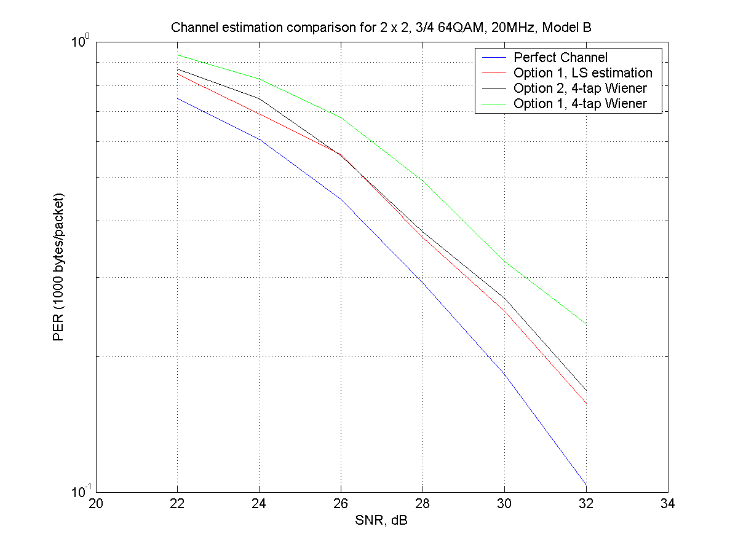
Fig. 7: Channel estimation comparison for 2x2, rate ¾ 64QAM, 20 MHz, model B
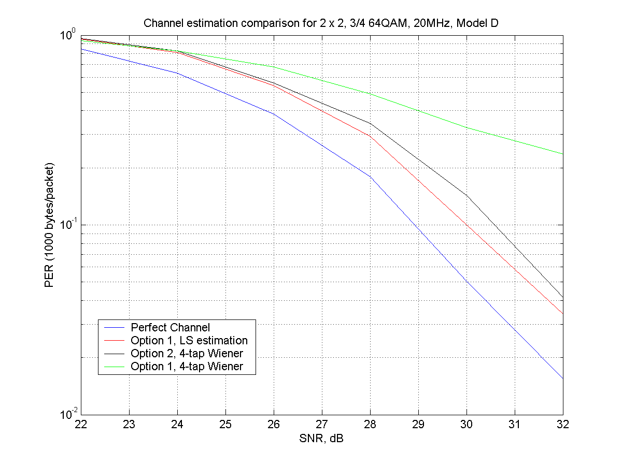
Fig. 8: Channel estimation comparison for 2×2, rate 3/4 64QAM, 20 MHz, model D
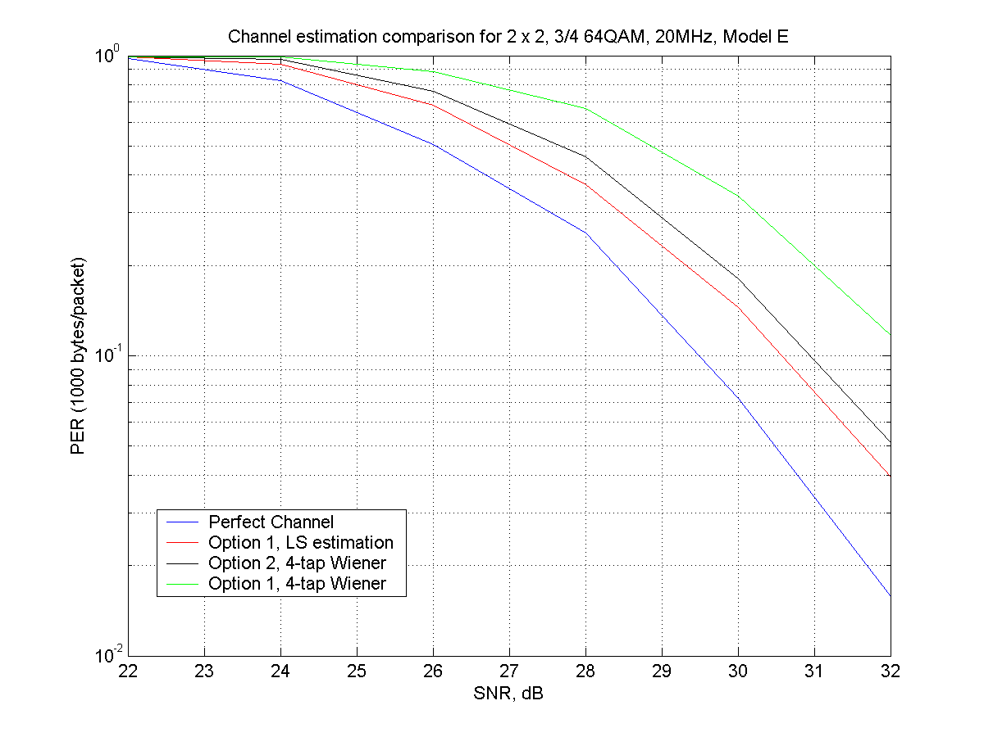
Fig. 9: Channel estimation comparison for 2×2, rate 3/4 64QAM, 20 MHz, model E

Peak to average ratio (PAR)
The PAR of a 128-fft system is shown below in Fig. 10. It is about .75 dB higher than a 64-fft system.
Fig. 10: Empirical CDF

Effect of phase noise
Since the 128-fft system has tones spaced 156.25kHz apart instead of the 312.5kHz spacing of the 64-fft system, phase noise could have a worse impact on the performance. However, as described previously, the 128-fft system has 6 pilots in the frequency domain that are used for tracking phase noise and residual frequency offset as opposed to 4 pilots in a 64-fft system. Simulation results (cf. Fig. 11) indicate that the performance of a 128-fft system with 4-tap channel estimator, with frequency offset of 1.56kHz, phase noise of –100dbc/Hz and channel model E is better than that of a 64-FFT system with per-tone channel estimation with the same impairments.

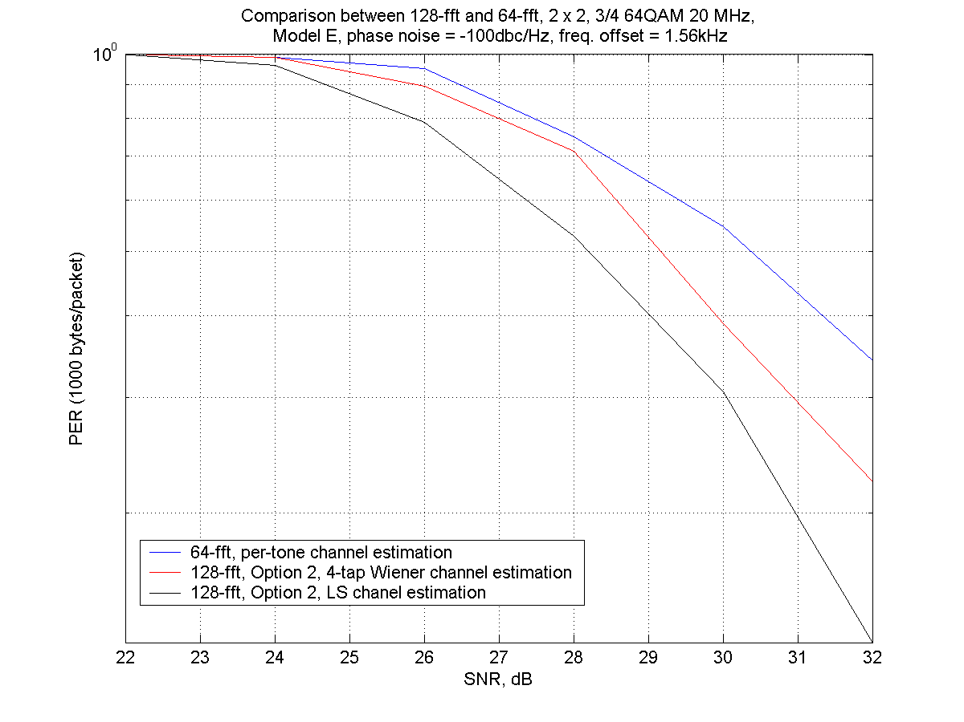
Fig. 11: Comparison between 128-FFT and 64-FFT, 2×2, 3/4 64QAM 20MHz, model E, phase noise = −100dbc/Hz, frequency offset = 1.56kHz

Interleaving and parsing
The bit interleaver is used to interleave the output of the punctured convolutional code. In 802.11a, interleaving is done over one OFDM symbol, which has 48 data carriers. When 128-fft and multiple antennae are used, it is advantageous to interleave not only over the 96 data carriers in one OFDM symbol but over all 96N_T data carriers where N_T is the number of transmit streams. After interleaving, the bits are grouped N_BPSC at a time, where N_BPSC is the number of bits per symbol (e.g. 6 for 64 QAM). Each group of bits is then sent to a separate antenna in round-robin fashion. The interleaver is implemented as follows:
All encoded data bits shall be interleaved by a block interleaver with a block size corresponding to the number of bits in a single OFDM symbol, N_CBPS, multiplied by the number of transmitted streams N_T. The interleaver is defined by a two-step permutation. The first permutation ensures that adjacent coded bits are mapped onto nonadjacent subcarriers on different antennae. The second ensures that adjacent coded bits are mapped alternately onto less and more significant bits of the constellation and, thereby, long runs of low reliability (LSB) bits are avoided.
We shall denote by k the index of the coded bit before the first permutation; i shall be the index after the first and before the second permutation, and j shall be the index after the second permutation, just prior to modulation mapping.
The first permutation is defined by the rule:
i = (N_T*N_CBPS/16) (k mod 16) + floor(k/16) k = 0,1,...,N_T*N_CBPS -1 (1)
The function floor (.) denotes the largest integer not exceeding the parameter.
The second permutation is defined by the rule
j = s × floor(i/s) + (i + N_T*N_CBPS - floor(16 × i/(N_T*N_CBPS))) mod s, i = 0,1,... N_T*N_CBPS - 1 (2)
The number of coded bits per subcarrier, N_BPSC, determines the value of s according to
s = max(N_BPSC/2,1) (3)
The deinterleaver, which performs the inverse relation, is also defined by two permutations. Here we shall denote by j the index of the original received bit before the first permutation; i shall be the index after the first and before the second permutation, and k shall be the index after the second permutation, just prior to delivering the coded bits to the convolutional (Viterbi) decoder. The first permutation is defined by the rule
i = s × floor(j/s) + (j + floor(16 × j/(N_T*N_CBPS))) mod s j = 0,1,..N_T*N_CBPS - 1 (4)
where s is defined in Equation (3). This permutation is the inverse of the permutation described in Equation (2). The second permutation is defined by the rule
k = 16 × i - (N_T*N_CBPS- 1)floor(16 × i/(N_T*N_CBPS)) i = 0,1,...N_T*N_CBPS - 1 (5)
This permutation is the inverse of the permutation described in Equation (1).
After interleaving, the bits are parsed as follows. The bits are grouped into groups of N_BPSC bits corresponding to one constellation symbol. Each group is then sent to one antenna in round-robin fashion. Fig. 12 shows that this method of interleaving performs almost 1dB better than interleaving separately over each antenna.
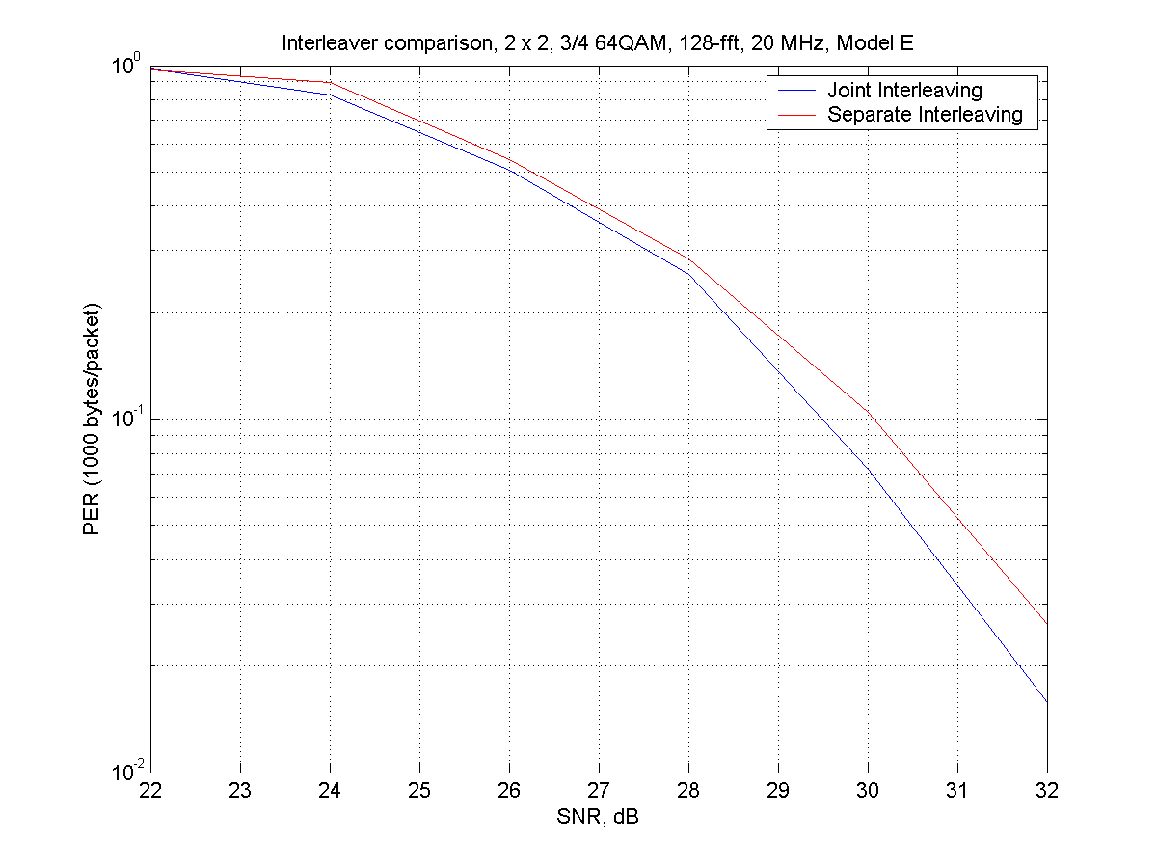
Fig. 12: Interleaver comparison, 2×2, 3/4 64QAM, 128-FFT, 20 MHz, model E

Advanced Coding Schemes

RS encoding
It is proposed to use an outer RS encoder in the system as follows:
Fig. 13: Advanced Coding
We propose using a (220,200) 20 byte-error correcting RS encoding over GF(256) using the following generator polynomial: x⁸+x⁴+x³+x²+1. This is the same generator polynomial used in the ATSC HDTV standard. This code will correct up to 10 byte errors per 220-byte codeword. The optional byte interleaver spreads the bytes over multiple RS codewords and the parameters will be specific to the number of RS codewords in a packet.
The proposal does not restrict the packet size to be an integral multiple of the codeword size. The RS encoder begins encoding data in blocks of 200 bytes and any leftover bytes (< 200) are encoded as a shortened RS codeword with the same number of parity bytes (20). This scheme does not need any other mechanism to inform the receiver as to the number of codewords in a packet. For packet sizes less than 200 bytes, 20 bytes of parity are always appended. In many cases, the number of RS parity bytes is less than the number of pad-bits that are needed to transmit an integer number of OFDM symbols per antenna, and in those cases the overhead due to the RS encoding will be zero. For example, in a 2 x 2 rate ¾ 64QAM system in 40 MHz, a 100-byte data packet requires 166 bits as pad-bits. Hence 20 bytes of parity can be accommodated with no extra overhead.
The nominal overhead due to the RS code is 10%. However by judiciously choosing packet sizes such that the number of pad-bits is greater than the number of parity bytes, this overhead can be made essentially zero. This is especially true as the data rate becomes higher. Fig. 14 shows the overhead due to the RS code, measured in terms of number of OFDM symbols required to transmit a data packet, versus packet size for a 2 x 2, rate ¾ 64QAM, 40MHz system. We see that for packet sizes of less than 1000 bytes, one could always pick a size such that the overhead due to RS encoding is zero.
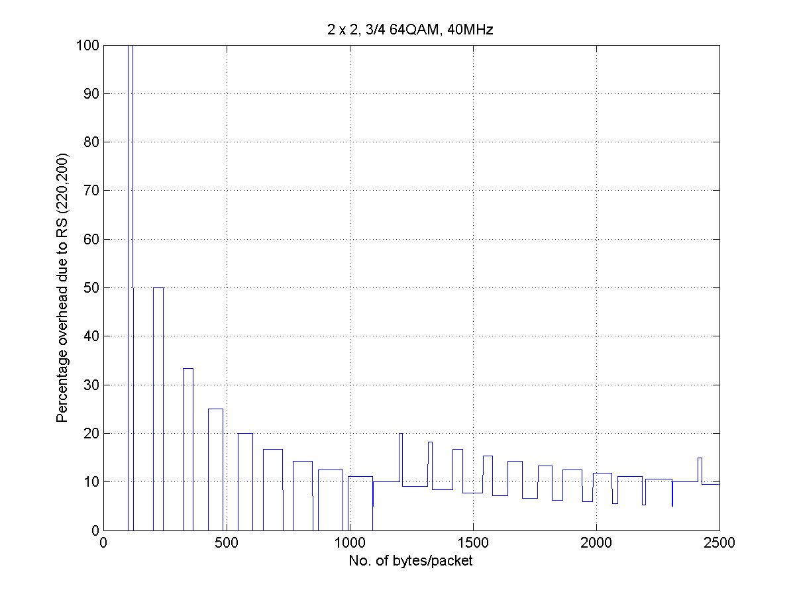
Fig. 14: Reed-Solomon overhead

RS Coding and 128-fft in 20 MHz
In a 20 Mhz bandwidth system, the performance can be optimized by using 128-fft with RS encoding. This combination gives the same nominal data rate as 64-fft with no RS encoding, but the performance improves due to the additional coding gain of the RS code. Thus, a 2 x 2, rate ¾ 64QAM, 128-fft system with RS coding has a data rate of 108 Mbps, but performs 2 to 3 dB better than a 2 x 2 rate ¾ 64QAM, 64-fft system with no RS coding that has the same data rate. This is shown in Fig. 15-Fig. 17, below for channel models B, D and E. The coding gain varies from 2 dB for channel model B to 3 dB for channel model E.
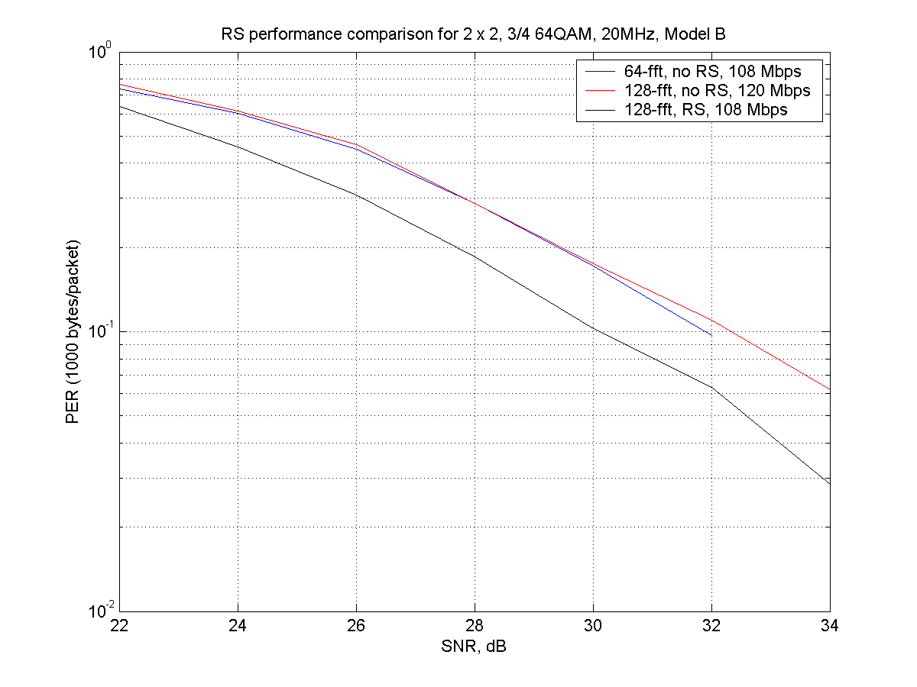
Fig. 15: RS performance in Model B
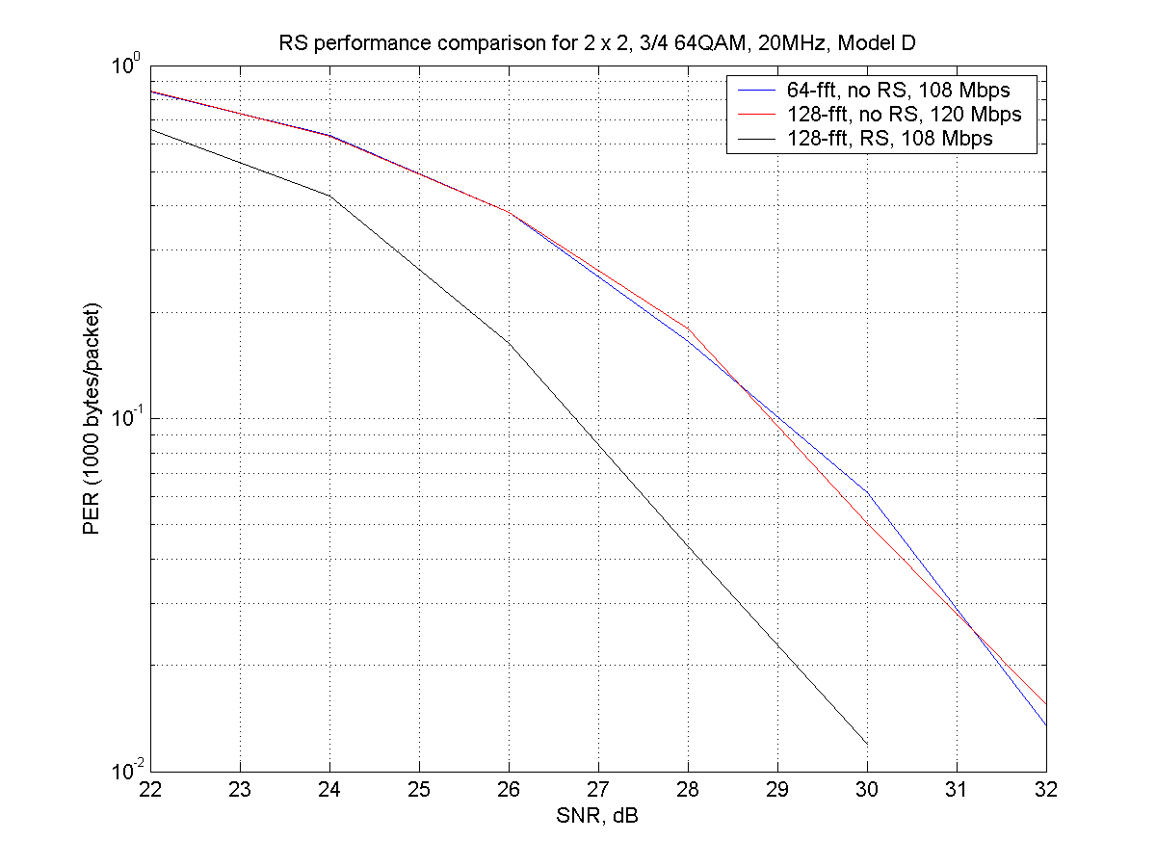
Fig. 16: RS performance comparison for Model D
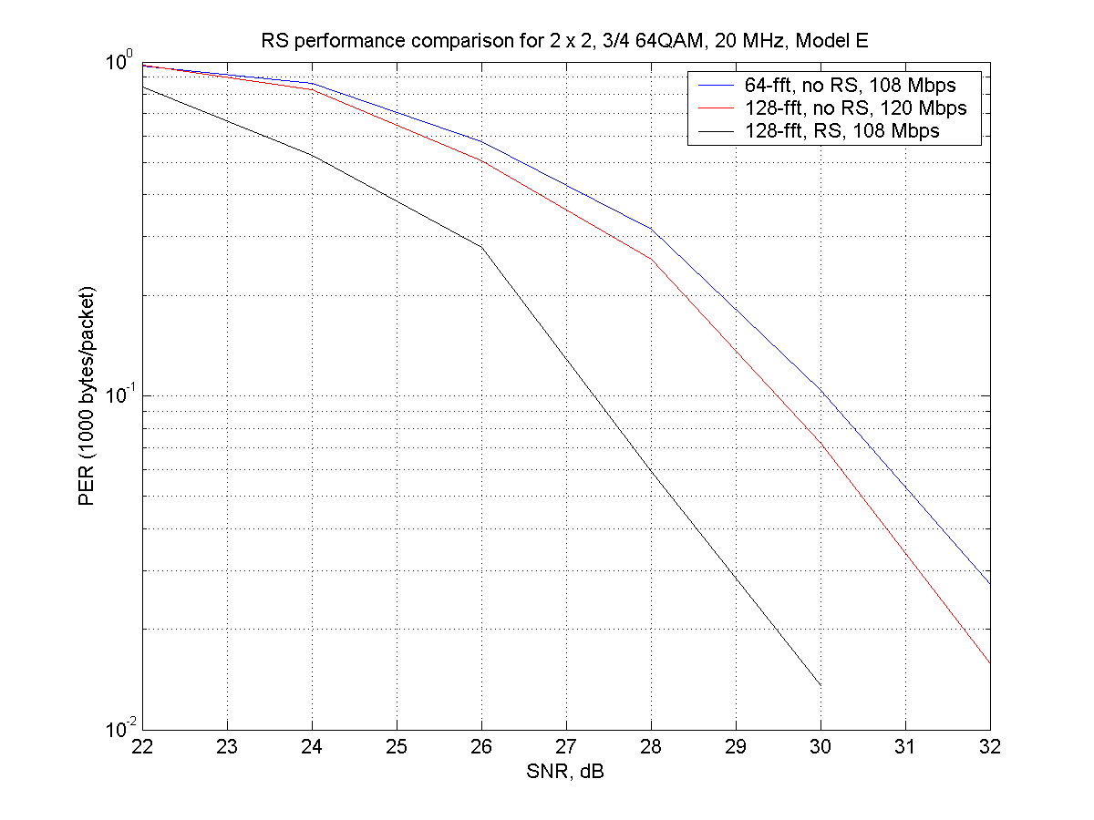
Fig. 17: RS performance comparison for model E

Overall performance of the 128-fft system and RS coding with impairments.
In this section we show some results for a 128-fft system with RS coding with frequency offset of –73.44kHZ and phase noise of –100dBc/Hz as specified in the CC document. The 128-fft system uses the Option 2 preamble with 4-tap Wiener channel estimation and the result is compared with a 64-fft system with per-tone channel estimation. Fig. 18 shows the performance for a 2 x 2, rate-1/2, 16QAM, 20 MHz system with channel model D. We see that in the presence of impairments, the gain due to the RS code is more than 3 dB.

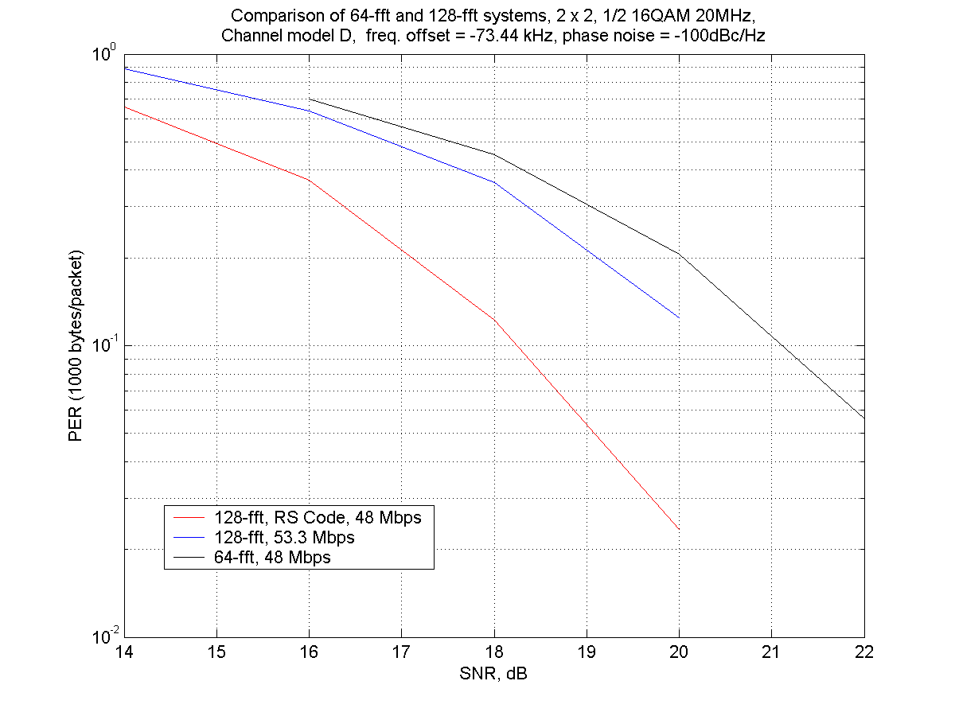
Fig. 18: Overall performance of 128-FFT system with RS encoding

Extended Convolutional Code

Introduction
The existing 802.11a/g has a ½ rate CC (133,171) with constraint length k=7. For finer granularity of data rate and better protection, lower-rate convolution codes can be considered. To be backward compatible to legacy devices, the existing convolution code is extended to a new ¼ CC (133,171,xxx,xxx).

Procedure of finding the generator
The first step is to go through all combinations and find the set of codes (set A) that i) has the maximal minimum free distance, and ii) is not catastrophic. We have thus found 118 codes that have free distance 20.
The second step is to find the set of code (set B) out of set A that has the smallest number of paths at free distance 20. We then find a set of 6 codes that has 16 paths.
The third step is to find the code that has the smallest number of paths at free distance 21, 22, 23, etc. We have thus selected (133, 171, 135, 175) as the best candidate for the extended convolution codes of (133,171) at ¼ rate.
The fourth step is to verify this code’s performance at rate 1/3. We go through the same step for rate 1/3 and, in this case, (133, 171, 135) happens to be the best code with the best-known free distance of 15.
We therefore conclude that for the mother code of ½ rate, k=7 (133, 171), the best ¼ extended convolutional code is (133, 171, 135, 175) and the best 1/3 code, as punctured from the ¼ code is (133, 171, 135).

Performance analysis
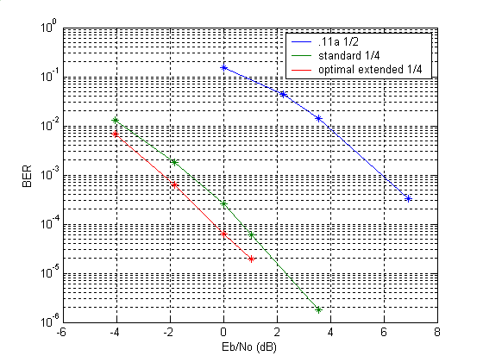
Fig. 19: Performance of different codes using BPSK in AWGN
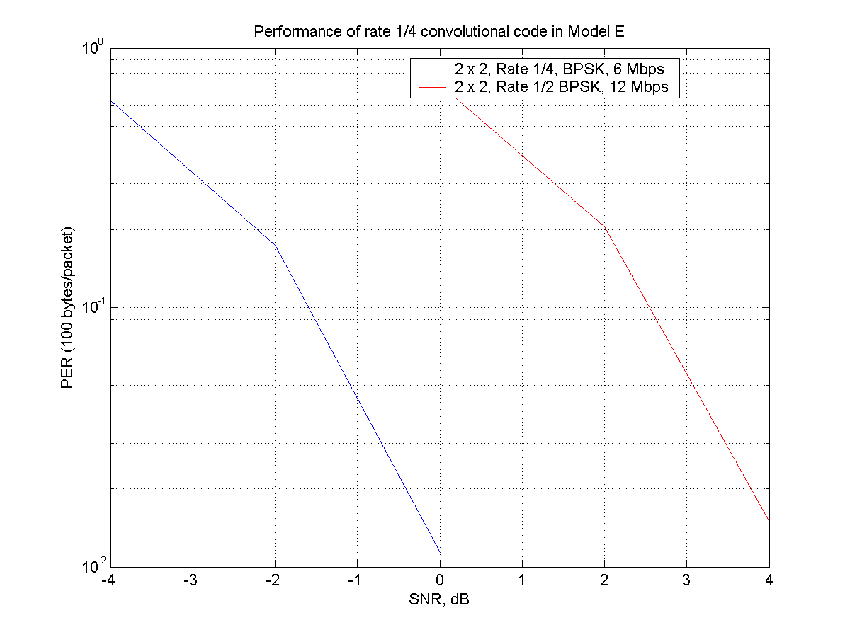
Fig. 20: Performance of ¼ CC in Model E

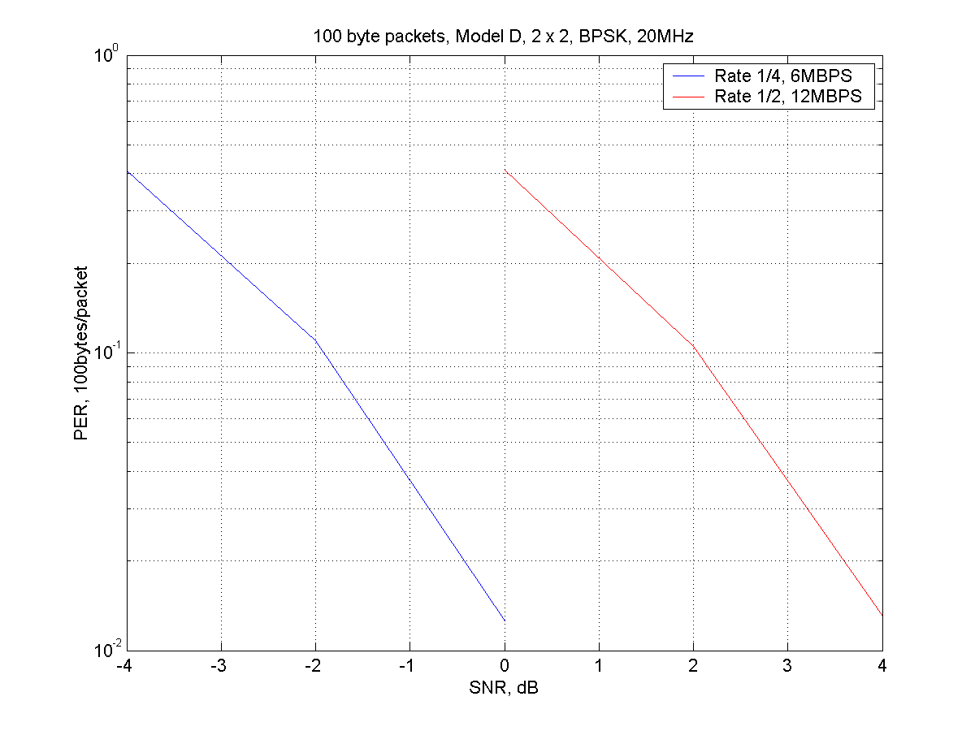
Fig. 21: Performance of ¼ CC in Model D

Embedded Signalling

Introduction
Embedded signalling is the encoding of additional information in a signal having all energy in the in-phase (I) component, by using the quadrature (Q) component and employing low-rate coding. The two main applications of embedded signalling are:
- To signal as early as possible (i.e., in the legacy preamble) that the upcoming transmission is actually an 11n transmission;
- To extend in an easy way the payload of a BPSK coded OFDM symbol with a few bits.
Let us elaborate on both applications.

HT Signalling
When 11n devices are in a network in which also legacy 11a devices are active, every 11n-transmission needs to be understood by the legacy devices, at least in so far that the legacy devices know how long the transmission is going to occupy the channel. Therefore, every 11n-transmission in such a mixed 11a/11n network will start with an 11a preamble. In the legacy signal field, contained in this preamble, there are no spare bits to signal to the 11n devices the start of an 11n-transmission. Therefore, we propose to use embedded signalling for this purpose. In addition a few of the 11n transmission parameters (e.g. the number of spatial streams) can be communicated to the receiver.

Payload extension
A second application of embedded signalling is to extend the data-capacity of a packet that is employing BPSK coding; for instance, the signal field of an 11n Signal Field. If the required amount of signal-bits is just higher than the actual capacity, embedded signalling prevents the need for an additional complete OFDM symbol, thus reducing the required preamble overhead by 4 microseconds.

Description
In this section we describe the embedded signalling method in detail. The basic idea is to use on the 48 active carriers a signal constellation in which the BPSK constellation points {-1,1} are replaced by a rectangular, i.e. non-square, QAM constellation as shown in Fig. 22.
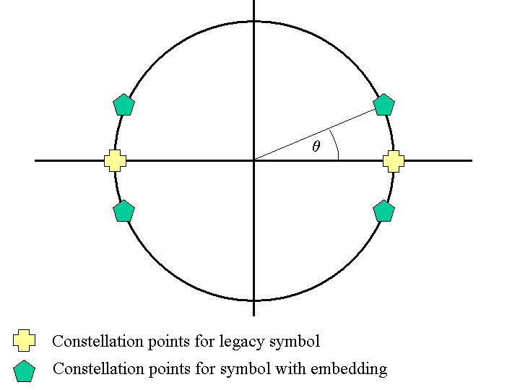
Fig. 22: Constellation diagram for embedded signaling
The trade-off between the SNR loss to the legacy signal in the I-component and the SNR in the Q-component is determined by the value of the angle θ. To keep the SNR loss for the legacy symbol limited to 1 dB, we set θ to 0.47 radians.

In this way, additional information can be encoded with a very limited loss in SNR for the underlying I-component. Obviously, the newly created Q-component has very little energy, and so, to obtain an acceptable error rate, low-rate error correction must be applied. To reduce the additional complexity, the existing convolutional code is reused. The coding is applied as shown in Fig. 23.
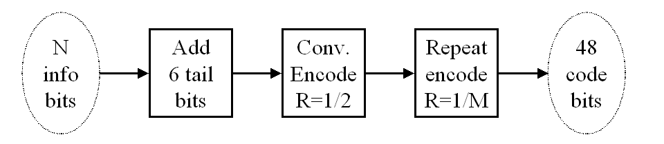
Fig. 23: Encoding of the embedded bits
The repeat code rate 1/M is chosen so as to achieve 48 coded bits. Possible choices are M=3 for N=2, M=2 for N=6 or M=1 for N=18. For other values of N, M must be chosen so that the number of coded bits is as close as possible to 48 and subsequently, a number of the coded bits can be removed or again be repeated to obtain exactly 48 bits. In the latter case, the resulting repeat code has a rate of 1/M per symbol, but M is not an integer, so M denotes the average number of repetitions.
The resulting codeword is represented as a 48-tuple B with entries $b_{i}∈\left\{−1,1\right\}$. When the underlying 48 BPSK symbols are represented by $x_{i}∈\left\{−1,1\right\}$, then the resulting QAM symbols are described by $y_{i}=x_{i}\text{cos}(θ)+{\text{jb}}_{i}\text{sin}(θ)$. No embedding (i.e., a legacy 11a OFDM symbol) is represented by $θ=0$, or approximately by B=0, the all-zero codeword.
The decoder computes the bit metrics for each of the received bits. The bit metrics for repeated bits are added together (with additional normalization in case some of the bits are repeated more often than others) and the accumulated bit metric is supplied to the Viterbi decoder.

Performance
The resulting bit error rate is plotted in Fig. 24and Fig. 25, below. It is computed using an MLD detector, which takes into account all possible embedded codewords, as well as the all-0 codeword, which corresponds to no embedding. As this concerns the legacy part of the transmission, we have used the 11a (SISO) channel model, with delay spreads of 0ns (flat fading) and 50ns.
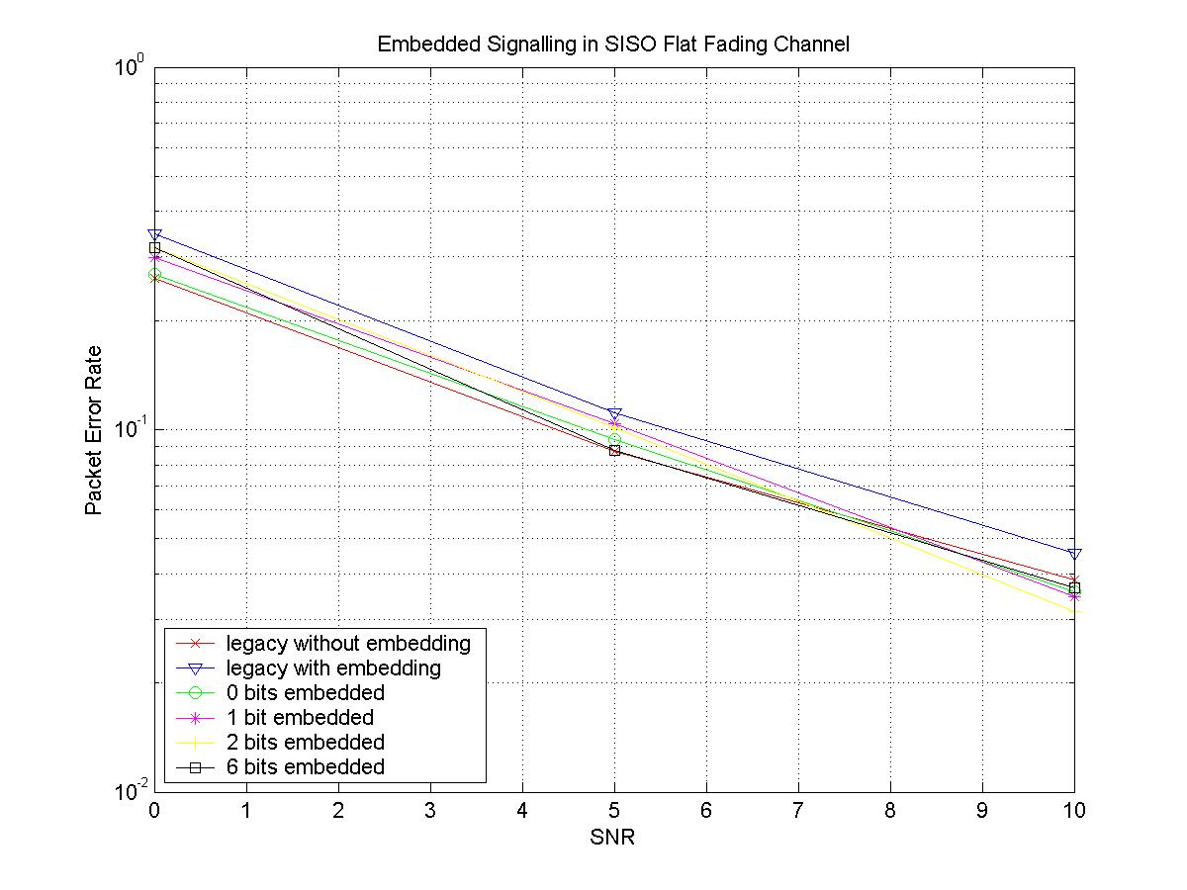
Fig. 24: Bit error rate versus SNR for embedded signalling in a flat fading channel
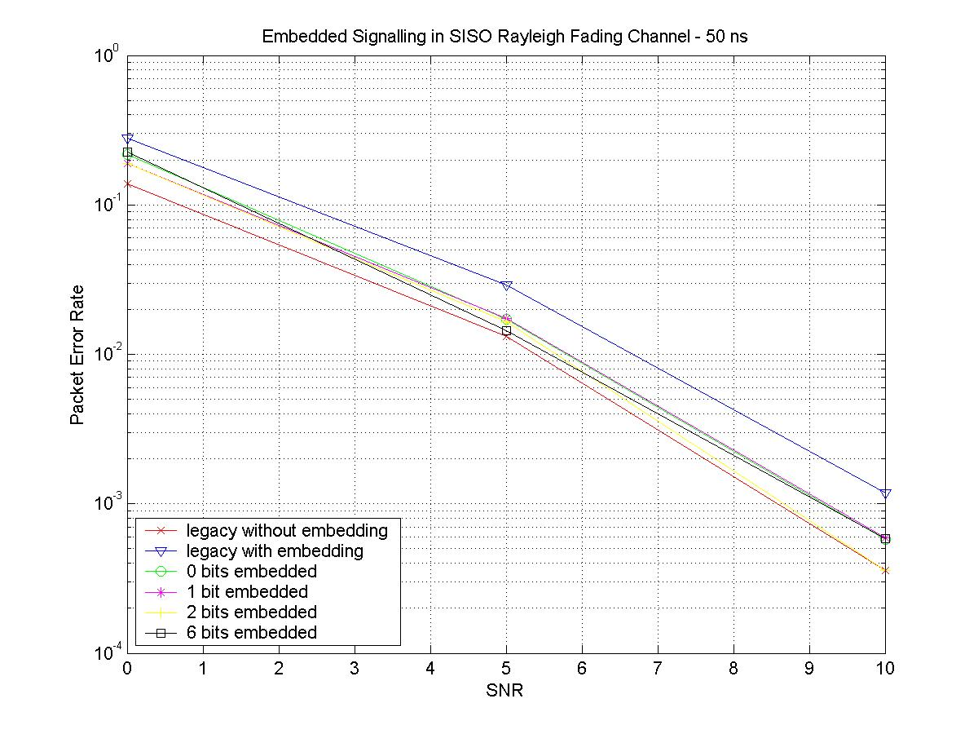
Fig. 25: Bit error rate versus SNR for embedded signalling in a Rayleigh fading channel (50ns delay spread)

Complexity
The additional complexity needed to decode the embedded bits is limited. When the amount of embedded bits is small, a Maximum Likelihood decoder can be implemented at very low cost. Alternatively, a detector can be implemented to detect the presence of the embedded bits (e.g. by measuring the relative amount of energy in the quadrature component). Upon positive detection, the received quadrature component can be decoded using the existing decoding hardware.

Multiple MCS and Receiver Aggregation (MMRA)

Introduction and functional description
Multiple MCS and Receiver Aggregation (MMRA) is a method to aggregate several Protocol Data Units MPDUs, that are intended for different receivers and can be transmitted at different Modulation and Coding Schemes (MCS). Traditional aggregation schemes only link MPDUs between the same source and destination device pair together. The main purpose of the aggregation is to reduce the number of access attempts to the medium and thereby significantly increase the protocol efficiency and data throughput.
An improvement to this traditional type of aggregation is to also aggregate packets that are intended for more than one receiver. This feature is especially useful at the Access Point (AP), which has to sent packets to many different receivers on the downlink. For delay-critical applications aggregation poses problems, because of the delay that is introduced by waiting for subsequent data packets for the same destination and buffering older packets in the meantime. If MPDUs for different receivers can be aggregated, a reasonable aggregate size can be reached much faster and thereby the buffering delay is reduced.
In the case of multiple receiver aggregation, the distance and propagation conditions between the sender and the different receivers can differ significantly. An exemplary scenario is illustrated in Fig. 26.

Fig. 26: Exemplary scenario for m multiple rate and receiver aggregation
If MPDUs of the three stations in Fig. 26 were aggregated and transmitted at the same MCS, the lowest MCS of all links would have to be chosen, which would limit the throughput of all other stations. In this example, either the whole aggregate would have to be transmitted at a data rate of 6 Mbps or another option would be not to aggregate and access the medium three times at different MCSs. Choosing the first option, aggregation at a single MCS, would result in a major decrease in efficiency in such a scenario. Therefore, under these circumstances, transmitting the MPDUs separately at different MCS and not aggregating would result in better performance. It would be up to the sender, rsp. AP to decide in which situations linking of MPDUs for different receivers together makes sense and in which not.
In order to avoid this decision and to make multiple receiver aggregation possible in most scenarios, the proposed Multiple MCS and Receiver Aggregation (MMRA) allows the aggregation of MPDUs that have to be transmitted at different MCSs. For this purpose MCS information is transmitted in the PHY Header, where additional information for 802.11n is included, and sub-aggregates of different MCS are separated by preambles. The frame format will be described in more detail in the following section.
The MMRA scheme solves another problem of packet aggregation, which is the power efficiency for the receiving stations (STAs). Aggregation on MAC level requires that a receiving STA stays awake during the whole aggregate (at least until its own MPDUs have been received) in order to keep PHY layer synchronization. With long aggregates, remaining awake during the entire aggregate can lead to very inefficient power saving at the receiving stations. The MMRA scheme solves this problem by introducing preambles inside the aggregate. The preambles allow the receiving stations to go into sleep-mode and re-synchronize after wake-up. Preambles could be included between every set of MPDUs of different receivers or only at certain places inside the aggregate. Both alternatives are possible with the present MMRA scheme. There is a trade-off between throughput and power efficiency. Having less preambles increases the throughput but also increases the power consumption at the receivers. As a compromise between throughput and power efficiency, preambles are included in this proposal, whenever the MCS changes inside the aggregate. An aggregate consequently consists of one or several MCS (sub-)aggregates, and re-synchronization by means of the intermediate preamble is performed after a sleeping period at the beginning of each MCS sub-aggregate.

MMRA frame formats
The overall structure of an aggregated PPDU is according to Fig. 2. The detailed format of the aggregation specific parts is illustrated in Fig. 27 below for the example of five receivers and three different MCSs. Most elements of the HT-SIG MMRA part could also be located at different places inside the aggregate (on PHY or MAC level), but the inclusion inside the HT-SIG has been chosen here.
Fig. 27: Format of MMRA part in HT-SIG and aggregated PSDU-DATA
The HT-SIG field contains an MMRA specific part of variable length. The length and MCS of the MMRA part of the HT-SIG is also signaled in the HT-SIG field. Thereby the MMRA part of the HT-SIG field can be transmitted at a variable MCS. The MMRA part shall be transmitted with an MCS, which is at least as robust as the most robust MCS of all MPDUs in the aggregate.
The MMRA part of the HT-SIG contains for each MCS in the aggregate the number of receivers as well as for each receiver the MAC-address and total length of all MPDUs intended for this MAC-address. An overview of the different fields of the MMRA part in the HT-SIG is given in Table 1.

Table 1: Fields of HT-SIG MMRA Part
HT-SIG MMRA Part | Size (bits) | Description
MCS | 8 | Code of the MCS scheme, with which the MPDUs of this MCS sub-aggregate will be transmitted
No. of receivers | 8 | Number of receivers/MAC-addresses with this MCS in the aggregate
MAC-address | 48 | MAC-address of the receiver (present for each receiver)
Length | 16 | Total length of all MPDUs intended for this receiver in octets (present for each receiver)
The MCS field indicates the MCS at which the receivers listed in the following fields shall decode their MPDUs. The number of receivers field is present to indicate the number of MAC-address and Length fields that follow for this MCS. For each receiver of this MCS sub-aggregate the MAC-address and total Length of all its MPDUs is signaled. This allows all STAs to check the HT-SIG field whether their MAC-address (or a broadcast/multicast address) is included in the MMRA Part. The Length field not only gives an indication of the expected amount of data but in combination with all other Length fields also the position of the MPDUs in the aggregate. Alternatively, offset information could be transmitted instead of the length information, but the latter gives more detailed information and has therefore been chosen.
The PSDU of an aggregate consists of one or several MCS sub-aggregates. An MCS sub-aggregate starts with a preamble, except for the first MCS sub-aggregate in the aggregate. Within an MCS sub-aggregate MPDUs of the same or different receivers are separated by a delimiter, which could e.g. be a fixed bit pattern. The delimiter is not strictly necessary and could also be omitted. The structure with delimiters is illustrated in Fig. 27. The elements inside the PSDU are summarized in Table 2.
Table 2: Elements of DATA-PSDU
DATA-PSDU | Size/Length | Description
MPDU | variable | MPDU including MPDU Header, Payload and Frame Check Sequence
Preamble | 8μs or 16μs | Short or long preamble (optional)
Delimiter | 16 bit | Fixed bit pattern. This field is optional and could also be omitted, which would slightly increase the throughput efficiency in the analysis section below.

Power saving scheme
The MMRA scheme allows for efficient power saving at the receiving STAs. All STAs shall decode the HT-SIG field and check whether their MAC-address is listed in the MMRA part. If the MAC-address is not included, the STA may go into sleep mode for the entire duration of the aggregate. This is illustrated in Fig. 28, which is based on the same example as Fig. 27, i.e. five STAs involved in the aggregate plus a sixth STA, which is not listed in the HT-SIG field. The figure shows the active and sleep phases of the STAs. A high level means the STA is in active state, a low level means the STA is in sleep state. It can be seen that STA6, which is not involved in the aggregate goes directly into sleep mode after decoding the HT-SIG field.
Fig. 28: Active/sleep states with MMRA scheme
The STAs have decoded the HT-SIG field and know in which MCS sub-aggregate and at which exact position their MPDU(s) are expected. A STA may go into sleep mode until the beginning of the MCS sub-aggregate, in which its MPDUs are expected. It has to wake up shortly before the preamble in order to re-synchronize on PHY level. As no re-synchronization during an MCS aggregate is possible, the STA has to stay awake until its MPDUs have been received. Afterwards, the STA may fall back into sleep state again. This is illustrated in Fig. 28 for STAs 1 to 5.

Performance analysis

Reference system: Single MCS Multiple Receiver Aggregation (SMRA)
SMRA allows aggregation of multiple Data and Control MPDUs in one PPDU at the same MCS. However, as it has already been explained in section 5.1, SMRA does not always result in the best overall performance. In order to corroborate this argument and compare it to the proposed MMRA scheme, where multiple MCS aggregation is performed, some analytical calculations have been carried out, which are presented in the following sections.

PSDU Format for SMRA
The example in Fig. 1 shows the reference SMRA PSDU format and MAC frames for the same situation as in Fig. 27, where five STAs receive their MPDUs at different MCS. Aggregation at the lowest MCS has not been evaluated, because it obviously yields to a worse performance for the high rate STAs. In Fig. 29, STA1 and STA2 are receiving their MPDUs in the first MCS1 SMRA PSDU1 aggregate, STA3 and STA4 in the second MCS2 PSDU2 aggregate and STA5 in the third MCS3 PSDU3 aggregate.

Fig. 29: SMRA in 3 station example
In Fig. 29 it can be seen that each PSDU aggregate requires an additional MPDU (PSDU Header), in which the MAC addresses of the receivers are included. In Table 3, the elements of the PSDU header are summarized:
Table 3: Fields of PSDU Header MPDU
PSDU Header MPDU | Size (bytes) | Description
Frame Control | 2 | Frame type is Control.
Duration | 2
Receiver-address | 6 | The RA field is the broadcast group address
Transmitter-address | 6 | The TA field is the address of the STA transmitting the SMRA aggregate.
Number of receivers | 1 | The number of receivers (n) for which the MPDUs are included inside the SMRA aggregate.
Receiver info fields | N*6 | N Receiver Info fields, one for each Receiver Address in the MRA aggregate.
FCS | 4
Moreover, it must be taken into account that each PSDU is including its PHY Header and that between each PSDU a SIFS time is needed for the medium access. For this example an overhead comparison between SMRA and MMRA is shown in Table 4:
Table 4: Overhead comparison between SMRA and MMRA
Number | SMRA | MMRA | Description
PHY Headers | 3 | 1 | In SMRA a PHY Header for each PPDU is sent. MMRA aggregates all MPDUs at different MCS in the same PPDU, needs just one PHY Header.
Additional  HT-SIG MMRA Fields | - | 16 | MMRA requires additional HT-SIG fields to signal the MCS, MAC address and length of the MPDUs included in the aggregate (see section 5.2 and Table 1)
PSDU Headers | 3 | - | SMRA needs to signal the MAC addresses of the receivers included in the aggregate. (MAC level)
Delimiters | 5 | 2 | SMRA requires one delimiter for each MPDU. MMRA may also use a delimiter to separate MPDUs within one MCS sub-aggregate, even though this is not required, as the starting point of the MPDUs is already given in the PHY header.  Note: Delimiters could be beneficial for synchronization on MAC level after the preceding MPDU has been lost.
Preambles | - | 2 | MMRA uses PREAMBLEs in order to allow power saving.
SIFS | 2 | - | SMRA requires access to the medium every time an aggregate at a different MCS is transmitted.

Sleep operation with SMRA
In the previous section, the overhead of the SMRA scheme has been exemplarily compared to the MMRA scheme. However, MMRA is not only aiming at maximizing throughput by increasing the efficiency, but it also mainly targets at reducing power consumption between MPDUs belonging to different STAs as described in section 5.3. In Fig. 30, the sleep operation of STAs in the SMRA scheme is shown, which should be compared to the sleep operation of the MMRA scheme shown in Fig. 28.

Fig. 30: Active/sleep states with SMRA scheme
With SMRA all STAs have to stay awake in order to read the PHY Header, PSDU Header and SIFS for all transmitted PPDUs. There are more sleep-awake changes and longer awake times during the MAC frames, which increases power consumption, compared to the case where all MPDUs are transmitted at different rates in the same aggregate and a STA just wakes up at the beginning of the corresponding MCS group, like in the MMRA scheme.

Evaluation methodology
The following calculations have been performed for the MMRA scheme and the SMRA scheme:
- MMRA scheme
- MMRA HT-SIG Time calculation
For the calculation of the number of bits of the ${\text{HTSIG}}_{\text{MMRA}}$ field, the sum of all fields presented in Table 1 is calculated multiplied by the number of receivers (No.Rx) at each MCS group j:
${\text{HTSIG}}_{{\text{MMRA}}_{[\text{bits}]}}=\sum_{j=1}^{\text{No}\text{.}\text{MCS}}{{\text{MCS}}_{j_{[\text{bits}]}}+\text{No}\text{.}{\text{Rx}}_{j_{[\text{bits}]}}+({\text{MACAddr}}_{j_{[\text{bits}]}}+{\text{Length}}_{j_{[\text{bits}]}})∗\text{No}\text{.}{\text{Rx}}_{j}}$ [1]
The duration of the ${\text{HTSIG}}_{\text{MMRA}}$ is the total number of bits, which are a multiple of an octet, divided by either the minimum MCS used in the MMRA scheme or the most robust MCS (1/2 BPSK) at 6 Mbps.
${\text{tHTSIG}}_{\text{MMRA}}=\frac{{\text{HTSIG}}_{{\text{MMRA}}_{[\text{bits}]}}}{{\text{MCS}}_{\text{min}}}$ [2]
${\text{tHTSIG}}_{\text{MMRA}}=\frac{{\text{HTSIG}}_{{\text{MMRA}}_{[\text{bits}]}}}{{\text{6*10}}^{6}}$ [3]
- MPDU Time calculation
The MPDU time is the sum of all MPDU fields in bits multiplied by the number of MPDUs in each MCS group, divided by the corresponding MCS rate:
$\text{tMPDU}=\sum_{j=0}^{\text{No}\text{.}\text{MCS}}{\frac{({\text{MACHeader}}_{[\text{bits}]}+{\text{MSDULength}}_{[\text{bits}]}+{\text{WEP}}_{[\text{bits}]}+{\text{FCS}}_{[\text{bits}]})_{j}∗\text{No}\text{.}{\text{MPDUs}}_{j}}{{\text{MCS}}_{j}}}$ [4]
- MPDU Delimiter Time calculation
The MPDU Delimiter calculation uses the Delimiter field from Table 2 and multiplies it by the number of MPDUs (minus 1) in each MCS group j. The result is divided by the rate of the corresponding MCS mode.
${\text{tMPDU}}_{\text{De}\text{lim}\text{iter}}=\sum_{j=0}^{\text{No}\text{.}\text{MCS}}{\frac{\text{De}\text{lim}{\text{iter}}_{[\text{bits}]}∗(\text{No}\text{.}\text{MPDUs}−1)}{{\text{MCS}}_{j}}}$ [5]
An MPDU Delimiter at the beginning of each MCS group after the preamble is not necessary.
- PSDU Time calculation
The PSDU is an aggregate of the different MPDUs with all Delimiters and Preambles included. In our analytical curves presented in the following section, several tests have been carried out considering a short tPreamble at 8μs or a long tPreamble at 16μs. Additionally, there are the Service and Tail bits considered within the PSDU data, which for our calculations have been received either at the minimum MCS or at the most robust MCS mode:
${\text{PSDU}}_{\text{Symbol}}=\text{ceil}\left[\frac{\frac{({\text{Service}}_{[\text{bits}]}+{\text{Tail}}_{[\text{bits}]})}{{\text{MCS}}_{\text{min}}}+t\text{Pr}\text{eamble}+{\text{tMPDU}}_{\text{De}\text{lim}\text{iter}}+\text{tMPDU}}{\text{tSymbol}}\right]$ [6]
$\text{tPSDU}={\text{PSDU}}_{\text{Symbol}}∗\text{tSymbol}$ [7]
- PPDU Time calculation
For the PPDU calculation the PPDU frame format shown in Fig. 2 is followed:
$\text{tPPDU}=\text{tLSTF}+\text{tLLTF}+\text{tLSIG}+\text{tHTSIG}+{\text{tHTSIG}}_{\text{MMRA}}+\text{tHTTF}+\text{tPSDU}$ [8]
- MMRA Time Efficiency
The MMRA time efficiency is defined as the ratio of the total duration of MPDUs received (tMPDU) and the total time needed for transmitting the whole aggregate (tPPDU):
$\text{MMRAEfficiency}=\frac{\text{tMPDU}}{\text{tPPDU}}$ [9]
- SMRA Scheme
- MPDU Time calculation
For the SMRA scheme the duration of the MPDU is the sum of all MPDU fields in bits multiplied by the number of MPDUs in each MCS PSDU aggregate k divided by the corresponding MCS rate that is used for this PSDU aggregate k:
${\text{tMPDU}}_{k}=\frac{({\text{MACHeader}}_{[\text{bits}]}+{\text{MSDULength}}_{[\text{bits}]}+{\text{WEP}}_{[\text{bits}]}+{\text{FCS}}_{[\text{bits}]})_{k}∗\text{No}\text{.}{\text{MPDUs}}_{k}}{{\text{MCS}}_{k}}$ [10]
- MPDU Delimiter
The duration of the MPDU Delimiter for the SMRA scheme is calculated in the following way:
${\text{tMPDU}}_{{\text{De}\text{lim}\text{iter}}_{k}}=\frac{\text{De}\text{lim}{\text{iter}}_{[\text{bits}]}∗(\text{No}\text{.}\text{MPDUs})_{k}}{{\text{MCS}}_{k}}$ [11]
One delimiter is used for every MPDU.
- PSDU Header Time calculation
The PSDU Header time is calculated based on Table 3:
${\text{tPSDU}}_{{\text{Header}}_{k}}=\frac{{\text{21}}_{[\text{bytes}]}8+(6_{[\text{bytes}]}8∗\text{No}\text{.}{\text{Rx}}_{k})}{{\text{MCS}}_{k}}$ [12]
- PSDU Time calculation
The PSDU is an aggregate of the different MPDUs at the same MCS with all Delimiters plus the PSDU Header at the beginning of each PSDU:
${\text{PSDU}}_{{\text{Symbol}}_{k}}=\text{ceil}\left[\frac{\frac{({\text{Service}}_{[\text{bits}]}+{\text{Tail}}_{[\text{bits}]})}{{\text{MCS}}_{k}}+{\text{tPSDU}}_{{\text{Header}}_{k}}+{\text{tMPDU}}_{\text{De}\text{lim}{\text{iter}}_{k}}+{\text{tMPDU}}_{k}}{\text{tSymbol}}\right]$ [13]
${\text{tPSDU}}_{k}={\text{PSDU}}_{{\text{Symbol}}_{k}}∗\text{tSymbol}$ [14]
- PPDU Time calculation
For the PPDU time calculation the PPDU frame format shown in Fig. 2 is followed without the ${\text{HTSIG}}_{\text{MMRA}}$ part:
${\text{tPPDU}}_{k}=\text{tLSTF}+\text{tLLTF}+\text{tLSIG}+\text{tHTSIG}+\text{tHTTF}+{\text{tPSDU}}_{k}$ [15]
- SMRA Time Efficiency
The SMRA time efficiency is defined as the ratio between the sum of the durations of MPDUs received (tMPDU_{k}) and the total time needed for transmitting all SMRA aggregates (tPPDU_{k}) plus the SIFS times for the medium access:
$\text{SMRAEfficiency}=\frac{\sum_{k=1}^{\text{No}\text{.}\text{MCS}}{{\text{tMPDU}}_{k}}}{\sum_{k=1}^{\text{No}\text{.}\text{MCS}}{{\text{tPPDU}}_{k}+(\text{No}\text{.}\text{MCS}−1)∗\text{SIFS}}}$ [16]

Considered scenarios for time efficiency evaluation
Several scenarios have been selected to analyze the performance of both MMRA and SMRA schemes. For each scenario five result curves have been generated. The ones presented in purple belong to the MMRA scheme when the HT-SIG MMRA part is sent with the lowest of the MCS modes that participate in the aggregation. The curves in blue are the same as the purple ones but when the HT-SIG MMRA part is sent at the most robust PHY mode (1/2 BPSK). For each of these two colors there are also two different curves for a short or long preamble in-between the MCS sub-aggregates. The red curve corresponds to the SMRA scheme.

MMRA at 3 MCS (24, 54, 108) Mbps

Scenario 1: MMRA with 5 Stations
The first scenario shows MMRA efficiency (purple and blue curves) compared to SMRA efficiency (red curve) within a group of five stations receiving MPDUs at three different PHY rates (24 Mbps, 54 Mbps and 108 Mbps). In Fig. 31 it is easily seen that the MMRA scheme, which the HT-SIG is received at the minimum MCS (purple curved) is around 20% more efficient than the SMRA scheme for small packets sizes and a bit more than 5% efficient for long MSDU lengths. In this scenario there is one MPDU for each receiver, but note that longer MSDU lengths could also be interpreted as higher number of MPDUs for each receiver. For a scenario, in which the PHY rates were lower the resulted curves were almost the same.
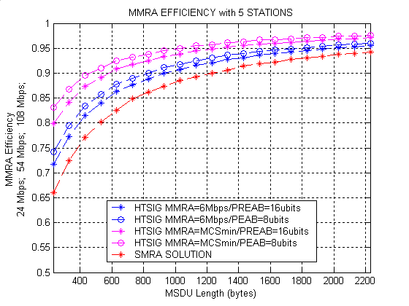
Fig. 31: Efficiency of MMRA and SMRA in scenario 1

Scenario 2: MMRA with 15 Stations
In this second scenario the number of stations was increased to 15 while keeping the same PHY rates (24 Mbps, 54 Mbps and 108 Mbps) for the different aggregated PSDUs in the SMRA scheme and for the different MCS sub-aggregates in the MMRA scheme. Fig. 32 shows MMRA efficiency (purple and blue curves) compared to SMRA efficiency (red curve) in this scenario. In this situation the MMRA scheme still performs better in terms of efficiency (around 15% more efficient for small packets and 3% more efficient for long packets) than the SMRA scheme in the case that the HT-SIG MMRA part is received at the most robust of the three MCS modes (24Mbps). The blue curves, in which the HT-SIG MMRA part is sent with a very small data rate (6 Mbps) compared to the high PHY rates used in this scenario, show that some overhead is introduced by the additional fields in the HT-SIG MMRA part. However, this would probably not be chosen as solution, since for high throughput stations the HT-SIG MMRA part may be transmitted at a higher MCS mode (purple curve).

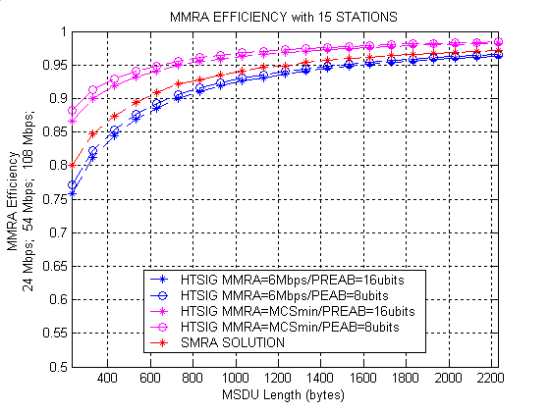
Fig. 32: Efficiency of MMRA and SMRA in scenario 2
It should be stressed that the higher time efficiency is not the only purpose of the MMRA scheme, but especially an improvement in power consuming owing to the receiver information at the beginning of the aggregate and the preambles inside the aggregate.

MMRA at 5 MCS (18, 24, 48, 54, 108) Mbps

Scenario 3: MMRA with 10 Stations
The third scenario has been created by using a large number of MCS modes in the same aggregate (18Mbps, 24Mbps, 48Mbps, 54Mbps and 108Mbps) for the MMRA scheme and five PSDU aggregates at different MCS modes for the SMRA scheme. There are ten stations in this third scenario.
In Fig. 33, it can be seen that the MMRA scheme with the HT-SIG MMRA part received at 18Mbps performs close to 18% better than the SMRA scheme for small packets and around 5% for long packets, while keeping the power saving properties of the MMRA scheme. Even for this scenario with ten stations the blue curves yield better performance than the red curve.
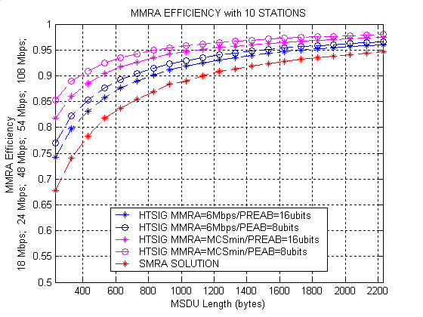
Fig. 33: Efficiency of MMRA and SMRA in scenario 3

Scenario 4: MMRA with 25 Stations
In this fourth scenario the number of stations was increased to 25 while keeping the same PHY rates (18,24,48,54 and 108) Mbps as in the third scenario. For the MMRA scheme there are five MCS sub-aggregates at different data rates, while for the SMRA scheme five PSDU aggregates are sent separately at different MCS modes.
Fig. 34 shows once again that the MMRA scheme (purple and blue curves) performs better than the SMRA scheme (red curve) in this extreme scenario (25 stations to aggregate). MMRA is around 10% more efficient for small packets and 2% more efficient for long packets than SMRA in the case that the HT-SIG MMRA part is sent at the most robust of the five MCS modes (18Mbps). The blue curves, for which the HT-SIG MMRA part was transmitted at 6 Mbps has a similar efficiency than the SMRA scheme.
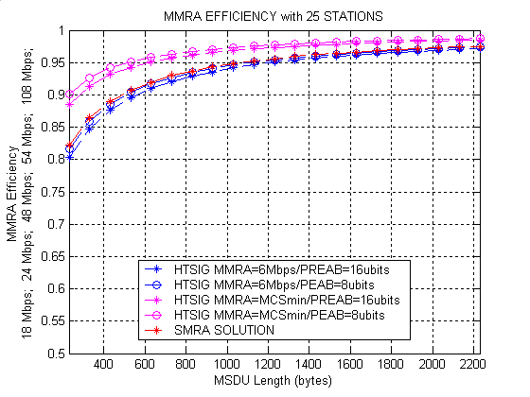
Fig. 34: Efficiency of MMRA and SMRA in scenario 1
It can be concluded that even for a large number of stations like in this last scenario the efficiency of the MMRA scheme is better than the one of the SMRA scheme. Furthermore, the power consumption at the receivers will be much lower with the MMRA scheme, especially for long aggregates with different MCSs, because the receivers just have to wake up for their own MCS sub-aggregate.

Summary
In this presentation we have described PHY and MAC enhancements that optimize the throughput and robustness of 802.11n systems in both 20 and 40MHz bandwidth.

These include :
1.128FFT for better data-rate efficiency in 20 MHz and lower overhead preamble design.
2.Advanced coding (concatenated RS and rate 1/4 convolutional code) for added robustness and range extension.
3.Embedded signaling as a means of coexistence and backward compatibility between legacy and HT devices.
4.Multiple MCS and receiver aggregation for improved MAC efficiency and power saving.

These features can be easily incorporated into 802.11n devices at low complexity while at the same time improving the overall system performance, as shown by the simulation results presented.

End.

Pen C. Li
August 13, 2004

