IEEE P802.11
Wireless LANs

Partial Proposal for 802.11n: Turbo Codes Technical Specification
Date: August 12th, 2004
Author: Marie-Helene Hamon, John Benko, Olivier Seller
France Telecom
4, rue du Clos Courtel – BP91226 – 35512 Cesson-Sevigne- France
Phone: 33 299 12 48 73
Fax: 33 299 12 40 98
e-Mail: mhelene.hamon@francetelecom.com

Abstract

This document discloses the technical specification of the Turbo Encoder regarding the Turbo Codes partial proposal, according to the document "IEEE TGn comparison criteria" (IEEE 802.11-03/814r31).
1.1– Turbo Encoding

The turbo encoder is an 8-state turbo encoder, as depicted on Figure 1. It uses a double binary Circular Recursive Systematic Convolutional (CRSC) code. The most significant bit of the first byte of the useful payload is assigned to A, the next bit to B, and so on for the remaining of the data burst content. The encoder is fed by blocks of k bits or N couples (k=2*N bits). N is a multiple of 4 (k is a multiple of 8).

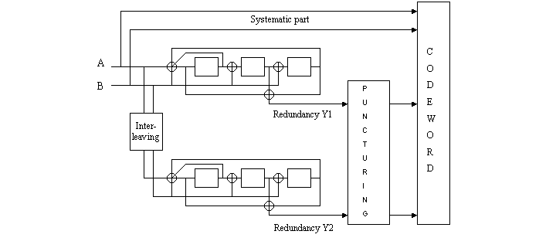
Figure 1 – Encoder block diagram

The polynomials, which shall be used for the connections, are described in octal and symbolic notations as follows:
- for the feedback branch: 15 (in octal), equivalently 1+D+D³ (in symbolic notation);
- for the Y1 and Y2 parity bits, 13, equivalently 1+D²+D³;

The input A shall be connected to tap “1” of the shift register and the input “B” shall be connected to the input taps “1”, D and D².

After initialisation by the circulation state $S_{c_{1}}$, the encoder shall be fed by the sequence in the natural order with incremental address i = 0,…,N-1. This first encoding is called C1 encoding.

After initialisation by the circulation state $S_{c_{2}}$, the encoder shall be fed by the interleaved sequence with incremental address j = 0,… N-1. This second encoding is called C2 encoding.

The function Π(j) that gives the natural address i of the considered couple, when reading it at place j for the second encoding, is given in clause 1.2.

1.2. Turbo Code Permutation

The permutation shall be done on two levels:
- the first one inside the couples (level 1),
- the second one between couples (level 2),

The permutation is expressed in the following algorithm.

- Set the permutation parameters P₀, P₁, P₂ and P₃.
For MPEG2-TS packet size (188 bytes): P₀ = 19, P₁ = 376, P₂ = 224 and P₃ = 600.

- j = 0,… N-1.

- level 1
if j mod. 2 = 0, let (A,B) = (B,A) (invert the couple)

- level 2
- if j mod. 4 = 0, then P = 0;
- if j mod. 4 = 1, then P = N/2 + P₁;
- if j mod. 4 = 2, then P = P₂;
- if j mod. 4 = 3, then P = N/2 + P₃.

    - i = P₀*j + P + 1 mod. N

Table 1 provides the combinations of the parameters N, P₀, P₁, P₂ and P₃, which shall be applied when using the algorithm. (other block sizes can be added as required)

Frame size in couples N | P0 | P1 | P2 | P3
4000 (1000 bytes) | 89 | 28 | 244 | 12

Table 1 – Turbo code permutation parameters

The interleaving relations shall satisfy the odd/even rule (i.e. when j is even, i is odd and vice-versa) that enables the puncturing patterns to be identical for the two puncturing levels.

1.3. Determination of Circulation States

The state of the encoder is denoted S (0 ≤ S ≤ 7) with S = 4.s₁ + 2.s₂ + s₃ (see Table 2). The circulation states $S_{c_{1}}$and $S_{c_{2}}$shall be determined by the following operations:

- Initialise the encoder with state 0. Encode the sequence in the natural order for the determination of $S_{c_{1}}$or in the interleaved order for the determination of $S_{c_{2}}$(without producing redundancy). In both cases, the final state of the encoder is denoted $S_{N−1}^{0}$.

- According to the length N of the sequence, the following correspondence shall be used to find $S_{c_{1}}$and $S_{c_{2}}$(see Table 2).

$S_{N−1}^{0}$  Nmod.7 | 0 | 1 | 2 | 3 | 4 | 5 | 6 | 7
1 | Sc=0 | Sc=6 | Sc=4 | Sc=2 | Sc=7 | Sc=1 | Sc=3 | Sc=5
2 | Sc=0 | Sc=3 | Sc=7 | Sc=4 | Sc=5 | Sc=6 | Sc=2 | Sc=1
3 | Sc=0 | Sc=5 | Sc=3 | Sc=6 | Sc=2 | Sc=7 | Sc=1 | Sc=4
4 | Sc=0 | Sc=4 | Sc=1 | Sc=5 | Sc=6 | Sc=2 | Sc=7 | Sc=3
5 | Sc=0 | Sc=2 | Sc=5 | Sc=7 | Sc=1 | Sc=3 | Sc=4 | Sc=6
6 | Sc=0 | Sc=7 | Sc=6 | Sc=1 | Sc=3 | Sc=4 | Sc=5 | Sc=2

Table 2 – Circulation state correspondence table

1.4. Rates & Puncturing Map

Three code rates are defined here (more can be given upon request): R=1/2, 2/3, ¾.

These rates shall be achieved through selectively deleting the parity bits (puncturing). The puncturing pattern defined in Table 3 shall be applied.

Code Rate | Puncturing vector
1/2 | Y = [1 1 1 1 1 1]
2/3 | Y = [1 0 1 0 1 0]
3/4 | Y = [1 0 0 1 0 0]

Table 3 – Puncturing patterns for turbo codes (“1”=keep, “0”=delete)

In Table 3, the value “1” means that the bit shall be kept, while the value “0” means that the bit shall be deleted. The puncturing patterns shall be identical for both codes C1 and C2.

